**ALL INDIA INSTITUTE OF SPEECH AND HEARING, MYSURU-6**

**अखिल भारतीय वाक श्रवण संस्थान, मैसूर-६**

**DEPARTMENT OF SPECIAL EDUCATION**

**विशेषशिक्षाविभाग**

**MONTHLY REPORT: March 2020**

1. **ACADEMIC ACTIVITIES**
2. Orientation Programs (For outsiders): NIL
3. Clinical /Special Educational postings and/or Observation Postings
4. Students from Other Institutes: NIL
5. AIISH Students in Other Institutes:NIL
6. Seminars/Conferences/Workshops/Training Programs:-NIL
7. Staff enrichment / In-house training programs: NIL
8. **Staff Enrichment Programs (For own staff members):**

**Coordinators:** Ms.Leena C C, Ms.Latha C &Mr.Sharanaiah M. M

**Objectives:** To orient faculty and staff on different topics of communication disorders

|  |  |  |  |  |
| --- | --- | --- | --- | --- |
| **S.No.** | **Theme/Topic** | **Resource Person** | **Number**  **of Participants** | **Date** |
|  | Orientation about *Different activities of SAKSHAM for the Empowerment of Persons / Children with Disabilities* | Mr.KamalakantPandey, General Secretary, SAKSHAM, Nagpur | 22 | 13.03.2020 |
| C:\Users\Administrator\Downloads\WhatsApp Image 2020-04-16 at 12.52.40.jpeg | | | | |

1. Guest Lectures: NIL
2. Additional Academic Services rendered by the Faculty and Staff:
3. Invited Talks: NIL
4. Resource person during interaction program:NIL
5. Development of Material to Support Learning: NIL
6. Curriculamdevelopment:NIL
7. Academic Classes: By faculty–
8. **Theory classes (no. of hours)**

|  |  |  |  |
| --- | --- | --- | --- |
| **Name of the Faculty** | **No. of hours of theory classes** | | |
| **DECSE-HI** | **B.Ed.Spl.Ed. (HI)** | **Total** |
| Dr.Alok Kumar Upadhyay | -- | 18 | **18** |
| Dr.Prithi V | 5 | 11 | **16** |
| Dr.PalnatyVijetha | - | 25 | **25** |
| Dr. G. Malar | 2 | 18 | **20** |
| Ms. Lakshmi Prabha | 4 | 14 | **18** |
| **Total no. of hours** | | | **97** |

1. **Practical Classess (no. of hours)**

|  |  |  |  |
| --- | --- | --- | --- |
| **Name of the Faculty** | **No. of hours of practical classes** | | |
| **DECSE-HI** | **B.Ed.Spl.Ed. (HI)** | **Total** |
| Dr.Alok Kumar Upadhyay | **--** | **--** | **--** |
| Dr.Prithi V | -- | 98 | **98** |
| Dr.PalnatyVijetha | **--** | -- | **--** |
| Dr. G. Malar | 52 | 21 | **73** |
| Ms. Lakshmi Prabha | 2 | 2 | **4** |
| **Total no. of hours** | | | **175** |

1. **Service in Academic Bodies of other Organizations:**
2. **Dr.Alok Kumar Upadhyay**

* Member, Board of Studies (BOS):
  + RamkrishnaMission Vivekananda University, Coimbatore: for Diploma, U.G & P.G.
  + N.G.B. University, Allahabad: for U.G & P.G.
  + J.R.H. University, Chitrakoot: for U.G & P.G.
  + Mysore University,Mysuru :for U.G & P.G.
* Member, Board of Examiners (BOE):
  + UG Special Education of University of Mysore.

1. **Dr. G. Malar**

* Member, BOAE–Special Education of University of Mysore.
* Member, BOE–UG Special Education of University of Mysore.
* Panel of Examiners, B.A.Ed., B.Sc.Ed. &M.Sc.Ed. Programmes of NCERT’s Regional Institute of Education – Mysuru (REIC-M).

1. **Dr. PrithiVenkatesh**

* Member, BOE–UG Special Education of University of Mysore

1. **Dr.PalnatyVijetha**

* Member of BOS in special education, University of Mysore
* Member of BOS in Human development (CB & PG), University of Mysore.
* Member of BOEin special education, University of Mysore

1. **Ms. Lakshmi Prabha J K**

* Member,MonthlyPublic Lecture Series committee, AIISH

1. Participation in Committees/Taskforce and Panels setup by other organizations/agencies:NIL
2. Any Others (Please Specify):
3. **Research Projects (ARF)**
4. Completed –NIL
5. New Research Projects - NIL
6. Ongoing Research Projects - 04

**Project 1**

|  |  |
| --- | --- |
| **Title** | **ARF Project No. 65**: Effect of Resource Materials on Impact of Inclusive Education in Children with Intellectual Disabilities (ID) and Learning Disabilities (LD) |
| **Department** | Special Education |
| **Principal Investigator &**  **Co-Investigator** | **Dr. G. Malar**&Ms. S. Prathima |
| **Funding Agency** | AIISH Research Fund (ARF) |
| **Date of initiation of the project** | 12 months from February 2017 |
| **Amount** | Rs. 3,85,000/- |
| **Status** | Ongoing |
| **Summary of work done** | **In the process of analysing data and compiling report.** |

**Project 2**

|  |  |
| --- | --- |
| **Title** | **ARF No. 02:** Development of Grade Level Assessment Tools in Social Science (GLAT-SS) of Karnataka State Education Board. |
| **Objectives** | The present study is being initiated with the aim to develop and standardize Grade Level Assessment Tool in Social Sciences (GLAT-SS) at GRADE VI of Karnataka State Education Board in English and Kannada. |
| **Department** | Special Education |
| **Principal Investigator &**  **Co-Investigator** | Principal Investigator  **Dr.PalnatyVijetha**  Reader in Special Education  AIISH, Manasagangothri, Mysore: 570006  Co-Investigators   1. Dr.Alok Kumar Upadhyay   Associate Professor in Special Education  AIISH, Manasagangotri, Mysore: 570006   1. Ms.LakshmiPrabha J.K.   Lecturer in Special Education  AIISH, Manasagangotri, Mysore: 570006  Research Officer:   1. Mr. Anil Abbur, AIISH, Mysuru |
| **Funding Agency** | AIISH Research Fund (ARF) |
| **Date of initiation of the project** | 09.10.2018 (approval date) |
| **Amount** | Rs. 3,85,000/- |
| **Status** | Ongoing |
| **Summary of work done** | * **First draft of introduction.** * **Literature review and method is completed.** * **Data analysis is in process.** |

**Project 3**

|  |  |
| --- | --- |
| **Title** | **ARF No. 01:**Efficacyof Developing Skills through Curricular Activities among Preschool Children with Hearing Impairment at AIISH |
| **Objectives** | To investigate the effectiveness of curricular activities in developing:   * Cognitive skills * Language Arts * Pre-academic skills (pre-reading, pre-writing, pre-arithmetic) among children with hearing impairment |
| **Department** | Special Education |
| **Principal Investigator &**  **Co-Investigator** | Principal Investigator  **Dr.Alok Kumar Upadhyay**  Associate Professor in Special Education  AIISH, Manasagangotri, Mysore: 570006  **Co-Investigator**  Dr.PalnatyVijetha  Reader in Special Education  AIISH, Manasagangothri, Mysore: 570006  **Research officer**  Mr.Subramanya K R |
| **Funding Agency** | AIISH Research Fund (ARF) |
| **Date of initiation of the project** | 09.10.2018 (approval date) |
| **Amount** | Rs. 3,80,000/- |
| **Status** | Ongoing |
| **Summary of work done** | * **Data Collection work has over successfully** |

**Project 4**

|  |  |
| --- | --- |
| **Title** | **ARF No. 03:**Development of grade level Assessment test in Science for Upper Primary School Children (VI-VIII) |
| **Objectives** | The aim of the study is to develop grade level assessment test for upper primary school children (VI-VIII) in science subject.  The study will be taken up with the following objectives in mind:   1. To develop grade level assessment test in Science for upper primary school children (VI-VIII) 2. To verify the reliability and validity of the test 3. To establish the norms for the test 4. To test its applicability with learners with hearing impairment 5. To compare the performance of the learners with hearing impairment on the test. |
| **Department** | Department of Special Education |
| **Principal Investigator &**  **Co-Investigator** | **Dr.PrithiVenkatesh**  Reader in Special Education  AIISH, Manasagangothri, Mysore: 570 006  **Research Officer:**  Ms.Dhivya D |
| **Funding Agency** | AIISH Research Fund (ARF) |
| **Date of initiation of the project** | 09.10.2018 |
| **Amount** | Rs.4,00,000/- |
| **Status** | Ongoing |
| **Summary of work done** | * **Completed pilot study and evaluation of the same.** * **Collecting resources for introduction.** * **Collecting resources for review of literature.** |

1. Postgraduate /Ph.DResearch Completed: NIL
2. Postgraduate Research ongoing: NA
3. Research Papers presented at National/International Conferences/Seminars: - NIL
4. Research Papers published:-
5. Papers published in National / International Journals: NIL
6. Papers published in Conference / Seminar Proceedings (Abstract):-NIL
7. Books published (in APA format)
8. *Books published*
9. *Books in press*
10. Book chapters published (in APA format): NIL
11. Articles Published: NIL
12. Books/Manuals/Seminar Proceedings edited: NIL
13. Journal Editorship: NIL
14. Scholarly Reviewing Activities: NIL
15. Special Educational Services Offered through Teacher Trainees Outside Campus: NIL

**III CLINICAL/ SPECIAL EDUCATIONAL SERVICES**

1. General Clinical Services: Not Applicable
2. **Specialized Clinical / Educational Services :**
3. Pre-school Training and Special Educational services for children with special needs

|  |  |  |  |  |  |  |  |  |  |  |  |  |
| --- | --- | --- | --- | --- | --- | --- | --- | --- | --- | --- | --- | --- |
| **S. No.** | **Nature of Services** | | | | | | | | | | | |
| 1. ***Special Educational Assessment Unit (SEA-U)*** | | | | | | | | | | | | |
|  |  | Nature of Special Need  Language | ASD / PDD NOS | Hearing Impairment (HI) | Intellectual Disability (ID) | Learning Disability (LD) | Motor Problems/ Cerebral Palsy (CP) | Multiple Disabilities (MD) | Others | No. of Clients | No. of Sessions | ***Total No. of Sessions*** |
| 1. | Screening &Referral | Kannada | -- | 6 | 2 | -- | 1 | 1 | 2 | ***12*** | ***12*** | ***17*** |
| Malayalam | 1 | 1 | -- | -- | -- | -- | 2 | **2** | **2** |
| Hindi | -- | 2 | -- | -- | -- | -- | -- | -- | -- |
| Urdu | -- | -- | -- | -- | -- | -- | -- | -- | -- |
| English | 3 | -- | -- | -- | -- | -- | -- | **3** | **3** |
| Telugu | -- | -- | -- | -- | -- | -- | -- | -- | -- |
| Tamil | -- | -- | -- | -- | -- | -- | -- | -- | -- |
| Any Other | -- | -- | -- | -- | -- | -- | -- | -- | -- |
| ***Total No. of Clients*** | ***4*** | ***9*** | ***--*** | ***--*** | ***1*** | ***1*** | ***2*** | ***17*** | ***17*** |
| 2. | Assessment &Report | Kannada | -- | 1 | 1 | -- | -- | -- | -- | 2 | 6 | ***8*** |
| Malayalam | -- | -- | -- | -- | -- | -- | -- | -- | -- |
| Hindi | -- | 1 | -- | -- | -- | -- | -- | 1 | 6 |
| Urdu | -- | -- | -- | -- | -- | -- | -- | -- | -- |
| English | -- | -- | -- | -- | -- | -- | -- | -- | -- |
| Telugu | -- | -- | -- | -- | -- | -- | -- | -- | -- |
| Tamil | -- | -- | -- | -- | -- | -- | -- | -- | -- |
| Any Other | -- | -- | -- | -- | -- | -- | -- | -- | -- |
| ***Total No. of Clients*** | ***--*** | ***2*** | ***1*** | ***--*** | ***--*** | ***--*** | ***--*** | ***3*** | ***12*** |
| Places from which seen: (1)Karnataka: 15(2)Kerala: 4(3)AP: 1(4)Telangana: Nil (5)TN: NIL(6)Other Parts of India: 03 (1 each from Arunchal Pradesh, Assam & Jharkhand) (7)Any other: 1 | | | | | | | | | | | |
| Age groups seen:(1)Birth to 2.5yrs: 3(2)2.5+ to 6 yrs: 12(3)6yrs+ to 16 years: 6(4)16yrs+: nil | | | | | | | | | | | |
| Total No. of Referrals: (1)Educational Assessment: 04 (2)Educational Guidance: 04 (3)PIP: 03(4)PPEP/PBC/GECS: 11 (5)CSS/IEP/NFE/DET:03 (6)Any Other Services at AIISH: nil (7)Any Other Services Outside AIISH: nil | | | | | | | | | | | |
| No. of Reports Issued/Ready for Issue: (1) School Readiness: nil(3) Curriculum-Based Grade Level Assessment: nil (4) Post-School: nil | | | | | | | | | | | |

|  |  |  |  |  |  |
| --- | --- | --- | --- | --- | --- |
| **Curricular Support Services – Supportive training to augment education in mainstream school/ other educational programmes** | **Language** | **No. of children with HL** | **No. of children with ID/CP/ASD/MD/LD/DD** | **Total No. of clients** | **No. of sessions** |
| Kannada | 4 | 11 | 15 | 57 |
| Malayalam | 0 | 2 | 2 | 5 |
| Hindi | 0 | 1 | 1 | 4 |
| English | 0 | 2 | 2 | 7 |
| Telugu | 0 | 2 | 2 | 13 |
| Tamil | -- | -- | -- | -- |
| **Total** | | | | **22** | **86** |
| |  |  |  |  |  |  | | --- | --- | --- | --- | --- | --- | | **Individualised Educational Programme (IEP) – Training in functional academics for out of school individuals** | **Language** | **No. of children with HL** | **No. of children with ID/CP/ASD/MD/LD/DD** | **Total No. of clients** | **No. of sessions** | | Kannada | 0 | 1 | 1 | 6 | | Malayalam | 1 | 0 | 1 | 0 | | Hindi | 0 | 0 | 0 | 0 | | English | 0 | 0 | 0 | 0 | | Telugu | 0 | 0 | 0 | 0 | | Tamil | 0 | 1 | 1 | 3 | | **Total** | | | **3** | **9** | | | | | | |
| |  |  |  |  |  |  | | --- | --- | --- | --- | --- | --- | | **Demonstration Educational Training: Short-term demonstration to caregivers in any of the above** | **Language** | **No. of children with HL** | **No. of children with ID/CP/ASD/MD/LD/DD** | **Total No. of clients** | **No. of sessions** | | Kannada | 0 | 1 | 1 | 6 | | Malayalam | - | - | - | - | | Hindi | - | - | - | 6 | | English | - | - | - | - | | Telugu | - | - | - | - | | Tamil | - | - | - | - | | **Total** | | | **1** | **6** | | | | | | |
| Total no. of clients:26  Old clients:29  New clients: NIL  Discharged (DET): NIL  Discharged(CSS): NIL  Discharged(IEP): NIL  Discontinued(DET):NIL  Discontinued(CSS): NIL  Discontinued (IEP): 1 | | | | | |

|  |
| --- |
| **Pre-school Training: Preparatory programme for schooling by providing training in self-help, cognitive, language and (pre-) academic skills, Preschool Supplementary Services (PSS)** |
| |  |  |  |  | | --- | --- | --- | --- | | **Language & Disability** | **No. of Groups** | **No. of Children** | | | MALE | FEMALE | | Kannada; ASD & ID &MD | 14 | 51 | 19 | | Kannada HL | 6 | 29 | 12 | | Malayalam HL | 1 | 5 | 2 | | Malayalam ASD & ID &MD | 6 | 17 | 10 | | Hindi HL | 2 | 10 | 1 | | Hindi MD & ID & ASD | 2 | 6 | 3 | | Telugu HL  &ASD & ID & MD | 2 | 9 | 4 | | **Total number of children** | **33** | **127** | **51** | | **TOTAL** |  | **178** | | | **Sessions** | **1584 (Group-wise)** | | | |
| **Preschool Statistics – March 2020** |

**Note: - March 31st – 35 Male and 17 Female got discharged after completing their training.**

|  |  |  |  |  |  |  |  |  |  |  |  |  |  |
| --- | --- | --- | --- | --- | --- | --- | --- | --- | --- | --- | --- | --- | --- |
| **Pre-school Parent Empowerment Programme – PPEP** | | | | | | | | | | | | | |
|  | **Language groups of children** | **HL** | **ID** | **CP** | **ASD** | **MD** | **LD** | **DD** | **SLD** | **ADHD** | **Total No. of clients** | **Group** | **No. of sessions** |
| Kannada | 33 | 19 | - | 6 | 1 | - | - | - | - | 59 | 12 | **180** |
| Malayalam | 16 | 50 | - | - | - | - | - | - | - | 66 | 3 | **45** |
| Hindi | 3 | 4 | - | - | - | - | - | - | 1 | 8 | 2 | **30** |
| English | 1 | 5 | - | - | - | - | - | - | 1 | 7 | 1 | **15** |
| Telugu | - | 3 | - | - | - | - | - | - | - | 3 | 1 | **15** |
| Tamil | - | 3 | - | - | - | - | - | - | - | 3 | 1 | **15** |
| **Total** | | | | | | | | | | | **146** | **22** | **300** |
| No. of clients promoted to the next higher level(Preschool) of service: NIL  No. Of discharged: NIL  No. Of discontinued: NIL  No. Of New clients (**March**): NIL  Shifted from PPEP to PIP: NIL  No. of Long leaves: NIL | | | | | | | | | | | | | |

|  |  |  |  |  |  |
| --- | --- | --- | --- | --- | --- |
| **ParentInfant Programme – PIP(Birth to 2 ½ years):** | | | | | |
|  | **Language groups of children** | **HL** | **ID/CP/ASD/**  **MD/LD/DD** | **Total No. of clients** | **Total No. of sessions** |
| Kannada | 5 | 4 | 9 | 44 |
| Malayalam | 3 | 4 | 8 | 30 |
| Hindi | 1 | - | 1 | - |
| English | - | - | - | - |
| Telugu | 1 | 1 | 2 | 12 |
| Tamil | - | - | - | - |
|  | **Total** | | | **20** | **86** |
| No. of Old clients : 20  No. of New clients enrolled: NIL  Total clients: 20  No. discharged : 2  No. discontinued: NIL  No. of Promoted to next level: 1 | | | | | |

|  |  |  |
| --- | --- | --- |
| **Library of Books & Toys** – LiBoToy  Services: issuing educational toys & books for home-based training. | Total number of members enrolled during 2019-20:131  No. of new members: NIL  Amount: NIL  Total number of sessions:12 | |
| **Age group** | **Total number** |
| 0-2.5yrs | 5 |
| 2.5- 3yrs | 37 |
| 2.5-6yrs | 85 |
| 6 yrs and above | 4 |

|  |  |  |
| --- | --- | --- |
| **Services** | **Number of Clients** | **Number of Sessions** |
| Co-Curricular Training | 178 | 30 |

1. **Support for Empowering Caregivers:**

|  |  |  |
| --- | --- | --- |
| **Name of Training Unit** | **No. of Parent**  **Beneficiaries** | **No. of Sessions** |
| Caregiver Computer Training Unit | - | - |
| Caregiver Literacy Training Unit | - | - |
| Caregiver yoga training unit  (from 14.3.2019 onwards) | - | - |

1. **Clinical/ Educational Support Services to Parents and Family**
2. **Educational guidance**

|  |  |
| --- | --- |
| No. of Clients | Sessions |
| - | - |

1. **U-SAFE**

|  |  |
| --- | --- |
| No. of Clients | Sessions |
| - | - |

1. **SUMERU (Special Use of Music for Educational Readiness and Upbuilding)**

|  |  |  |
| --- | --- | --- |
| *Activity* | *No. of Clients* | *Sessions* |
| Taining for Drum | 8 | 35 |
| Traning for Choir group | - | - |

1. **Details of Certificates Issued: Bonafide Certificates : 06**

|  |  |  |
| --- | --- | --- |
| **Diagnosis** | **Number of certificates issued** | **Purpose** |
| HI | 02  02 | Mainstream Admission  Scholarship |
| ID/ASD | 02 | Adhaar Card |

1. **Specialized Clinical/ Educational Services:**

**Group Therapy Statistics- 1st March to 29th March, 2020**

|  |  |  |  |  |  |
| --- | --- | --- | --- | --- | --- |
| **LANGUAGE** | **DISABILITY** | **NO. OF GROUPS** | **NO. OF CHILDREN** | | **NO. OF SESSIONS ATTENDED** |
|  |  |  | **M** | **F** |  |
| **KANNADA** | HEARING LOSS | 06 | 27 | 11 | 35 |
| ASD | 05 | 19 | 07 | 27 |
| INTELLECTUAL DISABILITY | 07 | 25 | 10 | 43 |
| MULTIPLE DISABILITY | 02 | 08 | 02 | 11 |
| **MALAYALAM** | HEARING LOSS | 01 | 04 | 03 | 8 |
| ASD | 02 | 05 | 03 | 10 |
| INTELLECTUAL DISABILITY | 04 | 09 | 08 | 27 |
| MULTIPLE DISABILITY | - | - | - | - |
| **HINDI** | HEARING LOSS | 02 | 08 | 0 | 8 |
| ASD | 01 | 04 | 01 | 10 |
| INTELLECTUAL DISABILITY | 01 | 03 | 02 | 9 |
| MULTIPLE DISABILITY | - | - | - | - |
| **TELUGU** | HEARING LOSS | 01 | 00 | 03 | - |
|  | ASD | - | 03 | 00 | - |
|  | INTELLECTUAL DISABILITY | 01 | 04 | 01 | 16 |
|  | MULTIPLE DISABILITY | - | 02 | 00 | - |
| **TOTAL** |  | **33** | **121** | **51** | **204** |
| **172** | |
| Daily Average Group Sessions | | **33** | | | |

1. Financial Aid: NIL
2. Legal advice: NIL
3. Any other(Please Specify):

Team of Special Educators with their floor area for painting done on 18.03.2020 to 20.03.2020.

|  |  |  |  |  |
| --- | --- | --- | --- | --- |
| **Team 1** | **Team 2** | **Team 3** | **Team 4** | **Team 5** |
| **Near Play Area** | **Front of AV Room** | **Chillipilli corner** | **Near Traffic Signal** | **Prayer Hall** |
| 1. Ms. Vijayalakshmi S 2. MS. Leena C C 3. Ms. Sangeetha 4. Mr. Anil Abbur 5. Mr. Subramanya K R | 1. Ms. Shobha B N 2. Ms. Subalakshmi J 3. Ms. Kadambari N 4. Ms. Anjana K 5. Ms. Raksha Anand | 1. Ms. Kumudha R 2. Ms. Raksha Anand 3. Ms. Latha C 4. Ms. Sharanaiah M M | 1. Ms. Ramanakumari P V 2. Ms. Manjula P V 3. Mr. Rajkumar R 4. Mr. Balu M | 1. Ms. Sumana H P 2. Ms. Asha S A 3. Ms. Lakshmi M 4. Ms. Dhivya D |

Photo:-

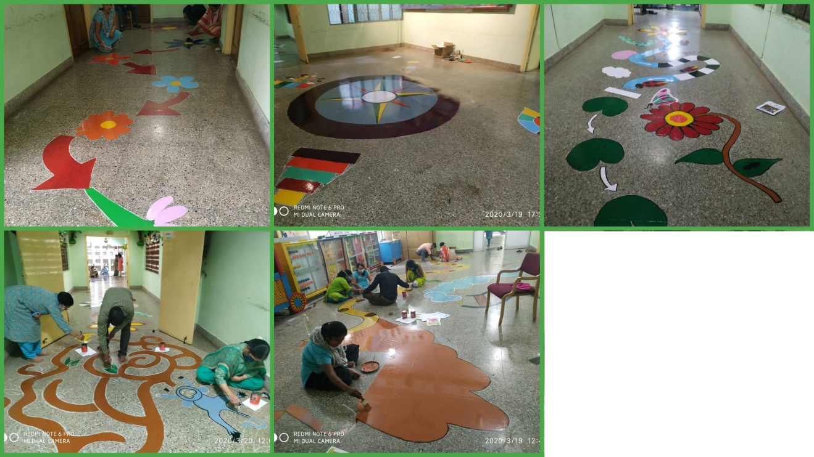

1. Attended workshop/Seminar/Orientation program in AIISH 2019-20: NIL
2. Attended workshop/Seminar/Orientation program outside institute 2019-20: NIL

**IV. EXTENSION ACTIVITIES**

1. Public Lecture Series:NIL

V. TECHNLOGICAL CONSULTANCY SERVICES: NIL

VI. CENTRAL FACILITIES

* + - 1. Library and Information Services
      2. Public Information Activities
      3. Major Events with a brief account:
      4. **Press Releases and Media Coverage:**

**Kannada Actress Ms.Amulya visited the AIISH and inaugurated smart class for the children with speech and hearing impairment** was in various newspapers was published below pictures:-

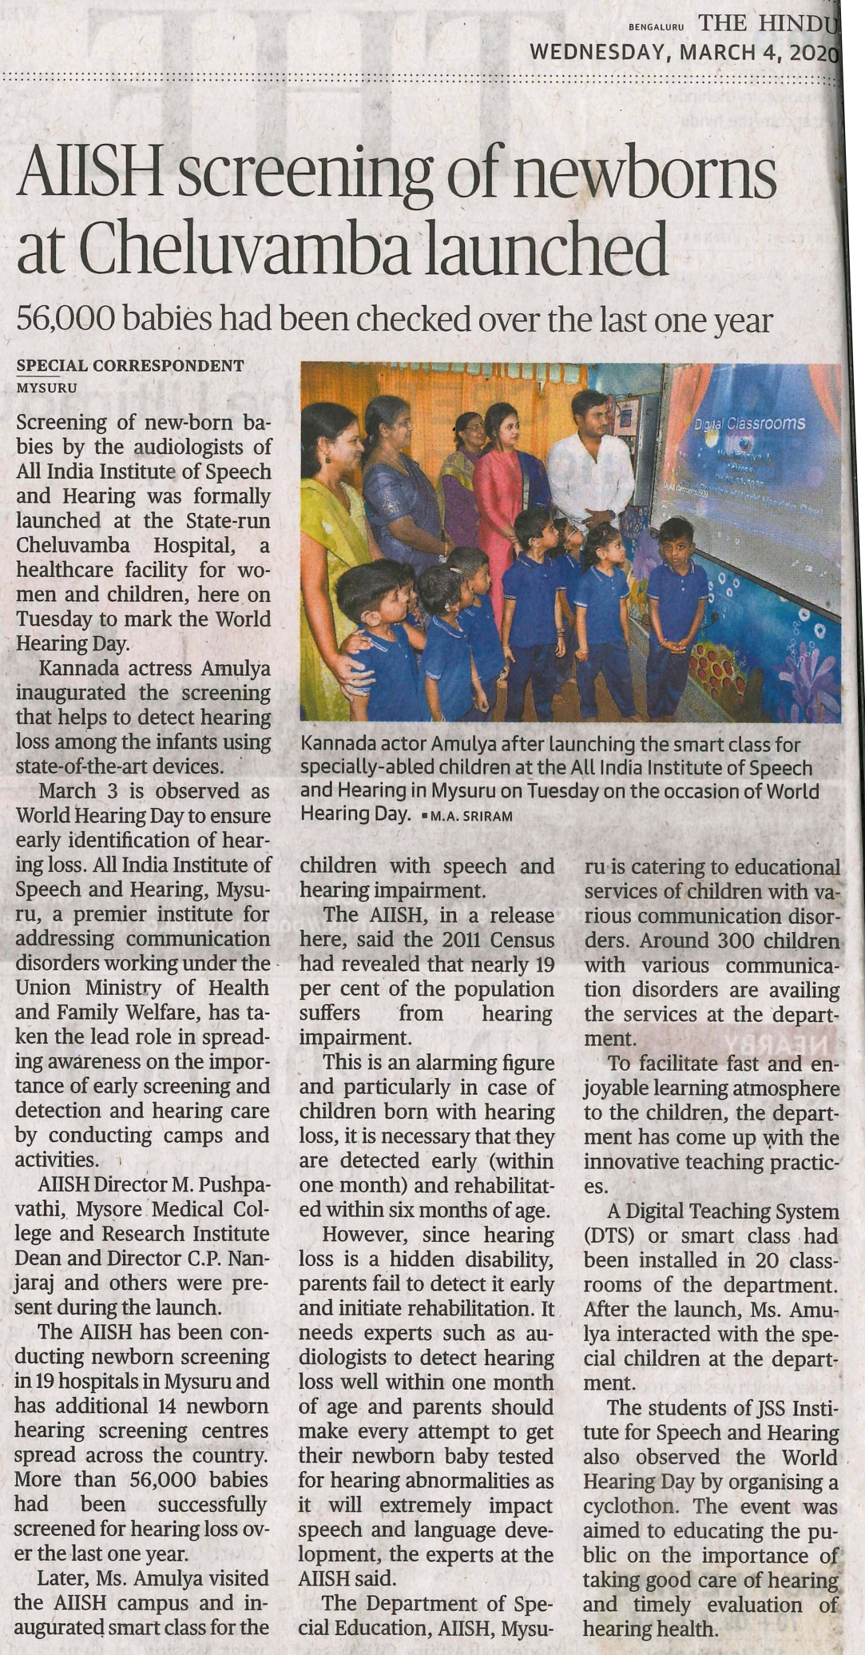

**C) Material Development:**The following Teaching Learning Material wereprepared for training children with various communication disorders in preschool.

|  |  |  |  |
| --- | --- | --- | --- |
| **Sl.**  **No.** | **Nature of**  **Teaching-Learning**  **Materials** | **Skill** | **Number** |
| 1. | Flash cards | For all skill areas | 273 |
| 2. | Work Cards | For all skill areas | 285 |
| 3. | Charts | For all skill areas | 24 |
| 4. | PPT | For all skill areas | 12 |
| 5. | Models | For all skill areas | 1 |
| 6. | Sentence strips | For all skill areas | 125 |
| 7. | Story cards | For all skill areas | 41 |
| 7. | U-Safe | For all skill areas | 2 |
| 8. | Others | For all skill areas | 0 |

**Material Development:**The following materials were prepared by the B.ASLP students for teaching various speech and language concepts in children with various communication disorders in preschool.

|  |  |  |
| --- | --- | --- |
| **Sl.**  **No.** | **Nature of**  **Speech and Lnguage Therapy**  **Materials** | **Number** |
| 1. | Short Story Books | - |
| 2. | Memory Game | - |
| 3. | Model of Railway Station | - |
| 4. | Model of Restaurant | - |
| 5. | Odd one out Game | - |
| 6. | Reasoning skills | - |

1. AWARDS AND HONORS RECEIVED BY FACULTY AND STAFF: NIL
2. EXTRA CURRICULAR ACTIVITIES:
   * + - 1. AIISH Gymkhana: NIL
3. EMINENT VISITORS:
4. ANY OTHER:

**Kannada Actress Ms.Amulya visited the Department of Special Education, AIISH and inaugurated smart class for the children with speech and hearing impairment on 03.03.2020.**

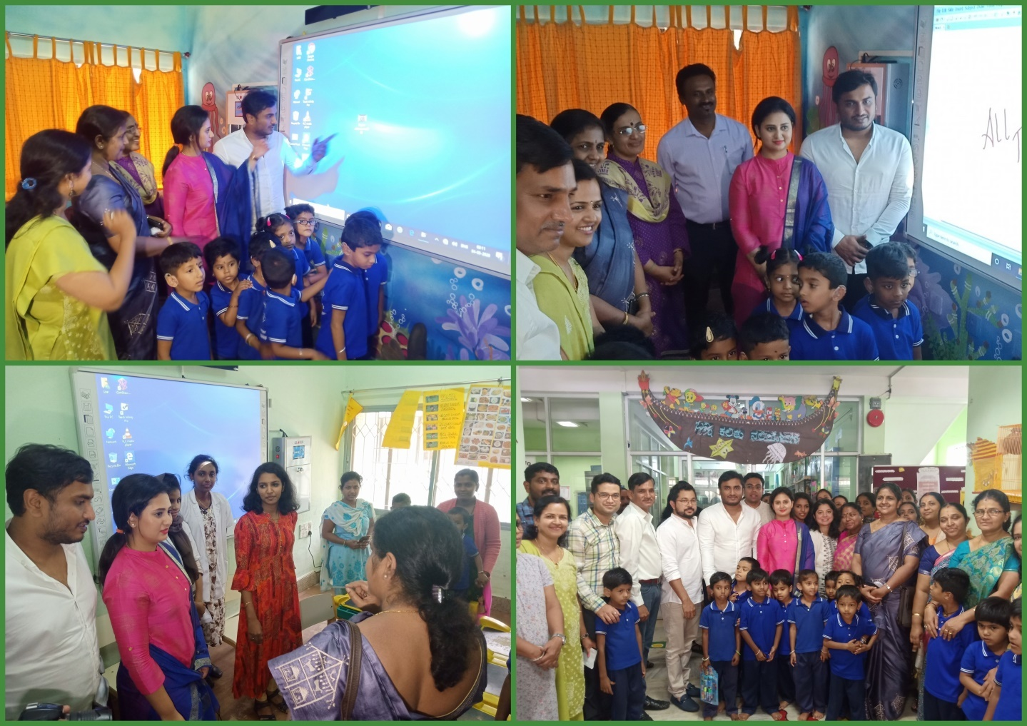

1. **OfficialLanguage Implementation:**

* No. of notings/letters (**March 2020**):

|  |  |
| --- | --- |
| Bilingual ( hindi and English ) | 72 |
| English | 3 |

Speech and Language Therapy

* New batches of 1st and 3rd BASLP students were oriented regarding group therapy.
* Sessions were taken for various groups as 2nd BASLP were not posted in this month.
* Groups were assigned to student clinicians and group therapy sessions were regularly monitored.
* Differnt speech and language goals were recommeneded for all the groups and students were counselled on the same and helped in planing activities for the session.
* Meetings were conduceted along with the teacher, supervisor and the parents of few groups.
* Children/ Groups going who were discharged were counselled for different speech and language activities to be carried out at home.
* Students were guided to prepare materials for speech and language therapy.

Sd/-

HOD- Special Education