संप्रेषणविकृतिरोकथामविभाग
DEPARTMENT OF PREVENTION OF COMMUNICATION DISORDERS
महीनेकेविवरण/ MONTHLY REPORT –February 2020
- ACADEMIC ACTIVITIES
- No. of short-term training programs organized: NIL
- No. of orientations: 36
As a part of primary prevention activities, several orientation/sensitization programs are being conducted regularly. The objective of the orientation programs was to create awareness among general public and various other professionals such as Medical doctors, Nurses, Health related workers, teachers, school students etc., on different types of communication disorders, its prevention and early identification methods and their appropriate referral and timely management. Table 1a, 1b, 1c shows the details of the orientation programs conducted by staff and students of department of POCD, staff of NBS, OSC centers respectively.
Table 1a): Details of orientation Programs at Department of POCD during the month of February 2020.
- Number of Orientation Programs at POCD : 14
Theme/Topic of the program: Prevention & early identification of communication disorders
Coordinators: Dr. N. Sreedevi, Dr. M. Sandeep & Mr. Arunraj K.
S.No | Date | Name of the institute/  Hospital | Target group | Total participant | Oriented by
1. | 07.02.2020 | AYUSH doctors, ESI Hospital, Brindavan Extension. | Ayurveda Doctors | 39 | Ms. Sharanya K Kumar (Aud Gr I)& Ms. Krishnendu (SLP Gr I)
2. | 11.02.2020 to 13.02.2020 | Royale Concorde School | Teachers& Students | 140 | Ms. Abhinaya (Aud Gr I), Ms. Ritu (Aud Gr I)& Ms. Anusha (SLP Gr II)  Devi and Priya
3. | 13.02.2020 | Anganvadi, Akkihebbal, Mandya | Anganawadi workers | 48 | Ms. Bhanumathi, Ms. Chandana &  (Intern students)
4. | 14.02.2020 | B.Ed. College Malapuram, Kerala | B.Ed. students | 95 | Ms. Krishnendu (SLP Gr I)& Ms. Aparna U (Aud Gr II)
5. | 16.02.2020 | Expectant Mothers from in and around Mysuru | Expectant Mothers | 30 | Ms. Anusha(SLP Gr II),& Ms. Ritu(Aud Gr I)
6. | 18.02.2020 | Hoysala Karnataka Sangha,  Mysuru | Ladies wing of Sangha | 50 | Ms. Anusha(SLP Gr II)& Ms. Ritu(Aud Gr I)
7. | 19.02.2020 | AIISH, Mysuru | Administrative staffs | 39 | Dr. N Sreedevi (Prof. of Speech Sciences) & Mr. Harish Kumar  (Aud Gr I)
8. | 20.02.2020 | AIISH preschool, Mysuru | Preschool parents | 80 | Mr. Kishore Kumar(Aud Gr I), Ms. Ritu (Aud Gr I)& Ms. Priya (Aud Gr I)
9. | 22.02.2020 | AIISH, Mysuru | Security Guards and Housekeeping staffs | 75 | Dr. N Sreedevi (Prof. of Speech Sciences) & Mr. Harish Kumar(Aud Gr I)
10. | 23.02.2020 | Kannada Habba Kalamandir, Mysuru | General Public | 800 | AIISH staff
11. | 28.02.2020 | AIISH, Mysuru | Yoga practitioners | 65 | Dr. Abhishek B.P. (Lecturer in Speech Sciences)  & Ms. Mamatha N M (Assistant Professor in Audiology)
12. | 28.02.2020 | Ha rohally, near H D Kote | Students | 80 | Dr. Sreedevi. N (Prof. of Speech Sciences) , Mr. Harish Kumar(Aud Gr I) & Sharanya k Kumar (Aud Gr I)
13. | 28.02.2020 | Cheluvamba Hospital | Expectant mothers | 06 | Dr. Geetha C. (Reader in Audiology)
14. | 17.02.2020 to 28.02.2020 | Schools of Mysuru | Students & Teachers | 4000 | AIISH staff

Table 1b): Orientation Programs conducted by staff at different NBS centers in the month February, 2020.
- Number of Orientation Programs at OSC centre :14
Theme/Topic of the program: Prevention & early identification of communication disorders

S. No | Date | Name of the institute/  Hospital | Target group | Total participant | Oriented by
1. | 03.2.2020 | NGO.SC colony Anganwadi, Sagara | Students and teachers | 21 | Mr. Monish. V (SLP Gr I)  Ms. Durga S (Aud Gr I)
2. | 05.02.2020 | BIMS, Belagavi | Doctors | 27 | Mr. Gowtham H.S (SLP Gr I)  Mr. Advaith B (Aud Gr I)
3. | 06.02.2020 | A.B. Vajapiyee School, Sagara | Students and teachers | 146 | Mr. Monish. V (SLP Gr I)  Ms. Durga S (Aud Gr I)
4. | 08.02.2020 | Government pre-metric Girls Hostel, Sagara | Students | 49 | Mr. Monish V (SLP Gr I)  Ms. Durga S (Aud Gr I)
5. | 12.02.2020 | Nanjangud Taluk Hospital, Nanjangud | School Teachers | 13 | Ms. Spoorthy C (SLP Gr I)
6. | 14.02.2020 | Nanjangud Taluk Hospital, Nanjangud | School Teachers | 10 | Ms. Spoorthy C (SLP Gr I)
7. | 19.02.2020 | Taluk General hospital, KR Pete | Caregivers of Speech language disordered population | 08 | Ms. Minu Lalu (SLP Gr I)
8. | 19.02.2020 | KoIMS-TH, Madikeri | Staff nurses | 35 | Ms Kavita (Aud Gr I) & Ms Anita (SLP Gr I)
9. | 20.02.2020 | Government School Belagavi,Belagavi | School Teachers | 11 | Mr. Advaith B (Aud Gr I) & Mr.Gowtham H S (SLP Gr I)
10. | 24/02/2020 | VMH, Sargur | Teachers | 44 | Ms. Arpitha V (SLP Gr I)
11. | 25/02/2020 | VMH, Sargur | ANM workers | 18 | Ms.Arpitha V (SLP Gr I)
12. | 26/02/2020 | VMH, Sargur | Teachers | 38 | Ms Deepashree (SHT) & Ms Arpitha V (SLP Gr I)
13. | 27/02/2020 | VMH, Sargur | Teachers | 42 | Ms Deepashree (SHT) & Ms Arpitha V (SLP Gr I)
14. | 28.02.2020 | Nanjangud Taluk Hospital, Nanjangud | School Teachers & Students | 205 | Ms. Spoorthy C (SLP Gr I)

Table 1c): Details of Orientation Programs conducted at different OSC centre during the month of February, 2020.
III. Number of orientation Programs at NBS centre :08
Theme/Topic of the program: Prevention & early identification of communication disorders

S. No | Date | Name of the institute/  Hospital | Target group | Total participant | Oriented by
1. | 06.02.2020 | Dr. Ram Manohar Lohya Hospital,New Delhi | Medical students | 15 | Sneha Uttakalika (Aud Gr I)
2. | 19.02.2020 | Netaji Subash Chandra bose Medical college, Jabalpur | Staff (BASLP) | 05 | Ms.Kriti Arora (Aud Gr I)
3. | 20.02.2020 | King George Medical University, Lucknow | Professional working at Different districts hospitals in UP | 10 | Dharm Pal Singh (SHT)
4. | 20.02.2020 | Ashtavakra institute of rehabilitation sciences and research, New Delhi | BASLP students | 25 | Ms. Sneha Uttakalika (Aud Gr I)
5. | 24.02.2020 | Govt. Hospital Pune | Masters first year | 12 | Ms. Suman Penwal (Aud Gr I)
6. | 26.02.2020 | Govt. Hospital Pune | Intern batch | 12 | Ms. Suman Penwal (Aud Gr I)
7. | 27.02.2020 | JIPMER, Puducherry | Mothers of Preterm and term babies | 20 | Saranya M (Aud Gr I)
8. | 29.02.2020 | Maharaja Agrasen Pubilc School, Ajmer | School Teachers (primary and secondary) | 56 | Ms. Chhandasi Anarse (Aud Gr I)
Overall Total oriented (I+II+III) |  |  |  | 6 369

Table 2: Total number of participants oriented in the month of February, 2020
S. No | Target group | Gender |  | Total number of Participants
S. No | Target group | Male | Female | Total number of Participants
1. | Teachers | 435 | 319 | 754
2. | Students | 2019 | 2202 | 4221
3. | Anganwadi workers | 01 | 47 | 48
4. | Nurses | 04 | 31 | 35
5. | ASLP & MASLP Students | 10 | 14 | 24
6. | Ayurveda doctors | 15 | 24 | 39
7. | General public | 400 | 450 | 850
8. | Doctors | 15 | 12 | 27
9. | Medical students | 07 | 08 | 15
10. | Expectant mothers | 00 | 36 | 36
11 | Admin staffs in AIISH | 19 | 20 | 39
12. | Parents of preschool children | 04 | 76 | 80
13. | Security and Housekeeping staff | 30 | 45 | 75
15. | Yoga practitiopners | 30 | 35 | 65
16. | Caregivers of Speech language disordered population | 02 | 06 | 08
17. | ANM workers | 14 | 04 | 18
18. | Professional working at Different districts hospitals in UP | 04 | 06 | 10
19. | BASLP professionals | 02 | 03 | 05
 | Mothers of Preterm and term babies | 00 | 20 | 20
TOTAL |  | 3011 | 3358 | 6369

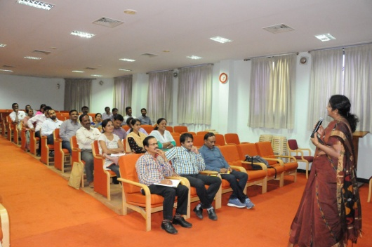
Figure 1: Orientation Program to AYUSH doctors (Ayurveda Doctors) at AIISH
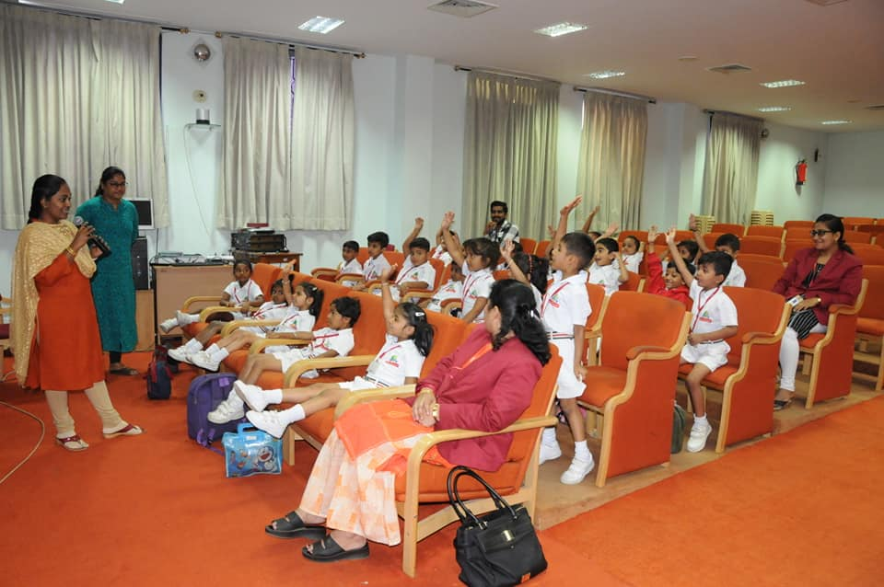

Figure 02: Orientation to students and teachers of Royale concord school by staff

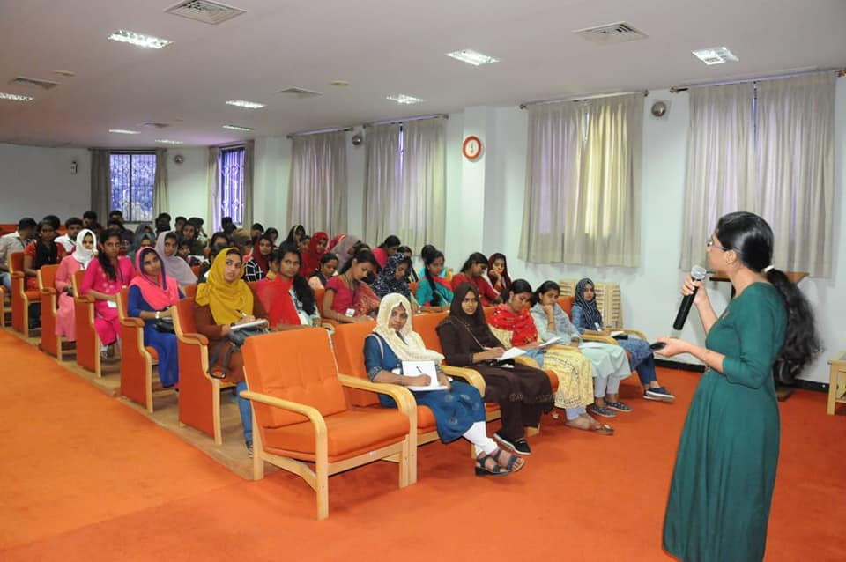
Figure 03: Orientation to B Ed students from Vivekananda teacher training institute Malapuram, Kerala by POCD staff.

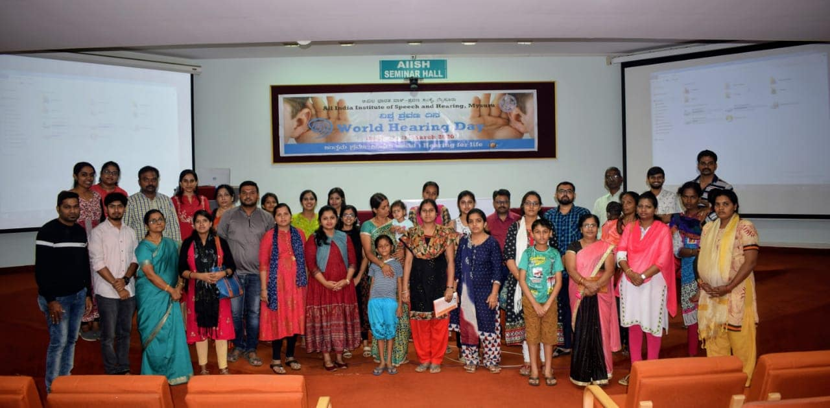
Figure 04: Orientation Program for expectant mothers at AIISH.
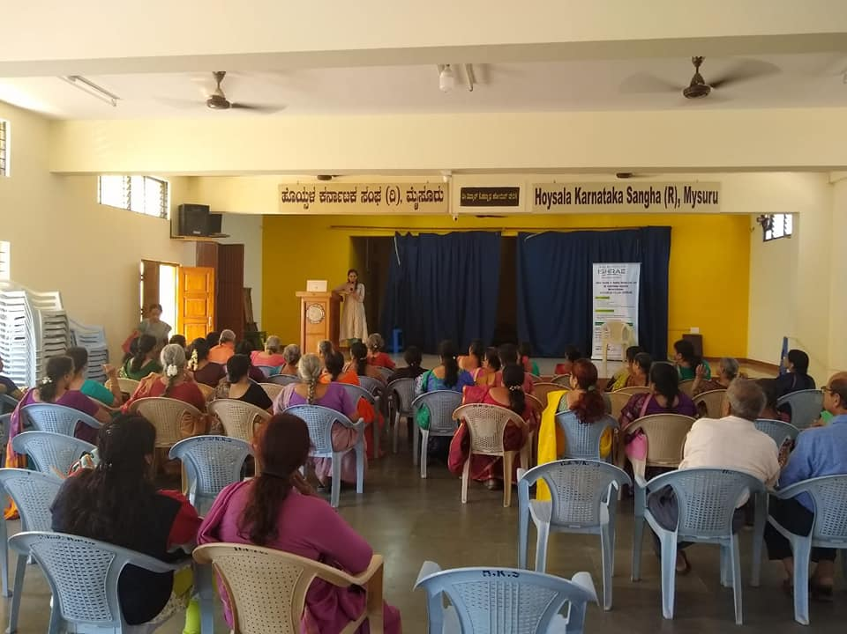
Figure 05: Orientation Program for general public at Hoysala Karnataka Sangha, Mysuru by POCD staff.
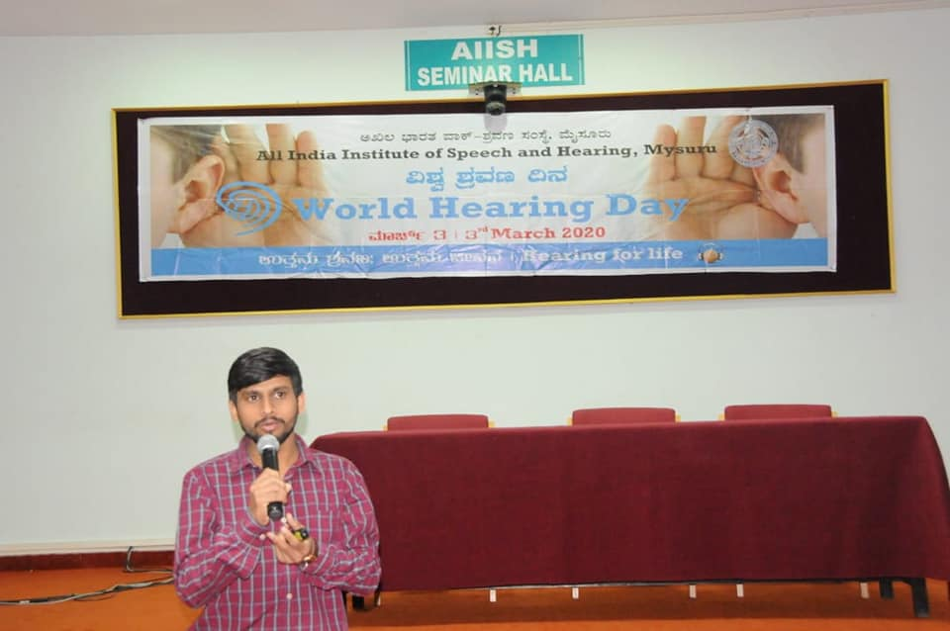
Figure 06: Orientation to administrative staff in AIISH by POCD staff.
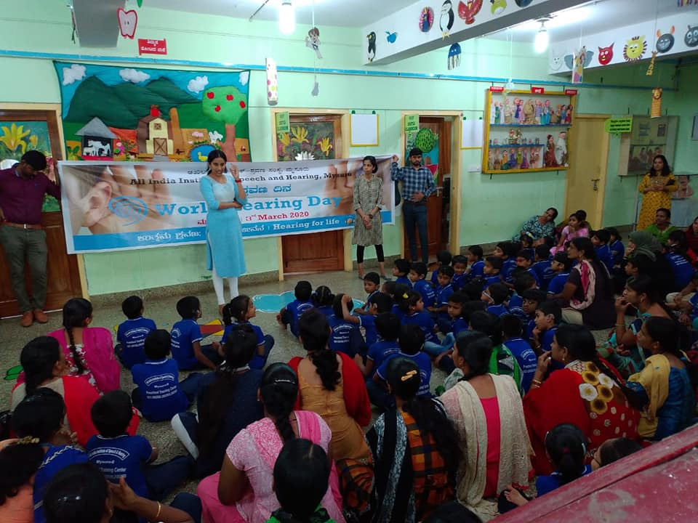
Figure 07: Orientation to parents of preschool children by POCD staff
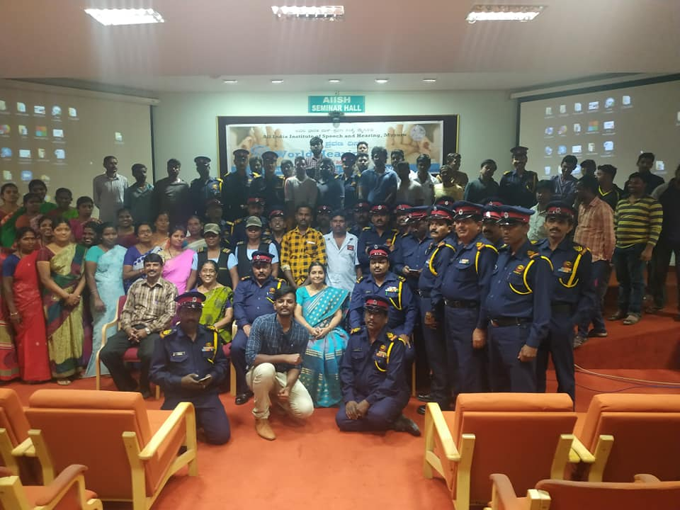
Figure 08: Orientation to Security Guards and Housekeeping staff by POCD.
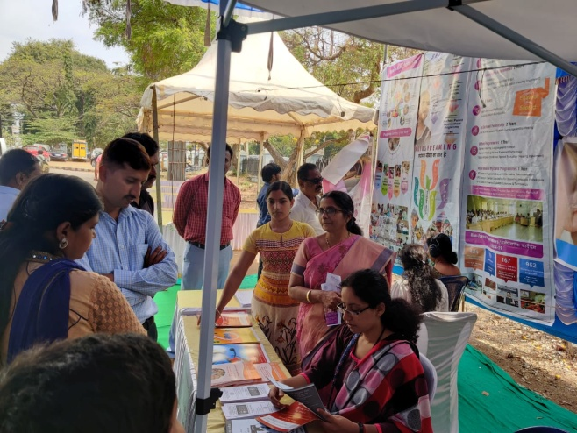
Figure 09: Orientation to general public at Kala mandir, MtTaluk General Hospital, KR Pete by Bond Staff
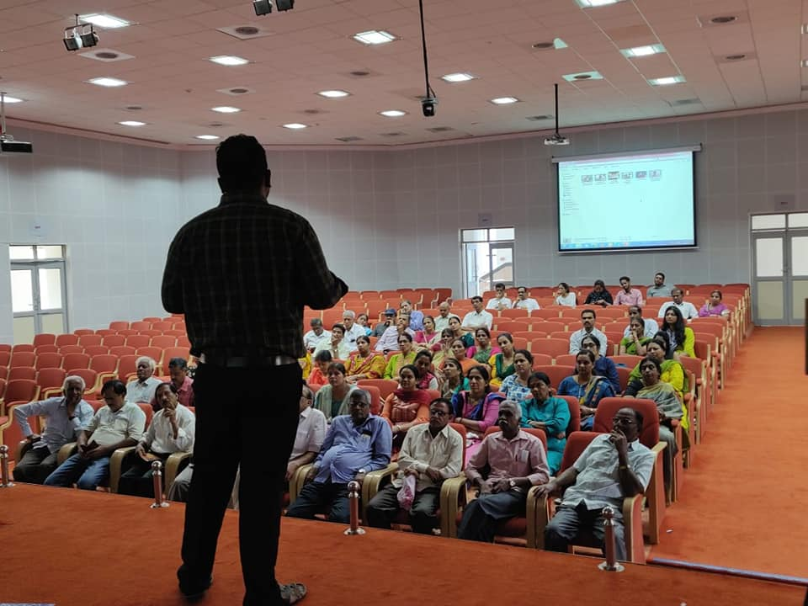
Figure 10: Orientation to Yoga practitioners by AIISH staff
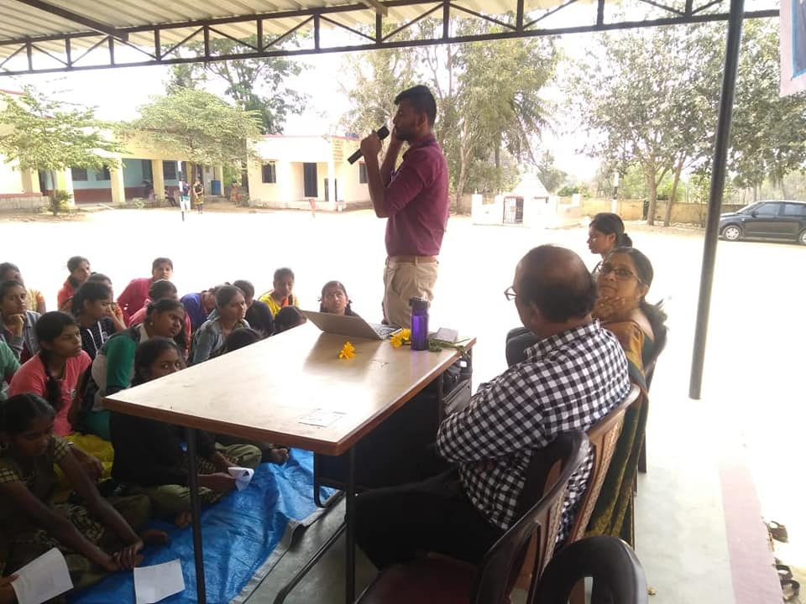
Figure 11: Orientation to Students at Arohalli, Jaipura by POCD staff.
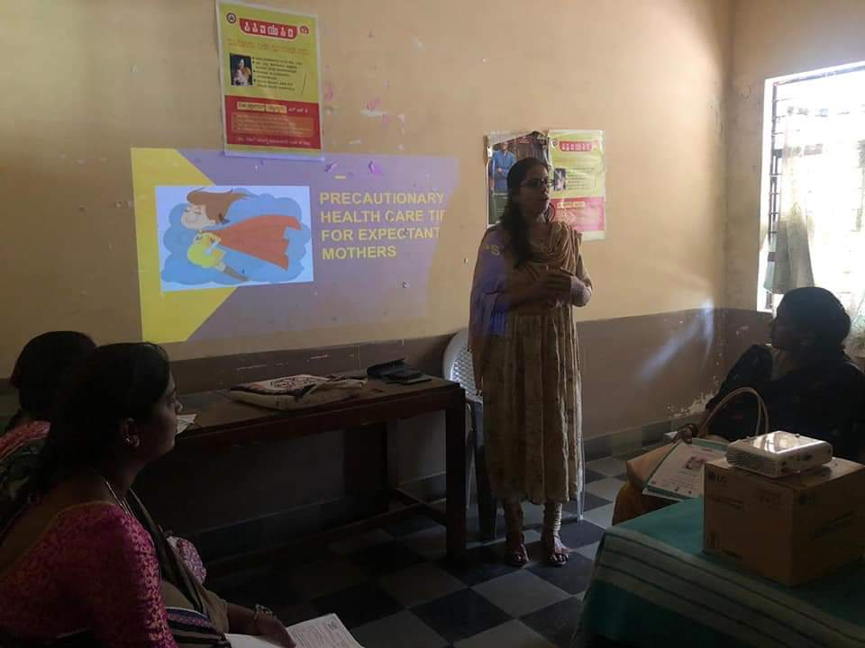
Figure 12: Orientation to expectant mothers by AIISH staff at Cheluvamnba Hospiatl.
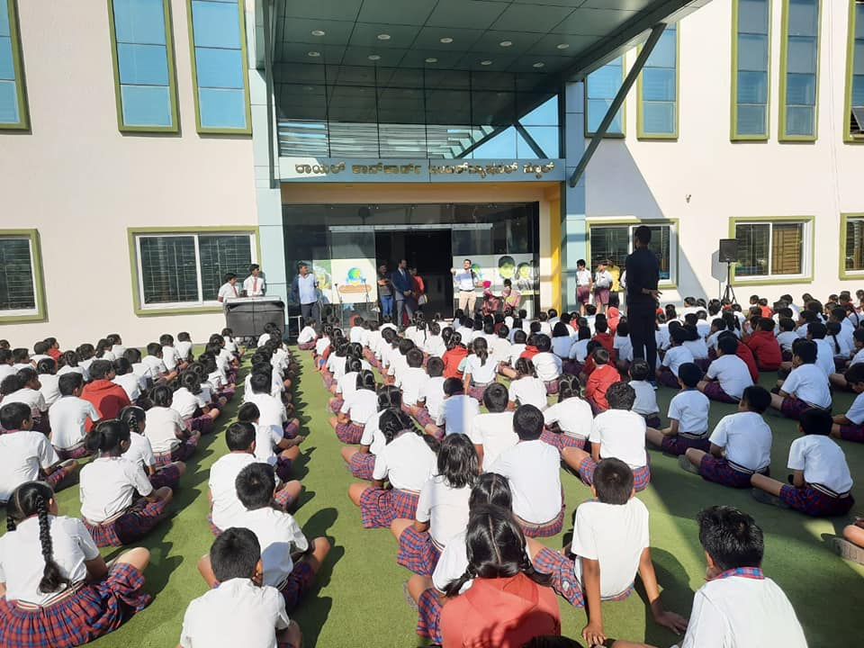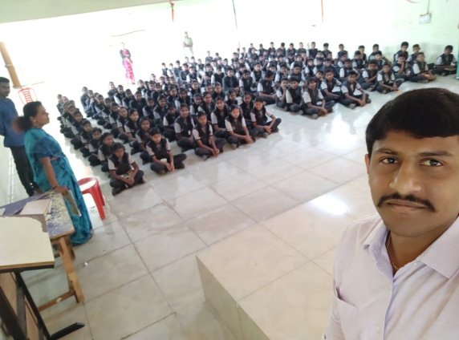
Figure 13: Orientation to Students & Teachers of schools in Mysuru by AIISH staff
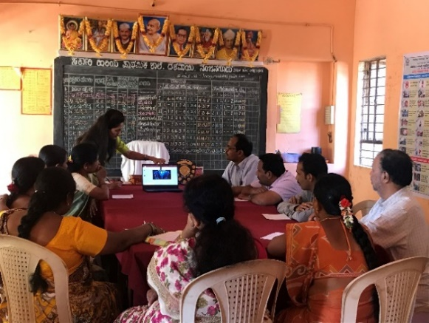

Figure 14: Orientation given to School Teachers at Government Dalavayi higher primary school
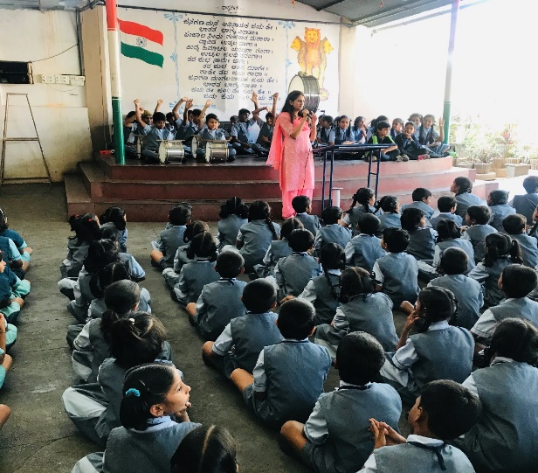

Figure 15: Orientation to school students at Kasturba Gandhi Balika vidhyalay
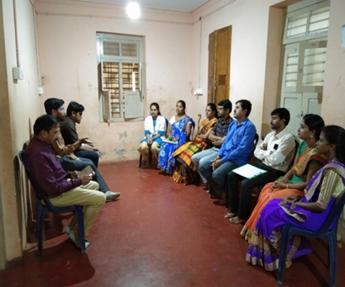

Figure 16:Orientation to staff at NGO.SC colony Anganwadi, Sagara

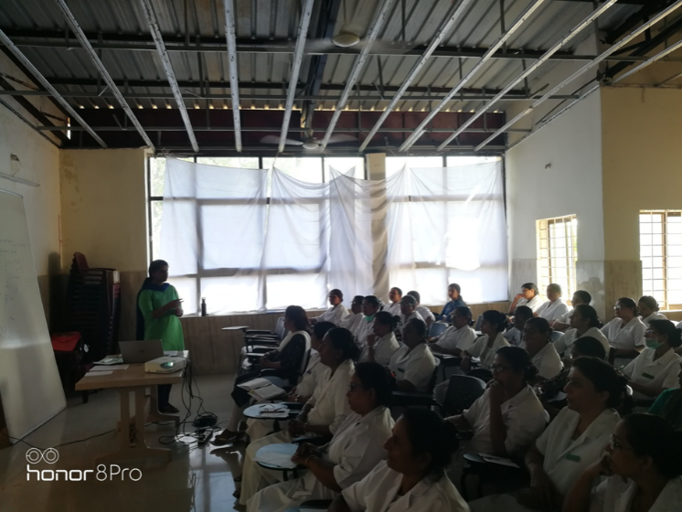

Figure 17:Orientation to staff nurses at Kodagu institute of medical science ,Madikkeri

- Clinical Observation postings of students from other Institutes: NIL
- No. of Seminars/ Conferences /Lectures /Workshop organized by the Dept.: NIL
- Conferences /Lectures /Workshop organized by the Dept.: NIL
- No. of Seminars/ Conferences /Workshop attended by the staff of the Dept: 02

 | Title of the program | Organizer | Attended by
 | Indian Speech and Hearing Association Conference, 2020 | Indian Speech and Hearing Association | Dr. Sandeep M
 | Indian Speech and Hearing Association Conference, 2020 | Indian Speech and Hearing Association | Mr. Arun raj K
2. | Cochlear Implant Instructional Course | Ashtavakra institute of rehabilitation sciences and research, New Delhi | Ms. Sneha Uttakalika
3. | Indian Speech and Hearing Association Conference, 2020 | Indian Speech and Hearing Association | Mr. Sanket Bhalerao

- No. of Seminars/Workshop attended by Staff of POCD: NIL
 | Title of the program | Date | Attended by
 | Workshop on administrative and financial matters. | 06.02.2020 & 07.02.2020 | Dr. Sreedevi.N
 | Workshop on “paradigm shift in early childhood for children with communication disorders” to special educator | 17.02.2020 & 18.02.2020. | Dr. Sreedevi.N

- Guest Lectures attended by staff of POCD: NIL
- No. of Guest Lectures organized: Nil
- No. of Invited Talks delivered by faculty and staff: NIL
- Any other:
Student clinical training: As part of human resource development, clinical training for Undergraduates [BASLP (Speech & Hearing)], Postgraduates [M.Sc. (SLP) &M.Sc. (AUD)] &BASLP (Interns) students on early identification, prevention &rehabilitation of communication disorders and Community based rehabilitation at OSCs were carried out. The details on the number of students who had undergone training are given below.

Internal (AIISH)
Class | No. of students posted
II BASLP students | 08
I M.Sc. (SLP) students | 05
I M.Sc. (Audiology) students | 09
BASLP Internship students | 12
Total | 34

External students : No external students posted for the month of February.
- Staff/Student Enrichment Programs: NIL
- Research Projects: NIL
- Research Papers published in National/ International Journals: NIL
- Books / Manuals published in the department: NIL

- CLINICAL SERVICES
- General Clinical Services
- Follow-up evaluation- Detailed evaluation
The newborns/infants referred during the newborn screening were followed up through telephone calls to parents/caregivers of infants. A complete test battery was administered for those clients who came for follow-up.The at-risk babies were monitored regularly by administering the speech-language & hearing checklist through phone call. The babies who are identified with delay in the milestones were referred to AIISH/concern NBS center for detailed evaluation.

Table 2 (a): Details of the results of follow-up evaluation for newborns and infants.
Categories | AIISH + Cheluvamba | OSC-Sarguru | OSC-Sagara | OSC-Kalburgi | OSC-Hullahalli | OSC-Nanjanagudu | OSC-Akkihebbalu | OSC-K.R.Pete | OSC-Belagavi | OSC-Gumballi | OSC Kodagu | Lucknow | Cuttack | Imphal | Puducherry | Ranchi | Jabalpur | Ajmer | New Delhi | Mumbai | Kolar | Bhagalpur | Total
Normal | 7 | 21 | 0 | 0 | 0 | 0 | 0 | 0 | 0 | 0 | 0 | 19 | 0 | 4 | 3 | 0 | 0 | 12 | 0 | 11 | 0 | 0 | 77
ENT disorders | 0 | 0 | 0 | 0 | 0 | 0 | 0 | 0 | 0 | 0 | 0 | 0 | 0 | 0 | 0 | 2 | 0 | 0 | 0 | 0 | 0 | 0 | 02
Auditory Maturation delay | 0 | 0 | 0 | 0 | 0 | 0 | 0 | 0 | 0 | 0 | 0 | 0 | 0 | 0 | 0 | 0 | 0 | 0 | 0 | 0 | 0 | 0 | 0
Hearing impairment | 0 | 0 | 0 | 2 | 0 | 0 | 0 | 0 | 0 | 0 | 0 | 2 | 2 | 0 | 4 | 6 | 4 | 0 | 0 | 0 | 0 | 0 | 20
Speech & language disorder | 0 | 0 | 0 | 0 | 0 | 0 | 0 | 0 | 0 | 0 | 0 | 0 | 0 | 0 | 0 | 10 | 0 | 0 | 0 | 0 | 0 | 0 | 10
Multiple Disorder | 0 | 0 | 0 | 0 | 0 | 0 | 0 | 0 | 0 | 0 | 0 | 0 | 0 | 0 | 0 | 0 | 0 | 6 | 0 | 0 | 0 | 0 | 6
Incomplete testing | 0 | 0 | 0 | 0 | 0 | 0 | 0 | 0 | 0 | 0 | 0 | 5 | 0 | 0 | 0 | 3 | 0 | 0 | 0 | 0 | 0 | 0 | 08
Total | 7 | 21 | 0 | 2 | 0 | 0 | 0 | 0 | 0 | 0 | 0 | 26 | 2 | 4 | 7 | 21 | 4 | 18 | 0 | 11 | 0 | 0 | 123

Table 2(b): Follow-up evaluation- Phone follow-up done at Mysuru Centre (POCD), OSC Centers and NBS Centers
Categories | Mysuru Centre (POCD) | OSC Centers | NBS Centers
Normal speech, language & hearing milestones | -- | 25 | 169
Referred for detailed evaluation | 22 | 00 | 10
Total Phone follow up | 22 | 25 | 179

- Follow-up Hearing evaluation of industrial workers at AIISH
Table 2(c): Details of industrial employees followed-up for hearing evaluation in February month.
Name of the industry | Total Evaluated | Total Number of ears with
Name of the industry | Total Evaluated | Normal hearing  (Ear wise) | Hearing loss  (Ear wise)
LGB forge limited, Metagalli | 13 | 13 | 13

- Specialized Clinical services: Bedside screening for speech, language, cognition & swallowing disorders

Table 2(d): Details of the bedside screening results done in January month.
Hospital | Total screened |  |  | Total referred |  |  |  | Clinically Normal
Hospital | Male | Female | Total | Cognitive Communication disorder  (CCD) | Motor Speech disorder  (MSD) | Swallowing disorder  (SD) | Multiple disorders | Clinically Normal
K R Hospital | 12 | 01 | 13 | 05 | 06 | - | 02 | -
Total | 12 | 01 | 13 | 05 | 06 | - | 02 | -
Grand total | 13 |  |  | 13

- EXTENSION ACTIVITIES
- Newborn screening for Communication Disorders
The department of POCD is actively involved in carrying out various extension activities such as screening, diagnostic and rehabilitation services outside the institute campus. The activities include newborn/infant screening, screening of school children, screening of elderly citizens, screening of industrial workers, conducting camps and also clinical services offered at the outreach service centers of AIISH.

Table 3 a): Details of the new born hearing screening done at Mysuru hospitals, OSC and NBS centers.
SN | Hospitals/Immunization Centers | Total births | Total No. Screened |  |  | Total No. at risk
SN | Hospitals/Immunization Centers | Total births | Male | Female | Total | Male | Female | Total
 |  | AIISH- Mysuru
 | KR Hospital (KRH)- Cheluvamba | 807 | 252 | 244 | 496 | 09 | 08 | 17
 | Kamakshi Hospital (KH) | 150 | 60 | 47 | 107 | 00 | 00 | 00
 | Combined Hospital (CH) | 40 | 15 | 17 | 32 | 00 | 00 | 00
 | Mission Hospital (MH) | 30 | 13 | 10 | 23 | 02 | 01 | 03
 | S.M.T.D.H Hospital | 49 | 15 | 13 | 28 | 01 | 00 | 01
 | Ashwini Nursing Home (ANH) | 15 | 07 | 07 | 14 | 00 | 01 | 01
 | Shree Devi Nursing Home (SNH) | 31 | 10 | 07 | 17 | 00 | 00 | 00
 | GopalaGowdaShanthaveri Memorial Hospital (GGSMH) | 14 | 06 | 01 | 07 | 00 | 00 | 00
 | Mahadeshwara Nursing Home (MNH) | 30 | 10 | 8 | 18 | 00 | 00 | 00
 | Sigma Hospital (SH) | 35 | 23 | 11 | 34 | 00 | 00 | 00
 | Brindavan Hospital | 30 | 08 | 06 | 14 | 01 | 01 | 02
 | Total (Mysuru hospitals) | 1231 | 419 | 371 | 790 | 13 | 11 | 24
Screening at OSC Centers
- 18. | Sub-divisional hospital, K R Nagar Taluk | -- | -- | -- | -- | -- | -- | --
- 19. | Sub-divisional hospital, T NarsipuraTaluk | -- | -- | -- | -- | -- | -- | --
- 20. | Sub-divisional Hospital, Sagara Taluk | 190 | 118 | 69 | 187 | 01 | 00 | 01
 | Vivekananda Memorial hospital, NBS, H. D. koteSarguru | 242 | 119 | 106 | 225 | 13 | 06 | 19
 | Taluk Hospital, H. D. Kote- Immunization | -- | -- | -- | -- | -- | -- | --
 | District Hospital, Kalaburagi | 34 | 15 | 49 | 33 | 12 | 45 | 00
 | Taluk Hospital, Nanjangud | 109 | 60 | 43 | 103 | 01 | 00 | 01
 | Community Health Centre (CHC), Hullahalli | 17 | 02 | 05 | 07 | 00 | 00 | 00
- 22. | Karuna Trust Hopital, Gumballi | 35 | 24 | 11 | 35 | 01 | 00 | 01
- 22. | Community Health Centre (CHC), Santhemarahalli | 12 | 05 | 06 | 11 | 01 | 00 | 01
19 | Yelandur, Taluk Hospital | 08 | 04 | 04 | 08 | 00 | 00 | 00
- 23. | Taluk General Hospital, KR. Pete | 41 | 21 | 20 | 41 | 00 | 00 | 00
- 23. | Primary Health Centre (PHC), Akkihebbalu | 23 | 15 | 08 | 23 | 00 | 00 | 00
 | KOIMS,Kodagu | - | 115 | 102 | 217 | 03 | 00 | 03
 | BIMS, Belagavi | - | 85 | 71 | 156 | 00 | 00 | 00
 | Total (OSCs) | 521 | 498 | 423 | 890 | 32 | 51 | 26
Screening at NBS Centers
- 25. | Sri RamachandraBhanj Medical College and Hospital (SCB MCH), Cuttack | 329 | 157 | 75 | 232 | 11 | 05 | 16
- 26. | Regional Institute of Medical Sciences (RIMS), Imphal | 345 | 151 | 173 | 324 | 00 | 01 | 01
27. | Janana Hospital & JLNMCH, Ajmer | 928 | 403 | 310 | 713 | 10 | 06 | 16
- 28. | JIPMER, Puducherry | 1028 | 524 | 504 | 452 | 19 | 14 | 33
- 29. | NetajiSubhash Chandra Bose Medical College (NSCB), Jabalpur | NA | 289 | 252 | 551 | 64 | 49 | 113
- 30. | Rajendra Institute of Medical Sciences, Baritayu, Ranchi | - | - | - | - | - | - | -
- 31. | Kings George’s Medical University, Lucknow | NA | 239 | 201 | 440 | 42 | 40 | 82
 | JLNMCH, Bhagalpur | NA | 70 | 71 | 204 | 24 | 16 | 40
 | All India Institute of Physical Medicine and Rehabilitation (AIIPMR), Mumbai | 11 | 08 | 03 | 11 | 08 | 03 | 11
 | Post Graduate Institute of Medical Education and Research (PGIMER), New Delhi | 152 | 83 | 69 | 152 | 07 | 11 | 18
 | Total (NBS centres) | 2793 | 1924 | 1658 | 3079 | 185 | 145 | 330
 | Overall Total (Mysuru+OSC+NBS) | 4545 | 2841 | 2452 | 4759 | 230 | 207 | 380

- Table 3 b) School screening: Screening for communication disorders done at schools and Anganwadi by OSC staff.

Date | Name of the School/Anganwadi | Total screened | Total identified with communication disorders
Date | Name of the School/Anganwadi | Total screened | Ear related disorder | Hearing loss | Speech language disorders
03.2.2020, Sagara | NGO.SC colony Anganwadi, Sagara  Coordinator: Ms Yeshoda | 02 | 01 | 00 | 01
06.2.2020, Sagara | A.B. Vajapiyee School, Sagara  Coordinator: Ms Rathna | 06 | 00 | 00 | 06
08.2.2020  Sagara | Government pre-metric Girls Hostel, Sagara  Coordinator: Ms Renuka Nayak | 04 | 01 | 01 | 02
05.2.2020  Saguru | Magudilu Anganwadi | 09 | 00 | 00 | 00
05.02.2020  Sarguru | Nerale Anganwadi | 07 | 00 | 00 | 01
08.02.2020  Sarguru | Gundathur Anganwadi | 16 | 00 | 00 | 01
08.02.2020  Sarguru | Udbur Hadi Anganwadi | 09 | 00 | 00 | 01
08.02,2020  Sarguru | Balle Hadi Anganwadi | 01 | 00 | 00 | 00
19.02.2020  Sarguru | Kommegowdana, Koppalu, Anganwadi | 23 | 00 | 00 | 02
19.02.2020  Sarguru | Krishnarajanagar, Hunsuru Anganwadi | 05 | 00 | 00 | 00
Total |  | 82 | 02 | 01 | 14

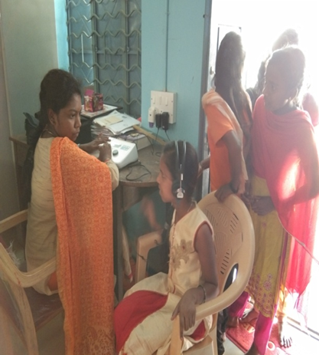

Figure 18: School screening done at Government pre-metric Girls Hostel, Sagara
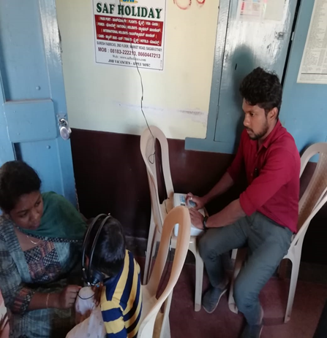

Figure 19: School screening done at NGO.SC colony Anganwadi, Sagara
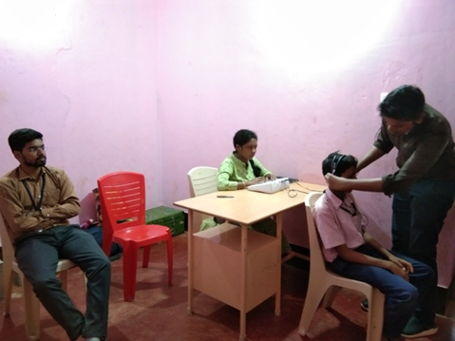

Figure 20: School screening done at A.B. Vajapiyee School, Sagara by POCD staff.

- Clinical services for the Elderly citizens: NIL
d) Industrial Screening: NIL
4) Clinical Services at Outreach Service Centers (OSCs):
The clinical activities are not only restricted to in and around Mysore, but also extended to rural areas where facilities for clinical services for persons with communication disorders were comparatively less. Currently,08 OSCs (01-VMH, Sarguru, HD Kote; 02-Sub-divisional taluk hospital at Sagara taluk, Shivamogga District; 03-Nanjangudu, Mysuru district; 04-K.R.Pete, Mandya district, 05-Karuna trust, Gumballi, Chamarajanagara district, 06-GIMS, Kalburgi, 07-BIMS, Belagavi and 08-KOIMS, Kodagu were initiated to meet the objective of extending the services of the institute to rural areas. The OSCs are functioning as a well-equipped unit for screening, diagnostics and therapeutic services for persons with communication disorders. The services include screening, diagnostic and rehabilitation which includes newborn/infant screening, screening of school children, Speech and Language evaluation, Audiological evaluation, ENT evaluation, Speech-Language therapy, issue of free body level hearing aids and ear molds, and counseling and guidance to individuals with communication disorders.

Table 4 a): Details of clients identified with communication disorders at the OSCs

OSC | Total Registered | ENT Evaluation  Registered=128 |  |  | Hearing Evaluation  Registered=491 |  | Speech & Language Evaluation  Registered= 117
OSC | Total Registered | Normal (Ear Wise) | Disorder (Ear wise) | ENT related  Others | Normal (Ear Wise) | Disorder (Ear wise) | Normal (Individuals) | Disorder (Individuals)
Taluk Hospital, Nanjangud | 49 | 00 | 00 | 00 | 24 | 66 | 00 | 04
Primary Health Centre (PHC), Hullahalli | 63 | 18 | 90 | 09 | 01 | 19 | 00 | 02
Primary Health Centre (PHC), Akkihebbalu | 39 | 12 | 30 | 05 | 00 | 18 | 00 | 04
Taluk General Hospital, KR Pete | 24 | 00 | 00 | 00 | 07 | 23 | 01 | 08
Primary Health Centre (PHC), Gumballi | 67 | 14 | 84 | 10 | 01 | 09 | 02 | 02
Sub-divisional Hospital (PHC), Sagara | 16 | 00 | 00 | 00 | 04 | 14 | 00 | 07
VMH, Sarguru | 21 | 00 | 00 | 00 | 04 | 18 | 01 | 09
Belgavi institute of medical sciences BIMS | 278 | 00 | 00 | 00 | 231 | 201 | 07 | 55
GIMS, Kalburgi | 00 | 00 | 00 | 00 | 92 | 220 | 00 | 00
KoIMS-TH, Madikeri Taluk,Kodagu | 00 | 00 | 00 | 00 | 07 | 24 | 00 | 15
Total | 557 | 44 | 204 | 24 | 371 | 612 | 11 | 106

Table 4 b): Details of clients followed up at the OSCs.
OSC | Total Follow up | ENT Evaluation = 46 |  |  | Hearing Evaluation=18 |  | Speech & Language Evaluation= 04
OSC | Total Follow up | Normal (Ear Wise) | Disorder (Ear wise) | ENT related  Others | Normal (Ear Wise) | Disorder (Ear wise) | Normal (Individuals) | Disorder (Individuals)
Taluk Hospital, Nanjangud | 06 | - | - | - | 00 | 12 | 00 | 00
Primary Health Centre (PHC), Hullahalli | 06 | 01 | 07 | 02 | 00 | 00 | 00 | 00
Primary Health Centre (PHC), Akkihebbalu | 12 | 03 | 07 | 06 | 00 | 02 | 00 | 00
Taluk General Hospital, KR Pete | 02 | 00 | 00 | 00 | 02 | 00 | 00 | 01
Primary Health Centre (PHC), Gumballi | 33 | 12 | 30 | 08 | 00 | 12 | 00 | 02
Sub-divisional Hospital (PHC), Sagara | 02 | 00 | 00 | 00 | 00 | 04 | 00 | 00
VMH, Sarguru | 03 | 00 | 00 | 00 | 02 | 02 | 00 | 01
Belgavi institute of medical sciences BIMS | 00 | 00 | 00 | 00 | 00 | 00 | 00 | 00
GIMS, Kalburgi | 00 | 00 | 00 | 00 | 00 | 00 | 00 | 00
KoIMS-TH, Madikeri Taluk,Kodagu | 00 | 00 | 00 | 00 | 00 | 00 | 00 | 00
Total | 64 | 16 | 44 | 16 | 04 | 32 | 00 | 04

Table 4 c): Details of clients identified with different types of communication disorders across OSCs
Type of Disorders |  |  |  | OSC
Type of Disorders | Taluk Hospital,Nanjangud |  | Primary Health Centre (PHC), Hullahalli |  | Primary Health Centre (PHC), Akkihebbalu | Taluk General Hospital, KR Pete | Primary Health Centre (PHC), Gumballi | Sub-divisional Hospital, Sagara (PHC) Taluk | VMH,  Sarguru | BIMS Belgavi | GIMS, Kalburgi | KoIMS,  Kodagu
 |  | Hearing disorders (Ear-wise data)
Normal | 24 |  | 10 |  | 00 | 07 | 01 | 04 | 05 | 231 | 92 | 07
Conductive | 22 |  | 02 |  | 00 | 09 | 00 | 06 | 04 | 46 | 33 | 04
Sensori- neural | 29 |  | 17 |  | 14 | 09 | 09 | 06 | 07 | 68 | 79 | 40
Mixed | 15 |  | 00 |  | 04 | 04 | 00 | 01 | 03 | 50 | 58 | 04
Profound | 00 |  | 00 |  | 00 | 01 | 00 | 01 | 03 | 37 | 50 | 00
Incomplete | 00 |  | 00 |  | 00 | 00 | 00 | 00 | 00 | 00 | 18 | 04
Aud-Total (ears) | 90 |  | 20 |  | 18 | 30 | 10 | 18 | 22 | 432 | 330 | 62
Aud-Total (Individuals) | 00 |  | 00 |  | 09 | 15 | 05 | 08 | 11 | 216 | 165 | 31
Voice | 00 |  | 00 |  | 00 | 02 | 01 | 01 | 02 | 00 | 00 | 04
Fluency | 01 |  | 00 |  | 01 | 02 | 00 | 01 | 01 | 12 | 00 | 03
Articulation disorders | 01 |  | 01 |  | 00 | 00 | 00 | 01 | 02 | 04 | 00 | 02
Language disorders | 02 |  | 01 |  | 03 | 05 | 01 | 04 | 04 | 46 | 00 | 06
Total (Individuals) | 04 |  | 02 |  | 04 | 09 | 02 | 07 | 09 | 62 | 00 | 15

Table 4d): Details of clients followed up with different types of communication disorders across OSCs.
Type of Disorders |  |  |  | OSC
Type of Disorders | Taluk Hospital Nanjangud | Primary Health Centre (PHC), Hullahalli | Primary Health Centre (PHC), Akkihebbalu |  | Taluk General Hospital, KR Pete | Primary Health Centre (PHC), Gumballi | Sub-divisional Hospital,  Sagara  (PHC) Taluk | VMH,  Sarguru | BIMS | GIMS, Kalburgi | KoIMS  Kodagu
 |  | Hearing disorders (Ear-wise data)
Normal | 00 | 00 | 00 |  | 02 | 00 | 00 | 02 | 00 | 00 | 00
Conductive | 02 | 00 | 00 |  | 00 | 00 | 00 | 00 | 00 | 00 | 00
Sensori- neural | 10 | 00 | 02 |  | 00 | 06 | 04 | 00 | 00 | 00 | 00
Mixed | 00 | 00 | 00 |  | 00 | 00 | 00 | 00 | 00 | 00 | 00
Profound | 00 | 00 | 00 |  | 00 | 02 | 00 | 02 | 00 | 00 | 00
Aud-Total (ears) | 12 | 00 | 002 |  | 02 | 08 | 04 | 04 | 00 | 00 | 00
Aud-Total (Individuals) | 06 | 00 | 01 |  | 01 | 04 | 02 | 02 | 00 | 00 | 00
Voice | 00 | 00 | 00 |  | 00 | 01 | 00 | 0 | 00 | 00 | 00
Fluency | 00 | 00 | 00 |  | 00 | 00 | 00 | 00 | 00 | 00 | 00
Articulation disorders | 00 | 00 | 00 |  | 00 | 00 | 00 | 00 | 00 | 00 | 00
Language disorders | 00 | 00 | 00 |  | 01 | 01 | 00 | 00 | 00 | 00 | 00
Sp&Lg -Total (Individuals) | 00 | 00 | 00 |  | 01 | 02 | 00 | 01 | 00 | 00 | 00

- Rehabilitation services at OSCs.
Table 4 e): Details of Rehabilitation services provided at Outreach service centers.
OSC | Hearing Aids Dispensed | Speech-language therapy |  | Medical Line of Treatment
OSC | Hearing Aids Dispensed | No. of clients | No. of sessions | Medical Line of Treatment
Taluk Hospital, Nanjangud | 04 | 03 | 24 | 00
Primary Health Centre (PHC), Hullahalli | 00 | 00 | 00 | 00
Primary Health Centre (PHC), Akkihebbalu | 00 | 02 | 09 | 00
Taluk General Hospital, KR Pete | 01 | 06 | 23 | 00
Primary Health Centre (PHC), Gumballi | 04 | 05 | 24 | 00
Sub-divisional Hospital, Sagara (PHC) Taluk | 00 | 18 | 61 | 00
VMH, Sarguru | 00 | 07 | 29 | 00
Belagavi institute of medical sciences BIMS | 00 | 00 | 00 | 00
GIMS, Kalburgi | 00 | 00 | 00 | 00
KoIMS-TH, MadikeriTaluk,Kodagu | 00 | 00 | 00 | 00
Total | 09 | 23 | 109 | 00

- Communication Disorders Screening Camps at OSC.
Screening camps for communication disorders were carried out at K Belathura and Kyathanahalli by staff of OSC-Sarguru.

Table 4f): Details of camps held at Belathura and Kyathanahalli

SN | Camp places | Total No. Screened |  |  | Total No. referred
SN | Camp places | Male | Female | Total | Male | Female | Total
1. | K Belathura | 02 | 00 | 02 | 02 | 00 | 02
2. | Kyathanahalli | 01 | 02 | 03 | 01 | 01 | 02
Total |  | 05 |  |  | 04

Field –based follow up visits: No. of visits conducted: 3 (Sarguru)
Field based Follow up visit to residence of clients with communication disorders and other disabilities were conducted. This was to ensure proper and continued home training support to the individual with communication disorder. It helps to identify and resolve challenges faced by the clients and their family members during home training.

Table 4f): Details of Field based follow up visit conducted at OSC- Sarguru
SN | Visited places | Total No. Screened |  |  | Total No. referred
SN | Visited places | Male | Female | Total | Male | Female | Total
1 | Gundathur | 01 | 02 | 03 | 00 | 00 | 00
2 | Udbur Hadi | 02 | 01 | 03 | 00 | 00 | 00
3. | Bavali Hadi | 00 | 02 | 02 | 00 | 00 | 00
4. | Hunsuru | 12 | 08 | 20 | 02 | 01 | 03
5. | Kome gowdana koppulu | 14 | 07 | 21 | 01 | 02 | 03
TOTAL |  | 29 | 20 | 49 | 03 | 03 | 06

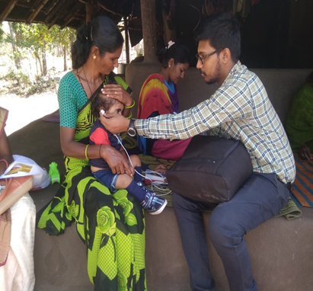
a)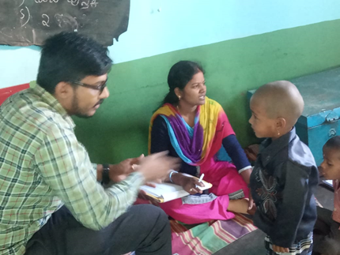 b)
Figure 21: Field based follow up visit at K Belathura, Kyathanahalli by staff of OSC-Sarguru

5) SPECIAL ACTIVITIES
- Library and information services: NIL
- Material Development: NIL
- Awards and honors received by staff of POCD : NIL

6) MAJOR EVENTS OF THE MONTH: Observed world hearing day with various programs.

- Conducted workshop on “paradigm shift in early childhood for children with communication disorders” to special educator on 17.02.2020 and 18.02.2020.

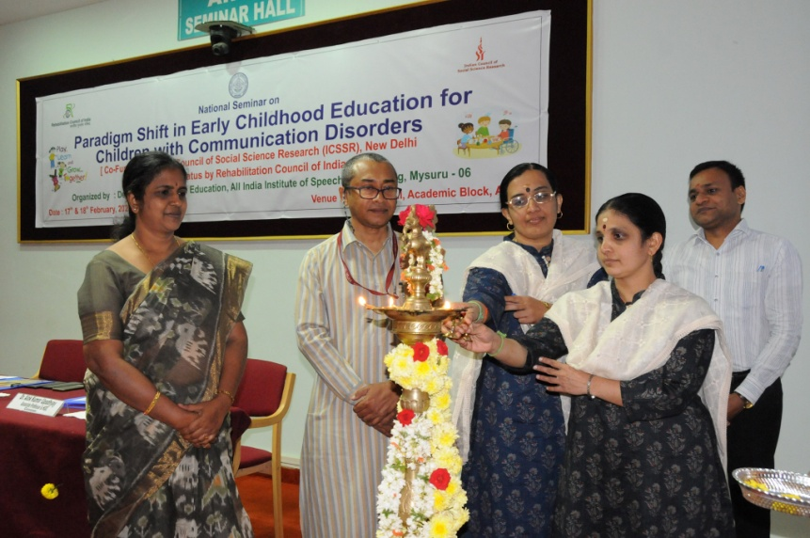
Figure 22: Special educator of AIISH preschool along with Director of AIISH inaugurating the work shop on “Paradigm shift in early childhood for children with communication disorders”.

- Broadcasted speech on early identification and prevention of different communication disorders by AIISH staff at All India Radio on 27.02.2020 to 03.03.2020.
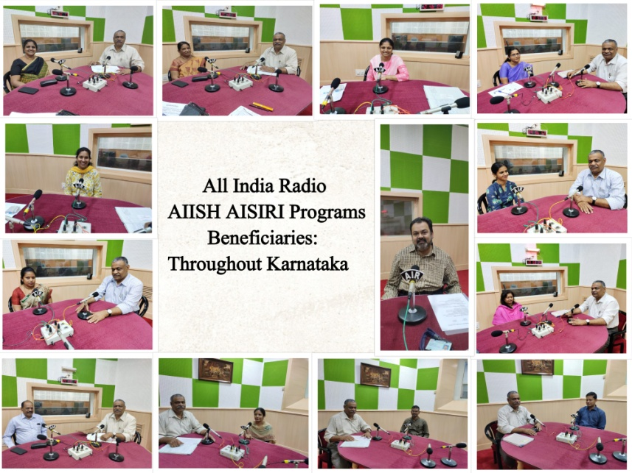
Figure 23: broadcasting speech on early identification and prevention of communication disorders at All India Radio by AIISH staff.

- A hearing screening program for elderly population above 50 years was carried out on 22.02.2020 and 23.02.2020.
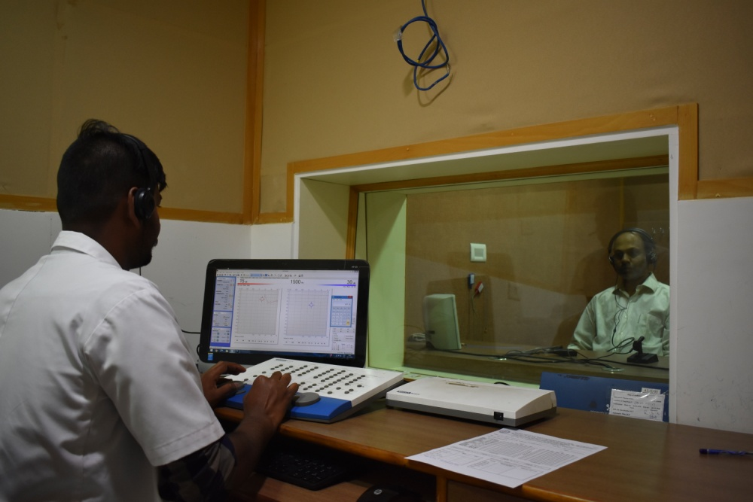
Figure 24: The hearing screening is carrying out for elderly individual by POCD staff.

- A stall was kept on 22.02.2020 at Kannada habba at Kalamandir,Mysuru.Hearing screening was carried out for general public along with pamphlets on early identification and prevention of communication disorders were put up.
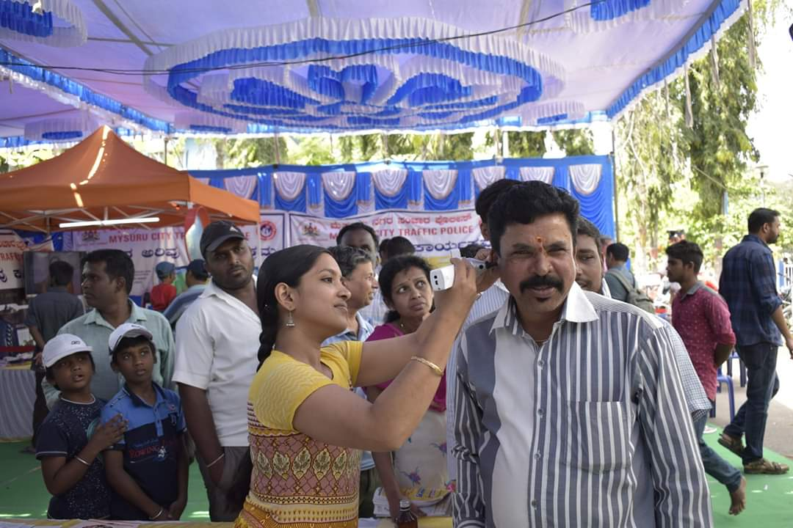
Figure 25: Hearing screening is carrying out at Kannada habba at Kalamandir, Mysuru by AIISH staff on 22.02.2020.
- A stall was kept during the 3 days of AIISH AAWAAZ cultural fest, where pamphlets on early identification and prevention of communication disorders were put up.
- A digital multiplex advertisement was shown at all the INOX film theatre across India from 26.02.2020 to 03.03.2020.
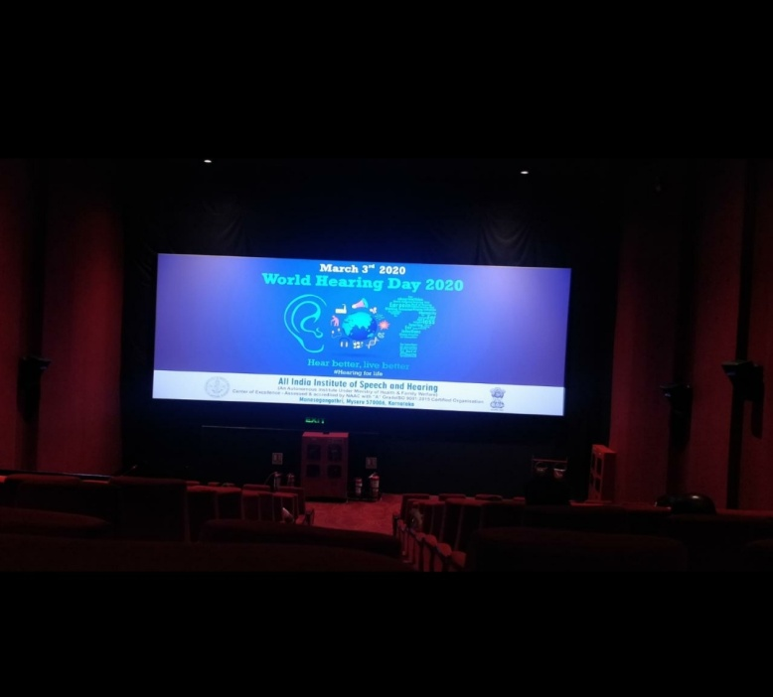
Figure 26: The advertisement on world hearing day put up on INOX Film theatre at INOX Mysuru.
- A flash mob program was carried out to promote world hearing day at Mall of Mysuru on 15.02.2020
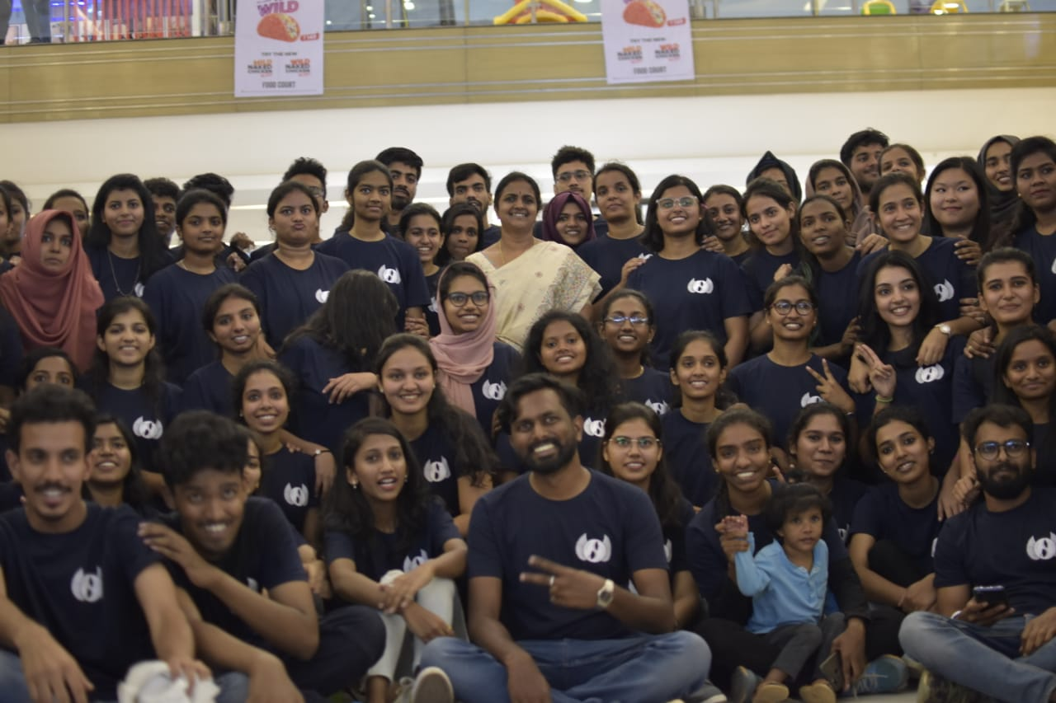
Figure 27: a glimpse of students of AIISH right after the flash mob at Mall of Mysore.

- The video clips of eminent personalities of across India were released to promote world hearing day from 18.02.2020 to 03.03.2020.

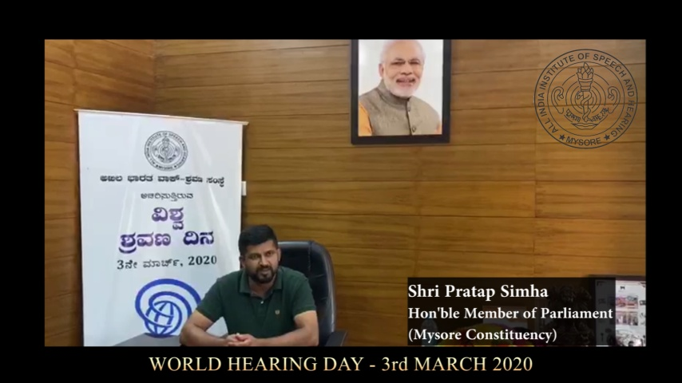
Figure 28: The screen short of promoting video released by Shri. Pratap Simha, Hon’ble Member of Parliament, Mysuru constituency.

- Others:
- Computerization activities: Computerization of OSC is in process.
- Activities carried out by the staff of the department
Table 7 a): Details of activities of staff of POCD in January month.
S. No. | Name of the staff | Designation | Activities
 | Dr.N. Sreedevi | HEAD, POCD | - Conducted Dept meeting on 19.2. 2020 and 23.1.2020 for world hearing day activities  - Coordinated the Dept activities for WHD  - Coordinated ISO audit of POCD on 26.2.2020  - Carried out orientation at Haro halli on 28.2.2020  - Attended the seminar on Administrative and financial matters on 06.02.2020 and 07.02.2020  - Attended workshop on “paradigm shift in early childhood for children with communication disorders” to special educator
 | Dr. Sandeep M | Associate Professor in Audiology | - Organised and carried out world hearing day programs.  - Coordinated ISO audit of POCD on 26.2.2020
 | Mr. Arunraj. K | Clinical Assistant | - Visited NBS-Shimla.and had meeting with NBS coordinator on 18.02.2020 and 19.02.2020  - Broadcasted speech on Noise induced hearing loss in All India Radio on 27.02.2020  - Coordinated ISO audit of POCD on 26.2.2020  - Coordinated the Dept activities for WHD
 | Ms. Ameena Subhakani S. | Speech Language Pathologist Grade I | - Carried out elderly screening in Mysuru on 22 and 23rd  - Carried out expecting mothers orientation program on 16th February 2020  - Carried out hearing screening for general public at Kannada habba at kalamandir on 22.02.2020
 | Mr. Harish Kumar M.K. | Audiologist Grade I | - Carried out elderly screening in Mysuru on 22 and 23rd  - Carried out expecting mothers orientation program on 16th February 2020  - Gave orientation for Maharani college students in Harohalli on 28.02.2020  - Gave oriented for administrative staff on 19.02.2020  - Gave orientation for Security Guards and Housekeeping staffs on 22.02.2020.  - Carried out hearing screening for general public at Kannada hanna at kalamandir on 22.02.2020
 | Mr.Kishore KumarBharshetty | Audiologist Grade I | - Carried out elderly screening in Mysuru on 22 and 23rd  - Carried out expecting mothers orientation program on 16th February 2020  - Gave orientation to preschool parents on 20.02.2020.
 | Ms. Krishnendu S. | Speech Language Pathologist Grade I | - Organized elderly screening program as part of world hearing day  - Carried out elderly screening in Mysuru on 22 and 23rd  - Organized school orientation program as part of world hearing day  - Carried out expecting mothers orientation program on 16th February 2020  - Gave orientation about speech language disorders to Ayurveda doctors (AYUSH Hospitals)  - Gave orientation about speech and language disorders to B.Ed. students from Malapuram, Kerala
 | Ms. Priya Abdul Khader M. T. | Audiologist Grade I | - Designed posters for World hearing day.  - Oriented parents of Preschool students of AIISH on hearing and World Hearing Day on 20th Feb 2020  - Translated WHO materials on World hearing day to Malayalam  - Carried out elderly hearing screening conducted on 23rd and 24th of Feb  - Carried out orientation program conducted for Pregnant women on 16th Feb  - Coordinated with Dr.Sathish Kumar, MMC to conduct Hearing evaluation of Industrial employees of LGB forge limited. at AIISH
 | Ms. Ritu A Venkatesh | Audiologist Grade I | - Translated orientation slides to Kannada.  - Conducted orientation for expectant mothers on 16.02.2020.  - Organised orientation program for Ayurveda doctor on 07.02.2020  - Served as resource person for Kids edutainment program on 11.02.2020.  - Conducted orientation at Hoysala Karnataka Sangha on 18.02.2020.  - Carried out elderly hearing check up on 22nd& 23rd February.  - Conducted orientation for AIISH preschool parents on 20.02.2020  - Organised orientation program for Yoga practitioners on 28.02.2020  - Drafted letters and scheduled dates for orientation program for Expectant Mothers.
 | Ms. Sharanya K. Kumar | Audiologist – Grade I | - Oriented Ayush Doctors on Hearing and hearing related disorders on 07.02.2020.  - Conducted orientation for Maharani college students in Haro halli on 28.02.2020  - Organized Kids Edutainment Program on 11.02.2020.  - Organized orientation to expecting mothers on 14.02.2020.  - Participated in the hearing screening for elderly on 23.02.2020 and 24.02.2020.  - Arranged customization of food items at different food outlets for publicity of world hearing day. Created posters for the same.
 | Ms. Abinaya R | Speech-Language Pathologist Grade I | - Carried out elderly screening in Mysuru on 22 and 23rd  - Carried out expecting mothers orientation program on 16th February 2020  - Served as resource person for Kids edutainment program on 11.02.2020.  - Prepared news paper regarding world hearing day celebrations  - Prepared compiled NBS monthly report of January month.
 | Ms. Aparna U. | Audiologist – Grade II | - Conducted orientation for expectant mothers on 16.02.2020.  - Served as resource person for the orientation program for B.Ed. students from Malapuram, Kerala  - Carried out elderly hearing check up on 22nd& 23rd February.  - Carried out orientation program conducted for Pregnant women on 16th Feb  - Organised orientation program for Yoga practitioners on 28.02.2020  - Prepared monthly report of Januray month
 | Ms. Anusha C. | Speech Language Pathologist – Grade II | - Visited (and followed up) various cafes and eatery places in Mysuru to request them to participate in World Hearing Day through food customization, displaying the posters and posting regarding the same on social media on 05.02.2020.  - Translated press release material (for free elderly hearing screening) to Kannada.  - Contacted (and followed up) INOX and PVR to enquire regarding the projection of World Hearing Day poster at theatre screens.  - Attended orientation for AYUSH doctors on 07.02.2020  - Co-conducted Kids Edutainment program for Montessori children Rolaye Concorde School on 12.02.2020 and 13.02.2020.  Visited hospitals and private obstetrics clinics to inform about the orientation event for Expectant Mothers held at AIISH on 12.02.2020.  - Co-conducted and gave orientation for expectant mothers regarding hearing development, how to communicate with the child and how to prevent hearing loss on 16.02.2020.  - Gave orientation regarding speech and language disorders at Hoysala Karnataka Sangha, Mysuru on 18.02.2020.  Co-conducted elderly hearing screening on 22.02.2020 and 23.02.2020 at AIISH, Mysuru
 | Ms. Faheema Luquman Ali | Audiologist – Grade II | - Conducted orientation for expectant mothers on 16.02.2020.  - Carried out elderly hearing check up on 22nd& 23rd February.  - Conducted orientation for expectant mothers on 16.02.2020.  - Drafted letters and scheduled dates for orientation program for Expectant Mothers.
 | Mr, Ullas N Bhargav | MTS (Data entry operator) | - Done NBS data entry of Mysore hospitals.  - Drafted letters in connection with World Hearing Day 2020.  - Involved in taking photographs of different activities organized by the department.  - Attended AIISH Aawaaz meeting on 26.02.2020  - Attended office council meeting on 26.02.2020

Sd-
विभागाध्यक्ष, विभाग-पिओसिडि- Head, Dept. Of POCD

