ALL INDIA INSTITUTE OF SPEECH AND HEARING, MYSURU-6
अखिल भारतीय वाक श्रवण संस्थान, मैसूर-६
DEPARTMENT OF SPECIAL EDUCATION
विशेषशिक्षाविभाग
MONTHLY REPORT: February2020

- ACADEMIC ACTIVITIES
- Orientation Programs (For outsiders): The following orientation programs were conducted to familiarizethe target group about the activities of the department and also to provide knowledge about the special educational facilities and welfare measures for children with special needs.
Sl No. | Coordinator | Targeted Audience | Number  of Participants | Date
 | Ms.Anjana | Staffs & Students, RMCTE, Thillenkery, | 42 | 11.02.2020
 | Dr.Kadambari | 30 students & 2 staffs, Farook college, Calicut | 31 | 13.02.2020
 | Dr.Kadambari | New staffs, AIISH, Mysuru | 5 | 18.02.2020
- Clinical /Special Educational postings and/or Observation Postings
- Students from Other Institutes: NIL
- AIISH Students in Other Institutes:NIL
- Seminars/Conferences/Workshops/Training Programs:-
Theme/topic | National Seminar on ‘Paradigm shift in early Childhood education for children with communication disorder’
Coordinators | Dr Alok Kumar Upadhyay,Ms. RamanakumariP.V,Mr. Rajkumar R. &Manjula P.V.
Objectives | - To equip early childhood teachers with the methods and techniques in early childhood education in order to improve their knowledge and accomplishment.  - To motivate teachers to use the recent trends in training children with communication disorders at an early age.  - To encourage early childhood teachers to develop and use age appropriate curriculum.  - To equip early childhood teachers with the policies and legislations in early childhood education.  - To showcase the importance of multidisciplinary team in early childhood education.
Targeted Audience | Students/staff from different B.Ed/ M.Ed colleges, Special Educators, B.Ed/ M.Ed Special Education students, research scholars, Diploma trainees and Mainstream teachers.
Number of Participants | 165
Date | 17th& 18th Feb 2020
Photo
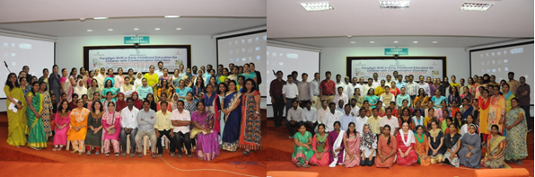

- Staff enrichment / In-house training programs: NIL
- Staff Enrichment Programs (For own staff members): NIL
- Guest Lectures: NIL
- Additional Academic Services rendered by the Faculty and Staff:
- Invited Talks:
Name, Designation, Institutional affiliation | Organized by Department/Section/Unit | Topic of Lecture | Date
Ms.Leena C C  Special Educator | D Banumaiah girls High School, Mysuru | Ordination about AIISH | 25.02.2020
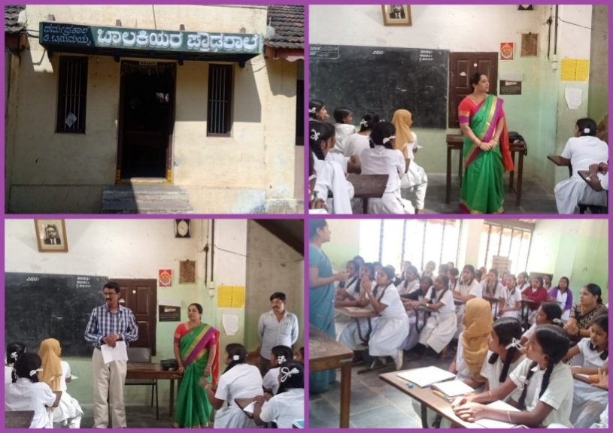
Dr. G. Malar, Reader in Special Education | Inter University Centre for Teacher Education, NCERT’s Regional Institute of Education – Mysuru (RIE-M) | Implications for UDL in Indian Classrooms | 05.02.2020
Dr. G. Malar, Reader in Special Education | Inter University Centre for Teacher Education, NCERT’s Regional Institute of Education – Mysuru (RIE-M) | Implementation of UDL in Indian Classrooms | 06.02.2020
Dr. G. Malar, Reader in Special Education | LD Clinic, Department of Clinical Services, AIISH, Mysuru | Instructional Adaptation for Children with Learning Disabilities | 19.02.2020
Dr. G. Malar, Reader in Special Education | Department of Special Education, AIISH, Mysuru | Curriculum,methods, and techniques in early childhood education of children with communication disorders. | 17.02.2020
Dr. Prithi V., Reader in Special Education | Department of Special Education, AIISH, Mysuru | ‘Assessment and Evaluation in Early Childhood Education’ | 18.02.2020
Ms.Ramanakumari P V, Special Educator | Department of Special Education, AIISH, Mysuru | Integration of Early Childhood Education of Children with Communication Disorders with Allied Services like Yoga, Music for Better Inclusion | 17.02.2020
- Resource person during interaction program:NIL
- Development of Material to Support Learning: NIL
- Curriculam development:NIL
- Academic Classes: By faculty–
- Theory classes (no. of hours)
Name of the Faculty | No. of hours of theory classes
Name of the Faculty | DECSE-HI | B.Ed.Spl.Ed. (HI) | Total
Dr.Alok Kumar Upadhyay | -- | 17 | 17
Dr.Prithi V | 10 | 13 | 23
Dr.PalnatyVijetha | -- | 30 | 30
Dr. G. Malar | 3 | 32 | 35
Ms. Lakshmi Prabha | 06 | 12 | 18
Total no. of hours |  |  | 126

- Practical Classess (no. of hours)
Name of the Faculty | No. of hours of practical classes
Name of the Faculty | DECSE-HI | B.Ed.Spl.Ed. (HI) | Total
Dr.Alok Kumar Upadhyay | -- | -- | --
Dr.Prithi V | 60 | -- | 60
Dr.PalnatyVijetha | -- | 7 | 7
Dr. G. Malar | 54 | 17 | 71
Ms. Lakshmi Prabha | 25 | 22 | 47
Total no. of hours |  |  | 185

- Service in Academic Bodies of other Organizations:
- Dr.Alok Kumar Upadhyay

- Member, Board of Studies (BOS):
  - RamkrishnaMission Vivekananda University, Coimbatore: for Diploma, U.G & P.G.
  - N.G.B. University, Allahabad: for U.G & P.G.
  - J.R.H. University, Chitrakoot: for U.G & P.G.
  - Mysore University,Mysuru :for U.G & P.G.

- Member, Board of Examiners (BOE):
  - UG Special Education of University of Mysore.

- Dr. G. Malar
- Member, BOAE–Special Education of University of Mysore.
- Member, BOE–UG Special Education of University of Mysore.
- Panel of Examiners, B.A.Ed., B.Sc.Ed. &M.Sc.Ed. Programmes of NCERT’s Regional Institute of Education – Mysuru (REIC-M).

- Dr. PrithiVenkatesh
- Member, BOE–UG Special Education of University of Mysore
- Dr.PalnatyVijetha
- Member of BOS in special education, University of Mysore
- Member of BOS in Human development (CB & PG), University of Mysore.
- Member of BOEin special education, University of Mysore

- Ms. Lakshmi Prabha J K
- Member,MonthlyPublic Lecture Series committee, AIISH

- Participation in Committees/Taskforce and Panels setup by other organizations/agencies:NIL
- Any Others (Please Specify):

Sl. No | Name of the staff | Name of Organization/Agency | Participation in Committees/Taskforce | Duration
01. | G. Malar | JSS Polytechnic for the Differently-Abled | Team Member of UKERI CHANGE Research Project titled ‘Expediency of Technical Signs in Polytechnic Education of the Differently-able – A Case Study’ led by Dr. S. G. Srikantaswamy | November 2019 to March 2020

- Research Projects (ARF)
- Completed –NIL
- New Research Projects - NIL
- Ongoing Research Projects - 04
Project 1
Title | ARF Project No. 65: Effect of Resource Materials on Impact of Inclusive Education in Children with Intellectual Disabilities (ID) and Learning Disabilities (LD)
Department | Special Education
Principal Investigator &  Co-Investigator | Dr. G. Malar&Ms. S. Prathima
Funding Agency | AIISH Research Fund (ARF)
Date of initiation of the project | 12 months from February 2017
Amount | Rs. 3,85,000/-
Status | Ongoing
Summary of work done | In the process of analysing data and compiling report.

Project 2
Title | ARF No. 02: Development of Grade Level Assessment Tools in Social Science (GLAT-SS) of Karnataka State Education Board.
Objectives | The present study is being initiated with the aim to develop and standardize Grade Level Assessment Tool in Social Sciences (GLAT-SS) at GRADE VI of Karnataka State Education Board in English and Kannada.
Department | Special Education
Principal Investigator &  Co-Investigator | Principal Investigator  Dr.PalnatyVijetha  Reader in Special Education  AIISH, Manasagangothri, Mysore: 570006  Co-Investigators  - Dr.Alok Kumar Upadhyay  Associate Professor in Special Education  AIISH, Manasagangotri, Mysore: 570006  - Ms.LakshmiPrabha J.K.  Lecturer in Special Education  AIISH, Manasagangotri, Mysore: 570006  Research Officer:  - Mr. Anil Abbur, AIISH, Mysuru
Funding Agency | AIISH Research Fund (ARF)
Date of initiation of the project | 09.10.2018 (approval date)
Amount | Rs. 3,85,000/-
Status | Ongoing
Summary of work done | - Completed data collection  - Submitted quarterly reports

Project 3
Title | ARF No. 01:Efficacyof Developing Skills through Curricular Activities among Preschool Children with Hearing Impairment at AIISH
Objectives | To investigate the effectiveness of curricular activities in developing:  - Cognitive skills  - Language Arts  - Pre-academic skills (pre-reading, pre-writing, pre-arithmetic) among children with hearing impairment
Department | Special Education
Principal Investigator &  Co-Investigator | Principal Investigator  Dr.Alok Kumar Upadhyay  Associate Professor in Special Education  AIISH, Manasagangotri, Mysore: 570006  Co-Investigator  Dr.PalnatyVijetha  Reader in Special Education  AIISH, Manasagangothri, Mysore: 570006  Research officer  Mr.Subramanya K R
Funding Agency | AIISH Research Fund (ARF)
Date of initiation of the project | 09.10.2018 (approval date)
Amount | Rs. 3,80,000/-
Status | Ongoing
Summary of work done | - Data Collection is going on.

Project 4

Title | ARF No. 03:Development of grade level Assessment test in Science for Upper Primary School Children (VI-VIII)
Objectives | The aim of the study is to develop grade level assessment test for upper primary school children (VI-VIII) in science subject.  The study will be taken up with the following objectives in mind:  - To develop grade level assessment test in Science for upper primary school children (VI-VIII)  - To verify the reliability and validity of the test  - To establish the norms for the test  - To test its applicability with learners with hearing impairment  - To compare the performance of the learners with hearing impairment on the test.
Department | Department of Special Education
Principal Investigator &  Co-Investigator | Dr.PrithiVenkatesh  Reader in Special Education  AIISH, Manasagangothri, Mysore: 570 006  Research Officer:  Ms.Dhivya D
Funding Agency | AIISH Research Fund (ARF)
Date of initiation of the project | 09.10.2018
Amount | Rs.4,00,000/-
Status | Ongoing
Summary of work done | - Took approval for conducting pilot study from four schools in Mysore  - Conducted pilot study on three schools who permitted for pilot study  - Preparation of answer key completed  - Correction of the tool is ongoing

- Postgraduate /Ph.DResearch Completed: NIL
- Postgraduate Research ongoing: NA
- Research Papers presented at National/International Conferences/Seminars: -

Manjula, P.V., Pushpavathi, M. &Ramanakumari, P.V. (2020). An Insight into Micronutrients in Children with Hearing Impairment:- An Exploratory Study Presented at National Seminar on Paradigm Shift in Early Childhood Education for Children with Communication Disorders on 17th February 2020 held at All India Institute of Speech and Hearing, Mysuru, 17th & 18th February, 2020.

Ms.Lakshmi PrabhaJ.K &Ms.RakshaAnand (2020). Universal Design for Learning in Indian Learning Environment: A preliminary Study. Paper presented in 85thNational Convention for the Educators of the Deaf (NCED) on February 5-7, 2020 held at Vadodara, Gujarat.

K. Anjana&Subalakshmi J (2020). Efficacy of Curriculum Based Technological Support in Enhancing Educational Upliftment A Case Study. Paper presented in 85thNational Convention for the Educators of the Deaf (NCED) on February 5-7, 2020 held at Vadodara, Gujarat.

Ramanakumari, P. V. &Manjula, P. V (2020).Effectiveness of Developed Computer Based Tutor for Developing Literacy Skills in Preschool Children with Hearing Loss. Paper presented in 85thNational Convention for the Educators of the Deaf (NCED) on February 5-7, 2020 held at Vadodara, Gujarat.

Subalakshmi.J, K. Anjana&RakshaAnand (2020).Effectiveness of Parent Mediated Educational Training Towardsimproved Educational Outputs of Children with Hearing Impairment – A Case Study. Paper presented in 85thNational Convention for the Educators of the Deaf (NCED) on February 5-7, 2020 held at Vadodara, Gujarat.

S. Vijayalakshmi&Leena. C. C (2020). Study on ‘Need and Importance of Parent Enrichment Programme’. Paper presented in 85thNational Convention for the Educators of the Deaf (NCED) on February 5-7, 2020 held at Vadodara, Gujarat.

Manjula, P. V &Ramanakumari, P. V (2020). Yoga and Music for Stress Management of Caregivers of Children with Various Communication Disorders. Paper presented in 85thNational Convention for the Educators of the Deaf (NCED) on February 5-7, 2020 held at Vadodara, Gujarat.

Prithi ., Alok K U.,& Asha S. A. (2020). Handwriting development skills in Children with Hearing Impairment using a Systematic Intervention Technique. Paper presented in National Seminar ‘Paradigm Shift in Early Childhood Education for Children with Communication Disorders. 17th &18th February 2020, AIISH, Mysuru.

Dhivya D & Prithi V (2020). Universal Curricular Design in Science-Are we meeting the 21st Centruy requirement?. Paper presented in a Two day national Conference on Inclusive Education and Adapted physical Education: Traditional and New Approaches in Developing 21st Century Skills for Students with Special Needs held on 21st and 22nd February 2020, RKMVERI, Coimbatore.

Prithi ., Alok K U.,& Asha S. A. (2020). Handwriting development skills in Children with Hearing Impairment using a Systematic Intervention Technique. Paper presented in National Seminar ‘Paradigm Shift in Early Childhood Education for Children with Communication Disorders. 17th &18th February 2020, AIISH, Mysuru.

Rajkumar R 1, RamanaKumari P V2 & Manjula P V 3(2020). Attitudinal Change Among Caregivers Of Children With Communication Disorders Towards Use Of Sign Language In Early Intervention For Better Inclusion. Paper presented in National Seminar ‘Paradigm Shift in Early Childhood Education for Children with Communication Disorders. 17th &18th February 2020, AIISH, Mysuru.

- Research Papers published:-
- Papers published in National / International Journals:-
Upadhyay A.K., Lakshmi Prabha J.K., &Rajkumar (2018). Development of Emerging linguistic skills among children with hearing impairment. Journal of National Convention of Educators of the Deaf (JNCED), (10)-1. 41-46.

Prithi V, Subramnay KR &Dhivya D. (2018) Concerns in Teacher Training Programme affecting Sustainability in Human Resource Development. Journal of National Convention of Educators of the Deaf(JNCED), (10)-1.

- Papers published in Conference / Seminar Proceedings (Abstract):-

Ms.LakshmiPrabhaJ.K &Ms.RakshaAnand (2020).Universal Design for Learning in Indian Learning Environment: A preliminary Study. Souvenir of 85thNational Convention for the Educators of the Deaf (NCED) on February 5-7, 2020held at Vadodara, Gujarat, Page no. 38-39.

Subramanya K R &Dr.Alok Kumar Upadhyay (2020).A Study on Importance of Developing Pre Academic Skills at Early Age for Children with Hearing Impairment to Help Them in Mainstream Setup.Souvenir of 85thNational Convention for the Educators of the Deaf (NCED) on February 5-7, 2020 held at Vadodara, Gujarat, Page no. 36.

Subramanya K R &Dhivya (2020).Effectiveness of Redesigning Accessibility for 21st Century in Inclusive Setup Exclusively for Elementary School Level.Souvenir of 85thNational Convention for the Educators of the Deaf (NCED) on February 5-7, 2020 held at Vadodara, Gujarat, Page no. 39.

K. Anjana&Subalakshmi J (2020).Efficacy of Curriculum Based Technological Support in Enhancing Educational Upliftment A Case Study. Souvenir of 85thNational Convention for the Educators of the Deaf (NCED) on February 5-7, 2020 held at Vadodara, Gujarat, Page no. 45.

Ramanakumari, P. V. &Manjula, P. V (2020).Effectiveness of Developed Computer Based Tutor for Developing Literacy Skills in Preschool Children with Hearing Loss. Souvenir of 85thNational Convention for the Educators of the Deaf (NCED) on February 5-7, 2020 held at Vadodara, Gujarat, Page no. 46-47.

Subalakshmi.J, K. Anjana&RakshaAnand (2020).Effectiveness of Parent Mediated Educational Training Towardsimproved Educational Outputs of Children with Hearing Impairment – A Case Study. Souvenir of 85thNational Convention for the Educators of the Deaf (NCED) on February 5-7, 2020 held at Vadodara, Gujarat, Page no. 54-55.

S. Vijayalakshmi&Leena. C. C (2020).Study on ‘Need and Importance of Parent Enrichment Programme’. Souvenir of 85thNational Convention for the Educators of the Deaf (NCED) on February 5-7, 2020 held at Vadodara, Gujarat, Page no. 57.

Manjula, P. V &Ramanakumari, P. V (2020).Yoga and Music for Stress Management of Caregivers of Children with Various Communication Disorders.Souvenir of 85thNational Convention for the Educators of the Deaf (NCED) on February 5-7, 2020 held at Vadodara, Gujarat, Page no. 63-64.

Subramanya K R &Dr.Alok Kumar Upadhyay (2020).Importance of Developing Pre Academic Skills Among Children with Hearing Impairment in Transition from Preschool to Mainstream Setup. Souvenir of 85thNational Convention for the Educators of the Deaf (NCED) on February 5-7, 2020 held at Vadodara, Gujarat, Page no. 74-75.

- Books published (in APA format)
- Books published
- Books in press
- Book chapters published (in APA format): NIL
- Articles Published: NIL
- Books/Manuals/Seminar Proceedings edited: NIL
- Journal Editorship: NIL
- Scholarly Reviewing Activities: NIL
- Special Educational Services Offered through Teacher Trainees Outside Campus: NIL

III CLINICAL/ SPECIAL EDUCATIONAL SERVICES
- General Clinical Services: Not Applicable
- Specialized Clinical / Educational Services :
- Pre-school Training and Special Educational services for children with special needs
S. No. | Nature of Services
- Special Educational Assessment Unit (SEA-U)
 |  | Nature of Special Need  Language | ASD / PDD NOS | Hearing Impairment (HI) | Intellectual Disability (ID) | Learning Disability (LD) | Motor Problems/ Cerebral Palsy (CP) | Multiple Disabilities (MD) | Others | No. of Clients | No. of Sessions | Total No. of Sessions
1. | Screening &Referral | Kannada | -- | 8 | 2 | 1 | -- | 1 | 4 | 16 | 16 | 31
1. | Screening &Referral | Malayalam | 1 | -- | 1 | -- | -- | 2 | 1 | 5 | 5 | 31
1. | Screening &Referral | Hindi | 1 | 3 | -- | -- | -- | -- | -- | 4 | 4 | 31
1. | Screening &Referral | Urdu | -- | -- | -- | -- | -- | -- | -- | -- | -- | 31
1. | Screening &Referral | English | -- | -- | 1 | 1 | -- | -- | -- | 2 | 2 | 31
1. | Screening &Referral | Telugu | -- | 1 | 1 | -- | -- | 1 | -- | 3 | 3 | 31
1. | Screening &Referral | Tamil | -- | -- | --- | -- | -- | 1 | -- | 1 | 1 | 31
1. | Screening &Referral | Any Other | -- | -- | -- | -- | -- | -- | -- | -- | -- | 31
1. | Screening &Referral | Total No. of Clients | 2 | 12 | 5 | 2 | -- | 5 | 5 | 31 | 31 | 31
2. | Assessment &Report | Kannada | -- | -- | 1 | -- | -- | -- |  | 1 | 4 | 8
2. | Assessment &Report | Malayalam | 1 | -- | -- | -- | -- | 1 | -- | 2 | 4 | 8
2. | Assessment &Report | Hindi | -- | -- | -- | -- | -- | -- | -- | -- | -- | 8
2. | Assessment &Report | Urdu | -- | -- | -- | -- | -- | -- | -- | -- | -- | 8
2. | Assessment &Report | English | -- | -- | -- | -- | -- | -- | -- | -- | -- | 8
2. | Assessment &Report | Telugu | -- | -- | -- | -- | -- | -- | -- | -- | -- | 8
2. | Assessment &Report | Tamil | -- | -- | -- | -- | -- | -- | -- | -- | -- | 8
2. | Assessment &Report | Any Other | -- | -- | -- | -- | -- | -- | -- | -- | -- | 8
2. | Assessment &Report | Total No. of Clients | 1 | -- | 1 | -- | -- | 1 | -- | 3 | 8 | 8
2. | Places from which seen: (1)Karnataka: 19(2)Kerala: 5(3)AP: 3(4)Telangana: Nil (5)TN: 1 (6)Other Parts of India: 03 (1 each from Arunchal Pradesh, Assam & Jharkhand) (7)Any other: Nil
2. | Age groups seen:(1)Birth to 2.5yrs: 1(2)2.5⁺ to 6 yrs: 14(3)6yrs⁺ to 16 years: 16(4)16yrs⁺: nil
2. | Total No. of Referrals: (1)Educational Assessment: 06 (2)Educational Guidance: 07 (3)PIP: 01(4)PPEP/PBC/GECS: 17 (5)CSS/IEP/NFE/DET:06 (6)Any Other Services at AIISH: nil (7)Any Other Services Outside AIISH: nil
2. | No. of Reports Issued/Ready for Issue: (1) School Readiness: nil(3) Curriculum-Based Grade Level Assessment: nil (4) Post-School: nil

Curricular Support Services – Supportive training to augment education in mainstream school/ other educational programmes | Language | No. of children with HL | No. of children with ID/CP/ASD/MD/LD/DD | Total No. of clients | No. of sessions
 | Kannada | 6 | 6 | 12 | 54
 | Malayalam | 1 | 4 | 5 | 21
 | Hindi | 0 | 0 | 0 | 0
 | English | 0 | 6 | 6 | 26
 | Telugu | 1 | 1 | 2 | 12
 | Tamil | 0 | 0 | 0 | 0
Total |  |  |  | 25 | 113
Individualised Educational Programme (IEP) – Training in functional academics for out of school individuals | Language | No. of children with HL | No. of children with ID/CP/ASD/MD/LD/DD | Total No. of clients | No. of sessions
 | Kannada | 0 | 1 | 1 | 6
 | Malayalam | 0 | 0 | 0 | 0
 | Hindi | 0 | 0 | 0 | 0
 | English | 0 | 1 | 1 | 3
 | Telugu | 0 | 0 | 0 | 0
 | Tamil | 0 | 1 | 1 | 2
 | Total |  |  | 3 | 11

Demonstration Educational Training: Short-term demonstration to caregivers in any of the above | Language | No. of children with HL | No. of children with ID/CP/ASD/MD/LD/DD | Total No. of clients | No. of sessions
 | Kannada | - | - | - | -
 | Malayalam | - | - | - | -
 | Hindi | - | 1 | 1 | 0
 | English | - | - | - | -
 | Telugu | - | - | - | -
 | Tamil | - | - | - | -
 | Total |  |  | 1 | 0

*6 BSEd. Students: 6 clients x 22 sessions = 132 sessions
Total no. of clients:29
Old clients:28
New clients:4
Discharged (DET): NIL
Discharged(CSS): 1
Discharged(IEP): 1
Discontinued(DET):1
Discontinued(CSS): NIL
Discontinued (IEP): NIL

Pre-schoolTraining:Preparatory programme for schooling by providing training in self-help, cognitive, language and (pre-) academic skills, Preschool Supplementary Services (PSS)
Language & Disability | No. of Groups | No. of Children
Language & Disability | No. of Groups | MALE | FEMALE
Kannada; ASD & ID &MD | 14 | 51 | 19
Kannada HL | 6 | 30 | 13
Malayalam HL | 1 | 5 | 2
Malayalam ASD & ID &MD | 6 | 17 | 11
Hindi HL | 2 | 10 | 1
Hindi MD & ID & ASD | 2 | 6 | 3
Telugu HL  &ASD & ID & MD | 2 | 9 | 4
Total number of children | 33 | 128 | 53
TOTAL |  | 181
Sessions | 2,508 (Group-wise)

Pre-school Parent Empowerment Programme – PPEP
 | Language groups of children | HL | ID | CP | ASD | MD | LD | DD | SLD | ADHD | Total No. of clients | Group | No. of sessions
 | Kannada | 33 | 19 | - | 6 | 1 | - | - | - | - | 59 | 12 | 264
 | Malayalam | 16 | 50 | - | - | - | - | - | - | - | 66 | 3 | 66
 | Hindi | 3 | 4 | - | - | - | - | - | - | 1 | 8 | 2 | 44
 | English | 1 | 5 | - | - | - | - | - | - | 1 | 7 | 1 | 22
 | Telugu | - | 3 | - | - | - | - | - | - | - | 3 | 1 | 22
 | Tamil | - | 3 | - | - | - | - | - | - | - | 3 | 1 | 22
Total |  |  |  |  |  |  |  |  |  |  | 146 | 22 | 440
No. of clients promoted to the next higher level(Preschool) of service: NIL
No. Of discharged: NIL
No. Of discontinued: 11
No. Of New clients (February): 18
Shifted from PPEP to PIP: NIL
No. of Long leaves: NIL

ParentInfant Programme – PIP(Birth to 2 ½ years):
 | Language groups of children | HL | ID/CP/ASD/  MD/LD/DD | Total No. of clients | Total No. of sessions
 | Kannada | 05 | 04 | 09 | 47
 | Malayalam | 03 | 05 | 08 | 33
 | Hindi | 01 | 00 | 01 | 05
 | English | 00 | 00 | 00 | 00
 | Telugu | 01 | 01 | 02 | 09
 | Tamil | 00 | 00 | 00 | 00
 | Total |  |  | 20 | 94
No. of Old clients : 22
No. of New clients enrolled: 01
Total clients:20
No. discharged : NIL
No. discontinued: NIL
No. of Promoted to next level: NIL

Library of Books & Toys – LiBoToy  Services: issuing educational toys & books for home-based training. | Total number of members enrolled during 2019-20:131  No. of new members: 01  Amount: Rs. 50/-  Total number of sessions:16
 | Age group | Total number
 | 0-2.5yrs | 5
 | 2.5- 3yrs | 37
 | 2.5-6yrs | 85
 | 6 yrs and above | 4

Services | Number of Clients | Number of Sessions
Co-Curricular Training | 181 | 38

- Support for Empowering Caregivers:
Name of Training Unit | No. of Parent  Beneficiaries | No. of Sessions
Caregiver Computer Training Unit | - | -
Caregiver Literacy Training Unit | - | -
Caregiver yoga training unit  (from 14.3.2019 onwards) | 14 | 15

- Clinical/ Educational Support Services to Parents and Family
- Educational guidance
No. of Clients | Sessions
3 | 7
- U-SAFE
No. of Clients | Sessions
29 | 24

- SUMERU (Special Use of Music for Educational Readiness and Upbuilding)
Activity | No. of Clients | Sessions
Taining for Drum | 18 | 14
Traning for Choir group | - | -

- Details of Certificates Issued: Bonafide Certificates :
Diagnosis | Number of certificates issued | Purpose
HI | 01 | Scholarship
- Specialized Clinical/ Educational Services:

Group Therapy Statistics- 1st February to 29th February, 2020
LANGUAGE | DISABILITY | NO. OF GROUPS | NO. OF CHILDREN |  | NO. OF SESSIONS ATTENDED
 |  |  | M | F
KANNADA | HEARING LOSS | 06 | 27 | 11 | 76
KANNADA | ASD | 05 | 19 | 07 | 54
KANNADA | INTELLECTUAL DISABILITY | 07 | 25 | 10 | 87
KANNADA | MULTIPLE DISABILITY | 02 | 08 | 02 | 22
MALAYALAM | HEARING LOSS | 01 | 04 | 03 | 17
MALAYALAM | ASD | 02 | 05 | 03 | 28
MALAYALAM | INTELLECTUAL DISABILITY | 04 | 09 | 08 | 55
MALAYALAM | MULTIPLE DISABILITY | - | - | - | -
HINDI | HEARING LOSS | 02 | 08 | 0 | 5
HINDI | ASD | 01 | 04 | 01 | 19
HINDI | INTELLECTUAL DISABILITY | 01 | 03 | 02 | 19
HINDI | MULTIPLE DISABILITY | - | - | - | -
TELUGU | HEARING LOSS | 01 | 00 | 03 | -
 | ASD | - | 03 | 00 | -
 | INTELLECTUAL DISABILITY | 01 | 04 | 01 | 29
 | MULTIPLE DISABILITY | - | 02 | 00 | -
TOTAL |  | 33 | 121 | 51 | 411
TOTAL |  | 33 | 172 |  | 411
Daily Average Group Sessions |  | 33
Total sessions attended/allotted |  | 411/458

- Financial Aid: NIL
- Legal advice: NIL
- Any other(Please Specify):NIL
- Attended workshop/Seminar/Orientation program in AIISH 2019-20: NIL
- Attended workshop/Seminar/Orientation program outside institute 2019-20: NIL
IV. EXTENSION ACTIVITIES
- Public Lecture Series:NIL
V. TECHNLOGICAL CONSULTANCY SERVICES: NIL
VI. CENTRAL FACILITIES
      - Library and Information Services
      - Public Information Activities
      - Major Events with a brief account:
      - Press Releases and Media Coverage:

National seminar on ‘Paradigm Shift in Early Childhood Education for Children with Communication Disorders was in various newspapers was published below pictures:-
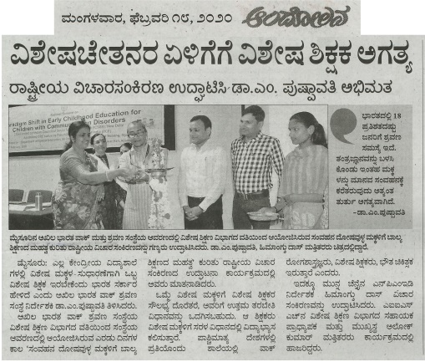 | 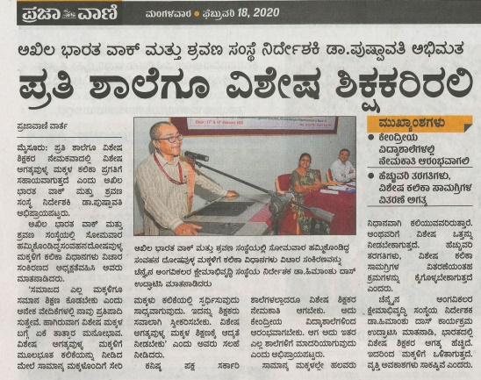
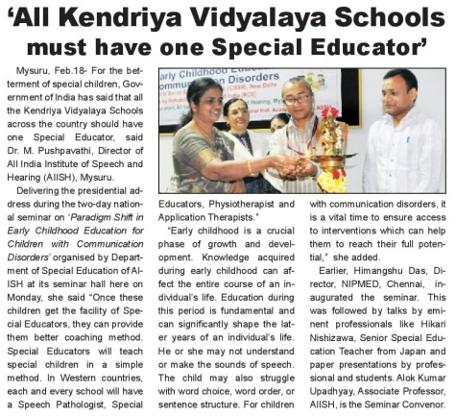 | 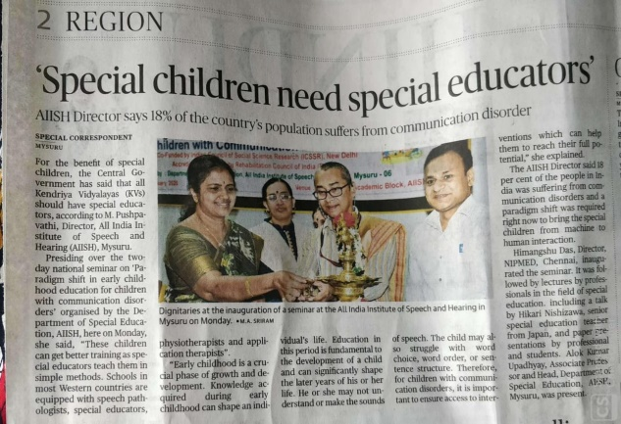
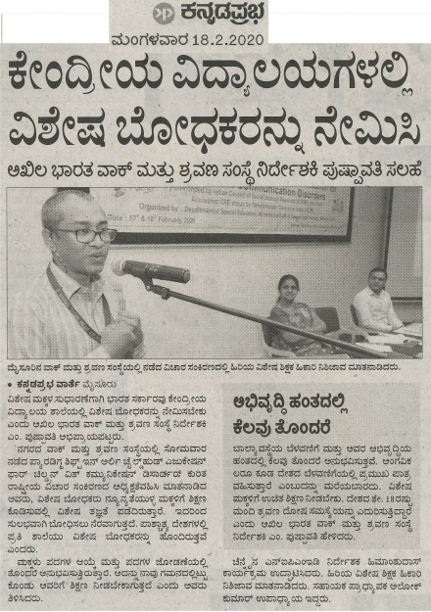 | 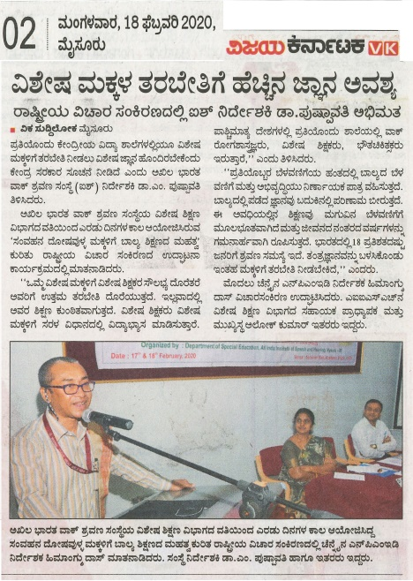

C) Material Development:The following Teaching Learning Material wereprepared for training children with various communication disorders in preschool.
Sl.  No. | Nature of  Teaching-Learning  Materials | Skill | Number
1. | Flash cards | For all skill areas | 274
2. | Work Cards | For all skill areas | 181
3. | Charts | For all skill areas | 17
4. | PPT | For all skill areas | 11
5. | Models | For all skill areas | 18
6. | Sentence strips | For all skill areas | 181
7. | Story cards | For all skill areas | 207
7. | U-Safe | For all skill areas | 0
8. | Others | For all skill areas | 274

Material Development:The following materials were prepared by the B.ASLP students for teaching various speech and language concepts in children with various communication disorders in preschool.
Sl.  No. | Nature of  Speech and Lnguage Therapy  Materials | Number
1. | Short Story Books | 4
2. | Memory Game | 1
3. | Model of Railway Station | 1
4. | Model of Restaurant | 1
5. | Odd one out Game | 1
6. | Reasoning skills | 1

- AWARDS AND HONORS RECEIVED BY FACULTY AND STAFF: NIL
- EXTRA CURRICULAR ACTIVITIES:
        - AIISH Gymkhana:

- Cine Actor and Singer Vasishta N. Simhawas with Preschool Children during AIISH Aawaaz 2020 in AIISH Gymkhana on 28.02.2020.

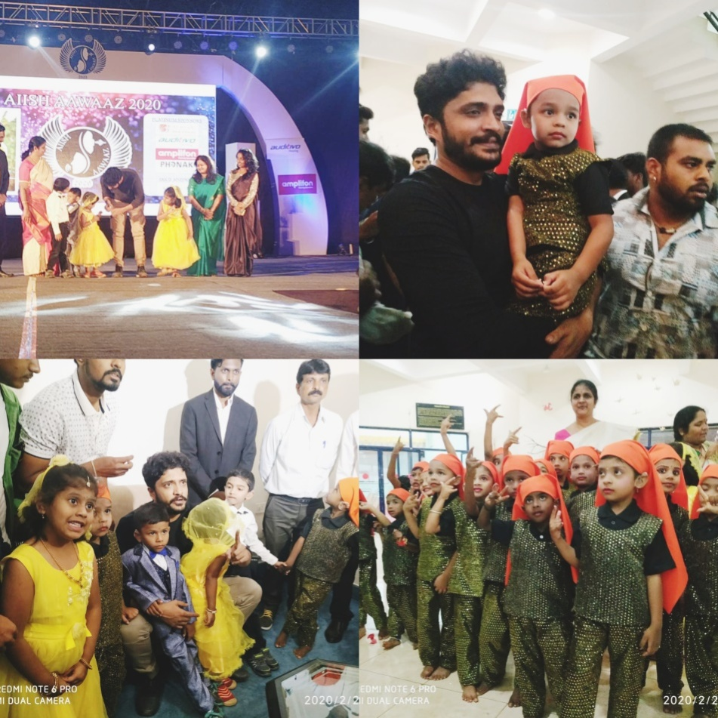

- Attended AIISH Aawaaz 2020 inaugural function and coordinated Djembe program of Preschool children on 28.02.2020

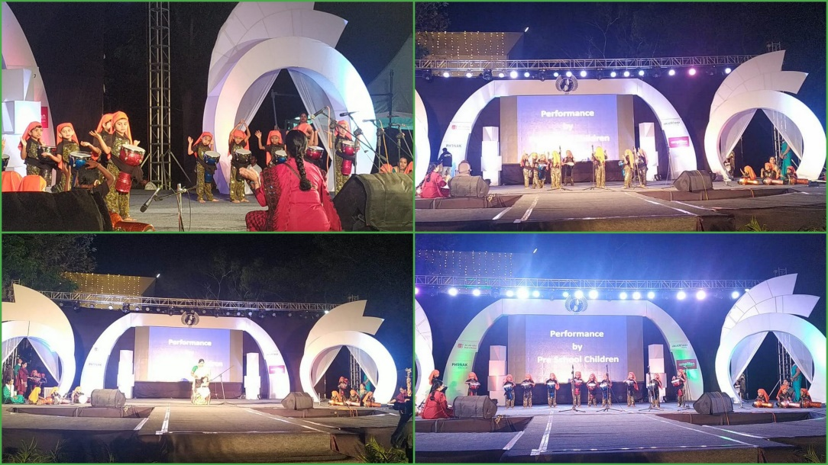
- EMINENT VISITORS:
- ANY OTHER:

Speech and Language Therapy:
- New batches of 1^{st,} 2nd and 3rd BASLP students were oriented regarding group therapy.
- Groups were assigned to student clinicians and group therapy sessions were regularly monitored.
- Differnt speech and language goals were recommeneded for all the groups and students were counselled on the same and helped in planing activities for the session.
- Meetings were conduceted along with the teacher, supervisor and the parents of few groups.
- Students were guided to prepare materials for speech and language therapy.

- OfficialLanguage Implementation:
- No. of notings/letters (February2020):

Bilingual ( hindi and English ) | 70
English | 9

Sd/-
HOD- Special Education

