संप्रेषणविकृतिरोकथामविभाग
DEPARTMENT OF PREVENTION OF COMMUNICATION DISORDERS
महीनेकेविवरण/ MONTHLY REPORT – OCTOBER 2020

- ACADEMIC ACTIVITIES
A. No. of webinars & Orientations: 45
As a part of primary prevention activities, orientation/sensitization programs are being conducted regularly. The objective of the orientation programs was to create awareness among the general public and various other professionals such as Medical doctors, Nurses, Health-related workers, teachers, school students, etc., on different types of communication disorders, its prevention and early identification methods, and their appropriate referral and timely management. Due to the COVID-19 pandemic condition in the country, the orientation programs are carried out through Tele-mode/Webinars. Table 1&2 shows the details of the webinar’s programs conducted by staff and students of the department of POCD, NBS, and OSC centers.
Table 1: The details of webinar Programs in October 2020.
I. No. of Webinar Programs at POCD : 16
Theme/Topic of the program: Prevention & early identification of communication disorders
Coordinators: Dr. N. Sreedevi, Dr. M. Sandeep & Mr. Arunraj K.
S.No | Date | Name of the institute/  Hospital | Target group | Total participants | Oriented by
 | 01.10.2020 | HD Kote school teachers | School teachers | 54 | Mr. Gowtham G & Ms. Ritu V
 | 05.10.2020 | HD Kote school teachers | School teachers | 67 | Ms. Spoorthy.C Mr. Kishore & Ms. Prathima M
 | 06.10.2020 | HD Kote school teachers | School teachers | 27 | Ms. Anusha.C & Mr. Advaith
 | 07.10.2020 | HD Kote school teachers | School teachers | 45 | Ms. Anusha c & Mr. Harish
 | 08.10.2020 | HD Kote school teachers | School teachers | 30 | Ms. Ritu & Ms. Spoorthy
 | 09.10.2020 | HD Kote school teachers | School teachers | 40 | Ms. Spoorthy & Ms. Sharanya
 | 07.10.2020 | Indian Academy of Pediatrics, Mysuru branch | Pediatricians | 30 | Dr. Sandeep M.
 | 20.10.2020 | Hunsur school teachers | School teachers | 102 | Ms. Sharanya & Mr. Gowtham
 | 21.10.2020 | Hunsur school teachers | School teachers | 165 | Mr. Harish & Ms.Spoorthy
 | 22.10.2020 | Hunsur school teachers | School teachers | 142 | Mr. Gowtham & Ms. Anusha
 | 23.10.2020 | Hunsur school teachers | School teachers | 125 | Mr. Kishore & Ms. Spoorthy
 | 27.10.2020 | Hunsur school teachers | School teachers | 110 | Mr. Advaith & Mr. Gowtham
 | 22.10.2020 | SSK, Karnataka | Resource teachers | 450 | Mr. Kishore, Ms. Anusha & Dr. Devi N
 | 25.10.2020 | SSK, Karnataka | Resource teachers | 300 | Dr. Vijetha, Ms. Kumuda & Ms. Vijayalakshmi  (Special educators)
 | 28.10.2020 | SSK, Karnataka | Resource teachers | 310 | Mr. Raj Kumar, Ms. Shobha & Ms. Leena  (Special educators)
 | 29.10.2020 | SSK, Karnataka | Resource teachers | 415 | Dr. Hema. N
Total |  |  |  | 2412
II. No. of Webinar Programs at OSC centers: 05
 | 14.10.2020 | Vivekananda Memorial Hospital, Sarguru | ASHA Workers | 15 | Mr. Vishnu Mohan
 | 10.10.2020 | Taluk Hospital, Sagara | School teachers | 46 | Ms. Durga. S  Mr. Monish V
 | 17.09.2020 | Kodagu Institute of Medical Sciences, Madikkeri | Traffic Police, Madikeri division | 13 | Ms. Kavitha.G.S.
 | 21.09.2020 | Kodagu Institute of Medical Sciences, Madikkeri | Traffic Police, Madikeri Division | 5 | Ms. Kavitha.G.S.
 | 30.10.2020 | BIMS ,Belagavi | Hospital staffs | 15 | Mr Advaith.B &  Mr Gowtham G
Total |  |  |  | 94
III. No. of Webinar Programs at NBS centers: 06
 | 16.10.2020 | Rims, Imphal | ASLP Professionals | 01 | Ms.Vishali C
 | 13.10.2020 | NSCBMCH, Jabalpur | Nurses | 07 | Ms. Kriti Arora
 | 15.10.2020 & 22.10.2020 | SDUAHER, Kolar | Neolatogist, PG students (PEDI) | 10 | Mr. Ashique Rahman M
 | 06.10.2020,  13.10.2020,  16.10.2020 &  19.10.2020 | AIIPMR, Mumbai | Caregivers and patients with motor impairment and speech and disorders | 23 | Ms. Suman Penwal
 | 28/10/2020 | JIPMER, Puducherry | Caregivers | 11 | Ms. Saranya M
 | 28.10.2020 | RIMS, Ranchi | Pharmacy students | 08 | Mr. Yashwanth Kumar
Total |  |  |  | 60

Table 2: The details of orientation programs at AIISH DCS in October 2020.
 | 01.10.2020 | 40 | Ms. Spoorthy.C & Ms. Ritu.V
 | 05.10.2020 | 70 | Ms. Sharanya Kumar & Ms. Krishnendu. S
 | 06.10.2020 | 71 | Ms. Anusha C & Ms. Aparna U
 | 07.10.2020 | 75 | Ms Ritu.V & Ms. Faheema A
 | 08.10.2020 | 87 | Mr. Kishore Kumar & Ms. Abinaya R
 | 09.10.2020 | 80 | Mr. Harish Kumar & Ms. Priya Khader
 | 12.10.2020 | 38 | Ms. Spoorthy. C& Ms. Susan T
 | 13.10.2020 | 65 | Mr. Advaith. B & Mr. Gowtham.G
 | 14.10.2020 | 55 | Ms. Sharanya Kumar & Ms. Krishnendu. S
 | 15.10.2020 | 72 | Ms. Anusha C & Ms. Aparna U
 | 16.10.2020 | 35 | Ms Ritu.V & Ms. Faheema A
 | 19.10.2020 | 65 | Mr. Kishore Kumar & Mr. Advaith.B
 | 20.10.2020 | 84 | Mr. Harish Kumar & Ms. Ritu.V
 | 21.10.2020 | 70 | Ms. Spoorthy.C & Ms. Susan T
 | 22.10.2020 | 74 | Mr. Advaith. B& Mr. Gowtham G
 | 23.10.2020 | 40 | Ms. Sharanya Kumar & Ms. Krishnendu.S
 | 26.10.2020 | 14 | Ms. Anusha C & Ms. Aparna U
 | 27.10.2020 | 50 | Ms Ritu.V& Ms. Abhinaya.R
 | 28.10.2020 | 103 | Mr. Kishore Kumar & Ms. Ameena. S
 | 29.10.2020 | 47 | Mr. Harish Kumar & Ms. Priya Khader
Total |  | 1235

Table 3: Total number of participants oriented including Webinars and orientations (Group wise
S. No | Target group | Total no. of Participants
I | Grass Root Level Workers
a) | ASHA Workers | 15
II | Professionals
 | School Teachers | 953
 | Resource Teachers | 1475
 | Audiologists/Speech language Pathologist | 01
 | Medical Doctors | 40
 | Nurses | 07
 | Hospital Staff | 15
 | Police | 18
II | Students
 | Medical Students | 08
III | Public
 | General Public | 1235
 | Mothers/Parents of children with communication disorders | 23
 | Post-Partum Mothers | 11
Total |  | 3801
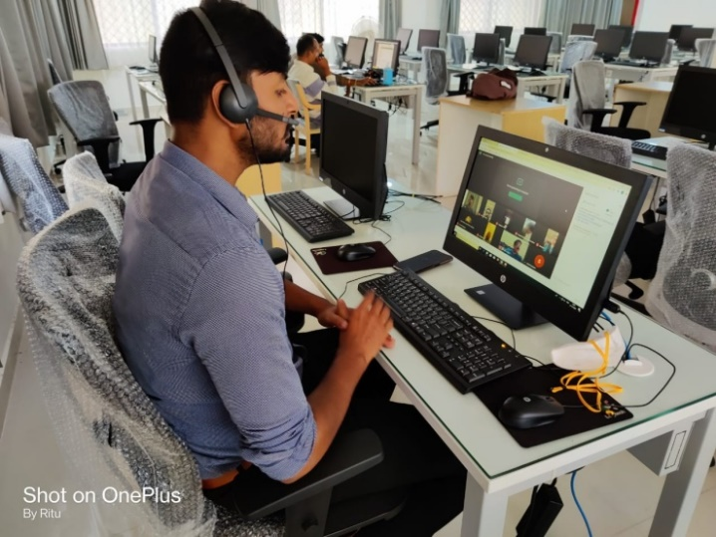
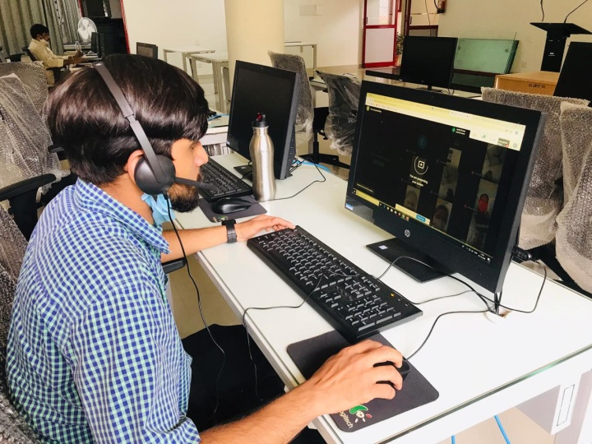

Figure: Glimpses of webinar programs organized at Dept. of POCD
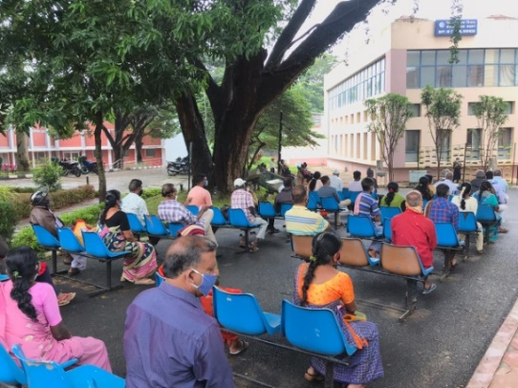
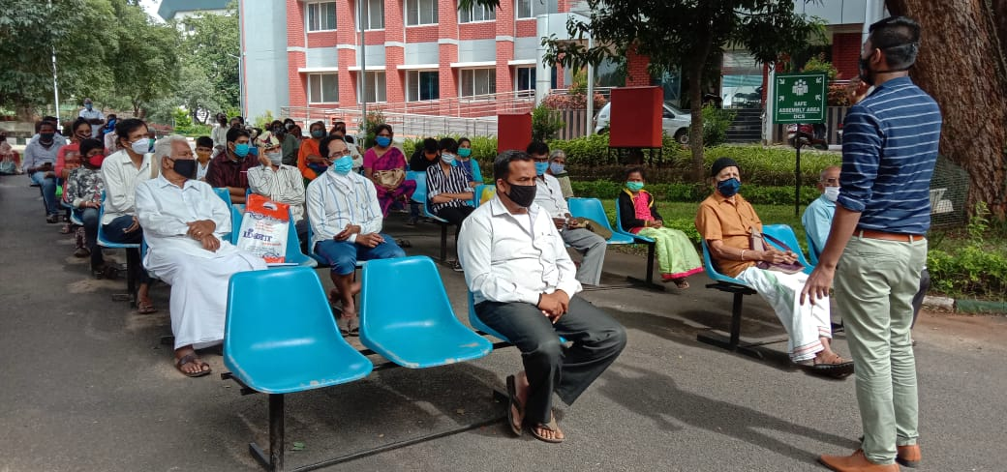
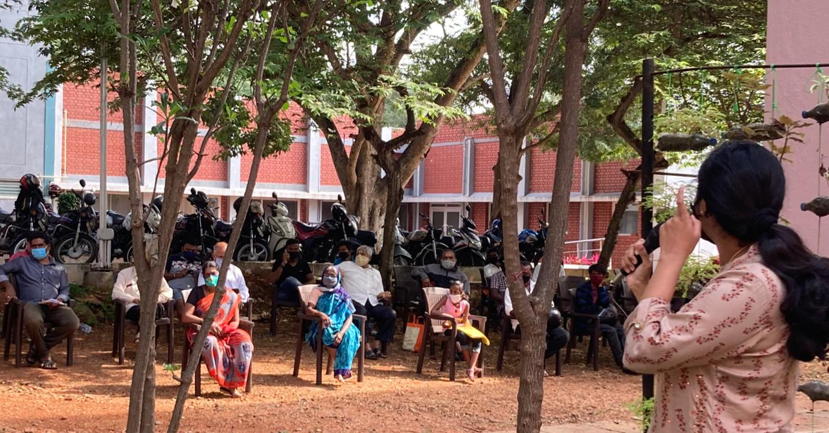
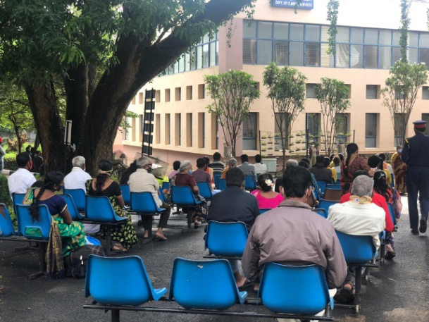
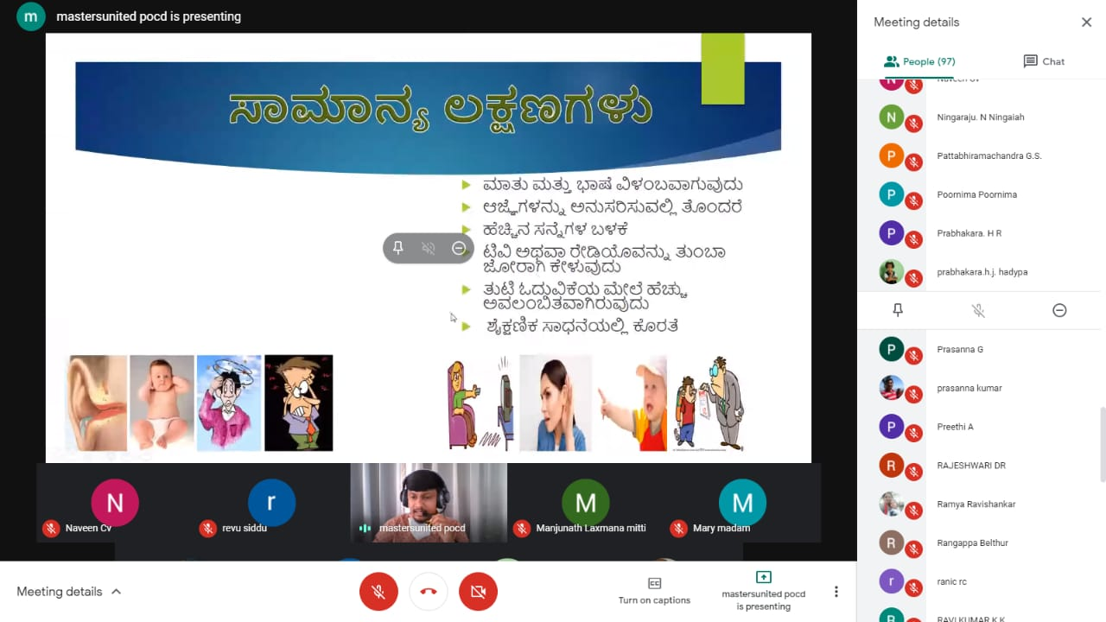

Figure: Glimpses of orientations conducted in DCS to the General public

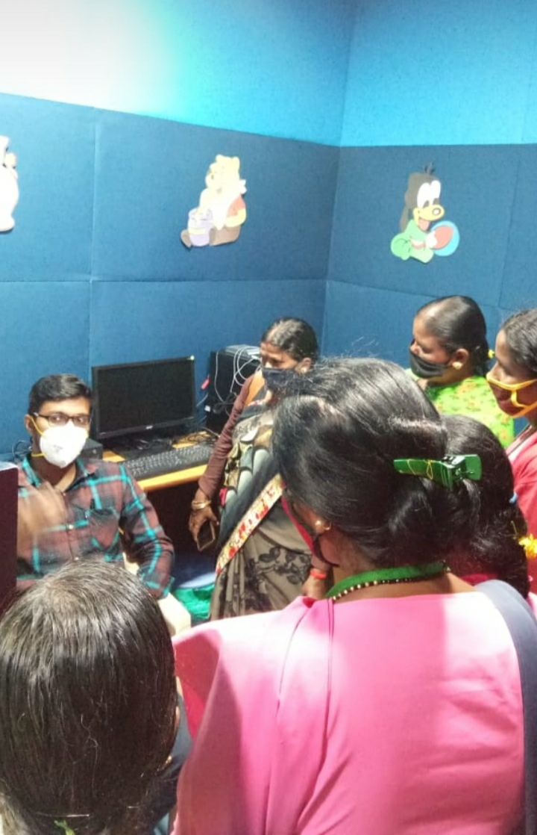
Figure : Glimpses of Orientation program at OSC Sarguru
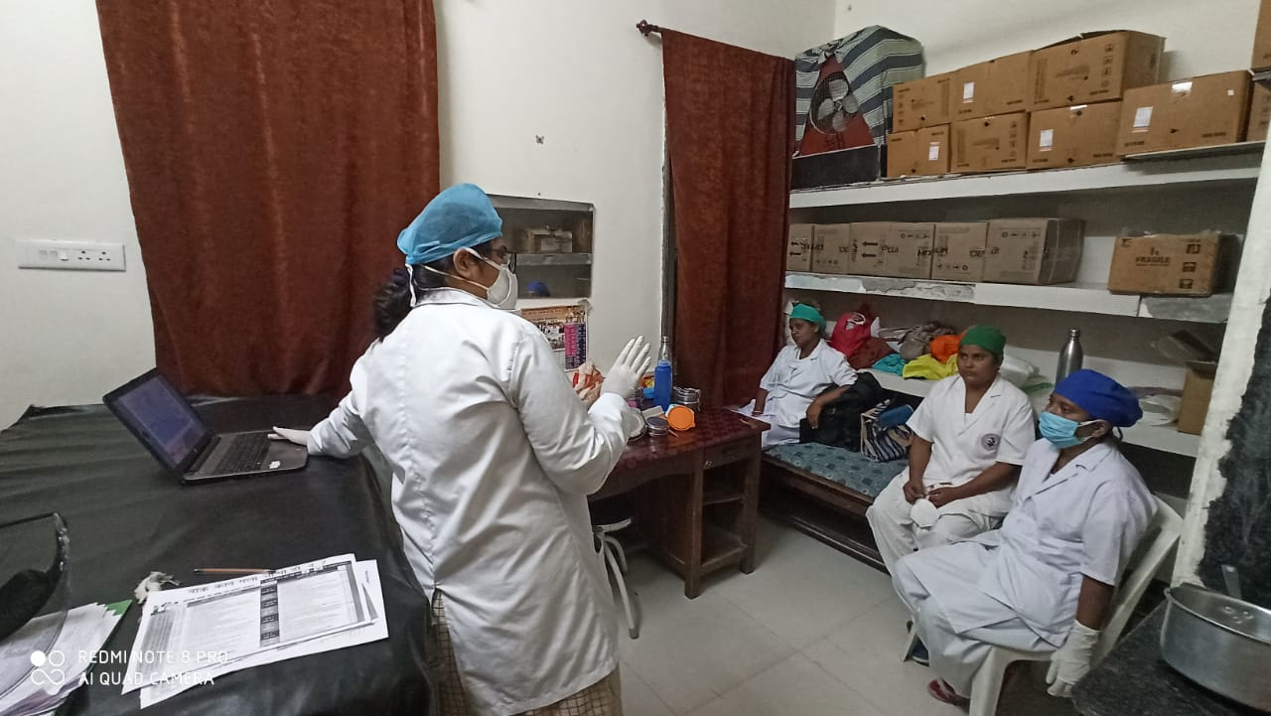

Figure : Glimpses of orientation program at AIIPMR , Mumbai

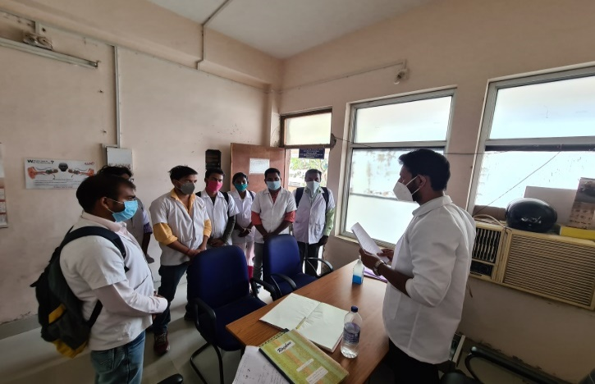

Figure : Glimpses of orientation program at RIMS, Ranchi

B) Seminars/ Conferences /Lectures /Workshops/Training programs
- No. of Seminars/ Conferences /Lectures /Workshops attended by NBS centers: 01
Table 4: Details of seminar/conference /Lectures /Workshops attended by NBS staff.
RIMS, IMPHAL

Date& venue | 21.10.2020 on online
Topic | New born hearing screening protocols in a medical college hospital set up
Name of the resource person | Mr. Hemaraja Nayaka
Name of the co-ordinator/s | Dr. Sriharsha Tikka, Dr. Bhargaw Ilapakurty
Name of the organizers | Sahasra ENT Foundation
Target group | ENT and ASLP
Number of beneficiaries | 100
Objectives | Need. SOPs, instrumentation, clinical evaluation, implementation.

- RESEARCH ACTIVITIES: The New born hearing screening data of all the NBS and OSC centres and OSC data were analysed and following activities have been carried out
- Verified the uniformity of variables across the year and centre wise
- Verified the uniformity of codes assigned to each of the variables across the year and centre wise
- Added and re-coded the variables to make it uniform for merging
- Merged all data on year wise followed by center wise for data analysis

III) EXTENSION ACTIVITIES
The department of POCD is actively involved in carrying out various extension activities such as screening, diagnostic and rehabilitation services outside the institute campus. The activities include newborn/infant screening, screening of school children, screening of elderly citizens, screening of industrial workers, conducting camps and also clinical services offered at the outreach service centers of AIISH. Due to the outbreak of COVID-19, limited activities were carried out in October 2020.
- New-born screening programs for Communication Disorders
Table 5: Details of newborn screened in OSC and NBS centers in August 2020.
S. No | Hospitals/Immunization Centers | Total births | Total screened |  |  | Total No. at risk |  |  | Phone Follow up
 |  |  | Male | Female | Total | Male | Female | Total | Male | Female | Total
I. Mysuru Hospitals
 | KR Hospital (KRH)- Cheluvamba |  | 266 | 237 | 503 | 10 | 18 | 28 | 11 | 15 | 26
 | Kamakshi Hospital (KH) |  | 36 | 29 | 65 | 1 | 1 | 2 | 4 | 2 | 6
 | Mission Hospital (MH) |  | 7 | 1 | 8 | 0 | 0 | 0 | 0 | 0 | 0
 | S.M.T.D.H Hospital |  | 7 | 7 | 14 | 0 | 0 | 0 | 1 | 0 | 1
 | Ashwini Nursing Home (ANH) |  | 2 | 0 | 2 | 0 | 0 | 0 | 0 | 0 | 0
 | Shree Devi Nursing Home (SNH) |  | 7 | 2 | 9 | 0 | 0 | 0 | 0 | 0 | 0
 | Mahadeshwara Nursing Home (MNH) |  | 6 | 3 | 9 | 0 | 0 | 0 | 2 | 0 | 2
 | Sigma Hospital (SH) |  | 22 | 23 | 45 | 1 | 0 | 1 | 1 | 2 | 3
 | Jayanagar maternity hospital |  | 6 | 10 | 16 | 0 | 0 | 0 | 0 | 0 | 0
 | Chamundeshwari Nurshing Home |  | 4 | 2 | 6 | 0 | 0 | 0 | 0 | 0 | 0
Total |  |  | 363 | 314 | 677 | 12 | 19 | 31 | 19 | 19 | 38
II. OSC Centers
1. | Sub-divisional Hospital, SagaraTaluk | 195 | 41 | 44 | 85 | 4 | 4 | 8 | 195 | 41 | 44
2. | St,Mary’s Hospital, HD kote | 115 | 61 | 48 | 109 | 0 | 2 | 2 | 10 | 12 | 22
3. | Vivekananda Memorial hospital, H. D. Kote Sarguru | 49 | 24 | 23 | 47 | 0 | 4 | 4 | 3 | 5 | 8
4. | Taluk Hospital, H. D. Kote- Immunization | 98 | 42 | 48 | 90 | 1 | 3 | 4 | 8 | 4 | 12
5. | Kodagu Institute of Medical Science ,Kodagu | 232 | 85 | 85 | 170 | 3 | 1 | 4 | 7 | 5 | 12
Total |  | 689 | 253 | 248 | 501 | 8 | 14 | 22 | 223 | 67 | 98
NBS Centers
 | Janana Hospital & JLNMCH, Ajmer | 936 | 389 | 174 | 563 | 8 | 6 | 14 | 6 | 8 | 14
 | Jawaharlal Nehru Medical College & Hospital, Bhagalpur, Bihar |  | 161 | 94 | 195 | 11 | 6 | 17 | 4 | 2 | 6
 | JIPMER, Puducherry | 584 | 217 | 309 | 526 | 19 | 29 | 48 | 22 | 19 | 41
 | NetajiSubhash Chandra Bose Medical College (NSCB), Jabalpur |  | 261 | 258 | 519 | 15 | 5 | 20 | 13 | 9 | 22
 | Post Graduate Institute of Medical Education and Research (PGIMER), New Delhi |  | 31 | 41 | 72 | 1 | 2 | 3 | 13 | 11 | 24
 | Rajendra Institute of Medical Sciences, Baritayu, Ranchi | 264 | 140 | 82 | 222 | 1 | 1 | 2 | 6 | 4 | 10
 | Sri DevarajUrs Academy Of Higher Education and Research (SDUAHER), Kolar | 131 | 68 | 63 | 131 | 0 | 0 | 0 | 7 | 8 | 15
 | Sri RamachandraBhanj Medical College and Hospital (SCB MCH), Cuttack | 219 | 107 | 72 | 179 | 05 | 02 | 07 | 0 | 0 | 0
 | Total (NBS centers) |  | 1374 | 1093 | 2407 | 61 | 51 | 111 | 71 | 61 | 132
Total |  | - | 1990 | 1655 | 3585 | 81 | 84 | 164 | 313 | 147 | 268

B) Tele- follow-up evaluation
The at-risk babies were monitored regularly through Phone calls by administrating Speech-language & hearing developmental checklist. The babies identified with delay in any of the developmental milestones, were referred to AIISH/concerned center for detailed diagnostic evaluation.

Table 6: Details of Tele-phone follow- up carried out at Hospitals in Mysuru.
S. No. | Mysuru Hospitals | Number of infants with normal developmental milestones. | Total infants at risk | Total call attended/ Total no of calls
 | Brindavan Hospital | 3 | 1 | 4/6
 | Cheluvamba Hospital (KRH) | 43 | 4 | 47/97
 | GopalaGowdaShanthaveri Memorial Hospital | 0 | 0 | 0/1
 | Kamakshi Hospital | 2 | 0 | 2/3
 | Mahadeshwara Nursing Home | 0 | 1  (mortality) | 1/1
 | Mission Hospital | 0 | 1 | 1/1
 | S.M.T.D.H Hospital | 1 | 0 | 1/2
 | Shree Lakshmi DevammaShankarshetty Maternity Hospital | 0 | 0 | 0/2
 | Total | 49 | 7 | 56/113

Table 7: Details of Tele-phone follow- up carried out at OSCs in October 2020

OSC centers | Number of infants with normal developmental milestones. | Total infants at risk | Total call attended/ Total no of calls
Subdivision hospital, Sagara | 29 | 2 | 31/38
St. Mary’s Hospital, HD Kote | 18 | 0 | 18/27
Vivekananda Memorial Hospital, Sarguru | 2 | 0 | 2/8
Taluk Hospital, H. D. Kote- | 8 | 0 | 8/9
GIMS, Kalaburgi | 42 | 0 | 42/47
Taluk Hospital, Yelanduru | 4 | 0 | 4/5
Primary Health centre, Gumballi | 1 | 0 | 1
Taluk Hospital, Nanjangudu | 11 | 0 | 11/12
Community Health Centre (CHC), Hullahalli | 1 | 0 | 1/1
BIMS, Belagavi | 51 | 0 | 43/51
KoIMS, Madikkeri | 22 | 0 | 22/29
Total | 189 | 02 | 183/228
Note: The calls not attempted were repeated a minimum of 5 times on consecutive days

Table 8: Details of Tele-phone follow- up carried out at NBS centers in October 2020.
NBS centers | Number of infants with normal developmental milestones. | Total infants at risk | Total call attended/ Total no of calls
Ajmer | 52 | 1 | 53/71
Cuttack | 7 | 0 | 7/12
Delhi | 5 | 0 | 5/7
Imphal | 2 | 1 | 3/3
Jabalpur | 15 | 1 | 16/39
Puducherry | 26 | 0 | 18/26
Ranchi | 8 | 0 | 8
Total | 115 | 03 | 110/166

c) Tele screening Programs
Tele-screening program (virtual mode) was carried out to identify the babies at risk for communication disorders since new born screening program couldn’t be carried out in many centers. The details including the behavioral responses of the new born to environmental sounds and HRR were collected from the parents through Tele-phone mode. The babies at risk were asked to undergo follow up evaluation in detail.
Table 9: Details of Tele-screening carried out at NBS Centers in Mysuru in October 2020
Mysore Hospitals | Total Tele-screened | Mortality | Detailed Evaluation (Referred) | Total infants at risk (Phone Follow up) | Normal Speech and Language milestones
Jayanagar Maternity Hospital | 16/25 | 0 | 0 | 2 | 14
Total | 16/25 | 0 | 0 | 2 | 14

Table 10: Details of Tele-screening at OSCs.
OSC Centre | Total Tele-screened / Total calls made | Mortality | Detailed Evaluation  (Referred) | Total infants at risk  (Screening) | Normal Speech and Language milestones  (Phone Follow up)
Subdivision Hospital, Sagara | Carrying out NBS
Vivekananda Memorial Hospital, Sarguru | Carrying out NBS
GIMS, Kalaburgi | 42/88 | 11 | 0 | 31 | 42
Taluk General Hospital, KR. Pete | Carrying out NBS
Primary Health Centre, Gumballi | 30/35 | 1 | 0 | 3 | 29
Taluk Hospital, Nanjangud/ Community Health Centre (CHC), Hullahalli | * Not done as the hospital did not send the contacts.  They will send it by next week.
BIMS, Belagavi | 304/357 | 15 | 0 | 31 | 273
Total | 376/480 | 27 | 00 | 65 | 344
Note: Those babies who missed out during the pandemic situation for testing
Note: No tele-screening activity carried out at NBS centers in October 2020.

D) New born follow-up evaluation (Detailed assessment)
The newborns/infants referred during the newborn screening/ Tele-screening were advised for detailed evaluation at AIISH/NBS centers/OSCs. A complete test battery was administered for those babies/infants who came for follow-up.

Table 11: Details of the results of follow-up evaluation carried out at OSCs
Categories |  | OSC- Sagara | OSC- Sarguru
Normal | Newborn  (0-2 months) | - | 07
Normal | Infants  (2-12 months) | 02 | -
Normal | Toddlers  (1 year to 4years) | - | -
Normal | Children  (above 4years) | - | -
Hearing impairment | Newborn  (0-2 months) | - | -
Hearing impairment | Infants  (2-12 months) | - | -
Hearing impairment | Toddlers  (1 year to 4years) | - | -
Hearing impairment | Children  (above 4years) | - | -
Speech &language disorder | Newborn  (0-2 months) | - | -
Speech &language disorder | Infants  (2-12 months) | - | -
Speech &language disorder | Toddlers  (1 year to 4years) | - | -
Speech &language disorder | Children  (above 4years) | - | -
Multiple Disorder | Newborn  (0-2 months) | - | -
Multiple Disorder | Infants  (2-12 months) | - | -
Multiple Disorder | Toddlers  (1 year to 4years) | - | -
Multiple Disorder | Children  (above 4years) | - | -
Total |  | 02 | 07

Table 12: Details of the results of detailed follow-up evaluation (Referred from other depts.)
Categories |  | OSC- Kodagu
Normal | Newborn  (0-2 months) | 01
Normal | Infants  (2-12 months) | --
Normal | Toddlers  (1 year to 4years) | -
Normal | Children  (above 4years) | -
Hearing impairment | Newborn  (0-2 months) | -
Hearing impairment | Infants  (2-12 months) | -
Hearing impairment | Toddlers  (1 year to 4years) | -
Hearing impairment | Children  (above 4years) | -
Speech &language disorder | Newborn  (0-2 months) | -
Speech &language disorder | Infants  (2-12 months) | -
Speech &language disorder | Toddlers  (1 year to 4years) | -
Speech &language disorder | Children  (above 4years) | -
Multiple Disorder | Newborn  (0-2 months) | -
Multiple Disorder | Infants  (2-12 months) | -
Multiple Disorder | Toddlers  (1 year to 4years) | -
Multiple Disorder | Children  (above 4years) | -
Total |  | 01

Table 13: Details of the results of follow-up evaluation carried out at NBS centers.
Categories | Age range | IMPHAL | JABALPUR | PUDUCHERI | RANCHI | Total
Normal | Newborn  (0-2 months) | 02 | - | - | 09 | 11
Normal | Infants  (2-12 months) |  | 02 | 01 |  | 03
Normal | Toddlers  (1 year to 4years) | - | - | - | - | -
Normal | Children  (above 4years) | - | - | - | - | -
Hearing impairment | Newborn  (0-2 months) | - | - | 02 |  | 02
Hearing impairment | Infants  (2-12 months) | - | - | - | - | -
Hearing impairment | Toddlers  (1 year to 4years) | 01 | 02 | - | - | 03
Hearing impairment | Children  (above 4years) | - | - | - | - | -
Speech & language disorders | Newborn  (0-2 months) | - | - | - | - | -
Speech & language disorders | Infants  (2-12 months) | - | - | - | - | -
Speech & language disorders | Toddlers  (1 year to 4years) | - | - | - | - | -
Speech & language disorders | Children  (above 4years) | - | - | - | - | -
Multiple Disorder/ Syndromes | Newborn  (0-2 months) | - | - | - | - | -
Multiple Disorder/ Syndromes | Infants  (2-12 months) | - | - | - | - | -
Multiple Disorder/ Syndromes | Toddlers  (1 year to 4years) | - | - | - | - | -
Multiple Disorder/ Syndromes | Children  (above 4years) | - | - | - | - | -
Total |  | 03 | 04 | 03 | 09 | 19

D) Anganawadi /Preschool/School screening program
Screening of preschool, primary school children and Anganawadi was conducted focusing on the early identification of communication disorders and early rehabilitation of children at risk for communication disorders.
Table 14: Details of Anganawadi/Preschool/School screening program in October 2020
Date | Name of the Anganawadi/Preschool/ School | Total screened |  |  | Total referred with communication disorders
Date | Name of the Anganawadi/Preschool/ School |  |  |  | Ear related disorder | Hearing loss | Speech language disorders
Date | Name of the Anganawadi/Preschool/ School | Male | Female | Total
07-10-2020 | Doddanerale, Anganawadi, periyapatna(TK) | 15 | 16 | 31 | 2 | - | -
14-10-2020 | Manuganahalli,Anganwadi,Hunsuru(TK) | 11 | 11 | 22 | 2 | - | -
21-10-2020 | Bettadapura,Anganwadi,Periyapatna(TK) | 8 | 16 | 24 | 1 | - | -

E) Clinical Services at Outreach Service Centers (OSCs)

The clinical activities are not only restricted to in and around Mysuru, but also extended to rural areas where facilities for clinical services for persons with communication disorders are scanty. Currently there are 08 OSCs centres at different part of the country rendering services to unreached population. The details of those who were registered and availed various services/benefits at the OSCs are tabulated below.
- Clients identified and followed up with communication disorders at OSCs

Table 15: Details of clients identified and followed up with communication disorders at OSCs.
S. No | OSC Centre | Total registered |  | ENT Evaluation |  | Hearing Evaluation |  | Speech & Language Evaluation
S. No | OSC Centre |  |  | Normal | Disorder | Normal | Disorder | Normal | Disorder
 | Community Health Centre (CHC), Hullahalli | New cases | 16 | 0 | 16 | 0 | 1 | 0 | 16
 | Community Health Centre (CHC), Hullahalli | F/u Old | 6 | 0 | 6 | 0 | 0 | 0 | 6
 | Primary Health Centre (PHC), Akkihebbalu | New cases | - | - | - | - | - | - | -
 | Primary Health Centre (PHC), Akkihebbalu | F/u Old | - | Not visiting | - | - | - | - | -
 | Primary Health Centre (PHC), Gumballi | New cases | 44 | 0 | 44 | 0 | 4 | 0 | 0
 | Primary Health Centre (PHC), Gumballi | F/u Old | 28 | 0 | 28 | 0 | 5 | 0 | 0
 | Sub-divisional Hospital (PHC), Sagara | New cases | 7 | 0 | 0 | 0 | 4 | 0 | 1
 | Sub-divisional Hospital (PHC), Sagara | F/u Old | 0 | 0 | 0 | 2 | 0 | 0 | 0
 | Vivekananda Memorial Hospital, Sarguru | New cases | 25 | 0 | 0 | 6 | 7 | 0 | 12
 | Vivekananda Memorial Hospital, Sarguru | F/u Old | 2 | 0 | 0 | 1 | 1 | 0 | 0
 | Gulbarga Institute of Medical Sciences | New cases | 0 | 0 | 0 | 31 | 97 | 0 | 08
 | Gulbarga Institute of Medical Sciences | F/u Old | 0 | 0 | 0 | 0 | 0 | 0 | 0
 | Kodagu Institute of Medical Sciences, Madikkerri | New cases | 0 | 0 | 0 | 3 | 24 | 0 | 6
 | Kodagu Institute of Medical Sciences, Madikkerri | F/u Old | 0 | 0 | 0 | 0 | 0 | 0 | 0

- Table 16: Clients identified with different types of communication disorders across OSCs
Type of Disorders | OSC
Type of Disorders | Taluk Hospital, Nanjangud | Primary Health Centre (PHC), Hullahalli | Primary Health Centre (PHC), Akkihebbalu | Taluk General Hospital, KR Pete | Primary Health Centre (PHC), Gumballi | Sub-divisional Hospital, Sagara (PHC) Taluk | VMH,  Sarguru | BIMS Belagavi | GIMS, Kalburgi | KoIMS,  Kodagu
 |  | Hearing disorders (Ear-wise data)
Normal | 0 | 0 | - | - | 0 |  | 12 |  | 22 | 13
Conductive | 0 | 0 | - | - | 0 |  | 4 |  | 03 | 6
Sensori- neural | 0 | 4 | - | - | 7 |  | 4 |  | 16 | 47
Mixed | 0 | 0 | - | - | 0 |  | 0 |  | 26 | 7
No type (Minimal & Profound) | 0 | 0 | - | - | 1 |  | 6 |  | Minimal-09 & Profound-52 | 31
Aud-Total (ears) | 0 | 4 | - | - | 8 |  | 26 |  | - | 104
Aud-Total (Individuals) | 0 | 2 | - | - | 4 |  | 13 |  | 128 | 52
Voice | 0 | 0 |  |  | 0 |  | - |  | - | 0
Fluency | 0 | 0 |  |  | 0 |  | - |  | 02 | 0
Articulation disorders | 0 | 0 |  |  | 0 |  | 1 |  | 05 | 0
Language disorders | 0 | 0 |  |  | 0 |  | 11 |  | 01 | 6
Total (Individuals) | 0 | 0 |  |  | 0 |  | 12 |  | 08 | 6

- Table 17: Clients followed up with different types of communication disorders at OSCs
Type of Disorders |  |  |  | OSC
Type of Disorders | Taluk Hospital Nanjangud | Primary Health Centre (PHC), Hullahalli | Primary Health Centre (PHC), Akkihebbalu |  | Taluk General Hospital, KR Pete | Primary Health Centre (PHC), Gumballi | Sub-divisional Hospital,  Sagara  (PHC) Taluk | VMH,  Sarguru | Belagvi institute of medical sciences BIMS | GIMS, Kalburgi | KoIMS-TH, MadikeriTaluk,Kodagu
 | Hearing disorders (Ear-wise data)
Normal | 0 | 0 | - |  | - | 0 | 4 | 1 | - | - | 0
Conductive | 0 | 0 | - |  | - | 2 | 0 | - | - | - | 0
Sensori- neural | 0 | 0 | - |  | - | 8 | 1 | 3 | - | - | 0
Mixed | 0 | 0 | - |  | - | 0 | 5 | - | - | - | 0
No type (Minimal & Profound) | 0 | 0 | - |  | - | 0 | 2 | - | - | - | 0
Aud-Total (ears) | 0 | 0 | - |  | - | 10 | 12 | 4 | - | - | 0
Aud-Total (Individuals) | 0 | 0 | - |  | - | 5 | 6 | 2 | - | - | 0
Voice | 0 | 0 | - |  | - | 0 | - | - | - | - | 0
Fluency | 0 | 0 | - |  | - | 0 | - | - | - | - | 0
Articulation disorders | 0 | 0 | - |  | - | 0 | - | - | - | - | 0
Language disorders | 0 | 0 | - |  | - | 0 | - | - | - | - | 0
Sp&Lg -Total (Individuals) | 0 | 0 | - |  | - | 0 | - | - | - | - | 0

- Rehabilitation services at OSCs.

Table 18: Details of rehabilitation services provided at OSCs in October 2020.
OSC | Hearing Aids Dispensed | Tele-Speech-language therapy
OSC | Hearing Aids Dispensed | No. of clients | No. of sessions
Taluk Hospital, Nanjangud | 0 | 3 | 12 (Tele-therapy)
Primary Health Centre (PHC), Hullahalli | 0 | 0 | 0
Primary Health Centre (PHC), Gumballi | 0 | 3 | Teletherapy: 14
Sub-divisional Hospital, Sagara (PHC) Taluk |  | 12 | 97(Tele sessions)
VMH, Sarguru | 1 | 18 | Regular – 12  Camp - 42
Belagavi institute of medical sciences BIMS | 0 | 3 | Tele-therapy: 12
GIMS, Kalburgi | - | 07 | 30 Tele-sessions
KoIMS-TH, Madikeri Taluk | 5 | 11 | 51 tele-sessions  5-regular sessions
Total | 06 | 57 | 275

d) Table 19: Screening Camps for communication Disorders
Date | Camp site | Total Screened | Total Referred |  |  |  | Total hearing aid distributed | Total
Date | Camp site | Total Screened | Hearing impairment |  | Speech- language disorders |  | Total hearing aid distributed | Total
Date | Camp site | Total Screened | Male | Female | Male | Female
16/10/2020  to  21/10/2020 | Viveka Rural Livelihood Centre (Kenchanahalli) | 14 | 0 | 0 | 7 | 7 | 0 | 14
Total |  | 14 | 0 | 0 | 7 | 7 | 0 | 14
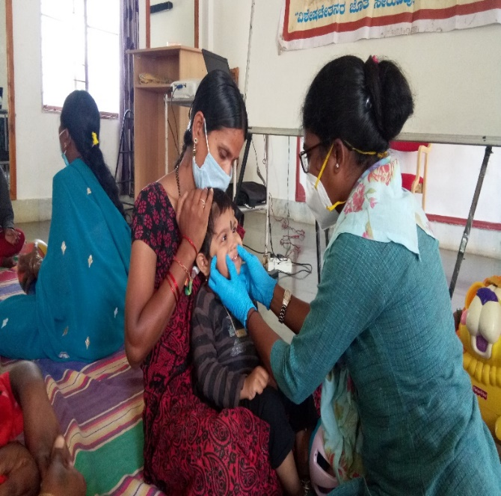
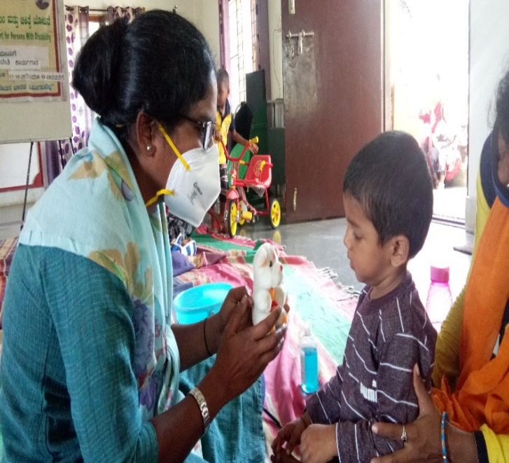

Figure : Glimpses of Residential Camp for Persons with cerebral palsy

IV) TECHNOLOGICAL CONSULTANCY SERVICES: NIL

V) CENTRAL FACILITIES
a) Library and information Services: NIL
VI) MAJOR EVENTS OF THE MONTH: AIISH AISIRI Programs
Table 20: details of AIISH AISIRI progams
S.NO | Date | Staff | Topic details
1. | 03.10.2020 | Dr Yashaswini R | Autism Spectrum Disorders
2. | 10.10.2020 | Ms. Sahana V | Voice disorders
2. | 18.10.2020 | Ms. Geetha M P | Early identification of communication disorders
3. | 25.10.2020 | Ms. Shobha B N | Curriculum adaptation for special children

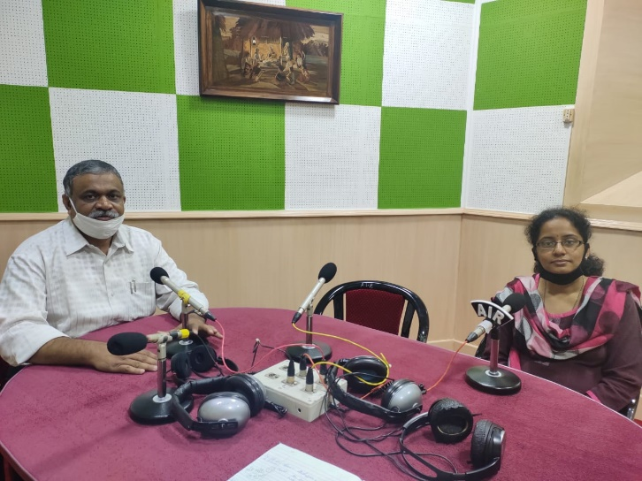
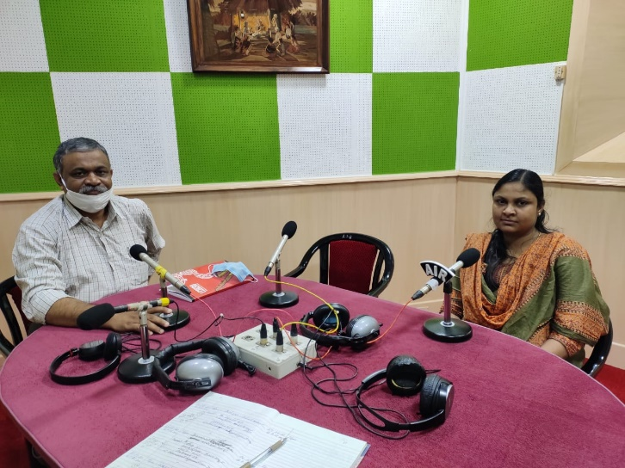
Figure : Glimpses of AIISH AISIRI Programs by AIISH staff, Mysuru.
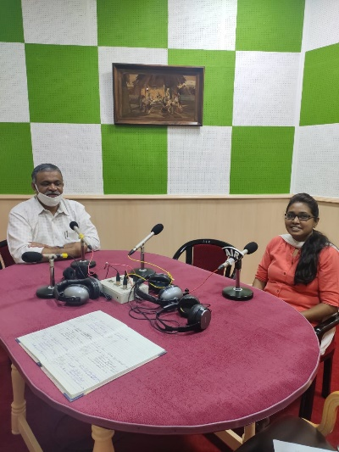
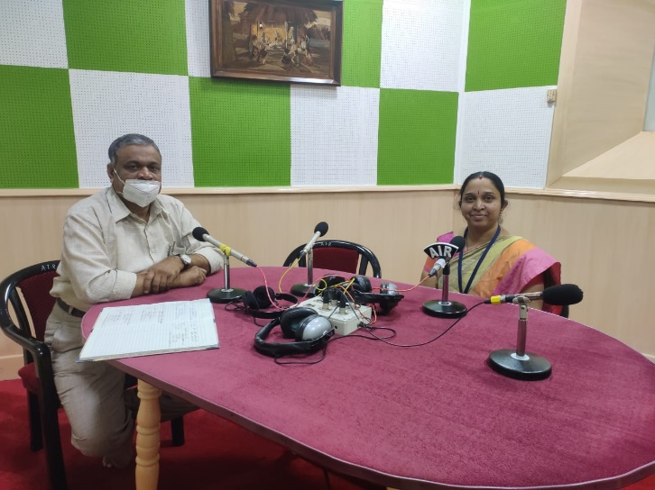

VII) OTHERS
- Submitted the following documents
- Details for academic sub-committee
- Details for NAAC updation

- Computerisation activities: An online meeting was conducted in regard with hosting the AIISH server for the module. Currently the computerization modules are under minor revisions.
- Recorded interview for DD Chandana TV programme to spread awareness among the public
- On the occasion of world cerebral palsy day (06/10/2020) Community Radio program was organized. In this program Ms. Deepa R, from OSC-Sarguru participated and conducted orientation on Role of Speech Language Pathologist (SLP), What are the Communication intervention available for persons with Cerebral palsy and Parents responsibility.

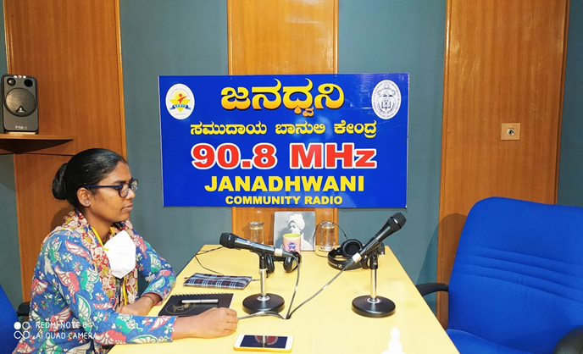

VII) ACTIVITIES CARRIED OUT BY THE STAFF OF THE DEPARTMENT OF POCD.

Table 21: Details of activities carried out by POCD staff in October 2020.
S.No. | Name of the staff | Designation | Activities
 | Dr. N Sreedevi | - Head, Dept. of POCD | - Officiating as HOD-POCD  - Has been coordinating webinars/ orientation on communication disorders to general public, teachers and Industrial workers : 16 nos  - Coordinated DCS campus orientations 20 Nos.  - Attended Purchase meeting on 1.10.2020  - Coordinated the inauguration of Kodagu OSC on 3.10.2020  - Conducted the performance analysis meeting july-aug 2020 on 5.10.2020  - Conducted a meeting on computerization on 5.10.2020  - Conducted a virtual meeting with OSCs on 7.10.2020  - Coordinated with Prasar Bharathi Doordarshan, for the talk of six staff members  - Conducted meeting on statistical NBS data cleansing on 9.10.2020  - Coordinated with SSK-Karnataka for webinar series on four half days  - Coordinated the compilation of NAAC material  - Coordinated webinars to teachers from Hunsur Taluq  - Attended SPC meeting reg POCD material on 16.10.2020  - Conducted performance analysis meeting of SEP 2020 on 28.10.2020  - Worked on correction of Kannada and Malayalam pamphlets, videos and other public education materials  - Attended 2 CC
 | Dr. Sandeep M | Associate Professor in Audiology | - Coordinated OSC and NBS centre activities  - Delivered a talk on New Born Hearing Screening & Early Identification of childhood hearing loss on 07.10.2020  - Attended Purchase meeting on 1.10.2020  - Coordinated the inauguration of Kodagu OSC on 3.10.2020  - Attended the performance analysis meeting july-aug 2020 on 5.10.2020  - Conducted a virtual meeting with OSCs on 7.10.2020  - Attended performance analysis meeting of SEP 2020 on 28.10.2020  - Verified the manuals for the programs of POCD
 | Mr. Arunraj. K | Clinical Assistant | - Attended Purchase meeting on 1.10.2020  - Coordinated the inauguration of Kodagu OSC on 3.10.2020  - Attended the performance analysis meeting july-aug 2020 on 5.10.2020  - Attended a meeting on computerization on 5.10.2020  - Conducted a virtual meeting with OSCs on 7.10.2020  - Drafted letters for  - compilation of NAAC material  - Academic sub-committee content  - Infant cry  - Attended performance analysis meeting of SEP 2020 on 28.10.2020  - Attended the guest lecture on Vigilance awareness Do’s and Don’ts on 29.10.2020
 | Ms. Ameena Subhakani S. | Speech Language Pathologist Grade I | - Orientation on Speech, Language and hearing disorders to general public in front of DCS  - Information update for NAAC  - Verified the details  - September 2020 monthly report  - Academic sub-committee  - Drafted letters  - Infant cry  - Doodharshan Chandana Channel designating a coordinator  c. Compliance report for Integrity pledge  - Computerization module corrections  - Compiled pictures and videos for Doordharshan Chandana channel recording  - Organized and compiled K.R. Nagar NBS data  - Conducted meeting on statistical NBS data cleansing on 9.10.2020  - Attended the Infant cry meeting on 24.10.2  - 020  - Attended monthly meeting on 28.10.2020  - Attended the webinar on Office 365 on 28.10.2020  - Attended the guest lecture on Vigilance awareness Do’s and Don’ts on 29.10.2020
 | Mr. Harish Kumar M.K. | Audiologist Grade I | - Designed FAQs on Aphasia English Pamphlet  - Orientation for general public infront of AIISH DCS on 9 th , 20 th &amp; 29 th October 2020  - Orientation for HD Kote School teachers on 07.10.2020  - Orientation for Hunsur School teachers’ orientation on 21 st of October  - Attended Webinar on New Born Hearing Screening & Early Identification of childhood hearing loss by Dr. Sandeep M. on 07.10.2020  - Ajmer NBS Data compiling  - Finished Computerization corrections  - Training Internship students
 | Mr. Kishore KumarBharshetty | Audiologist Grade I | - Updating the equipment’s calibration sheet  - Attended negotiation meeting of purchase files  - Preparation of Comparative statements of RE equipment’s, 2020.  - Conducted orientation on speech and hearing among general public near DCS  - Calibration of equipment’s from electronics dep
 | Ms. Krishnendu S. | Speech Language Pathologist Grade I | - School Screening data correction  - SSK Karnataka Webinar organization.  - Tele screening for NBS  - Organized KD Kote and Hunsur orientation.  - Certificate preparation for SSK Kerala participants, Resource persons of SSK Kerala and Karnataka  - WHD certificate preparation.  - Report making for SSK Karnataka Webinar
 | Ms. Priya Abdul Khader M. T. | Audiologist Grade I | - Data analysis of industrial screening  - Finalized the variables for industrial hearing screening data  - Finalized the variables for industrial diagnostic data  - Prepared value label coding for industrial hearing screening  - Prepared value label coding for industrial diagnostic data  - Carried out phone follow up for referred cases  - Total number of calls: 10  - Appointments given: 2  - Carried out NBS  - Conducted DCS orientation: 2
 | Ms. Ritu A Venkatesh | Audiologist Grade I | - Designed FAQs on Aphasia English Pamphlet  - Designed FAQs on Voice disorder English Pamphlet  - Designed FAQs on Learning Disability English Pamphlet  - Designed FAQs on Stuttering English Pamphlet  - Orientation for general public infront of AIISH DCS on 7th, 16th, 20th & 27th October 2020  - Orientation for HD Kote School teachers on 01.10.2020 & 08.10.2020  - Co-ordinated Hunsur School teachers’ orientation on 20th, 21st, 22nd, 23rd & 27th of October.  - Co-ordinated SSK Karnataka orientation on 22nd, 23rd, 27th & 28th of October  - Attended Webinar on New Born Hearing Screening & Early Identification of childhood hearing loss by Dr. Sandeep M. on 07.10.2020  - Prepared posters for Hunsur school teachers orientation program & SSK Karnataka resource teachers orientation program  - Translated Classroom modifications for children with communication disorders Orientation Slides to Kannada
 | Ms. Sharanya K. Kumar | Audiologist – Grade I | - Data cleansing with respect to variables Ranchi from 2015 to 2019  - Data cleansing with respect to variables Puducherry from 2015 to 2019  - Called phone follow-up infants enquiring about their developmental milestones (60 calls).  - Orientation for the general public in front of clinical services.  - Orientation for resource teachers of Hunsur District (101+ 101 participants)  - Letter to collect number for tele-screening in Cheluvamba.  - Collecting numbers from Cheluvamba for tele-screening.  - Compilation of referred cases and follow-up cases of all hospitals of September month.  - Compiling information for NAAC  - Preparation NBS manual  - Preparation of SPSS Format for Referred and phone follow-up cases
 | Ms. Abinaya R | Speech-Language Pathologist Grade I | - Monthly Report Compilation of outside NBS centres  - Attended monthly meeting  - DCS orientation – 3 times  - NAAC report submitted for outside NBS centers  - Followed up with NBS Centres and PL Section about withdrawal and extension letters for staffs  - Cuttack data cleansed, made correction and submitted  - Prepared NBS staff meeting Agenda – In Process  - Newborn Hearing Screening
 | Ms. Aparna U. | Audiologist – Grade II | - Prepared Monthly report of August 2020.  - Verified 04 Malayalam pamphlets  - Carried out tele-screening  - Prepared compiled Monthly report  - Prepared ppt for performance analysis for June, July &August month.
 | Ms. Anusha C. | Speech Language Pathologist – Grade II | - Attended Peer review meeting on 05.10.2020 for the month of June, July and August.  - Conducted webinar for H D Kote school teachers regarding “speech and language disorders in children” on 06.10.2020.  - Merged NBS data of Jabalpur center from 2015-2019.  - Conducted webinar for H D Kote school teachers regarding “speech and language disorders in children” on 07.10.2020.  - Attended a webinar about New Born Hearing Screening on 07.10.2020 by conducted by POCD, AIISH.  - Prepared list of questions and Multi Media Materials for TV interview on Speech Disorders.  - Cleansed NBS data of Jabalpur center from 2015-2019.  - Attended a webinar about AAC- challenges in teaching and learning AAC and Latest Equipments/software in AAC on AAC awareness day, 19.10.2020 by conducted by AIISH.  - Conducted webinar for Resource teachers across Karnataka in association with SSK regarding “Management of Communication Disorders in Children” on 22.10.2020.  - Conducted webinar for Resource teachers across Karnataka in association with SSK regarding “Assessment and Management of Learning Disability in Children” on 23.10.2020.  - Finalizing the designs of Bedside handouts (2 no.) and 2 Hindi PEPs.  - Carried out 6 th month phone follow up of referred cases for the month of January 2020.
 | Ms. Faheema Luquman Ali | Audiologist – Grade II | - 01.10.2020 &amp; 02.10.2020 OSC monthly report compiled  - 05.10.2020- Monthly meeting July and August  - 06.10.2020-Value coding of Sagara and Sarguru  - 07.10.2020- All 8 centres OSC Meeting, Statistics meeting regarding Data cleansing and Attended webinar regarding NBS – presented by Dr.Sandeep  - 08.10.2020 – Prepared NBS Ph- up and referred cases format. OSC Sagara data cleansing corrections done. Verified Minutes of OSC Meeting  - 09.10.2020 –NAAC write up for OSC centres  - 12.10.2020 –Sagara and Sarguru Data final cleansing  - 13.10.2020-NAAC write up corrections done.  - 12.10.2020-16.10.2020 New-born screening, Corrected Pre-natal care unit, OSC minutes verified. Meeting on variables.  - 19.10.2020 Prenatal care unit, and Phone Follow up  - 19.09.2020- 23.09.2020–Worked on OSC manual and Data Value coding  - 21.10.2020- Sagara OSC meeting prepared MOM for the same.  - 28.10.2020- Monthly meeting for the month of September.  - 29.10.2020- Prepared for JCIH  - Alternative weeks attended Newborn screening.
 | Ms. Deepika. R | Office assistant Grade II | - Assisted in Monthly report preparation  - Drafted office correspondence letters (Internal & external)  - Preparation and formatting letters for orientation/webinars, - mailing and posting  - Verified attendance certificate of staff and prepared leave statement  - Attended one departmental meeting on 05.10.2020  - Attended one OSC meeting on 06.10.2020  - Prepared minutes for 2 meetings  - Indenting items for the department also for the NBS activities and keeping register  - Notice board updated  - Made supplier advance settlement and TA bills for the department  - Prepared additional details for NAAC committee and submitted  - Prepared details for academic sub-committee and submitted  - Prepared one compliance report  - Filed the official documents on a daily basis
 | Ms. Spoorthy | SLP – Grade I | - Postings in NBS: 01.10.20 to 02.10.20, 12.10.20 to 16.10.20, 26.10.20 to 30.10.20 (Afternoon)  - Designed pamphlet on ASD in Kannada  - Designed pamphlet on SSD in Kannada  - Data cleansing of SPSS data (T N Pura)  - Video editing of OSC videos, Hullahalli  - Conducted orientation for Mysuru school teachers on 05.10.20  - Conducted orientation for HD Kote school teachers- 08.10.20 & 09.10.20  - Conducted orientation for Hunsuru school teachers- 23.10.20  - Attended OSC meeting on 07.10.20 (Forenoon)  - Attended POCD monthly meeting on 28.10.20 (Forenoon)  - Tele-therapy: 12 sessions
 | Mr Advait | Audiologist | - Dsc postings 15 days(1st -15days)  - Nbs postings (16th-29th)  - Bhagalpur data cleansing  - Bhagalpur data re-arrangement in spss formats from xcel format  - Development of hearing kannada translation  - Orientation for mysore teachers  - Orientation for hunsuru teachers  - Belagavi tele screening  - Phone followup
 | Mr Gowtham |  | - Dsc postings 15 days(1st -15days)  - Nbs postings (16th-29th)  - KR Nagar Data Cleansing  - Orientation for mysore teachers  - Orientation for hunsuru teachers  - Belagavi tele screening  - Phone followup  - Development of comic strip on SSD LD and Autism on Pixon
 | Ms Susan |  | - 16.10.20-30.10.20: Afternoon Clinics [Tuesdays-forenoon & afternoon]  - 1.10.20-31.10.20: OSC Gumballi OPD [Wednesdays]  - SSD Comic strip  - Cleansing and merging of complete Santhemarahalli Data (2011-2019)  - Cleansing and merging TN pura data (2011-2015  - Telescreening and Telesessions for OSC Gumballi  - NBS for 4 days

Sd-
Dr. N Sreedevi
विभागाध्यक्ष, विभाग-पिओसिडि- Head, Dept. Of POCD

