Download XAMPP

Download Moodle latest

Install XAMPP by selecting the installation drive/folder

Check the installation is perfect by opening a browser and typing ‘**localhost**’

Now, it should display the page given below.

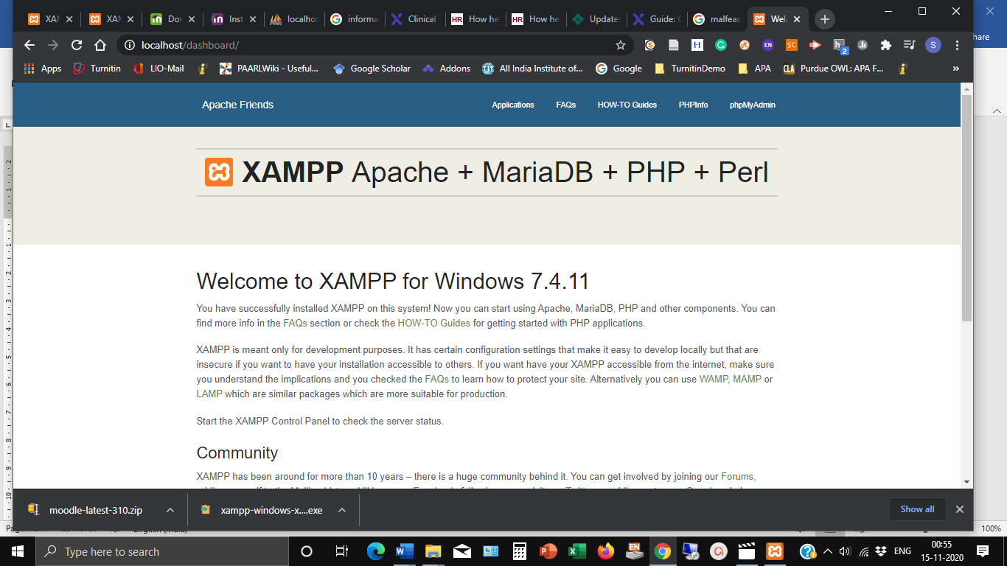

Click the link phpMyAdmin and click **Databases**

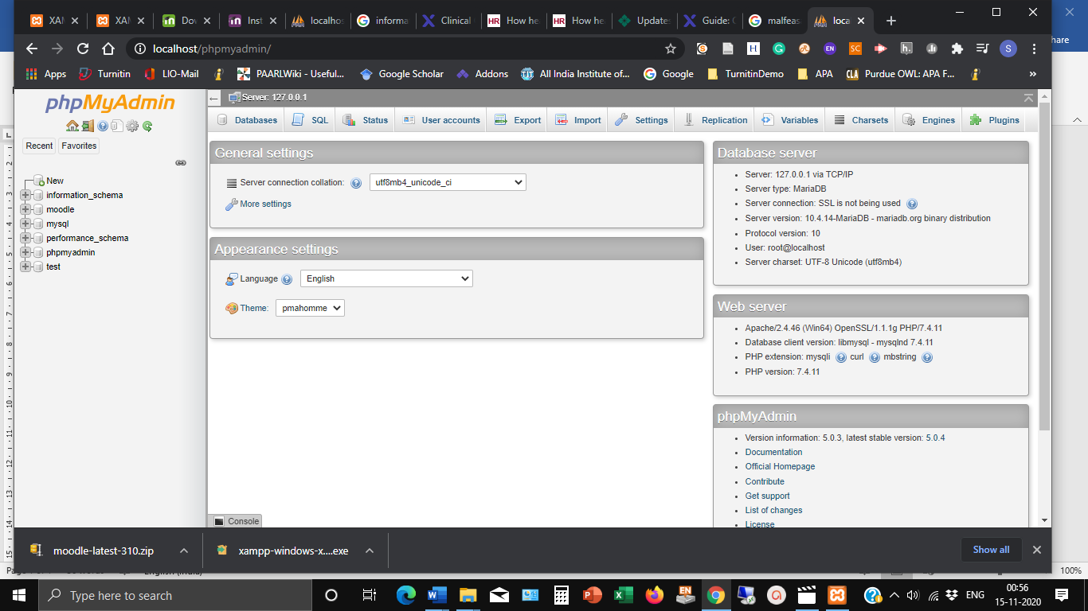

Click **Create** and enter **a name**

Now, unzip the downloaded moodle package

Unzipping will result in a folder by name Moodle

Copy the folder to the **htdocs** folder of the XAMPP

Now, open a browser and type ‘localhost/moodle’

It will take you to the installation of moodle step by step

Enter the language

Then choose the database driver (here MaraiDB)

Enter the database host (localhost), database name (moodle), database password (leave blank), database port (3306) (Taken by opening the XAMPP and identifying where MySQL is running)

Click accept ‘terms and conditions’

In the next window, wherever the server checks is giving the plugin status as **Check, open them in separate windows.**

**Then open XAMPP directory and php folder**

**Under that open php file (with type *Configuration settings*) using notepad**

**Locate the term [intl]**

**Under that uncomment “** intl.default_locale = en_utf8 intl.error_level = E_WARNING

**Add** extension= php_intl.dll

**Remove semicolon from extension=xmlrpc**

**Remove semicolon from extension=soap**

**Add** zend_extension**=**php_opcache.dll

**Save the file and restart Apache**

**Refresh browser**

**Now it will permit** Continue for installation