Attendance

The Attendance activity allows teachers to maintain a record of attendance, replacing or supplementing a paper-based attendance register. Using this tool the teachersare able to take attendance during class, and the students to be able to view their own attendance record. Thus, the teacher can track and optionally provide a grade for the students’ attendance. They can set the frequency of their classes or create specific sessions. Sessions can also be configured to allow students to record their own attendance and a range of different reports are available.

To take attendance, the instructor clicks on the "Update Attendance" button and is presented with a list of all the students in that course, along with configurable options and comments. The default options provided are: Present, Absent, Late & Excused. Instructors can download the attendance for their course in Excel format or text format.

Sessions can also be configured to allow students to record their own attendance and a range of different reports are available.

The following steps are to be followed in setting up and taking attendance.

1. Go to the Course home page and click **turn editing on** from the gear icon on the top right
2. Click the Add an activity or resource link
3. Select **Attendance** activity from the resulting pop-up window (Figure 1) and click **ADD** button

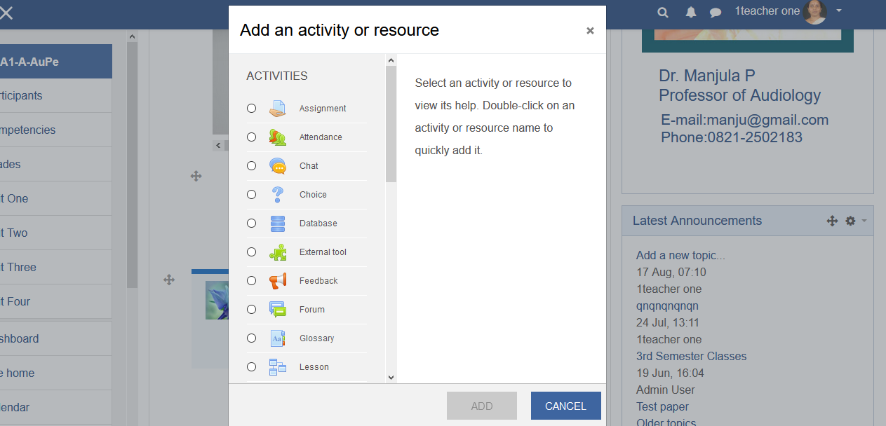

1. Give the attendance a **name** and description, if any. The attendance can be graded if required.

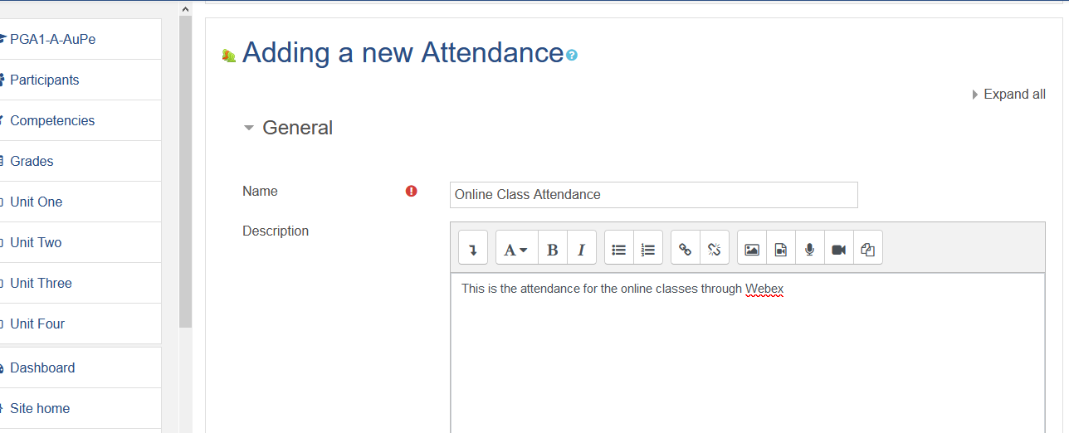

1. Maintain the **default** settings for **Common Module**, **Restrict Access, Activity Completion, Tags, Competencies** and **Extra Restrictions**
2. Click **SAVE AND RETURN TO COURSE** button

**Note:** A teacher canadd as many Attendance instances as necessary. Each instance must be given a meaningful name that indicates what it will be used for.

**Setting Attendance Session**

1. On the course main page click the newly created attendance link. It will take you to the Attendance settings page (Figure ) with six tabs namely, **Sessions**, **Add Session**, **Report**, **Export**, **Status Set** and **Temporary Users**.

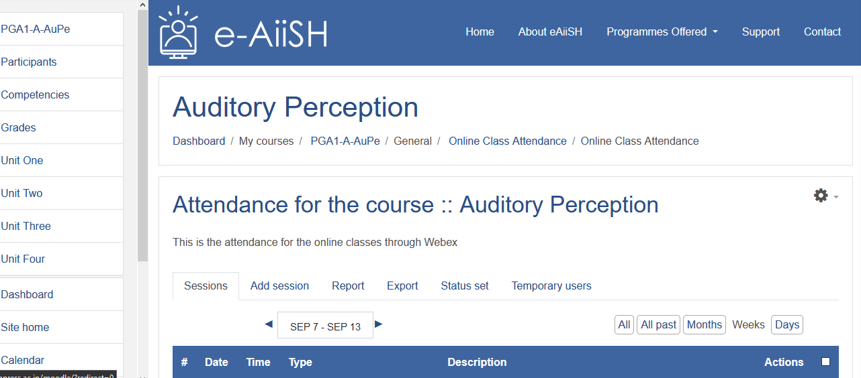

1. Click **Add Session** button
2. The default type is **All students**
3. Add the **Date** and **Time** of the activity for which you are recording attendance
4. Give a description for the Session
5. Tick the option **Create calendar event for session**
6. Click **Multiple Sessions** for recording the attendance for a recurring activityand set the frequency of theactivity. First set the days of the session and then if it is repeated every week select **Repeat Every Week** as **1** , every two weeks as 2 etc. and then enter the last date of the Activity (*end date of the course*) at **Repeat Until**.

**Attendance Marking by Students (Follow Sl. No. 8 to 12)**

1. If you wish, the students can be permitted to mark attendance by themselves by ticking **Allow students to record own attendance** option.
2. There are three options for **Automatic marking** of student attendance: (i) Yes (ii) Set unmarked at the end of session (iii) Disabled.

If **Yes** option is selected, the student will be automatically marked as present when he/she just log on to the course. *Hence, it is better NOT TO select this option*.

The most useful option is **Set unmarked at end of the session.** This means the students who have not marked their attendance by himself can be marked as per the status (Present, Absent or Excused) by the teacher at the end of the session.

The Automatic marking can be ‘**Disabled’,** if you wish for students who have not registered to have their status left as unset.

1. **Next, decide whether the students need** to enter a **password** to record their attendance or only record attendance from certain computers, leave these **blank** if they aren’t needed. The password can be decided and entered manually by the teacher and or it can be generated randomly. Also, QR Code can be generated. The QR code generated can be communicated to the students during the start of the session.

**Attendance Marking by the Teacher ( Skip the Sl. No. 8 & 9 above)**

1. In case the teacher wants to record the attendance by him/herself:
2. Click the ADD button at the bottom
3. Go to the **Sessions tab**
4. From the list of Sessions select the session for which you have set up the attendance and click button i.e. **Take attendance** (figure …) to take the attendance.
5. From the resulting attendance table (figure….) tick the P (i.e. Present) against the **Set status for all** option on the top portion of the table.
6. Then, change the status of the individual student who are *absent / excused or late* by clicking the corresponding status radio button against each student and SAVE ATTENDANCE.

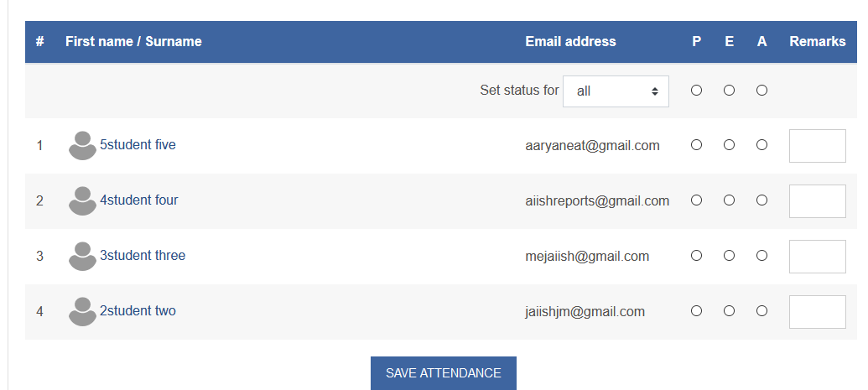

**Editing, Exporting, Deleting etc. of Attendance**

1. The newly created sessions will be found in the tab **“Session”**.From here **you** can **edit**, **change** **delete** the sessions. You can also use the **Select** tick box above the session list to make universal changes, such as **delete all sessions**.

**Changing Status Sets**

1. Click the **Status Set** button from the main attendance activity page.
2. This allows you to set names and point values for attendance grades. The default ***Status set*** uses four marking options: **P***resent,* **E***xcused,* **L***ate, and* **A***bsent*. You can rename, add, or delete options to fit your own needs.