Assignment

Using the **Assignment Activity**, a teacher can assign a number of tasks to the students and provide grades and feedback. The system permits the submission of assignments in any digital files such as MS-Word, Excel, Image, Audio and Video. The students can also submit the assignment by typing text directly into the text editor. It is also possible to set up an assignment to remind students of the offline assignments. In order to set up an Assignment Activity and evaluate it, following settings need to be done.

**Settings for Submission of Assignment**

1. Click the Gear Icon on the top right and select ‘**Turn Editing on**’ button (Figure 1)

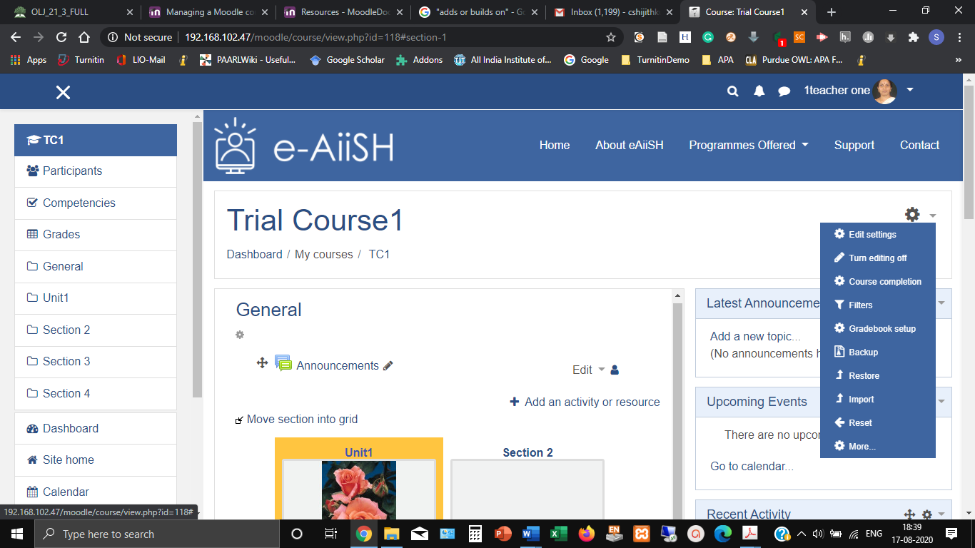

1. Click the ‘**Add an activity or resource**’ button at the location/ unit where you need to set up the Assignment Activity
2. Select the **Assignment** button from the resulting activity chooser (Figure 2) and click **ADD** button

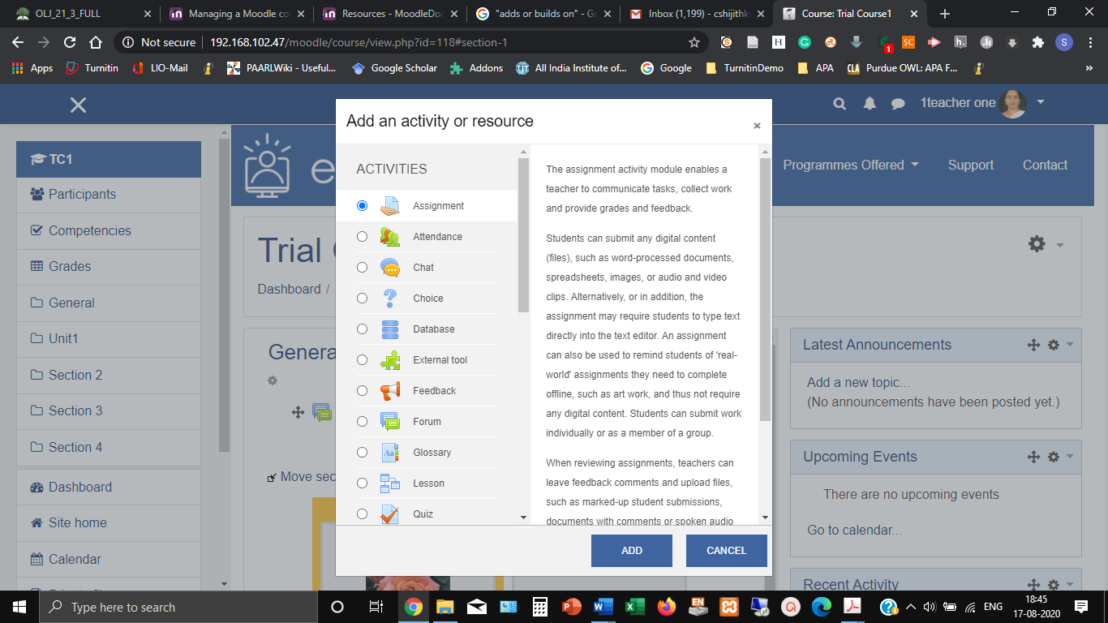

1. Give Assignment a meaningful **name.** The **instructions** to the students about the assignmentcan be provided in **description** column**.** The teacher can also mention about the grading criteria here.The description can be made as text, audio and video format.
2. In order to display the description on the course page, tick the **Display description on course page**, if required.
3. Using the **Additional files** option, attach supporting documents or templates, if any, for reference for the students to complete the assignment. E.g. answer templates.
4. Under the **Availability** option, decide the **starting date**, **due date** and **cut-off** **date** of assignment submission and a **reminder date** for you to review /assess the submitted assignment
5. The student can submit the assignment even after the set due date. However, it will be red marked as late submission.
6. Set **Cut-off date** onlyif required. The students cannot submit the assignment after cut-off date.
7. Set a date to remind the teacher (you) for grading the assignment using **Remind me to grade by** option. *Remember to set a date after the due date of assignment.* The reminder will be displayed when at least one student has submitted the assignment. This date will display on your Course overview block and in the Calendar,
8. Decide the **Type of Submission** depending upon the nature of assignment. It can be **Online text** wherein the student can type the assignment using the online text editor like composing an email message **OR** and they can submit audio and video. The **File submission** permits the students to upload the assignment file in the required format such as MSWord, excel etc. The maximum number of words need to be specified in case of ‘online text’ assignment.
9. Keep the **Maximum number of uploaded files** and the **Maximum submission size** to minimum (*To save our server space*).
10. Depending upon the nature of assignment decide the **Accepted file types**. If it is kept **empty** all file types will be acceptable.
11. Select the **Feedback types:** i.e. Feedback comments / Annotate PDF/ Offline grading worksheet/ Feedback files.

*When reviewing assignments, teachers can leave feedback comments and upload files, such as marked student submissions, documents with comments, audio and video feedback.*

The **Feedback comments** permits the teacher to make comments on each submission.

**Annotate** **PDF** converts the student submission file in MS Word to pdf so that the teacher can annotate and comment on the submission while reviewing it.

**Offline Grading Worksheet,** if enabled,facilitatesdownloading and uploading a worksheet with student grade.

**Feedback files** facilitate uploading of files with teacher’s comments including audio.

The **Comments Inline** facilitates the teacher to make inline comments for an online text submission

1. Under **Submission settings** decide the following (a) Require students to click the submit button, (b) Require that students accept the submission statement, (c) Attempts reopened.
2. The option **Require students to click the submit button** if made **Yes**, a *submission button* will appear at the student assignment submission area which he has to click for submitting the assignment. **This option will prevent the student from editing the assignment once it is submitted**. In other words, if the teacher did not enable this option, the student can revise/edit the assignment and then submit again even after the teacher reviewed and graded it.
3. In case **Require that students accept the submission statement** is made **Yes**, then a declaration statement will appear at the student assignment submission area which he has to agree to submit the assignment.
4. **Attempts reopened** is related to the re-submission of an assignment after it is graded by the teacher. There are two options: (a) Automatic re-opening until the student gets the minimum grade required for the assignment. (b) Manual opening by the teacher so that the student can re-submit.
5. **Group submission settings** facilitates the submission of assignments by a group of students. This is possible only if the teacher has already made classes into groups.

1. **Notifications**: There are three clauses for Assignment Submission Notification with Yes or No options.
2. **Notify graders about submissions**: If this is enabled, the Teacher will get notification for each student submission. BETTER NOT TO ENABLE THIS
3. **Notify graders about late submissions**: In this case, only the late submissions will be notified to the teacher.
4. Default setting for "**Notify students**": This option facilitates notifying the student regarding the teacher feedback on the submitted assignment.
5. **Grade**: Select the grade type as **Point** and enter the **Maximum Grade** point for Assignment based on the earlier decision

Select **Grading method** as **Simple Direct Grading**

1. Decide whether the assignment should be included in **Grade category**: (Assignments/ Tests in our case)
2. Enter the **Grade to pass**, if any
3. **Blind marking** hides the identity of the student while grading
4. **Hide grader identity** from students is to hide the teacher details from the student
5. **Use marking workflow** facilitates multiple round of grading
6. **Common module settings** facilitates **Showing** or **Hiding** of the Availability of the Assignment on the Course Page
7. [**Restrict access**](http://192.168.102.47/moodle/course/modedit.php?add=assign&type=&course=118&section=0&return=0&sr=0)option facilitates the Restriction on the access to the Assignment
8. [**Activity completion**](http://192.168.102.47/moodle/course/modedit.php?add=assign&type=&course=118&section=0&return=0&sr=0) settings allows the teacher to set completion criteria for Assignment
9. [**Tags**](http://192.168.102.47/moodle/course/modedit.php?add=assign&type=&course=118&section=0&return=0&sr=0)permits entering of keywords for searching items related to the activity
10. **Save**

**Submission of Assignment by the Students**

Once teacher has created an assignment with appropriate settings mentioned above, the participants (students) of the course will receive automatic notification regarding the Assignment. He has to access the course and the specific assignment area and add submission.

**Reviewing, Grading and Providing Feedback for the Submitted Assignment**

Once the students submit the assignments and due date is over the teacher will receive a notification in the **Upcoming Events** block of her dashboard

1. In order to review the assignments submitted by the students, **login** to your account. From the dashboard access the concerned Course Page. Click on the assignment name on the course page. This will take you to the **Grading Summary** Page of the Assignment (Figure 1) which lists summary of the assignment, including; number of participants, number of submitted assignments, due date and time remaining with links to: **View All Submissions** and **Grade.**

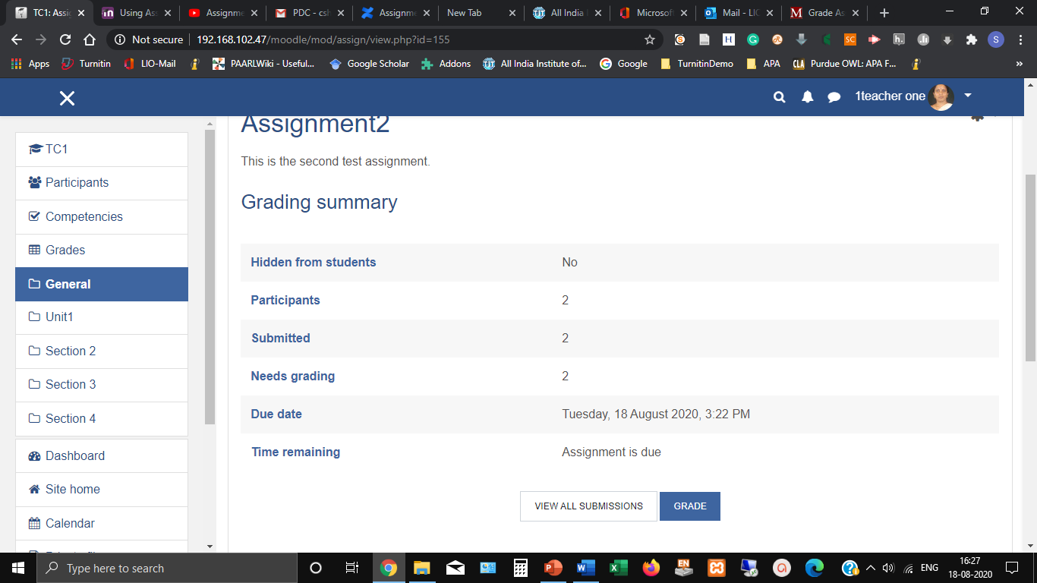

1. Clicking **Grade** will take you to the first student’s assignment grading page/ interface so you can start grading all the assignments one by one (Figure .)

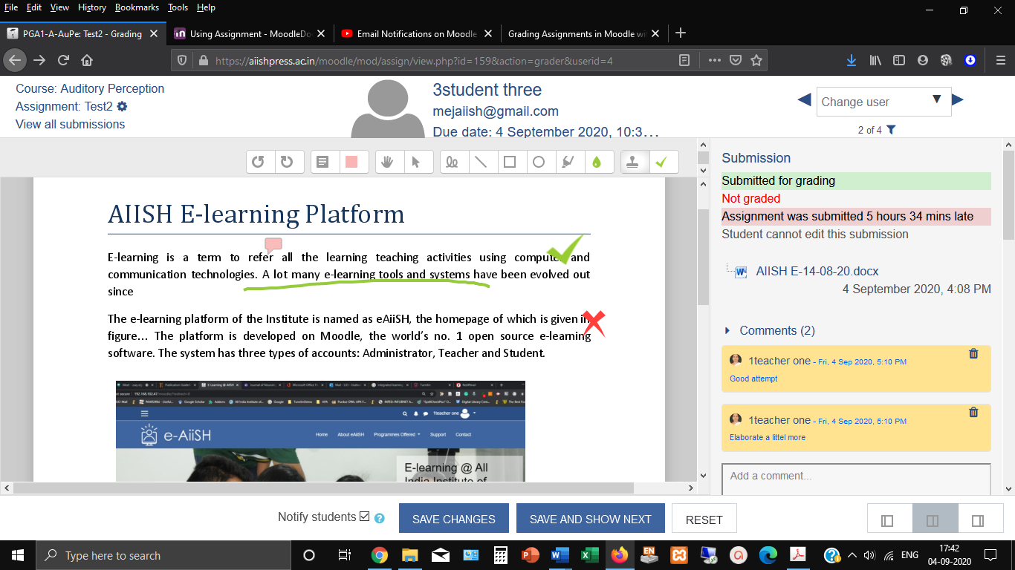

1. Clicking **'View all Submissions**' will take you to a *Grading Table* where you can see the submission records of all the students. Each student on the course will have a **record** in the Grading Table regardless of whether they’ve submitted anything. The Grading Table contains columns of information about the student, the status of their submission, a link to grade their submission, a link to each submission and feedback comments and files (Figure ). The data shown in the table will vary based the settings your assignment is using.

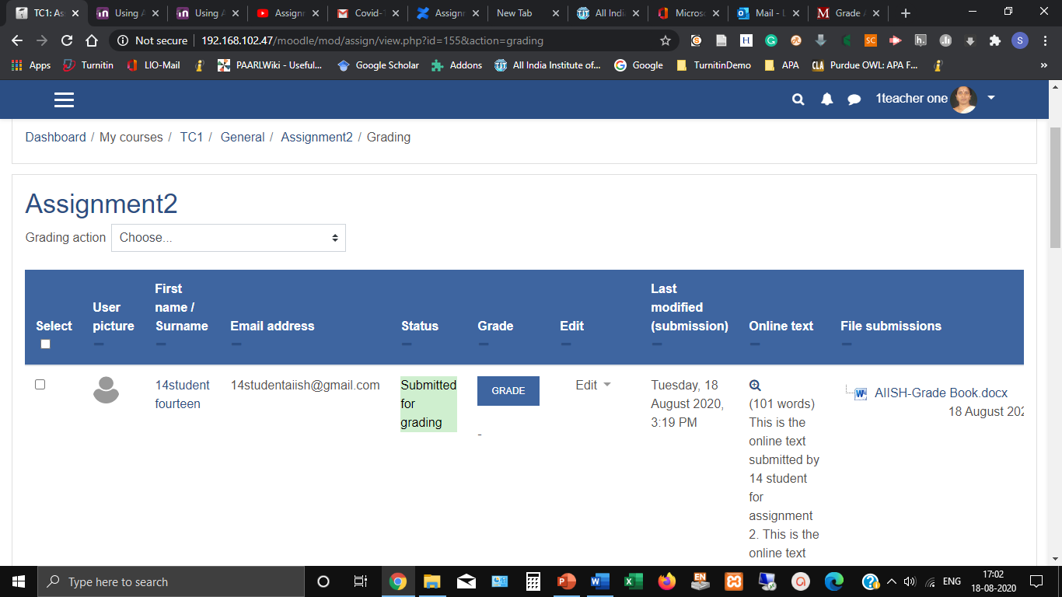

The **Filter** tool under **Options** at the bottom of the Grading Table allows you to filter submissions and display which submission records need to be displayed in the grading table say for e.g. display only the records of students who have submitted the assignments. By default, no filters are applied so you see all records, even that of students who haven’t submitted assignments.

1. Upon clicking the **Grade** button against an individual student in the Grade Table will again take you to that student’s Grading Interface mentioned at ‘a’ above (Figure above )

The Grading Interface consists of four areas: a top banner (Figure ), a central area (Figure ) , a right column (Figure ) and a footer area.

The T**op Banner** consists of three area: On the left top name of the course, below that assignment name and below that a link named “View all submissions” The middle side of the banner lists the name of the student, his email id and , there will be The Left side middle and submission due date. The right side of the top banner with arrow marks allows to navigate to the next student submission.



**The Central Area** displays the PDF version of the assignment on which the teacher can make annotations and comments. On the top of the Central Area there is a Page Slider (Figure ) and below that (*upon scrolling*) an annotation toolbar to mark up the submitted PDF document (Figure ).





The annotation toolbar has 14 icons which can be divided into five sets. The two icons at the extreme left are used for rotating the pdf. The next two icons are for adding a free text comment on the pdf. Of these, the first one is to draw a comment box and the second one for selecting the colour of the comment icon. The set of next two icons are for moving, editing or deleting annotations. The third set of six icons are for free drawing and highlighting. The final set of two icons are stamp tools. Of these, the left hand icon is to select the stamp and right hand icon to choose the stamp image.

**Add a Free text comment.**

1. To add a free text comment, select the comment box icon  and if required, you can change the background colour by clicking on the coloured icon next to it . Position the black crosshair +where you want the comment to appear and drag a box to create a new comment box. Select inside the box and type in the comment. By default, all free text comments will collapse to a speech icon  and will expand on click to show the full comment.
2. To move an existing comment, click the select tool icon  and then click and drag the comment you wish to move to its new position.
3. To delete a comment, select the comment and then click the menu icon in the top right hand corner of the comment box  and choose “Delete comment” from the options.

**Quicklist**

1. Frequently used comments can be added to a personal Quicklist of comments which can then be re-used quickly. To add an existing comment to your quicklist, click the icon in the top right hand corner of the comment box  and from the menu, choose “Add to quicklist”.
2. To re-use an existing quicklist comment, create an empty comment box and click the menu icon in the top right hand corner of the comment box. Select the comment that you wish to use



**Add a shape or highlight**

1. Additional drawing and highlighting tools are available as follows:
2.  Free drawing
3.  Straight line
4.  Rectangle
5.  Circle/Oval
6.  Highlight text
7.  Choose the colour of the shape/highlight
8. To add a shape or highlight, click on the appropriate icon and annotate the document as required.
9. To delete or move a shape or highlight. Click the select tool  and then click and drag the shape/highlight to the new position or click and select the dustbin icon  to delete.

**Add a Stamp**

1. Select the stamp tool  and then select the stamp image that you wish to use from the list:



1. Click on the document to add the stamp.
2. To delete or move a stamp, click the select tool  and then click and drag the stamp to the new position or click and select the dustbin icon  to delete.

**Save the Annotations**

1. The system will automatically save any changes you make to the document as a draft. When you have completed the marking, you will need to click the “Save Changes” button. This will save all feedback to Moodle and will generate a pdf document with all the annotations included.
2. Once saved, all feedback will be accessible to the student. Use the “Notify Students” checkbox to send an email to the student to inform them of the availability of feedback.

The right column of the annotation tool displays a link to the **assignment submission file** in its original file format. Below that a hyper link titled **comments (upon clicking it a small text box will appear to make comments)** followed by **Grade** with a small column to enter **Grade** for the assignment. Below the grade column, a text editor with the title **Feedback Comments**. In the text editor, the teacher can type the comments or insert video or audio. Below the Feedback Comments text box, there is an area for uploading Feedback files, if any.

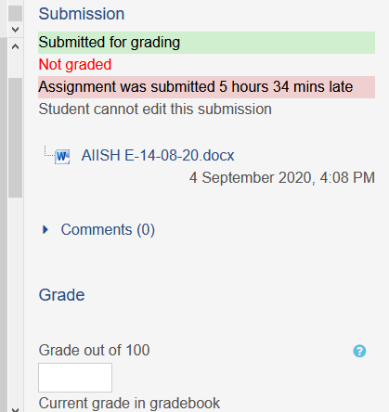

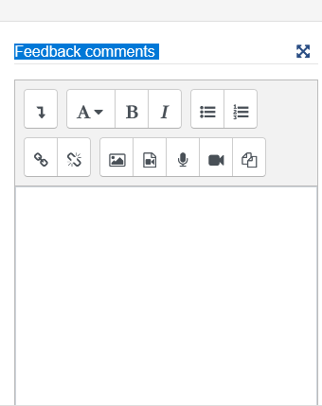

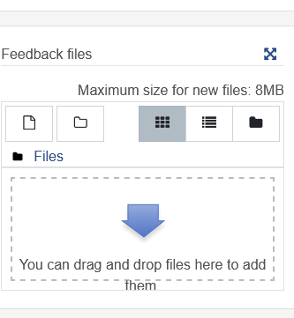

The Footer Area has options for **Notify** **students**, **Save** **Changes, Save** and **Show Changes** and **Reset** on the left side and on the right corner there are three grey square buttons for changing the **layout** of the **grading interface** (*The default layout is the display of left side central area along with the right panel. This can be changed to display only the Central Area or Right Panel*).

* **Notify students** will send the current student an email notifying them that their assignment has been graded. *Uncheck* this box if you do not want the student to receive a notification
* **Save** changes is required to complete grading the assignment of the current student selected
* **Reset** will clear all feedback comments made in the text editor as well as the in the textbox.
* Of the three grey buttons on the right side for collapsing and hiding the panels, the left button, the left one is to hide the central area. and the right one to hide right panel. The centre button , which is the default, is for the normal view i.e. with Central area and Right Panel.



# **Offline Grading of Assignments**

Instead of grading from the **Grading Interface**, the teacher can grade the assignments offline by downloading them in bulk, review and upload back to the site. In this case the teacher can use a grading worksheet to record grades locally on his computer.

The Offline Grading of Assignments consists of two stages

1. Bulk Downloading of Student Submissions
2. Downloading, Grading and Uploading of Worksheets
3. **Bulk Downloading of Student Submissions**

The first step in offline grading in bulk is the downloading of all submissions in zip file to your computer. To do this:

1. From the **Grading Summary** of the assignment click **View All Submissions** button
2. This will list all the student submissions in a **grading table**
3. On the top of the **Grading Table,** clickon the pop-down menu titled **Grading action** and choose **Download all submissions** (Figure ).
4. Save the resulting zip file in a folder and unzip / extract.
5. Unzipping will result in individual folders with the students' names prepended.
6. Each student submission folder will contain the file submitted by him. For online text submissions, another folder containing an .html page will be created which can be opened in a browser or in a word processing application such as MS Word.

Note: *It is also possible to download the entire student submissions into a single folder instead of individual folders. In order to enable this, before downloading, got to the* ***Options*** *section**at the bottom side of the Grading Table (Figure ) and untick the option* ***Download Submissions in Folders***

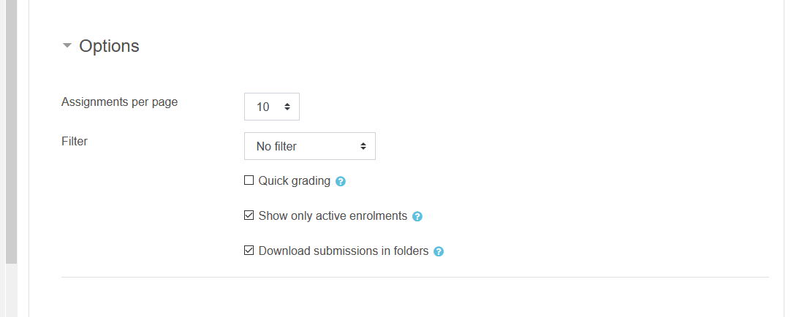

1. **Downloading, Grading and Uploading of Worksheets**
2. From the **Grading Summary** Page (Figure 1) click **View All Submissions** link. This will list all the student submissions in a **grading table**
3. On the top of the **Grading Table,** clickon the pop-down menu titled **Grading action** and choose **Download grading worksheet**

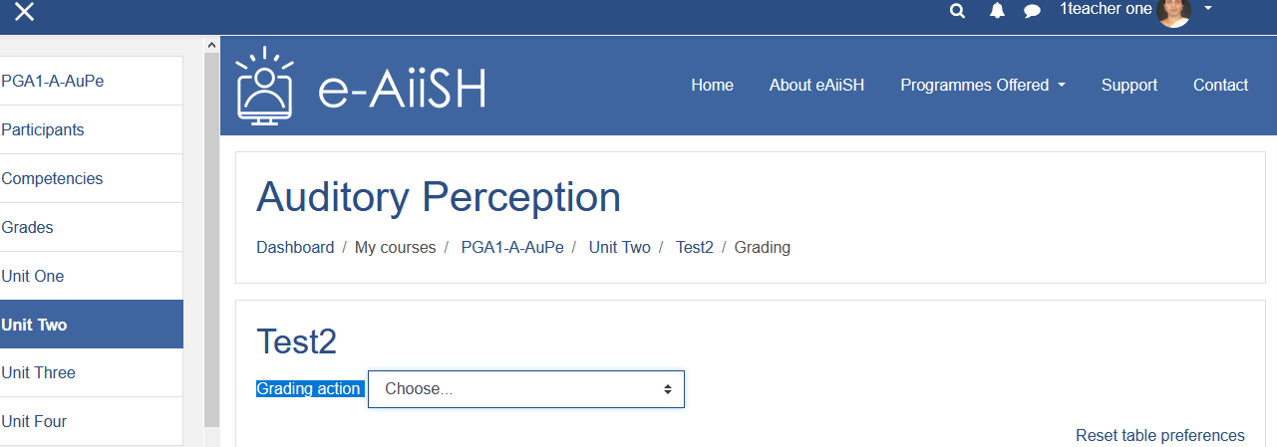

1. Save the worksheet downloaded as a **.csv** file in your computer
2. Open the file and input **grades** and **feedback comments** as text entries. **Don’t forget to save as .csv file**. *Do not change any other entries in the worksheet or change the field names.*
3. Once enter grades and feedback comments to all the students Go back to **Grading Action** area mentioned at Sl. No. 2 above.
4. Choose **Upload** **Grading Worksheet** from the pop-down menu and upload the worksheet saved in .csv file
5. While uploading make sure that the **Separator** selected is **Comma** and tick the option ‘**Allow updating records that have been modified more recently in Moodle than in the spreadsheet’**
6. Click **Confirm changes in grading worksheet** button**,** followed by **Continue** button