**ATTENDANCE**

The Attendance Activity allows the teacher to maintain a record of attendance, replacing or supplementing a paper-based attendance register. Using this tool, the teacher can take class attendance, mark the status of a student as "Present," "Absent," "Late," or "Excused," and the students can view their attendance records.The tool can be configured to record their attendance by the students. It is possible to generate attendance reports for the whole class or individual students. Also, the teacher can provide a grade for the students' attendance.

Setting up of Attendance Activity

The following are the steps to set up an Attendance Activity in a course.

1. Click the TURN EDITING ON button at the top right corner of the course home page.
2. Click the Add an activity or resource link and select Attendance Activity from the list of activities and resources page (Figure ).

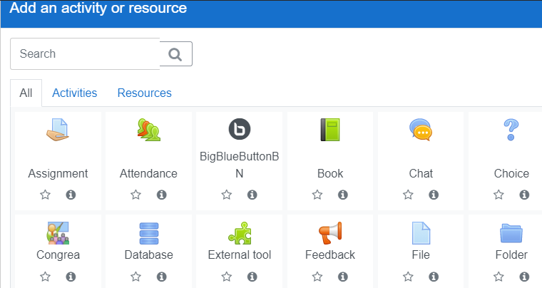

1. Add a name and description for the attendance and decide whether the description should be displayed on the course page.

Note: A teacher can add as many attendance instances as necessary. A meaningful name must be given for each instance that indicates what it will be used for. E.g. Attendance for video conferencing session, Attendance for Chat session etc.

1. If required, the attendance can be graded by deciding the grade type, maximum grade, grade category, and grade to pass.

Note: When grading an activity, it is possible to use a grading scale (in terms of letter grading or descriptive words), a grade point (numerical scale) or neither.

1. Maintain the default settings for Common Module, Restrict Access, Activity Completion, Tags, Competencies and Extra Restrictions
2. Click SAVE AND DISPLAY button.
3. Now, a new window will appear with six tabs, namely Sessions, Add Session, Report, Export, Status Set, and Temporary Users. (Figure )

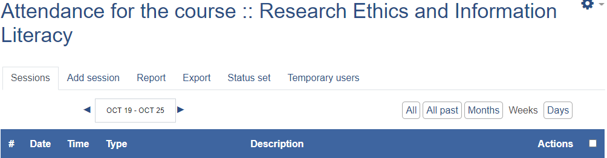

1. Click the status Set button. The status Set window has six options: Acronyms, Descriptions, Points, Available for students (minutes), Automatically set when not marked and Action (Figure ).
2. The attendance status is given in Acronyms such as P, L, E and A and their descriptions under Descriptions, namely, P for present, L for late, E for excused and A for absent.
3. If required, an additional status can be set using the ADD button at the bottom. Also, the existing status options can be removed using the button on the Action menu. It is also possible to rename a current status.
4. Points can be entered for each status under the Points column.
5. The option Available for students (minutes) is applicable if the students are allowed to mark the attendance by themselves (*Sl. no. 16 below*). In such cases, using this option allows deciding how long the students can record their attendance after the commencement of the Activity.
6. Using the Automatically set when not marked option, the attendance status can be decided if a student did not mark self-attendance i.e. whether he/she should be considered as *Present*, *Late*, *Excused* or *Absent*.
7. Click the UPDATE button when the needed changes are made on this page.

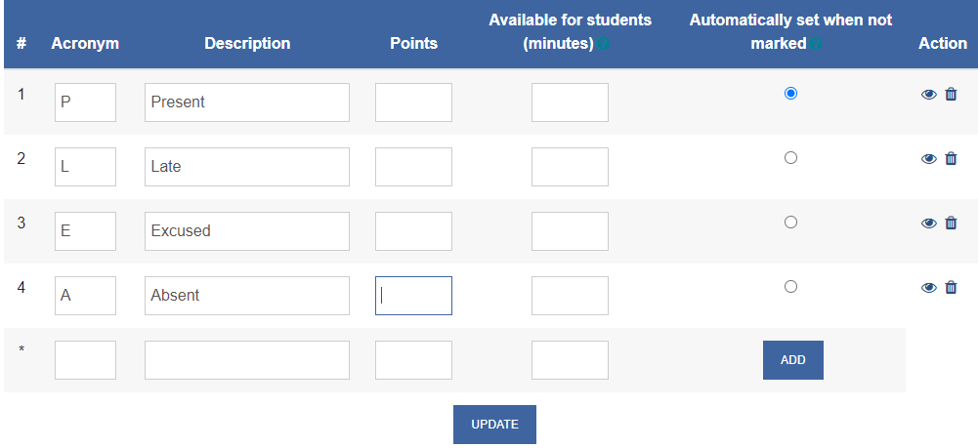

1. Next, add an attendance session by clicking the Add Session tab.
2. The default Type is All students
3. Add the Date and Time of the Activity for which the attendance needs to be recorded.
4. Give a description of the session, if required.
5. If your classes follow a regular schedule which the students are well aware of, and you do not want *Upcoming Activity block of the dashboard and Course Page will be filled with the upcoming class attendance sessions* do not tick the option, Create calendar event for the session. *.*
6. Click Multiple Sessions for recording the attendance for a recurring activity and set the frequency of the Activity. First, set the sessions' days, and then if it is repeated every week, select Repeat Every Week as 1, every two weeks as 2 etc. and then enter the last date of the Activity (*end date of the course*) at Repeat Until.
7. In case the Activity for which attendance required is happening recuring but not at regular intervals, then additional sessions have to be created using Add Sessions button.
8. The students can be permitted to mark the attendance by themselves by ticking Allow students to record own attendance option under the Student Recording section.
9. In case the above option is enabled, then Automatic marking of student attendance may be made as (i)Set unmarked at the end of session OR Disabled.
10. Password can be set for recording attendance by the students. The teacher has to create the password manually or it can be generated randomly. Also, QR Code for password can be generated and communicated to the students during the session.
11. If the Automatic marking is set as Set unmarked at end of the session, the attendance of the student who has not marked by himself can be marked as per the status (Present, Absent or Excused) by the teacher at the end of the session.
12. The settings Require network address and Prevent students sharing IP address may be ignored.
13. Click ADDbutton at the bottom.

Attendance Marking by the Teacher

In case the teacher wants to record the attendance:

1. Go to the Sessions tab
2. From the list of Sessions select the session for which you have set up the attendance and click ▶ button i.e. Take attendance(Figure )to take the attendance.



1. From the resulting attendance table with the First name/ surname, email ids, P, A, E and remarks options, tick the P (i.e. Present) or any other option that applies to majority of the students against the Set status for all option on the top portion of the table.
2. Then, change the status of the individual student who are *absent / excused or late* by clicking the corresponding status radio button against each student and SAVE ATTENDANCE.

Editing, Exporting, Deleting etc. of Attendance

1. The newly created sessions will be found in the tab "Session". From here you can edit, change delete the sessions (Figure).



1. You can also use the Select tick box above the session list to make universal changes, such as delete all sessions.
2. Also, using the export button, attendance reports can be generated in different formats (like excel spread sheets) and exported.