**ASSIGNMENT**

Using the **Assignment Activity**, a teacher can assign a number of tasks to the students and provide grades and feedback. The system permits the submission of assignments in any digital files such as MS**-**Word, Excel, Image, Audio and Video. The students can also submit the assignment by typing text directly into the text editor. It is also possible to set up an assignment to remind students of the offline assignments. In order to set up an Assignment Activity and evaluate it, following settings need to be done.

**Settings for Submission of Assignment**

1. On the course homepage, click **TURN EDITING ON**button at the top right corner.
2. Click the ‘**Add an activity or resource**’ button available at the location/ unit where you need to set up the Assignment Activity
3. Now, a list of activities and resources (*known as activity chooser)* will be displayed. Click on the **Assignment** icon from the list (Figure 1).

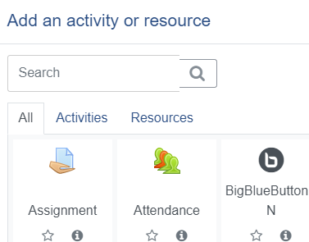

Figure 1

1. Give Assignment a meaningful **name.** The instructions to the students about the assignment can be provided in **description** column**.** The teacher can also mention about the grading criteria here. The description can be made as text, audio and video format.
2. Tick the option **Display description on course page**, if required.
3. Using the **Additional files** option, attach supporting documents or templates, if any, for reference for the students to complete the assignment. E.g. *answer templates*.
4. Under the **Availability** option, decide the **starting date**, **due date** and **cut-offdate**of assignment submission and a **reminder date**for you to review /assess the submitted assignment.
5. The student can submit the assignment even after the set due date. However, it will be red marked as late submission.
6. Set **Cut-off date** only if required. The students cannot submit the assignment after cut-off date.
7. Set a date to remind you for grading the assignment using **Remind me to grade by** option. *Remember to set a date after the due date of assignment.* The reminder will be displayed when at least one student has submitted the assignment. This date will be displayed on your *Upcoming Events* on the course dashboard and in the Calendar.
8. If the **Always show description option is enabled**, the information regarding the Assignment will be displayed to the students only from the start date of the assignment submission.
9. Decide the **Submission types**. It can be **Online text** or **File submission** or both depending upon the nature of assignment. In case of *Online text*, the students can type the assignment using the online text editor similar to composing an email message. They can also incorporate audio and video in the text editor. The **File submission** permits the students to upload the assignment file in the required format such as MSWord, Excel etc. The **word limit** needs to be specified in case of *online text* assignment.
10. Decide the **Maximum number of uploaded files** and the **Maximum submission size**. *Note: Keep both minimum to save our server space*.
11. Depending upon the nature of assignment, decide the **Accepted file types**. If it is kept **empty** all file types will be acceptable.
12. Select the **Feedback types,** i.e. Feedback comments / Annotate PDF/ Offline grading worksheet/ Feedback files.

The **Feedback comments** permits the teacher to make comments on each submission.

**Annotate PDF** converts the student submission file in MS Word to pdf so that the teacher can annotate and comment on the submission while reviewing it.

**Offline Grading Worksheet,** if enabled, facilitates downloading and uploading a worksheet with student grade.

**Feedback files** facilitate uploading of files with teacher’s comments including audio.

The **Comments Inline** facilitates the teacher to make inline comments for an online text submission

1. Under **Submission settings** decide the following (a) Require students to click the submit button, (b) Require that students accept the submission statement, (c) Attempts reopened.
2. The option **Require students to click the submit button** if made **Yes**, a *submission button* will appear at the student assignment submission area which he has to click for submitting the assignment. **This option will prevent the student from editing the assignment once it is submitted**. In other words, if the teacher did not enable this option, the student can revise/edit the assignment and then submit againuntil due date even after the teacher reviewed and graded it.
3. In case **Require that students accept the submission statement** is made **Yes**, then a declaration statement will appear at the student assignment submission area which he has to agree to submit the assignment.
4. **Attempts reopened** is related to the re-submission of an assignment after it is graded by you. There are two options: (a) Automatic re-opening until the student gets the minimum grade required for the assignment. (b) Manual opening by the teacher so that the student can re-submit.
5. **Group submission settings** facilitates the submission of assignments by a group of students. This is possible only if the teacher has already made classes into groups.
6. **Notifications**: There are three clauses for Assignment Submission Notification with Yes or No options.
7. **Notify graders about submissions**: If this is enabled, you will get notification for each student submission. BETTER NOT TO ENABLE THIS.
8. **Notify graders about late submissions**: In this case, only the late submissions will be notified to you.
9. Default setting for "**Notify students**": This option facilitates notifying the student regarding the teacher feedback on the submitted assignment.
10. **Grade**: Select the grade type as **Point** or **Scale** and enter the **Maximum Grade** point for Assignment based on the earlier decision
11. Decide whether the assignment should be included in **Grade category**:
12. Enter the **Grade to pass**, if any
13. **Blind marking** hides the identity of the student while grading
14. **Hide grader identity** is to hide the identity of evaluating teacher and other details compromising confidentiality from the student
15. **Use marking workflow** facilitates multiple round of grading
16. **Common module settings** facilitate **Showing** or **Hiding** of the Availability of the Assignment on the Course Page.
17. **Restrict access** option facilitates the Restriction on the access to the Assignment.
18. [**Activity completion**](http://192.168.102.47/moodle/course/modedit.php?add=assign&type=&course=118&section=0&return=0&sr=0)settings allows the teacher to set completion criteria for Assignment.
19. [**Tags**](http://192.168.102.47/moodle/course/modedit.php?add=assign&type=&course=118&section=0&return=0&sr=0)permits entering of keywords for searching items related to the activity
20. Maintain the default settings for *Common module*, [*Restrict access*](http://192.168.102.47/moodle/course/modedit.php?add=assign&type=&course=118&section=0&return=0&sr=0), [*Activity completion*](http://192.168.102.47/moodle/course/modedit.php?add=assign&type=&course=118&section=0&return=0&sr=0) and [*Tags*](http://192.168.102.47/moodle/course/modedit.php?add=assign&type=&course=118&section=0&return=0&sr=0)*.*
21. Now, click the SAVE AND DSIPALY button at the bottom. It will display a **Grading Summary Page** (Figure 2) from where you can evaluate and grade the assignments once the students submit them.

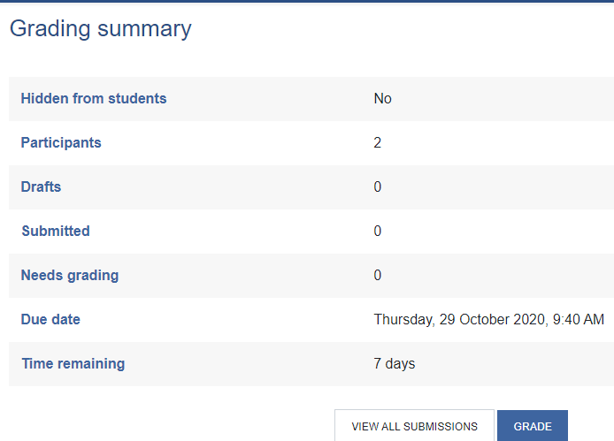

Figure 2

**Submission of Assignment by the Students**

Once teacher has created an assignment with appropriate settings mentioned above, the participants (students) of the course will receive automatic notification for assignment submission. The student has to access the course and submit the assignment.

**Reviewing, Grading and Providing Feedbackfor the Submitted Assignment**

Once the students submit the assignments and due date is over, you will receive a notification for grading the assignment in the **Upcoming Events** block of your dashboard.

1. Click on it to access the Assignment Activity (Figure3 ).

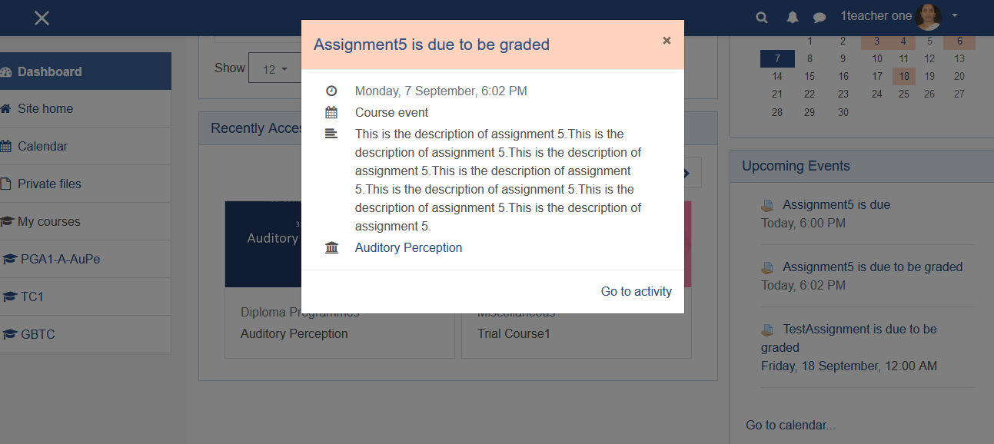

Figure3

1. This will take you to the **Grading Summary** Page of the Assignment (Figure 2) which lists summary of the assignment, including; number of participants, number of submitted assignments, due date and time remaining with links to: **View All Submissions** and Grade**.**
2. Clicking *'View all Submissions'* will take you to a *Grading Table* where you can see the submission records of all the students. Each student on the course will have a **record** in the Grading Table regardless of whether they’ve submitted an assignment. The Grading Table contains columns of information about the student, the status of their submission, a link to grade their submission, a link to each submission and feedback comments and files (Figure 4). The data shown in the table will vary based the settings your assignment is using.

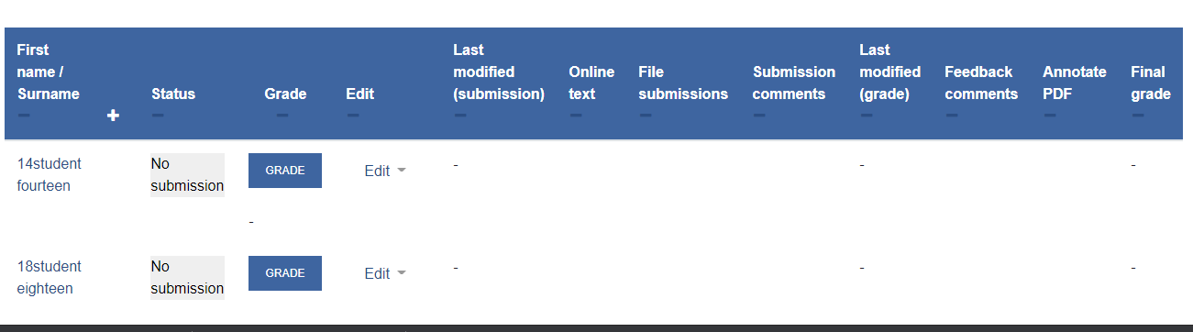

Figure 4

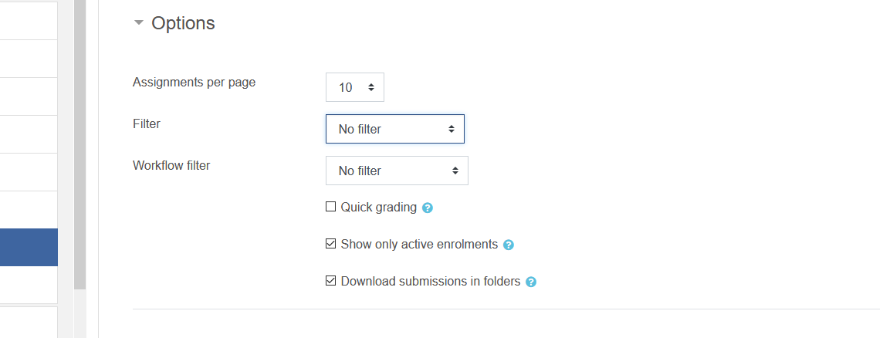The **Filter** tool under **Options** at the bottom of the *Grading Table* allows (Figure 5) you to filter submissions and display which submission records need to be displayed in the grading table, say for e.g. display only the records of students who have submitted the assignments. By default, no filters are applied so you can see all records, even that of students who haven’t submitted assignments.

Figure5

1. Apply the filter, if required and then start grading by clicking the Grade button of a particular student record in the Grade table.
2. Upon clicking the Gradebutton against an individual student in the *Grade Table* that student’s **Grading Interface** will be displayed (Figure 6) from where you can grade the assignments.

Note: The *Grading Interface* can also be accessed directly from the Grade button provided along with the **View All Submissions** button in the **Grading Summary** page as mentioned at the Sl. No. 2 above.

41

3

21

11

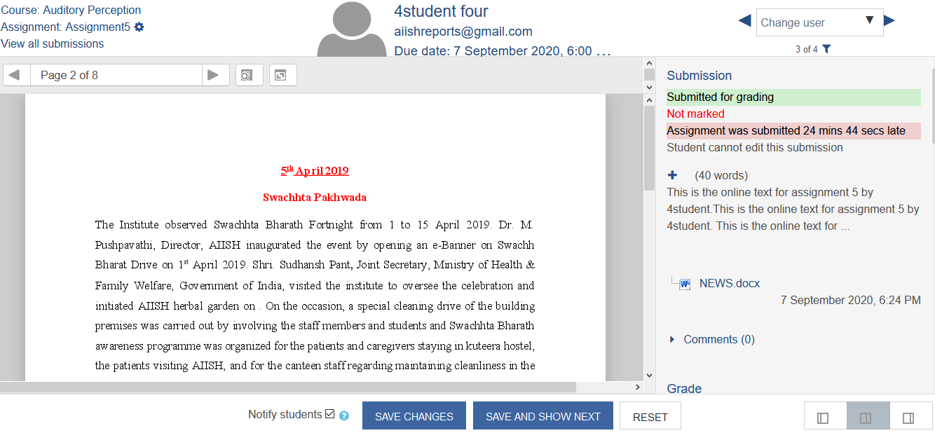Figure 6

The Grading Interface consists of four areas: (1) top banner, (2) central area, (3) right column and (4) footer area.

The **Top Banner** (Figure 7) consists of three area: On the left top name of the course, below that assignment name and below that a link named “View all submissions” The middle side of the banner lists the name of the student, his email id and, and submission due date. The right side of the top banner with arrow marks allows to navigate to the next student submission.



Figure 7

**The Central Area** displays the PDF version of the assignment on which the teacher can make annotations and comments (Figure 8). On the top of the Central Area there is a *Page Slider* (Figure 9) and below that (*upon scrolling*) an *annotation toolbar* to mark up the submitted PDF document (Figure 10 ).

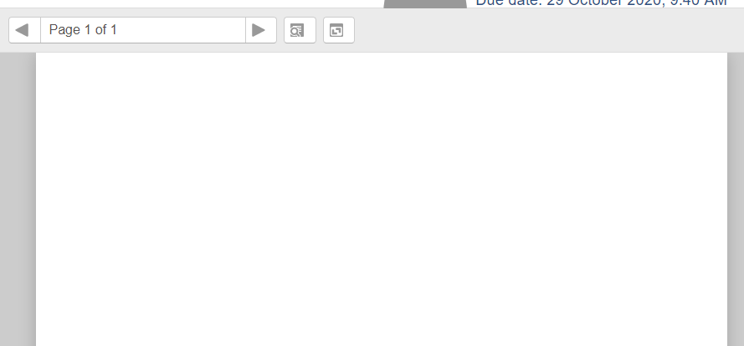

Figure 8



Figure 9



Figure 10

The annotation toolbar has 14 icons which are divided into five sets.

1. The two icons at the extreme left are used for rotating the pdf
2. The next two icons are for adding a free text comment on the pdf. Of these, the first one is to draw a comment box and the second one is for selecting the color of the comment icon.
3. The set of next two icons are for moving, editing or deleting annotations
4. The third set of six icons are for free drawing and highlighting.
5. The final set of two icons are stamp tools. Of these, the left hand icon is to select the stamp and right hand icon to choose the stamp image.

Add a Free text comment

1. To add a free text comment, select the comment box icon  and if required, you can change the background colour by clicking on the coloured icon next to it . Position the black crosshair +where you want the comment to appear and drag a box to create a new comment box. Select inside the box and type in the comment. By default, all free text comments will collapse to a speech icon  and will expand on click to show the full comment.
2. To move an existing comment, click the select tool icon  and then click and drag the comment you wish to move to its new position.
3. To delete a comment, select the comment and then click the menu icon in the top right-hand corner of the comment box  and choose “Delete comment” from the options.

**Quick list**

1. Frequently used comments can be added to a personal Quick list of comments which can then be re-used quickly. To add an existing comment to your quick list, click the icon in the top right hand corner of the comment box  and from the menu, choose “Add to quicklist”.
2. To re-use an existing quick list comment, create an empty comment box and click the menu icon in the top right hand corner of the comment box. Select the comment that you wish to use



**Add a shape or highlight**

1. Additional drawing and highlighting tools are available as follows:
2.  Free drawing
3.  Straight line
4.  Rectangle
5.  Circle/Oval
6.  Highlight text
7.  Choose the colour of the shape/highlight
8. To add a shape or highlight, click on the appropriate icon and annotate the document as required.
9. To delete or move a shape or highlight. Click the select tool  and then click and drag the shape/highlight to the new position or click and select the dustbin icon  to delete.

**Add a Stamp**

1. Select the stamp tool  and then select the stamp image that you wish to use from the list:



1. Click on the document to add the stamp.
2. To delete or move a stamp, click the select tool  and then click and drag the stamp to the new position or click and select the dustbin icon  to delete.

**Save the Annotations**

1. The system will automatically save any changes you make to the document as a draft. When you have completed the marking, you will need to click the “SAVE CHANGES” button at the bottom. This will save all feedback and will generate a pdf document with all the annotations included.
2. Use the “Notify Students” checkbox to send an email to the student to inform them of the availability of feedback
3. The SAVE AND SHOW NEXTbutton will take you to the next student’s assignment.

The **Right Column** of the **Grading Interface** starts with a heading ‘**submission**’ followed by information such as whether the student submitted the assignment or not, whether it is marked or not, whether it is submitted late or not, and whether the student can edit the submission or not (Figure 11).

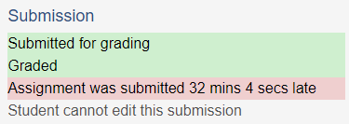

Figure 11

Below this descriptive information, the online text of the assignment submitted by the student will be displayed with a + sign to expand it and the number of words of the online text. (Figure 12)

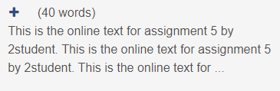

Figure 12

Below the online text, a link to the **assignment submission file** in its original file format will be displayed followed by a hyperlink titled **comments** (*upon clicking it a small text box will appear to make comments*) (Figure 13).

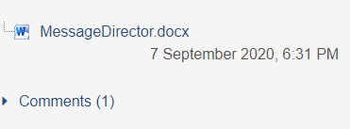

Figure 13

This is followed bya small box to enter**Grade** for the assignment. (Figure 14)

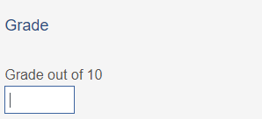

Figure 14

Below the grade box, a **text editor** with the title **Feedback Comments** can be seen (Figure 15).

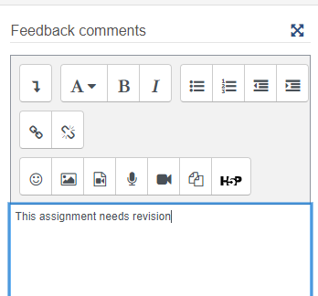

Figure 15

In the text editor, the teacher can type the comments or insert video or audio. Below the Feedback Comments text box, there is an area for uploading Feedback files, if any. (Figure 16).

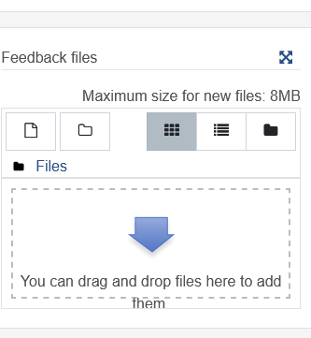

Figure 16

Below the facility for uploading file, there is an area for settings for the number of assignment attempts (Figure 17).

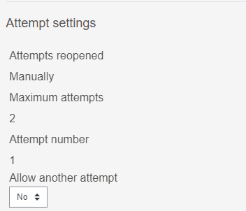

Figure 17

The Footer Area has options for **Notify students**, **Save Changes, Save** and **Show Changes** and **Reset** on the left side (Figure 18).

* **Notify students** will send the current student an email notifying them that their assignment has been graded. *Uncheck* this box if you do not want the student to receive a notification
* **Save** changes is required to complete grading the assignment of the current student selected
* **Reset** will clear all feedback comments made in the text editor as well as the in the textbox.

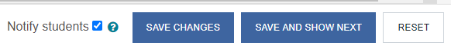

Figure 18

On the right corner of the footer, there are three grey square buttons (Figure 19) for changing the **layout** of the **grading interface** (*The default layout is the display of left side central area along with the right panel. This can be changed to display only the Central Area or Right Panel*).



Figure 19

# **Offline Grading of Assignments**

Instead of grading from the **Grading Interface**, the teacher can grade the assignments offline by downloading them in bulk, review and upload back to the site. In this case the teacher can use a grading worksheet to record grades locally on his computer.

The Offline Grading of Assignments consists of two stages

1. Bulk Downloading of Student Submissions
2. Downloading, Grading and Uploading of Worksheets
3. **Bulk Downloading of Student Submissions**

The first step in offline grading in bulk is the downloading of all submissions in zip file to your computer. To do this:

1. From the **Grading Summary** of the assignment click **View All Submissions** button
2. This will list all the student submissions in a **grading table**
3. On the top of the **Grading Table,** click on the pop-down menu titled **Grading action** and choose **Download all submissions** (Figure 20).

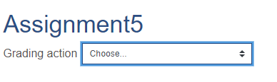

Figure 20

1. Save the resulting zip file in a folder and unzip / extract.
2. Unzipping will result in individual folders with the students' names prepended.
3. Each student submission folder will contain the file submitted by him. For online text submissions, another folder containing an .html page will be created which can be opened in a browser or in a word processing application such as MS Word.

**Note**: It is also possible to download the entire student submissions into a single folder instead of individual folders. In order to enable this, before downloading, got to the **Options** section at the bottom side of the Grading Table (Figure 21) and **untick** the option **Download Submissions in Folders**

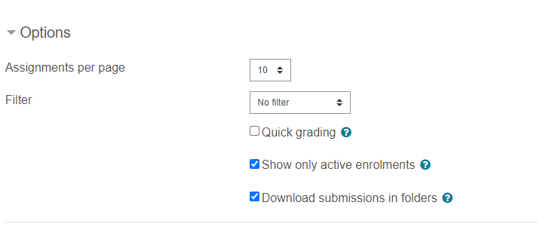

Figure 21

1. **Downloading, Grading and Uploading of Worksheets**
2. Go back to the pop-down menu titled **Grading action** and choose **Download grading worksheet**

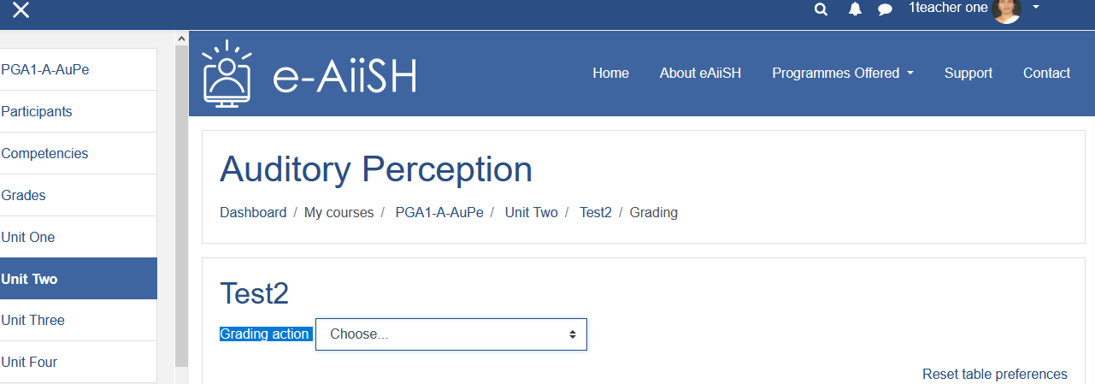

1. Save the worksheet downloaded as a **.csv** file in your computer
2. Open the file and input **grades** and **feedback comments** as text entries. **Don’t forget to save as .csv file**. *Do not change any other entries in the worksheet or change the field names.*
3. After entering the grades and feedback comments to all the students, go back to **Grading Action** area mentioned at Sl. No. 1 above.
4. Choose **Upload Grading Worksheet** from the pop-down menu and upload the worksheet saved in .csv file
5. While uploading make sure that the **Separator** selected is **Comma** and tick the option ‘**Allow updating records that have been modified more recently in Moodle than in the spreadsheet’**
6. Click **Confirm changes in grading worksheet** button, followed by **Continue** button