|  |  |
| --- | --- |
| **eAiiSH Manual RESOURCES** | **All India Institute of Speech & Hearing** |

**UAL**

**Introduction**

A **Resource** is a learning material or supporting tool that the teacher can create or/ and add to the course page. There are seven standard types of resources. (1) Books, (2) Files, (3) Folders, (4) IMS Content, (5) Labels, (6) Page, and (7) URL. To add a resource to the course page, the teacher has to select the TURN EDITING ON button from the course page's top right corner. The same button is used for moving, hiding, editing, and deleting an added *resource*. The learners of the course are only permitted to view and or download the resources. The seven types of *resources* and the methods of adding them to the course page are detailed below.

1. **File**

The File is a type of learning resource that a teacher can add to a course page. The eAiiSH supports different file formats such as text, word processing, spreadsheet, audio, video, image, presentation, and HTML. A file resource can be added to the course page in two ways: (a) Using the *activity chooser* (b) Drag and drop method.

**Adding a File to a Course using Activity Chooser**

1. Select the Turn Editing Onbutton.
2. Click on the Add an Activity or Resource link available at the location the teacher wants to add a File resource.
3. The resulting window with three sections, *All*, *Activities* and *Resources*, is calledActivity Chooser.

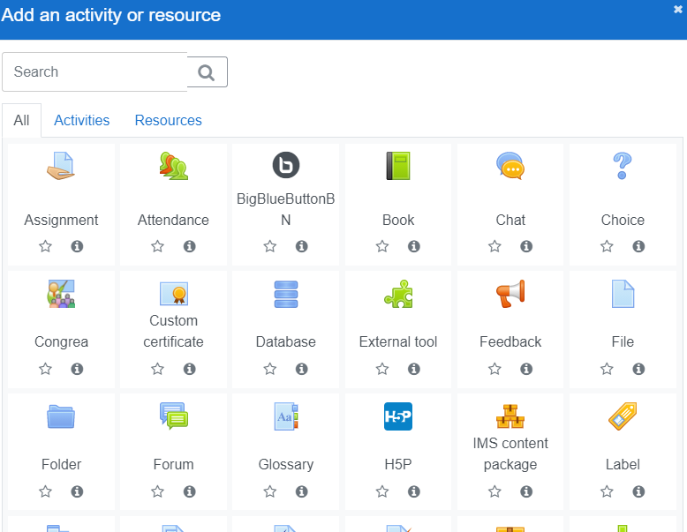

1. Click the File resource from the listed activities on the *Activity Chooser*



1. Enter a name for the *File* and a description, if required. The description can be displayed on the course page by ticking the option for it.
2. Under Select files section, click on the file icon to **Add…** a file

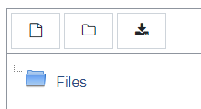

1. From the resulting File Picker, select Upload a file optionand choosethe file from the computer.

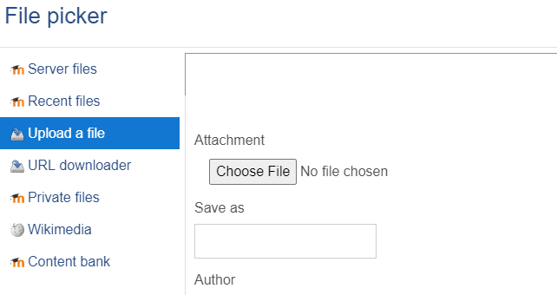

1. The Save as (*filename*) and Author names are optional. By default, the author's name will be that of the teacher.
2. Choose license, if required.
3. Click UPLOAD THIS FILE
4. The uploaded file will automatically stored and displayed in a default folder by name **Files**.

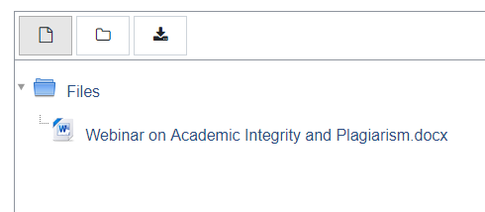

1. The uploaded files and associated folder can be displayed in three ways: *Display folder with file icons* (default option), *Display folder with file details*, *Display folder as file tree*.



1. There is a provision for creating a new folder by clicking the *folder* icon and store the file in it.

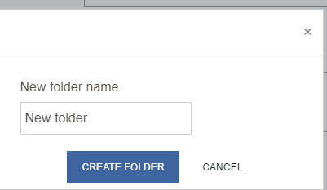

1. The file along with the accociated folder are downloadable using the **download** option.
2. Under **Appearance** the teacher can decide: (i) how to display the file, (ii) whether to show the file size and type, and (iii) whetherto show the file uploaded / modified date.

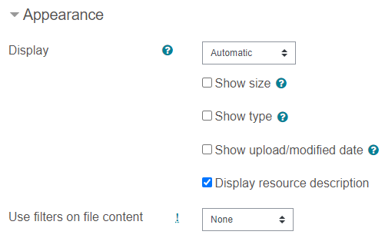

1. The file display options are: Automatic (*default option*), Embed, Force download, Open, and In pop-up

In case of *Automatic* file display, the best mode of file display will be automatically decided based upon the file type.

The *embed* option allows to display the file as a part of the course page. It is suitable for for pdfs, videos and images. For other file types like MS Word, the *Embed* option will create a blank square and force a file download.

The *Force download* option, as its name indicates downloads the file when the student clicks on it.

In case of *Open* option, the file will be opened. It is suitable for pdfs, videos and images. The MS Word files will get downloaded with this option.

The *In pop-up* option will open a separate window and download the file in it.

1. The **Show size** option displays the size of the file. If there are multiple files, the total size of all files will be displayed.
2. The **Show type** option displays the size of the file. If there are multiple files, the type of the first entered file will be displayed.
3. The **Show upload/modified date** displays the file uploaded / modified date**.** If there are multiple files, the details of the first file will be displayed.
4. Upon clicking the file name, an edit file window will appear using which the file can be downloaded, deleted and set as main file.
5. There are two options for saving the files uploaded from **Private Files**, **Drop Box**, **Google Drive** etc. (A) to create a shortcut or alias (2) make a copy (a new, unconnected version). When the short-cut or alias option is selected, then the uploaded file will automatically change as per the changes happening in the original file. The ‘Make a Copy’ option will
6. Maintain the default settings for **Common module**, **Restrict access**, **Activity completion**, **Tags,** and **Competencies.**
7. Now, the students will be able to access the file after logon to the course.

**Drag and Drop**

The file can also be dragged from the computer and dropped in the dotted line box with an arrow. Only compressed folder can be dragged and dropped.

1. **Folder Resource**

Folders are a Moodle resource to organise files on the module page. It is a useful resource to organise related content for the students. One folder may contain sub-folders. Moodle automatically orders files in folders alphabetically.

**Adding a Folder to a Course**

**A new folder can be added to the course page either using the File Picker or by Drag and Drop.**

1. Go to the **Gear** icon on the course page and select **Turn Editing On**
2. Click on the **Add an Activity or Resource** link available at the location the teacher wants to add the **Folder**.
3. From the Activity Chooser, choose **Folder**
4. Enter a name for the **Folder** and a description, if required. The description can be displayed on the course page by ticking the option.
5. Now, compress / zip the folder that needs to be uploaded (in the computer) and go to **Content** section, **drag** and **drop** the compressed folder into the course page area you need to place the folder. Now, the system will prompt a question: **What do you want to do with the file** **“…..zip'?** with three options: (a) Unzip files and create folder (b) Create file resource (c) Add a SCORM package. The option one will unzip the files and store them in a folder and the option two will create a zip file.

**Or**

Click the **Add** button with file icon, open the **File picker,** choose a file from your computer or a repository and uoplad file. Repeat the same for all the files.

1. Under **Display folder contents** decide how to **display the folder contents,** i.e. **on the course page** or **a separate page.**
2. Maintain the default settings for **Common module**, **Restrict access**, **Activity completion**, **Tags,** and **Competencies.**
3. Click the button **'Save and return to course'**

**Creating and uploading to a new folder**

The teacher can create a folder on the course page and then upload files into it by following the steps given below.

1. Click the 'Turn editing on' button at the top right of the course page
2. Click **'Add an activity or resource'** link, then from the **activity chooser**; select **folder** then click the "**Add**" button **or** select folder from the "Add a resource" dropdown menu.
3. Enter a name and a description (which may be required or optional according to the admin settings)
4. Click the "Create folder" link and choose a name for the new folder and then click "**Create folder**"
5. Click **INTO** the folder
6. The teacher can add individual files into the folder either by dragging and dropping into the box or clicking the "Add" to upload files from the **File picker**
7. Choose how to display the folder contents
8. Maintain the default settings for **Common module**, **Restrict access**, **Activity completion**, **Tags,** and **Competencies.**
9. Click "Save and return to course"
10. **Page Resource**

The page resources are nothing but webpages created on courses for communicating information to the students. In otherwords, instead of creating the course materials as MS Word or image files and uploading onto the course page, they can be directly created as web pages effortlessly using the text editor and linked from the main course page. A page can display text, images, sound, video, web links and embedded code. Accessibility and ease of updation are the benefits of page resource over the file resource. However, for large amounts of content, it's recommended that a book is used rather than a page.

**Adding a Page to the Course Page**

1. Click **Turn editing on** at the top right of the page.
2. In the appropriate section, click **Add a resource or activity**, scroll down and select **Page**from the pop-up list (Activity Chooser) and click **Add**.
3. On the *Adding a new Page*  page, enter a page **Name** (to display in the section content list) and a **Description**, if you wish.
4. Under **Content**, add **Page content e.g:**
   * enter text, embed images and video, add URL's to other websites
   * if you are copying text from Microsoft Word, use one of the methods described on this [page](https://teaching.unsw.edu.au/node/731).
   * to create a link from your web page to an individual topic or activity on the course home page, follow these [instructions](https://teaching.unsw.edu.au/node/774#indiv_topic).
5. Click **Appearance**, then select whether you want to **Display page name**or **Display page description**on the course home page.
6. Maintain the default settings for **Common module**, **Restrict access**, **Activity completion**, **Tags,** and **Competencies.**
7. Click **Save and display** to preview the page.
8. To make any changes to the page:
   * Click the Edit settings of the Page
   * It will open the same window mentioned at sl. No. 3 above
   * Make necessary changes and click **Save and Display** **Page**
9. **URL Resource**

The URL (Uniform Resource Locator) Resource is the web link to a useful information resource for the course. The teacher can provide the links of all the freely available online resources and the institute subscribed sources like e-journal articles and e-books. The URL need not be the home page of a website. The URLs can be directly copied and pasted onto the course page or the teacher can use the file picker and choose a link from the web. Also, URLs can be added to any other resource or activity type through the text editor.

**Adding a URL to the Course Page**

1. Click **Turn editing on** at the top right of the page.
2. In the appropriate section, click **Add a resource or activity**, scroll down and select **Page**from the pop-up list (Activity Chooser) and click **Add**.
3. On the *Adding a new URL*  page, enter a **Name** for the URL
4. Under **External URL,** enter or copy n paste the website address that is to be added to the Course page.
5. Add a **Description**, if you wish and tick the box to display that description on the course page if needed.
6. Under **Appearance** deecide how the URL has to be displayed on the course page. Also decide whether the URL description needs to be displayed.
7. The **URL Variable** section allows the teacher to pass internal information as part of the URL. This is optional and hence, may be kept blank.
8. Maintain the default settings for **Common module**, **Restrict access**, **Activity completion**, **Tags,** and **Competencies.**
9. Click **Save and display** to preview the page.

**BOOK Resource**

The **Book** Resource facilitates the creation of a multi-page resource material in the form of a book with chapters and sections. It is possible to insert audio, video and images in the book along with the text.

**Adding a book to the Course**

1. Click **Turn editing on** at the top right of the page.
2. In the appropriate section, click **Add a resource or activity**, scroll down and select **Page**from the pop-up list (Activity Chooser) and click **Add**.
3. On the *Adding a new Book*  page, enter a **Name** for the Book.
4. Add a **Description**, if you wish and tick the box to display that description on the course page if needed.
5. Under **Appearance** decide the **Chapter formatting** and **Style of navigation**. The chapter formatting can be done in three ways: (1) Numbers - chapters and subchapters are numbered, (2) Bullets - subchapters are indented and displayed with bullets, (3) Indented - subchapters are indented. The None - chapter and subchapter titles are not formatted at all. The chapters and subchapters can also be made without formatting.

The navigation can be through text links or image links. It is also possible not to have navigation other than the table of contents.

1. If the **Custom Titles** option is clicked, the chapter heading will not appear as a header at the top of the respective content. (However, the headings given in the table of conetnts will remain) Thus, it will facilitate a new title above the conent different from the one that appears in the table of contents, if required or not to display the title at all. This facility is useful wherein we have to provide a short title in the table of contents and a longer one as the content heading.
2. Maintain the default settings for **Common module**, **Restrict access**, **Activity completion**, **Tags,** and **Competencies.**
3. Click **Save and display**.
4. In the new window named Chapter title, enter the name of the first chapter and the content for the first chapter in the text editor box
5. Enter tags, if any which will act as keywords.
6. Click SAVE CHANGES
7. In the resulting window, go to the **Table Of Contents** area and click the **+** button against the chapter that is created (Figure ) to add more chapters. The gear icon **☼** is used for editing the chapter, the eye icon for hiding the chapter and delete icon for deleting.

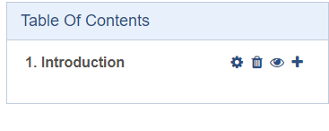

1. In order to enter a sub chapter, enter the sub chapter name in the column for Chapter title and tick the option **Subchapter** (Figure )

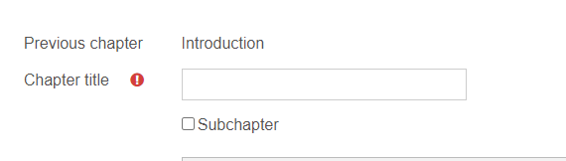

1. Continue adding more chapters and sub chapters.
2. After adding chapters and subchapters **turn editing off**.

**Label Resource**

Labels enable to add additional text, graphics or multimedia directly on to the course page. They can also be used to add banners to courses, name the sections of resources and activities, or provide quick instructions on the front page of the course. Labels are very versatile and can help to improve the appearance of a course if used thoughtfully.

**Adding a Lable to the Course**

1. Click **Turn editing on** at the top right of the page.
2. In the appropriate section, click **Add a resource or activity**, scroll down and select **Page**from the pop-up list (Activity Chooser) and click **Add**.
3. A new window tiltled *Adding a new Lable*  page will appear. Here, under the **Label text,**  enter the text and or images, audio, video etc. that the Tecahre wants to add directly onto the Course page a **Name** for the Book.
4. Maintain the default settings for **Common module**, **Restrict access**, **Activity completion**, **Tags,** and **Competencies.**
5. Click the button SAVE AND RETURN TO THE COURSE