**Introduction**

The chat activity facilitates real-time, instant (synchronous) discussion between the teacher and students or among the students in a course on a topic of chosen by the teacher. Chat has an advantage over a **Forum** in that it takes place in Real Time. The students themselves cannot start a **Chat** unless the teacher ‘**create**’ it.

1. **Setting up of Chat Activity**

The **Chat Activity** like other activities in the Moodle can be created inside the Units or in the general area on the top. To create a Chat Activity:

1. Click the gear icon on the top left
2. Decide the section/ place where you want to create the chat
3. Click the corresponding ‘Add an activity or resource’ button and select the Chat activity from the Activity Chooser
4. In the resulting window shown in Figure 2 below, enter a meaningful name for the Chat Activity and in description explain the purpose of it. In order to bring the chatting specific to the topic and make the activity disciplined, the teacher can outline chat etiquette here.

(or)

1. Turn on the editing mode by clicking the Turn editing Mode button.
2. In the section you wish to add your chat, click the “Add an activity or resource” link (or, if not present, the “Add an activity” drop down menu) and choose Chat.
3. In the “Name of this chat room” field whatever you type here will form the link learners click on to enter the chat so it is helpful to give it a name that suggests its purpose - for example for continued in-depth discussions on topics of interest beyond scheduled classes, or planning for forthcoming assessment or class activities. Chat messages can also serve as a handy emergency tool in case of audio, video disruptions in the video sessions.
4. In the description box - type the description of the chat. Include precise instructions for students regarding the subject of the chat. This could include details of chat etiquette such as – using socially acceptable language, avoiding using all uppercase letters which stands for ‘shouting’, trying to be civil in arguments avoiding critical comments or personal remarks, avoiding beeping into others, etc.

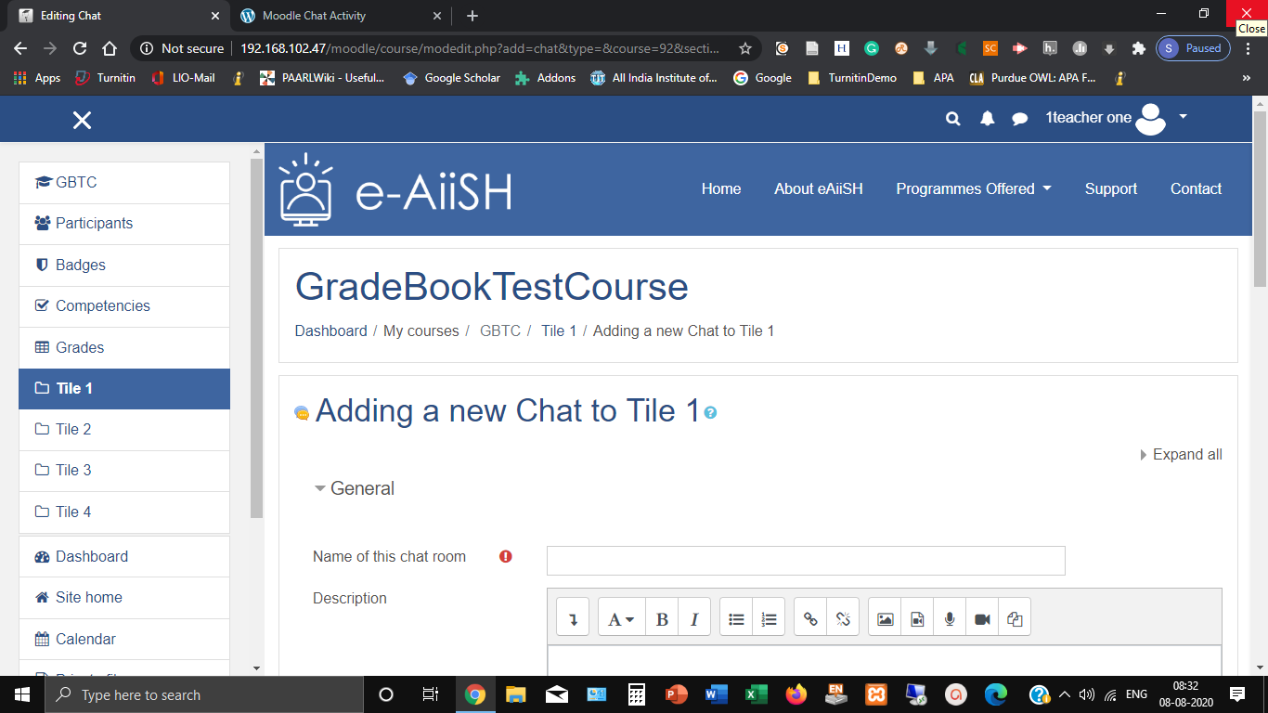

1. Enable ‘display description on the course front page’ option, if desired

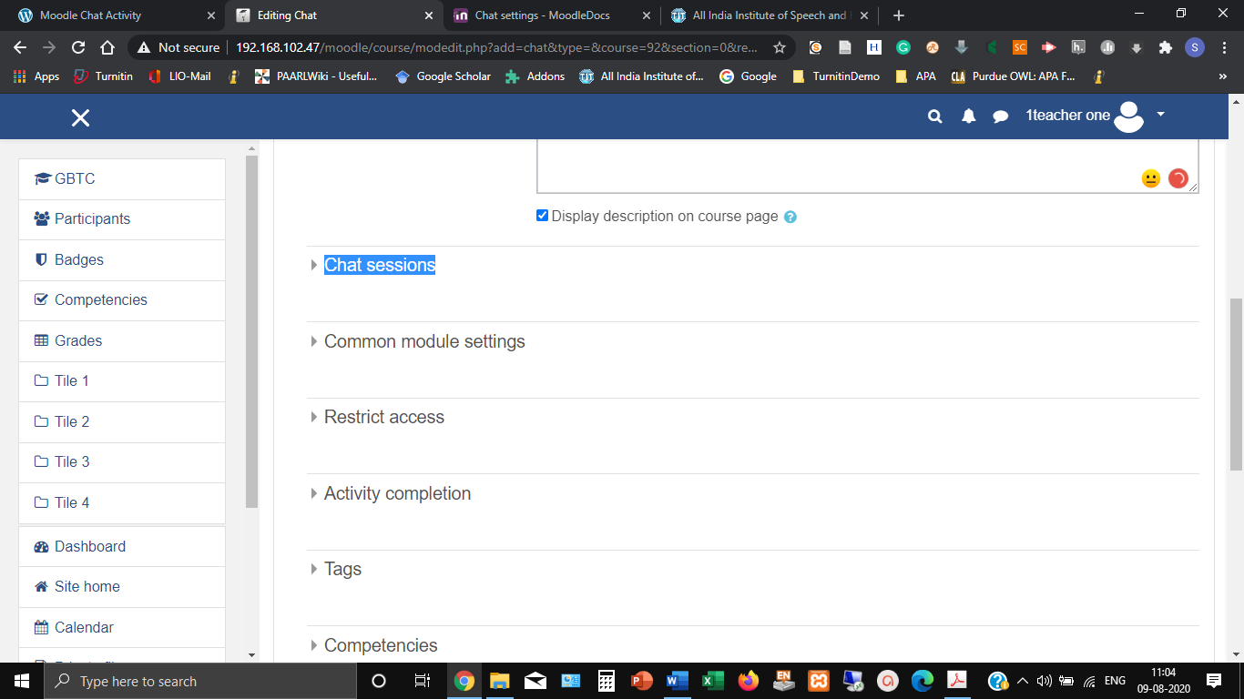

1. Click on **Chat sessions** link to expand the settings (Figure )

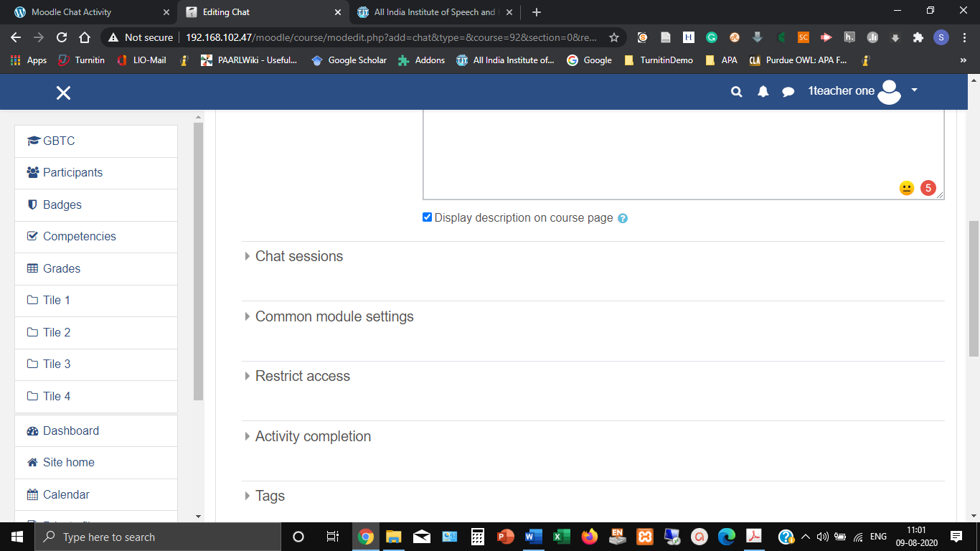

1. Input the day and hour that you will be using the Chat activity at **Next chat time section** (Figure ). This will appear in the calendar so students know the schedule but it doesn’t stop them accessing the chatroom at any other time. 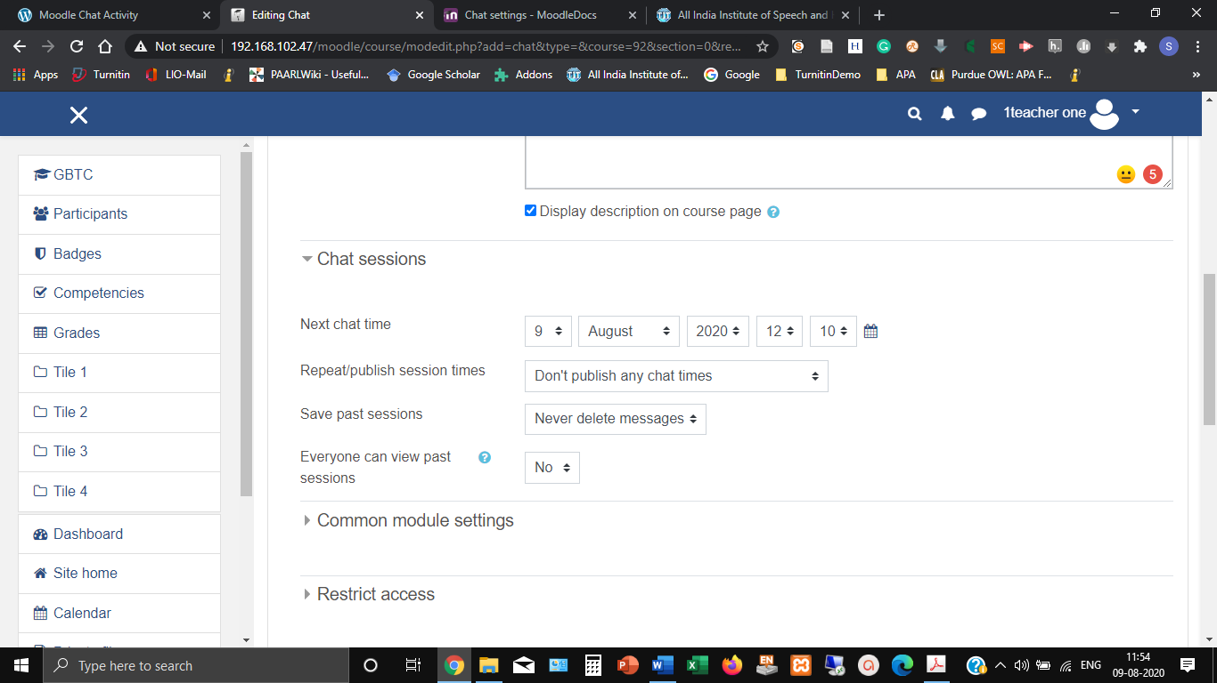
2. In case the teacher wants to avoid students accessing the chatroom at other times, hide it using the **Common module settings** (Figure ) **OR** adding date restrictions under **Restrict access** (Figure )

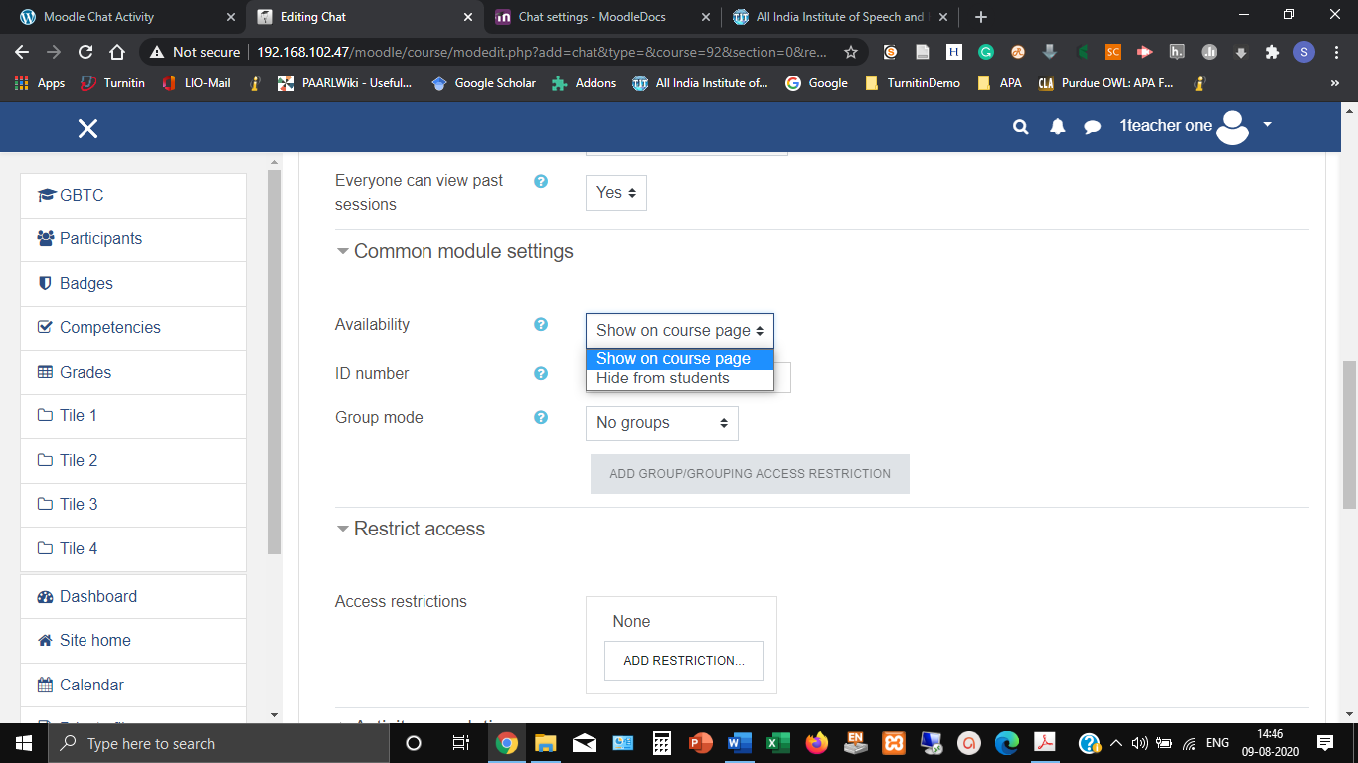

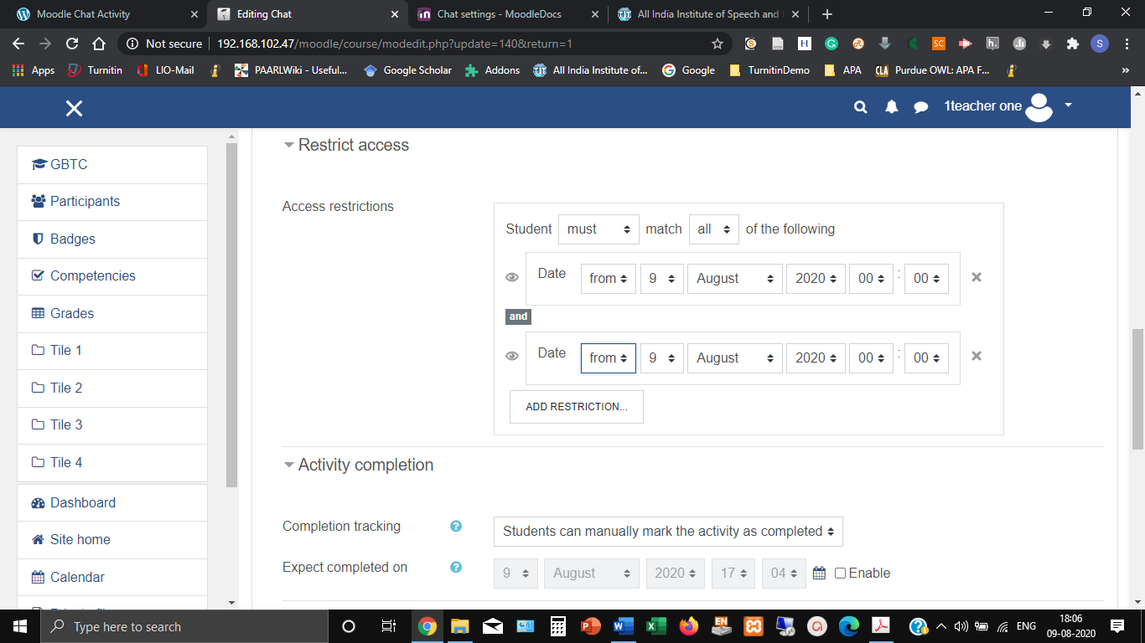

1. When the access is restricted based no date, the student course interface will display ‘**Restricted**’ message. (Figure )

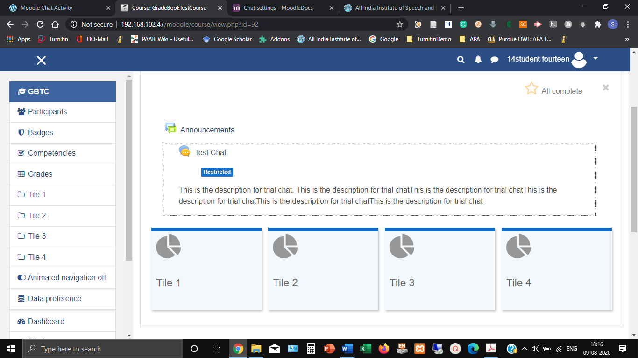

1. A teacher can choose whether to publish the times when he/she is available on the chat activity, e.g. repeated at the same time daily or weekly session or just a one-off slot at **Repeat/ publish sessions.**
2. The teacher can decide for how many days the past discussions in chat sessions should be saved with **Save past chat sessions** options. If required the messages in the chat session can be saved for ever by opting **Never Delete Messages.**(Figure

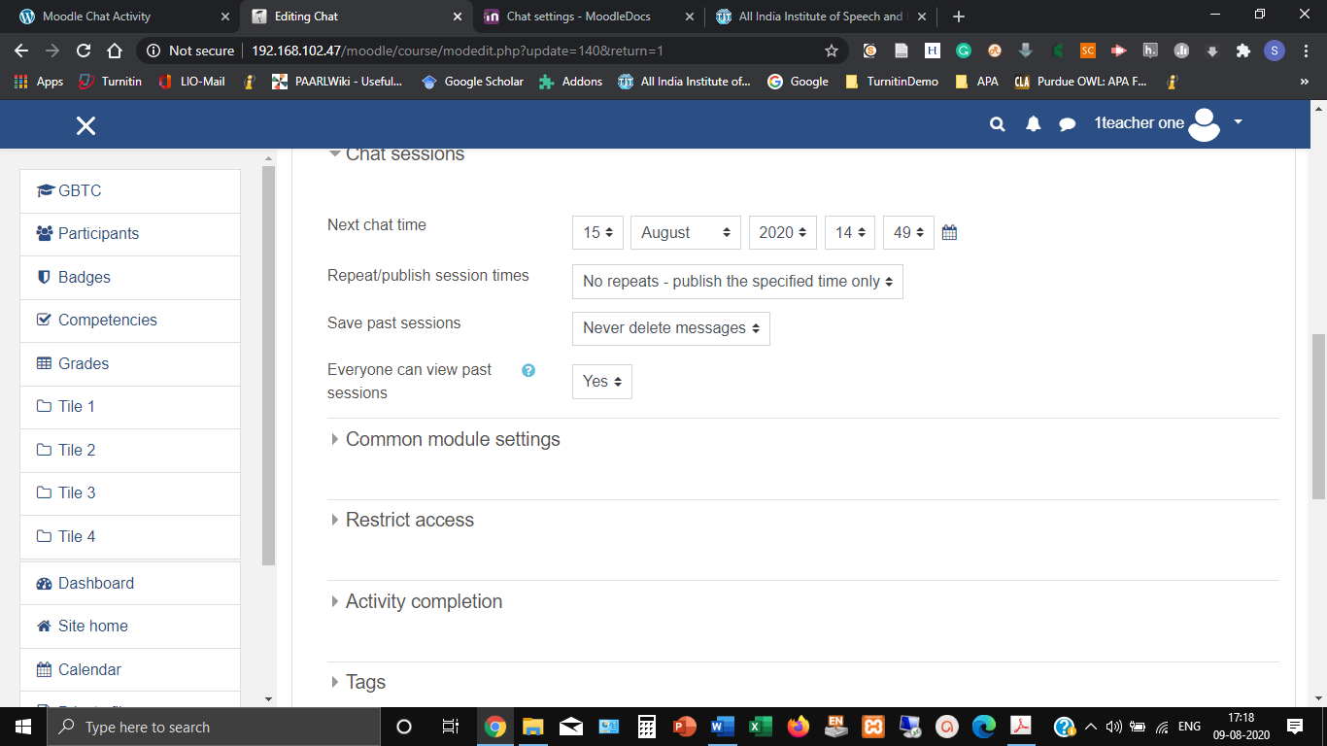

1. The teacher can also decide whether to allow students to view past chat sessions using the option **Everyone can view past sessions**. It may be noted that the teacher can always view the past sessions.

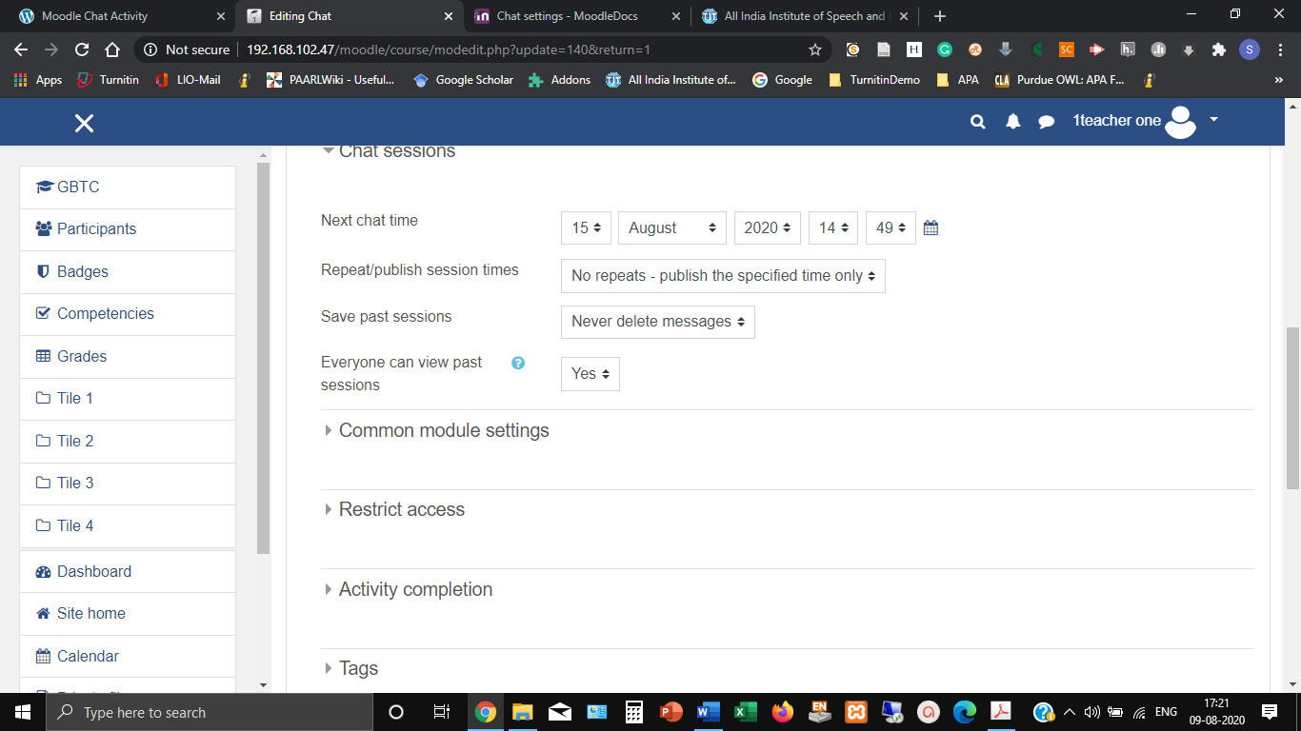

1. **Taking part in a Chat activity**

Once the Chat Activity is set up, the chat link will be available on the on the course page with three options (Figure ):

Click here to enter the chat now – this takes the user to the chat using the chosen site default chat method

Use more accessible interface – this gives a simpler chat room

without frames and java script

View past sessions – if enabled and the user is allowed to view

past chat sessions, they will see a list of past sessions

1. **Joining in a chat session**

In normal view, the screen is in two parts with the participants on the right, the messages on the left and a box at the bottom into which user stype their message and press “Send” to make their contribution:

Users can change the appearance of the messages by clicking on

“Themes” next to the “Send” button. Alongside the default course theme, there are two other available themes. Bubbles or Compact