|  |  |
| --- | --- |
| eAiiSH Manual **Introduction** | **All India Institute of Speech & Hearing** |

Introduction

E-learning is a term to refer to all the learning-teaching activities using computer and communication technologies. Rapid developments in technology have resulted in the emergence of several e-learning tools and systems. One of the most revolutionary advancements in the e-learning scenario is the emergence of the Learning Management System (LMS), a software application that enabled the academic community to move out of the traditional classroom to a completely online learning environment.

Using LMS, a teacher can set-up his courses online, create eLearning content needed for the courses, enroll students in the said courses, deliver the content, and finally, monitor and assess the learner's performance. There are both commercial (eg. *Blackboard & Adobe captivate prime*) and open-source Learning Management Systems Eg. *Moodle & Canvas*). An LMS deployed at an Institutional level is known as the Institutional Learning Management System (ILMS). The ILMS constitutes a necessary academic infrastructure of a higher education institution.

**eAiiSH**

An Institutional Learning Management System has been developed for the All India Institute of Speech and Hearing and names as eAiiSH. It is set on *Moodle*, the world's most popular open-source learning management system.

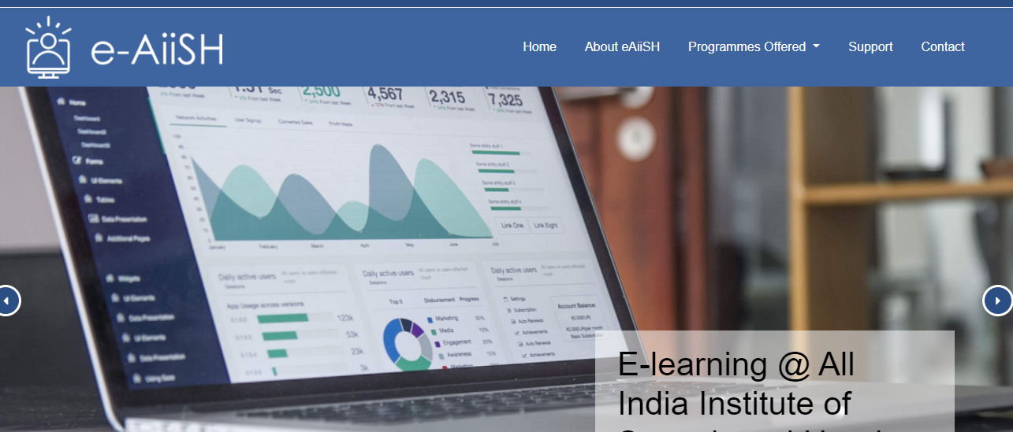

Figure: eAiiSH homepage

Username and password-based accounts are created for the Institute faculty and students on *eAiiSH*. The platform can be accessed from anywhere (*not necessarily from inside the campus*) using the hyperlink **E-learning @ AIISH** on the official website of the Institute at[**www.aiishmysore.in**](http://www.aiishmysore.in)and the Library and Information Centre website at[**www.aiish.ac.in**](http://www.aiish.ac.in)**.**

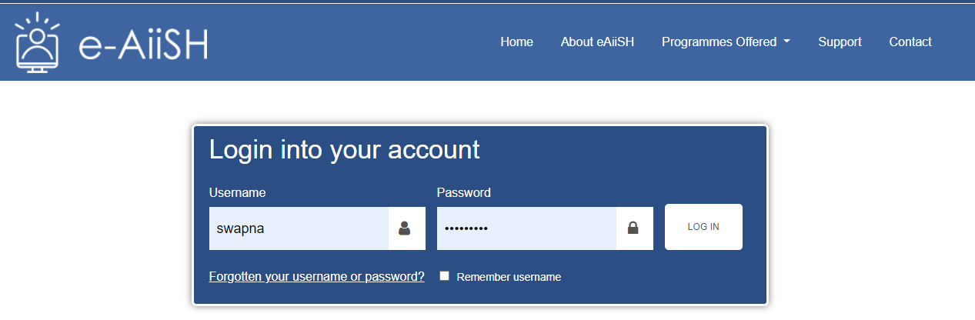

The user can tick the **Remember Username** option on the login screen if she uses the same computer to access the platform every time. Also, there is an option for retrieving the forgotten username and password through the registered email.



**Personal Dashboard**

The account holders of eAiiSH are provided with a personal dashboard. Upon login, the user will be taken first to her Dashboard. The Dashboard of a teacher differs from that of a student. The teacher's Dashboard gives an overview of the courses assigned to her for teaching, and a student's Dashboard provides an overview of the courses in which she has enrolled as a student.

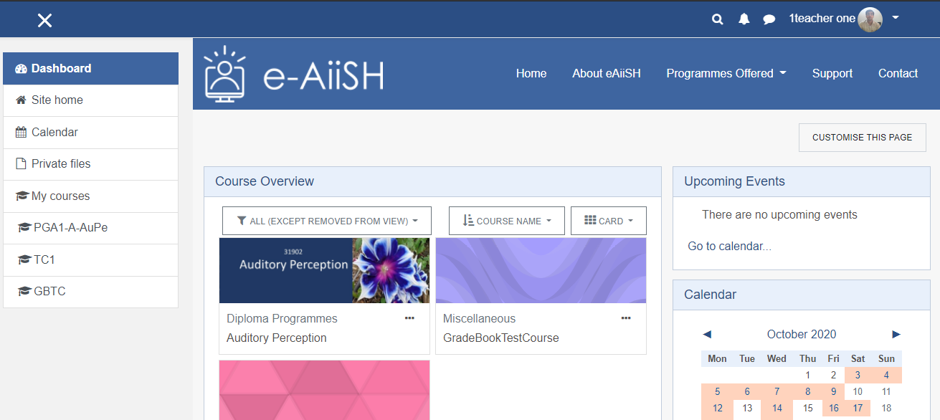

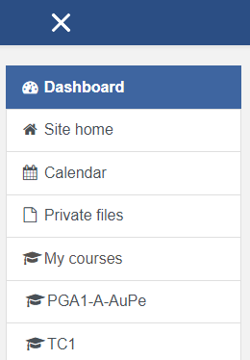The Dashboard has three portions: (1) the left side **Navigation Drawer** with links to: **Site home**, **Calendar**, **Private Files**, and **My Courses**. Below *'My Courses',* abbreviated names of the courses assigned to the teacher are listed. If required, the Navigation Drawer can be closed by clicking the **X** symbol on the top of it.The closedNavigation Drawer can be re-instated by clicking the triple bar symbol appearing in place of X symbol. 

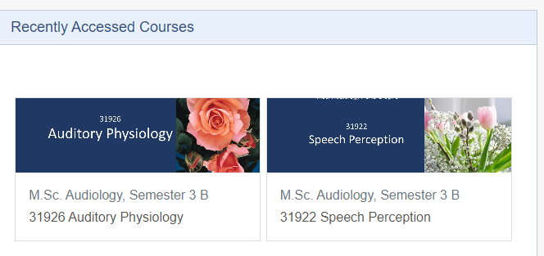(2) The middle portion of the Dashboard has two components. On the top, there is the **Recently Accessed Courses** block, and below that, a **Course Overview** block**.** As its name suggests, the *Recently Accessed Courses* liststhe courses that the teacher viewed recently.

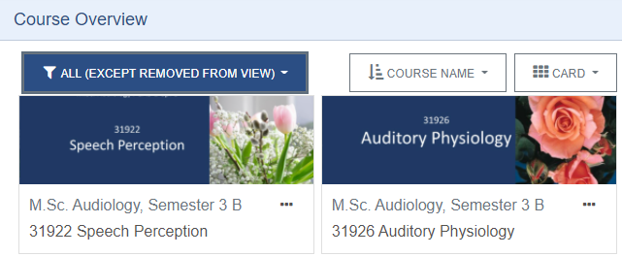The *Course Overview* block listsall the teacher's courses, including the past, currently progressing and forthcoming ones. The *Course Overview* can be changed from the default **ALL** to *In Progress* OR *Future* OR *Past* OR *Starred*OR*Removed from view*by clickingthe top right corner's pop-down button.

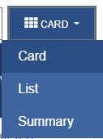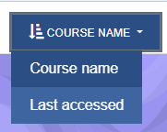Also, by default, the courses are arranged alphabetically by course name. However, they can be arranged based on last access. The courses' default view is Card, which can be changed to **List** view or **Summary** view.

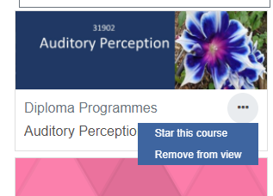The courses may be **starred** or **removed from view** by clicking the three-dot (…) icon at the course card's bottom. *Starring* a course will make it easily accessible. It is like bookmarking. *Remove from view,* helps to hide un-used courses from the display.

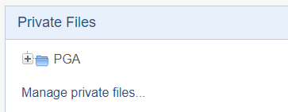(3) The Right-side portion of the Dashboard lists a series of blocks, namely, **Calendar**, **Upcoming events**, **Private Files**, and **Mfreak Avatar**. Of these, the *calendar* displays site, course, group, user, and category-wise events in addition to assignment and quiz deadlines, chat times, and other course events. The **Private Files** blockis a folder where theteacher can store various files useful for the courses. The files can be organized into folders.

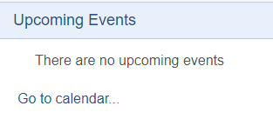The **Upcoming Events block** lists all the upcomingevents in various courses assigned to the teacher. The upcoming events will also be marked in *Calendar* (*display when the cursor moves on the Calendar*).

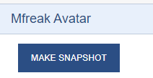The **MFreak Avatar** is a plugin that allows the user to take a snapshot with a live webcam and then upload it onto the profile.

The Dashboard can be **customized** using the CUSTOMISE THIS PAGE button on the top right. In customization mode, the header of all the blocks at the central area and the rightside panel of the dashboard will display two icons . Of these, the **anchor** icon is used for moving the block from one place to other and using the pop-down menu near the **gear** icon, the block can be configured or hid from view or deleted. 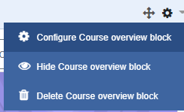

Customization can be stopped using STOP CUSTOMIZING THIS PAGE button, which will appear automatically upon clicking the *customize this page* button. The RESET PAGE TO DEFAULT button can be used to revert to the default setting.

**User Menu**

A dropdown **User Menu** is available at the small triangle next to the user name with a photo at the [Dashboard](https://docs.moodle.org/39/en/Dashboard)'s top right corner. The dropdown menu has links to the D[ashboard](https://docs.moodle.org/39/en/Dashboard), P[rofile](https://docs.moodle.org/39/en/Profile), [Grades](https://docs.moodle.org/39/en/Grades), M[essages](https://docs.moodle.org/39/en/Messages), P[**references**](https://docs.moodle.org/39/en/Preferences)**,** anda link toLogout of the site.

1. **Profile**

Clicking the profile link will open the **Profile page** of the teacher on the site. All the account holders will have their profile page, which can be edited. The profile page has six sections: User details, Course details, Miscellaneous, Reports, Login activity, and Mobile app.

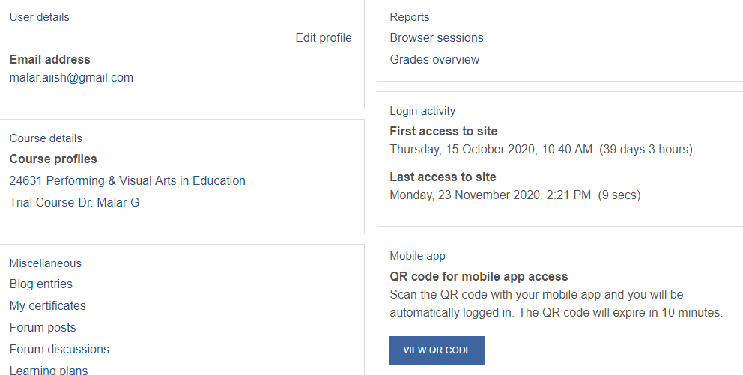

The **User details** display the email id of the user. Using the Edit profile link on the user details' right side, the teacher can add/ edit under six categories: (1) **General,** which includes name, email id, MoodleNet profile (*social media platform for educators, focussed on professional development and open content*), City/town, country, Timezone, Description, (2) [**User picture**](https://aiishpress.ac.in:81/user/edit.php?id=305&returnto=profile),(3) [**Additional names**](https://aiishpress.ac.in:81/user/edit.php?id=305&returnto=profile), (4) [**Interests**](https://aiishpress.ac.in:81/user/edit.php?id=305&returnto=profile), (5) **Options** which includes web page information, Institution, Department, phone numbers, address and different online service ids of the teacher such as Skype ID, and Yahoo ID.

The **Course details** provide the information regarding the courses assigned to the teacher.

Under **Miscellaneous**, links to blog entries, certificates, forum posts, forum discussions and learning plans are provided.

Under the **Reports** the teacher will get the details of browser sessions and students’ grade overview of the courses in which he is a teacher.

Under the **Login activity** the teacher can view the details of his first and last access to site.

The **Mobile app** section provides the facility for scanning the QR code for accessing the site automatically

1. **Grades**

The Grades section of the **User Menu** links directly to the gradebooks of the courses that the teacher teaches.

1. **Messages**

The messages section links to the automatic notification section of the dashboard

1. **Preferences**

The preferences has two parts: User acconts and Blogs

provide the following information: profile information and preferences, view their forum/blog posts, and check any reports they have access to. In order to change/ edit the personal profile click the **profile** link on the **User menu** and from there click **Edit Profile** and make changes in the name, email id etc. For changing the password from **User Menu** click **Preferences** 🡪 **Change password.** Use **Mfreak Avatar** to take a snapshot with the webcam and update your profile photo.

**Course Hoepage**

Clicking a particular course will take to that course's homepage. The couse homepage has 3 sections: The left side navigation drawer, middle course content area and the right side panel with Course Instructor details, Upcoming Events, Calendar and Mfreak Avatar.

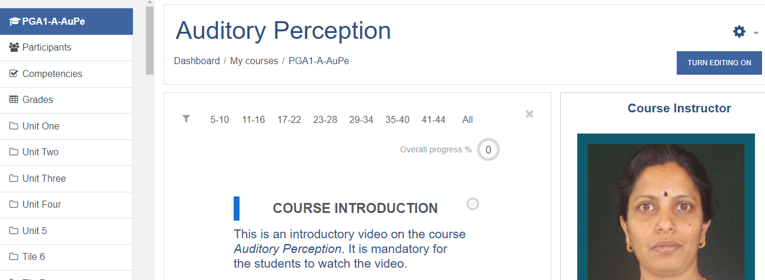

Figure: Course dashboard

The **Navigation drawer** lists the following (*in the order from top to bottom*): (a) **Short name** of the course on the top. Using the short-name link, the teacher can navigate back to the home page from other pages of the course. (b) **Participants**.Theparticipants of the course,namely, the learners enrolled for the course and the teacher herself are listed here.(c) **Competencies**. Competenciesare theskillsthat the learners need to aquire in order to successfully complete the course. The competencies have to be set by the teacher. (d) **Grades**. The Grades or Gradebook is a tool for assigning and storing grades or internal marks to the learners based on the online and offline activities. The has to set up the gradebook at the starting of the course. (e) **Course sections**.Thecourse content can be divided into sections. Depending upon the format chosen, thecourse sections vary. *Week* and *topic* formats are the two major types of course formats.

The middle course content area is the main learning space where the teacher adds learning **resources** and **activities**. The activities and resources are the backbone of a Moodle course. The *resources* refers to the static learning materials related to the course in the form of books, files and web pages, and the tools for organizing the resources and activities like labels and folders. The *activities* on the otherhand are the interactive tasks that the teacher creates for the learners in the form of assignment, chat, discussion forum, quiz etc.

The TURN EDITING ON button on the top right corner of the course page has to be clicked in order to add an activity or resource to the course.