**eAiiS**

|  |  |
| --- | --- |
| eAiiSH Manual **Announcement** | All India Institute of Speech & Hearing |

**[[[H Manu Assignment**

**Introduction**

The Announcement, as its name suggests, is a facility for making announcements related to a course. It **appears automatically** when a new course is created, at the top middle section of the course page.

The *Announcement* is a handy tool for communicating with the learners in a course on matters like date of examination and other important information. The teacher may change the name *Announcement* to something more appropriate, like ‘Important Announcements’ or ‘Course Announcement.’ Only the teacher can post information in the *Announcement,* and the learners can read the post. When the teacher makes a new post, the learners will receive an e-mail notification. The new post will appear immediately in the course *announcement,* but the e-mail notification will be delayed for 30 minutes. This delay will allow the teacher to edit the *Announcement* before sending the e-mail notification.

**Setting up of Announcement**

1. Click on the Announcement button. In the resulting window, add a new topic for *Announcement*.



1. Enter a **Subject** and **Message** to be announced
2. The message needs no be a *text*. It can be in *audio* and *video* format.
3. Using the ADVANCED button, the teacher can attach files, if any, along with the message.
4. The default settings have been made for the Announcement to be subscribed by all the users. (*If required, it can be made optional by the site administrator*)
5. The **pinned** option will bring the post on top of other posts in the announcement section.
6. Ticking the **Send forum post notifications with no editing time delay** will enable the teacher to distribute the post through e-mail without the default 30 minutes delay.
7. The teacher can set a display period for a post to appear in Announcement using the **Display Period** option

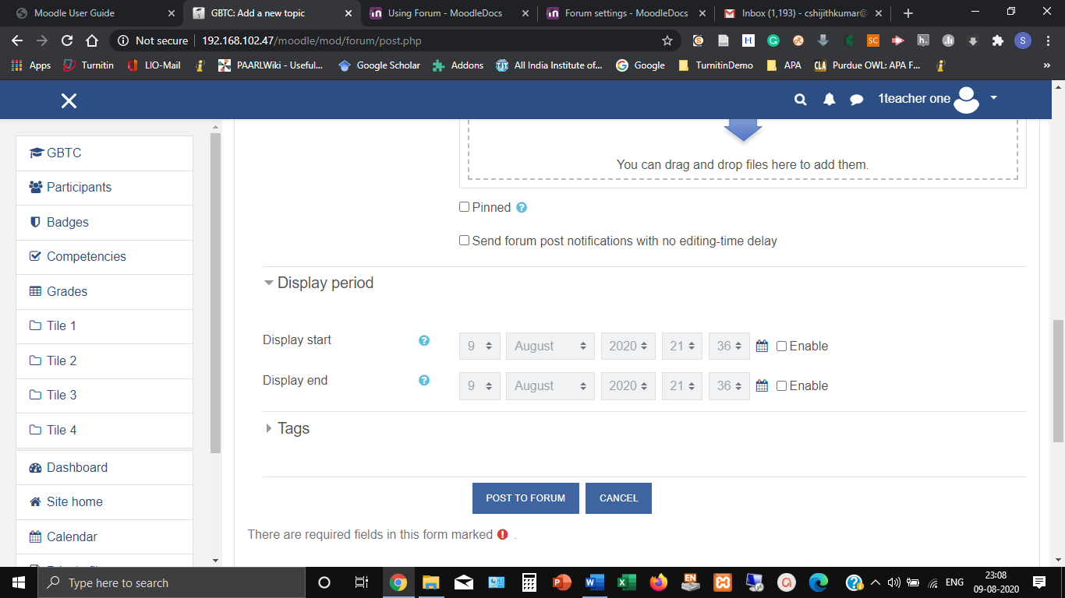

1. After setting the display period, click the tab POST TO FORUM