Grade points and Grade Scales

Grading is an essential part of the teaching and learning process: it gives the teacher feedback on the effectiveness of the teaching methods and study materials used and students about their level of achievement.

The Moodle activities can be graded (*the activity must be previously set as graded*). After the learner submits an assignment, the teacher can directly from the same activity enter the marks, assessment, or grade to the student. The result is automatically transferred to the grade book. For each graded activity, a column is automatically created in the grade book. You can manually create new columns and manually enter grades/marks in them.

A teacher may select **grade type** as **points** or **scale** by going to the **Edit settings** screen of an activity, for example, an assignment, scrolling to 'Grade' and then selecting **'Point'** or **Scale** from the **Type** dropdown. If **Point** is preferred, provide the **Maximum Grade** (Figure ).

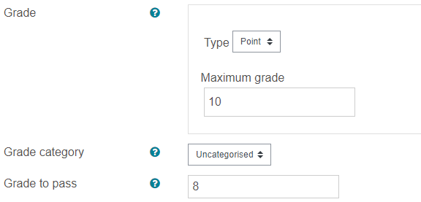

If the **scale** is selected from the **Type** dropdown menu, decide the type of scale from the **Scale** dropdown menu (Figure ).

