AIISH E-learning Platform

E-learning is a term to refer all the learning teaching activities using computer and communication technologies. A lot many e-learning tools and systems have been evolved out since

We developed an e-learning platform for the Institute by name eAiiSH. The homepage of the AIISH e-learning platform is given in figure… The platform is developed on Moodle, the world’s no. 1 open source e-learning software. The system has three types of accounts: Administrator, Teacher and Student.

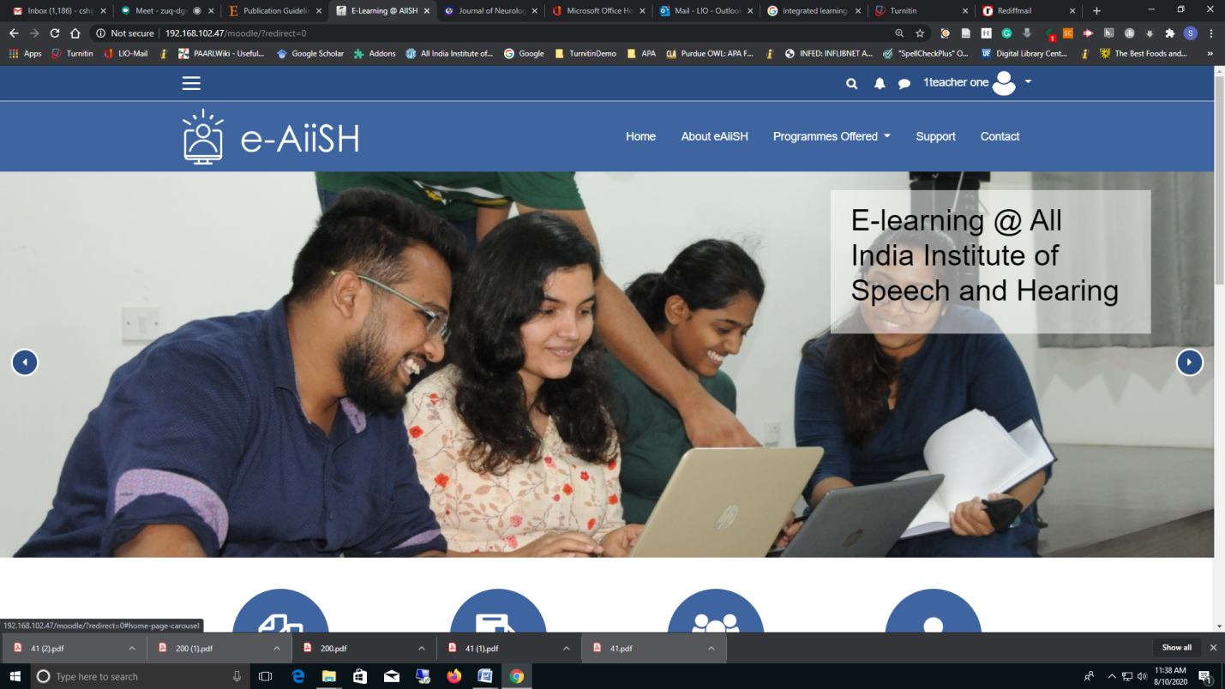

The platform is accessible using the **Username** and **Password** from anywhere (*not necessarily from inside the campus*) by the User.

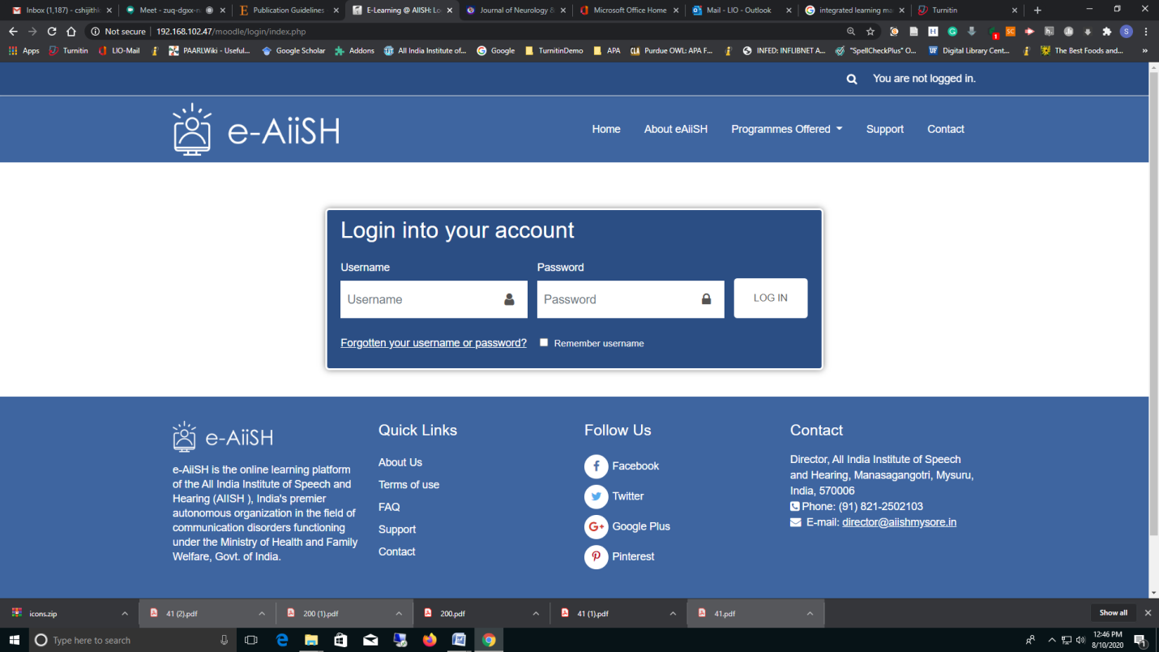

The User will be taken first to his Dashboard from where he/she can access the enrolled courses. (Figure ..)

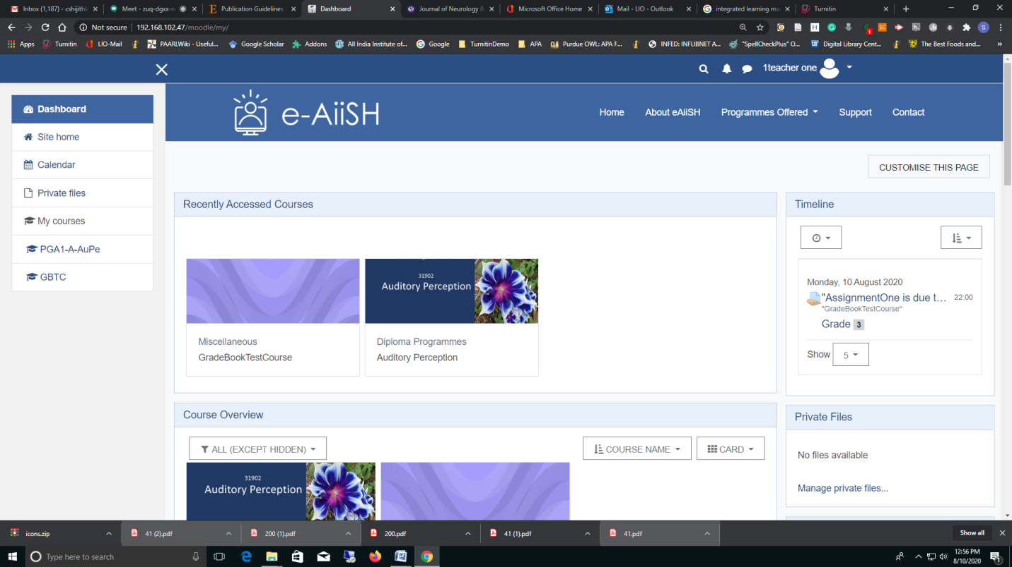

*The very first-time access to the dashboard will facilitate a flash-card ‘tour’ to familiarize the user about the various components or blocks of the dashboard.*

The dashboard has 3 portions: (1) the Left side Navigation *Drawer* with links to : **Site home**, **Calendar**, **Private Files**, **My Courses**. Below ‘**My Courses**’ all the courses assigned to the teacher across the programmes conducted by AIISH have been listed, (2) the Middle portion listing the **Recently Accessed Courses** and **Course Overview** and (3) a series of blocks like Timeline, Calendar, Private Files and Upcoming events in various courses. The Dashboard can be customized using the **CUSTOMISE THIS PAGE** button on the top right.

By default, all the courses assigned to a teacher will be listed on the dashboard. However, if required the view courses option can be changed to: In Progress OR Future OR Past OR Starred OR Hidden.

The **Timeline block helps to set the the**