I B.Ed.Spl.Ed. (HI) 2019-20 – I Semester
Sl. No. | Name of the Student | E-mail ID | Phone Number | Photos
01. | Amina Shanavas | amanasha@gmail.com | 9746647973 | 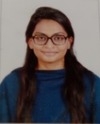
02. | Ananta Kabtiyal | anantakabtiyal601@gmail.com | 8126473796 | 
03. | Ayishasiddiqa K. | askamalbt@gmail.com | 9488987784 | 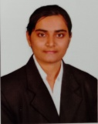
04. | Fane Mariam Sunny | fanesunny@gmail.com | 9446592519 | 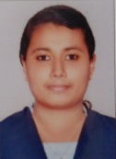
05. | Jobina C. Jose | jobijose95@gmail.com | 8281803517 | 
06. | Justin Selva Kumar | justinsg2011@gmail.com | 8762829120 | 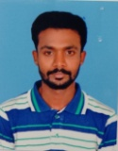
07. | Lekshmi S. | lekshmi23101997@gmail.com | 9496320351 | 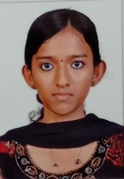
08. | Sai Pavadarshani J. | saipavadarshani@gmail.com | 9789841892 | 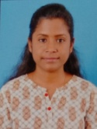
09. | Samrendra Kumar | samrendra1498@gmail.com | 9155707032 | 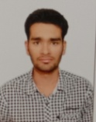
10. | Sereena K. | sereena_k5666@gmail.com | 8943522403 | 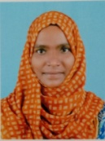
11. | Tintu M. S. | tintusimon179(0)@gmail.com | 9493375783 | 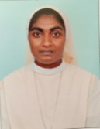
12. | Visano Mekro | vimhamekro@gmail.com | 9774531339 | 
13. | Yogeetha M. L. | yogeethajanu26@gmail.com | 8095491911 | 