**Setting up of High Tech Learning Centre at the Library and Information Centre**

**Equipment List**

All in one Desktop computers

Turnkey installation, operation and maintenance of solar photovoltaic based power plants to generate electricity power back up as safest and alternative traditional energy resource for smooth functioning of IT lab.

**Proposed IT Lab in Library and Information Centre**

Three options design of lab is given below :-

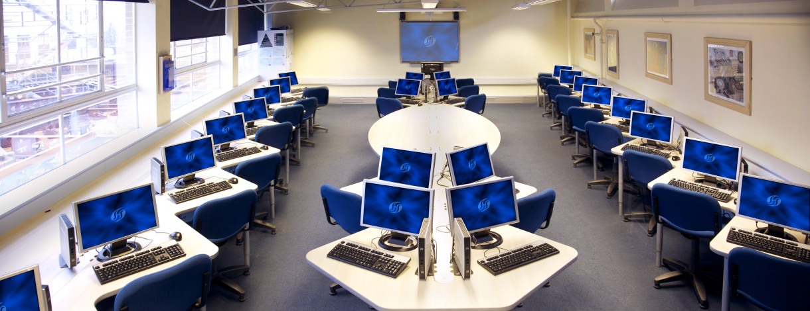

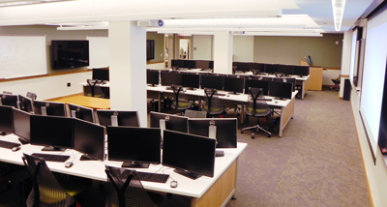

1. Flooring should be environmentally friendly bamboo floors.and additional blue carpet needed
2. Cable management

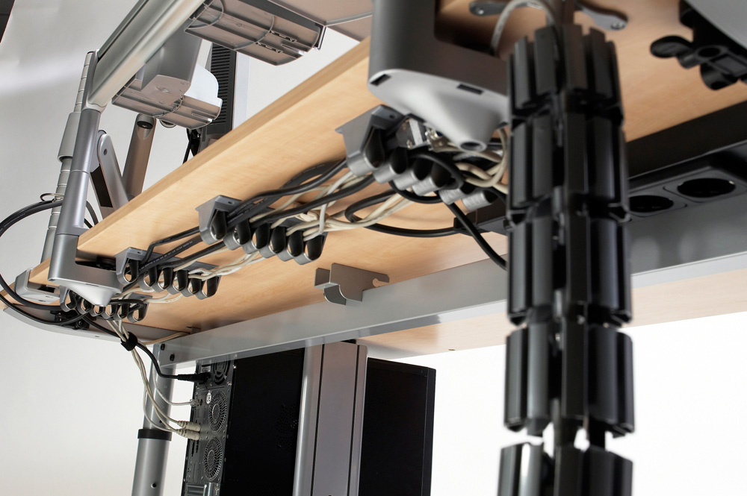

1. Refurbish safe electrical accessories

LED square lumiere should be fitted in the lab. Special LED

1. Furniture Requirements

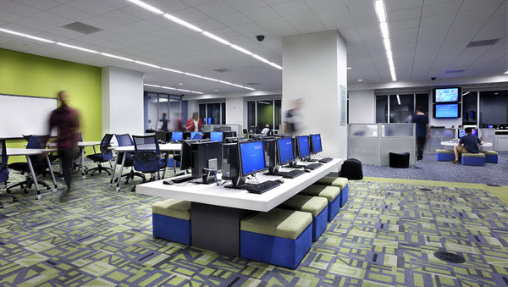

1. Computer Hardware, peripherals and other equipments

Computer Systems

Refurbish Computer Systems – 40 ( including 10 nos from Language Lab)

Dell Alienware Notebook with latest intel core capacity-1

Docking Station-1

Touch Screen Monitor for presentation

Laptop- 2 Nos

Multimedia Equipments

Video blaster-1 nos

LCD Projector and accessories- 2 nos

Color TV- 1 nos

Handy cam- 1 nos

Wireless keyboard and mouse- as per demands

Peripherals

a) Unshielded twist pair cable – as per demands

Justification

It provides high speed data transfer of IT lab

Specification

High density polyethylene insulated PVC jacket

Wiretype : Solid Copper Conductor 1000ft

Wiregauge : 24 AWG and 4 pairs

b) Cat6 cable – 1 nos

Justification

It works with solid or standard wire. Faster termination with reduced scrap

Specification

Simple one piece design, no bars or liners

c) Keystone cat6 cable – 60 nos

d) Surge Protector-based on demands

Firewall

Touch Screen Monitor

Servers -1

1. Computing Facilities

Thin Client /Server networking

Wireless LAN

Wireline Technologies

1. Software Packages Required
2. Operating System Software- MAC ,Windows, Linux platform
3. SPSS-latest version and other Statistical Softwares
4. Cyber café management
5. Oracle 7 Work Group server
6. Aldus Pagemakers
7. Maple
8. Educational Software Applications
9. Moodle Apps for Instructors
10. Research analytics tools