**TELE-CENTER FOR PERSONS WITH COMMUNICATION DISORDERS**

**ANNUAL REPORT (April, 2015- March, 2016)**

1. **ACADEMIC ACTIVITIES**
2. Orientation/Short-term Training Programs (For outsiders)Short-term Training Programs**- NIL**
3. Clinical Observation Posting of Students from other Institutes- **NIL**
   * + - Number of Students
       - Course
       - Institute
       - Date
4. Seminars/Conferences/Workshops/Training programs- **NIL**

* Theme /Topic
* Coordinator
* Resource Person
* Objectives
* Target Audience
* Number of Participants
* Date

1. Staff Enrichment/In-house training programmes) :

**In-house (From TCPD Staff to Staff in other Departments):**

|  |  |  |  |  |  |  |  |
| --- | --- | --- | --- | --- | --- | --- | --- |
| **Sl.No** | **Date** | **Theme /Topic** | **Resource Person** | **Coordinator** | **Objectives** | **Target Audience** | **Number of Participants** |
|  | 01.09.2015 | Orientation on activities of TCPD | Ms. Ansu | Dr. M. Pushpavathi , Head-TCPD | To create awareness on TCPD activities | I B.Sc. ‘B’ | 29 |
|  | 02.09.2015 | Orientation on activities of TCPD | Ms. Mandira | Dr. M. Pushpavathi , Head-TCPD | To create awareness on TCPD activities | JRFs | 5 |
|  | 03.09.2015 | Orientation on activities of TCPD | Ms. Yashaswini R | Dr. M. Pushpavathi , Head-TCPD | To create awareness on TCPD activities | II M.Sc. ‘A’ (SLP) | 15 |
|  | 08.09.2015 | Orientation on activities of TCPD | Ms. Yashaswini R | Dr. M. Pushpavathi , Head-TCPD | To create awareness on TCPD activities | III B.Sc. ‘B’ | 25 |
|  | 9.11.2015 | Orientation on activities of TCPD | Ms. Yashaswini R, Ms. Sonal Beliappa | Dr. M. Pushpavathi , Head-TCPD | Staff Enrichment | Speech Language Sciences | 10 |
|  | 16.11.2015 | Orientation on activities of TCPD | Ms. Yashaswini R | Dr. M. Pushpavathi , Head-TCPD | Staff Enrichment | Prevention of Communication Disorders | 08 |
|  | 13.11.2015 | Orientation on activities of TCPD | Ms. Yashaswini R & Ms. Sowmya M | Dr. M. Pushpavathi , Head-TCPD | Staff Enrichment | Stores | 03 |
|  | 21.12.2015 | Orientation on the activities at TCPD | Ms. Yashaswini R | Dr. M. Pushpavathi , Head | Staff Enrichment | Library Staff | 05 |

1. Guest Lectures: **NIL**

* Name, Designation and Institutional affiliation of Lecturer
* Topic of Lecture
* Date

1. Additional Academic Services rendered by the Faculty and Staff

**Prof. K. S. Prema, Professor in Language Pathology & Head-TCPD**

1. Invited Talks
2. ***NCED, 2016 (15-17 February, 2016)***

* Served as a Keynote Speaker for NCED, 2016 (Topic: Quality appraisal of Inclusive Education for Hearing Impairment*)

(P.S.: Topic re-assigned by the organizing Chairperson in the last week of January, 2016)

1. ***ISHA, 2016 (04-07 February, 2016)***
2. Served as a speaker in the Continuing Education Program on ‘Cognitive Linguistic Disorders in Adults: Role of SLP in assessment of Cognitive- Linguistic Functions’
3. Served as Chairperson for the Plenary session on ‘Early Identification of Reading Disorders’
4. Curriculum Development
5. Development of Materials to support Learning
6. Service in Academic bodies of other Organizations
7. Membership in Professional Organizations/Associations

**Dr. M. Pushpavathi (Served as Head from 1st May 2015 to 31st Dec 2015):**

|  |
| --- |
| * Supervision of Tele-lessons and Ad’s |
| * Supervision for preparation of PPT related to AIISH in Kannada and English |
| * Monitoring regular ongoing activities related to the center |
| * Attending HOD’s meeting on last Friday |
| * Supervision for Rupaka, next episodes for AIR-on ‘Cleft lip and palate’ for a Radio Programme (Rupaka, a drama format) |

**Prof. K. S. Prema, Professor in Language Pathology & Head-TCPD (from March 2015 to April 2015 and Jan 2016 to till now)**

1. Member of International Reading Association, USA that is re-named as International Literacy Association
2. Life member of Dravidian Linguistic Association
3. Life member of Indian Speech and Hearing Association
4. Life Member of All India Association for Educational Research
5. Life-member of AIISH Alumni Association.
6. Member of Rehabilitation Council of India
7. Editorial Board Member of IJOAL and LF Journals
8. Member of ‘Fulbright State Alumni Association’
9. Member of ‘Women in Science’.
10. Member of Specialty Clinics at AIISH-ASD Unit and LD Unit since 08-11-2011.
11. Member of Committee for Internal Quality Assurance Cell
12. Member of IQAC, AIISH (Received OM on 30-10-2014)
13. 17-07-2014: Received letter with nomination as “Member of Research Advisory Council ” for ONE year from 17-07-2014

**Ms. Yashaswini R, Clinical Supervisor**

* Life member of Indian Speech and Hearing Association
* Member of Rehabilitation Council of India
* Member of Indian Society for Augmentative Alternative Communication

**Ms. Mandira B, Speech Langauge Pathologist-I (26.09.2014 to 26.08.2015)**

* Member of Rehabilitation Council of India

**Ms. Vani L, Speech Langauge Pathologist-I (09.10.2014 to 08.10.2015)**

* Member of Rehabilitation Council of India

**Mr. Rakesh Gatla, Audiologist-I (09.10.2014 to 08.10.2015)**

* Member of Rehabilitation Council of India

1. **Participation in Committees/ Taskforces and Panels set up by other organizations/agencies.**
   1. Served as a Member of Technical Committee for NCED, 2016
2. Any Other (Please Specify)

II. **Research Activities**

1. Extramural Research Projects

i) Completed during 2015-16:- **NIL**

* Title
* Objectives
* Investigators
* Funding Source
* Grant Amount

ii) New Research Projects initiated during 2015-16: **NIL**

* Title
* Objectives
* Investigators
* Funding Source
* Grant Amount

iii) **Ongoing Research Projects-**

**In-house Project:**

1. **Title : Feedback survey of resource materials developed by the center**

Objectives: To Validate the resource materials available in print

Investigators: Dr. Prema Rao, Ms. Rithu, Ms. Ansu Thomas, Ms. Vani L, Ms. Sujitha

1. **Title : Basal Ganglia Support Group**

Objectives: To Build up awareness on usefulness of Helpline for persons with Parkinson disease.

|  |  |  |  |
| --- | --- | --- | --- |
| **Sl No.** | **Client name** | **Age/sex** | **Educational Qualification** |
|  | Nagamani | 86 Y/F | PUC |
|  | Kushalappa | 78 y/m | Ph. D. |
|  | Nagaraj | 64 Y/M | B Sc. BEd |
|  | Yallappa | 71 Y/M | M Sc. |
|  | Devaki | 63 Y/F | BA |
|  | Ramnath | 68 Y/M | Diploma in civil engineering |
|  | S.G. Narasimhan | 76 Y/M | B Sc. BE |
|  | Marigowda | 75 Y/M | 3rd Standard |
|  | Gopalagowda G.K. | 75 Y/M | B Sc. BEd |
|  | Ram Kumar | 75 Y/M | BE |
|  | B.D. Parthasarathy | 80 Y/M | Diploma |
|  | M.A. Faroqui | 77 Y/M | Ph. D. |
|  | Satyanarayanamurthy | 78 Y/M | B Tech |
|  | S.R. Ratnamma | 79 Y/F | 8TH standard |
|  | Mayarajeeva | 64 Y/F | PUC |
|  | Vishwamurthy | 57 Y/M | BE |
|  | Jayappa Gowda | 60 Y/M | MA Ph. D. |
|  | Gowramba | 60 Y/F | 10th standard |
|  | Lalithamma | 65 Y/F | SSLC |
|  | Guptha | 59 Y/M | B Sc. |
|  | Kishore | 28 Y/M | B Tech |
|  | Karthik | 38 Y/M | B Tech |
|  | Sreenivas | 56 Y/M | - |
|  | Balaji | 73 Y/M | - |
|  | Rajamma | 58 Y/F | - |

1. **Postgraduate Research Completed- NA**

* Title/Topic
* Candidate
* Guide

1. **Ph. D Research Ongoing**

* Title/Topic: Pre-symbolic communication behaviors in typically developing children and children with intellectual impairments (0.6 to 1.6 years): a comparative study
* Candidate: Ms. Yashaswini R
* Guide: Dr. R Manjula

1. Research Papers presented at National/International Conferences/ Seminars (in APA format)- NIL
2. Research Papers Published (in APA format): - **NIL**
3. Papers published in National /International Journals
4. Papers published in Conference/Seminar Proceedings
5. Books published (in APA format)
6. Book chapters published (in APA format) **NIL**
7. Books in press
8. **Books/Manuals/Seminar Proceedings edited**

Scripts for resource books, Video modules, Tele-lessons, success-stories, communication disorders awareness snippets are being developed and edited

1. Journal Editorship: -**NIL**
2. Scholarly Reviewing Activities:- **NIL**
3. Journal Articles
4. Conference Papers
5. Research Projects

**III.Clinical Services**

1. General Clinical Services:- **NIL**
2. Speech and Language Assessment

Refer to Extension Services

1. Speech and Language Rehabilitation
2. Hearing Evaluation
3. Hearing Aid Trial
4. Hearing Aid Dispensing
5. Psychological Evaluation
6. Counseling and Guidance
7. Ear Moulds
8. Hearing Aid Issue and Electro-Acoustic Evaluation (ADIP Scheme, Ministry of Social justice)
9. AIISH Hearing Aid Dispensing Scheme
10. Specialized Clinical Services- **NIL**
11. Augmentative and Alternative Communication Unit
12. Autism Spectrum Disorder Unit
13. Fluency Unit
14. Learning Disability Clinic
15. Listening Training Unit
16. Neuromotor Speech Disorder Unit
17. Pre-School Training and Special education
18. Professional Voice Care Unit
19. U-SOFA
20. Vertigo Clinic
21. Voice Clinic
22. Any other (Please Specify)
23. Clinical Support Services to Patients and Family- **NIL**

i) Details of Certificates Issued

ii) Financial Aid

iii) Legal advice

iv) Any other (Please Specify)

1. Clinical Electronic Services:- **NIL**

i) Electro-Acoustic Evaluation

ii) Hearing Aid Dispensing

iii) Repair of Hearing Aids

IV. Extension Activities

1. Tele-Rehabilitation and Tele- Education Guidance

-**Out reach Clinical/rehabilitation/Special educational activities through tele-mode.**

**Number of Tele- Rehabilitation cases and sessions through Video-conference from April 2015 to till March 2016**

|  |  |  |  |  |  |  |  |  |  |  |  |  |
| --- | --- | --- | --- | --- | --- | --- | --- | --- | --- | --- | --- | --- |
|  | **Phonological Disorders** | | **Fluency Disorders** | | **Voice Disorders** | | **Language Disorders** | | **Multiple Disorders** | | **Total** | |
|  | Clients | Sessions | Clients | Sessions | Clients | Sessions | Clients | Sessions | Clients | Sessions | **Clients** | **Sessions** |
| Pediatric | 5 | 8 | 10 | 11 | 4 | 10 | 9 | 11 | 1 | 4 | 29 | 44 |
| Adult | 1 | 1 | 2 | 3 | 1 | 1 | 3 | 3 | 9 | 36 | 16 | 44 |
| Geriatric | 0 | 0 | 0 | 0 | 1 | 1 | 0 | 0 | 2 | 7 | 3 | 8 |
| **Total** | **6** | **9** | **12** | **14** | **6** | **12** | **12** | **14** | **12** | **47** | **48** | **96** |

**Number of Tele- Rehabilitation cases and sessions through SKYPE from April 2014 to March 2015**

|  |  |  |  |  |  |  |  |  |  |  |  |  |
| --- | --- | --- | --- | --- | --- | --- | --- | --- | --- | --- | --- | --- |
|  | **Phonological**  **Disorders** | | **Fluency Disorders** | | **Voice Disorders** | | **Language Disorders** | | **Multiple Disorders** | | **Total** | |
|  | Clients | Sessions | Clients | Sessions | Clients | Sessions | Clients | Sessions | Clients | Sessions | Clients | Sessions |
| Pediatric | 25 | 69 | 14 | 89 | 32 | 145 | 45 | 245 | 24 | 130 | 140 | 678 |
| Adult | 14 | 35 | 14 | 67 | 14 | 56 | 15 | 86 | 26 | 71 | 83 | 315 |
| Geriatric | 0 | 0 | 0 | 0 | 0 | 0 | 8 | 35 | 0 | 0 | 8 | 35 |
| **Total** | 39 | 104 | 28 | 156 | 46 | 201 | 68 | 366 | 50 | 201 | **231** | **1028** |

|  |  |
| --- | --- |
|  |  |

1. Prevention of Communication Disorders
2. Communication Disorders Screening Camps
3. Orientation Programs
4. **Public Lecture Series**:

Ms. Yashaswini R, Clinical Supervisor delivered Monthly Public Lecture on 27.06.2016 on ‘Tele-rehabilitation in Communication Disorders

V.**Technological Consultancy Services**

**VI.Central Facilities**

1. Library and Information Services
2. Public Information Activities
3. Major Events of the Year with a brief account
4. Press Releases and Media Coverage
5. Institute Publications
6. Material Development

|  |  |
| --- | --- |
| ***Other Materials at TCPD*** | |
| **Name Of The Material** | ***Language*** |
| Train Your Child - Level 5 | English |
| Train your child – Level 2 | Telugu |
| Parent and Child | Malayalam |
| Train your child for attention and concentration skills | Hindi |
| Train your child – Level 1 | Telugu |
| Parent and child | Telugu |
| Train your child for attention and concentration | English |
| Train your child level 4 | Kannada |
| Train your child level 4 | Hindi |
| Train your child level 5 | Hindi |
| Train your child in Pre-academic skills | Hindi |
| Train your child level 3 | Kannada. |
| AIR Tele-Lesson 1 | Kannada |
| AIR Tele-Lesson 2 | Kannada |
| AIR Tele-Lesson 3 | Kannada |
| AIR Tele- Lesson 4 | Kannada |
| AIR Tele-Lesson 5 | Kannada |
| AIR Tele-Lesson 6 | Kannada |
| AIR Tele-Lesson 7 | Kannada |
| AIR Tele-Lesson 8 | Kannada |
| AIR Tele-Lesson 10 | Kannada |
| Ads about AIISH service for AIR | English, Kannada |
| TCPD Bookmark Design | English |
| Working Model | - |
| Tinnitus Assessment App | English |

|  |  |  |  |  |
| --- | --- | --- | --- | --- |
| **Other Materials** | | | | |
| **Name of the work** | **Nature of work** | **Number of Designs** | **Completed On** | **Total no of work** |
| **Posters design** | Posters for open day | 2 posters | 21.1.16 | 8 no.s |
| Posters for TCPD display board | 6 posters | 26.2.16 |
| **Cover page design and Book inner layout** | Parent and child (Telugu) | 60 pages (inner layout)  cover page | 18.09.15 | 7 no.s |
| Train Your Child – Level 5 English | 42 pages (inner layout)  Cover page | 09.06.15 |
| Train Your Child – Level 5 Hindi | 42 pages (inner layout)  Cover page | 09.06.15 |
| Train Your Child – Level 2 Telugu | 44 pages (inner layout)  Cover page | 15.12.15 |
| Train Your Child – Level 1 Malayalam | 48 pages (inner layout)  Cover page | 08.02.16  Draft sent for Proofread |
| Prospectus 2016-17 Cover Page | 2 Designs | 23.03.16 |
| **Audio Editing** | AIR Tele-Lesson 1 Kannada | Audio editing | 13.03.15 | 21 no.s |
| AIR Tele-Lesson 2 Kannada | Audio editing | 03.03.15 |
| AIR Tele-Lesson 3 Kannada | Audio editing | 20.03.15 |
| AIR Tele-Lesson 4 Kannada | Audio editing | 22.03.15 |
| Ads about AIISH service for AIR | Total 9 Ads Audio editing | 26.03.15 |
| AIR Tele-Lesson 5 Kannada | Audio editing | 05.05.15 |
| AIR Tele-Lesson 6 Kannada | Audio editing | 06.05.15 |
| AIR Tele-Lesson 7 Kannada | Audio editing | 27.04.15 |
| AIR Tele-Lesson 8 Kannada | Audio editing | 05.05.15 |
| AIR Tele-Lesson 10 Kannada | Audio editing | 08.05.15 |
| Ads about AIISH service for AIR | Total 3 Ads Audio editing | 29.05.15 |
| **Video Editing/Video Shoot** | Video presentation slides for Audiology department | 2 Video Editing (Adult Block & Children’s block) | 23.11.15 | 3 no.s |
| Audio-Video Shooting & editing | Client Interview video shoot & Video Editing | 30.11.15 |
| **Illustrations** | FAQ and glossary related to audiology video slides | 4 Illustrations | 30.06.15 | 61 no.s |
| PowerPoint presentation related to audiology video slides | 4 Illustrations | 30.06.16 |
| **Pamphlets/Brochures** | TCPD brochure in Malayalam | A4 size Design (2 pages) | 14.09.2015 | 10 no.s |
| Brochure for Helpline for Parkinson’s disease in Malayalam | A4 size Design (2 pages) | 14.09.2015 |
| Dementia: Public Education pamphlets - POCD | A4 size Design (2 pages) | 11.02.2016  Draft sent for Proofread |
| Learning Disabilities: Public Education pamphlets - POCD | A4 size Design (2 pages) | 11.02.2016  Draft sent for Proofread |
| FAQs NIHL: Public Education pamphlets - POCD | A4 size Design (2 pages) | 11.02.2016  Draft sent for Proofread |
| Know this with Pics & Text: Public Education pamphlets - POCD | A4 size Design (2 pages) | 19.02.2016  Draft sent for Proofread |
| Specific Language Impairment: Public Education pamphlets -POCD | A4 size Design (2 pages) | 19.02.2016  Draft sent for Proofread |
| **Book Mark** | TCPD Bookmark Design | 1 Design | 21.01.16 | 1 no. |
| **Working Model for Open day** | Working Model | Related to Effect of mobile usage for longer duration on hearing | 28.01.16 | 1 no. |
| **App Design** | Tinnitus Assessment | 16 pages | 31.03.16 | 1 no. |

**VII. Awards and Honors Received by Faculty and Staff**

**VIII .Extra Curricular Activities**

1. AIISH Gymkhana
2. NSS
3. Others –Model was done by TCPD staff Members for Open Day
4. **Ix.MAJOR EVENTS OF THE YEAR**

* Sound proofing of Audio Visual Laboratory
* Development of digital resource materials
* Shooting of activities for development of MMC level-3 & level 4
* Proposal planned for Cross Country Virtual Seminar between September – October 2016
* Public Private Partnership to serve persons with Parkinson’s Disease as a CSR objective
* Dr. Santhosh, M and Mr. Ramkumar were the auditors for the 6th ISO internal audit on 1st March, 2016.
* Co-ordinated with Mr. Keshav, Director Swift Solutions, Staff TCPD, Head and Staff- Dept. Special Education, mother-child pairs at Dept. of Special Education for video shooting of MMC level 3 and level 4 on 21st, 22nd and 23rd March, 2016.
* Visit of Internal ISO Auditors-Dr. Santhosh M & Mr. Manohar on 8th Feb 2016
* Resource Materials developed at the center shifted to product development cell on 25.02.2016=2662 books

**x. Eminent Visitors**

* Dr. Rangasayee & Dr. Roopa Nagarajan, RCI Inspection on 12.5.2015.
* M Dhanthir panda, Joint Secretary, Ministry of Health & Family Welfare on 15.5.2015
* Dr. Raj, Pediatric Nerologist, UK London n 10.6.2015
* Mr. Ziley Singh, Health & Family Welfare on 16.11.15
* Mr. J P Nadda, Minister, Central Health & Family Welfare on 4.1.16

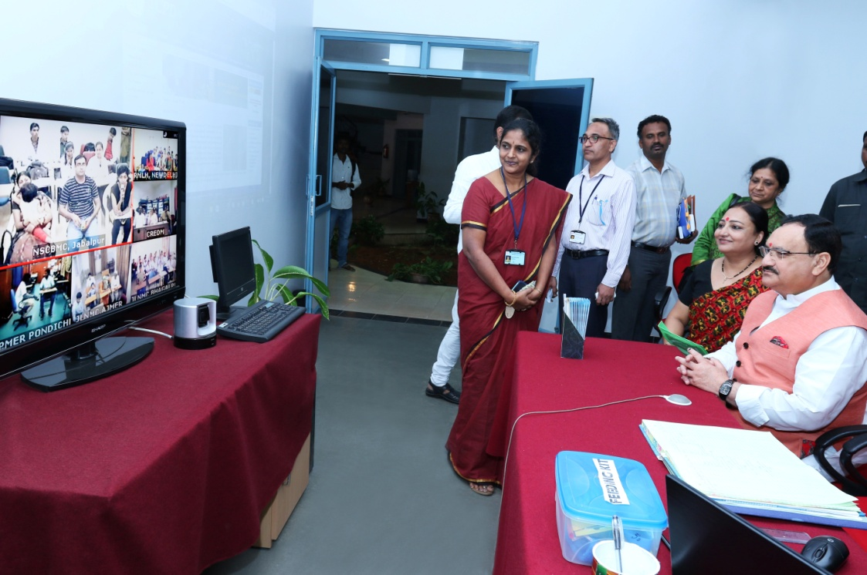

**Mr. J P Nadda, Minister, Central Health & Family Welfare on 04.01.2016**

XI.Any Other

1. **Services through VC, Skype or Team Viewer or Google Hangout:**

The Center offers services for persons with communication disorders through videoconferencing, Skype and other ICT modes

|  |  |
| --- | --- |
| C:\Users\user\Desktop\CREDM World Map 2.jpgH:\Swetha-CREDM-06.01.2014\Website updation\Photos\Skype Session.JPG  \\192.168.104.77\Shared Files\TCPD Video C.jpg  Tele orientation to participants across India through ICT (Videoconferencing) facility  Tele-service offered through ICT (Skype) facility  Tele-services spread across and outside the country |  |

1. **Helpline for senior citizens with communication disorders.**

The Center has a dedicated Helpline for Persons with Parkinson’s disease ([www.aiishcredmhelpline.in](http://www.aiishcredmhelpline.in)). This is the first in line to meet one of the objectives of the center to reach out to elderly persons with various communication disorders. Parkinson’s disease (PD) often affects the elderly population. Lack of awareness and lack of sufficient facilities to identify and treat this disease often leads to poor quality of life in Persons with Parkinson’s disease (PsWPD). In order to avail services for Parkinson’s clients it is necessary to register in the dedicated website.

|  |  |
| --- | --- |
| G:\Shared Files\AIISH & CREDM Documents\CREDM Gallery\Picture of CREDM PD Helpline.jpg |  |

* The website contains all the details of Parkinson ’s disease. Patients of Basal Ganglia Support Group are being informed about the availability of services at TCPD by the staff during the camps organized by them.
* The Staff of TCPD regularly attends the monthly meet (every Second Sunday of the month) organized by Basal Ganglia Support group
* Parkinsons disease helpline registration is in progress- 8 members registered

1. **PG Students Training in Tele Service**

|  |  |
| --- | --- |
| H:\Swetha-CREDM-06.01.2014\Website updation\Photos\Student Training 2.JPG | H:\Swetha-CREDM-06.01.2014\Website updation\Photos\Student Training.JPG |

1. **TCPD website:** [**www.aiishTCPD.in**](http://www.aiishcredm.in)

Number of Hits till 31.03.2016: 15519

1. **Parkinson’s disease Helpline: website:** [**www.aiishTCPDhelpline.in**](http://www.aiishcredmhelpline.in)

Number of Hits till 31.03.2016: 6192

1. **Civil work:** Audio-visual lab work completed

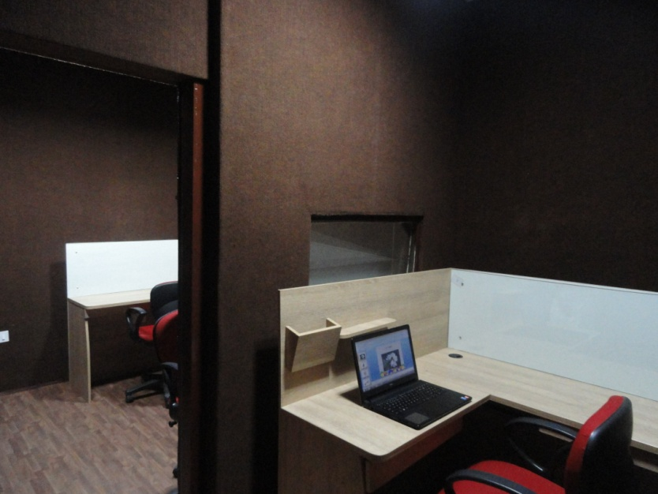

**Audio-visual lab**

1. **Recruitment:**
   * + - 1. **Permanent Staff**: Nil
         2. **Contract:**

|  |  |  |
| --- | --- | --- |
| **New Staff** | **Renewed Staff/Extension** | **Relieved Staff-2014-15** |
| **Speech Language Pathologists Grade-I:**   * Ms. Sonam Beliappa * Ms. Sujitha P S * Ms. Rofina Babin P   **Audiologists:**   * Ms. Swathi C.S * Ms. Sowmya M | * Mr. Shivaprasad.M, Graphic Designer * Ms. Roopashree, Copywriter * Ms. Nithyashree, Technical Writer | * Mr. Rakesh Gatla, Aud-I * Mr. Ramix Malik, Aud-I * Ms. Vani L, SLP-I * Ms. Ansu Elisa Thomas, SLP-I * Ms. Mandira Bhattacharjee, SLP-I * Ms. Shailaja Shukla, SLP-I |

* + - * 1. **Internal Transferred Staff: (Contract):**
* Ms. Preethi K, Data Entry Operator (Every day from 9.00 am to 11.00am) (to TCPD)
* Ms. Swetha S, Administrative Assistant (from TCPD to Audiology)

**HEAD-TCPD**