**Extracurricular Events**

The institute carries out various extracurricular activities which include celebration of Institute annual day, observation of important commemorative days and organization of intercollegiate cultural festival. These activities are spearheaded by AIISH Gymkhana, the cultural organization of staff and students and the National Service Scheme Unit. The extracurricular activities took place during the reporting year are given below.

**AIISH Gymkhana**

AIISH Gymkhana provides platform for recreational, social and cultural activities not only for its members but also for other central government institutions to conduct their social and cultural activities. It is having facilities for indoor and outdoor sports, gymnasium, and library. The following programs were conducted by AIISH Gymkhana during the report year.

**Annual Day**

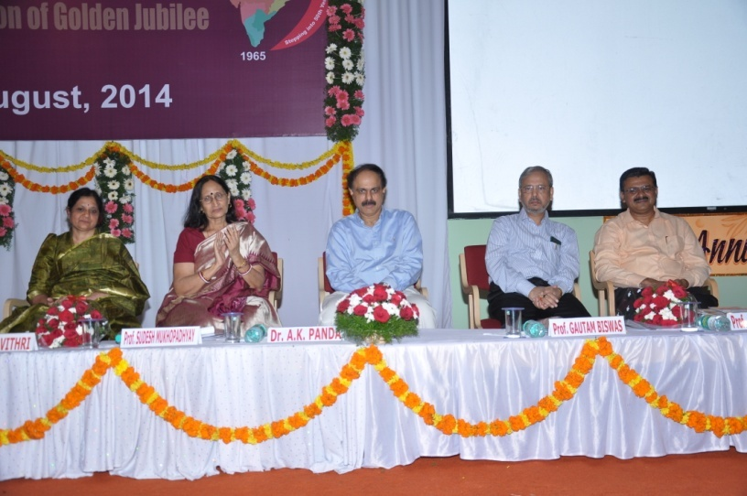

The 49th anniversary of the institute was celebrated on 9th August, 2014. Dr. A.K. Panda, IAS, Joint Secretary, Ministry of Health & Family Welfare, Government of India, New Delhi. Prof. Sudesh Mukhopadhyay, Chairperson, Rehabilitation Council of India, New Delhi and Prof. Gawtam Biswas, Director, IIT Guwahati were the chief guests. Golden jubilee celebrations of the institute were also inaugurated during the occasion by Dr. A. K. Panda , IAS by releasing the Golden Jubilee logo. A cultural extravaganza was held in the evening, for which Dr. Sarvamangala Shankar, Vice Chancellor, Music University, Mysuru, Prof. D. ShrijayDevarajUrs, Registrar-Evaluation, University of Mysore and Prof. Umesh, Retd Principal, Sharadavilas College, Mysore were the chief guests. The retired employees, employees completing 25 years of institute service, and employees selected for best AIISHian awards were honored, and various public education materials prepared by the institute were released during the occasion. Also, the staff, students and preschool children presented various cultural performances.

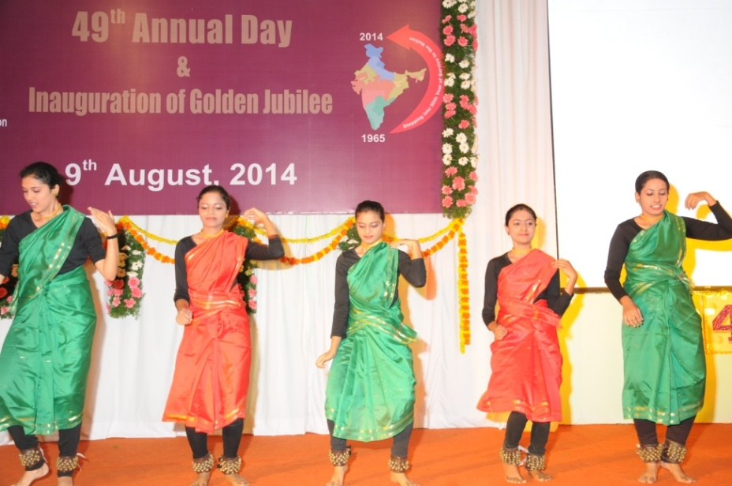

Students performance at the annual day celebrations

**Pratibha Puraskar and Talents Day**

Meritorious children of the institute employees who excelled in the curricular and extracurricular activities were honored**o**n 9th September, 2014. Prathibha puraskar was given to the meritorious children and they showcased their talents during the occasion**.**

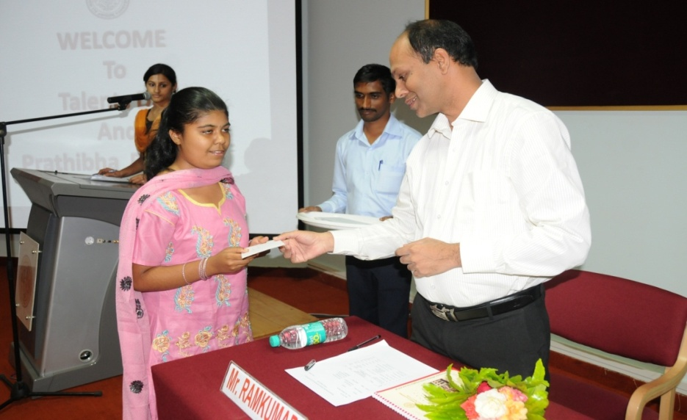

Distribution of prathibha puraskar

**Independence Day**

The 68th independence day of the nation was celebrated on 15th August, 2014. Dr.S.R.Savithri, Director of the institute hoisted the national flag during the occasion. Various cultural activities such as recital of patriotic songs by the students and fancy dress presentation by the pre-school children were held as a part of the event.

**Kannada Rajyotsava Day**

Kannada Rajyathosva was celebrated on 3rd November, 2014. Prof. KikkeriNarayana, a well known writer and retired Professor, CIIL, Mysuru was the chief guest. Group song competition in Kannada was held department-wise and the prizes were distributed.

**Open Day**

The institute celebrated Open dayon 16th December, 2014 to make the general public and students aware of its facilities and services. Smt. Rashmi V Mahesh, IAS, Director General, ATI, Mysore inaugurated the event and Dr.S.R.Savithri, Director of the institute presided over. Sri. H.R. Basappa, Deputy Director of Public Instruction, Office of DDPI, Mysore was the guest of honour. An exhibition with many interesting and fun loving games were conducted for children and general public to create awareness about disability and the needs of persons with disability.

**Republic Day**

The 66thRepublic Day of the nation was celebrated on 26th January, 2015, with Major General (Rtd.) S.G. Vombatkere as the chief guest. Children from AIISH Preschool presented cultural programs.

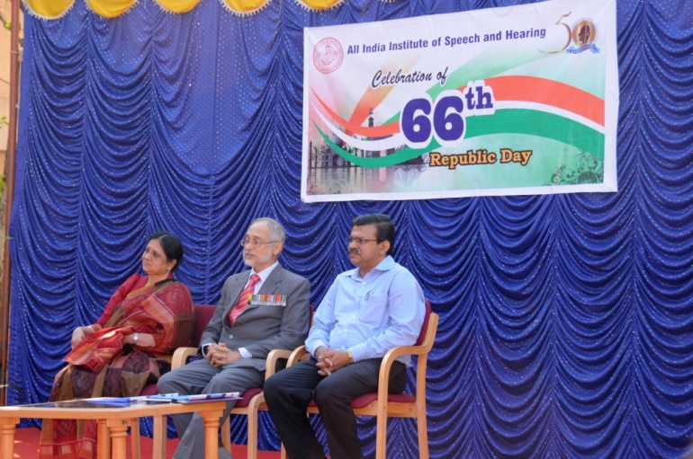

Major General (Rtd.) S.G. Vombatkere accompanied by the Director

**National Science Day**

The institute celebrated the National Science Day on 27th February 2015. Dr. S.K. Shivakumar, one of the distinguished scientists behind India’s successful Mangalyaan Mission and Director, ISRO Satellite Centre, Bengaluru was the chief guest and delivered a talk on Indian Satellites and Success of Mars Orbiter Mission on the occasion.

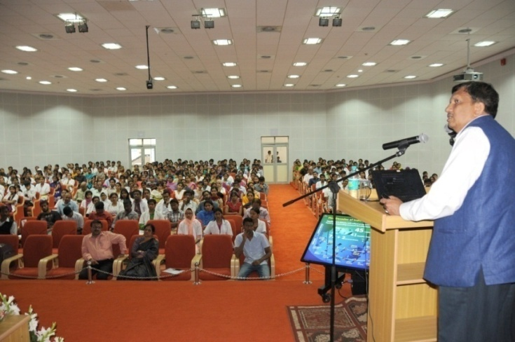

Dr. S.K. Shivakumar delivering lecture

**International Women’s Day**

The Inter National Women’s Day, 2015 was celebrated on 5th March 2015 and a cook without fire and vegetable carving competitions were arranged for women employees of the Institute.

**Mini Marathon**

As a start to the AIISH AAWAAZ 2015, the institute organized a mini marathon in the city on 7th March, 2015. Sri. V. Srinivas Prasad, Hon’ble District In-charge Minister and Revenue Minister, Govt. of Karnataka flagged off the function.

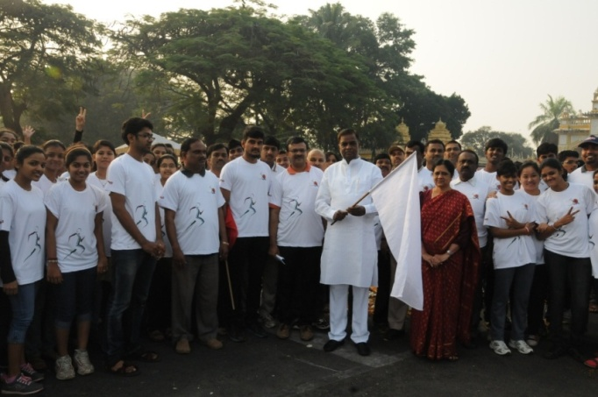

Marathon flag off by Sri. V. Srinivas Prasad, Hon’ble District In-charge Minister and

Revenue Minister, Govt. of Karnataka

**AIISH AAWAAZ**

The annual inter-collegiate cultural festival AIISH AAWAAZ was organized on 13- 15 March, 2015. Smt. Sudha Baraguru, internationally renowned humorist inaugurated the event on 13th March, 2015 in which Sri. Avinash Diwakar, Kannada film actor was the guest of honour. Sri. Badal Nanjundaswamy, renowned artist and Sri. Namadeo Dinesh Kumar, Deputy Zonal Head, Bank of Baroda, Karnataka Zone were the guests of the valedictory function held on 15th March 2015 in which Sri. Naveen Sajju, Kannada play back singer was the guest of honour. Dr. S.R.Savithri, President, AIISH Gymkhana, presided over the function. The competitions included solo singing, mime, skit, group dance, treasure hunt, group song ,mock press, mad adds, self-composition, fashion extravaganza, spoof, duet singing and spot dance. The cultural and fine arts events at the festival witnessed intense competition among the students from 39 colleges of Mysore and 7 Speech and Hearing institutes across the country. Madras ENT Research Foundation (MERF), Chennai bagged the overall championship.

**Farewell Programs**

Farewell programs were arranged for Sri. Anil Kumar, Sri. Chowdaiah, Sri. Mahadeva M, Ms .Padma, Smt. V. Shubha, Smt. J Raguna, the staff members who attained superannuation, Smt. B.V. Jyothi, the staff member who took voluntary retirement and the outgoing students of 2013-14 batches.

**National Service Scheme**

The National Service Scheme (NSS) unit of the institute rendered a variety of community services during the reporting year. The major services among them are given below.

**Orientation program:** A**n o**rientation programme on the activities of NSS unit was conducted to the students **o**n 26th August, 2014 and 100 students participated in the event.

**Shramdaan:** A shramdaan activity was conducted at the foothills of the Chamundi hill on 6th September, 2014and the NSS volunteers cleaned all the foot steps to the hills and the surroundings.

**Craft Making:** A craft making activity was carried out on 13th September, 2014 in which greeting cards, paper bags and posters were prepared.

**Rally on Alzheimer’s Disease:** A walkathon was organized in Mysore city in order to spread awareness on Alzheimer’sdiseaseamong the general public **o**n 20th September, 2014. Sri Pratap Simha, Hon’ble Member of Parliament inaugurated the walk.

**Campus Cleaning:** The volunteers cleaned the whole Institute campus and its surroundings **o**n 4th October, 2014.

**Talk on Waste Management:** A lecture on waste management by Mr. Ramesh Kikkeri, Assistant Professor, Vivekananda Institute for Leadership Development was organized **o**n 13th October, 2014.

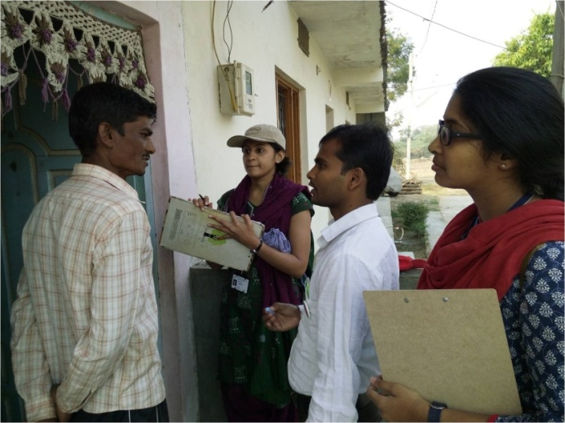

**Rally on Noise Awareness:** A noise awareness rally wasorganized in Mysore city to educate the general public onhazard of noise on 18th October, 2014.Dr. Rudraaiah NSS Programme Officer, University of Mysore. The programme inaugurated the program. The volunteers presented skits related to the hazard of noise during the event.

**Orphanage Visit:** The volunteers visited Sri Chayadevi Anathashrama Trust orphanage in Mysore and distributed the clothes, food items and stationeries among the inmates, collected from students and staff of AIISH on 25th October, 2014.

**Special Camp:** The NSS Unit conducted aSpecial Camping Programme at Mota Fofalia, Vadodara, Gujarat from 22nd February to 5th March, 2015 under the coordination of Dr. Sujeet Kumar Sinha, NSS Officer. Shaktikrupa Charitable Trust, Motafofalia, Vadodara was the supporting agency for the programme. Dr. Animesh Barman, Professor in Audiology, AIISH and Mr. Jeetendra Bhai Patel, Mrs. Meghana Patel, and Mr. Ashok Patel, Members, Shaktikrupa Charitable Trust, Mota Fofalia, spoke during the inaugural function. The Speech-Language Pathologists, Audiologists, ENT Specialist, Clinical, Psychologists, Earmold technician and the Electronic Engineer of the Institute attended programme along with 48 NSS volunteers. The main focus of the camp was identification, assessment and rehabilitation of individuals with communication disorders. Survey was conducted in 15 villages of Sinor Taluq. The volunteers also visited various schools, addressed the teachers regarding communication disorders and their identification and pamphlets were distributed. Totally, 28954 people were surveyed and 1186 were identified with various types of communication disorders. Among them, 1313 persons availed clinical/rehabilitation services such as speech language therapy and counseling, hearing aid trial and fitting, Issuing of hearing aids and ear molds, and medicine distribution.