**Public Education**

The institute has been taking various steps to make the common man aware of communication disorders, educate them on prevention of the disorders and provide guidance and counseling to persons suffering from such disorders. The major public education activities carried out during the reporting year are the following.

**Monthly Public Lectures**

In order to create public awareness on various communication disorders such as stuttering, articulation disorders, aphasia, mental retardation,hearing and voice problems, the institute organized monthly public lectures tailored for common man, throughout the year, during which expert professionals working in the institute delivered one-hour lecture followed by question and answer session with the audience. The details of the lectures delivered during the reporting year are given in table 33.

Table 33: Public lectures

|  |  |  |
| --- | --- | --- |
| **Date** | **Topic** | **Resource person** |
| 26.04.14 | Articulation problems in children | Mr. Abhishek B P., Lecturer in Speech Sciences, Department of Speech-Language Sciences, AIISH |
| 31.05.14 | Tele-rehabilitation for persons with Parkinson’s Disease | Mr. Mahendra Kumar N., Speech-Language Pathologist- Grade I, Tele Centre for Persons with Communication Disorders, AIISH |
| 28.06.14 | Voce &voice care | Dr. Jayakumar T., Lecturer in Speech Sciences, Department of Speech-Language Sciences, AIISH |
| 26.07.14 | Cerebral palsy | Dr. Swapna N., Reader in Speech Pathology & HOD -Special Education, AIISH |
| 30.08.14 | Causes of hearing loss | Vikas M. D., Research Assistant, Department of Audiology, AIISH |
| 27.09.14 | Dementia | Dr. Deepa M. S. , Lecturer in Speech Pathology, Department of Speech-Language Pathology, AIISH |
| 25.10.14 | Effect of noise on hearing | Mr. Kishore T., Lecturer in Audiology, Department of Audiology, AIISH |
| 29.11.14 | Identification of communication disorders at school | Ms. Prathima. S., Itinerant Speech Therapist, Department of Clinical Services, AIISH |
| 27.12.14 | Facts about hearing loss and hearing aids | Mr. Ganapathy M. K., Lecturer in Audiology, Department of Audiology, AIISH |
| 31.01.15 | Language development and disorders in children | Ms. Shylaja K., Lecturer in Speech Pathology, Department of Speech-Language Pathology, AIISH |
| 28.02.15 | Differentiated instruction | Dr. G. Malar, Reader in Special Education (contract), Department of Special Education, AIISH |
| 28.03.15 | Use and maintenance of hearing aids | Mr. Hemanth N., Lecturer in Audiology (contract), Department of Audiology, AIISH |

**Preparation and Dissemination of Information Resources**

The Institute developed and disseminated a variety of public education resources on communication disorders in different media formats. The details are given in table 34.

Table 34: Public education resources

|  |  |  |  |  |  |
| --- | --- | --- | --- | --- | --- |
| **Sl.No.** | **Title** | **Author(s)** | **Resource Type** | **Format** | **Language** |
| 1 | Tips for better use of earmolds | Vivek A, Jayaram, M.T, Ajith Kumar, U, Rajalakshmi, R | Pamphlet | Print | English |
| 2 | Vividha Maadhariya kivi acchugalu | Vivek A, Jayaram, M.T, Ajith Kumar, U, Rajalakshmi, R | Pamphlet | Print | Kannada |
| 3 | Kaan ke saanche ke behatar upayog ke liye | Vivek A, Jayaram, MT, Dr. Ajith Kumar U, R. Rajalakshmi. Translated by: Chandni Jain, R. Rajalakshmi | Pamphlet | Print | Kannada |
| 4 | Types of earmolds | Vivek A, PrashanthPrabhu P, Ajith Kumar U, Rajalakshmi R | Pamphlet | Print | English |
| 5 | Troubleshooting of earmolds | Vivek A, PrashanthPrabhu, P., Ajith Kumar U, Rajalakshmi R | Pamphlet | Print | English |
| 6 | Tips for better use of earmolds | Chandni Jain  Dr. Ajith Kumar U  Rajalakshmi R | Pamphlet | Print | Hindi |
| 8 | Correcting simple problems of body-level hearing aid | Kishore T, Nisha K.V. Darga Baba F | Pamphlet | Print | Telugu |
| 9 | Adjusting to amplification | Chandni Jain  Rajalakshmi R | Pamphlet | Print | English /Hindi |
| 10 | Newborn communication screening | PG Students | Disk pamphlet | Print | English |
| 11 | Cerebral palsy | Department of POCD | Pamphlet | Print | English, Kannada, Hindi, Tamil Malayalam |
| 12 | About hearing loss | Department of POCD | Pamphlet | Print | English, Kannada, Hindi, Tamil, and Malayalam |
| 13 | FAQ’s on Newborn Hearing Screening | Department of POCD | Pamphlet | Print | English, Kannada, Hindi, Tamil, and Malayalam |
| 14 | Always unique, totally interesting, sometimes mysterious: Documentary on autism | Department of POCD | Documentary film | Video | English |
| 15 | Does your baby hear: Documentary on hearing loss | Department of POCD | Documentary film | Video | English |
| 16 | Is my child dull and lazy: Documentary on learning disability | Department of POCD | Documentary film | Video | English |
| 17 | Parkinson’s diseases | TCPD | Brochure | Print | English/Hindi/Kannada |
| 18 | FAQ’s & glossary on Audiology & Special Education | TCPD | Brochure | Print | English |
| 19 | Speech Stimulation Techniques | TCPD | Video lesson | Video | English |
| 20 | Swallowing disorders | Manjula, R., & Gayathri Krishnan | Brochure | Print | English |

**Camp based Awareness Activities**

The institute organizes communication disorders screening camps in different localities in the state and other parts of the country. As a part of the camp extensive awareness programmes are being conducted to educate the public on the prevention and management of communication disorders. During the reporting year, ***nine*** such camps were conducted and thousands of general public were educated on communication disorders.

**Open Day Activities**

The institute celebrates open day with the objective of providing opportunity for the public to visit the institute and understand various facilities and services it offers with respect to the prevention and control of communication disorders.

The open day was celebrated on 16th December, 2014 during the reporting year. Smt. Rashmi V Mahesh IAS, Director General, Administrative Training Institute, Mysore inaugurated the event in which Sri. H.R. Basappa, Deputy Director of Public Instruction, Mysore was the guest of honour. An exhibition with many interesting and fun loving games were conducted for students and general public to create awareness about disability and the needs of persons with disability. More than four thousand people participated in the event.

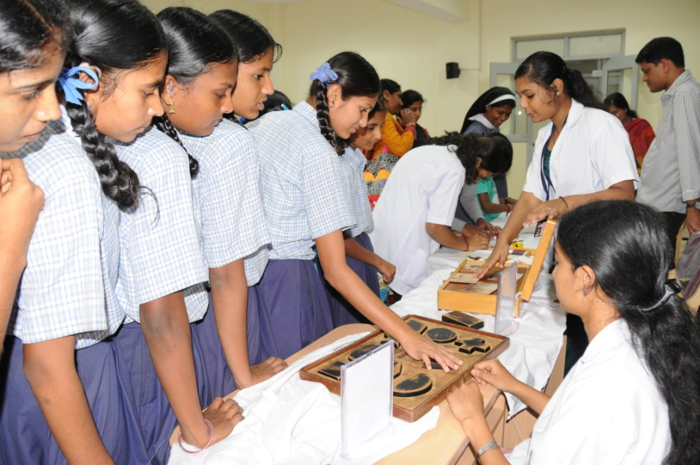

**Participation in Dasara Procession and Exhibition** The institute participated in Mysore Dasara festival celebrated on 25th September– 4th October, 2014 and presented a tableau depicting the misery of speech and hearing impairment in the procession held on 4th October. A sculpture was displayed at the Dasara exhibition to create awareness of communication disorders among the public. The sculpture won first prize of the Dasara Exhibition committee.

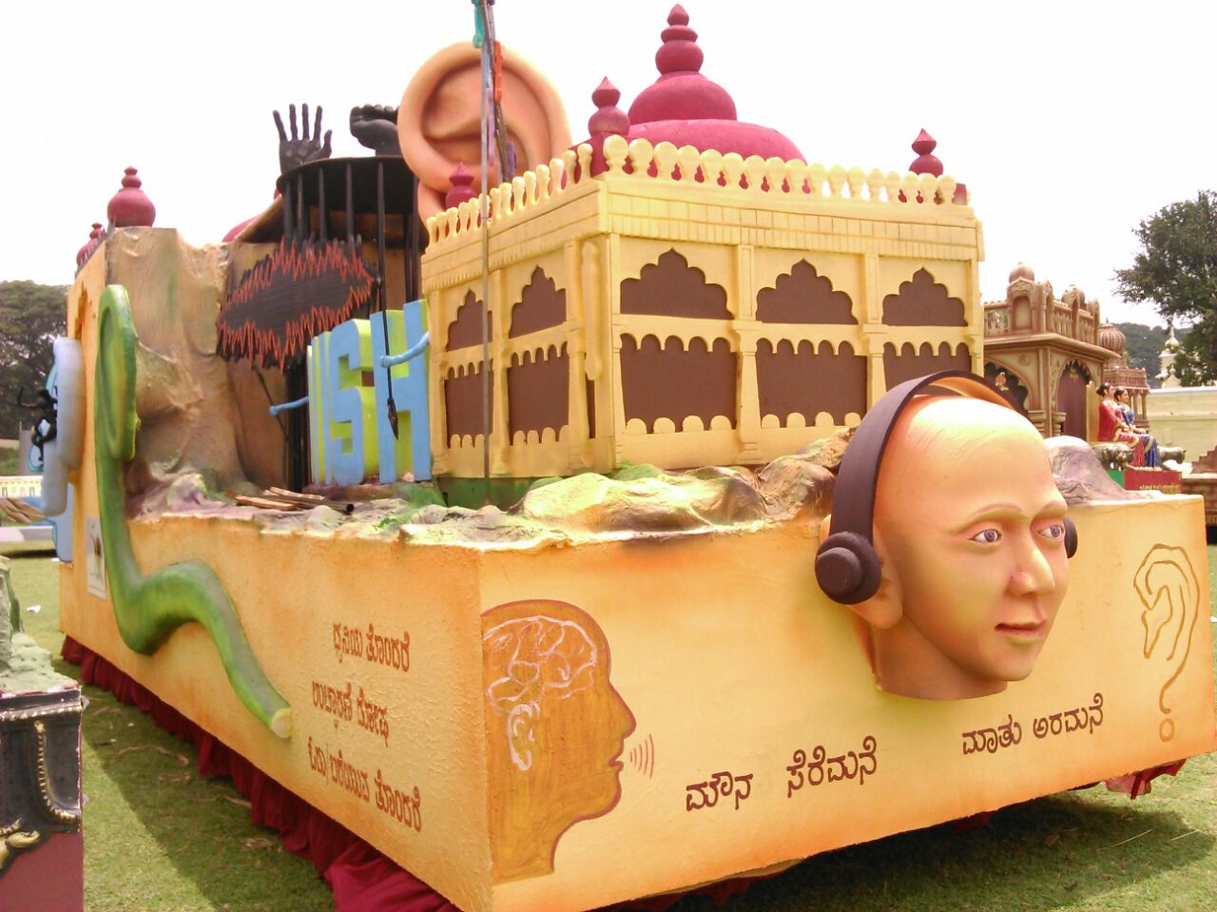

Tableau displayed at Dasara procession

Also, the Institute participated in Children’s Dasara Exhibition held at the Jagmohan palace, Mysore, and models depicting normal speech, language and hearing development were displayed and the general public were made aware of various speech, language and hearing disorders, its identification signs and the rehabilitation facilities.

**Organization of Street Play and Awareness Rallies**

As part of primary prevention, a street play on communication disorders was organized by the staff and students of the Institute under the aegis of the Dept. of POCD on 31st December, 2014 at YelandurTaluk, Chamarajanagara District. The theme includes hearing loss, mental retardation, stuttering, cerebral palsy and learning disability. Public education materials on communication disorders developed at the Institute were distributed among the public who attended the program.

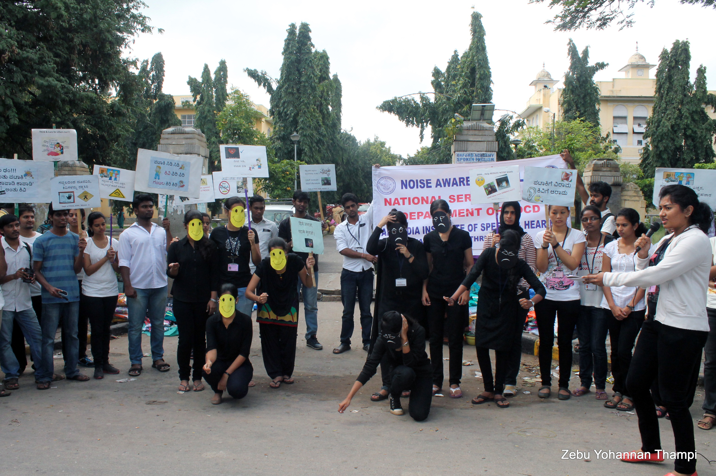

Street Play

A walkathon was organized on 20th September, 2014 on the eve of the World Alzemer’s day under the aegis of the NSS unit of the Institute in Mysore city. Sri Pratap Simha, Member of Parliament inaugurated the event. The participating volunteers educated the general public on Alzheimer’s disease and its related dementia during the walk.

In order to spread the harmful effects of noise on the eve of Diwali celebrations, a rally was organized in Mysore city under the aegis of the Dept. of POCD and the NSS Unit of the Institute on 18th October, 2014. Eighteen staff and 160 NSS volunteers participated in the rally which created awareness on noise control by presenting a tableau, reciting slogans and distribution of pamphlets and handouts.

A mini marathon with the theme Go for Hearing Aids was organized to spread awareness on wearing hearing aids among the persons with hearing impairment on 7th March 2015 in Mysore city. Sri. V. Srinivas Prasad, Hon’ble District In-charge and Revenue Minister, Govt. of Karnataka inaugurated the event. Dr. S. R.Savithri, Director, AIISH, Mysore and Prof. Ajish K. Abraham, Vice President of AIISH Gymkhana were present. The marathon covered a distanceof 5 kilometers in city. About 300 students and staff of the institute participated in the event.

**Observation of Commemorative Days**

The following commemorative days associated with speech and hearing and allied fields were observed at the institute to raise awareness, and hundreds of people from different walks of life attended them.

1. World Voice Day on 16th April, 2014.
2. International Stuttering Awareness Day on 28th October, 2014.
3. International Day of Persons with Disability on 3rd December, 2014.
4. National Cerebral Palsy Day on 24- 25 November, 2014

**Public Orientation Programmes**

In addition to the monthly public lecture series conducted at the institute campus, the institute organized 37 orientation lectures on prevention of communication disorders in various localities in Mysore and nearby districts under the aegis of the Department of Prevention of Communication Disorders. Totally, 1650 persons including senior citizens, students, industry workers, and teachers benefitted from these orientation programmes. The details are shown in the figure 20.

Figure 20: Public Orientation Programmes

**Mass media based Public Education**

Public Education on the prevention and control of communication disorders was also carried out through the print and electronic media. Some of the media based activities carried out during the reporting year are the following.

1. An article on Kids with Autism Don’t have Dedicated School was published in The Times of IndiaEnglish daily on 2nd April, 2014 in connection with the World Autism Day based on the input given by the Institute***.***
2. An article titled Indu Autism Jagruthi Dhinacharanewas published in Prajavani, Kannada daily on 2nd April, 2014 in connection with the World Autism Daybased on the input given by the Institute.
3. An article titled Your Voice Matters was published in The Hindu English daily on 16th April, 2014 based on the input given by Dr. Y.V. Geetha, Professor in Speech Sciences.
4. An article on Carriers in Hearing Aids was published in Vol. XXXIX (9) (31 May- 6 June, 2014) of the Employment News by Mr. N.Manohar, Lecturer in Electronics.
5. A radio talk on Newborn Screening for Communication Disorders was delivered by Dr. Jayashree C. Shanbal, Head, Department of POCD in Doctor’s Talk programme at All India Radio on 30th May, 2014.
6. An article titled Speech Palace was published in Samyukath Karnataka, Kannada dailyon institute activities on 28th June, 2014.
7. A radio show on communication disorders and the activities of the Institute was presented by the staff and students of the Institute in the Youth Programme of the All India Radio on 23rd July, 2014 and 13th August, 2014.
8. An article titled Stuttering Problem was published in The Hindu, English daily on 29th October, 2014 connection with the International Stuttering Awareness Day based on the input given by the Institute.
9. An interview with the Director, Dr. S. R. Savithri was published as a special feature article AIISH-Aiding Effective Communication on 18th January, 2015 in City Today, English daily.
10. A radio talk at All India Radio in ‘Paraspara Phone-in-program’ by Dr.K.S.Prema, Professor of Language Pathology and HOD-TCPD on 27th January 2015.

**Survey of Communication Disorders**

A survey of communication disorders by trained ASHA workers is going on as a part of an AIISH funded research project worth Rs. 48.23 lakhs in the districts of Mysore, Mandya and Chamarajanagara. In this regard, training for 77 ASHA workers was conducted on the topic Identification of Hearing and Speech and Language Disorders at the Institute. During the reporting year, the ASHA workers screened 84,033 persons staying in 17,253 households in 135 villages in Srirangapatna taluk, Mandya and 1419 among those screened were identified with various types of communication disorders. Totally, 157 were referred for Speech and Language therapy at the Institute and 15 attended the therapy.

