**OUTREACH SERVICES**

In addition to the diagnostic and therapeutic services provided within its walls, the institute carries out various outreach services on communication and its disorders in different parts of the country. The major outreach services during the reporting year are given below.

**Communication Disorder Screening Programmes**

The Institute conducted screening programmes for communication disorders in different settings and localities. The individuals participating in the programmes were checked for speech, language and hearing abilities and provided with diagnostic and therapeutic services. The screening programmes conducted in different settings are mentioned below.

Figure 17 : Screening done in different settings

**Newborn/Infant Screening**

This programme focuses on screening neonates and infants who are at risk for communication disorders using various tools such as High Risk Register for communication disorders, Behavioral Observation Audiometry, Oto Acoustic Emission Screening and Screening Checklists. During the reporting year, screening programme was carried out at 15 hospitals and three immunization centres in Mysore, six Outreach Service Centres of the Institute functioning in different parts of Karnataka and three Newborn Screening Centres functioning in hospitals attached with the AIISH DHLS centres, at Sriram Chandra Bhanj Medical College & Hospital, Cuttuck, Odisha, Regional Institute of Medical Sciences, Imphal, Manipur and Jawaharlal Nehru Medical College, Ajmer, Rajasthan and a total of 26334 new borns were screened. Of these, 5318 new borns (20.19%) were at risk for communication disorders. The details are given in table 28.

Table 28: Newborn/Infant Screening

|  |  |  |  |  |  |
| --- | --- | --- | --- | --- | --- |
| **SN** | **Hospitals/Immunization Centers** | **No. of children screened** | | | **No. children at risk for disorders** |
| **Male** | **Female** | **Total** |
| **Hospitals in Mysore** | | | | | |
| 1 | Apollo BGS Hospital (BAH), | 145 | 135 | 280 | 39 |
| 2 | Basappa Memorial Hospital (BMH) | 104 | 96 | 200 | 28 |
| 3 | Combined Hospital (CH) | 62 | 57 | 119 | 26 |
| 4 | Harsha Hospital (HH) | 42 | 34 | 76 | 14 |
| 5 | Kamakshi Hospital (KH) | 306 | 300 | 606 | 83 |
| 6 | KR Hospital (KRH) | 4813 | 4464 | 9277 | 2025 |
| 7 | Makkalakoota Immunization Center (MIC) | 93 | 139 | 232 | 51 |
| 8 | Mission Hospital (MH) | 365 | 304 | 669 | 142 |
| 9 | Immunization Center at Mission Hospital (ICMH) | 37 | 31 | 68 | 23 |
| 10 | N.P.C Hospital | 50 | 33 | 83 | 10 |
| 11 | S.M.T.D.H Hospital | 291 | 235 | 526 | 97 |
| 12 | Railway Hospital (RH) | 25 | 21 | 46 | 9 |
| 13 | Employees State Insurance (ESI) Hospital | 17 | 20 | 37 | 7 |
| 14 | Ashwini Nursing Home (ANH) | 88 | 45 | 133 | 36 |
| 15 | Shree Devi Nursing Home (SNH) | 84 | 68 | 152 | 35 |
| 16 | GopalaGowdaShanthaveri Memorial Hospital (GGSMH) | 37 | 33 | 70 | 18 |
| 17 | Family Planning Association Immunization (FPAI) center | 124 | 96 | 220 | 42 |
| 18 | Mahadeshwara Nursing Home (MNH) | 76 | 51 | 127 | 23 |
| **Total** | | **6759** | **6162** | **12921** | **2708** |
| **Outreach Service Centers** | | | | | |
| 19 | Sub-divisional hospital, K R Nagar | 272 | 268 | 540 | 86 |
| 20 | Sub-divisional hospital, T Narsipura | 207 | 171 | 378 | 65 |
| 21 | Sub-divisional Hospital, SagaraTaluk | 32 | 25 | 57 | 0 |
| 22 | Primary Health Centre (PHC), Hullahalli | 117 | 92 | 209 | 16 |
| 23 | Community Health Centre (CHC), Santhemarahalli | 178 | 187 | 365 | 57 |
| 24 | Primary Health Centre (PHC), Akkihebbalu | 25 | 20 | 45 | 7 |
| **Total** | | **831** | **763** | **1594** | **231** |

|  |  |  |  |  |  |
| --- | --- | --- | --- | --- | --- |
| **Newborn screening centres** | | | | | |
| 25 | Sri Ramachandra Bhanj Medical College and Hospital (SCB MCH), Cuttack | 1334 | 934 | 2268 | 445 |
| 26 | Regional Institute of Medical Sciences (RIMS), Imphal | 2287 | 2243 | 4530 | 113 |
| 27 | Janana Hospital & JLNMCH, Ajmer | 3343 | 1678 | 5021 | 458 |
|  | **Total** | **6964** | **4855** | **11819** | **1016** |
| **Grand Total** | | **14,554** | **11,780** | **26,334** | **5,318** |

Of these, 380 children underwent follow-up evaluation in all the centres. They were administered a complete test battery.

**Industrial Screening**

Hearing evaluation of industrial workers, were carried out for the employees working in Karnataka Silk Industries Company (KSIC), Mysore. One forty three ears of the 117 employees screened were found to have hearing impairment on administration of complete audiological test battery. The persons with hearing impairment were given rehabilitation services.

In addition to the services provided at their work settings, the industrial workers were encouraged to undergone hearing evaluation at the Institute clinical settings. Totally, 245 employees working with KSIC, Rane Madras and Bhaba Atomic Research Centre availed clinical service at the Institute during the report year and 282 (57.5%) ears had hearing impairment. All the employees were counseled on the importance of hearing protection devices and the need for using it regularly in noisy conditions to protect their hearing ability.

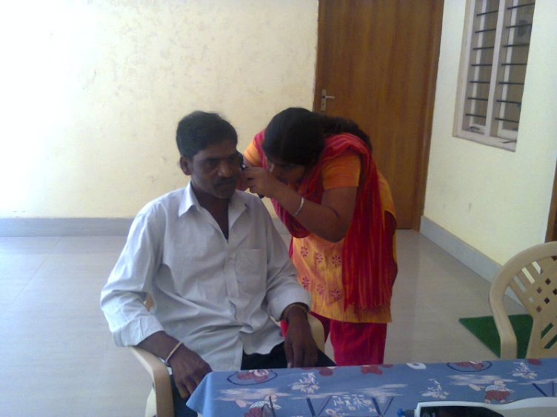

Industrial screening

**School Screening**

Nursery and primary school students of various Schools in Mysore and Tumkur districts were screened for communication disorder as a part of the school screening program during the reporting year. Totally 5247 students were screened and among them 1052 (20.04%) were identified with ear related disorders, 67 (1.27%) with hearing loss and 563 (10.72%) with speech-language disorders. They were recommended for follow-up at the Institute.

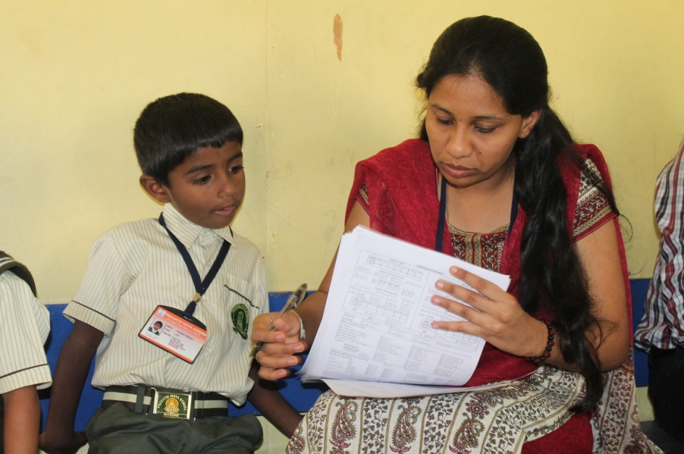

Screening of schoolchildren for communication disorders

**Elderly Screening**

Speech, language and hearing evaluations were carried out for elderly citizens residing in different old age homes in Mysore. One hundred and seventy persons underwent evaluations. Of these 73 (42.94%) had hearing problems, 4 (2.35%)speech problems, and 24(14.11%) multiple disorders.

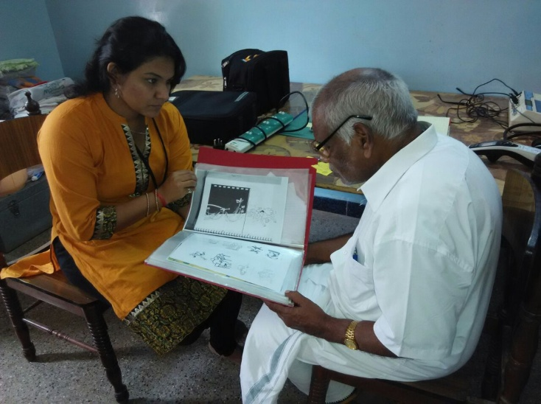

Elderly screening

**Camp based Screening**

The Institute organized nine camps in various localities across Karnataka, and Kerala and Gujarat. The expert speech and hearing and allied health professionals of the institute screened 1812 persons for communication disorders in the camps. The details are given in table 29.

Table 29: Camp based screening

|  |  |  |  |  |  |  |
| --- | --- | --- | --- | --- | --- | --- |
| **Place** | **Organizers** | **Month** | **Persons screened/ evaluated** | **Diagnosis** | | |
| **ENT disorders** | **Hearing loss** | **Speech- language disorders** |
| Hospet, Karnataka | Lions Club, Hospet | June, 2014 | 393 | - | 263 | 95 |
| Mysore, Karnataka | Mysore City Corporation,Mysore | June, 2014 | 126 | 16 | 16 | 72 |
| Periyapatna, Karnataka | SSA, Mysore, | July, 2014 | 12 | - | 11 | - |
| Mysore, Karnataka | SSA, Mysore, | July, 2014 | 80 | - | 79 | - |
| H.D. Kote, Karnataka | SSA, Mysore, | July, 2014 | 20 | - | 7 | 13 |
| Hunsur | SSA, Mysore | July, 2014 | 35 | - | 12 | 23 |
| Calicut, Kerala | Lions Club, Perambra | December, 2014 | 295 | 8 | 170 | 116 |
| Ahmedabad, Gujarat | NSS Unit, AIISH | February,2015 | 710 | - | 162 | - |
| Udupi, Karnataka | Lions Club Midtown, Udupi | March, 2015 | 141 | - | 85 | 48 |
| **Total** | | | **1812** | **18** | **805** | **200** |

**Clinical Services at the Outreach Service Centres**

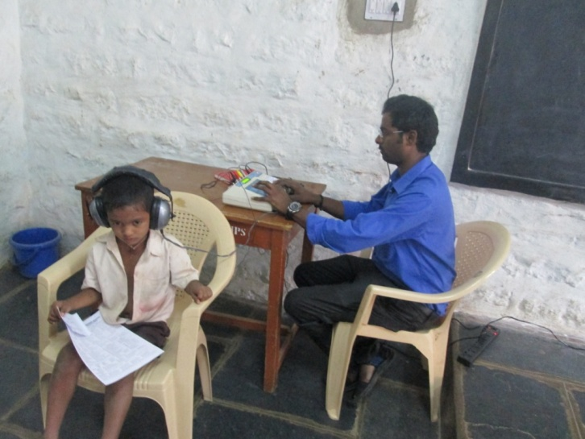

Hearing test in Outreach Service Centre

Diagnostic and therapeutic services on communication disorders were provided at the four Outreach Service Centres of the institute located in sub-divisional taluk hospital at Sagara taluk, Shivamoga and the Primary Health Centres at Hullahalli, Mysuru, Akkihebbalu, Mandya and Gumballi, Chamarajanagara. Totally, 2111 persons availed the services the details are given in table 30. Thirty six persons (1.70%) identified with speech-language disorders underwent therapy in 303 sessions. Also, 142 hearing aids were distributed among the persons identified with hearing impairment.

Table 30: Clinical services at the Outreach Service Centres

|  |  |  |  |  |
| --- | --- | --- | --- | --- |
| **Outreach Service Centres** | **Total persons registered** | **Diagnosis** | | |
| **ENT Disorder (Ear wise)** | **Hearing Disorder**  **(Ear wise)** | **Speech & Language Disorder (Individuals)** |
| Primary Health Centre,Hullahalli | 888 | 1229 | 281 | 34 |
| Primary Health Centre,Akkihebbalu | 475 | 762 | 238 | 20 |
| Primary Health Centre, Gumballi | 748 | 954 | 430 | 43 |
| Sub-divisional Hospital, Sagara | 9 | 0 | 16 | 1 |
| Total | **2111** | **2945** | **965** | **98** |

**Tele-Intervention and Tele-Assessment Services**

Tele-assessment and tele-intervention services were offered to Persons with Communication Disorders at the DHLS centres of the Institute located in different parts of the country through AIISH video conferencing system. The Tele Centre for Persons with Communication Disorder also offered the tele-intervention and tele-assessment services through Skype, the popular web based communication tool. The details are given in tables 31 and 32 and figures 18 and 19.

Table 31: Tele Intervention and Tele Assessment Services through Videoconferencing

|  |  |  |  |  |  |  |  |  |  |  |  |  |
| --- | --- | --- | --- | --- | --- | --- | --- | --- | --- | --- | --- | --- |
| Services | Phonological / articulation | | Fluency | | Voice | | Language | | Multiple | | Total | |
| C | S | C | S | C | S | C | S | C | S | C | S |
| Tele Assessment | 5 | | 11 | | 4 | | 22 | | 1 | | 43 | |
| Tele Intervention | 6 | 11 | 22 | 33 | 7 | 9 | 49 | 56 | 4 | 7 | 88 | 116 |

C-Clients; S-Sessions

Figure 18: Tele-intervention through videoconferencing

Table 32: Tele Intervention and Tele Assessment Services through Skype

|  |  |  |  |  |  |  |  |  |  |  |  |  |
| --- | --- | --- | --- | --- | --- | --- | --- | --- | --- | --- | --- | --- |
| Services | Phonological / articulation | | Fluency | | Voice | | Language | | Multiple | | Total | |
| C | S | C | S | C | S | C | S | C | S | C | S |
| Tele Assessment | - | | 5 | | 1 | | 32 | | 3 | | 41 | |
| Tele Intervention | - | - | 4 | 36 | 1 | 16 | 27 | 436 | 2 | 44 | 34 | 532 |

C-Clients; S-Sessions

Figure 19: Tele-intervention through skye

**Tele-Educational Guidance and Counseling**

Educational guidance and counseling were given to 8 parents of children with communication disorders at the DHLS centres through videoconferencing and Skype on various topics related to the education of children with special needs and on the government sponsored beneficiary schemes.

**Mainstream School Adoption**

In order to ensure proper care for the children with communication disorders, studying in normal schools, a mainstream school adoption programme was initiated and 6 schools were adopted and 70 teachers in these schools were oriented on identification of special needs in children, curricular adaptation and management of their special educational needs in the inclusive learning environments.

**Itinerant Service**

The Institute offered itinerant service on prevention and control of communication disorders for the regular school and Anganwaadi children through the Itinerant Speech Therapist and Medical Social Worker. The service was provided at 32 schools and 22 Anganwaadis in Mysore district and 129 children identified with various types communication disorders were referred to AIISH for evaluation, and 185 teachers/ Anganwaadi workers were oriented on prevention and control of communication disorders during the reporting year. In addition, follow-up of 77 regular school children availing therapy at AIISH were carried out, 61 teachers and 13 parents oriented and 54 parents counseled on school placement.