Clinical Care

The Institute offers a comprehensive range of clinical services pertaining to communication disorders. These include general speech, language and hearing assessment and rehabilitation and a wide range of specialized testing and treatment services. Also, it offers psychological and otorhinolagyngolical assessment and rehabilitation and various medical specialty services to the persons with communication disorders.

Patient Registration
Totally 63,450 persons were registered for availing clinical services at the institute during the reporting year. This includes 22,650 new and 40,800 review cases. The geographical details of new clients are given in table 13. Majority of them (21346) were from Karnataka, the state in which the institute is located, followed by the neighboring states of Kerala (803), Andra Pradesh (206) and Tamil Nadu (161). There were 6 clients from north-east region. In addition, there were 11 clients from abroad. Females (8550) outnumbered males (14100) in availing clinical services.
Table 11: State & Gender wise distribution of new clients
Sl. No. | State / Union Territories | Male | Female | Total
 | Andra Pradesh | 150 | 56 | 206
 | Assam | 2 | 2 | 4
 | Bihar | 14 | 1 | 15
 | Delhi | 6 | 1 | 7
 | Goa | 3 | 0 | 3
 | Gujarat | 3 | 0 | 3
 | Hariyana | 1 | 1 | 2
 | Jharkhand | 8 | 4 | 12
 | Karnataka | 13214 | 8122 | 21336
 | Kashmir | 1 | 1 | 2
 | Kerala | 522 | 281 | 803
 | Madhya Pradesh | 5 | 5 | 10
 | Maharastra | 17 | 8 | 25
 | Orissa | 8 | 4 | 12

 | Punjab | 1 | 0 | 1
 | Rajasthan | 8 | 2 | 10
 | Tamil Nadu | 115 | 46 | 161
 | Tripur | 1 | 1 | 2
 | Uttar Pradesh | 6 | 3 | 9
 | Uttaranchal | 1 | 0 | 1
 | West Bengal | 7 | 8 | 15
22. | Union Territories | 1 | 0 | 1
 | Other countries
1. | Afghanistan | 1 | 0 | 1
2. | U S A | 1 | 0 | 1
3. | Dubai (U A E) | 0 | 1 | 1
4. | Maldives | 4 | 1 | 5
5. | Nepal | 1 | 1 | 2
 |  | 14101 | 8549 | 22650

Totally, 11,586 persons with various communication disorders availed speech- language therapy, physiotherapy, occupational therapy, listening training and other special clinic therapies in 66,745 sessions.

Speech and Language Assessment and Rehabilitation
The speech and language outpatient unit evaluated 8910 clients which includes 7202 new and 1708 review cases. Of the new cases, 6812 were identified with various kinds of speech and language disorders and 390 were found to have normal speech. The details of clients with speech and language disorders along with the category of disorders are given in table 12 and figure 4.

Table 12 : Assessment of speech-language disorders
Disorders | Language Disorders |  |  | Fluency Disorders |  |  | Voice Disorders |  |  | Articulation Disorders |  |  | Multiple Disorders |  |  | Normal |  |  | Total
Months | C | A | G | C | A | G | C | A | G | C | A | G | C | A | G | C | A | G | Total
April | 376 | 33 | 5 | 69 | 19 | 0 | 23 | 24 | 5 | 69 | 6 | 6 | 61 | 10 | 1 | 19 | 9 | 5 | 740
May | 445 | 36 | 10 | 78 | 28 | 0 | 11 | 32 | 13 | 60 | 15 | 5 | 43 | 5 | 0 | 27 | 12 | 1 | 821
June | 414 | 63 | 5 | 28 | 22 | 0 | 9 | 32 | 11 | 30 | 10 | 3 | 67 | 7 | 1 | 27 | 8 | 1 | 738
July | 320 | 52 | 15 | 20 | 41 | 0 | 6 | 32 | 17 | 24 | 8 | 2 | 73 | 10 | 0 | 14 | 10 | 1 | 645
Aug | 276 | 41 | 4 | 17 | 13 | 0 | 2 | 17 | 12 | 20 | 5 | 1 | 7 | 1 | 0 | 20 | 11 | 2 | 449
Sept | 317 | 55 | 9 | 25 | 16 | 0 | 6 | 24 | 14 | 37 | 3 | 3 | 25 | 4 | 0 | 16 | 11 | 0 | 565
Oct | 265 | 61 | 7 | 49 | 20 | 0 | 4 | 23 | 5 | 53 | 11 | 2 | 36 | 3 | 0 | 31 | 14 | 0 | 584
Nov | 256 | 40 | 3 | 11 | 15 | 1 | 5 | 19 | 13 | 34 | 6 | 0 | 54 | 11 | 1 | 27 | 10 | 1 | 507
Dec | 374 | 58 | 14 | 2 | 29 | 24 | 12 | 32 | 12 | 51 | 14 | 2 | 78 | 0 | 0 | 30 | 0 | 0 | 732
Jan | 311 | 47 | 0 | 34 | 10 | 1 | 15 | 16 | 3 | 33 | 2 | 5 | 4 | 2 | 0 | 15 | 1 | 1 | 500
Feb | 197 | 62 | 10 | 25 | 8 | 0 | 7 | 28 | 16 | 31 | 1 | 2 | 24 | 3 | 0 | 15 | 11 | 0 | 440
March | 224 | 48 | 3 | 24 | 20 | 0 | 3 | 30 | 14 | 26 | 7 | 4 | 34 | 5 | 0 | 27 | 10 | 2 | 481
Total | 3775 | 596 | 85 | 382 | 241 | 26 | 103 | 309 | 135 | 468 | 88 | 35 | 506 | 61 | 3 | 268 | 107 | 14 | 9301
Disorder Wise Total | 4456+1518  (repeat cases) |  |  | 649+67 (repeat cases) |  |  | 547+46 (repeat cases) |  |  | 591+77 (repeat cases) |  |  | 570 |  |  | 390 |  |  | 9301
Grand total | 9301
C- Child, A-Adult, G-Geriatric

Clients requiring further management were given various speech/language therapies depending upon the type and severity of disorder, for daily sessions of 45 minutes duration. A total of 35129 therapy sessions were conducted for 5711 persons with speech/ language disorders during the reporting year. The details of disorder- wise therapy carried out are given in table 13.
Table 13: Speech-Language Therapy
Disorders | Language Disorders |  |  | Voice Disorders |  |  | Articulation Disorders |  |  | Multiple Disorders |  |  | Total
Months | C | A | G | C | A | G | C | A | G | C | A | G | Total
April | 420 | 5 | 10 | 6 | 19 | 5 | 21 | 0 | 0 | 56 | 0 | 0 | 542
May | 254 | 5 | 5 | 3 | 11 | 6 | 14 | 1 | 0 | 39 | 0 | 0 | 338
June | 164 | 0 | 4 | 0 | 7 | 3 | 5 | 3 | 0 | 18 | 1 | 0 | 205
July | 388 | 6 | 12 | 5 | 11 | 7 | 14 | 4 | 0 | 57 | 1 | 1 | 506
Aug | 481 | 7 | 13 | 7 | 14 | 11 | 15 | 1 | 0 | 69 | 1 | 0 | 619
Sept | 414 | 6 | 7 | 3 | 16 | 6 | 7 | 1 | 2 | 47 | 0 | 1 | 510
Oct | 439 | 12 | 12 | 3 | 11 | 5 | 19 | 1 | 0 | 57 | 0 | 0 | 559
Nov | 260 | 8 | 12 | 3 | 13 | 9 | 25 | 2 | 1 | 32 | 0 | 0 | 365
Dec | 339 | 13 | 9 | 2 | 6 | 8 | 19 | 3 | 1 | 28 | 0 | 0 | 428
Jan | 374 | 7 | 6 | 1 | 13 | 9 | 19 | 1 | 0 | 51 | 1 | 0 | 482
Feb | 480 | 12 | 6 | 7 | 13 | 10 | 19 | 1 | 0 | 34 | 3 | 0 | 585
March | 465 | 11 | 9 | 3 | 19 | 10 | 19 | 1 | 0 | 35 | 0 | 0 | 572
Total | 4478 | 92 | 105 | 43 | 153 | 89 | 196 | 19 | 4 | 523 | 7 | 2 | 5711
Disorder Wise | 4675 |  |  | 285 |  |  | 219 |  |  | 532 |  |  | 5711
Over All | 5711
C- Child, A- Adult, G- Geriatric
Language Disorder - Paediatric | Language Disorder – Adult | Language Disorder - Geriatric
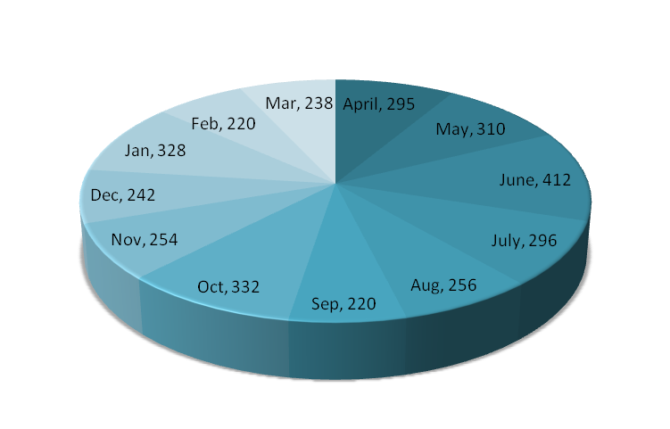 | 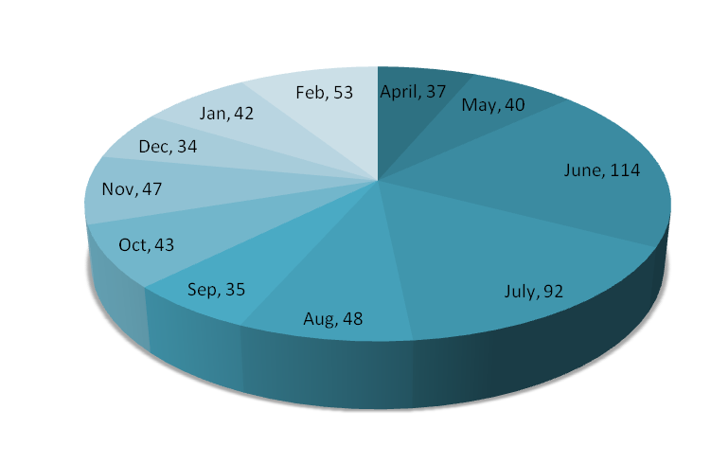 | 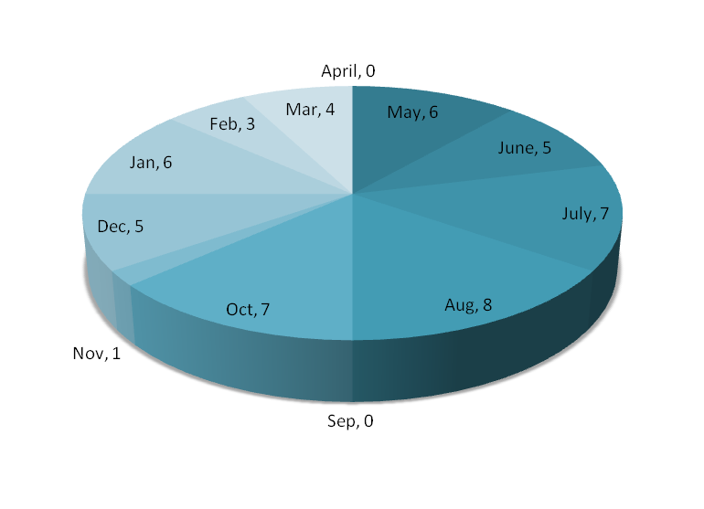
Voice Disoder – Pediatric | Voice Disorder – Adult | Voice Disorder – Geriatric
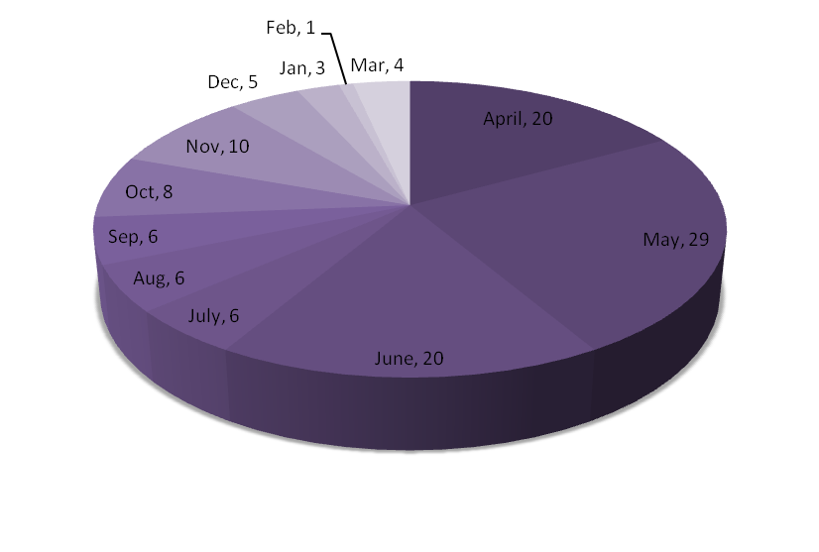 | 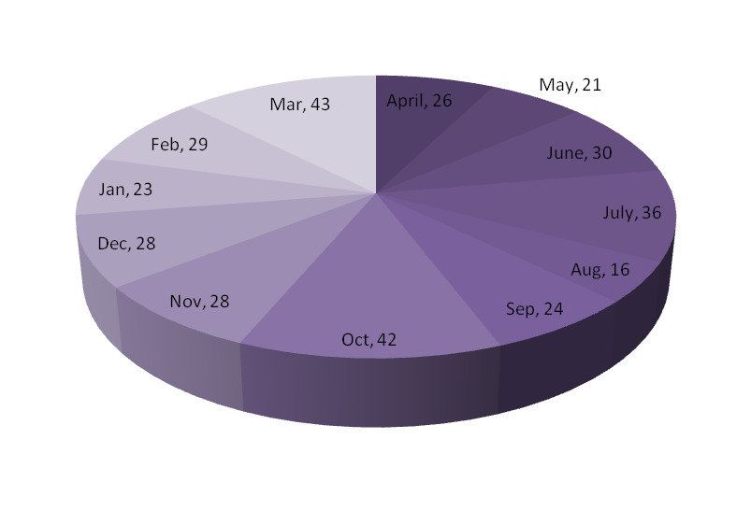 | 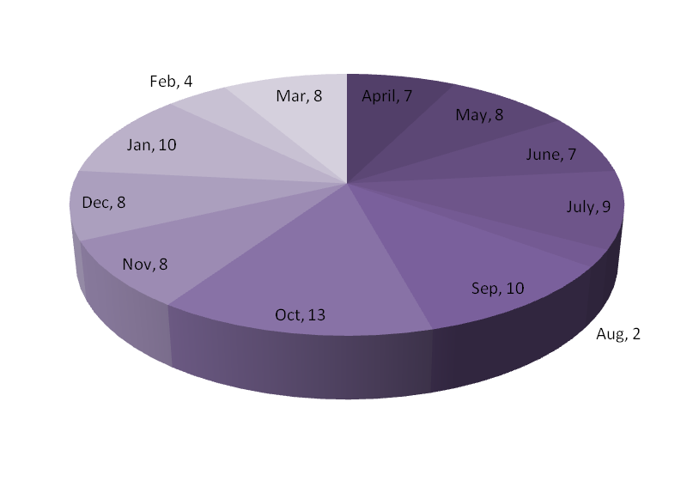
Fluency Disorder – Pediatric | Fluency Disorder – Adult | Fluency Disorder – Geriatric
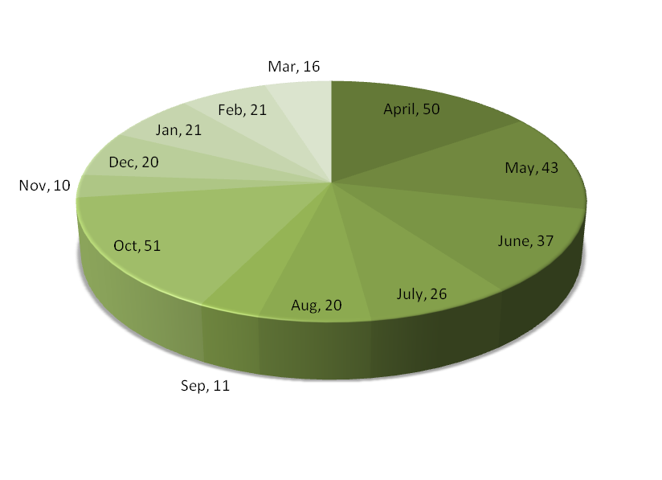 | 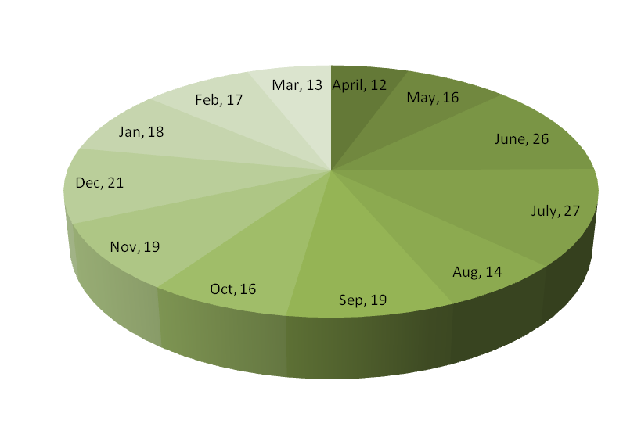 | 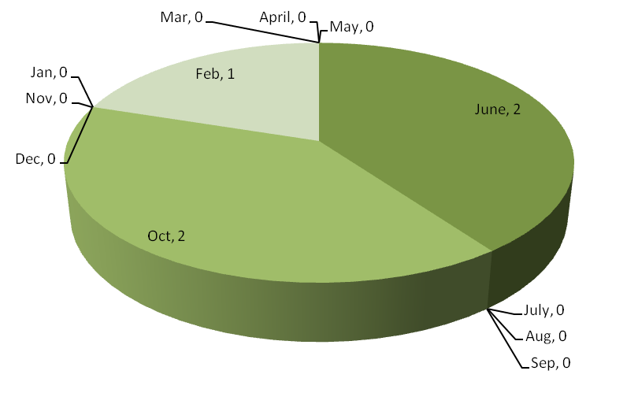
Articulation Disorder - Pediatric | Articulation Disorder – Adult | Articulation Disorder – Geriatric
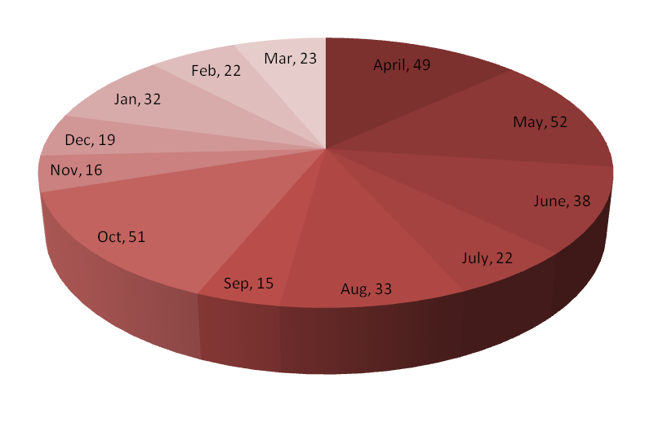 | 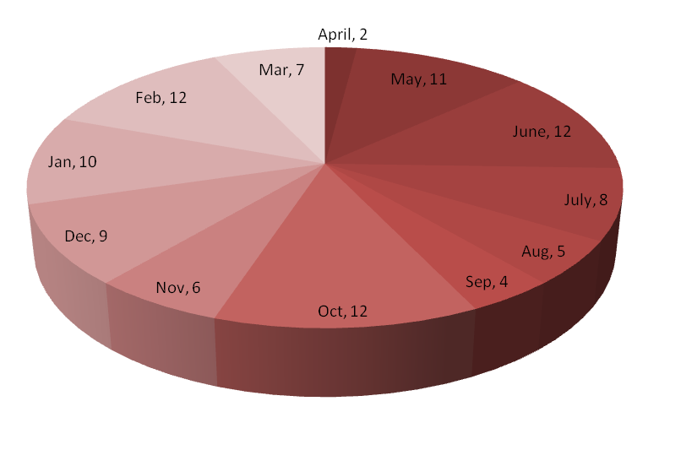 | 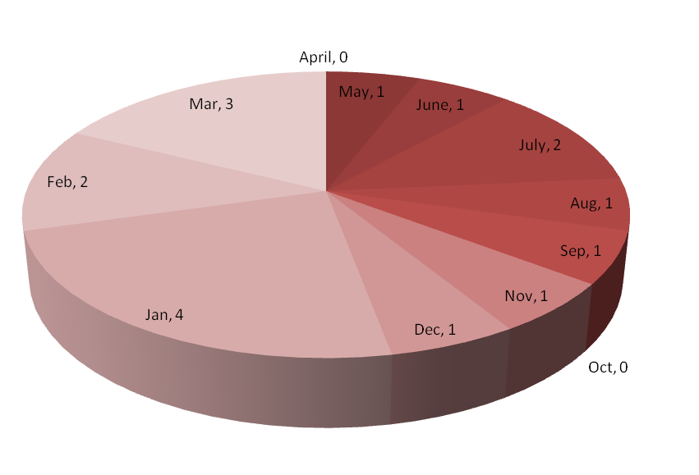
Multiple Disorder- Pediatric | Multiple Disorder – Adult | Multiple Disorder – Geriatric
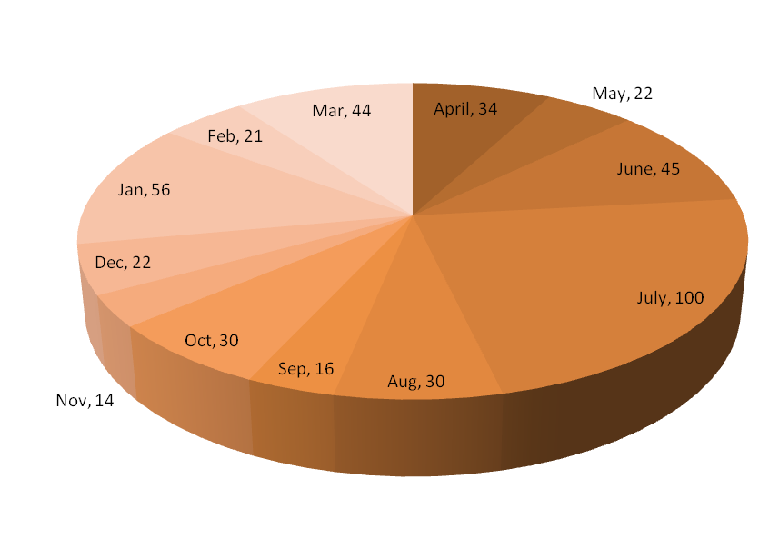 | 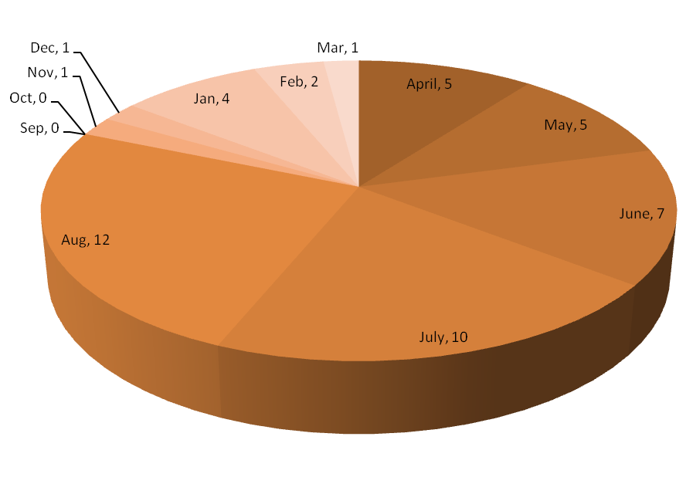 | 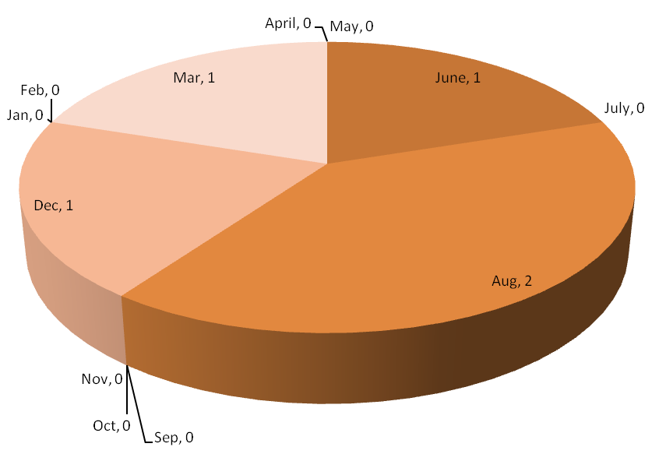
Normal - Pediatric | Normal – Adult | Normal – Geriatric
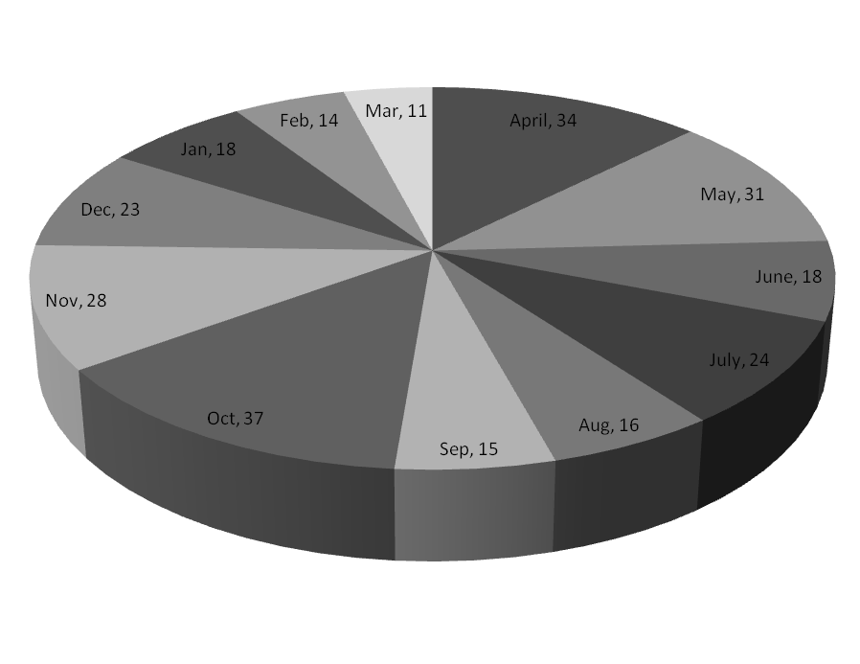 | 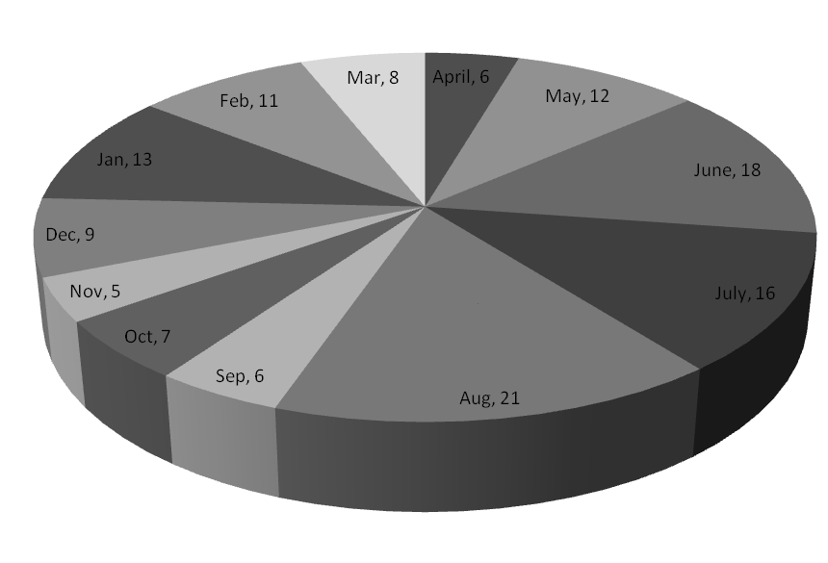 | 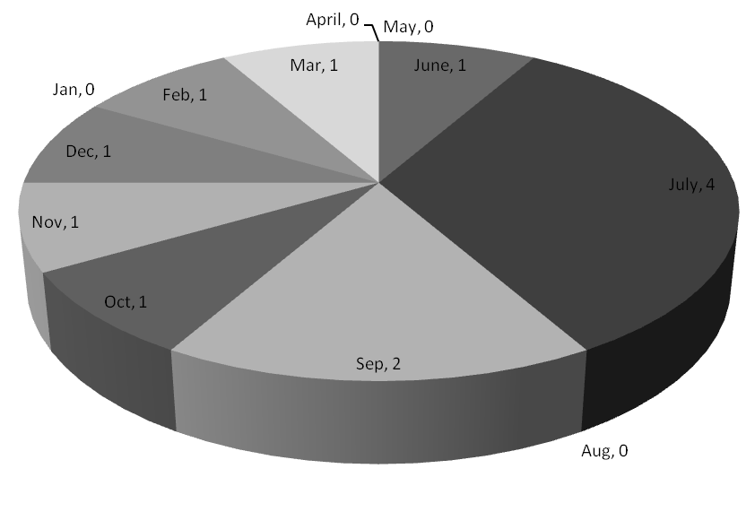
Figure 4: Speech-Language Therapy
Speech and language assessment and therapeutic services were also provided at the nine DHLS centres of the Institute located in different parts of the country, the details of which are given in table 14.
Table 14: Speech-language clinical services at the DHLS Centres
Centers | Assessment |  |  |  |  | Therapy
Centers | Language | Voice | Phonology | Fluency | MSD/  Dysphasia | Language | Voice | Phonology | Fluency | MSD/  Dysphasia
Ranchi | 113 | 4 | 9 | 52 | 0 | 178 | 10 | 8 | 212 | 00
Cuttack | 190 | 18 | 53 | 87 | 00 | 86 | 8 | 33 | 64 | 00
Ajmer | 132 | 43 | 118 | 102 | 00 | 337 | 29 | 136 | 188 | 00
Lucknow | 23 | 10 | 30 | 36 | 00 | 74 | 41 | 103 | 106 | 00
Mumbai | 795 | 15 | 16 | 25 | 34 | 1081 | 21 | 18 | 27 | 50
New Delhi | 8 | 9 | 5 | 4 | 00 | 8 | 24 | 5 | 4 | 00
Shimla | 56 | 198 | 71 | 46 | 00 | 112 | 126 | 126 | 73 | 00
Bhagalpur | 76 | 8 | 1 | 12 | 00 | 1 | 00 | 00 | 00 | 2
Mysore | 50 | 3 | 4 | 5 | 5 | 00 | 00 | 00 | 00 | 00
Total | 1443 | 308 | 307 | 369 | 39 | 1877 | 259 | 429 | 674 | 52

Audiological assessment and rehabilitation
Hearing Evaluation: The hearing evaluation section of the Department of Audiology specializes in assessment of the hearing abilities of the individuals. During the reporting year, the Section evaluated 14762 by administering various audiological tests such as pure tone audiometry, speech audiometry and otoacoustic emission and threshold-equalizing noise test. Totally, 29524 ears were diagnosed with different degrees of hearing loss including severe (4959) and profound (4605) cases. Further, different types of hearing loss such as sensori neural loss, mixed, conductive, auditory processing disorders and auditory dys-synchrony were identified during the evaluation. The details of hearing evaluation and diagnosis are given in Table 15 and figures 5-8.
Table 15: Details of hearing evaluation
Hearing Evaluation | Total
Clients seen | 14762
Types of Evaluation
Audiotry brainstem response audiometry | 3913
Behavioural observation audiometry | 709
Immittance evaluation | 14022
Otoacoustic emission test | 3167
Pure tone audiometry | 13556
Speech Audiometry | 12881
Tinnitus evaluation | 242
Vestibular evoked myogenic potentials test | 28
Clients for VRA | 159
Degrees of hearing loss diagnosed
Ears with Normal hearing | 4780
Ears with diff degrees of HL | 29524
· Minimal | 2640
· Mild | 3535
· Moderate | 4214
· Moderately severe | 4238
· Severe | 4959
· Profound | 4605
. Minimal to mild | 77
. Minimal to moderate | 20
. Mild to moderate | 79
. Mod.to modtly severe | 76
. Moderate to severe | 8
. Severe to profound | 84
. Modtly severe to sev. | 90
. Sloping | 73
. Mod. to modtly. sev.sloping | 11
. Modtly sev. to sev. sloping | 8
. Mild to moderate | 27
Types of hearing loss diagnosed
Ears tested | 17619
. Conductive hearing | 3348
. Mixed hearing loss | 4758
. SN hearing loss | 9423
Other hearing disorders diagnosed
Clients with unilateral hearing loss | 2458
Clients with bilateral hearing loss | 9594
Ears with Auditory dys-synchrony | 84
Clients with auditory processing disorders | 21
Clients with functional hearing loss | 126

Figure 5: Type of evaluation | Figure 6: Degree of hearing loss diagnosed
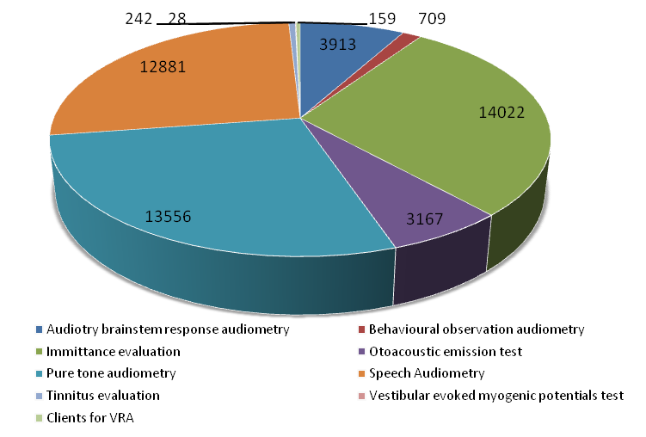 | 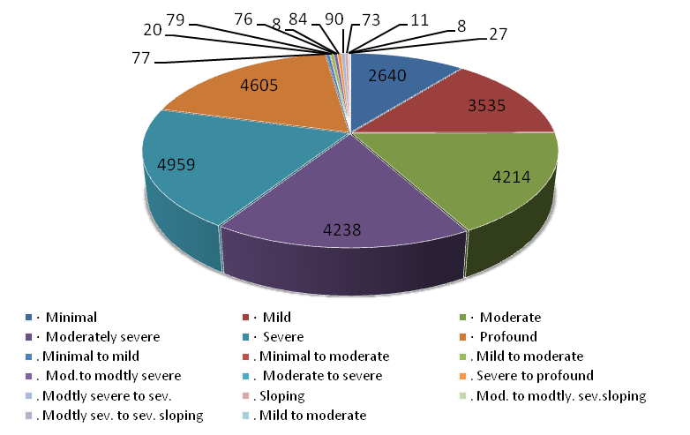

Figure 7: Types of hearing loss diagnosed | Figure 8: Other hearing disorders diagnosed
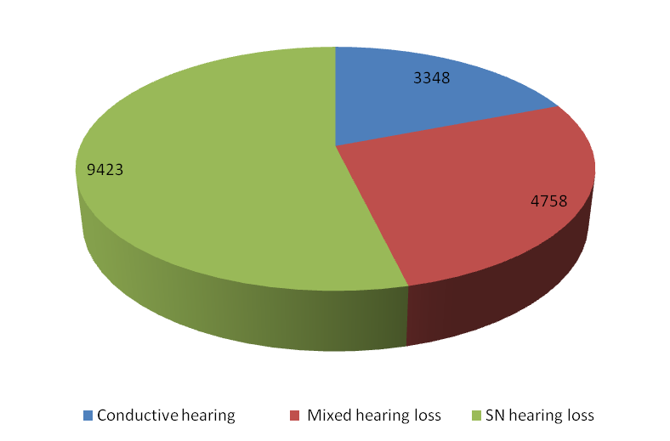 | 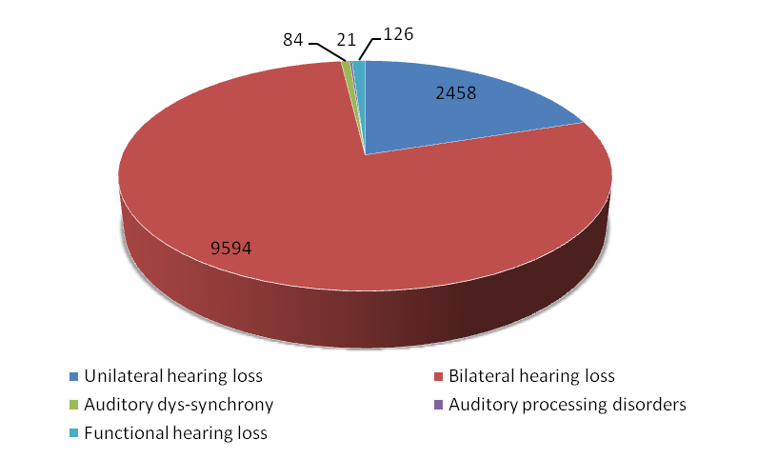

Hearing aid trial was done for 10453 clients to determine the appropriate hearing aids and assistive learning devices. The candidacy for cochlear implants was also determined. The detailed statistics on hearing aid trial and hearing aids prescribed during the report year are given in table 16.
Table 16 : Hearing aid trial and prescription
Hearing Aid Trial | Total
Clients evaluated for hearing devices | 10453
Hearing Aids prescribed at AIISH | 6427
Types of hearing aids distributed
. ADIP scheme | 3707
. Body level hearing aid | 45
· Analogue BTE | 4
· Digital BTE | 2465
· Trimmer Digital BTE | 28
· Digital ITE | 2
· Digital ITC | 34
· Digital CIC | 16
. Digital RIC | 126
Hearing aids prescribed on exchange | 150
Recommendations to clients | 4209
· Auditory training | 3265
· Speech reading | 944
Unaided/aided audiograms | 871
Aided VRA | 433
Programming of digital hearing aids | 1609
No. of IGO done | 56
EAC of hearing aids done | 257
Recomd. for retrial with CEM | 705
Recommended for ear plugs | 41
Unaided & aided LLR done | 20

The ear mould laboratory made custom ear moulds for the clients who were prescribed hearing aids. Totally 8306 ear impressions of 5627 clients were taken during the reporting year and 4000 ear moulds were made free of cost. The detailed ear mould statistics are given in table 17.
Table 17: Ear mould statics
Earmold lab | Total
Clients for whom ear impression taken | 5627
- New clients | 4220
- Old clients | 1407
Ear impressions taken | 8306
Ear moulds made free-of-cost | 4000
Ear moulds made on payment | 4306
Ear Moulds completed | 8478
Ear moulds issued | 7520
Hard regular moulds made | 3713
Hard shell mould made | 12
Soft mould made | 4284
Soft canal moulds | 41
ITC impression made | 54
Swimmer plug (soft) | 157
No. of ear blocked | 42
EMs with aco. modificns. | 3
Clients seen at camp | 608
Ear impressions taken-camp | 1120
CPL impressions received | 16
CPL moulds completed | 16
Def. ear imp recd by CPL | 0

Age-wise statistics of clients seen in Hearing Evaluation, Hearing Aid Trial & Counseling sections and Ear Mold laboratory are given in table 18 and figure 9. Audiological assessment and rehabilitation services were also provided at the nine DHLS centres of the Institute located throughout the country, the details of which are given in table 19.

Table 18: Age-wise Audiological Assessment
Age group  in years | HE |  | HAT |  | EM
Age group  in years | Male | Female | Male | Female | Male | Female
00-01 | 164 | 84 | 145 | 104 | 89 | 65
02-05 | 991 | 749 | 1301 | 960 | 743 | 582
06-10 | 675 | 507 | 693 | 444 | 321 | 238
11-15 | 424 | 331 | 355 | 256 | 218 | 155
16-20 | 441 | 331 | 289 | 174 | 170 | 119
21-25 | 472 | 335 | 212 | 127 | 137 | 82
26-30 | 470 | 273 | 165 | 112 | 93 | 58
31-35 | 439 | 303 | 169 | 91 | 94 | 62
36-40 | 414 | 332 | 174 | 137 | 150 | 59
41-45 | 422 | 338 | 205 | 129 | 94 | 78
46-50 | 458 | 338 | 252 | 170 | 166 | 87
51-55 | 583 | 362 | 339 | 202 | 171 | 103
56-60 | 570 | 418 | 425 | 240 | 170 | 112
61-65 | 638 | 356 | 514 | 266 | 195 | 102
66-70 | 579 | 342 | 523 | 276 | 292 | 176
71-75 | 513 | 218 | 494 | 216 | 205 | 130
76-80 | 376 | 150 | 411 | 144 | 212 | 82
81-85 | 186 | 76 | 200 | 84 | 121 | 36
86-90 | 62 | 24 | 70 | 21 | 48 | 23
91+ | 33 | 12 | 36 | 9 | 25 | 8
Total | 8910 | 5852 | 6988 | 4162 | 3714 | 2357
Grand Total | 14762 |  | 11150 |  | 6071

Figure 9: Agewise audiological assessment

Table 19: Audio logical services at the DHLS Centres
Centers | OPD  (Case history) | Evaluation | Ear moulds | Hearing aid trail (HAT) | Listening Therapy
Ranchi | 2318 | 2396 | 00 | 00 | 14
Cuttack | 4450 | 4450 | 00 | 00 | 324
Ajmer | 1797 | 2069 | 00 | 00 | 209
Lucknow | 00 | 5465 | 00 | 00 | 3
Mumbai | 52 | 52 | 27 | 27 | 19
New Delhi | 582 | 612 | 00 | 00 | 3
Shimla | 70 | 50 | 800 | 20 | 15
Bhagalpur | 1227 | 1093 | 00 | 00 | 00
Mysore | 70 | 50 | 800 | 20 | 15
Total | 10566 | 16237 | 1627 | 67 | 602

Referred Evaluation-1: Psychological Assessment and Rehabilitation
Psychological assessment was carried out for the deserving cases with communication disorders registered at the institute by the Department of Clinical Psychology. This includes pre-vocational assessment for adolescent/adults with communication disorders, neuro-psychological evaluations for individuals with neuro-linguistic/communication problems, psycho-educational achievement testing and grade level assessment for children with scholastic backwardness and academic under achievement and behavior assessment for children with problem behaviors/skill deficits. In addition, family assessment was done on specific cases requiring family intervention programmes.

Psychological assessment of 5485 new and 925 review cases was done at the clinic during the reporting year. This includes 165 cases from Hindi region. The new cases include patients with mental retardation (2095), expressive language disorders (1182), Average intelligence (725), learning disability (663),stuttering (507), misarticulation (239), aphasia (53), autism (32), cerebral palsy (43), functional voice disorders (5), voice problem (13) and others (853). The details are given in figure 10.
Figure 10: Psychological assessment

The details of the psychological rehabilitation provided are given table 20:
Table 20: Psychological rehabilitation
Particulars | Cases | Sessions
Behavior therapy | 231 | 535
Home based training program for MR/SLD | 43 | 64
Remedial training for SLD cases | 29 | 105
Parent counseling | 6410 | 6410
Group Counselling | 42

Referred Evaluation-2: Otorhinolaryngological Assessment and Rehabilitation
The Otorhino-laryngological assessment and rehabilitation for persons with communication disorders are being carried out at the Department of Otorhinolaryngology. In addition to the clinical services provided at the Institute, the Department staff render diagnostic, therapeutic and surgical services at K.R. Hospital, Mysore Medical College.

Totally, 18491 new and 19011 review cases were examined during the reporting year at the institute and 6105 microscopic, 330 stroboscopic /endoscopic, 115 vertigo, 71 oto endoscopic and55 diagnostic naso endoscopic examinations were carried out. Also, 7262 new and 5197 review cases were examined and 86 major and 56 minor surgeries were successfully carried out at K.R.Hospital. The details of diagnostic services provided are given in table 21.
Table 21: Otorhinolaryngological diagnostics
Category | Cases New | Follow up Cases
Acute Otitis Media | 274 | 353
Acute Suppurative Otitis Media | 549 | 490
Ankyloglossia | 20 | 33
Apthous Ulcer | 0 | 1
Atresia/ Microtia | 48 | 43
BPPV | 120 | 67
Carcinoma larynx | 8 | 6
Chronic Suppurative Otitis Media | 4399 | 2765
Cleft lip | 1 | 1
Cleft Palate | 12 | 18
Delayed speech language with hearing loss | 2817 | 1415
Deviated Nasal Septum | 119 | 71
Down’s syndrome | 15 | 35
DSL | 61 | 76
Eustachian Catarrah | 226 | 440
Foreign Body Ear | 20 | 118
Gastroesophageal reflux disease | 01 | 0
Glottic Chink | 24 | 18
Haematoma Auris / Perichondritis | 8 | 20
Keratosis obturans | 22 | 16
Laryngeal Web | 1 | 8
Laryngitis | 32 | 29
Meniere’s Disease | 119 | 105
Misarticulation | 13 | 28
Miscellenous (Voice Eual, Not Found, NAD) | 1223 | 89
MR/ DSL | 182 | 170
Otitis Externa (Furunculosis, Dermatitis) | 331 | 436
Otomycosis | 263 | 256
Otosclerosis | 53 | 147
Palatal Palsy | 2 | 1
Pharyngitis | 24 | 36
Pre Auricular Sinus | 20 | 6
Puberphonia | 05 | 5
Referred otalgia | 57 | 62
Reinkie’ s oedema | 19 | 9
Rhinitis | 83 | 89
Screening for hearing loss | 139 | 226
Secretory Otitis Media | 759 | 827
Sinusitis | 15 | 24
Spastic Dysphonia | 11 | 30
Stuttering | 5 | 24
Sudden Hearing Loss | 4694 | 5687
Temparomandibular Joint Arthritis | 7 | 18
Tinnitus | 295 | 288
Tonsillitis | 56 | 71
Trigeminal Neuralgia | 1 | 0
Upper-Respiratory tract Infection | 39 | 62
Vascular Headache | 7 | 15
Vertigo | 207 | 162
Vocal Cord Nodules | 22 | 30
Vocal Cord Palsy | 43 | 19
Vocal Cord Papilloma | 0 | 2
Vocal Cord Polyp | 43 | 34
Voice Evaluation | 16 | 42
Wax | 1390 | 1399
TOTAL | 19011 | 18491

Specialized Clinical Services
The institute provided a variety of specialized clinical services for individuals with communication disorders during the reporting year at the following clinical units.

Augmentative and Alternative Communication (AAC) Unit: The AAC unit supported, enhanced and provided alternative methods of communication for individuals who are non-verbal. The unit evaluated 56 new cases in 58 sessions and 259 therapy cases in 1563 sessions during the reporting year. It also attended 17 demonstration therapy and 4 home training cases. In addition, 43 PG students of the institute were given training in 117 sessions. The details of AAC evaluation are given in Figure 11.
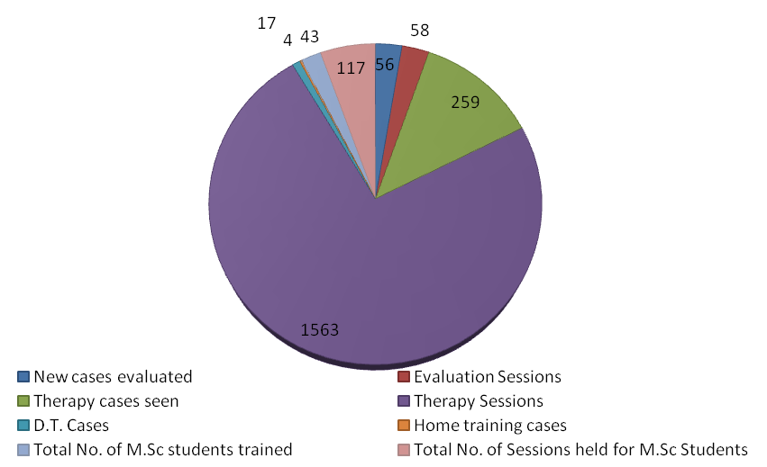
Figure 11: AAC evaluation
Autism Spectrum Disorders (ASD) Unit: Assessment and treatment were provided for 337clients with autism spectrum disorders at the ASD unit during the reporting year. Of them, 50 were from Hindi region. The unit also attended 766 therapy and 95 demonstration therapy cases. Thirty one therapy cases discharged and 16 discontinued during the period. The total number of therapy sessions conducted was 4589.
The occupational therapy section of the unit evaluated 74 cases in 64 sessions. There were 173 therapy cases and 27 Demonstration Therapy cases. Totally, 643 therapy sessions were carried out. Five cases were discharged, one discontinued and 18 re-evaluated.
Clinic for Adult and Elderly Persons with Language Disorders (CAEPLD): CAEPLD provides clinical services to adult and elderly persons. Totally, seventeen clients were evaluated in the clinic during the reporting year.
Fluency Unit: This unit catered to the needs of persons with stuttering and other fluency disorders and provided clinical services to 634 (549 new cases and 45 review cases) persons with fluency disorders during the reporting year.
Implantable Hearing Devices Unit: The activities of this unit include selection of candidates, mapping/programming, trouble shooting of implantable hearing devices such as cochlear implant, bone anchored hearing aids and middle ear implants. Rehabilitation of individuals using such devices was also undertaken. During the reporting year, 99 clients were seen in the unit. Totally, 105 mapping and 72unaided/aided audiograms for Cochlear Implants were done. In addition, 52 bone anchored hearing aids were tried and 49 Cochlear Implant devices trouble shooted. Also, 69 cochlear implant clients were counseled in 88 sessions.

Learning Disability Clinic: The objectives of the clinic include early identification of students with learning disability, undertake their detailed evaluation by a multi-disciplinary team of experts, plan individualized remediation programmes for the identified students, serve as nodal center for issue of certificates for certain educational concessions, conduct action research to facilitate advocacy, policy change and public education and develop related literature/ materials for or about students with learning disabilities. The details of the activities carried out at the clinic during the reporting year are given in figure 12.
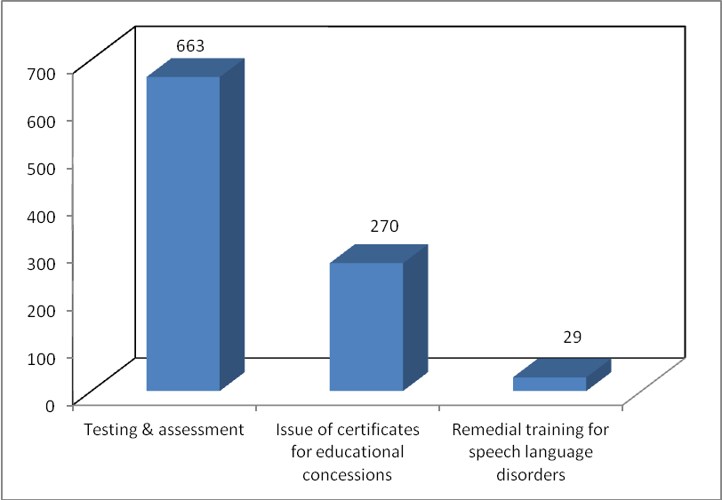
Figure 12: Activities of LDC

Listening Training (LT) Unit: The unit is committed to provide aural rehabilitation to the clients who use hearing aid and cochlear implant devices and to the persons suffering from (central) auditory processing disorder, tinnitus and hyperacusis. Totally, 3165 persons underwent listening training comprising of 13294 sessions during the reporting year. The detailed statistics on listening training activities are given in table 22 and figure 13.
Table 22: Activities of LT unit
Particulars | Number
Clients seen | 3165
demo therapy given | 272
New clients | 503
Repeat clients | 2662
Sessions taken | 13294
Clients discharged | 138
Clients discontinued | 106
Pre-school sessions attended | 570
Clients given training in Hindi | 269
Clients with CI trained | 202
Sessions for clients with CI taken | 1218
Clients with tinnitus attended therapy | 6
Sessions for clients with tinnitus | 29
Clients for speech reading | 19
Clients with CAPD | 1
Sessions for clients with CAPD | 16
Clients for observation for session hearing aid fitting | 29
Clients with ANSD | 7
Sessions for clients with ANSD | 46
Clients with hyperacusis | 2

Figure 13: Activities of LT Unit

Motor Speech Disorders Unit: This specialized unit caters to the needs of persons with Motor Speech Disorders. It enables them to realize their potential and become contributing members of the society. The detailed clinical statistics of the unit for the reporting year are given in Table 23.
Table 23: Activities of MSD Unit
Prticulars | Number
No. of new clients for speech-language assessment | 41
No. of new clients for intervention | 41
No. of new children for feeding assessment | 49
No. of new children for feeding therapy (through home training) | 47
Follow up intervention sessions for speech-language issues | 20
Follow up intervention sessions for feeding issues (activities given for home training) | 27
Counseling | 53
No. of cases of Hindi Region | 12

Neuropsychology Unit: The services offered in the unit includes the assessment of specific function of the brain through standard individualized test, detailed assessment of lobular functions through standardized batteries and rehabilitation through paper pencil techniques or through computer assisted packages. Totally, 21 neuropsychological assessments, 12 neuropsychological rehabilitation and 07 home based neuropsychological rehabilitation were made during the reporting year in the unit.
Professional Voice Care (PVC) Unit: The unit provided specialized assessment and management services to professional voice users during the reporting year. It organized various programs to orient and sensitize professional voice users on care, maintenance and conservation of voice. The unit imparted clinical services to 13 clients during the reporting year.
Structural Orofacial Anomalies (U- SOFA) Unit: Clients with deformalities in the growth of head and facial bones were given multi-disciplinary diagnostic and rehabilitation services in the clinic. Totally 163, clients were evaluated at the clinic by the experts. The detailed clinical statistics of the unit are given in table 24 and figures 14 and 15.
Table 24: Details of U-SOFA Unit
Particulars | Total
Speech-Language Evaluation | 163
Plastic surgery evaluation | 165
Prosthodontist evaluation | 1
Orthodontic evaluation | 29
Rehabilitation Recommended
Orthodontic treatment | 24
Surgery | 31
Speech therapy | 65
Rehabilitation carried out
No. of speech prosthesis prepared | 1
No. of session taken for preparation of prosthesis | 6
Speech and lang. therapy carried out | 61
Demonstration therapy carried out | 24
Manpower development
No of postgraduate students trained | 66
No of sessions ( D.T ) | 47
No of speech and language therapy sessions held | 574

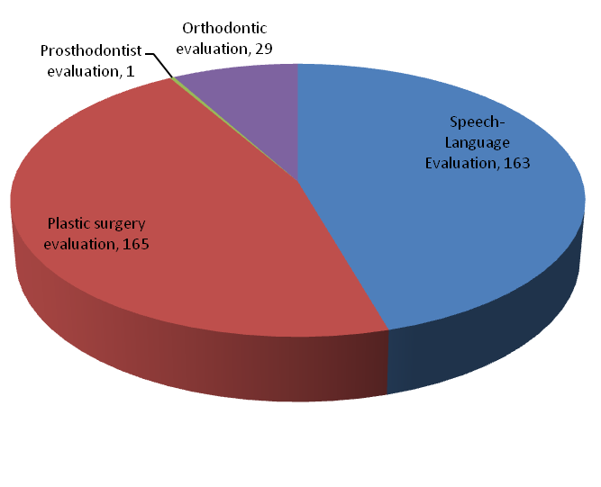 | 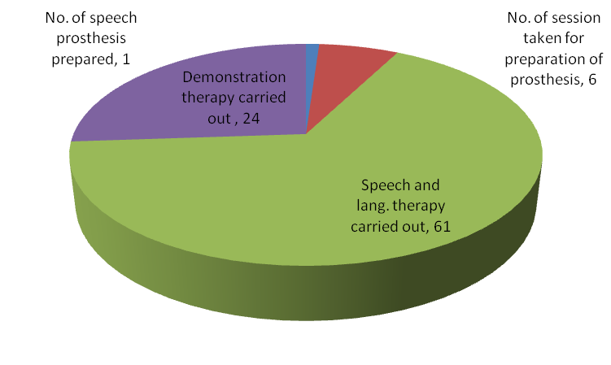
Figure 14: U-SOFA Diagnosis | Figure 15: U-SOFA Evaluation

Swallowing Disorders’ Unit: This is a new unit opened in the Department of Speech-Language Pathology to facilitate assessment and management of persons with swallowing disorders with state-of-the-art equipment. Totally, 4 intervention service was carried out.

Vertigo Clinic: The clinic offered comprehensive care in evaluation and management of patients with vertigo. A multidisciplinary team comprising of ENT surgeon, neurologist and audiologist evaluated 115 patients in the clinic for both peripheral and central vertigo during the reporting year and diagnostic tests like microscopic examination of ear, electro nystagmography, vestibulo spinal tests, neurological evaluation, video nystagmography, audiological tests and vestibular evoked myogenic potential test were carried out for the needy ones. Also, 29 followup cases were attended.

Voice Clinic: This clinic offered evaluation and management services to persons of all ages with voice disorders. So far, 403 clients with voice disorders were evaluated in the clinic using video stroboscopy and software for voice assessment.

Medical Specialty & Allied Health Services :The institute facilitated the services of variousmedical specialists such as pediatrician, neurologist, plastic surgeon, prosthodontist, orthodontist, phono-surgeon and services of allied health professionals such as physiotherapist and occupational therapist, to the needy clients. Totally, 845 patients underwent occupational therapy in5931 sessions and 819 underwent physiotherapy in7234 sessions, during the reporting year. In addition, 771, 325,202, 60, 12 and 125 clients consulted neurologist, pediatrician, plastic surgeon, ortho-dontist, prosthodontist and phono-surgeon, respectively. The details are given in table 25.
Table 25: Medical speciality / allied health services
Consultants | Total
Neurologist | 771
Pediatrician | 325
Phonosurgeon | 125
Plastic Surgeon | 202
Orthodontist | 60
Prosthodontist | 12
Physio and Occupational Therapy | 1172

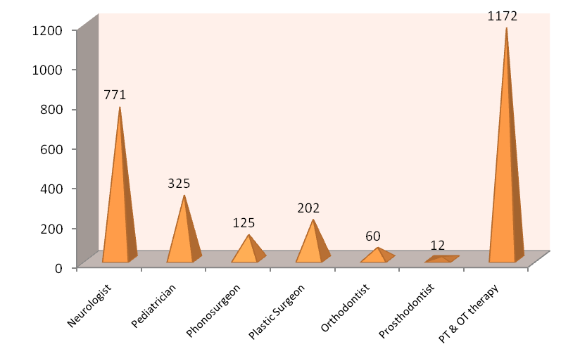
Figure 16: Medical specialty and allied health

Special Educational Services
In order to achieve the mission of mainstreaming Children with Special Needs, various services such as Special Educational Assessment Unit (SEA-U), Parent Infant Program (PIP), Preschool Parent Empowerment Program (PPEP), Preschool Program, Preschool Bridge Course (PBC), Individualized Education Program (IEP), Curricular Support Services (CSS), Non formal education (NFE), Demonstration Educational Training (DET) and Guidance and Counseling to children with communication disorders and their caregivers are provided. In addition, parents / caregivers are empowered to manage children with special needs through training for parallel teaching in preschool. Practical training is also provided to them in developing special teaching-learning material for children with communication disorders. Also, basic literacy and computer literacy program are also provided. The activities are being carried out by the pre-school functioning under the aegis of the Department of Special Education. The details of the various services /activities carried out during the reporting year are given below.

Pre-school Training: Totally 231 children with communication disorders underwent preschool training in 43700 sessions during the reporting year. The training was given in two batches during the periods April-November, 2014 and December, 2014-March, 2015. They were provided with curricular training as well as training in co-curricular activities such as yoga, drama, music and craft works.

Special educational services provided are shown in table 26.
Table 26: Summary of special educational services
 | Clients | Sessions
Parent Infant Programme | 24 | 1243
Parents empowerment | 266 | 2412
Pre-school training | 231 | 43700
Pre school bridge course | 26 | -
Curriculum support service | 58 | 2314
Counselling and guidance | 495 | 549
Computer training | 57 | 250
Literacy training | 10 | 40
Special educational assessment unit | 397 | 397

Other Services/ Activities
- Organization of Summer Camp: A one month summer camp was organized for children with disability from 1st to 23rd May, 2014 and 48 children attended the camp.
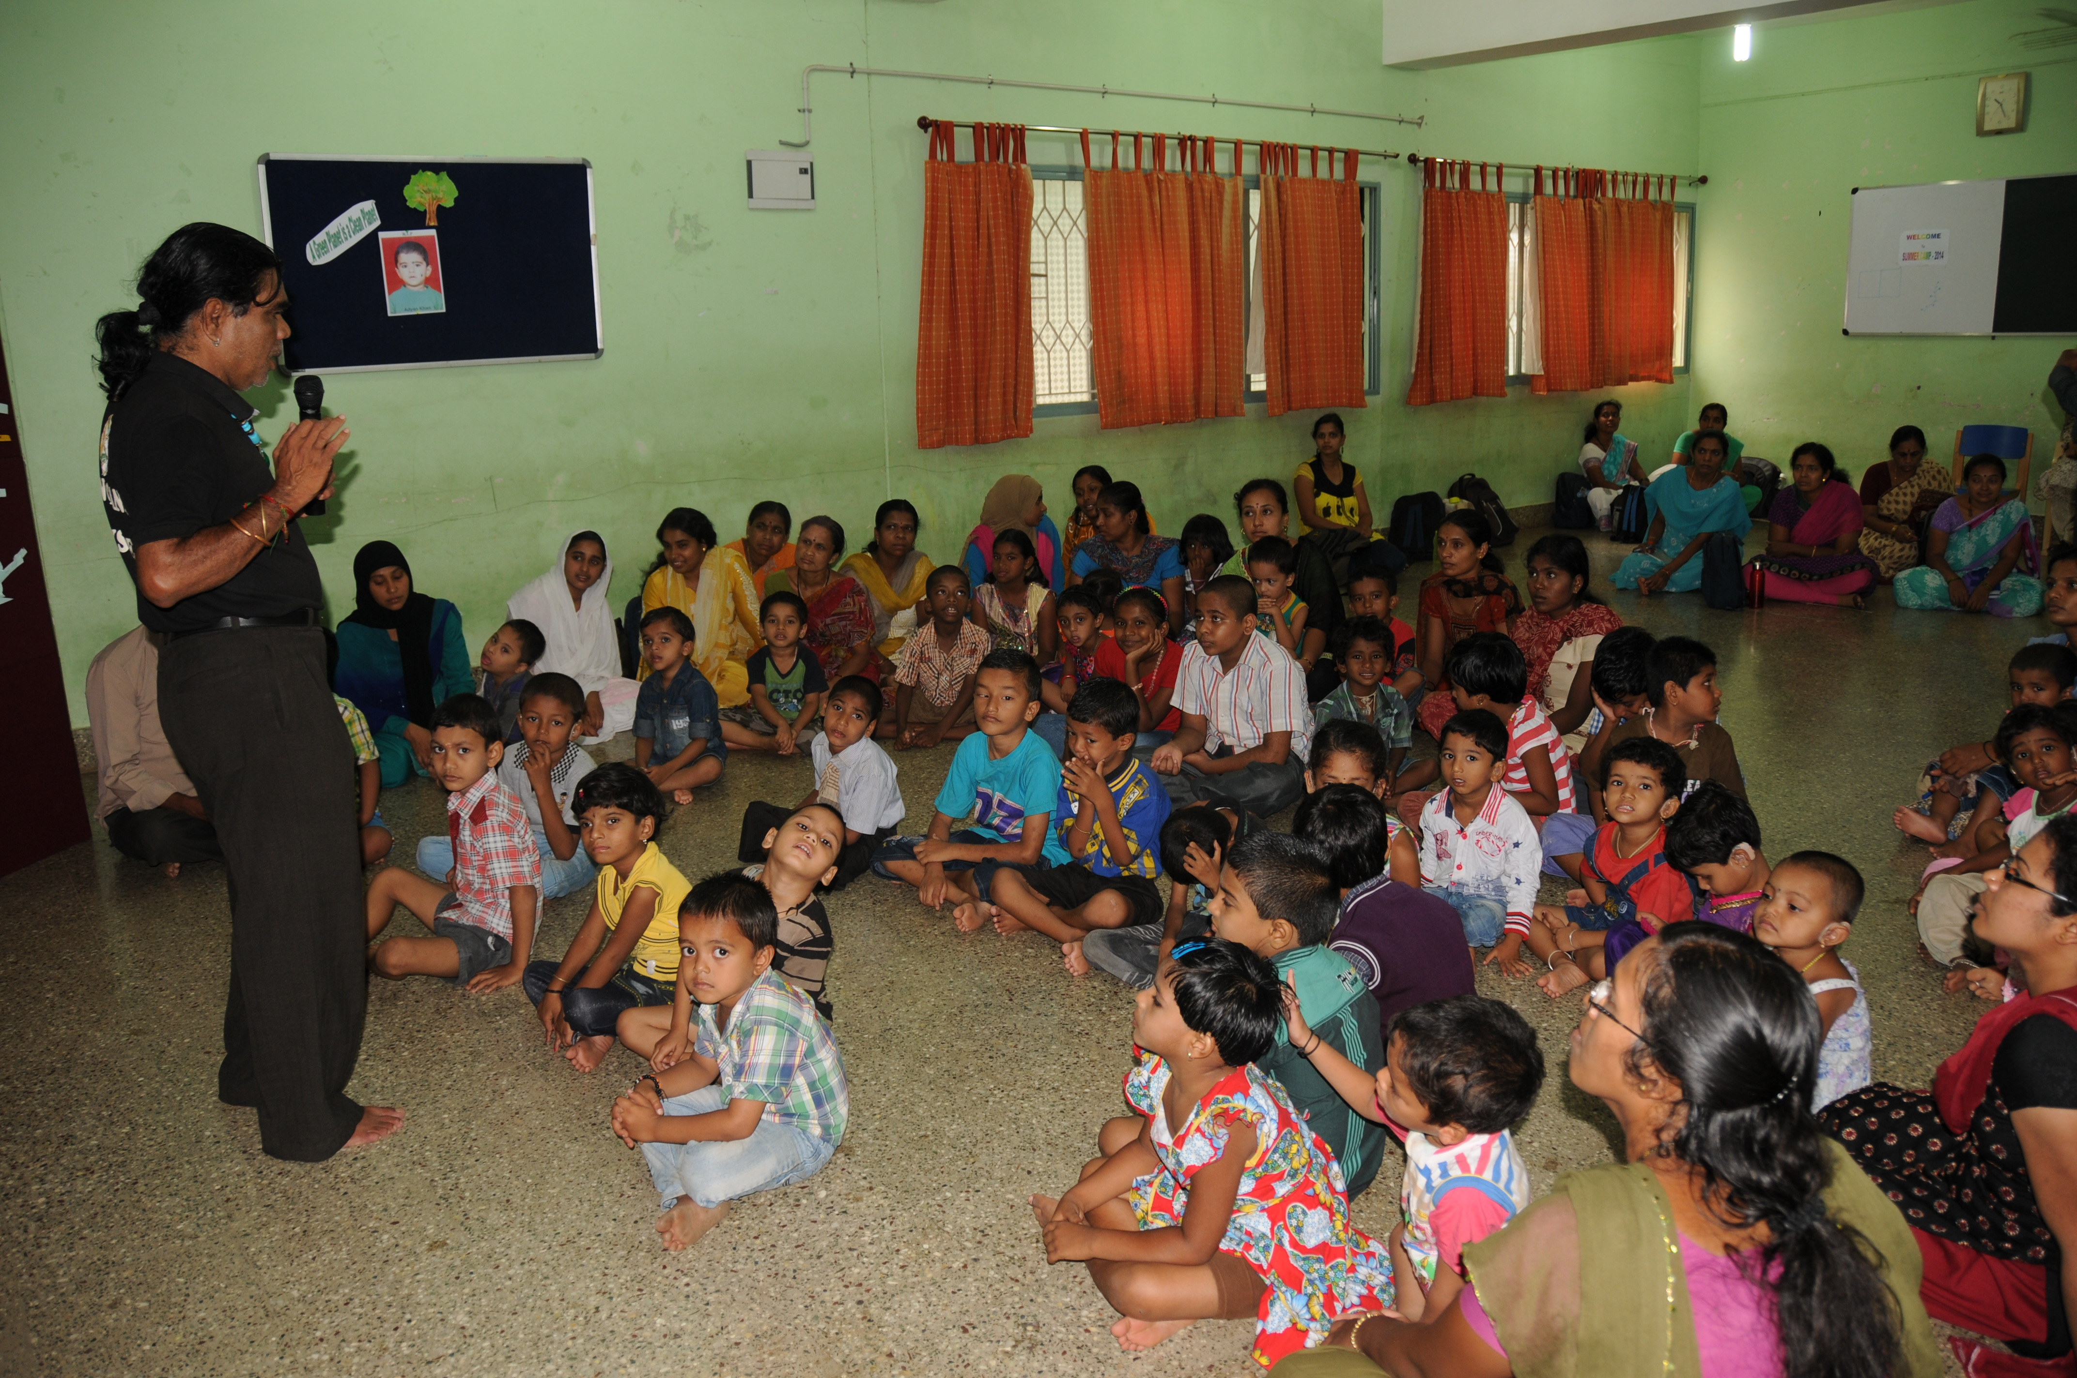
Clinical Support Services
The institute extended a diverse range of support services to patients and their family. These include the following.
Distribution and Repairing of Hearing Aids: Electro-acoustic evaluation, management and repair of hearing aids were carried out under the aegis of Department of Electronics. Totally 4286 hearing aids with solar battery chargers were distributed at the main campus (3314), camps (831), and clinical outreach centers (141), after electro-acoustic evaluation and testing under ADIP scheme. Under AIISH Hearing Aid Dispensing Scheme, 1831hearing aids were issued at concessional rate. Also, 30673 hearing aid spares were issued. In addition, the department repaired 577 body level and 738 BTE hearing aids.
Counseling and Guidance: The professional experts of the Institute provided counseling and guidance on various aspects of the disorders such as treatment procedures, usage and care of tools like hearing aids during the reporting year.
Distribution of toy kits: 115 toy kits were distributed to eligible disabled children worth Rs, 86250.
Issue of Certificates: Various certificates like financial aid, income tax exemption, educational scholarship, and school admission were issued to the eligible candidates during the reporting year, the details of which are given in table 27.

Table 27: Details of certificates issued
Particulars | Total
Transfer certificate | 28
Evaluation reports | 536
Attendance certificate | 59
School admission certificate/  Language exemption certificate | 78
Admission to deaf school | 470
Physically handicapped | 133
Tax exemption | 73
Education scholarship | 31
Others | 85
Certificate issued at camp | 61
Financial Aid | 360
MR Certificate | 712
Railway concession certificate | 113
Learning disabilities. certificate | 270
Psychological Report | 245
Slow Learner Certificate | 104
Income Tax Exemption Certificate | 26
Medico-legal cases | 10
Bonafide certificate | 45
Driving license | 14
LIC | 2
CI | 54
Others | 85

Financial Aid: The institute distributed total amount of Rs. 19,99,931/- among 204 clients below poverty line towards the purchase of hearing aids during the reporting year under the aegis of the Department of Clinical Services.

Clinical Observership
Mr. Rajath Salegame, 3280 Cool Springs Court Naperville, IL, 60564 (US.A.) was provided with observership at the Department of Clinical Services from 23rd December 2014 to 2nd January 2015. He was oriented about the objectives of the institute and the department along with the functions to begin with. As an observer he witnessed the clinical activities/ functions such as students taking case history of clients with hearing impairment, aphasia associated with dysarthria, cleft palate, stuttering, and voice disorder, staff doing quantitative assessments for a client with complaint of voice problems using instruments/ software, functioning of a specialized clinical units, staff conducting practical teaching for the B.Sc. (Sp. & Hg.) students. He interacted with the students and got to know about the programme, their interests/ inclinations, their passion for the field and their reasons for choosing Speech-Language Pathology and Audiology for career building.

Clinical Observation Posting
The institute facilitated clinical observation posting for students in the area of communication disorders and allied fields from other institutes in the country and abroad. Around one thousand students and staff from 40 institutions across the country and abroad were posted for clinical observation in different clinical units and departments of the institute during the reporting year. The details of the institutions are given in table 28.
Table 28: Clinical Postings
Al - Nahdha Hospital, Ministry of Health, Muscat, Oman
Amrutha School of Education, Mysore
ASHA workers, Srirangapatna
AYTMIHH, Bhubaneshwar
BM Institute of Nursing, Mysore
BM Patil Medical College, Vijayapura
Cariappa College, Coorg
Christ University, Bangalore
DOS in Psychology, University of Mysore, Mysore
GHKTTC, Tilak Nagar, Mysore
Govt School for Deaf & Dum, Uttarpradesh
Govt School of Nursing District Hospital, Haveri
IAM & IAF Hospital, Bangalore
Jamaludhin School, Male
JSS College, Mysore
K.R. Hospital Mysore
KIMS, Hubli
Kuvempu University, Shivamogga
MMC & RI, Mysore
Montfort School for Disabled, Belagola.
MP Shah Govt. Medical College, Jam Nagar, Gujarat
Nair Hospital, Mumbai (TNMC)
NIEOMD, Hyderabad
Periyar University, Salem, Tamil Nadu
Samuha Samarthya, Koppala
School of Behavioural Sciences, Kannur
SDM College, Ujire
Shankara Eye Hospital, Bangalore
Spastic Society of T.N., Chennai
Spl. D.Ed students, Tilak Nagar, Mysuru
Sri BM Patil Medical College, Bijapur.
SS Institute of Medical Scs. & Res Centre, Davanagere
St. Agnes College, Mangalore
Surana College, Kengeri, Bangalore
Swami Vivekananda youth movement, H.D. Kote, Mysore
Teresian College, Mysore
Terpude College of Social Work, Maharashtra
VIMS, Belari
VIMS, Hubli
Vivekananda College of Education, Puttur

