AWARDS AND HONOURS

Awards hosted by other organizations

- The Institute received कार्यालयज्योतिस्मृतरचिन्हपुरस्कार for bringing out the reference materials and excellent publication in Hindi hosted by the Raj Bhasha Sansthan, New Delhi.
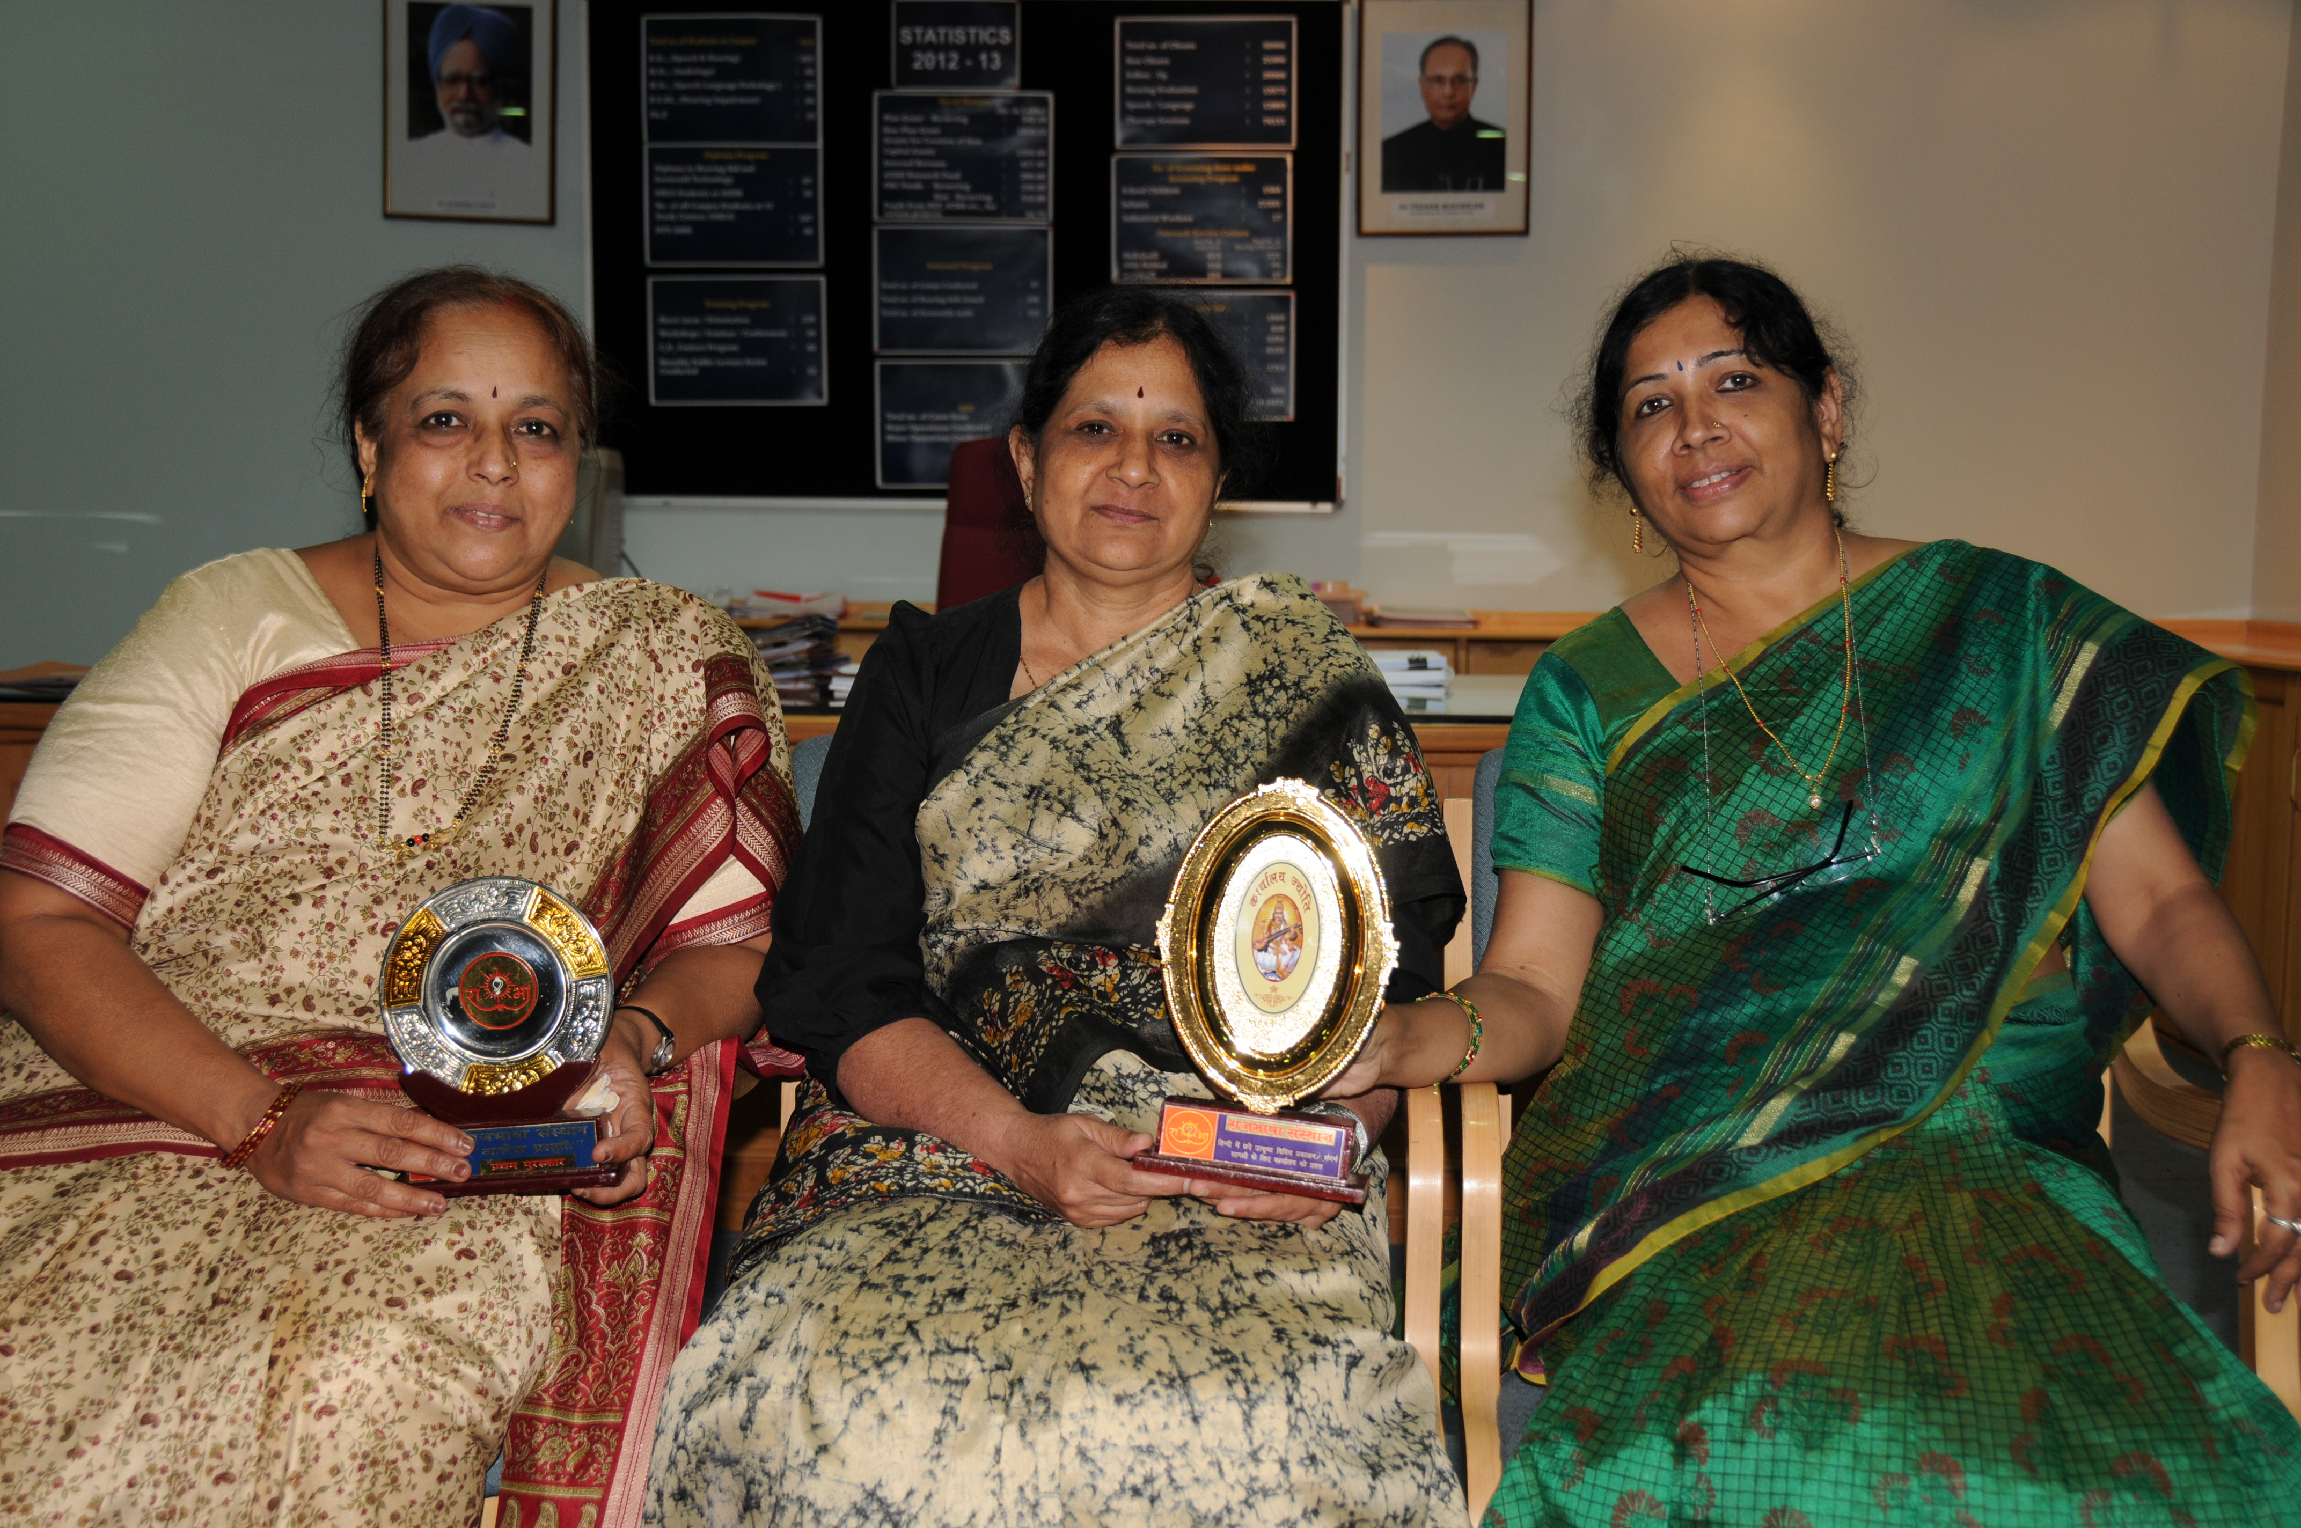
Dr. S.R. Savithri, Director, Mrs. Parimala, P.A. to the Director and
Dr. Uma Saraswathi, Hindi Translator with the कार्यालयज्योतिस्मृतरचिन्हपुरस्कार

- The Horticulture Section participated in the Dasara Horticultural Flower Show, 2015, organized by the Department of Horticulture, Govt. of Karnataka and won many prizes.
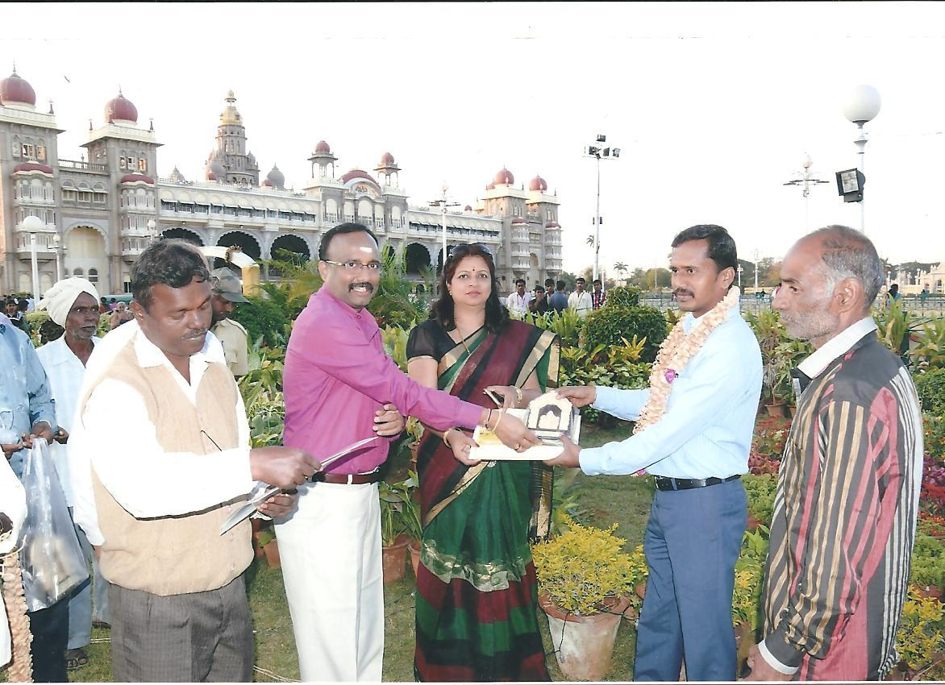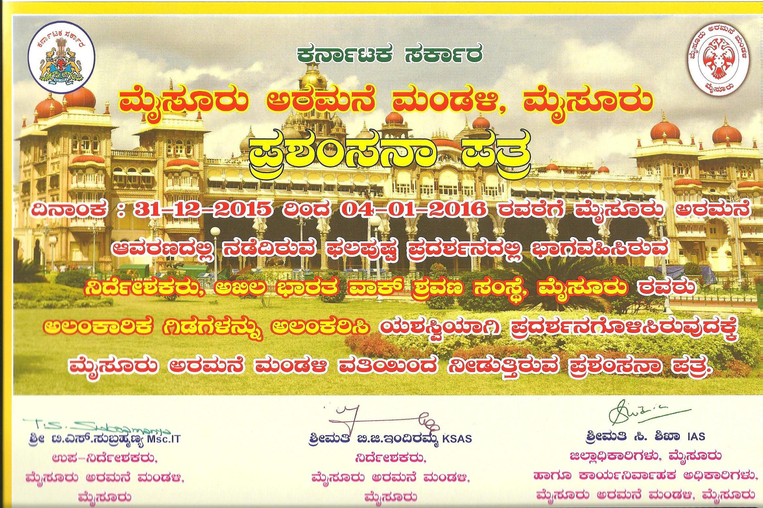
Mr. Gireesh, Assiatnt Horticuiture Dasara flowershow Award Certificate
Offcer receiving Dasara flowershow

- Mr. Shreyank Swamy, 2nd year M.Sc. (udiology) student won overall championship in Mysore University Intercollegiate Swimming Competition

- Sri. D K Venkatesh Murthy Gold Medal for the I Rank holder in B.Sc (Sp&Hg) 2013-14: Mr. Anuj Kumar Neupani.
- Sri. D K Venkatesh Murthy Gold Medal for the I Rank holder in B.Sc. (Sp&Hg) 2014-15: Ms. S. Akhilandeshwari.
- Smt. Jayalakshmamma Gold Medal for the first rank holder in M.Sc.( Speech-Language Pathology) 2013-14: Ms. Liji Antony
- FRIENDS united organization endowment scholarship for the first rank holder in M.Sc.( Speech-Language Pathology) 2013-14: Ms. Liji Antony
- Lakshmi M.S, Aarathi Venkataraman Gold Medal in the field of M.Sc. (Audiology), University of Mysore, Crawford Hall, Mysore, 17.04.15

- Prashanth Prabhu P. bagged best scientific paper presentation award for his paper Issues related to behavioral methods of auditory processing assessment: Procedures and normative and applications of physiological tests in auditory processing assessment at the National Conference on Audiological Sciences, Kasturba Medical College, Mangalore, 10.09.15
- Zeena, V.P., & Sreeraj K bagged best scientific paper presentation award for their paper extended high frequency audiometry in industrial workers exposed to occupational noise with varying duration of noise exposure, 8th KSB-ISHACON, held at Sultan Bathery, Kerala, 14.09.15
- Raja Rajan R., & Geetha, C., bagged best scientific paper presentation award for their paper Subjective and objective benefit of broadband wireless synchronization technology hearing aids, 8th KSB-ISHACON, held at Sultan Bathery, Kerala, 14.09.15
- G Nike Gnanateja & Sandeep M bagged best scientific paper presentation award for their paper Evaluating the time scale of temporal fine structure cues important for speech perception, ISAM-2015, Bhubaneswar, India, 5-7 December 2015.
- Jasiya K.M, Kirti Joshi & Prabhu, P.P bagged best scientific paper presentation award for their paper, Contralateral suppression of spontaneous otoacoustic emissions in individuals with auditory neuropathy spectrum disorder, NISH, 5-7 December 2015.
- Geetha C, Raja Rajan R & Kishore T. bagged best scientific paper presentation award for their paper, Evaluation of digital noise reduction algorithms in hearing aids with wireless synchronization technology, ISAM-2015, Bhubaneswar, India, 5-7 December 2015.
- Dhatri S. Devaraju, SantoshMaruthy, &Ajith Kumar, U. bagged best scientific paper presentation award for their paper Brainstem Encoding of Virtual Pitch in Adults who do and do not Stutter, Dr. N. R.Chaudhary Memorial Award for best paper in Audiology, 48th ISHACON 2016, Mumbai, 5th to 7th Feb 2016.
- Nisha K V,&Ajith Kumar, U. bagged best scientific paper presentation award for their paper Pre-attentive Cortical Processing of Auditory Spatial Information in Listeners with Normal Hearing: Insights into Cross-race Spatial Processing Similarities. Scientific paper presented in 48th ISHACON 2016, Mumbai held between 5th to 7th Feb 2016, Dayalan Samuel SSV award for best paper in Audiology, 48th ISHACON 2016, Mumbai, 5th to 7th Feb 2016.
- Arpitha V., Khyathi G., Devi N., &Ajith Kumar bagged best scientific paper presentation award for their paper Development and Standardization of “Questionnaire on Music Perception Ability”. Scientific paper presented in 48th ISHACON 2016, Mumbai held between 5thto 7th Feb 2016, ManoharMemorial Award, 48th ISHACON 2016, Mumbai, 5th to 7th Feb 2016.
- Jim Winston,&Sandeep Maruthy bagged best scientific paper presentation award for their paper. Effect of Auditory and Visual Distractors on Brainstem Encoding of Speech. Scientific paper presented in 48th ISHACON 2016, Mumbai held between 5th to 7th Feb 2016, Dr. M.Raghunathan Memorial Award for best paper in Audiology, 48th ISHACON 2016, Mumbai, 5th to 7th Feb 2016.
- Dr. Niraj Kumar Singh & Dr. Animesh Barman bagged best scientific paper presentation award for their paper. Can frequency tuning of O-VEMP differentiate Meniere’s Disease from BPPV, Muktesh Award for best paper in Audiology, 48th ISHACON 2016, Mumbai, 5th to 7th Feb 2016.
- Srushti Shabnam & Swapna.N, bagged best scientific paper presentation award for their paper Prof. Dr. B.M Abrol Award, Scientific paper titled ‘Feeding and oromotor skills in children with Autism Spectrum Disorders’, Laryngology summi t 2015 (4th Annual conference of Laryngology and Voice association, Ist SAARC International Conference, 21.08.15 to 23.08.15.
- Sneha, G. & Swapna, N, bagged best scientific paper presentation award for their paper Best Paper for speech oral presentation, Paper title: Fluency profile in Kannada speaking individuals with Down syndrome, 5th TAN-ISHACON 2015, 2.10.15 to 4.10.15.
- Darshini, K.J& Swapna., bagged best scientific poster presentation award for their paper Best Paper for poster presentation, Paper title: Phonological encoding in persons with stuttering- Does a deficit exist in this vista?, FRSM conference, 23.11.15 to 24.11.15.
- Dhathri, D., Santosh, M. & Ajith Kumar, U., Received Dr. N. R. Chaudhary Memorial award for the best paper in Audiology for the paper “Brainstem encoding of virtual pitch in adults who do and do not stutter” presented at the 48th Indian Speech and Hearing Association Conference, February 5-7, 2016, Mumbai.
- Shreya.R., Sharon.R.P., Shalini.B & Abhishek. B. P., received Mr. Manohar Memorial Award for the paper titled “Semantic organization in adolosents, younger and older individuals” presented at the 48th Indian Speech and Hearing Association Conference, February 5-7, 2016, Mumbai.
- Ms. Ramanakumari P.V., Special Educator received AIISHIAN Award ( technical staff)
- Smt. Annapurna memorial award for best interdisciplinary research paper in Special Education Award won by Odunavar, S., Devraju, N.B. (2016). Paper titled “Appreciation about Continuous and Comprehensive Evaluation for Children with Hearing Impairment by General and Special Educators-A comparative study”. in National Convention of educators of the deaf -2016
- Smt. Annapurna memorial award for best interdisciplinary research paper in Special Education Award won by Vijetha, P (2016). Paper titled “Impact of Early intervention by a Multidisciplinary team on the development of a child with hearing impairment: A case study”. in National Convention of educators of the deaf -2016
- Smt. Annapurna memorial award for best interdisciplinary research paper in Special Education Award won by Naniwadekar, K., Anjana, K., Dhivya, D(2016). Paper titled “Drama as a creative teaching tool in instruction of Children with Special Needs”. in National Convention of educators of the deaf -2016
- M.C.Sen Award for Best Research paper award won by Asha Suresh E. G., Raksha Anand for the paper titled “Post school communication options for learners with hearing impairment” in National Convention of educators of the deaf -2016
- Dr. H.P. Umasaraswathi, HT, received the best paper award for her paper भाषाप्रोद्योगिकीएवंपुनःसृजन at the national level Hindi Workshop organized by the Raj BhashaSansthan, New Delhi.

- Preschool of the Institute won the overall championship at the Inter school competition for special children organized by the Rotary Club, Mysuru

Awards hosted by the Institute

- Dr. Shyamala, K.C., Professor in Language Pathology, Dr. K.S. Prema, Professor of Language Pathology, Dr. H. Sundara Raju, Professor of ENT, Dr. Animesh Barman, Professor of Audiology, Mr. Gopi Sankar R., Prashanth Prabhu P, Clinical Assistant, Mr. S. S. Purushothama, JTO Ms. Kavitha N., Mr. Eshwara, Lab Attendant, Ms. Nandini P received the Best AIISHian award for the year 2014-15.
Academic Awards
- Dr.VijayalakshmiBasavaraj Gold medal for the 1st rank holder in M. Sc (Audiology) 2013-14: Ms. M.S. Lakshmi

- Mr. Jitendra Saini, Ms. Bashpa Bhardwaj, Ms. BharathiVimal&Ms. Pavithra K under the guidance of Dr. R. Rajasudhakar, Lecturer in Speech Sciences bagged the Best Journal Club Presentation Award for the year 2015-16.

- Mr. Appas Saha, Mr. Keshav Mishra &Ms. A Jumana under the guidance of Dr.N Swapna, Reader in Speech Pathology bagged the Best Clinical Conference Presentation Award for the year 2015-16.

- Ms. K J Darshini awarded the Abhilash Award for Best Student Clinician for the year 2015-16.
- Ms. Nisha K.V. was awarded Dr.Vijayalakshmi Basavaraj Gold Medal for securing first rank in M.Sc. (Audiology) Examinations, June, 2013.
- Mr.Shivaprasad, M, Graphic Designer bagged the best price in golden jubilee logo design competition.
Official Language Implementation Awards
- Department of Audiology, 1st prize in doing outstanding work in Official Language Implementation for the year 2014-15
- Chandni Jain, 1st prize in typing in Hindi Unicode during Hindi week,
- Niraj Kumar Singh, 2nd prize in typing in Hindi Unicode during Hindi week
- Dr. Prawin Kumar, 1st prize in Hindi noting and drafting during Hindi week
- Niraj Kumar Singh, 2nd prize in Hindi noting and drafting during Hindi week
- Srikar V, 3rd prize in General knowledge competition in Hindi noting and drafting
- Dr. Jayshree C Shanbal secured first prize in Hindi writing competition held as part of Hind week celebration
- Ms. Renjini A Mathew secured second prize in Hindi writing competition held as part of Hind week celebration.
- Ms. Archna R secured third prize in Hindi writing competition held as part of Hind week celebration.
- Mr. Adarsh. K secured consolidation prize in Hindi writing competition held as part of Hind week celebration.

