Other Activities and Events

Other activities that are being carried out at the Institute include infrastructure development, library and information services,material development activities, personnel management andtechnological consultancy services. The details of the activities carried out during the reporting year are given below.

**Infrastructure Development and Maintenance**

The infrastructure development and maintenance activities of the institute are being carried out mainly by the Department of Electronics and the Engineering and Horticulture sections.

**Electronic and I.T. Infrastructure**

The electronic, electrical and I.T. infrastructure development and maintenance activities of the institute are being carried out by the Department of Electronics. The institute spent Rs. ……………………….lakhstowards this during the reporting year and the major developmental activities completed include the following.

1. **Audio Visual System for the Seminar Hall, Knowledge Park**

State of the art Audio-Visual systems was setup in the newly inaugurated Knowledge Park with HDMI quality multimedia projectors and world class audio amplification system. The entire audio visual system was digitally integrated and controlled with touch panel control system.

1. **Infrastructure for Smart Classrooms, Knowledge Park**

Smart classrooms were setup in the Knowledge parkwith wireless slate coupled with a document camera, high end multimedia projector, computer workstations, integrated projector controller and digital audio system. The new system will provide state-of –the art ICT assistance to all the faculty and students and will enhance the quality of teaching learning process at the institute.

1. **Computer & Telephone Network for the New Buildings**

Three new buildings – Knowledge park, Jayachamarajendra Block and Type II and III quarters were networked to the data and voice networks of the institute. Necessary systems were added to the local area network and telephone network to incorporate this. All the buildings were linked through optical fiber to the server room. In addition the Knowledge parkwas equipped with Wi-Fi connectivity.

1. **Upgradation of Computer Network**

The last phase of upgradation of the campus network from 10/100 Mbps to 10/100/1000 Mbps was completed during the reporting year. The entire network isequipped with state-of-the art manageable network switches. The upgraded network will cater to the ever increasing data communication and information transfer demands of the institute, more effectively.

1. **New Electrical Substation with 1000 kVA capacity**

To cater to the increased power demand at the institute, the 22 kVA electrical substation was upgraded to 1000 kVA capacity. The new substation is equipped with state-of –the art systems such as OLTC transformer, automatic power factor compensation unit and world class safety and protection systems.

**Civil Engineering Infrastructure**

The institute spent Rs. 51,33,600/ towards civil engineering infrastructure maintenance during the reporting year. The major maintenance activities completed include installing solar water heating system in ladies hostel, renovation of guest house and old administrative building and painting to stone masonry compound wall & grills. In addition, construction of Centre of Excellence building was initiated under the aegis of the Central Public Works Department, Govt. of India at a cost of ……

**Garden and Landscape Development**

The Horticulture Section has been carrying out the development and maintenance of gardens, lawns and other landscaping works in the institute campus. The gardens spread across the campus are enriched with herbs, shrubs, climbers, creepers and trees of perennial nature. The major activities carried out by the section during the period includepropagation and development of various species of plants , development of Bermuda lawn and hedges in various localities in the campus, planting of banana suckers and fixing of Mexican turf. In addition, the routine maintenance works such as watering, mowing of lawn, weeding, sweeping, hoeing, clipping of hedges, pruning of trees and shrubs, top dressing of garden area with manure, spray of pesticides/insecticides, application of inorganic fertilizers and removal of garden waste were carried out.

The Institute participated in the dasara flower show 2014, conducted by the Dept. of Horticulture, Govt. of Karnataka under the aegis of the Section.

**Implementing the Right to Information Ac, 2005**

The institute has been implementing the Right to Information Ac, 2005 in best of spirit. The details of the RTI related queries received and disposed of during the reporting year are given in table 36. Also, the Institute suo-moto published various information on its policies & procedures on the official website thereby reducing the need for invoking the provisions of the Act for seeking information by the public.

**Ministry-wise and Public Authority-wise Abstract of Quarterly Returns**

|  |  |  |  |  |  |  |  |  |  |  |  |  |  |  |  |  |  |  |  |  |  |  |  |
| --- | --- | --- | --- | --- | --- | --- | --- | --- | --- | --- | --- | --- | --- | --- | --- | --- | --- | --- | --- | --- | --- | --- | --- |
| Sr.No. | Ministry/Department/Organisation | Quarter | Opening balance of Requests (as on start of Quarter) | No.of Requests Received during Quarter | Total no.of Requests (Column 3+4) | No.of Requests transferred to other PAs | Decisions where Applications for Information rejected | Number of cases where disciplinary action taken against any officer in respect of administration of RTI Act | Total Amount Collected (fee+addl. charges+ penalty) (Rs.) | No. of times various Provisions were invoked while Rejecting Requests | | | | | | | | | | | | | |
| Relevant Sections of RTI Act 2005 | | | | | | | | | | | | | |
| Section 8(1) | | | | | | | | | | Other Sections | | | |
| (a) | (b) | (c) | (d) | (e) | (f) | (g) | (h) | (i) | (j) | (9) | (11) | (24) | (Others) |
| (1) | (2) | (3) | (4) | (5) | (6) | (7) | (8) | (9) | (10) | (11) | (12) | (13) | (14) | (15) | (16) | (17) | (18) | (19) | (20) | (21) | (22) | (23) | (27) |
| 1 | Ministry of Health & Family Welfare | | | | | | | | | | | | | | | | | | | | | | | | | |
| 1.1 | Department of Health & Family Welfare | | | | | | | | | | | | | | | | | | | | | | | | | |
| 1.1.1 | All India Institute of Speech and Hearing | Ist Quarter (Apr14-Jun14) | 0 | 9 | 9 | 1 | 1 (11.1%) | 0 | 90 | 0 | 0 | 0 | 0 | 0 | 0 | 0 | 0 | 0 | 0 | 0 | 0 | 0 | 1 |  |  |  |
|  |  | 2nd Quarter (July14-Sept14) | 0 | 0 | 0 | 0 | 0 (0%) | 0 | 0 | 0 | 0 | 0 | 0 | 0 | 0 | 0 | 0 | 0 | 0 | 0 | 0 | 0 | 0 |  |  |  |
|  |  | 3rd Quarter (Oct14-Dec14) | 2 | 13 | 15 | 0 | 1 (7.7%) | 0 | 130 | 0 | 0 | 0 | 0 | 0 | 0 | 0 | 0 | 0 | 1 | 0 | 0 | 0 | 0 |  |  |  |
|  |  | 4th Quarter(Jan15-Mar15) | 7 | 10 | 17 | 1 | 6 (60%) | 0 | 1848 | 0 | 0 | 0 | 0 | 0 | 0 | 0 | 0 | 0 | 4 | 0 | 0 | 0 | 2 |  |  |  |
| Department Total | | | 9 | 32 | 41 | 2 | 8 (25%) | 0 | 2068 | 0 | 0 | 0 | 0 | 0 | 0 | 0 | 0 | 0 | 5 | 0 | 0 | 0 | 3 |  |  |  |

**Library and Information Services**

The following library and Information services were carried out during the reporting year.

**Acquisition of Information Resources**

Totally 552 print books were purchased during the reporting year making the total collection to 20328. In addition 115 national and international journals both in print and electronic format and two online databases were subscribed, and 83 research reports were added to the in-house digital repository. The institute received access to more than thousand e-journals as a part of ERMED consortium of the Ministry of Health and Family Welfare, Govt. of India and more than one lakh e-books and 3000 e-journals as a part of NLIST service of the Information and Library Network, University Grants Commission, Govt. of India.

**Information Services Offered**

The various information services provided include book lending, reference, current awareness, Internet, online public access catalogue, web portal based CD-ROM access, online database, e-books access, plagiarism detection, remote access information, language laboratory, newspaper clipping, digital repository and Virtual Private Network based resource access to the DHLS centers.

**New ServiceInitiated**

The Section initiated Bibliographic Management Service using EndNote software published by M/s Thomson Reuters during the reporting year.

**Orientation/Training Programmes**

The newly admitted students were oriented on various library resources and services. Also, the staff and students were trained in using Turnitin, the anti-plagiarism software. In addition, the faculty and research scholars were trained in using EndNote bibliographic management software.

**Material Development Activities**

The Department of Material Development assisted in creating materials for the public on prevention, identification and management of various communication disorders. In addition, it also assisted in producing materials on various rights and welfare measures available for individuals with communication disorders, design and printing of invitation cards for Institute events and the certificates issued for various purposes.

The details of various materials developed during the reporting year are given in table 37.

**Table 37: Material Development Activities**

|  |  |
| --- | --- |
| Particulars | Quantity |
| Designing & Editing of Materials  Brochures  Invitation cards  Posters  Pamphlets  Certificates  CD covers  Pitcher editing  Pamphlet editing  Brochure editing  Institute Diary  Others | 223  26  11  07  10  28  09  64  60  16  01  06 |
| Photo coverage  No. of events  No. of Photos taken & edited | 87  2221 |
| Printing  A3 size  A4 size | 1785  5313 |
| Video coverage (To get the name of event) | 04hrs |
| Others  Scanning  Translation work  English to Kannada  English to Hindi  Typing work  English  Kannada  Hindi  Proof Reading  Content Development | 170 pages  61pages  06 pages  19 pages  67 pages  478 pages  336 pages  23 pages |

**Observation of Vigilance Awareness Week**

**Personnel Management**

**New Recruitment**

Five regular appointments were made during the reporting year in which Ms. Yashaswini R, Sri. Vikas M. D., Sri. Reuben Thomas Varghese, Sri. Shyam H. R. and Sri.Sandesh S Cwere appointed to the posts of Clinical Supervisor, Research Assistant, Speech-Language Pathologist Grade II, Clinical Psychologist Gr. II, and Junior Documentation Assistant respectively. With this, the regular staff strength of the institute became 180 which includes 49 Group 'A', 60 Group 'B', 43 Group 'C' and 28 multitasking staff. In addition, 159 contract staff were also recruited. Thus the total staff strength of the institute was 339at the end of the reporting year,excluding the outsourced contract staff for housekeeping, gardening and security.

**Promotions**

There were four promotions under Assessment Promotion Scheme, and two regular promotion during the reporting year. Under the Assessment Promotion Scheme, Dr. Animesh Barman was promoted to the post of Professor in the scale of pay Rs. 15600-39100 + GP7600 and Dr. BrajeshPriyadarshi and Dr. T.K. Prakashto the post of Reader in the scale of pay Rs. 15600-39100 + GP ` 6600 and Mr. Freddy Antony for the post of Lecturer in the scale of pay Rs. 5600-39100 + GP `5400. Also, Mr. Chandrashekhar C. and Mr. K.P.Narasimha Prasad were promoted to the post of Upper Division Clerk. Smt. V Shubha, Stenographer Gr. II received f**inancial upgradation under Modified Assured Career Progression Scheme in scale of pay** PB-2 `9,300 - 34,800/- + GP `4800/-

**Completion of 25 Years in Services**

……… staff members, ………………………………….completed 25 years of service during the reporting year. They were felicitated during the annual day celebrations on 9th August, 2014.

**Retirement/ Repatriation/ Resignation**

Five staff members, Sri. Anil Kumar,Packer, Smt. D N Padma, Sweeper, Sri. M Mahadeva, Assistant Library & Information Officer, Smt. Shubha V., Stenographer Gr. IIand Smt. J Raguna,Staff Nursewere superannuated from the regular service during the reporting year. Also, two staff , Smt. JanwadkarKalyani, Special Educator and Smt. B V Jyothi, Senior Accountant resigned from the service and Mr. Chandrasekhar, N, LDC was removed from the service.

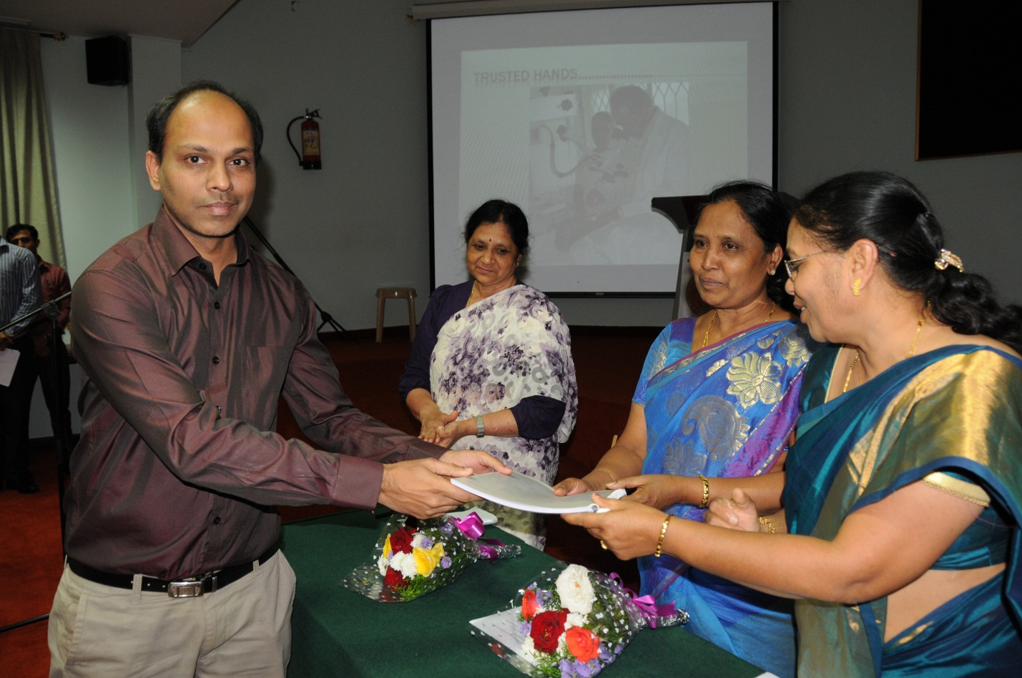

**Purchase of Equipment**

The institute also strengthened its infra- structure by procuring a number of sophisticated tools and instruments and by upgrading the existing scientific equipment. A total amount of Rs. 2.27 crores was spent towards the purchase of equipments during the reporting year.

**Technological Consultancy Services**

The Department of Electronics is equipped with stateof the art equipments and expertise in the area of acoustic noise measurements. During the reporting year, the following consultancyserviceswerecarriedoutby thedepartment.

1. Noise measurement of Patient Monitoring System received from M/s. Skanray Systems Pvt Ltd, Mysore .
2. Electro acoustic measurement of 4 Nos. Of BTE hearing aids received form Alps International Pvt Ltd, New Delhi
3. Testing of 3 nos. Of Speaker module received from L & T Pvt Ltd., Mysore
4. Electro acoustic measurement of 28 nos. of BTE hearing aids received from State Commissioner for Differently Abled, Chennai.
5. Testing of Audiometric room ( Noise measurement) at Baptist Hospital, Devanahalli, Bangalore.
6. Electro acoustic measurement of 6 nos. of Body worn hearing aids received from State Commissioner for Differently Abled, Chennai.
7. Calibration of Audiometer, Make Inventis from Pika Medicals Pvt Ltd, Bangalore.
8. Electro acoustic measurement of 7 nos. of BTE hearing aids received from Arphi Electronics Pvt Ltd. Mumbai
9. Electro acoustic measurement of 5 nos. of BTE hearing aids and 2 body worn hearing aids received from CDAC, Thiruvanathapuram
10. Noise measurement of Patient Monitoring System received from M/s. Skanray Systems Pvt Ltd, Mysore
11. Acoustic measurement and analysis of tones generated by Patient Monitoring System received from M/s. Skanray Systems Pvt Ltd, Mysore

In addition, the Department of Speech Language Sciences carried out forensic speaker verification of six cases.

**Eminent Visitors**

A large number of distinguished scholars in the field of communication disorders and allied fields, and distinguished personalities in public life both from India and abroad visited the institute during the reporting year. A few among them are given in table 38.

**Visits Abroad**

1. Dr. K. Rajalakshmi, Professor of Audiology visited Bates College I Lewsiston ME United States, to attend the Gordon Research Conference and Seminar on Auditory System on 12-18th July 2014.