Official Language Implementation

1. **Hindi Training**

The following training programmes were arranged for the staff as a part of Official Language Implementation

1. Training in Prabodh, Praveen and Pragya courses under which five staff members successfully completed the courses and five others were pursuing.
2. Computer-based Hindi training programme sponsored by the Ministry of Home Affairs, Govt. of India was given to three staff members.
3. Translation training programme sponsored by the Central Translation Bureau, Bangalore was given to two staff members
4. **Material Translation/ Development**

The following official documents in English were translated and developed in Official language during the reporting year.

1. Annual Outcome Budget Documents
2. Institute Annual Report 2013-14
3. **Word a day in Hindi**

Words on progressive use of Hindi in bilingual were displayed at 5 major Departments/Sections on a regular basis throughout the year.

1. **Workshop Organized**

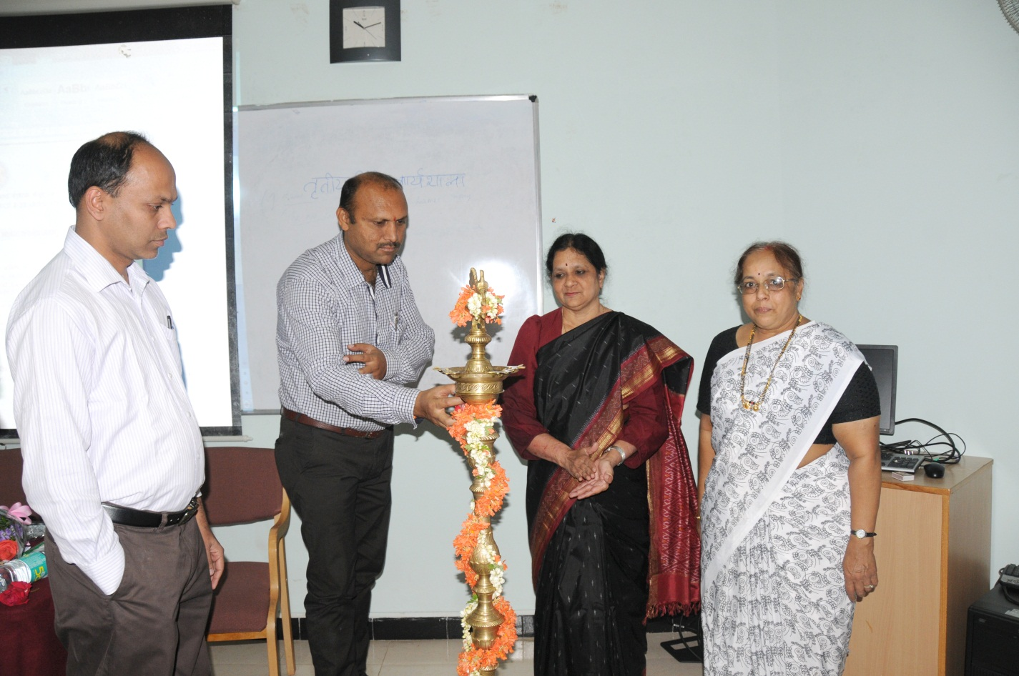

Inauguration of the …. Hindi workshop by …..

Totally four workshops were organized for the Institute staff during the reporting year as detailed below.

1. The first internal workshop on Hindi was organized on 3-4 June, 2014 in which four staff members participated and,Smt. Shashikala Asst. Director (OL) and Sri SangyaNaik, Hindi Translator, BSNL, Mysuruserved as resource persons.
2. The second internal workshop on Hindi was organized on 20th October, 2014 in which five staff members participated and,Smt. Anitha, Hindi Officer, CFTRI, Mysuru and Sri Subhodh Kumar Singh, Hindi Translator, Income Tax Dept., Mysuru served as resource persons.
3. The third internal workshop on Hindi was organized on 17-18 December, 2014 in which 29 staff members participated. Sri L. GovardhanRao, Senior Manager (OL), Corporation Bank, Mysuru, Smt. RekhaAgarwal, Lecturer, University of Mysore, Mysuru, Smt. Shashikala, Asst. Director (OL), BSNL, Mysuru, Sri Teckhand, Lecturer, HTS, CIIL, Mysuru, Dr. S. Lakshmi Narayan Aurora, Professor, (Rtd.), University of Mysore, , Mysore, Smt. Bhargavi R. Gopal, Hindi Officer, Defence Food Research Lab, Mysuru, Sri M.K. Anantha,Senior Manager (Computer), Corporation Bank, Mysuru, Prof. Ajish K. Abraham, Head, Dept. of Electronics, AIISH Mysore and Dr. H.P. Uma Saraswathi, Hindi Translator, AIISH, Mysuru served as resource persons for the workshop.
4. The fourth internal workshop on Hindi was organized on 10th February, 2014 in which four staff members participated and, Dr.Narayana Reddy, Lecturer, Regional Institute of Education, Mysuruserved as the resource person.
5. **Guest Lectures delivered at Other Organizations**

The staff of the Institute served as resource persons for Official language Implementation programmes of other government organizations and delivered invited lectures as detailed below.

1. Dr. H.P. Uma Saraswathi, HndiTranslatordelivered a lecture on टिप्पणऔरआलेखन

at the Hindi workshop organized by the Central Food Technological Research Institute, Mysore on date

1. Dr. H.P. Uma Saraswathi, Hndi Translator delivered a lecture on राजभाषानीतिएवं

हिंदीकार्यान्वयन at the Hindi workshop organized by the Bharath Sanchar Nigam Limited, Mysore ondate……

1. Dr. H.P. Uma Saraswathi, Hndi Translator delivered a lecture on हिंदीपत्राचारऔर

टिप्पण at the Hindi workshop organized by the Income Tax Office, Mysore, ondate……………….

1. Dr. N. Swapna, Reader & Head, Department of Special Education delivered a lecture

onCommunication Disorders – An overview at the Hindi workshop organized by the Bhaba Atomic Research Centre, Mysore on …Date……….[[[ Is this in Hindi???]]]]

1. **Hindi Week Celebration**

Hindi week was celebrated on 14- 20 September, 2014. The celebrations commenced on 14thSeptember, the Hindi Day. Many innovative coompetitions to promote the use of Hindi such as quiz on Hindi grammar, pick-n-speak, one minute gameand group singing were conducted for the staff and students on the occasion.The celebrations were concluded with Prize distribution to the winners of competition on the valedictory function held on…..date.

**Dignitories during Hindi week????**

1. **Awards / Prizes / Testimonials**
2. The Institute received कार्यालयज्योतिस्मृतरचिन्हपुरस्कारhosted by the Raj BhashaSansthan, New Delhi for bringing out the reference materials and excellent publication in Hindi.
3. Dr. H.P. Umasaraswathi, HT, received the best paper award for her paper भाषाप्रोद्योगिकीएवंपुनःसृजन at the National level Hindi Workshop organized by the Raj BhashaSansthan, New Delhi.