AWARDS AND HONORS

**Awards hosted by other organizations**

1. The Institute received **कार्यालयज्योतिस्मृतरचिन्हपुरस्कार**for bringing out the reference materials and excellent publication in Hindi hosted by the Raj BhashaSansthan, New Delhi.

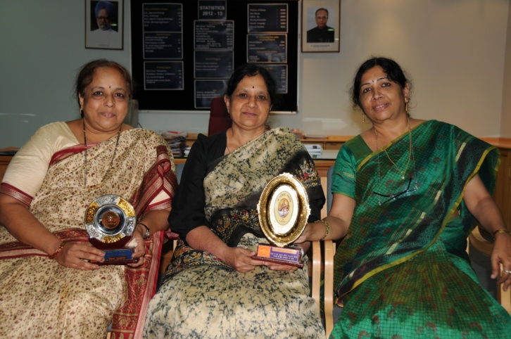

कार्यालयज्योतिस्मृतरचिन्हपुरस्कार

1. The Horticulture Section participated in the Dasara Horticultural Flower Show, 2014, organized by the Department of Horticulture, Govt. of Karnataka and won many prizes.

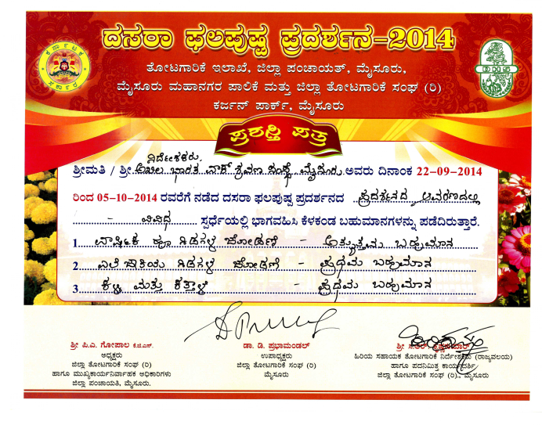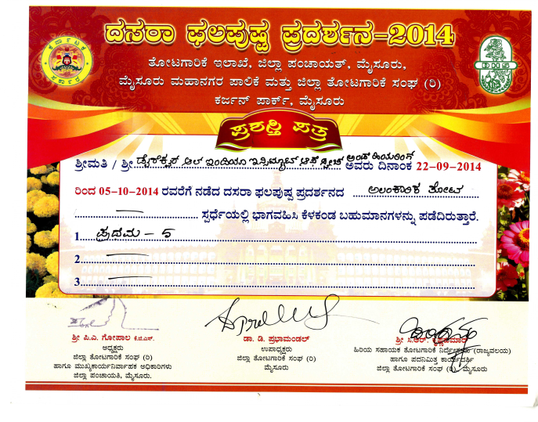

1. 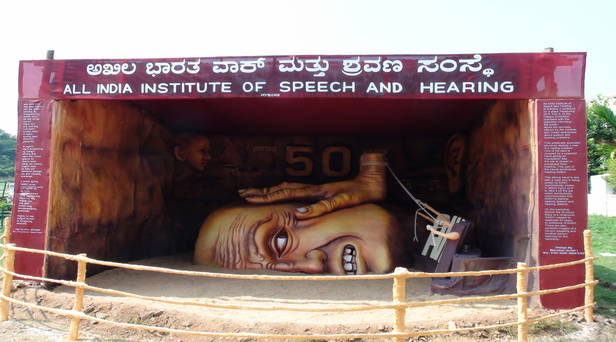The Institute participated in Mysore Dasara Exhibition and bagged first prize for its sculpture depicting Communication Disorders and their Rehabilitation.

Sculpture displayed at Dasara exhibition

1. Dr. K.S. Prema, Professor of Language Pathology and Head-TCPD received Dr.N. Rathna Oration Award hosted by Indian Speech and Hearing Association for her incredible contribution in the field of Speech and Hearing at 47th annual convention of Indian Speech and Hearing Association held at Manipal on 1-3 January, 2015.

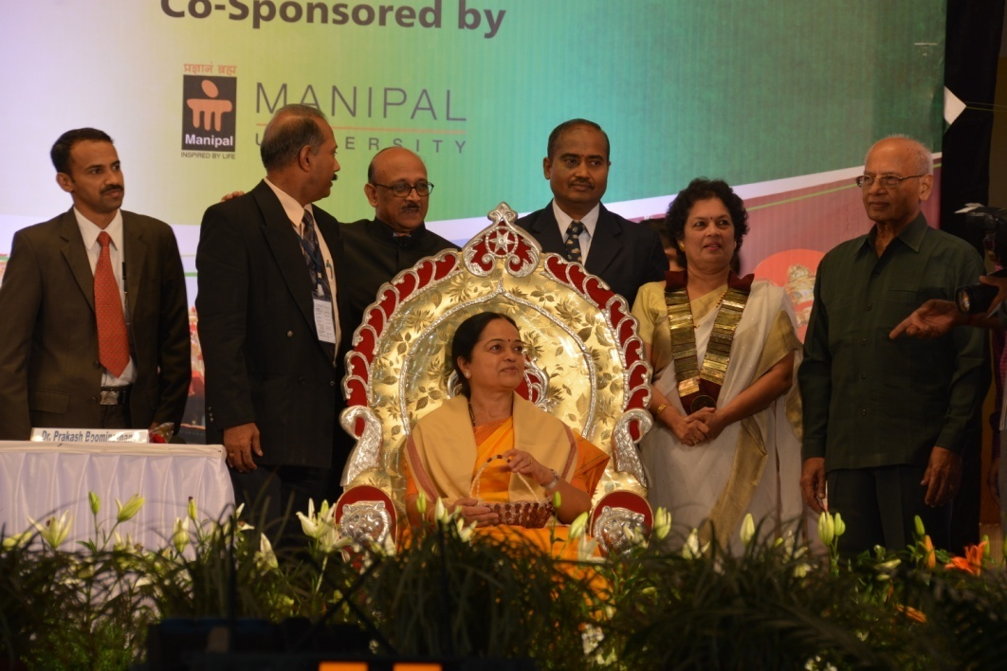

**Best scientific paper award**

1. Dr.Asha Yathiraj, Dr. Vanaja, C.S. and Muthu Selvi, T received ***Dayalan Samuuel SSV Award Best Paper in Audiology*** for their paper Cut-off criteria to classify children as having auditory processing disorders at the 47th ISHACON, Manipal, Karnataka, 1-3 January 2015.
2. Niraj Kumar Singh, Dr. Sujeet Kumar Sinha and Dr.Animesh Barman received ***Dr. N.R. Chaudhary Memorial Award for best paper in Audiology*** for their paper Assessment of otolith mediated neural reflexes through cervical and ocular vestibular evoked myogenic potentials in individuals with auditory neuropathy spectrum disorders at the 47th ISHACON, Manipal, Karnataka, 1-3 January 2015.
3. Usha Shastri, Dr. Ajith Kumar, U. received ***Manohar Memorial Award for best paper in Audiology***for their paper Electrical neuro-imaging evidence for differential representation of phonemes and allophones of native language at the 47th ISHACON, Manipal, Karnataka, 1-3 January, 2015.
4. Chandni Jain, and Ajith Kumar U. received the best paper award for their paper Age Related Differences in Some Psychoacoustical abilities, Speech Perception in Noise and Working Memory, in the **Sound Perception area** at the National Symposium on Acoustics 2014 held at Mysuru from 12th to 14th November, 2014
5. Mrs.Devi. N and Dr Ajith Kumar U received the best paper award for their paper Effect of short-term musical training on auditory cortical responses- in the **Musical Acoustics area** at the National Symposium on Acoustics 2014 held at Mysuru from 12th to 14th November, 2014.
6. Mr. Reuben T. V & Mr. Gopisankar, R received the best paper in Voice- Oral presentation SLP Award Category for their paper Voice Characteristics of Mothers of Children with Hearing Impairment at the XI Phonocon, 2015 held at Nagpur in February, 2015
7. Prof. Ajish K Abraham &Mr.Manohar N received the best paper award for their paper Assistive Technology to override poor acoustics for Museum visitors with hearing impairment, in the Transducers, Electro and Bioacoustics fieldat the National Symposium on Acoustics 2014 held at Mysuru from 12th to 14th November, 2014
8. Mrs. Renuka C received the best paper award for her paper Bilingual Lexicon for children with hearing impairment: Boon with Android applicationat the7th National Women’s Science Congress, RashtriyaMahilaVijnanaSammelana, held at Vijapur from 7th to 9th November 2014
9. Dr.Swapna N., Dr.PremaRao, Dr. Y. V. Geetha, Ms.Asha S. A. received Smt.Annapoorna memorial Award for best paper on technological development for PWD’sfor their paper Digital tutorial to facilitate pre-reading skills. NCED international conference, Bhubaneshwar8.1.15
10. Dr. H.P. Umasaraswathi, HT, received the b**est paper award for her paper भाषाप्रोद्योगिकीएवंपुनःसृजन at the national level Hindi Workshop organized by the** theRaj BhashaSansthan, New Delhi
11. **Dr. H. SundaRaju,** Professor & HOD-ENT received 1st Prize in Spot the Diagnostic Contest at the ISOCON-2014 held at Chennai on 14th to 16th November 2014.
12. **Preschool Children of the Institute won** *5 Gold, 7 Silver and 5Bronze***at the Special Olympics Bhandhavya- 2015**
13. **Preschool Children of the Institute won the overall championship at the** Inter school competition for special children organized by the Rotary Club, Mysuru
14. Mr. ShreyankSwamy, 2ndyear M.Sc. Audiologystudent won ……… medals in the Mysore University Inter-Collegiate Swimming Competitions, 2014-15.
15. Ms. …………..was awarded Dr. NateshRathna Gold Medal for securing first rank in B.Sc. (Sp. & Hg.) Examinations,University of Mysore, Mysore in June, 2014.
16. Ms. ………………was awarded National Hearing Care in Audiology Gold Medal for securing first rank in B.Sc. (Sp. &Hg.) Examinations, University of Mysore, Mysore in June, 2014.
17. Ms……………………. was awarded ArathiVenkataraman Gold Medal for securing firstrank in M.Sc. (Audiology) Examinations,University of Mysore, Mysore in June, 2014.
18. Ms……………… was awarded the P.D. Manohar Gold Medal for securing first rank in M.Sc. (Speech Language Pathology) Examinations, University of Mysore, Mysorein June, 2014.

**Awards hosted by the Institute**

1. ……. ………..under the guidance of ………………………………. bagged the Best Journal Club PresentationAward for the year 2014-15.
2. ……. ………..under the guidance of ………………………………. bagged the Best Club Presentation Award for the year 2014-15.
3. ……………..awarded the Abhilash Award for Best Student Clinician for the year 2014-15.
4. ………… was awarded Dr.VijayalakshmiBasavaraj Gold Medal for securing first rank in M.Sc. (Audiology) Examinations, June, 2013.

