Extracurricular Events

The institute carries out various extracurricular activities such as Institute annual day celebrations, important commemorative days and intercollegiate cultural festival. These extracurricular activities are spearheaded by AIISH Gymkhana, the cultural organization of staff and students and the National Service Scheme Unit. The extracurricular activities took place during the reporting year are given below.

**AIISH Gymkhana**

AIISH Gymkhana provides platform for recreational, social and cultural activities not only for its members but also for other central government institutions to conduct their social and cultural activities. It is having facilities for indoor and outdoor sports, gymnasium, and library. The following programs were conducted by AIISH Gymkhana during the report year:

**Annual Day**

On 9th August, 2014, 49th anniversary of the institute was celebrated. Dr. A.K. Panda, IAS, Additional Secretary, Ministry of Health & Family Welfare, Government of India, New Delhi. , Prof. SudeshMukhopadhyay, Chairperson, Rehabilitation Council of India, New Delhi and Prof. GawtamBiswas, Director, IIT Guwahati were the Chief Guests. Golden jubilee celebrations of the institute were inaugurated by Dr. A. K. Panda , IAS by releasing the Golden Jubilee logo. Dr. S. R. Savithri, Director presided over the function. A cultural extravaganza was also held in the evening, for which Dr. Sarvamangala Shankar, Vice Chancellor, Music University, Mysuru, Prof. D. ShrijayDevarajUrs, Registrar – Evaluation, University of Mysore and Prof. Umesh, Retd Principal, Sharadavilas College, Mysore were the Chief Guests. The retired employees, employees completing 25 years of institute service, and employees selected for best AIISHian awards were honored, and various public education materials prepared by the institute and the were released during the occasion. Also, the staff, students and preschool children presented various cultural performances.

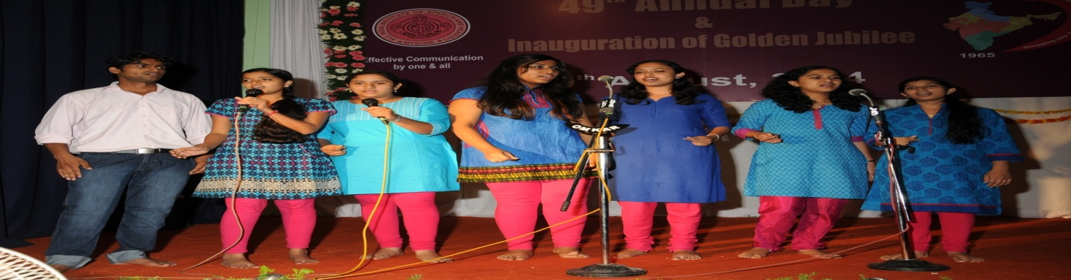

Students performance at Annual Day Celebrations

**PratibhaPuraskar and Talents Day**

**O**n 9th September, 2014 meritorious children of the institute staff who excelled in the curricular and extracurricular activities were hounored. Many children showcased their talents during the occasion**. (**To verify from Pushpavathy**)**

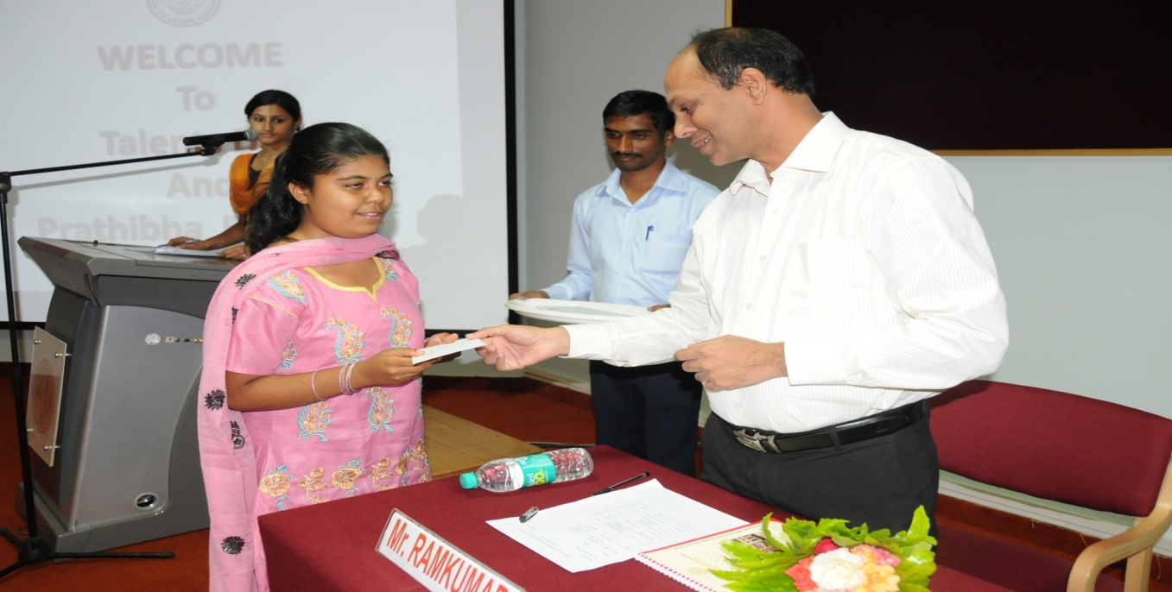

Felicitation of meritorious children of staff

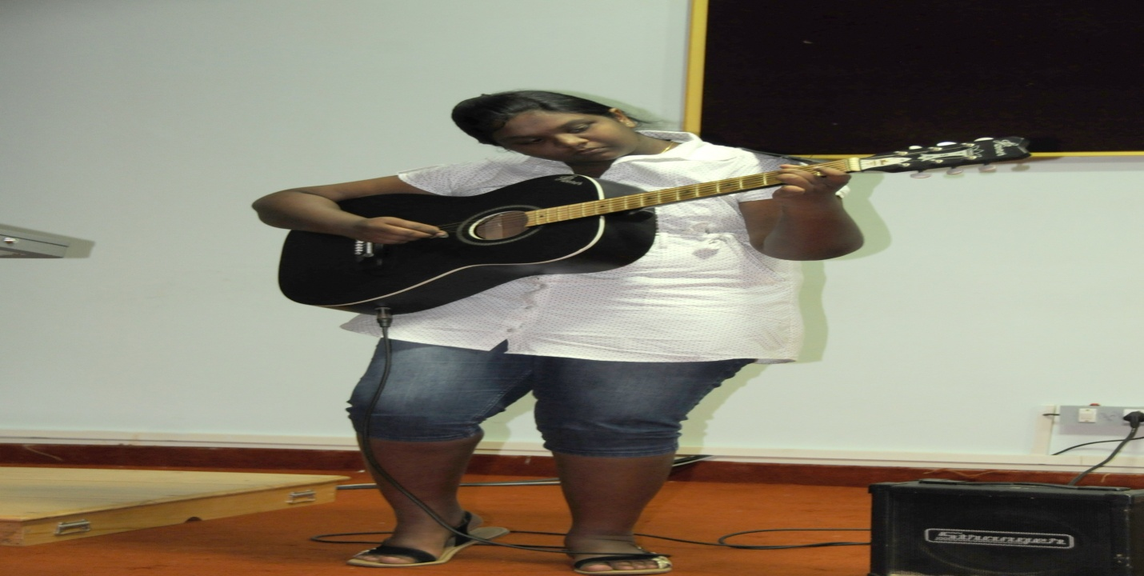

**Independence Day**

On 15th August, 2014,the independent day was celebrated to mark the 68th year of independence of the country. Dr.S.R.Savithri, Director of the institute hoisted the national flag during the occasion. Various cultural activities such as recital of patriotic songs by the students and fancy dress presentation by the pre-school children were also held as a part of the celebration.

**KannadaRajyotsavaDay**

on 3rd November 2014,Kannada Rajyathosva was celebrated. Prof. KikkeriNarayana, a well known writer and retired Professor, CIIL, Mysuru was the chief guest. Group song competition in Kannada was held department-wise and the prizes were distributed.

**OpenDay**

On 16th December, 2014, the institute celebrated Open day. Smt. Rashmi V Mahesh, IAS, Director General, ATI, Mysore inaugurated the event and Dr.S.R.Savithri, Director of the institute presidedover the function. Sri. H.R. Basappa, Deputy Director of Public Instruction, Office of DDPI, Mysore was the guest of honour. An exhibition with many interesting and fun loving games were conducted for children and general public to create awareness about disability and the needs of persons with disability.

**Republic Day**

On 26th January 2015, the institute celebrated the 66thRepublic Day of the nation. Major General (Retd.) S.G. Vombatkerewas the chief guest. Children from AIISH Preschool presented cultural programs.

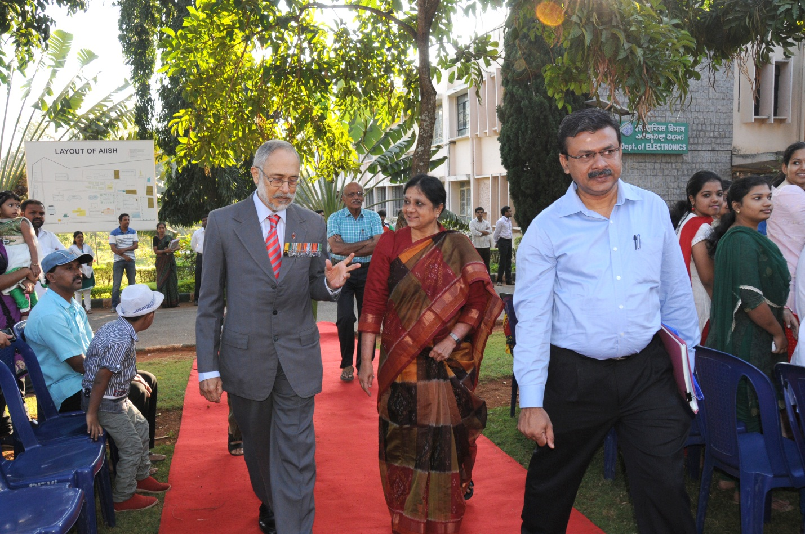

**National Science Day**

On 27th February 2015, the institute celebrated National Science Day. Dr. S.K. Shivakumar, one of the distinguished scientists behind India’s successful Mangalyaan Mission and Director, ISRO Satellite Centre, Bengaluru was the chief guest and delivered a talk on Indian Satellites and Success of Mars Orbiter Mission.

**International Women’s Day**

On 5th March 2015,the Inter National Women’s Day 2015 was celebrated and a cook without fire and vegetable carving competitions were arranged for women staff.

**Mini Marathon**

On 7th March 2015, as a start to AIISH AAWAAZ 2015, the institute organized a mini marathon starting from the palace circle. Sri. V. Srinivas Prasad, Hon’ble Revenue Minister, Govt. of Karnataka flagged off the Marathon.

**AIISH AAWAAZ 2015**

From 13th to 15th March 2015, an inter-collegiate cultural festival which is a platform for college students to showcase their cultural talents was conducted at AIISH Gymkhana. Smt. SudhaBaraguru, Internationally Renowned Humorist inaugurated the event on 13th March 2015 in which Sri. AvinashDiwakar, Kannada film actor was the guest of Honour. Sri.BadalNanjundaswamy (Renowned artist) &Sri.Namadeo Dinesh Kumar,inaugurated the valedictory function held on 15th March 2015 in which Sri. BadalNanjundaswamy (Renowned artist) &Sri.Namadeo Dinesh Kumar, Dy. Zonal Head, Bank of Baroda, Karnataka Zone were the chief guests and Sri. Naveen Sajju, Kannada play back singer the guest of honour. Dr. S.R.Savithri, Director, AIISH presided over the function. The competitions includedsolo singing, mime,skit,group dance, treasure hunt, group song ,mock press, mad adds, self composition, fashion extravaganza, spoof, duet singing and spot dance. The cultural and fine arts events at the festival witnessed intense competition among the students from 39 colleges of Mysore and 7 Speech and Hearing institutes across the country. Madras ENT Research Foundation (MERF), Chennai bagged the overall championship.

**Farewell Programs**

Farewell programswere arranged for Sri. Anil Kumar, Sri. Chowdaiah, Sri. Mahadeva M,Ms.Padma, Smt. V. Shubha, Smt. J Ragunathestaff memberswho attained superannuation,Smt. B.V. Jyothi the staff member who took voluntary retirement and the outgoing students of 2013-14 batches.

**National Service Scheme**

The National Service Scheme (NSS) unit of the institute rendered a variety of community services during the reporting year. The major services among them are given below.

**Orientation program: O**n 26th August, 2014 a**n o**rientation programme on the activities of NSS unit was conducted to the students and approximately 100 students participated in the event.

**Shramdaan: On 6th September, 2014 as**hramdaan activity was conducted at the foothills of the chamundi hill and the NSS volunteers cleaned all the steps from foothills to the top of chamundi hillsand the surroundings.

**Craft Making:** On 13th September, 2014 craft making was carried out in which greeting cards, paper bags and posters were prepared.

**Rally on Alzheimer’s Disease: O**n 20th September, 2014, a Walkathonwas organizedin Mysore city in order to spread awareness about the disease its related dementia among the general public. Sri PratapSimha, honourablemember of Parliament inaugurated the walk.

**Campus Cleaning:**On 4th October, 2014 thevolunteers cleaned the whole Institute campus and its surroundings.

**Talk on Waste Management:** On 13th October, 2014, a lecture on waste management by Mr. Ramesh Kikkeri, Assistant Professor, Vivekananda Institute for Leadership Development was organized.

**Rally on Noise Awareness:** On 18th October, 2014a noise awareness rally was **organized in Mysore city to educate the general public on** hazard of noise.The programme was inaugurated by Dr. Rudraaiah NSS ProgrammeOfficer, University of Mysore.Different skits related to the hazard of noise were performed during the event.

**OrphanageVisit: On 25th October, 2014 the volunteers visited** Sri ChayadeviAnathashrama Trust orphanage in Mysore and distributed the clothes, food items and stationeries among the inmates, collected from students and staff of AIISH.