OUTREACH SERVICES

In addition to the diagnostic and therapeutic services provided within its walls, the institute carries out various outreach services on communication and its disorders in different parts of the country. The major outreach services during the reporting year are given below.

**Communication Disorder Screening Programmes**

The Institute conducted screening programmes for communication disorders in different settings and localities under the aegis of the Department of Prevention of Communication Disorders. The individuals participating in the programmes were checked for speech, language and hearing abilities and provided with diagnostic and therapeutic services. The screening programmes conducted in different settings are mentioned below.



Figure 21 : Screening done in different settings

**Newborn/Infant Screening**

This programme focuses on screening neonates and infants who are at risk for communication disorders using various tools such as High Risk Register for communication disorders, Behavioral Observation Audiometry, Oto Acoustic Emission Screening and Screening Checklists. During the reporting year, screening programme was carried out at 15 hospitals and three immunization centres in Mysore, six Outreach Service Centres of the Institute functioning in different parts of Karnataka and three Newborn Screening Centres functioning in hospitals attached with the AIISH DHLS centres, at Cuttuck, Odisha, Imphal, Manipal and Ajmer, Rajasthan. The details are given in table…..

Table 9: Newborn/Infant Screening

|  |  |  |  |  |  |
| --- | --- | --- | --- | --- | --- |
| **SN** | **Hospitals/Immunization Centers** | **No. of children screened** | | | **No. children at risk for disorders** |
| **Male** | **Female** | **Total** |
| **Hospitals in Mysore** | | | | | |
| 1 | Apollo BGS Hospital (BAH), | 145 | 135 | 280 | 39 |
| 2 | Basappa Memorial Hospital (BMH) | 104 | 96 | 200 | 28 |
| 3 | Combined Hospital (CH) | 62 | 57 | 119 | 26 |
| 4 | Harsha Hospital (HH) | 42 | 34 | 76 | 14 |
| 5 | Kamakshi Hospital (KH) | 306 | 300 | 606 | 83 |
| 6 | KR Hospital (KRH) | 4813 | 4464 | 9277 | 2025 |
| 7 | Makkalakoota Immunization Center (MIC) | 93 | 139 | 232 | 51 |
| 8 | Mission Hospital (MH) | 365 | 304 | 669 | 142 |
| 9 | Immunization Center at Mission Hospital (ICMH) | 37 | 31 | 68 | 23 |
| 10 | N.P.C Hospital | 50 | 33 | 83 | 10 |
| 11 | S.M.T.D.H Hospital | 291 | 235 | 526 | 97 |
| 12 | Railway Hospital (RH) | 25 | 21 | 46 | 9 |
| 13 | Employees State Insurance (ESI) Hospital | 17 | 20 | 37 | 7 |
| 14 | Ashwini Nursing Home (ANH) | 88 | 45 | 133 | 36 |
| 15 | Shree Devi Nursing Home (SNH) | 84 | 68 | 152 | 35 |
| 16 | GopalaGowdaShanthaveri Memorial Hospital (GGSMH) | 37 | 33 | 70 | 18 |
| 17 | Family Planning Association Immunization (FPAI) center | 124 | 96 | 220 | 42 |
| 18 | Mahadeshwara Nursing Home (MNH) | 76 | 51 | 127 | 23 |
| **Total** | | **6759** | **6162** | **12921** | **2708** |
| **Outreach Service Centers** | | | | | |
| 19 | Sub-divisional hospital, K R Nagar | 272 | 268 | 540 | 86 |
| 20 | Sub-divisional hospital, T Narsipura | 207 | 171 | 378 | 65 |
| 21 | Sub-divisional Hospital, Sagara Taluk | 32 | 25 | 57 | 0 |
| 22 | Primary Health Centre (PHC), Hullahalli | 117 | 92 | 209 | 16 |
| 23 | Community Health Centre (CHC), Santhemarahalli | 178 | 187 | 365 | 57 |
| 24 | Primary Health Centre (PHC), Akkihebbalu | 25 | 20 | 45 | 7 |
| **Total** | | **831** | **763** | **1594** | **231** |
| **Newborn screening centres** | | | | | |
| 25 | Sri RamachandraBhanj Medical College and Hospital (SCB MCH), Cuttack | 1334 | 934 | 2268 | 445 |
| 26 | Regional Institute of Medical Sciences (RIMS), Imphal | 2287 | 2243 | 4530 | 113 |
| 27 | Janana Hospital & JLNMCH, Ajmer | 3343 | 1678 | 5021 | 458 |
|  | **Total** | **6964** | **4855** | **11819** | **1016** |
| **Grand Total** | | **14,554** | **11,780** | **26,334** | **5,318** |

The newborns/infants referred during the newborn screening were followed up through telephone calls and totally 380 children underwent follow-up evaluation in all the centres. They were administered a complete test battery.

Table 29:Newborn/ Infant screening



Figure 22: Infant/new born screening at outreach service centres &other hospitals



Figure 23: Newborn Screening at DHLS hospitals

**Industrial Screening**

Hearing evaluation of industrial workers, were carried out for the employees working in Karnataka Silk Industries Company (KSIC), Mysore. Of the 117 employees screened and 143 ears had identified as hearing impairment on administration of complete audiological test battery. The persons with hearing impairment were given rehabilitation services.

In addition to the services provided at their premises, theindustrial workers were made to undergone hearing evaluation at the Institute clinical settings and a total of 245 workers working with KSIC, Rane Madras and Bhaba Atomic Research Centre registered for availing in the service at the Institute during the report year. Out of ears evaluated, 282 had hearing impairment on administration of complete audiological test battery. All the registered employees were counseled regarding the importance of hearing protection devices and its need to use regularly in noisy conditions to protect their hearing ability.

**School Screening**

Nursery and primary school students of various Schools in Mysore and Tumkur districts were screened for communication disorder as a part of the school screening programme during the reporting year. Totally 5247 students were screened and among them 1052 were identified with ear related disorders, 67 with hearing loss and 563 with speech-language disorders. They were recommended for follow-up at the Institute. The details of the school screening are given in table…

|  |  |  |  |  |
| --- | --- | --- | --- | --- |
| **School** | **No. of Students Screened** | **Types of communication disorders** | | |
| **Ear related disorder** | **Hearing loss** | **Speech language disorders** |
| Lawrence [Montessori](http://en.wikipedia.org/wiki/Montessori_education)- Preschool | 21 | 0 | 0 | 6 |
| Bachpan Preschool | 39 | 3 | 0 | 4 |
| Cradle Academy preschool | 23 | 1 | 0 | 2 |
| Smart Kiddies preschool | 9 | 0 | 0 | 1 |
| Kindergarden Starters preschool | 14 | 0 | 0 | 0 |
| Siddaganga matt, Tumkur | 996 | 314 | 15 | 233 |
| Siddaganga matt, Tumkur | 1801 | 307 | 37 | 191 |
| Siddaganga matt, Tumkur | 2084 | 415 | 15 | 118 |
| PragathiVidya Kendra primary and high school | 102 | 8 | 0 | 7 |
| St. Joseph central school | 158 | 4 | 0 | 1 |
|  | 5247 | 1052 | 67 | 563 |

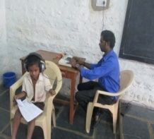

Screening of schoolchildren for communication disorders

**Elderly Screening**

Speech, language and hearing evaluation were carried out for elderly citizens residing in different old age homes in Mysore. One hundred and seventy persons underwent the evaluation. The details are given in table 31.

Table 31: Screening for communication disorders among elderly citizens

|  |  |  |  |  |
| --- | --- | --- | --- | --- |
| **Old age homes** | **Total screened** | **Total identified with communication disorders** | | |
| **Hearing disorders** | **Speech language disorders** | **Multiple disorders** |
| Vimala Terminal care centre, Mysore | 24 | 12 | 4 | 2 |
| Basal Ganglia Association, Mysore | 14 | 2 | 0 | 12 |
| Nirashrithara Parihara Kendra, Mysore | 32 | 8 | 0 | 7 |
| Little sisters for the poor, Mysore | 95 | 50 | 0 | 2 |
| Belakuvastalyadhama-Aid the aged, Mysore | 5 | 1 | 0 | 1 |
| Total | 170 | 73 | 4 | 25 |

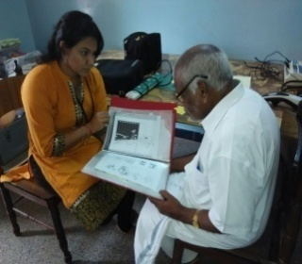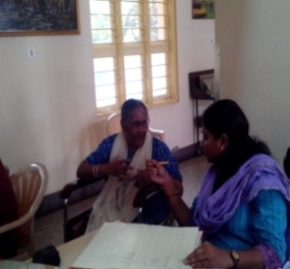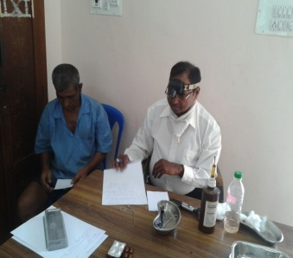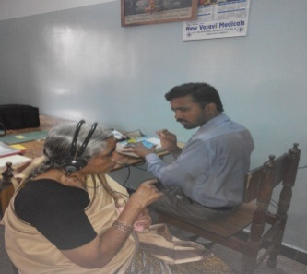

**Elderly Screening**

**Camp based Screening**

The Institute organized nine camps in various localities across the country and the expert speech and hearing and allied health professionals from the institute screened 1812 persons for communication disorders in the camps. The details are given in table 32.

Table 32: Communication disorders screening camps

|  |  |  |  |  |  |  |
| --- | --- | --- | --- | --- | --- | --- |
| Place | Organizers | Month | Total screened/ evaluated | Total identified with communication disorders | | |
| ENT disorders | Hearing loss | Speech language Disorders |
| Hospet | Lions club | June 2014 | 393 | - | 263 | 95 |
| Mysore | Mysore City corporation, | June 2014 | 126 | 16 | 16 | 72 |
| Periyapatna | Deputy Director of public instruction Department, SSA, Mysore, | July 2014 | 12 | - | 11 | - |
| Mysore | Deputy Director of public instruction Department, SSA, Mysore, | July 2014 | 80 | - | 79 | - |
| H.D. Kote | Deputy Director of public instruction Department, SSA, Mysore, | July 2014 | 20 | - | 7 | 13 |
| Hunsur | Deputy Director of public instruction Department, SSA, Mysore, | July 2014 | 35 | - | 12 | 23 |
| PerambCalicut | Lions club | Dec. 2014 | 295 | 8 | 170 | 116 |
| Gujarat | NSS, AIISH | Feb. 2015 | 710 | - | 162 | - |
| Udupi | Lions club Midtown | March 2015 | 141 | - | 85 | 48 |
| **Total** | | | **1812** | **18** | **805** | **200** |

**Clinical Services at the Outreach Service Centres**

Communication disorders related diagnostic and therapeutic services were provided at the four outreach centres of the institute located in 01 sub-divisional taluk hospital at Sagara taluk, Shivamogga District; 03 Primary Health Centre - PHC at Hullahalli, Mysuru district; Akkihebbalu, Mandya district & Karuna trust, Gumballi, Chamarajanagara district. Totally 2111 persons availed the services the details are given in table…. Thirty six persons identified with speech-language disorders underwent therapy in 303 sessions. Also, 142 hearing aids were distributed among the persons identified with hearing impairment.

**Table 13: *Details of clients identified with communication disorders at the OSCs.***

|  |  |  |  |  |
| --- | --- | --- | --- | --- |
| OSC | **Total registered** | **ENT Disorder (Ear wise)** | **Hearing Disorder (Ear wise)** | **Speech & Language Disorder (Individuals)** |
| Primary Health Centre (PHC), Hullahalli | 888 | 1229 | 281 | 34 |
| Primary Health Centre (PHC), Akkihebbalu | 475 | 762 | 238 | 20 |
| Primary Health Centre (PHC), Gumballi | 748 | 954 | 430 | 43 |
| Sub-divisional Hospital, Sagara (PHC) Taluk | 9 | 0 | 16 | 1 |
| Total | **2111** | **2945** | **965** | **98** |

**Tele-Intervention and Tele-Assessment Services**

**Video Conferencing System**: The Tele Centre for Persons with Communication Disorders (TCPD) offered tele-intervention and assessment services to the persons with communication disorders and their caregivers at nine DHLS centers of the institute located throughout the country through the AIISH video conferencing system. The details are given in table… and figure….

To draw table

**Web based Service:** In addition, the services were also provided through SKYPE, the web based communication system. details of which are given in table 33 and figure 25. To draw table

**Tele-Educational Guidance and Counseling**

Educational guidance and counseling were given to 8 parents of children with communication disorders at the DHLS study centres through videoconferencing and the SKYPE to make them understand how the child's special need might affect his education, how to prepare him for schooling, help in deciding appropriate schools for the child and inform them of various benefits and concessions offered by the central and state governments for the children with special needs.

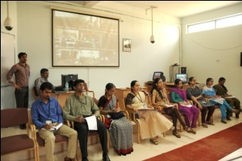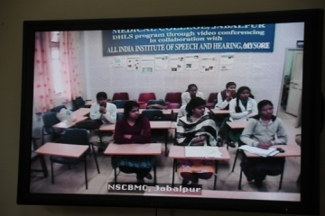

Tele-educational guidance

**Mainstream School Adoption**

In order to ensure proper care for the children with communication disorders, studying in normal schools, a mainstream school adoption programme was initiated and 6 schools were adopted and 70 teachers in these schools were oriented through 6 programmes on identification of special needs in children, curricular adaptation and management of their special educational needs in the inclusive learning environments.

**Itinerant Service**

The Institute offers itinerant service for the regular school and Anganwaadi children through the Itinerant Speech Therapist and Medical Social Worker. During the reporting year the service was provided at 32 schools and 22 anganwaadis in Mysore district and **totally** 129 children identified with various types communication disorders were referred to AIISH for evaluation, and 185 teachers/ anganwaadi workers were oriented on prevention and control of communication disorders. In addition, follow-up of regular school children availing therapy at AIISH were carried out and 77 children were followed up, 61 teachers and 13 parents oriented and 54 parents counseled on school placement.