**AIISH GYMKHANA**

AIISH Gymkhana is an association of staff and students of the institute. It provides a platform for recreational, social and cultural activities not only for its members but also for other central government institutions to conduct their social and cultural activities. It is housed in the Panchavati campus with facilities for indoor and outdoor sports, gymnasium, and library. The following programs were conducted by AIISH Gymkhana during the report year:

**AIISH Gymkhana Activities from April 1st 2014 to September 19th 2014.**

* Organized farewell function for Mr. Chowdaiah, MTS from AIISH Gymkhana on 01.04.2014
* Organized photography session for outgoing students organized by AIISH Gymkhana on 01.05.2014.
* Organizing Formal Farwell function for outgoing students of 2013-14 batches on 09.05.2014.
* Organized Farewell for Ms.Padma, MTS on 31.07.2014
* Inauguration of Day care center for staff of AIISH on Annual Day
* Talents Day and Formal fresher party was organized on 09.09.2014.
* Annual General Body meeting was held on 19.09.2014.

|  |  |
| --- | --- |
| **F:\gymkhana 2014-15\Gymkhana pic gallery\day care iaguration pics\DSC_1895.JPGF:\gymkhana 2014-15\Gymkhana pic gallery\day care iaguration pics\DSC_1903.JPG** | **F:\gymkhana 2014-15\Gymkhana pic gallery\day care iaguration pics\DSC_2118.JPG** |
| **F:\gymkhana 2014-15\Gymkhana pic gallery\Talents day\DSC_2923.JPG** | **F:\gymkhana 2014-15\Gymkhana pic gallery\Talents day\DSC_2743.JPG** |
| **F:\gymkhana 2014-15\Gymkhana pic gallery\Talents day\DSC_2753.JPG**  **F:\gymkhana 2014-15\Gymkhana pic gallery\Talents day\DSC_2861.JPG** | **F:\gymkhana 2014-15\Gymkhana pic gallery\Talents day\DSC_2780.JPG** |
| **F:\gymkhana 2014-15\Gymkhana pic gallery\Talents day\DSC_2769.JPG** | **F:\gymkhana 2014-15\Gymkhana pic gallery\Talents day\DSC_2764.JPG** |

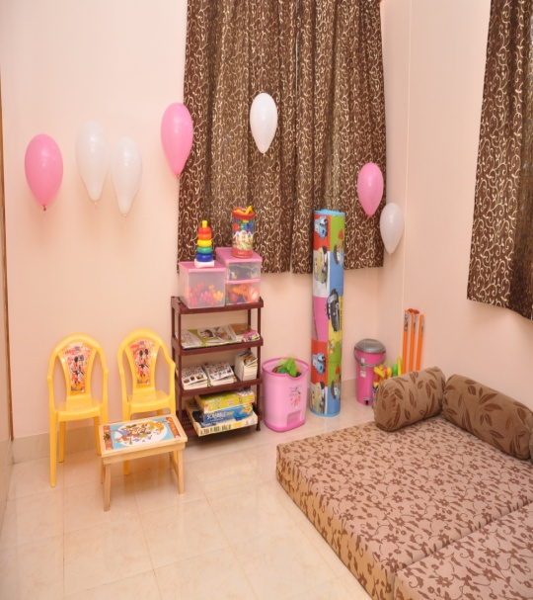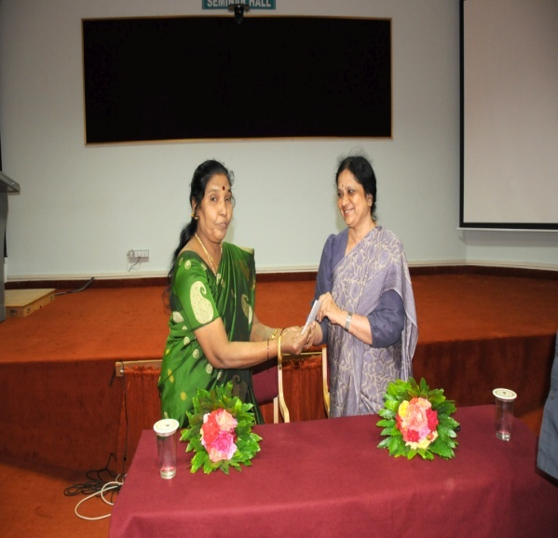

* **Annual day:** On 9th August 2014, the institute celebrated “49th Anniversary”. Dr. A.K. Panda, IAS, Additional Secretary, Ministry of Health & Family Welfare, Government of India, New Delhi. , Prof. Sudesh Mukhopadhyay, Chairperson, Rehabilitation Council of India, New Delhi and Prof. Gawtam Biswas, Director, IIT Guwahati were the Chief Guests. Golden jubilee celebrations of the institute were inaugurated by Dr. A. K. Panda , IAS by releasing the Golden Jubilee logo. Dr. S. R. Savithri, Director presided over the function. A cultural extravaganza was also held in the evening, for which Dr. Sarvamangala Shankar, Vice Chancellor, Music University, Mysuru, Prof. D. Shrijay Devaraj Urs, Registrar – Evaluation, University of Mysore and Prof. Umesh, Retd Principal, Sharadavilas College, Mysore were the Chief Guests.
* **Kannada Rajyathosava**: On 3rd November 2014, Kannada Rajyathosva was celebrated . Prof. Kikkeri Narayana, a well known writer and retired Professor, CIIL, Mysuru was the Chief Guest. Group song competition in Kannada was held department – wise and the prizes were distributed.
* **Open day:** On 16th December 2014, the institute celebrated “Open day”. The Open day was inaugurated by Smt. Rashmi V Mahesh IAS, Director General, ATI, Mysore and Sri. H.R. Basappa, Deputy Director of Public Instruction, Office of DDPI, Mysore was the Guest of Honour. An exhibition with many interesting and fun loving games were conducted for children and general public to create awareness about disability and the needs of persons with disability.
* **Republic Day:** On 26th January 2015, the institute celebrated “Republic Day”. Major General (Retd.) S.G. Vombatkere was the Chief Guest. Children from AIISH Preschool presented cultural programs.
* **National Science Day:** On 27th February 2015, the institute celebrated “National Science Day”. Dr. S.K. Shivakumar, one of the distinguished Scientists behind India’s successful Mangalyaan Mission and Director, ISRO Satellite centre, Bengaluru was the chief guest and delivered a talk on **“Indian Satellites and Success of Mars Orbiter Mission”.**
* **Inter National Women’s Day:** On 5th March 2015, as a part of “Inter National Women’s Day 2015”, cook without fire and vegetable carving competitions were arranged exclusively for women staff.
* **Mini marathon:** On 7th March 2015, as a start to AIISH AAWAAZ 2015, the institute organized a mini marathon starting from the palace circle. Sri. V. Srinivas Prasad, Hon’ble Revenue Minister, Govt. of Karnataka flagged off the Marathon.
* **AIISH AAWAAZ 2015:** From 13th to 15th March 2015, an inter-collegiate cultural festival which is a platform for college students to showcase their cultural talents was conducted at AIISH Gymkhana. On 13th March 2015, Smt. Sudha Baraguru, Internationally Renowned Humorist inaugurated the event and Sri. Avinash Diwakar, Kannada film actor was the Guest of Honour. On 15th March 2015, Valedictory function was held. Sri. Badal Nanjundaswamy (Renowned artist) & Sri. Namadeo Dinesh Kumar, Dy. Zonal Head, Bank of Baroda, Karnataka Zone were the chief Guests and Sri. Naveen Sajju, Kannada play back singer was the Guest of Honour. Dr. S.R.Savithri, Director, AIISH presided over the function. The competitions included Solo singing , Mime , Skit, Group dance , Treasure Hunt , Group song , Mock press , Mad adds , Self composition, Fashion Extravaganza, Spoof, Duet singing, Spot Dance. The cultural and fine arts events at the festival witnessed intense competition among the students from 39 colleges of Mysore and 7 Speech and Hearing institutes across the country. Madras ENT Research Foundation (MERF), Chennai bagged the overall championship.
* **Farewell Programs:** Farewell programs were arranged for four of our staff members who attained superannuation and one staff member who took voluntary retirement as per the details given below:-

|  |  |  |
| --- | --- | --- |
| **Sl.No** | **Names** | **Date** |
| 1 | Sri. Anil Kumar | 30.09.2014 |
| 2 | Smt. B.V. Jyothi | 30.09.2014 |
| 3 | Sri. Mahadeva M | 31.12.2014 |
| 4 | Smt. V. Shubha | 30.01.2015 |
| 5 | Smt. J Raguna | 30.01.2015 |