CLINICAL CARE
Patient Registration

Totally 23,232 new clients were registered for availing clinical services at the institute during the reporting year. In addition, 50,770 case files were retrieved for repeat/follow up visits for various evaluations. The geographical and gender-wise details of new clients are given in table 1. Majority of them (21,946) were from Karnataka, the state in which the institute is located, followed by the neighboring states of Kerala (690), Tamil Nadu (169), and Andhra Pradesh (163). Also there were clients from Bangladesh, Maldives and Nepal and Vietnam. Males (14192) outnumbered females (9035) in availing clinical services.
Table 1: Geographical & Gender wise distribution of new clients

Sl. No | State | Male | Female | Total
 | Andra Pradesh | 116 | 47 | 163
 | Arunachal Pradesh | 2 | 1 | 03
 | Assam | 11 | 5 | 16
 | Bihar | 29 | 8 | 37
 | Chattisgarh | 4 | 1 | 05
 | Delhi | 5 | 0 | 05
 | Goa | 1 | 1 | 02
 | Gujarat | 4 | 1 | 05
 | Hariyana | 5 | 1 | 06
 | Jharkhand | 14 | 2 | 16
 | Karnataka | 13314 | 8632 | 21946
 | Kashmir | 2 | 0 | 02
 | Kerala | 454 | 236 | 690
 | Madhya Pradesh | 16 | 1 | 17
 | Maharastra | 20 | 6 | 26
 | Manipur | 1 | 0 | 01
 | Meghalaya | 1 | 0 | 01
 | Mizoram | 0 | 1 | 01
 | Nagaland | 0 | 1 | 01
 | Orissa | 15 | 4 | 19
 | Rajasthan | 12 | 3 | 15
 | Sikkim | 0 | 0 | 00
 | Tamil Nadu | 110 | 59 | 169
 | Telangana | 8 | 9 | 17
 | Tripur | 0 | 1 | 01
 | Union Territories | 5 | 2 | 07
 | Uttar Pradesh | 27 | 8 | 35
 | West Bengal | 16 | 5 | 21
 | Total | 14192 | 9035 | 23227
Over Seas Clients |  | 03 | 02 | 05
Grand Total |  | 14195 | 9037 | 23232

Speech and Language Assessment and Rehabilitation

The speech and language outpatient unit evaluated 7,405 clients which include 5,834 new and 1571 review cases. Of the new cases, 5,652 were identified with various kinds of speech and language disorders and 182 were found to have normal speech. The details of various speech and language disorders diagnosed are given in table 2 and figure 1.
Table 2: Assessment of Speech-Language Disorders

Disorders | Language Disorders |  |  | Fluency Disorders |  |  | Voice Disorders |  |  | Articulation Disorders |  |  | Multiple Disorders |  |  | Normal |  |  | Total
Months | C | A | G | C | A | G | C | A | G | C | A | G | C | A | G | C | A | G | Total
April | 289 | 25 | 4 | 36 | 8 | 0 | 3 | 26 | 10 | 29 | 2 | 0 | 0 | 0 | 0 | 6 | 2 | 1 | 441
May | 460 | 39 | 4 | 42 | 16 | 0 | 7 | 36 | 5 | 69 | 6 | 0 | 14 | 2 | 0 | 8 | 3 | 0 | 711
June | 367 | 34 | 3 | 20 | 15 | 0 | 2 | 24 | 13 | 20 | 2 | 0 | 3 | 1 | 0 | 14 | 6 | 0 | 524
July | 360 | 74 | 4 | 22 | 18 | 0 | 10 | 45 | 11 | 19 | 8 | 0 | 19 | 3 | 0 | 16 | 9 | 0 | 618
Aug | 257 | 74 | 4 | 13 | 13 | 0 | 7 | 26 | 7 | 14 | 8 | 0 | 19 | 1 | 0 | 9 | 3 | 0 | 455
Sept | 249 | 61 | 3 | 8 | 12 | 0 | 3 | 21 | 3 | 19 | 6 | 0 | 13 | 0 | 0 | 6 | 5 | 0 | 409
Oct | 288 | 54 | 7 | 38 | 8 | 0 | 5 | 28 | 21 | 46 | 5 | 0 | 20 | 2 | 0 | 9 | 8 | 2 | 541
Nov | 293 | 52 | 7 | 27 | 16 | 0 | 3 | 28 | 14 | 18 | 5 | 0 | 10 | 0 | 0 | 9 | 7 | 0 | 489
Dec | 276 | 67 | 11 | 21 | 8 | 0 | 7 | 31 | 7 | 19 | 12 | 0 | 20 | 4 | 0 | 10 | 5 | 0 | 498
Jan | 292 | 65 | 8 | 24 | 13 | 0 | 10 | 27 | 8 | 22 | 5 | 0 | 21 | 5 | 0 | 10 | 10 | 1 | 521
Feb | 236 | 66 | 5 | 5 | 8 | 0 | 1 | 28 | 3 | 11 | 4 | 0 | 13 | 5 | 0 | 7 | 5 | 4 | 401
March | 125 | 34 | 5 | 4 | 5 | 0 | 4 | 19 | 6 | 6 | 3 | 3 | 5 | 0 | 0 | 4 | 3 | 0 | 226
Total | 3492 | 645 | 65 | 260 | 140 | 0 | 62 | 339 | 108 | 292 | 66 | 3 | 157 | 23 | 0 | 108 | 66 | 8 | 5834(N)+1571(R)
Disorder Wise | 4202(N)+1267(R) |  |  | 400(N)+59(R) |  |  | 509(N)+50(R) |  |  | 361(N)+78(R) |  |  | 180(N)+97(R) |  |  | 182(N)+20(R) |  |  | 5834(N)+1571(R)
Grand Total | 7405

C- Child, A-Adult, G-Geriatric, N-New, R-Review

Figure: 1 Assessment of Speech-Language Disorders (New cases Disorder-wise)

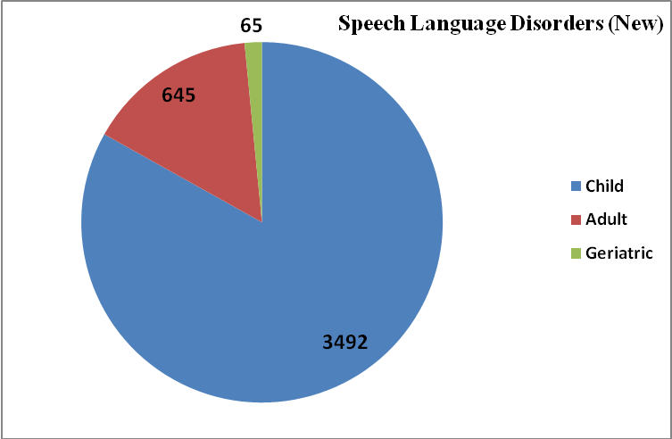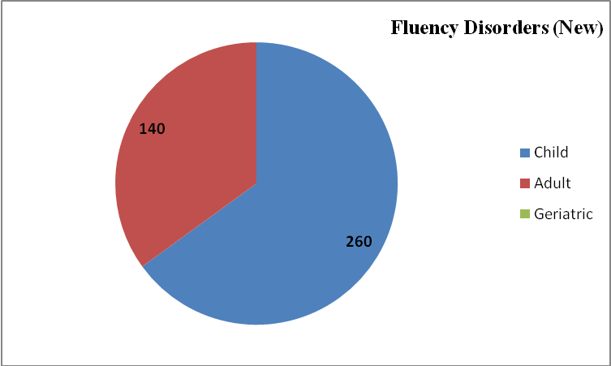
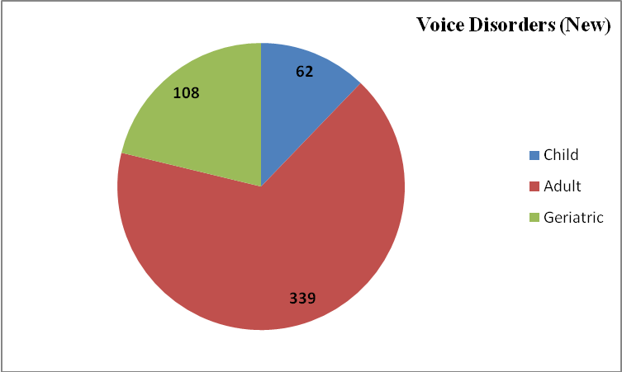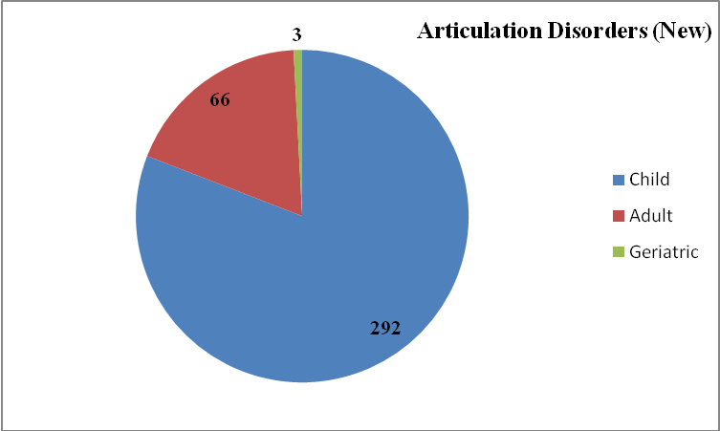

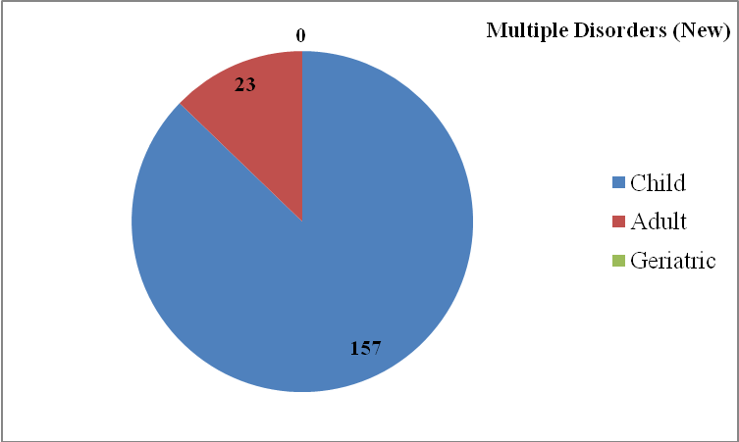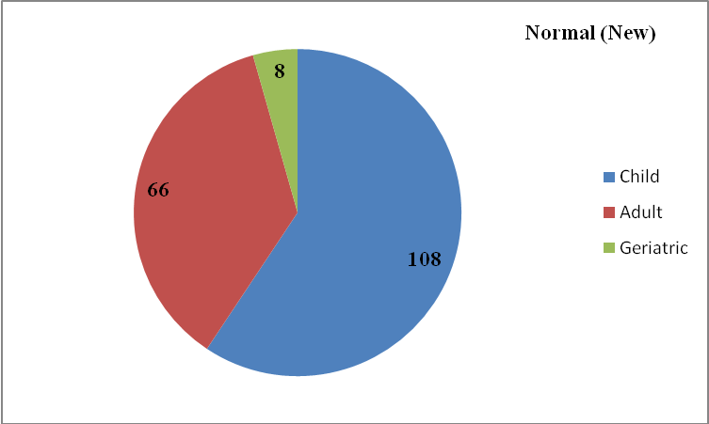

Overall Assessment of Speech-Language Disorders

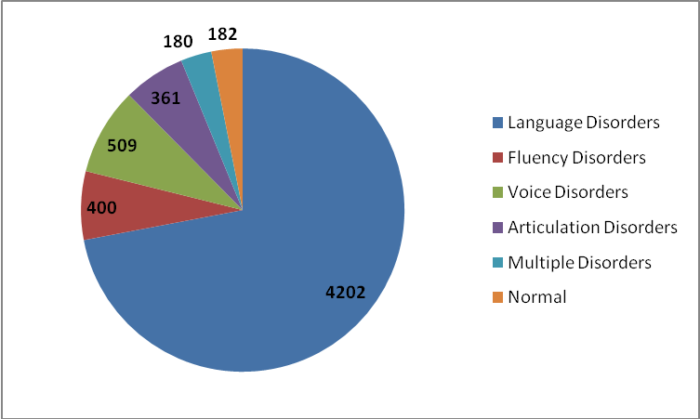
Clients requiring further management were given various speech/language therapies depending upon the type and severity of disorder, for daily sessions of 45 minutes duration. A total of 30,674 therapy sessions were conducted for 5,721 persons with speech/ language disorders during the reporting year. The details of disorder- wise therapy carried out are given in table 3 and figure 2.

Table 3: Speech-Language Therapy

Disorders | Language Disorders |  |  | Voice Disorders |  |  | Articulation Disorders |  |  |  | Multiple Disorders |  |  | MSD |  |  | LD |  |  | Total
Months | C | A | G | C | A | G | C | A | G | C |  | A | G | C | A | G | C | A | G
April | 323 | 11 | 3 | 3 | 19 | 7 | 37 | 4 | 2 | 1 |  | 0 | 0 | 0 | 0 | 0 | 0 | 0 | 0 | 410
May | 147 | 5 | 2 | 7 | 17 | 1 | 34 | 3 | 0 | 0 |  | 0 | 0 | 0 | 0 | 0 | 0 | 0 | 0 | 216
June | 408 | 11 | 0 | 8 | 25 | 5 | 33 | 4 | 1 | 0 |  | 0 | 0 | 0 | 0 | 0 | 0 | 0 | 0 | 495
July | 412 | 16 | 1 | 7 | 33 | 8 | 24 | 6 | 1 | 0 |  | 0 | 0 | 98 | 0 | 0 | 9 | 0 | 0 | 615
Aug | 444 | 15 | 3 | 7 | 36 | 6 | 22 | 11 | 1 | 0 |  | 0 | 0 | 111 | 0 | 0 | 8 | 0 | 0 | 664
Sept | 421 | 18 | 3 | 3 | 27 | 1 | 23 | 10 | 1 | 0 |  | 0 | 0 | 83 | 0 | 0 | 4 | 0 | 0 | 594
Oct | 323 | 16 | 3 | 3 | 23 | 7 | 26 | 8 | 0 | 0 |  | 0 | 0 | 75 | 0 | 0 | 6 | 0 | 0 | 490
Nov | 219 | 18 | 2 | 4 | 25 | 9 | 21 | 6 | 0 | 0 |  | 0 | 0 | 43 | 0 | 0 | 11 | 0 | 0 | 358
Dec | 215 | 18 | 0 | 21 | 11 | 0 | 11 | 4 | 0 | 0 |  | 0 | 0 | 54 | 0 | 0 | 7 | 0 | 0 | 341
Jan | 317 | 18 | 5 | 4 | 22 | 8 | 23 | 8 | 1 | 0 |  | 0 | 0 | 76 | 0 | 0 | 6 | 0 | 0 | 488
Feb | 361 | 22 | 5 | 4 | 28 | 7 | 20 | 5 | 2 | 0 |  | 0 | 0 | 90 | 0 | 0 | 7 | 0 | 0 | 551
March | 333 | 24 | 5 | 4 | 20 | 5 | 16 | 5 | 1 | 0 |  | 0 | 0 | 81 | 0 | 0 | 5 | 0 | 0 | 499
Total | 3923 | 192 | 32 | 75 | 286 | 64 | 290 | 74 | 10 | 01 |  | 00 | 0 | 711 | 0 | 0 | 63 | 0 | 0 | 5721
Disorder Wise | 4147 |  |  | 425 |  |  | 374 |  |  |  | 1 |  |  | 711 |  |  | 63 |  |  | 5721
Over All | 5721

C- Child, A- Adult, G- Geriatric
Figure 2: Speech-Language Therapy (Individual)

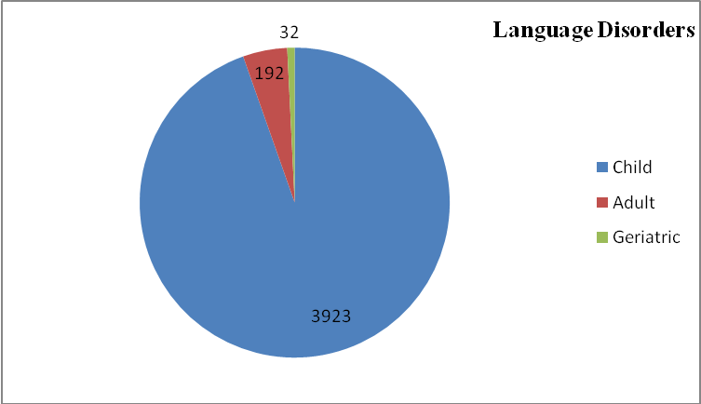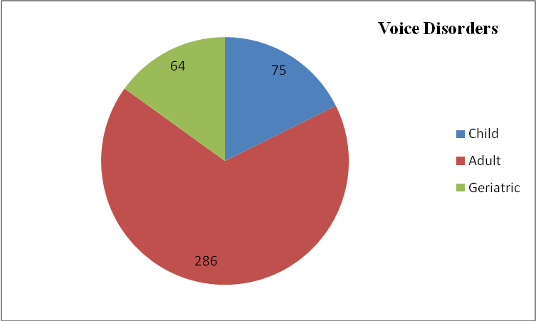
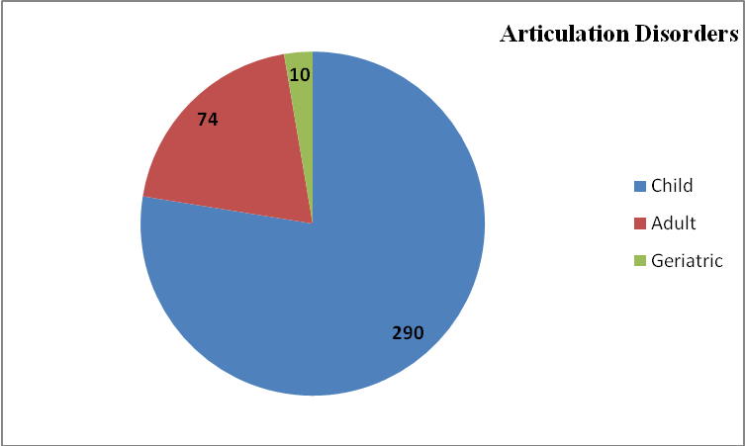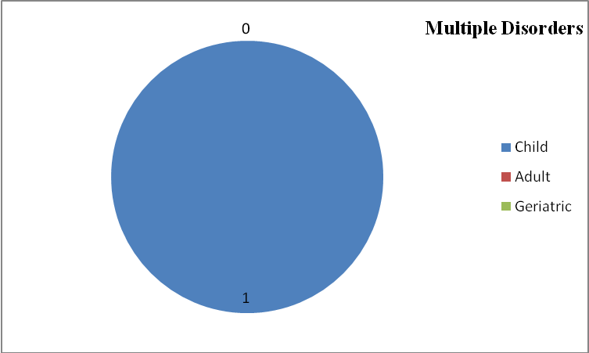

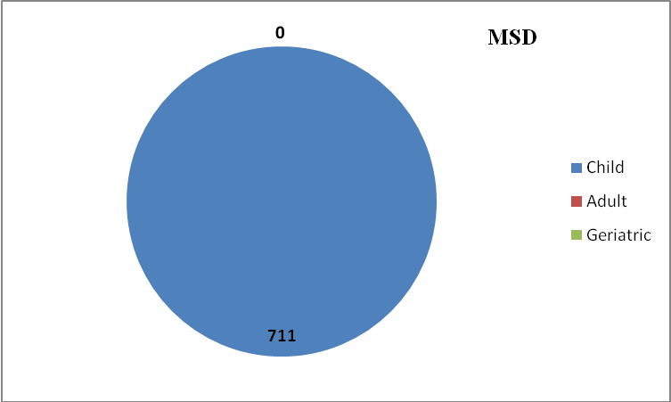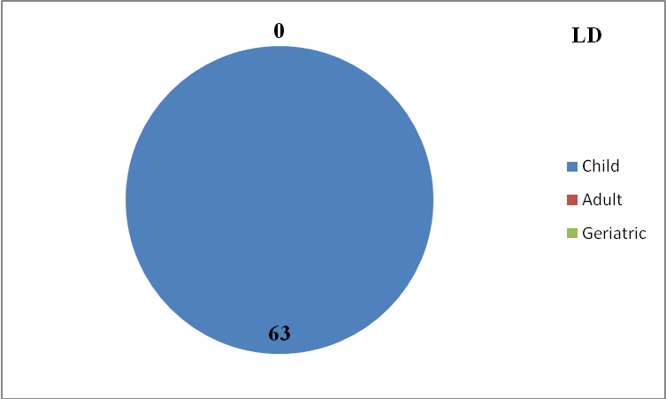

Overall Disorder wise Speech-Language Therapy

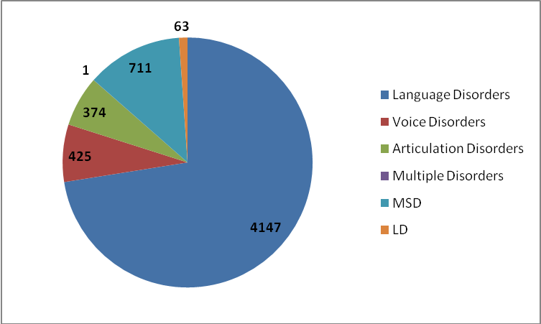

Speech and language assessment and therapeutic services were also provided at the seven DHLS centres of the Institute located in different parts of the country, the details of which are given in table 4.

Table 4: Speech-Language clinical services at the DHLS Centres

Assessment |  |  |  |  |  | Therapy Session
Centers | Language | Voice | Phonology | Fluency | MSD/  Dysphasia | Language | Voice | Phonology | Fluency | MSD/  Dysphasia
Mysore | 178 | 32 | 11 | 39 | 16 | --
Lucknow | 42 | 36 | 44 | 72 | 2 | 104 | 35 | 43 | 71 | 2
Mumbai | 646 | 5 | 19 | 10 | 57 | 2116 | 20 | 108 | 66 | 485
Delhi | 31 | 28 | 1 | 24 | 1 | 46 | 39 | 12 | 28 | --
Ranchi | 21 | 9 | 15 | 16 | 3 | 8 | 4 | 4 | 4 | --
Shimla | 143 | 292 | 82 | 61 | 45 | 143 | 292 | 82 | 61 | 45
Bhagalpur | 61 | 24 | 13 | 18 | 2 | 89 | 22 | 13 | 36 | 5

MSD: Motor Speech Disorders

Audio1ogical Assessment and Rehabilitation

Hearing evaluations were carried out on individuals who complained of hearing problems. In the Audiology outpatient department a total of 16368 clients were assessed and hearing evaluations were carried for 13,780 individuals. The details of the audiological evaluation are given in table 5.

Table 5: Hearing Evaluation
Category | Total
Clients seen in Outpatient department | 16368
Hearing Evaluation | 13780
Normal hearing | 2678
Minimal | 1109
Mild | 1071
Moderate | 1095
Moderately severe | 938
Severe | 849
Profound | 2166
Minimal to mild | 29
Mild to moderate | 86
Mod. to moderately severe | 64
Modtly severe to severe | 119
Severe to profound | 242
Moderate to severe | 11
Sloping | 1305
Ears tested having  - Conductive hearing  - Mixed hearing loss  - SN hearing loss | 2643  3899  7558
Clients with unilateral Hearing Level | 1506
Clients with bilateral Hearing Level | 10753
Ears with Aud. Dys-synchrony | 78
Clients with Auditory Processing Disorder | 17
Clients with Functional Hearing Loss | 186
Clients - tinnitus evaluation | 275
Clients for Pure Tone Audiometry | 13226
Clients for Speech and Audiometry | 13165
Clients for Immitance Evaluation | 13332
Clients for Otoacoustic Element | 3594
Clients for Auditory Brainstem Response | 3569
Clients for Vestibular Evoked Myogenic Potential | 224
Clients for Video Head Impulse Tests | 100
Clients for Behavioral Observation Audiometry | 247
Clients for Visual Reinforcement Audiometry | 242
Clients for Late Latent Response | 102

Hearing aid trial and prescription were carried out for clients in need for amplification and/or assistive listening devices. Clients evaluated of hearing aids were 6468 and 5537 hearing aids were prescribed at AIISH. Of the 6468 clients evaluated, 2322 were female and 4146 male. The details are given in table 6 and figure 3.

Table 6 : Hearing Aid Trial

Hearing Aid Trial |  |  | Total
No. of clients seen for Hearing Aid Trial |  |  | 6468
HAs prescribed at AIISH |  |  | 5537
- Body level hearing aids  - Analogue BTE  - Digital BTE  - Trimmer Digital BTE  - Mini BTE  - Digital ITC  - Digital CIC  - Digital RIC |  |  | 78  1592  3383  4  10  11  41  573
Testing for Cochlear Implant candidacy |  |  | 59
No. of clients recommended
Auditory training |  |  | 731
Speech reading |  |  | 120
HA prescribed on exchange |  |  | 8
Unaided/aided audiograms |  |  | 780
Aided audiogram for Cochlear Implant |  |  | 84
Behavioural Observation Audiometry |  |  | 44
Aided Visual reinforcement Audiometry |  |  | 62
Conditioning |  |  | 803
Programming of digital Hearing Aid |  |  | 2758
Reprogramming of Hearing Aid |  |  | 2030
Electro acoustic characteristics of hearing aids done |  |  | 14
Retrial with Custom Ear Mould |  |  | 316
Unaided & aided Late Latency Response done |  |  | 1
Rec. for Cochlear Implant candidacy |  |  | 55

Figure 3: Hearing Aid Trial

At the Ear mould lab, ear impressions were taken for 6320 clients. These include 1466 new and 4486 old clients at AIISH and 368 in community based camps. The earmould details are given table 7.
Central prosthetic lab
Table 7: Earmould Statistics

Category | Total
Clients attended | 5952
New clients | 1466
Old clients | 4486
At Camp 45 | 368
Ear impression taken | 10909
Free-of-cost | 4256
100% payment | 6251
Ear impression taken-camp | 400
Central Prosthetic Lab impressions | 2
Ear Moulds completed | 4637
No. Mould Lacquered | 2771
No. of sound tube issued | 0
Hard regular moulds | 885
Hard shell mould made | 10
Soft mould made | 3761
Hard canal moulds | 4
Soft canal moulds | 51
Instant moulds | 17
In the canal impression made | 149
Swimmer plug (soft) | 68
No. of ear blocked | 55
Ear Moulds with acoustic modifications. | 246
No. of students posted | 71

Audiological services were also provided at the eight DHLS centres of the Institute located in different parts of the country, the details of which are given in table 8.

Table 8: Audiological Services at the DHLS Centres
Centers | OPD  (Case history) | Evaluation | Earmoulds | Hearing aid trial (HAT) | Listening
Mysore | 297 | 59 | 50 | 10 | 56
Lucknow | 6696 | 6696 | - | - | 70
Mumbai | 393 | 640 | - | 17 | -
Ajmer | 1746 | 1746 | - | - | 6
Delhi | 2233 | 2233 | - | - | 9
Ranchi | 2832 | 2832 | - | - | -
Shimla | 12780 | 12780 | - | - | -
Bhagalpur | 818 | 818 | - | - | -

Referred Evaluation-1: Psychological Assessment and Rehabilitation
Psychological assessment was carried out for the referred cases registered at the Department of Clinical Psychology. This includes Routine Psycho-Diagnostic Assessment for Screening and Identification Detailed Psychological Assessment (including specialized assessment such
as assessment for Learning Disability, neuro-psychological assessment, assessment for disability certification, behavioral assessment and assessment for skill training. Psychological Intervention (including behavior modification programs, home based skill training programs, cognitive-behaviour and group intervention programs for caregivers).

Routine psycho-diagnostic assessment was carried out for 4973 new and 1451 repeat cases at the Department during the reporting year. The detailed is given in table 9.

Table 9: Routine Psycho-Diagnostic Assessment
Classification of disorders according to the criteria included in Chapter V (F) of ICD-10
F 70# | Mental retardation | 1667
F 80.0 | Specific speech articulation disorder | 261
F 80.1 | Expressive language disorder | 513
F 80.2 | Receptive language disorder | 355
F 88# | Other disorders of psychological development | 366
F81# | Specific developmental disorders of scholastic skills | 923
F 84# | Pervasive developmental disorders | 53
F 98.5 | Stuttering (stammering) | 325
F 44.4 | Dissociative motor disorders | 9
F00-F99 | Other disorders included in Chapter V (F) of ICD-10 | 481
The code # refers to "condensed" codes (Ref ICD-IO PC)
Classification according to the criteria included in Chapter XVIII (R) of ICD 10
R 47.0 | Dysphasia and aphasia | 39
R 41.83 | Borderline Intellectual Functioning | 784
Avg. Intelligence with disorders classified elsewhere |  | 648
TOTAL |  | 6424

Psychological assessment includes intelligence / developmental (778 cases in 1333 sessions), psycho-educational (1019 cases in 2463 sessions), neuropsychological (20 cases in 159 sessions), personality (1 case in 2 sessions) and behavioural (74 cases in 124 sessions).

The psychological intervention provided includes behavior modification (169 cases in 325 sessions), cognitive behavior therapy (27 cases in 62 sessions), Remedial training (1 case in 2 sessions) and motor disorder rehabilitation (3 cases in 9 sessions).

Referred Evaluation-2: Otolaryngological Assessment and Rehabilitation

The Otorhino-laryngological assessment and rehabilitation for persons with communication disorders were being carried out at the Department of Otolaryngology. In addition to the clinical services provided at the Institute, the Department staffs rendered diagnostic, therapeutic and surgical services at K.R. Hospital, Mysore Medical College, Mysore. Totally, 18995 new and 21594 review cases were examined during the reporting year at the institute, and 6796 microscopic, 166 stroboscopic / endoscopic examination, 71 vertigo, 88 oto endoscopic and 14 diagnostic naso endoscopic examinations were carried out. Also, 11167 new and 11414 repeat cases were examined and 117 major and 618 minor surgeries were successfully carried out at K.R. Hospital.

Specialized Clinical Services
The institute provided a variety of specialized clinical services for individuals with communication disorders during the reporting year at the following clinical units.

- Augmentative and Alternative Communication (AAC) Unit
The AAC unit supported, enhanced and provided alternative methods of communication for individuals who are non-verbal. The unit evaluated 201 clients in 1233 sessions during the reporting year.

- Autism Spectrum Disorders (ASD) Unit
Assessment and treatment were provided for 244 clients with autism spectrum disorders at the ASD unit during the reporting year. Of them, 26 were from Hindi region. The unit also attended 472 therapy and 104 demonstration therapy cases. Ninty-nine therapy cases discharged during the period. The total number of therapy sessions conducted was 3023.

- Clinic for Adult and Elderly Persons with Language Disorders (CAEPLD)
CAEPLD provides clinical services to adult and elderly persons. Totally, 32 clients were evaluated in the clinic during the reporting year.

- Dysphasia Unit
This unit facilitates assessment and management of persons with swallowing disorders. The unit evaluated 35 cases in 37 sessions. Also, there were 12 therapy cases. The number of cases discharged was 4.

- Fluency Unit
This unit catered to the needs of persons with stuttering and other fluency disorders and provided clinical services to 499 persons with fluency disorders in 2735 sessions during the reporting year.

- Implantable Hearing Devices Unit
The activities of this unit include selection of candidates, mapping/ programming, trouble shooting of implantable hearing devices such as cochlear implant, bone anchored hearing aids and middle ear implants. During the reporting year, 297 clients were seen in the unit. The mapping for Cochlear Implant cases was 297. Trouble shooting was done for 43 client devices. Also, counselling was given for 337 clients.

- Learning Disability Clinic
One case was evaluated in the Unit during the reporting year. Also there was 41 therapy cases who underwent therapy in 224 sessions.

- Listening Training (LT) Unit
Listening Training Unit: (LTU) is committed to provide aural rehabilitation to the needy. The listening training was provided to not only the clients who use hearing devices such as hearing aids and cochlear implants but also to those with (Central) auditory processing disorders. In addition, training was also imparted to individuals suffering from tinnitus or hyperacusis. Totally, 2792 persons underwent listening training in 14359 sessions during the reporting year. Of the 2792 clients, 351 were new and the remaining 2441 were repeat cases.

- Motor Speech Disorders Unit
This specialized unit caters to the needs of persons with motor speech disorders. It enables them to realize their potential and become contributing members of the society. Totally, 70 cases were evaluated in 70 sessions.

- Neuropsychology Unit
The services offered in the unit includes the assessment of specific function of the brain through standard individualized test, detailed assessment of lobular functions through standardized batteries and rehabilitation through paper pencil techniques or through computer assisted packages. Totally, 20 (159 sessions) neuropsychological assessment was made during the reporting year in the unit.

- Professional Voice Care (PVC) Unit
The unit provided specialized assessment and management services to professional voice users during the reporting year. It organized various programs to orient and sensitize professional voice users on care, maintenance and conservation of voice. The unit trained a total of 46 UG and PG students in 224 hours.

- Structural Orofacial Anomalies (U- SOFA) Unit
Clients with deformalities in the growth of head and facial bones were given multi-disciplinary diagnostic and rehabilitation services in the clinic. The experts of the clinic evaluated 176 clients during the reporting year. Also 176 cases were evaluated 528 sessions.

- Vertigo Clinic
The clinic offered comprehensive care in evaluation and management of patients with vertigo. A multidisciplinary team comprising of otolaryngologist, audiologist and neurologist evaluated 71 new and 436 follow up cases in the clinic for both peripheral and central vertigo during the reporting year and diagnostic tests like microscopic examination of ear, electro nystagmography, vestibulo spinal tests, neurological evaluation, video nystagmography, audiological tests and vestibular evoked myogenic potential test were carried out for the needy ones.

- Voice Clinic
This clinic offered evaluation and management services to persons of all ages with voice disorders. Totally, 607 clients with voice disorders were evaluated in the clinic using video stroboscopy and software for voice assessment.

Special Educational Services

The following educational services were provided to the children with special needs at the pre-school, attached to the Department of Special Education during the reporting year.

- Special Educational Assessment: Educational Assessment services are offered for 733 children with communication disorders to determine readiness for schooling and to suggest an appropriate grade, placement as well as necessary services.

- Parent Infant Program (PIP): PIP was provided to very young children ranging from birth to 2.5 years with the objective of improving physical, cognitive, communication, social and emotional skills as detailed in figure 4.

- Preschool Parent Empowerment Program (PPEP): PPEP was provided to 1865 caregivers of children ranging from 2.5-3 years before formal admission to preschool in 5401 sessions with the aim of empowering caregivers to train their children and get adjusted to preschool atmosphere.

- Preschool Training & Supplementary Services (PSS): Preschool service, a preparatory training for children with communication disorders in self-help, cognitive, communication and academic skills necessary for successful schooling was provided to children in the age range of 3-6 years having hearing impairment, cerebral palsy, and multiple disability and to those in the age range of 3-10 years having intellectual disability and autism. The details are given in table 10.

- Curricular Support Services, Individualized Education Program and Demonstration Education Therapy / Non formal Education Program were offered respectively to 274, 95 and 45 children with communication disorders who were mainstreamed but have certain difficulties in coping with academics.

- Sensory Adaptation for Education to cater to the sensory issues of young children with special needs.

- Special use of music for educational readiness and up-building
- Speech-Language group therapy
- Support services for Empowering Caregivers
- One-month summer camp for children
- Counselling and guidance for parents and family
- Literacy computer and yoga
- Parent Enrichment Program
- Library of books and toys
- Parents help parents program

Table 10: Pre School Training

Sl.No. | Apr | May | June | July | Aug | Sep | Oct | Nov | Dec | Jan | Feb | Mar | Total
Clients | 207 | 0 | 197 | 194 | 193 | 191 | 177 | 170 | 178 | 177 | 181 | 178 | 2043
Sessions | 2340 | 0 | 1400 | 3220 | 2940 | 2800 | 1960 | 2640 | 2772 | 2904 | 2508 | 1584 | 27068

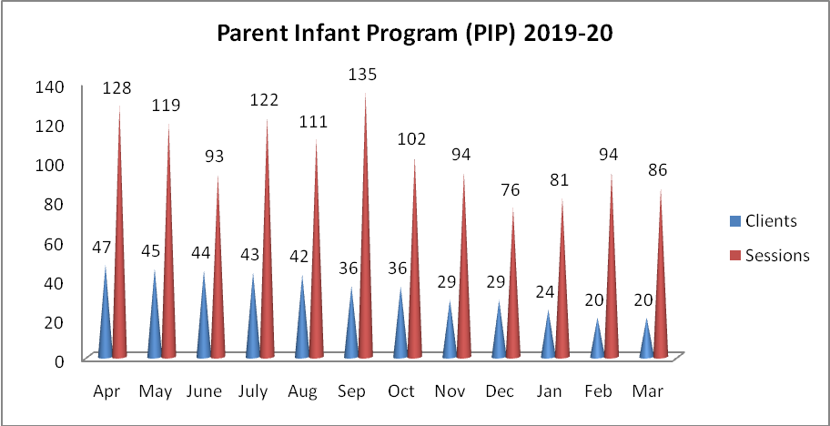

Figure 4: Parent Infant Programme

Medical Specialty & Allied Health Services
The institute facilitated the services of various medical specialists such as pediatrician, neurologist, plastic surgeon, prosthodontist, orthodontist, phono-surgeon and services of allied health professionals such as physiotherapist and occupational therapist, to the needy clients. Totally, 1,912 patients underwent Physio and Occupational therapy in 12,292 sessions, during the reporting year. In addition, 310, 137, 207, 115, 2317 clients consulted pediatrician, phonosurgeon, plastic surgeon, orthodontist, Dietician respectively. The details are given in figure 5.

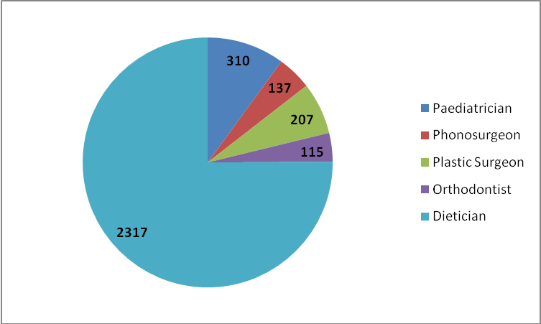

Figure 5: Medical specialty and allied health
Clinical Support Services
The institute extended a diverse range of support services to patients and their family. These include the following.

- Distribution and Repairing of Aids:
Electro-acoustic evaluation, management and repair of hearing aids were carried out under the aegis of Department of Electronics. Totally 1273 hearing aids were distributed (AIISH-789, POCD-59, Camps-425), after electro-acoustic evaluation and testing under ADIP scheme. Under AIISH Hearing Aid Dispensing Scheme, 1762 hearing aids were issued at concessional rate. Also, 24553 hearing aid spares such as HA cells, battery doors, ear hooks, body case, wind weather protector and BET Huggies were issued. In addition, 231 body worn hearing aids and 1233 BTE hearing aids were repaired, electronic-acoustic evaluation was carried out for 8 hearing aids and 4 audiometers were calibrated.

- Counselling and Guidance: The professional experts of the Institute provided counselling and guidance on various aspects of the disorders such as treatment procedures, usage and care of tools like hearing aids during the reporting year.

- Issue of Certificates:
Various certificates like financial aid, income tax exemption, educational scholarship, and school admission were issued to the eligible candidates during the reporting year, the details of which are given in table 11.

Table 11: Details of certificates issued
Particulars | Total
Transfer certificate | 17
Evaluation reports | 366
Attendance certificate | 37
School admission certificate | 93
Admission to deaf school | 01
MR Certificate | 649
Railway concession certificate | 341
Psychological Report | 870
Income Tax Exemption Certificate | 50
Bonafide certificate | 29
Handicapped Certificate (Pension) | 2265
Medical Certificate | 55

- Financial Aid: The institute distributed a total amount of Rs. 6,99,823/- among 124 clients below poverty line towards the purchase of hearing aids during the reporting year under the aegis of the Department of Clinical Services.

Clinical Observation Posting
The institute facilitated clinical observation posting for students in the area of communication disorders and allied fields from other institutes in the country and abroad. Around six hundred students and staff from 25 institutes across the country and abroad were posted for clinical observation in different clinical units and departments of the institute during the reporting year. The details of the institutions are given below.

- Avinashilingam University
- Baby Memorial College
- Central University, Gulbarga
- CMR University, Bangalore
- Composite Regional Center, Bhopal
- DOS in Psychology University of Mysore
- Dr. Manasi KLE, Belgaum
- Government College of Nursing
- Government School, Akkihebbal
- Govt. College of Nursing MMC & RI Mysore
- Govt. Teacher’s Training Centre, Tilak Nagar, Mysuru
- Human Development, University of Mysore
- Jawaharlal Nehru Medical College, Belgaum
- JSS Polytechnic for Differently-abled, Manasagangothri, Mysuru
- Karnataka Institute of Medical Sciences, Hubli
- KVG Medical college, Sullia
- Marthoma College of Special Education (Institute of Speech and Hearing), Kasargod, Kerala
- NSCB Medical College, Jabalpur
- Rajivgandhi National Institute of Youth Development
- S.S. Institute of Medical Sciences and Research Center, Davangere
- Shri BM Kankanawadi Ayurved Mahavidyalaya, Belagavi
- Smt. Puttveeramma Special Residential School for Girls with HI, Mysuru
- St. Agnes Center for PG Studies and Research Mangaluru
- Teresian College, Mysore
- University of Agricultural Sciences, Dharwad

