**अखिल भारतीय वाक् श्रवण संस्थान, मैसरु-570 006**

**ALL INDIA INSTITUTE OF SPEECH & HEARING, MYSURU- 570 006**

**Swachhta Committee**

09.04.2021

Annual Report 2020-21

Institute was actively involved in promoting Swachhta related activities during the year 2020-21. Building new infrastructure to promote Swacchta related activities in the campus was the major objective for this year. The following were the initiatives taken up in this direction.

|  |  |  |
| --- | --- | --- |
| Sl. No. | Activity/Particulars | Description of activity |
|  | Solid Waste Management Plant at AIISH | Work initiated to build a waste management yard in the north-eastern corner of the institute campus with the objective to segregate degradable and non-degradable waste. Further, the degradable waste will be converted to compost. The same work is entrusted to engineering section and the plan and estimate for the same is finalised and is due for publishing. |
|  | Renovation of canteen kitchen | The canteen kitchen is renovated in order to create hygienic environment. The renovation includes providing stainless steel kitchen equipment along with necessary civil works. (pictures enclosed) |
|  | Renovation of toilets/bathrooms | Renovation of old toilets and bathrooms in Kuteera building and in ladies hostel has been initiated. Work is in progress utilizing Swacchta funds. |
|  | Beautification of garden | The work of beautification of garden areas in ladies hostel, silver jubilee park, centre of excellence building had been initiated and is in progress. |
|  | Construction of shade net area and restroom facility for garden maintenance personnel | Construction of shade net area to carry out horticulture related activities along with rest room for garden maintained personnel has been initiated and due for commencement of work. |
|  | Open gym area in ladies hostel | An open gym area along with open gym equipment has been constructed in the Kapila ladies hostel. This includes equipment like elliptical bike, chest press, leg press etc.  (photo enclosed) |

Pics: Renovation of canteen kitchen

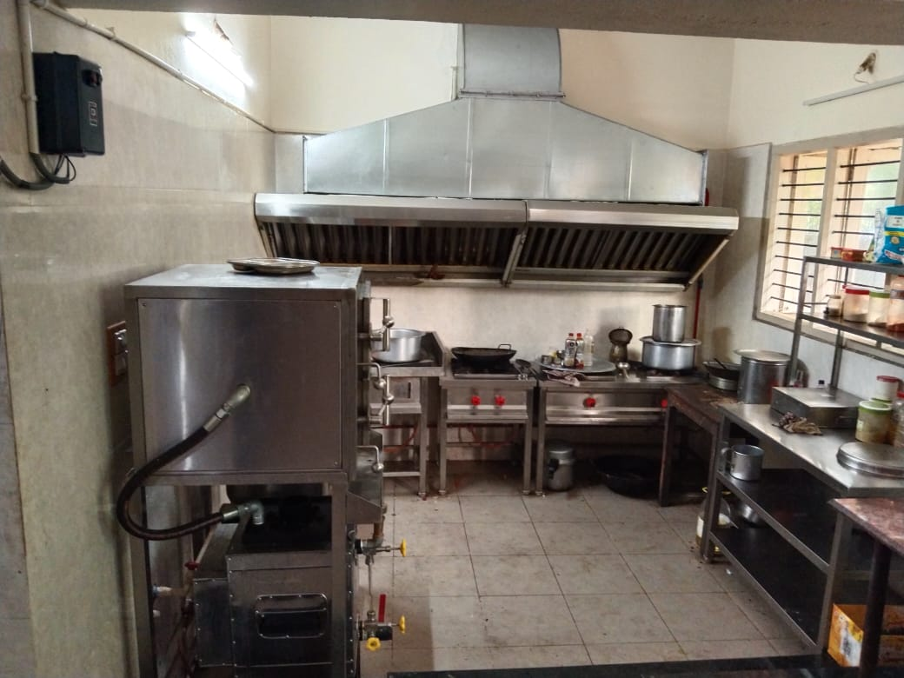

Pics: Open gym area in ladies hostel

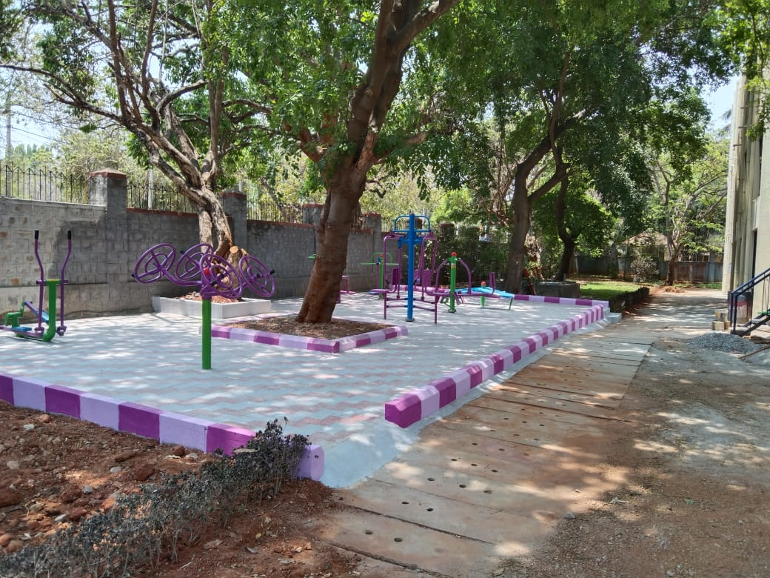

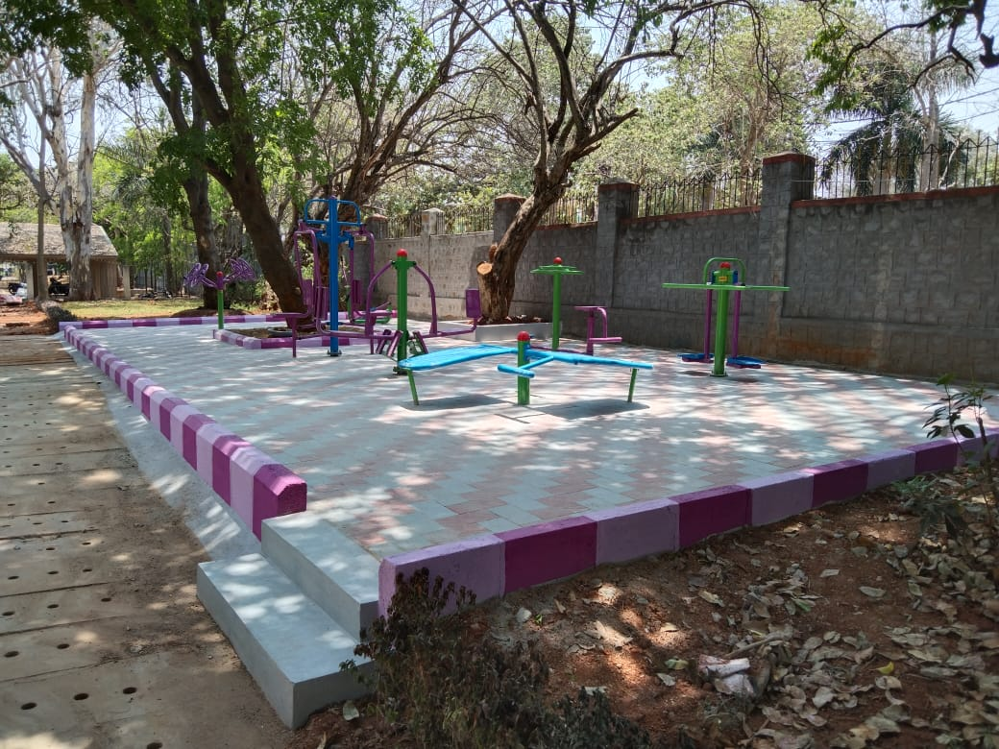

Sd/-

Chairperson-Swacchta Committee