**Monthly Public Lecture Series**

The Monthly Public Lecture is a programme organized by the All India Institute of Speech and Hearing on a regular basis (once a month) to the general public from Mysore and other states visiting AIISH for educational purpose. The target group varies from regular school teachers, students, teacher trainees, nurses, social activists and grass root level workers. The programme is undertaken with the main objectives of orienting and providing the participants about an overview of the functioning of the institute, the types of services provided, and types of courses offered. Along with the general information, disability specific information like voice care, classroom management of children with special needs, hearing impairment and its management and many more topics of interest on identification and management of children and people with communication disorder is covered. A team of experts including Audiologist, Speech–Language pathologist, special educator, social worker and public and information officer is involved in the orientation programme. The lecture is followed by AIISH tour to various departments of the institute. There is no fees charged for the programme and it is a need based programme as per the availability of the participants. The timing for the programme is between 9.30 am to 1.00 pm on the scheduled day. For the year 2020-21, approximately 457 participants got oriented about different communication disorders, causes, prevention and different activities of the institute. The pandemic didn’t stop the people getting oriented about the various activities of the institute, hence for seven months the programme was conducted virtually.

Interested participants may send their request to directoraiish@gmail.com. They will be intimated about the schedule for the monthly public lecture.

**ALL INDIA INSTITUTE OF SPEECH AND HEARING, MYSURU**

**ANNUAL REPORT-MONTHLY PUBLIC LECTURE SERIES**

**APRIL 2020-MARCH 2021**

|  |  |  |  |  |  |
| --- | --- | --- | --- | --- | --- |
| **Sl.No** | **Topic** | **Resource Person** | **Dates** | **Name of the School** | **Total Number of participants** |
|  | 1. Overview of the Activities of the institute 2. Communication Disorders: An Overview 3. Hearing Impairment: An overview 4. *Concessions and Provisions for Children with Special Needs* | 1. Ms. Lakshmi Prabha J K 2. Ms. Prathima S 3. Dr. Sharath Kumar K S 4. *Mr. Prashanth R* | 27th February 2020 | DMS School  DHLS Students from CRC Bhopal  PG Students from Department of Human Resource Development, University of Mysore | 57 |
|  | 1. Overview of the Activities of the institute 2. Communication Disorders: An Overview 3. Hearing Impairment: An overview 4. *Concessions and Provisions for Children with Special Needs* | 1. Dr.Prithi Venkatesh 2. Ms. Prathima S 3. Dr. Prashanth Prabhu 4. *Mr. Prashanth R* | 25th June 2020 | Excel Public School, Koorgalli | 32 |
|  | 1. Overview of the Activities of the institute 2. Communication Disorders: An Overview 3. Hearing Impairment: An overview 4. *Alternative and augmentative services for the rehabilitation of persons with communication disorders* | 1. Dr.Prithi Venkatesh 2. Dr.Sangeetha Mahesh 3. Dr.Sharath Kumar K S 4. Dr.Reuben Varghese | 22nd July 2020 | Royal Concorde International School | 32 |
|  | 1. Overview of the Activities of the institute 2. Communication Disorders: An Overview 3. Hearing Impairment: An overview 4. *Curriculum Adaptation* | 1. Ms. Vijaylakshmi S 2. Dr. Sangeetha Mahesh 3. Dr. Sharath Kumar, K.S 4. *Ms.Vijaylakshmi S* | 27th August 2020 | IEDS (BIERT s teachers) | 05 |
|  | 1. Overview of the Activities of the institute 2. Communication Disorders: An Overview 3. Hearing Impairment: An overview 4. *Curriculum Adaptation* | 1. Mr. Prashanth R 2. Dr.Priya M B 3. Dr. Prashanth Prabhu 4. *Ms.S.Vijayalakshmi* | 15th September 2020 | IEDS (BIERT s teachers) | 27 |
| 6 | 1. Overview of the Activities of the institute 2. Communication Disorders: An Overview 3. Hearing Impairment: An overview 4. *Curriculum Adaptation* | 1. Mr.Keerthi 2. Ms.Prathima S 3. Mr.Prashant Prabhu 4. *Ms.S.Vijayalakshmi* | 15th October 2020 | IEDS (BIERT s teachers) | 18 |
| 7 | 1. Overview of the Activities of the institute 2. Communication Disorders: An Overview 3. Hearing Impairment: An overview 4. *Identification of at risk children in educational setup* | 1. Dr.Prithi Venkatesh 2. Ms.Prathima S 3. Dr. Sharath Kumar K.S 4. *Dr.Kadambari N* | 1st December 2020 | IERTS teachers -24  Fourth Wave Foundation-12  Total -36 | 36 |
| 8 | 1. Overview of the Activities of the institute 2. Communication Disorders: An Overview 3. Hearing Impairment: An overview 4. *Management of ASD,ADHD and LD* | 1. Dr.Prithi Venkatesh 2. Dr. Priya M B, 3. Dr. Sharath Kumar K.S 4. Dr.Yashodhara Kumar | 22nd December 2020. | Staff of Wipro Technologies, | 165 |
| 9 | 1. Overview of the Activities of the institute 2. Communication Disorders: An Overview 3. Hearing Impairment: An overview 4. *Rights and Facilities for PWD* | 1. Ms. S.Vijayalakshmi 2. Ms. Prathima, 3. Dr. Sharath Kumar K.S 4. Mr.Prashanth | 22nd February 2021 | Department of Social Work, Manasagangothri,Mysore |  |
|  | 1. Overview of the Activities of the institute 2. Communication Disorders: An Overview 3. Hearing Impairment: An overview 4. *Curriculum Adaptation* | 1. Dr.Prithi Venkatesh 2. Dr. Priya M B, 3. Dr. Prashanth Prabhu 4. Ms.S.Vijayalakshmi | 19th March 2021 | Montessori Teachers trainee’s from IMKTA & teacher trainees from St.Joseph Teacher Training College | 50 |

No Monthly Public Lecture Series were conducted in March, April and May 2020 due to COVID-19 lockdown.

Due to the Covid-19 pandemic , the monthly public lecture series from June 2020 till December 2020 were conducted through the virtual mode.

**Glimpses of the program**

Dr.Sangeetha Mahesh, HOD-Clinical services and Resource Person MPLS, delivering lecture on Speech and Communication Disorder.

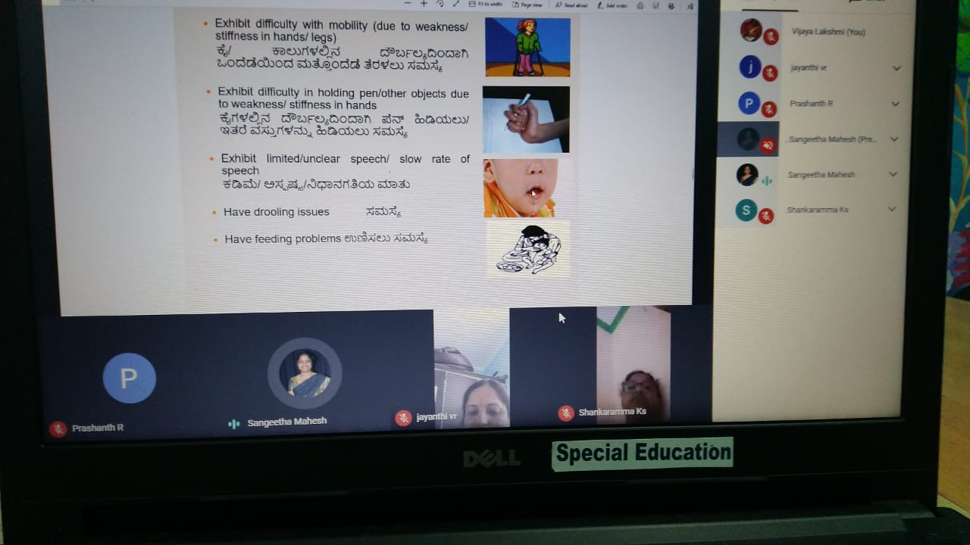

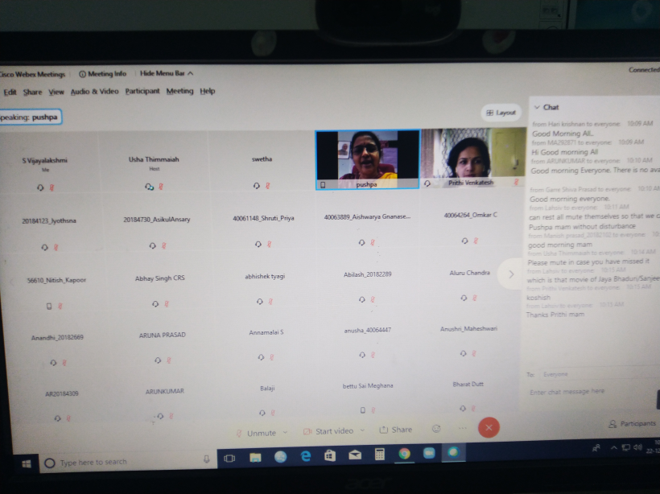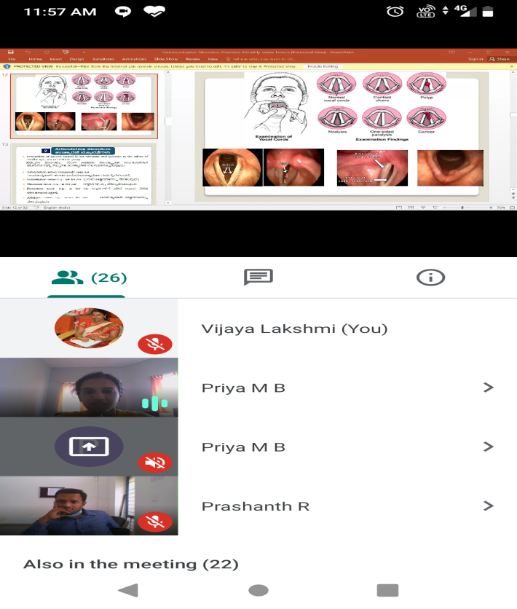

Dr.Priya.M.B, Resource Person MPLS, delivering lecture on Speech and Communication Disorder.

Dr.Pusphavathi, Director, All India Institute of Speech and Hearing, Mysuru addressing the gathering.

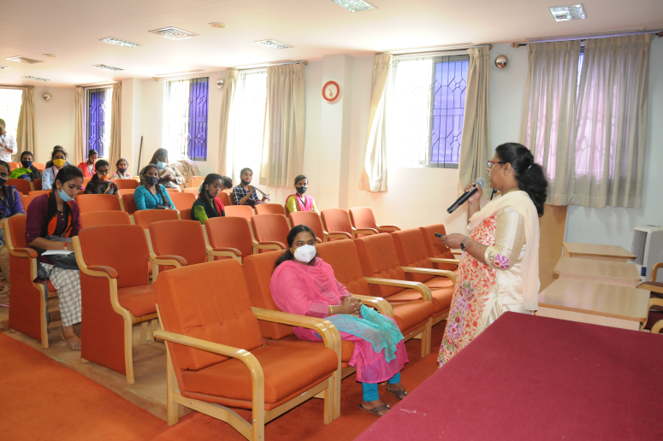

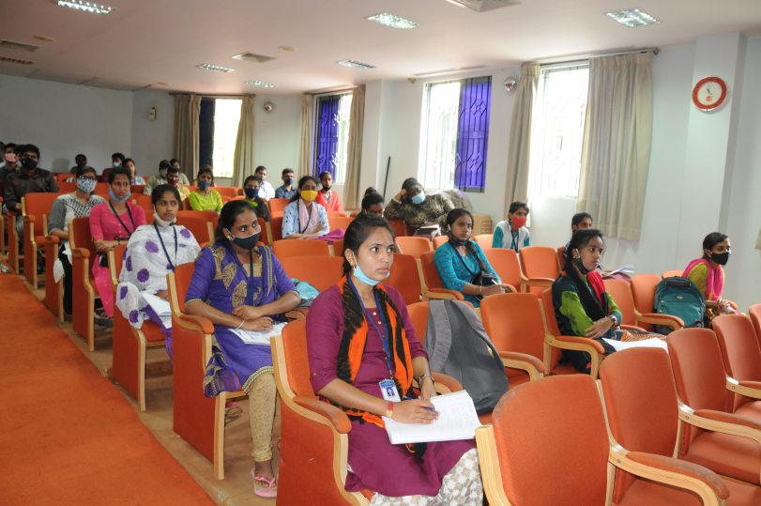

Ms.S.Vijayalakshmi, Special Educator, orienting about activities of institute activities

Participants of February 2021 Monthly Public Lecture Series