ALL INDIA INSTITUTE OF SPEECH & HEARING: MYSURU- 6

AAC UNIT

SH/DCS/AAC/2020-21

ANNUAL REPORT- AAC UNIT
Activity 1: Observance of International Day of Sign Languages
The Augmentative & Alternative Communication (AAC unit) of the institute observed International Day of Sign Languages ‘on 23rd September 2020 through online mode with the theme “Sign Languages for Everyone”. The program started with the overview of the Sign Language Day by Dr. Sangeetha M, HOD Clinical Services and Mr. Reuben T. Varghese, Member Secretary, AAC unit. An orientation program on Indian Sign language and finger spellings, basic vocabulary and grammar in Indian Sign Language was conducted by Shri. Rajkumar. R , Special Educator, Department of Special Education and Smt. Rubby , Sign Language Teacher, AAC Unit, Dept. of Clinical Services AIISH, Mysore. A total of 23 participants which included BASLP, M.Sc (SLP), BS.Ed students and staff of the institute participated in this online orientation program.

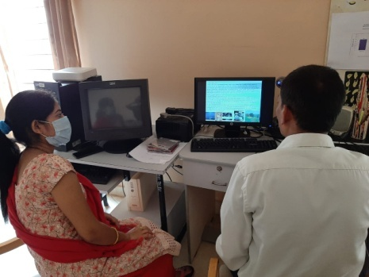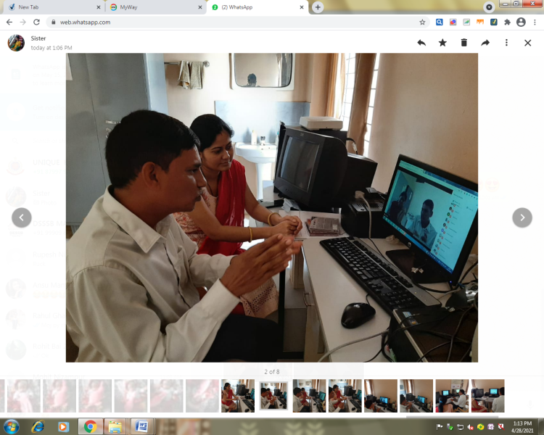
Photograph 1:- Orientation program on Indian Sign language
Activity 2: Observance of AAC Awareness Week
Augmentative & Alternative Communication (AAC unit) of the institute, observed the AAC awareness week from 19th – 21th October, 2020 as a part of the International AAC awareness month. Various competitions such as AAC & ISL quiz program, Creating Story & Joke videos in Indian Sign Language and e-poster design were organized.
Inaugural function of the International AAC Awareness Week 2020 was held on 19th October 2020, through virtual mode. Prof. Usha A Dalvi, Treasurer, International Society for AAC (ISAAC), India Chapter, served as the chief guest and delivered the key note address on the topic “Challenges in teaching and learning AAC”. Prof. M. Pushpavathi, Director- AIISH in her presidential address highlighted the significance of AAC Awareness month. Prof. Ajish. K. Abraham welcomed the gathering. After the inaugural function, Mr. Reuben T.V. gave an orientation about AIISH AAC Unit and the devices available at the unit. Mr. Karthik Venkat S. gave an orientation on the technological advancements in AAC. This was followed by brief orientation program on Finger Spellings, Basic Vocabulary and grammar in Indian Sign language by Ms. Rubby. Mr. Reuben T Varghese, Scientist proposed the vote of thanks. A total of 54 participants, which included staff and IInd M.Sc (SLP) students of AIISH attended the program.

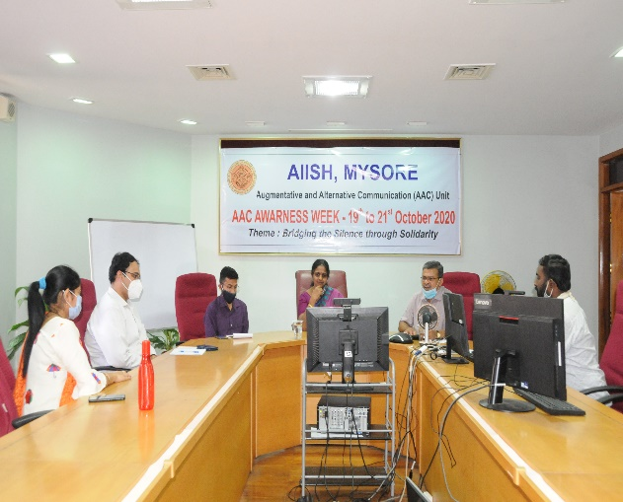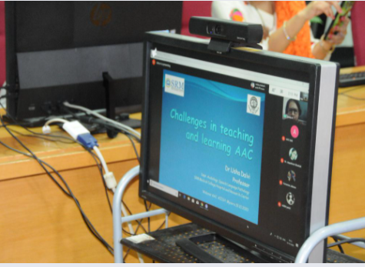

Photograph 2:- Inaugural function of the International AAC Awareness Week 2020
The prize winners of the various competitions such as AAC & ISL quiz program, Creating Story & Joke videos in Indian Sign Language and e-poster design, organized as a part of AAC Awareness Week are given below:-
Name of the competition | 1st Prize winner | 2nd Prize winner
Quiz competition on AAC & ISL | Ms. Akshaya S. | Mr. Abhishek. T. E
Creating Story videos in Indian Sign Language | Ms Lekshmi | Ms Jobina C Jose
Creating Joke videos in Indian Sign Language | Ms Jobina C Jose | -
E-poster on AAC and Sign language | Mr. Shivaramakrishnan & Ms. Akshaya. S | Dr. Malar. G

Activity 3: Orientation Program by Dr. David Goldberg on state of the art AAC devices
Dr David Goldberg, Princeton, New Jersey, USA – an internationally renowned AAC Specialist conducted an online orientation program on state of the art AAC devices on 22nd February 2021 from 3.30 pm to 5.00 pm. Members of the AIISH AAC unit attended the program. Mr. Reuben T Varghese, Scientist and Member Secretary – AAC Unit coordinated the program.
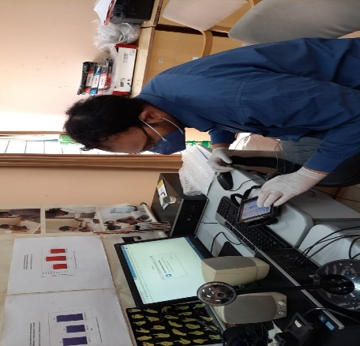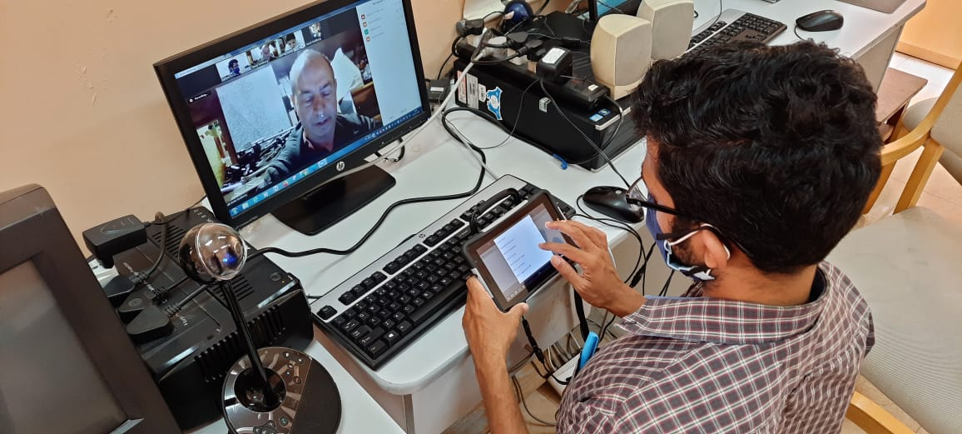
Photograph 3:- Orientation Program by Dr. David Goldberg, internationally renowned AAC Specialist
Activity 4: Online therapy and guidance sessions to Client Siddarth by Dr. David Goldberg
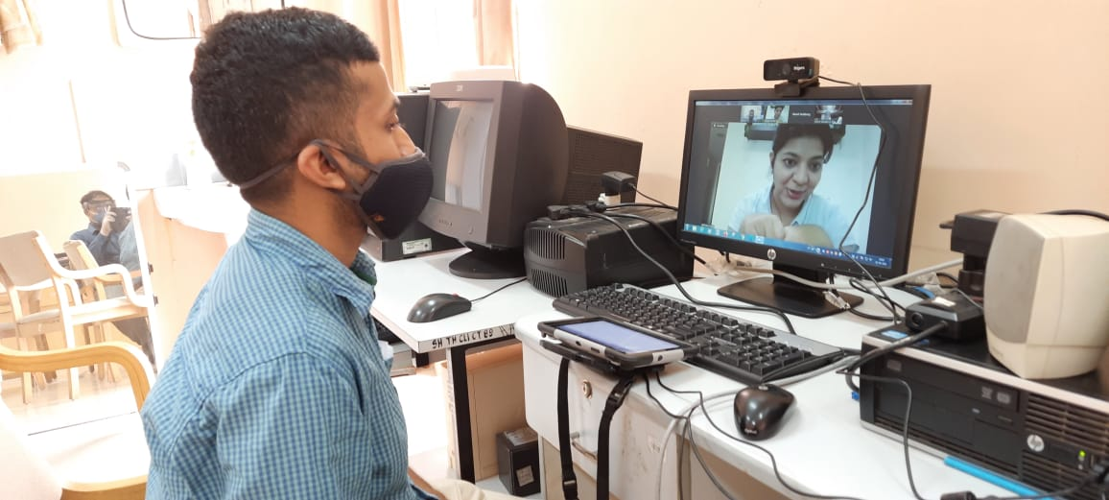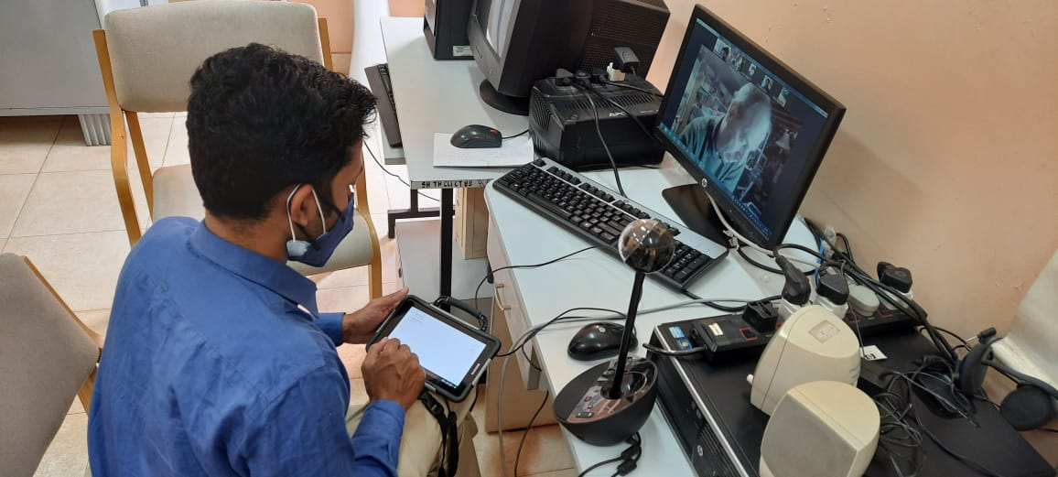
Photograph 4:- Online therapy and guidance sessions by Dr. David Goldberg
A series of online therapy and guidance sessions were conducted by Dr David Goldberg, Princeton, New Jersey, USA – an Internationally renowned AAC Specialist, in the months of February and March 2021 for Master Siddharth, a client who is availing therapy at AAC unit AIISH. AAC unit members along with the parents of Master Siddharth attended these online sessions. Mr. Reuben T Varghese, Scientist and Member Secretary – AAC Unit coordinated the program.
Prof. Ajish K Abraham
Technical co-ordinator AAC unit

