CLINICAL CARE
Patient Registration

Totally 13,432 new clients were registered for availing clinical services at the institute during the reporting year. In addition, 29,965 case files were retrieved for repeat/follow up visits for various evaluations. The geographical and gender-wise details of new clients are given in table 1. Majority of them (12970) were from Karnataka, the state in which the institute is located, followed by the neighboringstates of Kerala (174), Tamil Nadu (88), and Andhra Pradesh (67). Also, there were clients from Maldives, Nepal, Quatar, UAE, U.K and USA.The clients include 8136 males and 5296 females.
Table 1: Geographical & gender-wise distribution of new clients

Sl. No | Locality | Male | Female | Total
 | Andra Pradesh | 46 | 21 | 67
 | Arunachal Pradesh | - | 1 | 1
 | Assam | 2 | 1 | 3
 | Bihar | 12 | 2 | 14
 | Chattisgarh | 2 | 1 | 3
 | Delhi | 4 | 3 | 7
 | Goa | 1 | - | 1
 | Gujarat | 7 | - | 7
 | Hariyana | 1 | 2 | 3
 | Jarkhand | 6 | 2 | 8
 | Karnataka | 7817 | 5153 | 12970
 | Kashmir | 2 | 1 | 3
 | Kerala | 117 | 57 | 174
 | Madhya Pradesh | 3 | 2 | 5
 | Maharastra | 8 | 6 | 14
 | Orissa | 6 | 2 | 8
 | Punjab | 1 | - | 1
 | Rajasthan | 9 | 4 | 13
 | Sikkim | 1 | - | 1
 | Tamil Nadu | 59 | 29 | 88
 | Telangana | 8 | - | 8
 | Tripur | 1 | - | 1
 | Uttar Pradesh | 11 | 5 | 16
 | Uttaranchal | 2 | 1 | 3
 | West Bengal | 6 | 1 | 7
 | Overseas | 04 | 02 | 06
Total |  | 8136 | 5296 | 13432

Speech and Language Assessment and Rehabilitation

Totally, 3953 clients underwent speech and language evaluation which include 2,824 new and 1129 review cases. Of the 2824 new cases, assessment was carried out for 2350 clients in physical mode and 474 in virtual mode.
Of the new cases, 2,732 persons were identified with various kinds of speech and language disorders and 92 were found to have normal speech. Whereas, of the 1129 review cases, 1098 persons were with various disorders, and the remaining 31 were normal. The details of various speech and language disorders diagnosed are given in table 2 and figure 1.
Table 2: Assessment of Speech-Language Disorders

Disorders | Language Disorders |  |  | Fluency Disorders |  |  | Voice Disorders |  |  | Articulation Disorders |  |  | Multiple Disorders |  |  | Normal |  |  | Total
Months | C | A | G | C | A | G | C | A | G | C | A | G | C | A | G | C | A | G
April | Lockdown period
May | 35 | 0 | 0 | 8 | 4 | 0 | 2 | 1 | 2 | 2 | 2 | 0 | 0 | 0 | 0 | 2 | 0 | 0 | 58
June | 107 | 31 | 1 | 23 | 5 | 0 | 1 | 21 | 5 | 4 | 0 | 0 | 1 | 0 | 0 | 4 | 3 | 0 | 206
July | 32 | 6 | 1 | 10 | 6 | 0 | 0 | 4 | 0 | 1 | 2 | 0 | 0 | 0 | 0 | 0 | 1 | 0 | 63
Aug | 84 | 14 | 3 | 7 | 4 | 0 | 2 | 1 | 2 | 4 | 2 | 0 | 5 | 3 | 0 | 2 | 1 | 0 | 134
Sept | 123 | 25 | 4 | 16 | 2 | 0 | 2 | 3 | 1 | 12 | 7 | 1 | 6 | 6 | 0 | 4 | 7 | 0 | 219
Oct | 103 | 31 | 1 | 12 | 10 | 0 | 0 | 5 | 1 | 6 | 8 | 0 | 4 | 1 | 0 | 4 | 9 | 0 | 195
Nov | 138 | 27 | 1 | 19 | 3 | 0 | 2 | 10 | 3 | 5 | 4 | 0 | 4 | 6 | 0 | 8 | 1 | 0 | 231
Dec | 242 | 31 | 0 | 29 | 15 | 0 | 4 | 16 | 4 | 19 | 8 | 1 | 4 | 1 | 0 | 7 | 6 | 1 | 388
Jan | 259 | 31 | 2 | 18 | 10 | 0 | 3 | 13 | 3 | 21 | 10 | 0 | 9 | 1 | 1 | 13 | 0 | 0 | 394
Feb | 316 | 47 | 1 | 26 | 11 | 0 | 1 | 18 | 7 | 16 | 10 | 5 | 10 | 4 | 0 | 4 | 4 | 0 | 480
March | 276 | 67 | 9 | 28 | 12 | 0 | 1 | 19 | 2 | 17 | 2 | 1 | 9 | 2 | 0 | 6 | 5 | 0 | 456
Total | 1715 | 310 | 23 | 196 | 82 | 0 | 18 | 111 | 30 | 107 | 55 | 8 | 52 | 24 | 1 | 54 | 37 | 1 | 2824(N) + 1129(R)
Disorder Wise | 2048(N)+869(R) |  |  | 278(N) + 80(R) |  |  | 159(N) +22(R) |  |  | 170(N) +67(R) |  |  | 77(N)+60(R) |  |  | 92(N)+31(R)
Over All | 3953
C- Child, A-Adult, G-Geriatric, N-New cases, R-Review cases

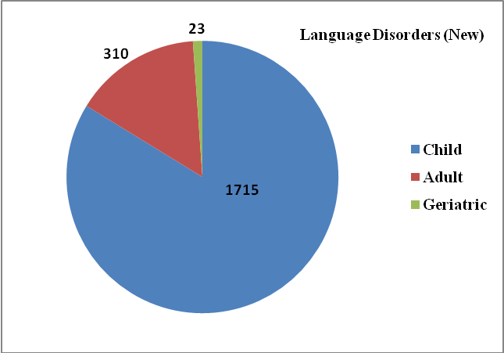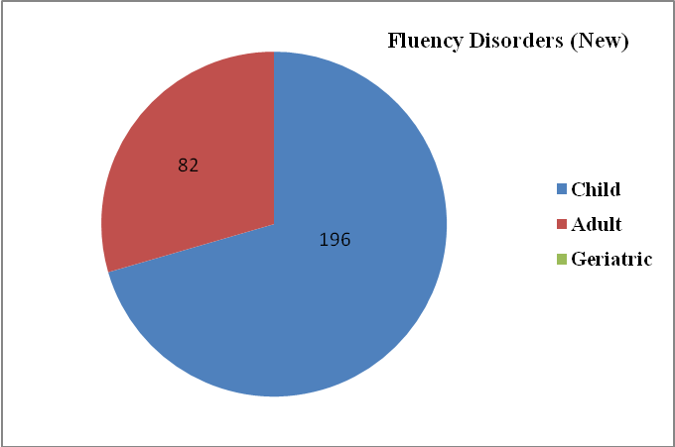

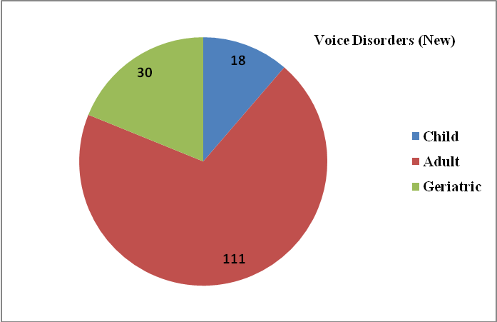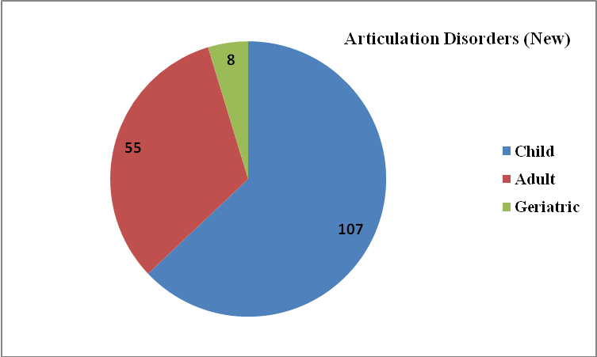

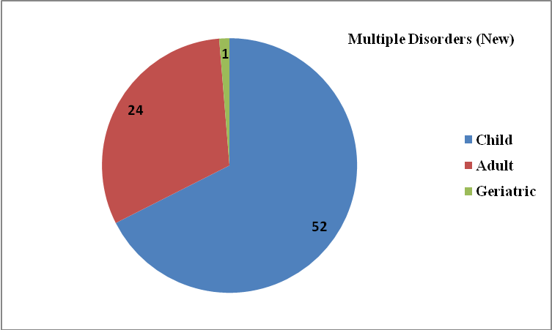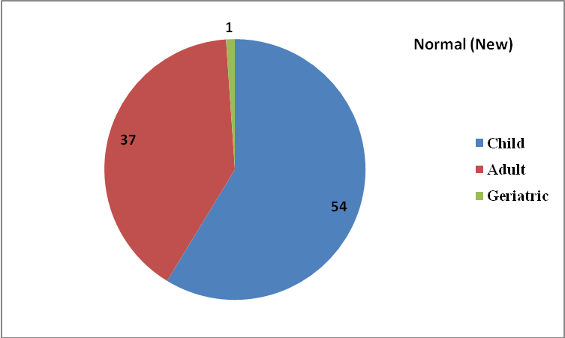
Figure: 1 Assessment of Speech-Language Disorders (New cases-disorder-wise)

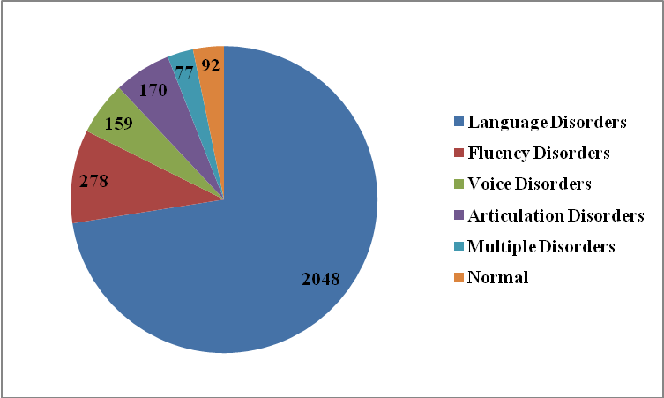

Overall Assessment of Speech-Language Disorders
Clients requiring further management were given various speech/language therapies depending upon the type and severity of disorder, for daily sessions of 45 minutes duration. In addition to the normal physical mode, the therapy sessions were conducted in virtual mode. A total of 1995 persons with speech/ language disorders underwent therapy in physical mode, and 791 persons underwent therapy in virtual mode during the reporting year. The total therapy sessions were 16667. The details of disorder-wise therapy carried out are given in table 3 & 4, and figure 2 & 3.
Table 3: Speech-Language Therapy (Virtual mode)

Disorders | Language Disorders |  |  | Voice Disorders |  |  | Articulation Disorders |  |  | Multiple Disorders |  |  | MSD |  |  | LD |  |  | Total
Months | C | A | G | C | A | G | C | A | G | C | A | G | C | A | G | C | A | G | Total
April | Lockdown period
May | 84 | 14 | 1 | 10 | 0 | 0 | 38 | 0 | 0 | 12 | 3 | 0 | 0 | 6 | 1 | 0 | 0 | 0 | 169
June | 120 | 14 | 0 | 1 | 6 | 2 | 10 | 2 | 0 | 0 | 0 | 0 | 44 | 0 | 0 | 15 | 0 | 0 | 214
July | 91 | 11 | 2 | 0 | 6 | 3 | 10 | 6 | 0 | 0 | 0 | 0 | 26 | 0 | 0 | 9 | 0 | 0 | 164
August | 80 | 5 | 4 | 2 | 6 | 2 | 6 | 3 | 0 | 0 | 0 | 0 | 34 | 0 | 0 | 4 | 0 | 0 | 146
September | 76 | 6 | 2 | 1 | 4 | 1 | 4 | 4 | 0 | 0 | 0 | 0 | 23 | 0 | 0 | 3 | 0 | 0 | 124
October | 127 | 6 | 2 | 1 | 7 | 0 | 8 | 8 | 0 | 0 | 0 | 0 | 34 | 0 | 0 | 3 | 0 | 0 | 196
November | 134 | 6 | 2 | 1 | 7 | 0 | 10 | 7 | 0 | 0 | 0 | 0 | 35 | 0 | 0 | 3 | 0 | 0 | 205
December | 97 | 2 | 2 | 0 | 5 | 0 | 7 | 6 | 0 | 0 | 0 | 0 | 22 | 0 | 0 | 2 | 0 | 0 | 143
January | 111 | 2 | 2 | 0 | 4 | 1 | 6 | 8 | 0 | 0 | 0 | 0 | 28 | 0 | 0 | 2 | 0 | 0 | 164
February | 97 | 1 | 1 | 1 | 5 | 2 | 7 | 7 | 0 | 0 | 0 | 0 | 20 | 0 | 0 | 1 | 0 | 0 | 142
March | 223 | 8 | 0 | 3 | 8 | 0 | 20 | 3 | 0 | 0 | 0 | 0 | 53 | 0 | 0 | 9 | 1 | 0 | 328
Total | 1240 | 75 | 18 | 20 | 58 | 11 | 126 | 54 | 0 | 12 | 3 | 0 | 319 | 6 | 1 | 51 | 1 | 0 | 1995
Disorder Wise | 1333 |  |  | 89 |  |  | 180 |  |  | 15 |  |  | 326 |  |  | 52 |  |  | 1995
Total no. of Cases | 1995
Total no. of Sessions | 9080

Figure 2: Overall Disorder wise Speech-Language Therapy (Virtual mode)

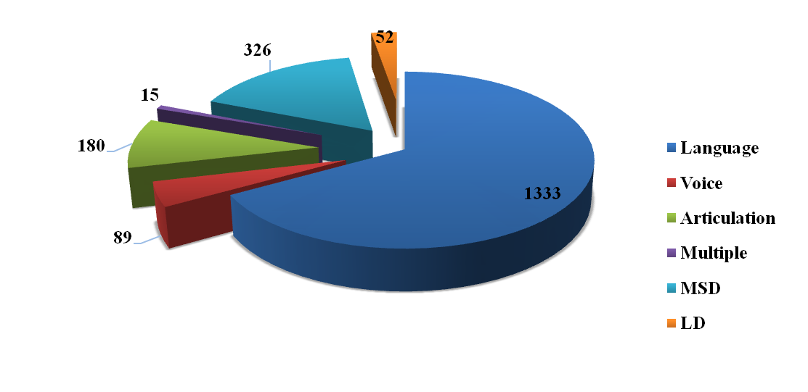
Table 4: Speech-Language Therapy (Physical mode)

Disorders | Language Disorders |  |  | Voice Disorders |  |  | Articulation Disorders |  |  | Multiple Disorders |  |  | MSD |  |  | LD |  |  | Total
Months | C | A | G | C | A | G | C | A | G | C | A | G | C | A | G | C | A | G | Total
Apr-20 | The services were provided through virtual mode due to the pandemic
May-20
Jun-20
Jul-20
Aug-20
Sep-20
Oct-20
Nov-20
Dec-20 | 110 | 6 | 0 | 0 | 9 | 1 | 18 | 2 | 0 | 0 | 0 | 0 | 26 | 0 | 0 | 1 | 1 | 0 | 174
Jan-21 | 187 | 9 | 0 | 2 | 12 | 0 | 22 | 1 | 0 | 0 | 0 | 0 | 48 | 0 | 0 | 8 | 0 | 0 | 289
Feb-21 | 223 | 8 | 0 | 3 | 8 | 0 | 20 | 3 | 0 | 0 | 0 | 0 | 53 | 0 | 0 | 9 | 1 | 0 | 328
Mar-21 | 0 | 0 | 0 | 0 | 0 | 0 | 0 | 0 | 0 | 0 | 0 | 0 | 0 | 0 | 0 | 0 | 0 | 0 | 0
Total | 520 | 23 | 0 | 5 | 29 | 1 | 60 | 6 | 0 | 0 | 0 | 0 | 127 | 0 | 0 | 18 | 2 | 0 | 791
Disorder Wise | 543 |  |  | 35 |  |  | 66 |  |  | 0 |  |  | 127 |  |  | 20 |  |  | 791
Total no. of Cases | 791
Total no. of Sessions | 7379

Figure 3: Overall disorder-wise Speech-Language Therapy (Physical mode)

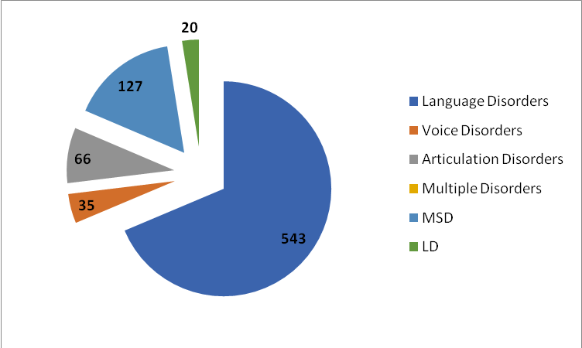

Speech and language assessment and therapeutic services were also provided at the seven DHLS centres of the Institute located in different parts of the country, the details of which are given in table 5.
Table 5 : Speech-Language clinical services at the DHLS Centres

Assessment |  |  |  |  |  | Therapy
Centers | Language | Voice | Phonology | Fluency | MSD/  Dysphasia | Language | Voice | Phonology | Fluency | MSD/  Dysphasia
Mysore | 131 | 30 | 22 | 27 | - | -
Ranchi | 55 | - | 17 | 18 | - | 56 | - | 11 | 18 | -
New Delhi | 8 | 17 | 6 | 4 | 1 | 38 | 46 | 14 | 11 | 3
Bhagalpur | 05 | 01 | 01 | 03 | - | 36 | 10 | 15 | 25 | -
Mumbai | 209 | 2 | 4 | 2 | 20 | 302 | 7 | 10 | 13 | 58
Lucknow | 12 | 3 | 4 | 7 | - | 26 | 10 | 20 | 12 | -

Audiological Assessment and Rehabilitation

Hearing evaluations were carried out on individuals who complained of hearing problems. In the Audiology outpatient department, a total of 10358 clients were assessed and hearing evaluations were carried out for 6686 individuals. Of the 6686 clients evaluated, 2569 were female and 4117 male. The details of the audiological evaluation are given in table 6.
Table 6: Hearing Evaluation

Sl. | Category | Total
1 | Clients seen in Outpatient department | 10358
2 | Hearing Evaluation | 6686
3 | Normal hearing | 1398
4 | Minimal | 862
5 | Mild | 1091
6 | Moderate | 1181
7 | Moderately severe | 1147
8 | Severe | 905
9 | Profound | 1021
10 | Minimal to mild | 4
11 | Mild to moderate | 52
12 | Moderate to severe | 54
13 | Moderately severe to severe | 62
14 | Severe to profound | 138
15 | Moderate to severe | 3
16 | Sloping | 480
17 | Ears tested having  - Conductive hearing  - Mixed hearing loss  - Sensorineural hearing loss | 1477  2412  4169
18 | Clients with unilateral hearing loss | 703
19 | Clients with bilateral hearing loss | 5107
20 | Ears with auditory dys-synchrony | 39
21 | Clients with auditory processing disorder | 2
22 | Clients with functional hearing loss | 56
23 | Clients - tinnitus evaluation | 147
24 | Clients for Pure Tone Audiometry | 6269
25 | Clients for Speech Audiometry | 1289
26 | Clients for Immittance evaluation | 6348
27 | Clients for Otoacoustic Element | 1072
28 | Clients for Auditory Brainstem Response | 990
29 | Clients for Vestibular Evoked Myogenic Potential | 2
30 | Clients for Video Head Impulse Tests | 1
31 | Clients for Behavioral Observation Audiometry | 138
32 | Clients for Visual Reinforcement Audiometry | 14
33 | Behavioral Vestibular Assessment | 2

Hearing aid trial and prescription were carried out for clients in need for amplification and/or assistive listening devices. Clients evaluated of hearing aids were 3321 and 2682 hearing aids were prescribed at AIISH. Of the 3321 clients evaluated, 1216 were female and 2105 male. The details are given intable 7 and figure 4.

Table 7: Hearing Aid Trial

Hearing Aid Trial | Total
No. of clients seen for Hearing Aid Trial | 3321
Hearing aids prescribed at AIISH | 2682
- Body level hearing aids | 196
- Analogue BTE hearing aids | 790
- Digital BTE hearing aids | 1702
- Trimmer Digital BTE | 2
- Digital ITE hearing aids | 514
- Digital ITC hearing aids | 7
- Digital CIC hearing aids | 20
- Digital RIC hearing aids | 305
- Testing for CI candidacy | 10
No. of clients recommended
Auditory training | 498
Speechreading | 132
Unaided/aided audiograms | 99
Aided audiogram for Cochlear Implant | 50
Behavioural Observation Audiometry | 5
Aided Visual reinforcement Audiometry | 3
Conditioning | 131
Programming of digital Hearing Aid | 1680
Reprogramming of Hearing Aid | 1429
Retrial with Custom Ear Mould | 278
Recommended for ear plugs | 2
Recommended for Cochlear Implant candidacy | 56

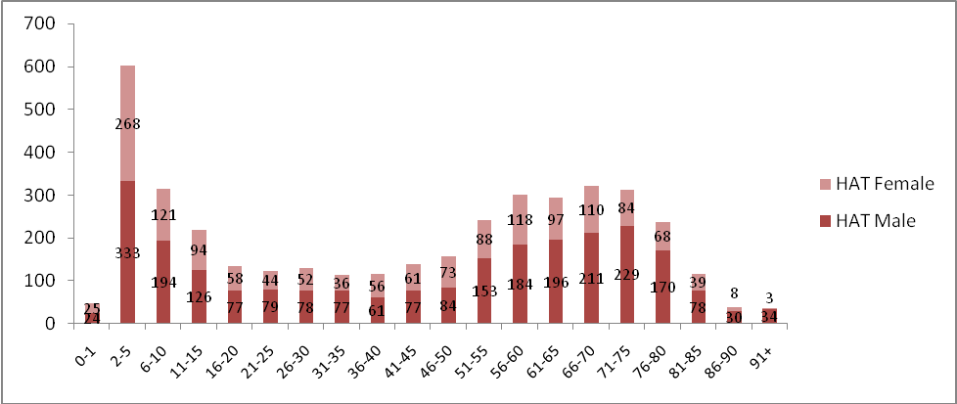
Figure 4: Hearing Aid Trial
At the Ear mould lab, ear impressions were taken for 4124 clients. These include 575 new and 3420 old clients at AIISH and 129 in community-based camps. The earmold details are given table 8.

Table 8: Earmould Statistics

Category | Total
Clients attended | 4406
New clients | 575
Old clients | 3420
At Camp | 129
Ear impressions taken
Free-of-cost | 3187
100% payment | 3601
Ear impressions taken-camp | 129
CPL impressions | 4
Ear Molds completed | 4423
No. Molds Lacquered | 1521
No. of sound tube issued | 181
Hard regular moulds | 34
Hard shell mould made | 561
Soft mould made | 2
Hard canal moulds | 443
Soft canal moulds | 17
Instant moulds | 92
ITC impression made | 24
Swimmer plug (hard) | 5
No. of ear blocked | 1359
Ear Moulds with acoustic modifications | 1178
No. of students posted | 3187

Audiological services were also provided at the DHLS centres of the Institute located in different parts of the country, the details of which are given in table 9.

Table 9: Audiological services at the DHLS centres

Centers | OPD  (Case history) | Evaluation | Earmoulds | Hearing aid trial (HAT) | Listening
Mysore | 70 | 156 | 78 | 75 | -
Ranchi | 1110 | 1110 | Nil | Nil | Nil
New Delhi | 430 | 476 | 00 | 16 | 0
Bhagalpur | 219 | 219 | - | - | -
Mumbai | 28 | 28 | - | - | -
Lucknow | 945 | 945 | 0 | 0 | 0

Referred Evaluation-1: Psychological Assessment and Rehabilitation

Psychological assessment was carried out for the referred cases registered at the Department of Clinical Psychology. This includes Routine Psycho-Diagnostic Assessment for Screening and Identification detailed psychological assessment (including specialized assessment such as assessment for Learning Disability, neuro-psychological assessment, assessment for disability certification, behavioral assessmentand assessment for skill training), Psychological Intervention (including behavior modification programs, home based skill training programs, cognitive-behaviour and group intervention programs for caregivers).

Routine psycho-diagnostic assessment was carried out for 2435 new and 670 repeat cases at the Department during the reporting year. The detailed is given in table 10.

Table 10: Routine Psycho-Diagnostic Assessment

Classification of disorders according to the criteria included in Chapter V (F) of ICD-10
F 70# | Mental retardation | 797
F 80.0 | Specific speech articulation disorder | 126
F 80.1 | Expressive language disorder | 271
F 80.2 | Receptive language disorder | 234
F 88# | Other disorders of psychological development | 135
F81# | Specific developmental disorders of scholastic skills | 270
F 84# | Pervasive developmental disorders | 34
F 98.5 | Stuttering (stammering) | 224
F 44.4 | Dissociative motor disorders | 3
F00-F99 | Other disorders included in Chapter V (F) of ICD-10 | 462
The code # refers to "condensed" codes (Ref ICD-IO PC )
Classification according to the criteria included in Chapter XVIII (R) of ICD 10
R 47.0 | Dysphasia and aphasia | 23
R 41.83 | Borderline Intellectual Functioning | 369
Avg. Intelligence with disorders classified elsewhere |  | 157
TOTAL |  | 3,105

Psychological assessment includes intelligence / developmental (203 cases in 322 sessions), psycho-educational (226 cases in 509 sessions), neuropsychological (7 cases in 48 sessions), personality (23 cases in 28 sessions), behavioural (2 cases in 5 sessions) and forensic assessments (4 cases in 18 sessions).The psychological intervention provided includes behavior modification (69 cases in 162 sessions), cognitive behaviour therapy (8 cases in 22 sessions) neuropsychological rehabilitation (3 cases in 9 sessions).

Referred Evaluation-2: Otolaryngological Assessment and Rehabilitation

The Otorhino-laryngological assessment and rehabilitation for persons with communication disorders were being carried out at the Department of Otolaryngology. In addition to the clinical services provided at the Institute, the Department staffs rendered diagnostic, therapeutic and surgical services at K.R. Hospital, Mysore Medical College, Mysuru. Totally, 11334 new and 12509 review cases were examined during the reporting year at the institute, and 3087 microscopic, 117 stroboscopic / endoscopic examination, 46 vertigo, 25 otoendoscopic and 5 diagnostic naso endoscopic examinations were carried out. Also, 9960 cases were examined and 87 major and 280 minor surgeries were successfully carried out at K.R.Hospital.

Specialized Clinical Services

The institute provided a variety of specialized clinical services for individuals with communication disorders in both physical and virtual mode during the reporting year. The details are provided in tables 11, 12 and 13.

Table 11: Evaluation at the Special Clinics
Units | Total
Augmentative and Alternative Communication (AAC) | 21
Autism Spectrum Disorders (ASD) | 46
Clinic for Adult and Elderly Persons with Language Disorders (CAEPLD) | 1
Fluency | 6
Voice | 8
Learning Disability (LD) | 32
Phonology | 20
Structure Orofacial Anomalies (U-SOFA) | 8
Motor Speech Disorders (MSD) | 2
Total | 144

Table 12: Rehabilitation at the special clinics (Virtual mode)
Unit | Child | Adult | Total Sessions
Fluency | 211 | 92 | 1565
ASD | 377 | 2 | 2133
U-SOFA | 21 | 8 | 184
AAC | 30 | 3 | 178
ADHD | 29 | 4 | 188
Total | 777 |  | 4248

Table 13: Rehabilitation at the special clinics (Physical mode)

Unit | Child | Adult | Total Sessions
Fluency | 126 | 37 | 1086
ASD | 222 | 0 | 1548
U-SOFA | 14 | 0 | 85
AAC | 10 | 0 | 46
ADHD | 17 | 0 | 120
Total | 426 |  | 2885

Special Educational Services

The following educational services were provided to the children with special needs at the pre-school, attached to the Department of Special Education during the reporting year.

- Special Educational Assessment: Educational Assessment services are offered for 337 children with communication disorders to determine readiness for schooling and to suggest an appropriate grade, placement as well as necessary services.

- Parent Infant Program (PIP): PIP was provided to very young children ranging from birth to 2.5 years with the objective of improving physical, cognitive, communication, social and emotional skills as detailed in figure 5.

- Preschool Parent Empowerment Program (PPEP): PPEP was provided to caregivers of children ranging from 2.5-3 years before formal admission to preschool with the aim of empowering caregivers to train their children and get adjusted to preschool atmosphere.The details are provided in table 14.

Table 14: Preschool Parent Empowerment Program
 | Apr’20 | May’20 | June’20 | July’20 | Aug’20 | Sep’20 | Oct’20 | Nov’20 | Dec’20 | Jan’21 | Feb’21 | Mar’21 | Total
Children with special needs | 72 | 72 | 76 | 28 | 35 | 40 | 43 | 52 | 56 | 102 | 131 | 151 | 858
Sessions | 361 | 285 | 285 | 220 | 220 | 220 | 160 | 216 | 286 | 288 | 304 | 456 | 3301

- Preschool Training & Supplementary Services (PSS): Preschool service, a preparatory training for children with communication disorders in self-help, cognitive, communication and academic skills necessary for successful schooling was provided to children in the age range of 3-6 years having hearing impairment, cerebral palsy, and multiple disability and to those in the age range of 3-10 years having intellectual disability and autism. The details are given in table 15.

Table 15: Pre-school Training

 | Apr’20 | May’20 | June’20 | July’20 | Aug’20 | Sep’20 | Oct’20 | Nov’20 | Dec’20 | Jan’21 | Feb’21 | Mar’21 | Total
Children with special needs | 145 | 154 | 154 | 164 | 173 | 169 | 169 | 168 | 164 | 164 | 160 | 153 | 1937
Sessions | 947 | 1391 | 711 | 712 | 561 | 680 | 549 | 590 | 652 | 714 | 696 | 790 | 8993

- Curricular Support Services, Individualized Education Program and Demonstration Education Therapy / Non formal Education Program were offered respectively to 256, 42 and 5 children with communication disorders who were mainstreamed but have certain difficulties in coping with academics.

- Sensory Adaptation for Education tocater to the sensory issues of young children with special needs.
- Speech-Language group therapy
- Support services for Empowering Caregivers
- Counselling and guidance for parents and family
- Literacy computer and yoga
- Parent Enrichment Program
- Library of books and toys
- Parents help parents program

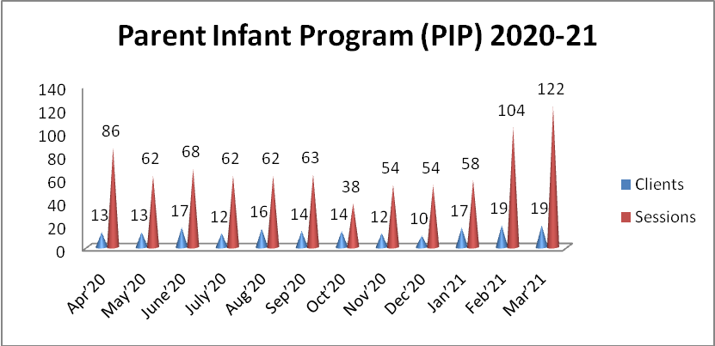
Figure 5: Parent Infant Programme

Medical Speciality & Allied Health Services

The institute facilitated the services of various medical specialists such as pediatrician, neurologist, plastic surgeon, prosthodontist, orthodontist, phono-surgeon and services of allied health professionals such as physiotherapist and occupational therapist, to the needy clients. Totally, 433 clients underwent physiotherapy and occupational therapy in physical mode and 301 clients in virtual mode during the reporting year. The physical sessions conducted were 2337 and tele sessions, 1932. In addition, 306, 39, 31, 39, 10, 30 clients consulted physician, pediatrician, phonosurgeon, plastic surgeon, orthodontist, dietician, respectively. The details are given in figure 6.

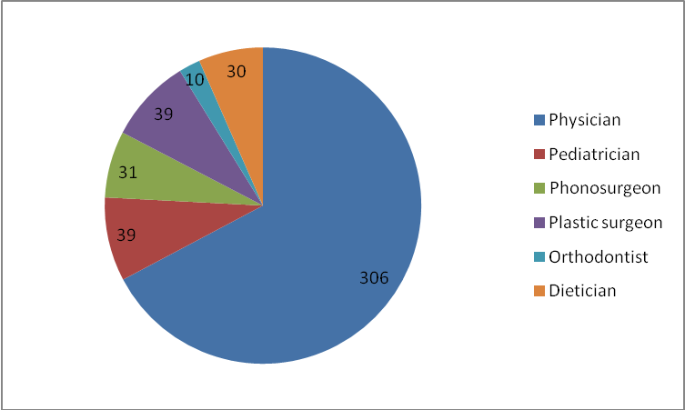

Figure 6: Medical specialty and allied health

Clinical Support Services

The institute extended a diverse range of support services to patients and their family. These include thefollowing.

- Distribution and Repairing of Aids:

Electro-acoustic evaluation, management and repair of hearing aids were carried out under the aegis of Department of Electronics. Totally 948 hearing aids were distributed after electro-acoustic evaluation and testing under AIISH Hearing Aid Dispensing Scheme. Also, 860 free hearing aids were distributed under the Client Welfare Fund. In addition, 71291 hearing aid spares such as hearing aid cells, cords, battery doors, ear hooks, body case, wind weather protector, BET huggies, domes and tips were issued. Also, 249 body level and 954 BTE hearing aids were repaired, electronic-acoustic evaluation was carried out for 7 hearing aids and 5 audiometers were calibrated.
The hearing aids were also distributed free of cost at the Outreach Service Centres (OSC) and Newborn Screening Centres of the Institute as detailed in table 16.

Table 16: Hearing aid distribution at OSCs / NBS Centers

Centre | No. of hearing aids
Outreach Service Centres
Taluk Hospital, Nanjungud | 31
Kodagu Institute of Medical Science, Kodagu | 22
Taluk General Hospital, K.R Pet | 17
Vivekananda Memorial hospital, H. D. Kote, Sarguru | 100
Sub-divisional Hospital, Sagara | 4
Primary Health Centre (Under Karuna trust), Gumballi | 19
Taluk Hospital, Akkihebbalu | 10
Newborn Screening Centers
Rajendra Institute of Medical Sciences, Baritayu, Ranchi | 12
All India Institute of Medical Science, Patna | 22

- Counselling and Guidance: The professional experts of the Institute provided counselling and guidance on various aspects of the disorders such as treatment procedures, usage and care of tools like hearing aids during the reporting year.

Issue of Certificates:

Various certificates like financial aid, income tax exemption, educational scholarship, and school admission were issued to the eligible candidates during the reporting year, the details of which are given in table 17.

Table 17: Details of certificates issued

Particulars | Total
Transfer certificate | 6
Evaluation reports | 154
Attendance certificate | 22
School admission certificate | 24
Admission to deaf school | 5
Railway concession | 17
Bonafide certificate | 9
Handicapped Certificate (Pension) | 690
Medical Certificate | 442

- Financial Aid: The institute distributed total amount of Rs. 3,76,938/-among 36 clients below poverty line towards the purchase of hearing aids during the reporting year under the aegis of the Department of Clinical Services.

