**Department of Special Education**

**ANNUAL REPORT 2020-21**

(*Period of Coverage: 1stApril 2020 – 31st March 2021)*

1. ACADEMIC ACTIVITIES
2. **Orientation/Short-term Training Programs (*For outsiders*)**

|  |  |  |  |  |
| --- | --- | --- | --- | --- |
| **SL No.** | **Coordinator** | **Targeted Audience** | **Number**  **of Participants** | **Date** |
| 1 | Ms.Ramanakumari  Ms. Shobha B N  Mr. Rajkumar R | Staff & Students, Vivekanand teacher training and research center, hoshalli | 19 | 11.01.2021 |
| 2 | Mr. Rajkumar R | Special Educators, Parents and Children with HI, The Association of People with Disability, Bangalore | 15 | 05.03.2021 |

1. Clinical Observation Posting of Students from other Institutes: NIL
   * + - Number of Students
       - Course
       - Institute
       - Date
2. **Seminars/Conferences/Workshops/Training Programs:05**

|  |  |
| --- | --- |
| Theme /Topic : | Webinar On ' Challenges and opportunities in mainstreaming Children with Special Needs in an Inclusive Set-up' |
| Coordinator | Dr.Alok Kumar Upadhyay  Dr.PrithiVenkatesh  Mr. Balu M. |
| Objectives | To orient the participants about information on creating conducive inclusive education scenario, and other topics like adapting instructional strategies, importance of multidisciplinary team approach and factors and criteria for successful inclusion. The participants also had an idea about prospects and challenges in remote learning. |
| Target Audience | Faculty, Special Educators, Students and Stakeholders of NGO’s |
| Number of Participants | 69 |
| Date | 26.06.2020 |

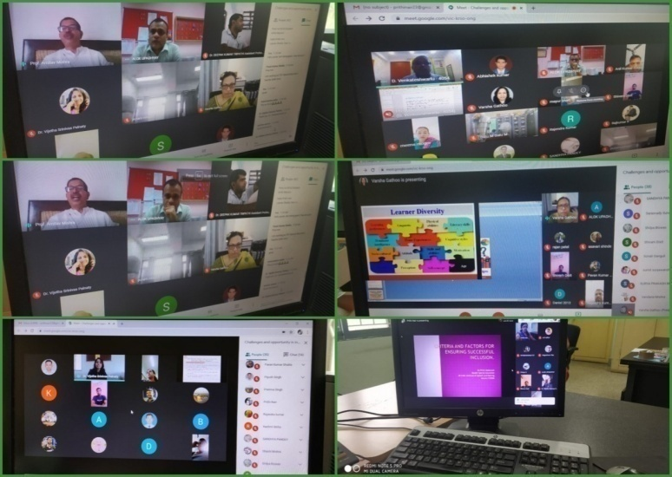

|  |  |
| --- | --- |
| Theme /Topic : | One day National Webinar on A practical approach to teach skills to children with hearing impairment at Preschool level |
| Coordinator | Dr. Alok Kumar Upadhyay, Dr. Palnaty Vijetha and Ms. Sreevidya M S |
| Objectives | To teach skills to children with hearing impairment at pre-school level, included demonstrations of skills like- language and art, story rhyme and also pre-academic skills. |
| Target Audience | Special Educators, Educators, D.Ed, B.Ed, MEd Students |
| Number of Participants | 84 |
| Date | 18.08.2020 |

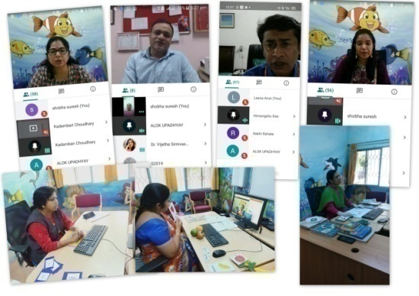

|  |  |
| --- | --- |
| Theme /Topic : | Two Days In-house workshop on ‘***Standardization of Preschool modules on Concept based pre-literacy skills, cognitive skills & pre-number skills for Children with Hearing Impairment***’ |
| Coordinator | Dr. Palnaty Vijetha and Mr. Subramanya K R |
| Objectives | Group discussion about each skill from the developed preschool module. |
| Target Audience | Special Educators, Educators,D.Ed,B.Ed,MEd Students |
| Number of Participants | Special Educators |
| Date | 24.09.2020 to 25.09.2020 |

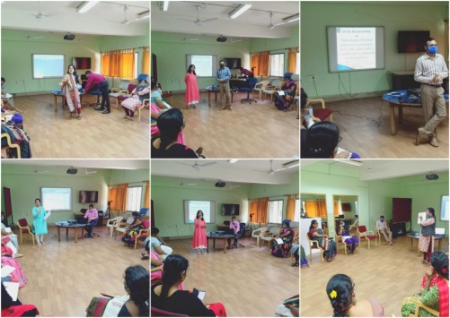

|  |  |
| --- | --- |
| **Theme/topic** | Webinar on Management of children with communication disorders in classrooms |
| **Coordinators** | Dr. Palnaty Vijetha, Reader in Special Education |
| **Objectives** | To educate teachers about *curriculum adaptation- a teaching strategy* for children with special needs |
| **Targeted Audience** | Resource/ Regular teachers across 30 districts of Karnataka |
| **Number of Participants** | Approximately 300 |
| **Date** | 27th & 28th October 2020 |
| C:\Users\ACER\Downloads\IMG-20201028-WA0020.jpegC:\Users\ACER\Downloads\IMG-20201028-WA0024.jpgC:\Users\ACER\Downloads\IMG-20201027-WA0002.jpegC:\Users\ACER\Downloads\IMG-20201027-WA0011.jpeg | |
|  | |

|  |  |
| --- | --- |
| **Theme/topic** | Webinar on “ Role of multidisciplinary team approach in successful rehabilitation of children with communication disorder” |
| **Coordinators** | Dr. Alok Kumar Upadhayay, Ms. K. Anjana, Dr. Kadambari N. |
| **Objectives** | Webinar will be creating awareness of how to combine the following in classroom settings:   1. Speech Therapy goals, 2. Listening Therapy goals, 3. Educational goals, and 4. Giving an insight on managing behaviour problems in the classroom with the help of behaviour therapists. 5. The participants will also be able to enhance their knowledge and skills to handle children with special needs in an inclusive set-up. |
| **Targeted Audience** | Special Educators and Allied professionals |
| **Number of Participants** | 100 |
| **Date** | 4-5, February 2021 |
| **Photo**  **C:\Users\ACER\Pictures\Picasa\Collages\Hindi.jpg** | |

1. **Staff Enrichment /In-house training Programmes (*For own staff members*) :01**

|  |  |  |  |  |
| --- | --- | --- | --- | --- |
| **SL No.** | **Coordinator** | **Targeted Audience** | **Number**  **of Participants** | **Date** |
| 1 | P.V.Ramanakumari | Special Educators Organised and attended orientation by Mr. Arjun Singh from globus regarding DTDS. | 15 | 23.02.2021 |
|  | IMG-20210223-WA0009.jpg | | | |

1. Guest Lectures: NIL
2. Additional Academic Services rendered by the Faculty and Staff
3. **Invited Talks**

|  |  |  |  |  |  |  |  |  |  |  |  |
| --- | --- | --- | --- | --- | --- | --- | --- | --- | --- | --- | --- |
| **S no.** | **Name, Designation, Institutional affiliation of Speaker** | | | **Organized by** | **Programme** | | **Topic of Lecture** | | | **Date** | |
| 1 | Dr.Alok Kumar Upadhyay  Associate Professor in Special Education,AIISH,Mysuru | | | SAKSHAM BHARAT  Nagpur | National Webinar through Face book live | | Teaching learning Strategies for children with special needs in inclusive classroom | | | 22.05.2020 | |
| 2 | Dr.Palnaty Vijetha  Reader in Dept. of Special Education | | | Dept. of Special Education  AIISH | Webinar On ' Challenges and opportunities in mainstreaming Children with Special Needs in an Inclusive Set-up' | | Multidisciplinary Team approach for successful inclusion | | | 26.06.2020 | |
| 3 | Dr.PrithiVenkatesh  Reader-Department of Special Education  AIISH | | | Dept. of Special Education  AIISH | Webinar On ' Challenges and opportunities in mainstreaming Children with Special Needs in an Inclusive Set-up' | | Criteria and factors for ensuring successful inclusion. | | | 26.06.2020 | |
| 4 | Ms. Sumana H P  Special Educator | | | AIISH, MYSURU | AISIRI Akashvani, Mysuru | | Educational Assessment Adaptions for CWSN | | | 31.07.2020 | |
| 5 | Ms. Sumana H P  Special Educator | | | AIISH, MYSURU | JANADHWANI LIVE IN RADIO | | LD – Myths and Facts | | | 01.07.2020 | |
| 6 | Ms. Sumana H P  Special Educator | | | AIISH, MYSURU | JANADHWANI LIVE IN RADIO | | Classroom Management of LD Children | | | 15.07.2020 | |
| 7 | Ms. Sumana H P  Special Educator | | | AIISH, MYSURU | JANADHWANI LIVE IN RADIO | | LD – Classroom Management | | | 29.07.2020 | |
| 8 | Dr. Alok Kumar Upadhyay  Associate Professor in Special Education,  AIISH,Mysuru | | | Kalyanam Karoti ,Mathura (U.P.) | National webinar on preventing double marginalization of person with disability during COVID-19 pandemic. | | Developing Skills in early childhood Education for Children with special needs | | | 11.08.2020 | |
| 9 | Dr. Alok Kumar Upadhyay  Associate Professor in Special Education,  AIISH,Mysuru | | | Shri Shah K.L Institute for the deaf-TTC  Bhavnagar,Gujrat | National webinar on Curriculum Adaptation in an Inclusive Classroom | | Concept and need of Curriculum and Inclusive curriculum | | | 20.08.2020 | |
| 10 | Ms. Kumudha  Special Educator | | | AIISH, MYSURU | AISIRI Akashvani, Mysuru | | Importance of parent empowerment in the early education of children with special needs | | | 03.08.2020 | |
| 11 | Ms. Shobha B N  Special Educator | | | AIISH, MYSURU | AISIRI Akashvani, Mysuru | | Importance of curriculum adaptation in the education of children with special needs | | | 03.08.2020 | |
| 12 | Dr. Kadambari N  Special Educator | | | GS Diet Culture | Connecting people group, Face book | | Health talk ‘ Autism is Manageable’ | | | 07.08.2020 | |
| 13 | Dr. Palnaty Vijetha, Reader in Special Education, AIISH | | | TCPD, AIISH | Project Reach-out | | Educational challenges and counselling for adolescents with communication disorders | | | 02.09.2020 | |
| 14 | Ms. Shobha B N, Special Educator | | | SVYM teachers training center, mysuru | Certificate course | | Children with specual needs at class room | | | 20.09.2020 | |
| 15 | Ms. Shobha B N, Special Educator | | | Swamy Vivekananda youth moment teachers training institute, Mysuru |  | | Children with Special Needs (CWSN) | | | 20.09.2020 | |
| 16 | Ms. Shobha B N, Special Educator | | | AIISH, Mysuru | Online training program for Government teachers of Kodagu district (through  SVYM, Sarguru) | | “Educational difficulties of children with learning disabilities” | | | 26.09.2020 | |
| 17 | Ms. Sumana H P  Special Educator | | | AIISH, Mysuru | Online training program for Government teachers of Kodagu district (through  SVYM, Sarguru) | | Understanding problems of children with learning disabilities | | | 23.09.2020 | |
| 18 | Mr. Rajkumar R  Special Educator | | | AIISH, Mysuru | International Day of Sign Languages (Department of Clincal Services-AAC Unit) | | Importance and objectives of IDSL-2020 | | | 23.09.2020 | |
| 19 | Ms. Vijayalakshmi M  Special Educator | | | MPLS | MPLS | | Curriculam Adaption | | | 15.10.2020 | |
| 20 | Rajkumar R  Special Educator | | | Department of POCD &  SSK Karantaka | CISCO Webex Webinar for teachers on management of Children with Communication Disorders in Classroom | | Textbook Adaptations for CWCD-English Subject | | | 25.10.2020 | |
| 21 | Leena C C  Special Educator | | | Department of POCD | Kodagu Teacher Training Programme | | Learning Disability | | | 21.10.2020 | |
| 21 | Leena C C  Special Educator | | | Department of POCD | Training to Karnataka primary school teachers | | Social Science Adaptation | | | 28.10.2020 | |
| 22 | Ms. Shobha B N  Special Educator | | | Swamyamy Vivekananda youth moment teachers training institute. Mysuru | Certificate course for Preschool Teachers | | Kinder garten and Montessori method of teaching | | | 10.10.2020 & 11.10.2020, 17.10.2020 & 18.10.2020, 31.10.2020 | |
| 23 | Dr. Palnaty Vijetha, Reader in Special Education, AIISH | | | POCD, AIISH | Ministry of Primary and secondary Education of and sakala of Karnataka | | Curriculum adaptation for children with special needs | | | 27th October 2020 | |
| 24 | Ms. Kumudha R  Special Educator | | | DCS, AIISH | Training to regular school IIRT teachers | | Demonstrated Kannada language curriculum adapataion for CWSN | | | 27.10.2020 | |
| 25 | Ms. Shobha B N  Special Educator | | | DCS, AIISH | Training to regular school IIRT teachers | | Demonstrated Science curriculum adapataion for CWSN | | | 28.10.2020 | |
| 26 | Dr Kadambari Naniwadekar  Special Educator | | | Sri Jagadamba Education and Research Institute, Sri Ganganagar, Rajasthan | National webinar on Addressing Barriers in the Environment and Universal Design | | Universal Design of Learning and its principles | | | 28.10.2020 | |
| 27 | Dr. Alok Kumar Upadhyay  Associate Professor in Special Education,  AIISH,Mysuru | | | LKC Sri Jagdamba Andh Vidyalaya Samiti, Sri Ganganagar, Rajasthan. | National webinar on Addressing Barriers in the Environment and Universal Design | | Advocacy for Policy reform to Solve issues related to barriers in the Environment for Individuals with Special Needs | | | 29 October  2020 | |
| 28 | Dr. Alok Kumar Upadhyay  Associate Professor in Special Education,  AIISH,Mysuru | | | Sh. Shah K.L. Institute for the Deaf-Trust  51, Vidyanagar, Bhavnagar(Gujrat) | National webinar on Impact of Pandemic on Teaching Learning Process for Individuals with Disabilities in Inclusive Classroom | | Source of material and evaluation strategies in pandemic era | | | 19th November  2020 | |
| 29 | Dr. Alok Kumar Upadhyay  Associate Professor in Special Education,  AIISH,Mysuru | | | Jeevandhara Rehabilitation Research Institute, Bareilly 243005 | National Consortium of Training Institutions in India (NCTI India) | | Strategies of Teaching Learning of Children with Hearing Impairment | | | 28th November  2020 | |
| 30 | Dr. Alok Kumar Upadhyay  Associate Professor in Special Education,  AIISH,Mysuru | | | Nehru Gram Bharati University,Prayagraj (UP) | CRE Webinar | | Best classroom practices in inclusive setups for enhancing language skills for CWHI | | | 24th November 2020 | |
| 31 | Dr. Palnaty Vijetha, Reader in Special Education, AIISH | | | National Consortium of Training Institutions in India | National Consortium of Training Institutions in India | | Content cum Methodology of Teaching Social sciences (CMTSS) for Diploma in Special Education (HI) III semester | | | 22nd to 23rd &  28th to 30th December 2020  (five days) | |
| 32 | Dr. Palnaty Vijetha, Reader in Special Education, AIISH | | | National Consortium of Training Institutions in India | National Consortium of Training Institutions in India | | Content cum Methodology of Teaching Social sciences (CMTSS) for Diploma in Special Education (HI) III semester | | | 11th,12th, 13th &  20th January 2021 | |
| 33 | Dr. Kadambari N, Special Educator, Served as Anchor | | | AIISH | Doordarshan | | Information decimation on Special Education | | | 03.02.2021 | |
| 34 | Dr. Alok Kumar Upadhyay,Associate Professor,AIISH,  Mysore,Served as Resource Person | | | AIISH | Doordarshan | | Information decimation on Special Education in Hindi | | | 03.02.2021 | |
| 35 | Dr.Prithi Venkatesh  Reader  Special Education | | | Department of Special Education, All India Institute of Speech and Hearing  Mysuru-570006 | National Webinar | | Role Of Special Educators In Educational Rehabilitation Of Children With Communication Disorders And Strategies To Include Therapy Goal In Thier Classroom Teaching | | | 05.02.2021 | |
| 36 | Dr.Prithi Venkatesh  Reader  Special Education | | | Regional Institute of Education, Mysuru | 5 days online, Training programme under PAC titled ‘Orientation programme on Technological support to teachers handling children with disabilities for effective curriculum transaction’. | | Adaptation for Children with Hearing Impairment | | | 10.02.2021 | |
| 37 | Ms. Shobha B. N, Special Educator | | | AIISH | Doordarshan | | Information decimation on Special Education | | | 12.02.2021 | |
| 38 | Ms. Ramanakumari P V,  Special Educator | | | AIISH | Janadwani radio | | Mainstreaming of children with intellectual disability | | | 24.02.2021 | |
| 39 | Dr. Alok Kumar Upadhyay,Associate Professor,AIISH,  Mysore | | | IIRD,Agra(U.P) | National Webinar | | Teaching Strategies for Functional Writings | | | 26.02.2021 | |
| 40 | Ms. Subalakshmi J, Special Educator, | | | Dr.NanduRadhakrishnan  Associate Professor, Speech and Hearing Sciences, Director, Voice Lab and Vocology Clinic, Lamar University, Beaumont, Texas. | You Tube  <https://youtu.be/CWv-9vdKO3Y> | | Art and Craft in Education | | | 28.02.2021 | |
| 41 | Ms. Ramanakumari P V, Special Educator | | | AIISH | Janadwani radio | | Inclusion of individuals with intellectual disability | | | 10.03.2021 | |
| 42 | Dr Alok Kumar Upadhyay,Associate Professor in Special Education  AIISH,Mysuru | | | Department of Education, Guru Ghasidas University, Bilaspur,Chattisgarh | National Workshop | | Curricular Adaptation for Children with Hearing Impairment Prose Teaching | | | 12.03.2021 | |
| 43 | Dr Alok Kumar Upadhyay,Associate Professor in Special Education  AIISH,Mysuru | | | Handicapped Development Council,Tears,Agra | National webinar | | Collabration & Streangthing the activities of Institute | | | 18.03.2021 | |
| 44 | Ms. Shobha B N  Special Educator | | | SVYM  Sargur | B IRT Teachers training program | | “ Educational Management of Children with special needs during Pandamic” | | | 25.03.2021 | |
| 45 | | Dr Alok Kumar Upadhyay, Associate Professor in Special Education  AIISH, Mysuru | Shri Shah K.L. Institute for Deaf-TTC  Bhavnagar,Gujrat | | | National webinar | | Barriers and obstacles in language development during covid era | 27.03.2021 | |

1. Curriculum Development
2. Development of Materials to Support Learning
3. Service in Academic bodies of other Organizations.
4. **Dr. Alok Kumar Upadhyay**

* Member, Board of Studies (BOS):
  + - Ramkrishna Mission Vivekananda University, Coimbatore: for Diploma, U.G & P.G.
    - N.G.B. University, Allahabad: for U.G & P.G.
    - J.R.H. University, Chitrakoot: for U.G & P.G.
    - Mysore University, Mysuru :for U.G & P.G.
* Member, Board of Examiners (BOE):
  + - UG Special Education of University of Mysore.

1. **Dr. Prithi Venkatesh**
   * + Member, BOE–UG Special Education of University of Mysore
     + Member of BOS in special education, University of Mysore
2. **Dr.PalnatyVijetha**
   * + Member of BOS in special education, University of Mysore
     + Member of BOS in Human development (CB & PG), University of Mysore.
     + Member of BOE in special education, University of Mysore
3. Participation in Committees/Taskforces and Panels set up by other organizations/agencies. :NIL
4. **Any Other (Please Specify)**
   * + Publicity of Academic programs in Dept. of clinical services as per Director’s & HOD’s instructions.

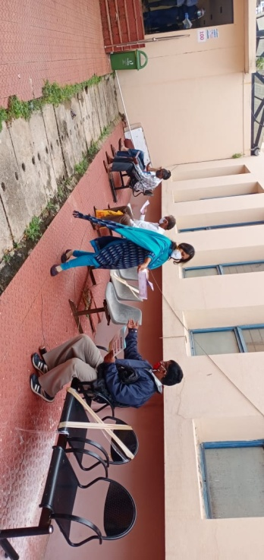

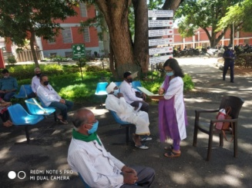

II.Research Activities

1. Extramural Research Projects

i) **Completed in 2020-21**

|  |  |
| --- | --- |
| Title: | Development of Grade Level Assessment Tools in Social Science (GLAT-SS) of Karnataka State Education Board. |
| Objectives | The present study is being initiated with the aim to develop and standardize Grade Level Assessment Tool in Social Sciences (GLAT-SS) at GRADE VI of Karnataka State Education Board in English and Kannada. |
| Investigators | 1. Dr.PalnatyVijetha   Reader in Special Education  AIISH, Manasagangothri, Mysore: 570006   1. Dr.Alok Kumar Upadhyay   Associate Professor in Special Education  AIISH, Manasagangotri, Mysore: 570006 |
| Funding Source | AIISH Research Fund (ARF) |
| Grant Amount | Rs. 3,85,000/- |

|  |  |
| --- | --- |
| Title: | Efficacy of Developing Skills through Curricular Activities among Preschool Children with Hearing Impairment at AIISH |
| Objectives | To investigate the effectiveness of curricular activities in developing:   * Cognitive skills * Language Arts   Pre-academic skills (pre-reading, pre-writing, pre-arithmetic) among children with hearing impairment |
| Investigators | 1. Dr.Alok Kumar Upadhyay   Associate Professor in Special Education  AIISH, Manasagangotri, Mysore: 570006   1. Dr.PalnatyVijetha   Reader in Special Education  AIISH, Manasagangothri, Mysore: 570006 |
| Funding Source | AIISH Research Fund (ARF) |
| Grant Amount | Rs. 3,80,000/- |

ii) New Projects initiated in 2020-21

* Title
* Objectives
* Investigators
* Funding Source
* Grant Amount

iii) **Ongoing**



|  |  |
| --- | --- |
| Title: | Development and Evaluation of Indigenous Curriculum Oriented Computer Based Tutor for Concept Learning in Preschool Children with Special Needs. |
| Objectives | Phase I: To develop story boards for 6 concepts viz. My Family, My Body, Things we use, Animals and Birds, Food we eat and My Journey in Kannada.  Phase II: To develop indigenous computer based tutor for the 6 concepts based on the story board in Kannada and integrating it with the multimedia content and devising reinforcement mechanism.  Phase III: To evaluate the performance of the developed computer based tutor. |
| Investigators | 1. Ms. P.V.Ramanakumari, Special Educator 2. Dr. Ajish K. Abraham, Professor in Electronics 3. Ms. P.V.Manjula, Special Educator |
| Funding Source | AIISH Research Fund (ARF) |
| Grant Amount | Rs. 3,85,000/- |

|  |  |
| --- | --- |
| Title: | Effect of Resource Materials on Impact of Inclusive Education in Children with Intellectual Disabilities (ID) and Learning Disabilities (LD) |
| Objectives | The purpose of the project is to investigate the impact of resource material on general teachers’ knowledge, attitude and practice for including children with ID and LD in general classrooms, through realisation of the following objectives:   * Developing tools for collecting data on general teacher competencies for facilitating inclusive education, * Field testing the tool for validity and reliability, * Developing multimedia materials involving text, audio, video, graphics and animations to provide essential information as well as simulated practical orientation, and   Experimenting with the resource material to study the impact on general teacher competencies, as well as school performances of learners with intellectual and learning disabilities. |
| Investigators | 1. Dr. G. Malar 2. Ms. S. Prathima |
| Funding Source | AIISH Research Fund (ARF) |
| Grant Amount | Rs. 3,85,000/- |

|  |  |
| --- | --- |
| Title: | Development of grade level Assessment test in Science for Upper Primary School Children (VI-VIII) |
| Objectives | The aim of the study is to develop grade level assessment test for upper primary school children (VI-VIII) in science subject.  The study will be taken up with the following objectives in mind:   1. To develop grade level assessment test in Science for upper primary school children (VI-VIII) 2. To verify the reliability and validity of the test 3. To establish the norms for the test 4. To test its applicability with learners with hearing impairment   To compare the performance of the learners with hearing impairment on the test. |
| Investigators | Dr. Prithi Venkatesh  Reader in Special Education  AIISH, Manasagangothri, Mysore: 570 006 |
| Funding Source | AIISH Research Fund (ARF) |
| Grant Amount | Rs.4,00,000/- |

1. Postgraduate Research Completed

* Title/Topic
* Candidate
* Guide

1. Postgraduate Research Ongoing

* Title/Topic
* Candidate
* Guide

1. **Research Papers presented at National/International Conferences/Seminars (*in APA format*):01**

Palnaty Vijetha. (2021). Teachers’ Knowledge about Hearing Impairment and Referral Services in Ooty, Tamil Nadu. Presented at National conference on Teacher Education in the 21st Century: Vision and Action” on 10th March 2021 held at Regional Institute of Education, NCERT, Bhopal.

1. Research Papers Published(*in APA format*)
2. **Papers published in National /International Journals: 08**

Vijetha, P. & Upadhyay, A. K.(2019). Formative Assessment Practices for Students with hearing impairment. Journal of Disability Management and Rehabilitation, 5(1): 3-10.

Manjula, P.V., &Ramanakumari, P.V. (2020). Profile of parameters of intelligence in preschool children with hearing impairment. International Journal of Engineering, Applied and Management Sciences Paradigms (IJEAM),54(11).

Subramanya K.R. & Upadhyay, A.K. (2020). A Survey Study on use of Story & Rhymes on Developing Listening & Speaking Skills among Children with Hearing Impairment in Preschool. Journal of Disability Management and rehabilitation, 6(1), 05-09

Dhivya D. & Upadhyay, A.K. (2020). Use of Computer Assisted Instruction in developing Memory skill for Preschool Children with Hearing Impairment. Journal of Disability Management and rehabilitation, 6(1), 10-16

Ramanakumari, P.V., & Manjula, P.V. (2020). Study of the Effectiveness of Computer Aided Instruction for Teaching the Concept of Place-Value to Primary School Children with Hearing Impairment. International Journal of Education and Psychological Research (IJEPR), 9(2).

Vijetha, P. , Narayana, U. L., & Upadhyay, A. K. (2019). Primary Education of Children with Cochlear implants in Mainstream schools: Parents’ Perspective. Journal of Nehru Gram Bharati University 8(2), 83-87.

Upadhyay, A.K., Vijetha, P., & Subramanya, K. S. (2020).Efficacy of Developing Skills through Curricular Activities among Preschool Children with Hearing Impairment. *Journal of Disability Management and Rehabilitation,6*(2),23-32.

Devraju N. B*.& Upadhyay A.K.(2020).*, Impact of Covid-19 on School Readiness of Children with Special Needs, *Journal of Disability Management and rehabilitation, 6(2),47-52 .*

**In Press: 03**

Prithi , V. & Dhivya .D. (**in press**).Ensuring Quality Assurance in Vocational and Technical Education. National Journal of Education.

Prithi , V. & Dhivya .D. (**in press**). Universal Curricular Design in Science. Are we meeting the 21st Century Requirements?’ Journal of Indian Education

Prithi , V. & Dhivya .D. (**in press**). Challenges and Opportunities In Teaching Science Subject To Children During This Covid-19. School Science

ii) Papers published in Conference/Seminar Proceedings

1. Books published(*in APA format*)
2. Book chapters published(*in APA format*)
3. Books/Manuals/Seminar Proceedings edited
4. Journal Editorship
5. Scholarly Reviewing Activities

i) Journal Articles

ii) Conference Papers

iii) Research Projects

III.Clinical Services

1. General Clinical Services
2. Speech and Language Assessment
3. Speech and Language Rehabilitation
4. Hearing Evaluation
5. Hearing Aid Trial
6. Psychological Evaluation
7. Otorhinolaryngology Evaluation
8. Ear Moulds
9. Hearing Aid Issue and Electro-Acoustic Evaluation (ADIP Scheme, Ministry of Social justice)
10. AIISH Hearing Aid Dispensing Scheme

Any other (*please specify*)

1. Specialized Clinical Services

Xi) Pre-School Training and Special education

**Educational services for children with special needs**

1. **Special Educational Assessment Unit:** Educational Assessment services are offered for all children with communication disorders to determine readiness for schooling and to suggest an appropriate grade, placement as well as necessary services from

|  |  |  |
| --- | --- | --- |
| Type of Service | Screening & Referrals | Assessment &  Reports generated |
| No. of clients | 337 | 10 |
| Total sessions | 337 | 32 |

1. **Parent Infant Program (PIP):** A service provided to very young children ranging from birth to 2.5 years with the objective of improving physical, cognitive, communication, social and emotional skills.

|  |  |  |  |  |  |  |  |  |  |  |  |  |
| --- | --- | --- | --- | --- | --- | --- | --- | --- | --- | --- | --- | --- |
|  | Apr’20 | May’20 | June’20 | July’20 | Aug’20 | Sep’20 | Oct’20 | Nov’20 | Dec’20 | Jan’21 | Feb’21 | Mar’21 |
| Clients | 13 | 13 | 17 | 12 | 16 | 14 | 14 | 12 | 10 | 17 | 19 | 19 |
| Sessions | 86 | 62 | 68 | 62 | 62 | 63 | 38 | 54 | 54 | 58 | 104 | 122 |

1. **Preschool Parent Empowerment Program (PPEP):** A service provided to caregivers of children ranging from 2.5-3 years before formal admission to preschool. This is aimed to empower caregivers to train their children and get adjusted to preschool atmosphere

|  |  |  |  |  |  |  |  |  |  |  |  |  |
| --- | --- | --- | --- | --- | --- | --- | --- | --- | --- | --- | --- | --- |
|  | Apr’20 | May’20 | June’20 | July’20 | Aug’20 | Sep’20 | Oct’20 | Nov’20 | Dec’20 | Jan’21 | Feb’21 | Mar’21 |
| Clients | 72 | 72 | 76 | 28 | 35 | 40 | 43 | 52 | 56 | 102 | 131 | 151 |
| Sessions | 361 | 285 | 285 | 220 | 220 | 220 | 160 | 216 | 286 | 288 | 304 | 456 |

1. **Preschool Training & Supplementary Services (PSS):** Preschool service is provided to children with hearing impairment, cerebral palsy, and multiple disability age ranging from 3 to 6 years. For children with intellectual disability and for children with autism age ranging from 3 to 10 years. This is preparatory training for children with communication disorders in self-help, cognitive, communication and academic skills necessary for successful schooling.

|  |  |  |  |  |  |  |  |  |  |  |  |  |
| --- | --- | --- | --- | --- | --- | --- | --- | --- | --- | --- | --- | --- |
|  | Apr’20 | May’20 | June’20 | July’20 | Aug’20 | Sep’20 | Oct’20 | Nov’20 | Dec’20 | Jan’21 | Feb’21 | Mar’21 |
| Clients | 145 | 154 | 154 | 164 | 173 | 169 | 169 | 168 | 164 | 164 | 160 | 153 |
| Sessions | 947 | 1391 | 711 | 712 | 561 | 680 | 549 | 590 | 652 | 714 | 696 | 790 |

* **Curricular Support Services (CSS) / Individualized Education Program (IEP)/ Demonstration Education Therapy (DET) and Non formal Education Program (NFE):** CSS is offered to children with communication disorders who are mainstreamed but have certain difficulties in coping with academics. IEP is offered to children who school dropouts or those who are not benefitted by regular school program. NFE is offered to children with communication disorders who are either out of school or unable to cope with the regular school curriculum.

|  |  |  |
| --- | --- | --- |
| **Type of Service** | **Number of Children with Special Needs** | **Number of Sessions** |
| CSS | 256 | 1340 |
| IEP | 42 | 148 |
| DET / NFE | 5 | 20 |

1. **Unit for Sensory Adaptation for Education (U-SAFE):** To cater to the sensory issues of young children with special needs, unit was discontinued during COVID-19.
2. **Special Use of Music for Educational Readiness and Up building (SUMERU):** SUMERU aims; for holistic development of children with various communication disorders and to develop curriculum for educational intervention through music. Unit was discontinued during COVID-19
3. **Speech-Language Group Therapy**

Speech and Language Group Therapy was re-started in the department of special education since January 2021

|  |  |  |  |
| --- | --- | --- | --- |
| **Details of Speech-Language Group Therapy Sessions** | | | |
| **Months** | **Total Groups** | **No. of Children** | **Sessions** |
| January 2021 | 34 | 158 | 411 |
| February 2021 | 34 | 158 | 552 |
| March 2021 | 34 | 158 | Nil (Because Trainees have Exam) |

1. **Clinical/ Educational Support Services to Parents and Family**
2. **Counseling and guidance**

|  |  |
| --- | --- |
| **No. of Clients** | **Sessions** |
| 82 | 116 |

1. **Certificates Issued:** A total of 09 bonafide certificates were issued in the year 2020-21. Among them, 05 certificates were for children with hearing impairment, 04 certificates were for children with intellectual deficit. The certificates were issued for various purposes like availing Adhaar card, scholarship, mainstream education for the caregivers and job related of the caregiver etc.
2. **Financial Aid –**NIL
3. **Legal advice –**NIL
4. **Any other (Please Specify):**
   * + 1. **Support services for Empowering Caregivers: NIL**
5. **Caregivers Literacy Training Unit (CLTU):** CLTU Aims to impart basic literacy to parents/caregivers of children with special needs
6. **Caregivers Computer Training Program (CCTP):** CCTP Creating awareness among parents/ caregivers regarding the use of computer in teaching children with special needs. Empowering parents/ caregivers in basic computer skills like MS-office, internet, e- mail, creating teaching learning materials, accessing websites related to disability etc.
7. **Caregivers Yoga Training Program (CYTP): NIL**
   * + 1. **Resource Room Services: - Library of Books and Toys (LiBoToy):** A library of books and toys which is to promote the use of scientifically oriented TLM for anytime anywhere learning by children with special needs and their caregivers. Rs. 50 is collected as annual fees to avail the facility.

Number of members enrolled: NIL

Income Generated: NIL

1. Clinical Support Services to Patients and Family
2. Counseling and Guidance
3. Certificates Issued
4. Financial Aid
5. Legal advice

Any other (*Please Specify*)

1. Clinical Electronic Services

i) Electro-Acoustic Evaluation

ii) Hearing Aid Dispensing

iii) Repair of Hearing Aids

IV. Extension Activities

1. Rehabilitation and Education through Distance Mode
2. Prevention of Communication Disorders
3. Communication Disorders Screening Camps
4. Orientation Programs
5. Public Lecture Series

Any other (*Please Specify*)

V.Technological Consultancy Services

VI.Central Facilities

1. Library and Information Services
2. Public Information Activities
3. Major Events of the Year with a brief account
4. Press Releases and Media Coverage
5. Institute Publications
6. **Material Development:** The following Teaching Learning Materials and Prepare for training children with various communication disorders an preschool.

|  |  |  |  |
| --- | --- | --- | --- |
| **Sl.**  **No.** | **Nature of**  **Teaching-Learning**  **Materials** | **Skill** | **Number** |
| 1. | Flash cards | For all skill areas | 4014 |
| 2. | Work Cards | For all skill areas | 3362 |
| 3. | Charts | For all skill areas | 226 |
| 4. | PPT | For all skill areas | 297 |
| 5. | Models | For all skill areas | 260 |
| 6. | Sentence strips | For all skill areas | 2482 |
| 7. | Story cards | For all skill areas | 2214 |
| 7. | U-Safe | For all skill areas | 217 |
| 8. | Others | For all skill areas | 4014 |

VII.PLACEMENT CELL ACTIVITIES

VIII. Awards and Honors Received by Faculty and Staff

Ix. .Extra Curricular Activities

1. AIISH Gymkhana
2. NSS
3. Others

X. ISO CELL ACTIVITIES

xI.Peer Evaluation

Peer Evaluation of the Department was held on 10.02.2020. A complete report of the activities of the Department held between Nov 2019 - Oct 2020 in the department was presented by Dr. Alok Kumar Upadhay, Head of the Department.

XII. RESEARCH COORDINATION

XIII.SOCIAL MEDIA ACTIVITIES

**Facebook videos ( Specific work done during covid 19)**

|  |  |  |  |  |
| --- | --- | --- | --- | --- |
| **Sl. No.** | **Name of the Staff** | **Topic** | **No. of Views** | **Date** |
| 1. | Ms. P.V.Manjula and Ms. P.V.Ramanakumari, Special Educators, | Kitchen music activities for children with special needs - Part 1 | 4.2K | 06.04.2020 |
|  | Ms. Manjula P V, Special Educator | Online sessions were initiated. By the special educators of the department of special education. | 780 | 27.03.2020 |
|  | Dr. Kadambari Naniwadekar, special educator, Department of Special education. | ऑटिज्म जागरूकता माह के दौरान ऑटिज्म के बारे में जानें..... हमारी विशेष शिक्षक डॉ। कादम्बरी नानिवडेकर से | 2.6K | 05.04.2020 |
|  | Dr. Shobha B N, special educator, Department of Special education. | A video on ‘ Learning and it’s facilitating factors | 2.5K | 07.04.2020 |
|  | Ms. P.V.Manjula and Ms. P.V.Ramanakumari, Special Educators, | Kitchen music activities for children with special needs - Part 2 | 1.4K | 12.04.2020 |
|  | Dr. Kadambari Naniwadekar, special educator, Department of Special education. | Video on 'Guidelines for parents on steps to be taken when their child gets diagnosed with Autism spectrum disorders' | 3.4K | 21.04.2020 |
|  | Dr. Priti Venkatesh, Reader | Lecture on 'Adaptation in Assessment | 1.2K | 09.05.2020 |
|  | Dr. Alok Kumar Upadhyay, Associate Professor and Head | Lecture on 'Learning strategies for children with special needs in inclusive classrooms' | 1.8K | 30.05.2020 |
|  | Dr. Palnaty Vijetha, Reader, Department of Special Education | Talk on "Adaptation Technique" | 1.6K | 30.06.2020 |
|  | Mrs. Sumana H P, Special Educator, | A talk on Conversation skill through picture description | 1.7K | 14.07.2020 |
|  | Mrs. J. Subalakshmi, Special Educator | A talk on "Importance of Crafts for Children with Special Needs” | 933 | 28.07.2020 |
|  | Ms. Lakshmi M., Special Educator, AIISH, Mysuru | Talk on 'Developing writing skill through models' | 725 | 03.08.2020 |
|  | Mr. Rajkumar, R., Special Educator, Department of Special Education, AIISH, Mysuru. | Talk on 'Using Directed Activity as a Special Technique for Teaching Language Skill' | 1.2K | 11.08.2020 |

**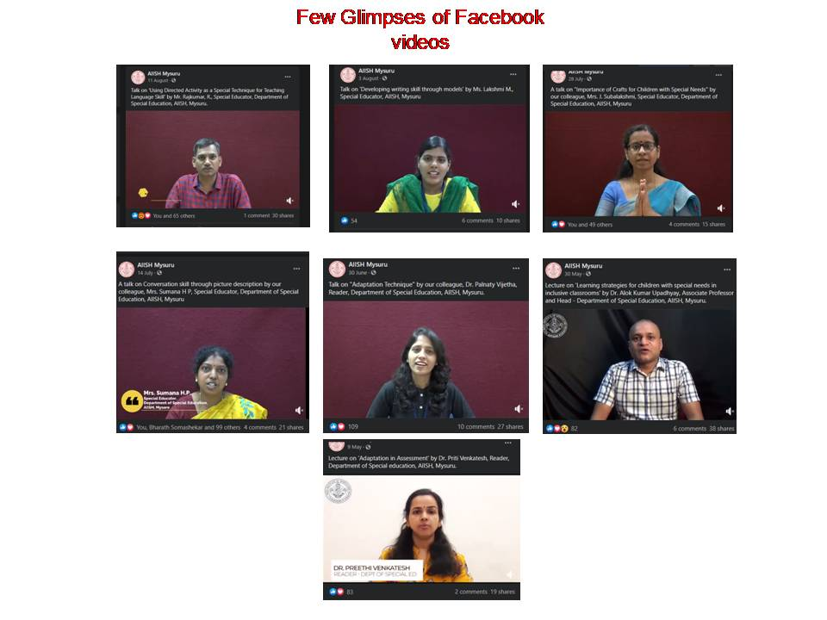**

XIV. MAJOR EVENTS OF THE YEAR

xV. Eminent Visitors

* Dr. Hamsalekha, Music Director visited to Department of Special Education on 25.03.2021.

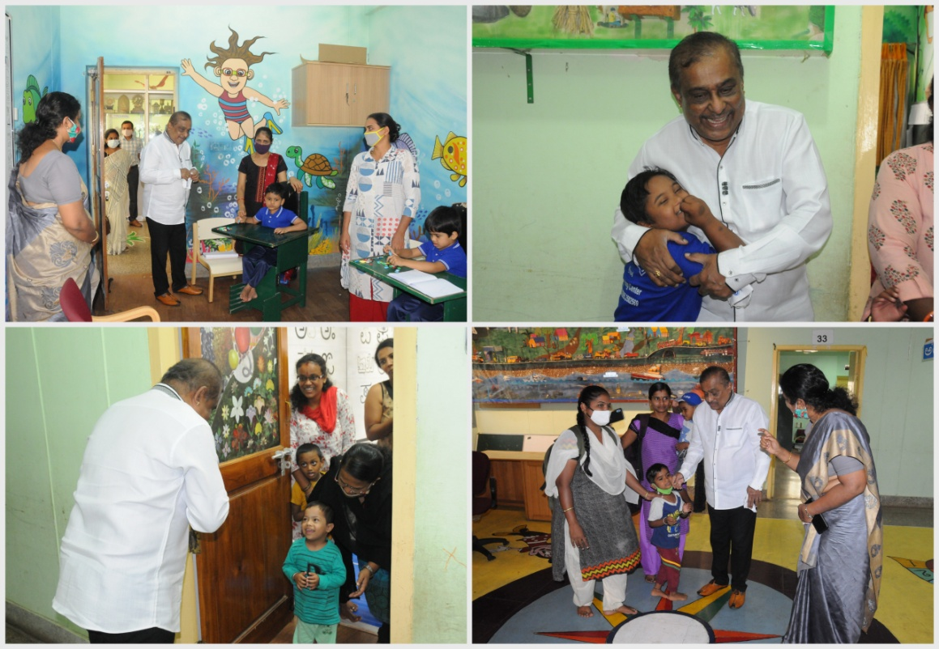

XVI. A**CTIVITIES AND SUPPORTING SERVICES / SPECIAL PROGRAMMES AND ARRANGEMENTS INITIATED DURING THE LOCKDOWN AND POST-LOCKDOWN PERIOD**

International Day of Persons with Disabilities (IDPWD-2020**)** was organized by the Department of Special Education, AIISH, Mysuru on 3rd December 2020. More than 150 children along with their parents and caregivers participated in this online event. This time it was conducted in a very unique way. With the current pandemic situation in mind and also not to miss the opportunity with a chance to show their talents, it was decided to go virtual and organize the event. The whole event was live streamed on AIISH Facebook. This was the first event of this sort in the history of AIISH to go live on social platform. We received an overwhelming response from the participants.

**The other details are as follows:**

Date of the event: 03/12/2020

Mode: Virtual

Total Number of Participants : 172

**Total number views received from of the Program live on Facebook: 36,918**

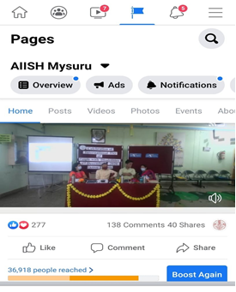

**Few glimpses of the event:**

|  |  |  |
| --- | --- | --- |
|  |  | DSC_1921 |
| DSC_1907 | DSC_1913 | DSC_1943 |
| DSC_1978 |  |  |

Mr. Mukesh, a person with special needs ,our former client and also a National swimmer in Special Olympics was the chief guest. He addressed the gathering by narrating how his weakness turned into strength. This was followed by address by Dr.S Venkatesan, who highlighted on the importance of rehabilitation of persons with special needs and making them contributing members of the society. The programme was followed by various online events conducted for children with Communication Disorders of Preschool training centre. Director Dr.M. Pusphavathi supported and encouraged the entire event and also addressed the gathering by her concluding remarks and stressed the role of AIISH with its state of art facilities with dedicated team of multi rehabilitation professionals in early intervention and rehabilitation of various persons with communication disorder’s into mainstream and urged the public to fully utilize the services rendered at the institute which was striving with the motto of effective communication for one and all.

Any Other (*Please specify*):NIL