**अखिल भारतीय वाक् श्रवण संस्थान, मैसूर – 570 006**

**ALL INDIA INSTITUTE OF SPEECH & HEARING, MYSURU – 570 006**

**DEPARTMENT OF E.N.T.**

**ई. एन. टी. विभाग**

SH/ENT/29/AR2020-21/2021-22 27.04.2021

**वर्ष 2020-21 की वार्षिक रिपोर्ट (01.04.2020 से 31.03.2021 तक)**

**Annual report for the year 2020-21 (From 01.04.2020 to 31.03.2021)**

# ACADEMIC ACTIVITIES

# Short-term Training Programs (*For outsiders*):

# Theme & Objectives : Orientation to Examinations of ENT cases and Discussion of Various Pathologies of Ear / Larynx/ Nose

# Hands on training for procedures like Microscopy, Endoscopy, Stroboscopy, Oto Endoscopy, Clinical Interpretation of Audiology reports. work up for a hearing impaired child and making a treatment protocol.

# H/o taking, in vertigo patients, Observation of ENG/VNG/vemp/HIT procedure. Lecture for Basics of vertigo evaluation.

# Coordinator : Dr. H. Sundara Raju

# Dr. G. Rajeshwari

# Dr. T.K. Prakash

# Target Audience : M.S. ENT (Post Graduates)

# No. of Participants : 06 Students – Year 2020-21

# ENT Post Graduates

|  |  |  |  |  |
| --- | --- | --- | --- | --- |
| Sl. No. | Number of Student | Course | Institute Name, Place | Date |
|  | 03 | Medical students | KIMS, Hubli | 14.12.2020 to 23.12.2020 |
|  | 02 | Medical students | Hassan Institute of Medical Sciences, Hassan | 18.01.2021 to 22.01.2021 |
|  | 01 | Medical students | Belagavi Institute of Medical Sciences, Belagavi | 01.02.2021 to 19.02.2021 |

# ORIENTATION PROGRAM

**Dr. G. Rajeshwari –** Prof. of ENT – conducted orientation program about ***“Guidelines to be followed for the maintenance of personal hygiene & hygienic environment during pandemic crisis”***for Teaching & Non-Teaching Staffs, MTS & House-keeping staffs on 15.05.2020 at Seminar hall, Academic block, AIISH.

**S/N Shakuntala L Gowda demonstrated the procedure of hand wash technique, wearing mask and disposable of mask, wearing and disposable technique of gloves.** for Teaching & Non-Teaching Staffs, MTS & House-keeping staffs on 15.05.2020 at Seminar hall, Academic block, AIISH.

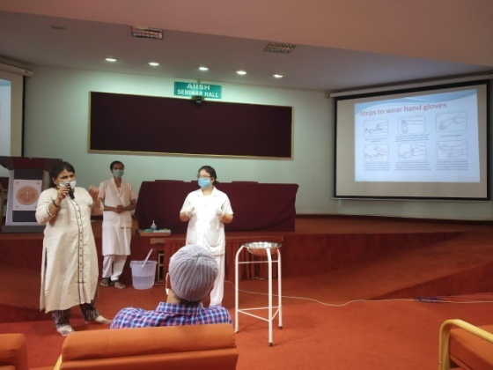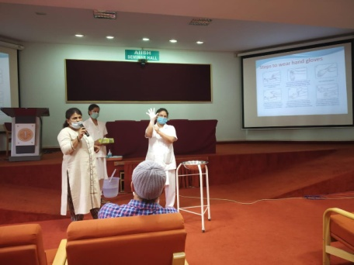

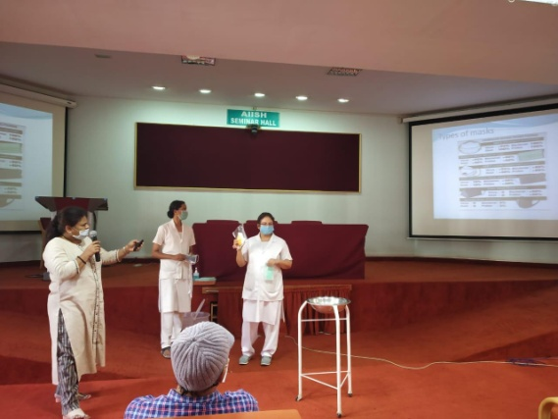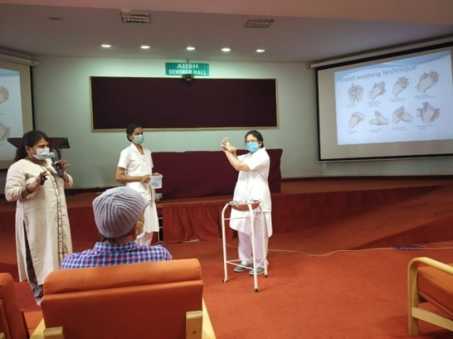

Demonstrated the procedure

# Clinical Observation Posting of Students from Other Institutes.

# No. of students : 15 Students

# Course : Engineering students – Electronics, ENT Surgeon

# Institute : 1. Vidyavardhaka College of Engineering, Mysore 2. Maharaja Institute of Technology, Mysore

# 3. Free lancer

# Date : 1. 18.03.2021 & 31.03.2021

# 2. 31.03.2021

# 3. 11.05.2020 to 24.07.2020

* + 1. **SEMINARS / CONFERENCES / WORKSHOPS CONDUCTED**

1. **Theme / Topic :** Guidelines to be followed for the maintenance of personal hygiene & hygienic environment during pandemic crisis

**Co-ordinator :** Dr. G. Rajeshwari – Prof. of E.N.T.

**Objectives :** To provide guidelines to prevent Corona pandemic during professional services and precautions to be taken during the corona pandemic.

**Target Audience :** Teaching & Non-Teaching Staffs, MTS & House keeping staffs

**No. of participant :** Two batches – 50 participants each.

**Date :** 15.05.2020

1. **Theme / Topic :** National Webinar CME on Sudden Sensori Neural Hearing Loss- Diagnosis and Management.

**Co-ordinator :** Dr. G. Rajeshwari – Prof. of ENT

**Panelist :** Dr. H. Sundara Raju – Prof. of ENT

**Objectives :** To provide protocols for diagnosis investigations and management of sudden Sensorineural hearing loss.

**Target Audience :**  PANINDIA – ENT Surgeons.

**No. of participant :** 300.

**Date :** 30.04.2020

**3. Theme / Topic :** Medical / Surgical management of hearing loss, Microscopic examination, pre-operative assessment, planning and post-operative follow-ups, Case discussion

**Co-ordinator :** Dr. H. Sundara Raju – Prof. of ENT

**Objectives :** To provide guidelines to prevention and management of hearing loss.

**Target Audience :**  For Doctors

**No. of participant :**

**Date :** 3rd to 6th November 2020

**4. Theme / Topic :** Balance Disorders – Evaluation & Management.

**Co-ordinator :** Dr. G. Rajeshwari – Prof. of ENT

**Objectives :** To provide protocols for diagnosis investigations and management of balance disorders.

**Target Audience : PHC Doctors, ENT Specialists.**

**No. of participant :**

**Date : 3rd ,** 4th, 5th & 6th November 2020

Dr. G. Rajeshwari Prof. In ENT, Dr. T. K Prakash, Associate Prof. in E.N.T, Dr. Swathi Chandresh (on Contract) conducted ZOOM online classes for B.Sc. Speech and Hearing and moderated M.Sc. seminar presentation on ZOOM online classes.

**SEMINARS / CONFERENCES / WORKSHOPS ATTENDED**

Mrs. Shakuntala L Gowda, Staff nurse, Has pursued studies and completed all the requirements for management of Corona virus (COVID-19) For Nursing Professionals on 10.04.2020.

Ms. Reena Dsouza, Staff nurse, has pursued studies and completed all the requirements for management of Coronavirus (COVID-19). For Nursing Professionals on 10.04.2020.

On 18.05.2020 & 19.05.2020, **Dr. G. Rajeshwari,** Prof. of ENT **& Dr. H. Sundara Raju,** Prof. of ENT has attended 15th Live International Otolaryngology Network (LION) Broadcast.

On 02nd May 2020 **Dr. G. Rajeshwari**, Prof. & Head of E.N.T. attended Digital CME on Management of BPPV by Dr. Milind V. Kirtane.

On 01st Jul 2020, **Dr. T. K. Prakash**, Associate Professor attended AOI lecture series on Surgical Anatomy of Larynx, Evaluation of Larynx Voice by Dr. Jayakumar Menon.

On 05th Jul 2020, **Dr. T. K. Prakash**, Associate Professor attended webinar by Dr. Sathish Jain, on topic “Almost everything about Stapes with extended discussion”.

NPC Webinar on "IPR- Introduction & Insights of Patent Act" on 24.08.2020 in virtual mode.

**S/N Shakunthala, S/N Reena & Smt. Lalitha S a**ttended on guest lecture to Administrative vigilance” on 29.10.2020 on virtual mode.

## Dr. Rajeshwari attended Webinar on “Scientific Session on Management of Allergic Disorder”. Speaker - Dr. Sowmya N Gosh held on 27.12.2020.

* + 1. **Staff Enrichment/ In-house training Programmes (*For own Staff members*)**

1. **Theme / Topic :** Provided training for bio-medical waste management in view of Corona Pandemic.

**Coordinator :** Mrs. Shakuntala L Gowda

**Objectives :** To provide hands on training

**No. of Participants :** 05 - MTS Staff

**Date :** 15.05.2020

**2. Theme / Topic :** Provided training for preparing and disinfecting of Sodium Hypochlorite solution/powder in view of Corona Pandemic.

**Coordinator :** Mrs. Shakuntala L Gowda

**Objectives :** To provide hands on training

**No. of Participants :** 03 - MTS Staff

**Date :** 18.05.2020

**3. Theme / Topic :** Provided training for Thermal Screening of patients in lieu of Corona Pandemic

**Coordinator :** Mrs. Shakuntala L Gowda

**Objectives :** To provide hands on training

**No. of Participants :** 02 - MTS Staff

**Date :** 18.05.2020.

1. **Theme / Topic :** Auto-clave Procedures

**Coordinator :** Mrs. Shakuntala L Gowda, Staff Nurse

**Objectives :** To provide hands on training

**No. of Participants :** 01 - MTS Staff

**Date :** 06.07.2020

1. **Theme / Topic :** Provided Training In Cleaning The Dept & About Sterilizing The Used Instruments

**Coordinator :** Mrs. Shakuntala L Gowda, Staff Nurse

**Objectives :** To provide hands on training

**No. of Participants :** 01 - MTS Staff

**Date : 06.07.2020**

1. **Theme / Topic :** Provided Training in file maintenance & Entry.

**Coordinator :** Mrs. Shakuntala L Gowda, Staff Nurse

**Objectives :** To provide hands on training

**No. of Participants :** 01 - MTS Staff

**Date :** 03.07 2020

1. **Theme / Topic :** Bio-Medical Waste Management

**Coordinator :** Mrs. Shakuntala L Gowda, Staff Nurse

**Objectives :** To provide hands on training in segregation of Biomedical waste.

**No. of Participants :** 01 - MTS Staff

**Date :** 01.07 2020

1. **Theme / Topic :** Thermal Screening of Patients

**Coordinator :** Mrs. Shakuntala L Gowda, Staff Nurse

**Objectives :** To provide hands on training in use of thermal screener

**No. of Participants :** 01 - MTS Staff

**Date :** 02.07 2020

1. **Theme / Topic :** Provided training on “Covid 19 Screening and First Aid management”

**Coordinator :** Mrs. Shakuntala L Gowda, Staff Nurse

**Objectives :** To provide hands on trainingin history taking for the Covid Pandamic and screening of out patient.

**No. of Participants :** 01

**Date :** 12.08 2020

1. **Theme / Topic :** Provided training on “How to sanitize the case files, usage of formalin tablets & regarding material safety data sheets

**Coordinator :** Mrs. Shakuntala L Gowda, Staff Nurse

**Objectives :** To provide hands on trainingin sanitization of case files and safety measures of data sheets.

**No. of Participants :** 05

**Date :** 12.08 2020

**11. Theme / Topic :** Identification marks for certification

**Coordinator :** S/N Bertila D’Souza

**Objectives :** To identify birth marks and identification marks for certification purpose and recording of the same.

**No. of Participants :**  10 - Staff of ENT Dept

**Date :** 07.10.2020

**12. Theme / Topic :** Facial injuries secondary to RTA

**Coordinator :** Dr. Swathi Chandresh

**Objectives :**  Classification, diagnosis and management of facial injuries.

**No. of Participants :**  9 - ENT Dept.

**Date :** 16.12.2020

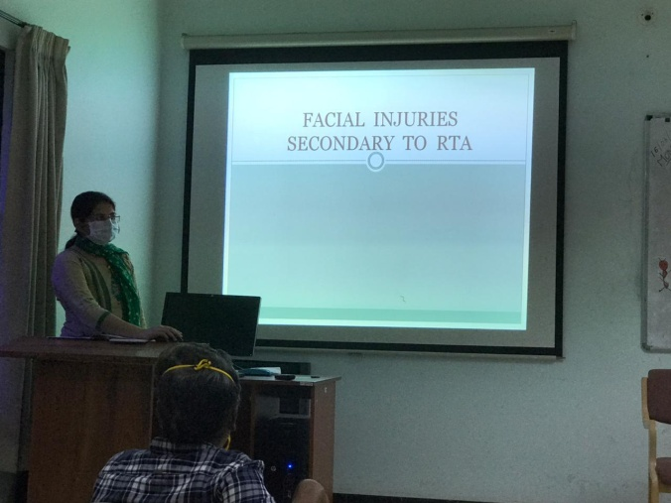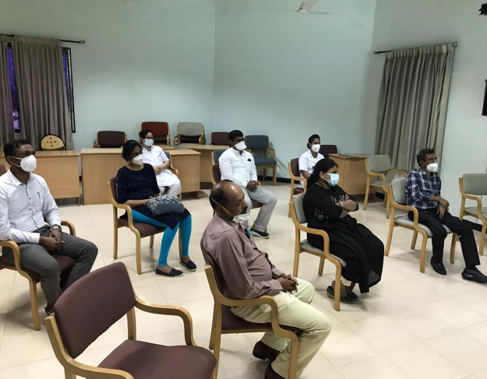

**Staff Enrich Program**

1. **Guest Lectures : Nil**

1. **Additional academic services rendered by the faculty and staff**
2. Invited Talks : Nil
3. Curriculum Development : Nil
4. Development of Materials to Support Learning : Nil
5. Service in Academic bodies of other Organizations : Nil
6. Participation in Committees/ Taskforces and Panel set up by other organizations/ agencies

* Nil –

1. **Any other (Please specify):**

**Dr. T. K. Prakash**, Associate Prof. ENT is the Member – Board of Examiners.

Dr. H. Sundara RajuHeaded COVID-19 SOP Committee as Chairperson on 21.08.2020.

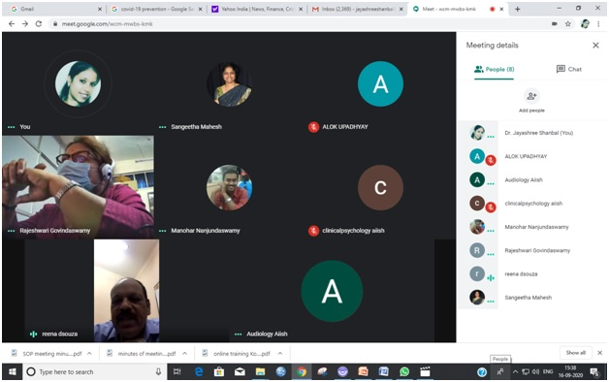

Dr. G. Rajeshwari, Member of COVID-19 - SOP Committee. .

Dr. H. Sundara Raju & Dr. G. Rajeshwari attended meeting on 25.01.21 at 11.00 a.m. regarding made in the prospectus for the year 2021-22 and Entrance Examination process 2021-22.

Dr. H. Sundara Raju Nominated as Dean (Infrastructure, Planning & Support) from September 2020.

Dr. G. Rajeshwari, Chairperson - Internal Grievance Redressal Committee (IGRC) at work place for persons belonging to SC/ST Community from December 2020.

Dr. G. Rajeshwari, AIISH Health Scheme – Member.

Dr. G. Rajeshwari, Nominated as a Nodal Officer – Covishield Vaccination Committee.

Dr. Prakash, Member – Public Grievance Committee.

Dr. Prakash - Chairperson – Professional Voice Clinic.

Dr. Prakash participated as a member of Technical Expert committee team for Demonstration of ENT Equipments under NPPCD on 08.02.2021

1. **RESEARCH ACTIVITIES:**
2. **Extramural Research Projects:**
   1. **Completed in 2020-21 : Nil**

* 1. **New Projects to be initiated in 2020-21 : Nil**

* 1. **Ongoing ; 01**

|  |  |  |  |  |
| --- | --- | --- | --- | --- |
| **Sl. No.** | **Title of the project** | **Duration** | **Funded by** | **Name of the**  **Principal Investigator &**  **Co-Principal Investigator** |
| 1 | Effect of Vestibular impairment and vestibular rehabilitation therapy on cognition and language processing. | Three years | DST Project | **PI :**  Dr. Niraj Kumar Singh  **Co-PI** :  Dr. T. K. Prakash |

1. **Postgraduate Research Completed : Nil**
2. **Postgraduate Research –Ongoing : 01**

|  |  |  |  |
| --- | --- | --- | --- |
| **Name of the thesis** | **Duration** | **Status** | **Guide / Co-guide** |
| A study of Hearing evaluation in high risk neonates using brain stem evoked response audiometry. (MMCRI, Mysuru) | Three years | Ongoing | Dr. G. Rajeshwari  Co-Guide |

1. **Research Papers presented at National/ International : Nil**

**Conferences/ Seminars (*in APA format*)**

1. **Research Papers Published in ( *in APA Format*)**
2. Papers Published in National/ International Journals : 01

|  |  |  |  |
| --- | --- | --- | --- |
| **Sl. No.** | **Name of the Author** | **Title of the Article** | **Name of the Journal & Details** |
| **1** | Prakash Tumkur Kumaraswamy1,  Abhilash Shambulingegowda2*, Devi Neelanmegarajan3 | Effect of canal widening (type I tympanoplasty) on hearing sensitivity. | International Journal of Otorhinolaryngology and Head and Neck Surgery. November 2020. Nov. 6(11):2086-2093. http:/www.ijorl.com. pISSN 2454-5929:eISSN 2454-5937. **DOI**: http://dx.doi.org/10.18203/issn.2454-5929.ijohns20204636. |

1. Papers Published in Conference/ Seminar Proceedings : Nil
2. **Books Published ( *in APA format*) : Nil**
3. **Book chapters Published in (*in APA format*) : Nil**
4. **Books/ Manuals / Seminar Proceedings edited : Nil**
5. **Journal Editorship : Nil**
6. **Scholarly Reviewing Activities**
7. Journal Articles : Nil
8. Conference Papers : Nil
9. Research Projects : Nil
10. **CLINICAL SERVICES:**
11. **GENERAL CLINICAL SERVICES:** 
    1. **Speech and Language Assessment : NA**
    2. **Speech and Language Rehabilitation : NA**
    3. **Hearing Evaluation : NA**
    4. **Hearing Aid Trail : NA**
    5. **Psychological Evaluation : NA**
    6. **Otorhinolaryngology Evaluation**

* The Department of Otorhinolaryngology offers diagnostic services to various ear, nose and throat diseases. On an average about 100 microscopic examinations and 10 endoscopies are done every day. The Department offers diagnostic, therapeutic, surgical treatment to about 200 to 250 patients per day. Minor procedures like suction clearance of ear discharge, Removal of foreign bodies, Removal of wax etc, Chemical Cauterization, Endoscopic evaluation of voice, Evaluation of vertiginous patients on conducting are the main activities of the Department.
* The Department of ENT, AIISH is running a separate unit (AIISH, ENT ‘D’ unit) at K.R Hospital attached to Mysore Medical College.
* OPD on every Thursday.
* O.T. on every Friday.
* Major surgeries, minor surgical procedures and emergency surgeries are done at KR Hospital. Inpatient facilities are being provided at KR Hospital for AIISH patients.
* ENT ‘D’ unit, with 20 bedded facility. Patients at the Institute who need surgery are evaluated and operated at K.R. Hospital.

**STATISTICS**

|  |  |  |
| --- | --- | --- |
| **Total No. of cases seen in the Department of ENT & Clinical Services, AIISH.** | | **Total No. of cases seen in the K.R. Hospital** |
| **New Cases** | **11,472** | **Total No. Cases - 9,960** |
| **Follow up cases** | **12,390** |
| **Total No. of Cases** | **23,862** |

**ANNUAL STATISTICS OF THE DIAGNOSIS – 2020-21**

|  |  |  |  |
| --- | --- | --- | --- |
| **Sl. No.** | **Diagnosis** | **No. of Follow up Cases** | **No. of New cases** |
| 1. | CSOM | 3079 | 1724 |
| 2. | SNHL | 2559 | 1775 |
| 3. | DSL/HL | 679 | 302 |
| 4. | ASOM | 229 | 225 |
| 5. | SOM | 324 | 499 |
| 6. | AOM | 93 | 127 |
| 7. | Otomycosis | 546 | 573 |
| 8. | MR/DSL | 17 | 5 |
| 9. | WAX | 1633 | 1481 |
| 10. | Atresia/Microtia | 33 | 27 |
| 11. | Keratosis Obturans | 16 | 11 |
| 12. | Referred Otalgia | 22 | 40 |
| 13. | Tinnitus | 341 | 412 |
| 14. | Vertigo | 98 | 105 |
| 15. | BPPV | 100 | 87 |
| 16. | Meniere’s Diseases | 86 | 76 |
| 17. | Otitis External  (Furunculosis, Dermatitis) | 328 | 406 |
| 18. | Eustachian Catarrah | 237 | 352 |
| 19. | Otosclerosis | 57 | 23 |
| 20. | Presbyacusis | 624 | 913 |
| 21. | Down’s Syndrome | 23 | 8 |
| 22. | Haematoma Auris / Seroma | 4 | 6 |
| 23. | Screening For Hl | 418 | 703 |
| 24. | Preauricular Sinus | 5 | 9 |
| 25. | Foreign Body Ear | 41 | 126 |
| 26. | Trigeminal Neuralgia | 8 | 10 |
| 27. | Temparo mandibular Joint Arthritis | 51 | 96 |
| 28. | Vascular Headache | 4 | 2 |
| 29. | DSL | 81 | 37 |
| 30. | Cleft Palate | 11 | 17 |
| 31. | Cleft Lip | 4 | 05 |
| 32. | Laryngitis | 14 | 17 |
| 33. | Pharyngitis | 08 | 19 |
| 34. | Ankyloglossia / Tongue Tie | 16 | 22 |
| 35. | V.C. Nodules | 12 | 11 |
| 36. | Puberphonia | 9 | 7 |
| 37. | V.C. Palsy | 17 | 15 |
| 38. | V.C. Polyp | 15 | 11 |
| 39. | V.C. Papilloma | 0 | 0 |
| 40. | Reinkie’s Oedema | 1 | 0 |
| 41. | Carcinoma Larynx | 2 | 3 |
| 42. | Spastic Dysphonia | 5 | 1 |
| 43. | Tonsillitis | 1 | 16 |
| 44. | Palatal Palsy | 0 | 0 |
| 45. | Stuttering | 8 | 6 |
| 46. | Misarticulation | 16 | 27 |
| 47. | Laryngeal Web | 0 | 0 |
| 48. | Apthous Ulcer | 0 | 14 |
| 49. | DNS | 14 | 9 |
| 50. | Allergic RHINITIS | 36 | 44 |
| 51. | Sinusitis | 16 | 18 |
| 52. | Upper-Respiratory Tract Infection | 7 | 9 |
| 53. | Traumatic Tympanic Perforation | 52 | 78 |
| 54. | SSN HL | 80 | 58 |
| 55. | GERD | 23 | 34 |
| 56. | Perichondritis | 144 | 128 |
| 57. | Mastoiditis / Mastoid Abscess | 6 | 4 |
| 58. | Expressive Language Disorder | 2 | 6 |
| 59 | Muscle Tension Dysphonica | 7 | 7 |
| 60 | Atrophic Rhinitis | 2 | 3 |
| 61 | Adhesive Otitis Media | 15 | 4 |
| 62 | Vestibular Neuritis | 9 | 10 |
| 63 | Migraine | 4 | 9 |
| 64 | Autism | 8 | 1 |
| 65 | Speech Evaluation | 21 | 25 |
| 66 | Voice Evaluation | 27 | 50 |
| 67 | Cerebral Palsy | 5 | 3 |
| 68 | Hyperacusis / Misophonia | 0 | 4 |
| 69 | Myringosclerosis/Tympanosclerosis | 1 | 2 |
| 70 | Phonaesthenia | 0 | 2 |
| 71 | Facial palsy | 5 | 4 |
| 72 | Adenoids | 2 | 5 |
| 73 | Auditory Neuropathy | 2 | 1 |
| 74 | Myringitis | 4 | 4 |
| 75 | Miscellaneous | 142 | 461 |
|  | **Total No. of Cases** | **12509** | **11334** |
|  | **Total No. of cases**  **(Follow up case + New cases)** | **23,843** | |

**Total No. of operations done at K.R. Hospital**

|  |  |  |
| --- | --- | --- |
| **No. of**  **Minor Operations**  (Intra tympanic steroid,  Inter tympanic, gentamycin,  Keratosis Obturans, Foreign body) | **No. of**  **Major Operations** | **Emergency cases**  (Epistaxis management, Oral / Nasal Foreign Body Removal,  Road Traffic Accident (RTA)  Abscess drainage. |
| **280 Cases** | **87 Cases** | **192 Cases** |

No. of Microscopic Examination : 3087

No. of Stroboscopy/ Endoscopic Examination : 117

No. of Oto Endoscopy Examination : 25

No. of Diagnostic Naso Endoscopy Examination : 05

No. of Vertigo cases Examination (Special Clinics) : 46

No. of Vertigo Follow up Cases : 424 :

**Ear Moulds : NA**

1. **Hearing Aid Issue and Electro-Acoustic Evaluation : NA**

**(ADIP Scheme, Ministry of Social Justice)**

1. **AIISH Hearing Aid Dispensing Scheme : NA**
2. **Any other ( Please Specify) : Nil**
3. **Specialized Clinical Services**
   1. **Augmentative and Alternative Communication Unit : NA**
   2. **Autism Spectrum Disorder Unit : NA**
   3. **Clinic for Adult and Elderly persons with Language Disorder : NA**
   4. **Dysphagia Unit**

**Dr. T. K. Prakash,** Associate Prof. of ENT is the member of Dysphagia Unit.

* 1. **Fluency Unit : NA**
  2. **Implantable Hearing Devices Unit : NA**
  3. **Learning Disability Clinic : NA**
  4. **Listening Training Unit : NA**
  5. **Neuromotor Speech Disorder Unit : NA**
  6. **Neuropsychology Unit : NA**
  7. **Pre-school Training and Special Education : NA**
  8. **U-SOFA : NA**
  9. **VERTIGO CLINIC**

The department of ENT AIISH, Mysore, provides a compressive care in evaluation and management of patients with Vertigo. The team comprises of ENT Surgeons, Neurologist, Audiologist, and Staff Nurse. The vertigo clinic was started in October 2010. It is run regularly on Wednesdays about 4 patients are evaluated for VNG/VEMP procedures. The beneficiaries are all patients with peripheral and central vertigo. A Total No. of 46patient were evaluated at the clinic and were offered Medical and surgical management as needed. At this clinic the patient are offered the following services:

* + - Microscopic examination of the Ear
    - Vestibular spinal tests
    - Video Nystagmography
    - Neurological evaluation
    - VEMP
    - Medical management
    - Surgery

**Dr. G. Rajeshwari Prof. & HOD – ENT** is Chairperson of Vertigo Clinic from 01.01.2020 onwards.

* 1. **Voice Clinic**

**Dr. T. K. Prakash,** Associate Prof. of ENT is the Member of Voice Care Clinic.

1. **Clinical Support Services to Patients and Family**
   1. **Counseling and Guidance : NA**
   2. **Certificates Issued :**

Handicapped Certificate (Pension) : 690

Railway Concession Certificate : 17

Medical Certificate : 442

* 1. **Financial Aid : NA**
  2. **Legal Advice : NA**

1. **Clinical Electronic Services**
   1. **Electro-Acoustic Evaluation : NA**
   2. **Hearing Aid Dispensing : NA**
   3. **Repair of Hearing Aids : NA**
2. **Extension Activities**
3. **Rehabilitation and Education through distance mode : NA**
4. **Prevention of communication Disorders : NA**
5. **Communication disorders screening Camps**

|  |  |  |  |  |
| --- | --- | --- | --- | --- |
| **Sl. No.** | **Camp attended by the Doctor** | **Camp Place** | **Date** | **No. of Beneficiaries** |
| 1 | Dr. Swathi Chandresh- Lecturer in ENT (Contract) | Varuna, Mysore  World Hearing Day 2021 | 05.02.2021 | 177 |
| 2 | Dr. Laxmi Purushothama  (On Contract)  S/N Shakuntala L Gowda | AIISH.  World Hearing Day 2021 | 28th Feb. 2021 | 18 |
| 3 | Dr. Laxmi Purushothama  (On Contract)  S/N Bertila D’Souza | AIISH.  World Hearing Day 2021 | 28th Feb. 2021 | 77 |
| 4 | Dr. Swathi Chandresh-  Lecturer in ENT (Contract)  Ms. Bertilla D’Souza  - Staff Nurse (Contract) | Bharuch, Gujarat | 21.03.2021 to 23.03.2021 | 105 |
| 5 | Dr. Swathi Chandresh-  Lecturer in ENT  (Contract)  S/N Reena D’Souza | AIISH.  World Hearing Day 2021 | 21.04.2021 | 41 |

1. **Orientation Programs : Nil**
2. **Public Lecture Series : NA**
3. **TECHNOLOGICAL CONSULTANCY SERVICES : Nil**
4. **CENTRAL FACILITIES**
5. **Library and Information Services : Nil**
6. **Public Information Activities**
   1. **Major Events of the Year with a brief account : Nil**
   2. **Press Release and Media Coverage : Nil**
   3. **Institute Publications : Nil**
7. **Material Development : Nil**
8. **PLACEMENT CELL ACTIVITIES : Nil**
9. **AWARDS AND HONORS RECEIVED BY :**

**FACULTY AND STAFF**

* + Dr. H. Sundara Raju Felicitated one of the Corona Warrior’s on 01.11.2020.
  + Mrs. Shakunthala participated in Hindi competition in virtual mode of Hindi Saptaahik Day.& was awarded two prizes.
  + Dr. G. Rajeshwari was honored and awarded as one of the women achievers for her contribution in the field of medical sciences on the eve of International Women's Day organized by the Nehru Yuva Kendra, Mysuru, Chamundeshwari Swasahaya Sangha (Reg.), Mysuru, Shree Samrudhi Swasahaya Sangha, Mysuru, Shree Annapoornmeshwari Swasahaya Sangha, Mysuru, Shree Bhuvaneshwari Mahila Swasahaya Sangha, Mysuru, Shree Mahalakshmi Swasahaya Sangha, Mysuru & Department of Health and Family Welfare, Mysuru, Shree Talakaveri Mahila Vidya Samsthe, Mysuru on 08.03.2021.. .

1. **EXTRA CURRICULAR ACTIVITIES**
2. **AIISH Gymkhana : Nil**
3. **NSS : Nil**
4. **Others**

On 21.05.2020, Teaching & Non-Teaching Staffs, MTS, Housekeeping Staffs of ENT Department, has taken Anti-Terrorism Pledge. [Anti-Terrorism Pledge Photos](https://drive.google.com/drive/folders/169SMDbMTreGYMlOoFhE0SlO32s9fFh1d?usp=sharing)

1. **ISO CELL ACTIVITIES :**
2. **PEER EVALUATION :**

Dr. G. Rajeshwari presented Department Peer Evaluation on 09.09.2020 through virtual mode.

1. **RESEARCH CO-ORDINATION : Nil**
2. **SOCIAL MEDIA ACTIVITIES : Yes**

* On 26th June 2020, **Dr. G. Rajeshwari**, Prof. & HOD of ENT addressed general public, a Health Awareness Program through Radio FM 93.5 under topic **“All Cold, Cough, Fever-may not be Covid-19’’.**
* Dr. G. Rajeshwari gave a video talk on External Ear Care”” on AIISH Mysore Facebook page.
* Dr. T.K. Prakash gave a video talk on “Voice and its problem” on AIISH Mysore Facebook page.
* On 21st Jul 2020, **Dr. G. Rajeshwari**, Professor and Head of ENT, delivered a Video talk on “How to Build Good Immunity, During the Pandemic” for AIISH Mysuru FB Page.
* Dr. Rajeshwari, gave a talk on “***Prevention of Common Cold and Self Medication’’*** for common public, and does and don't” in common cold on 16.08.2020 on Radio FM 93.5.
* Dr. T.K. Prakash AIISH Aisiri Radio talk given on “ಧ್ವನಿ ಬದಲಾವಣೆಗೆ ಕಾರಣವಾಗುವ ಕಾಯಿಲೆಗಳು” on 23.08.2020.
* Dr. Rajeshwari, gave a talk on “***Prevention of Common Cold and Self Medication’’*** for common public, and does and don't” in common cold on 16.08.2020 on Radio FM 93.5.
* Dr. G. Rajeshwari AIISH Aisiri Radio talk given on “Ear related problems in Children on 29.07.2020.

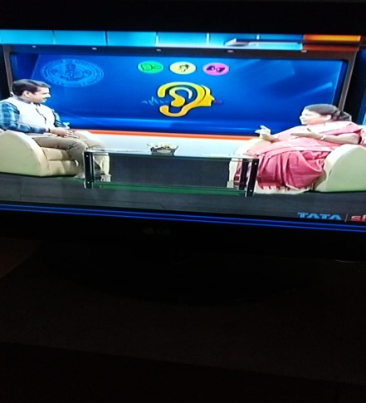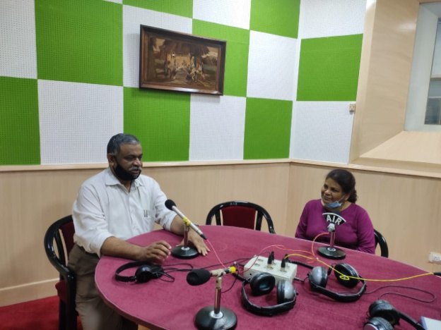

* Dr. Rajeshwari G, Attended to the DD Chandana programon **“Ear related problems in children**” heldon 21.10.2020 at Bengaluru.
* 15 questions prepared in bilingual (English & Kannada) on “Ear related problems in children” for DD Chandana program.

* Dr. T.K. Prakash Phone in program as a part of World Hearing Day 2021 held on 22.01.2021 title “Middle ear infections its consequences”.

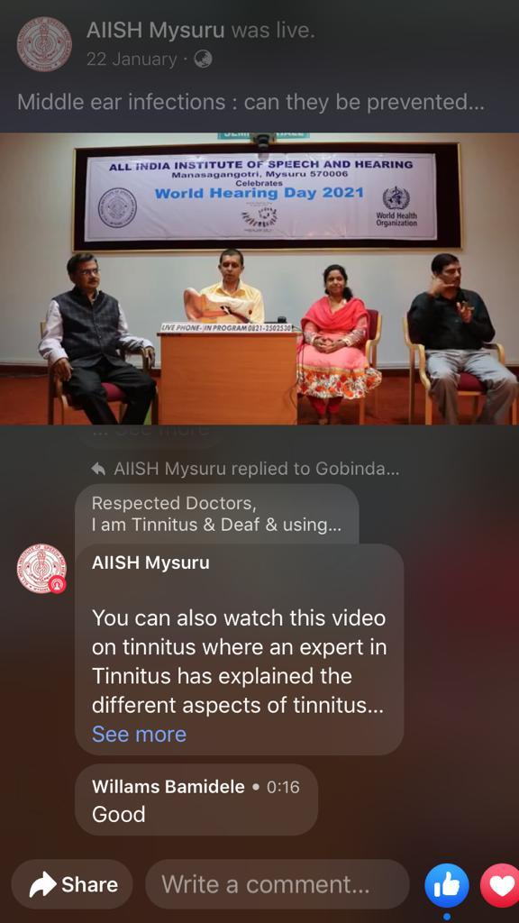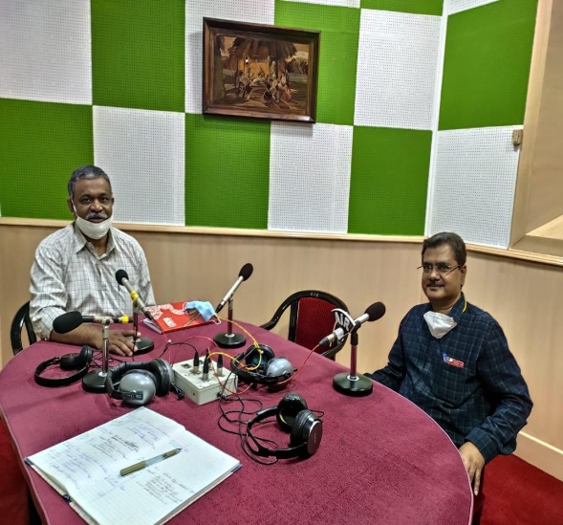

* Dr. G. Rajeshwari participated live phone in program for World Hearing Day 2021 and answered quires of public regarding Ear problems”.
* Dr. Laxmi Purushothama – Served as a Resource persons for sponsored programme on Doordarshan Kendras of South Zone “Ear related problems in children” for World Hearing Day 2021.

1. **MAJOR EVENTS OF THE YEAR : Nil**
2. **EMINENT VISITORS : Nil**
3. **ACTIVITIES AND SUPPRTING SERVICES / SPECIAL PROGRAMS & ARAGENEMNTS INITIATED DURING THE LOCKDOWN & POST-LOCKDOWN PERIOD.**

# In May 2020 after the corona pandemic lockdown, the clinical services resume from 18.05.2020 the clinical services were resumed for patients at the ENT department, and all the other departments provided their services at the ENT Department for a month. As a part of SOP guide lines.

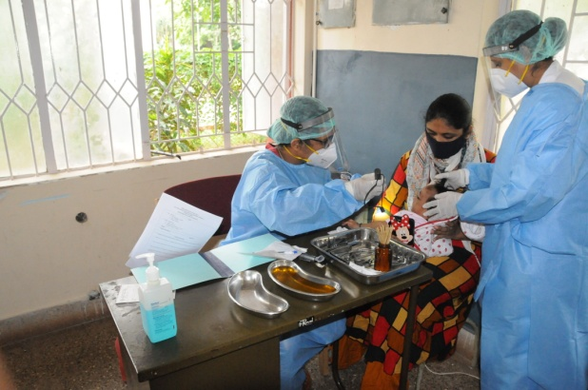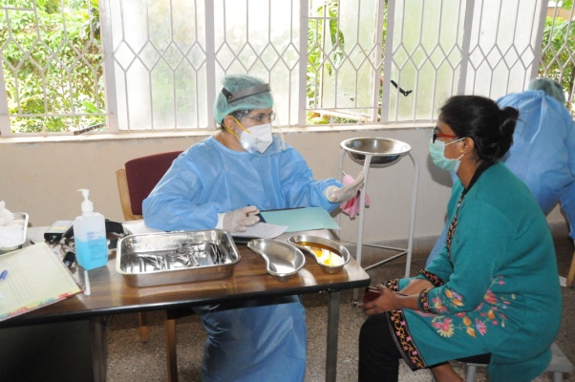

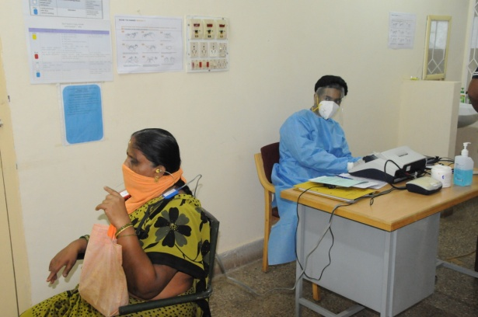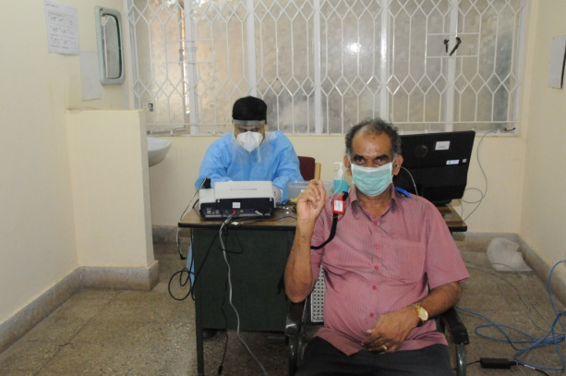

**Clinical services resume**

* + - 1. Department of ENT setup of Emergency Day Care Centre in AIISH Guest House for staffs and students.

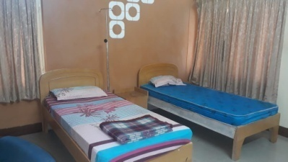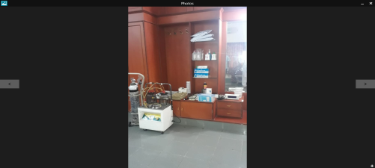

**Vaccination Drive**

* + - 1. Prepared database registry for Covid 19 vaccination for institute beneficiaries as per orders from Ministry of Health and Family Welfare,. Govt. of India. Delhi.
      2. Dr. G. Rajeshwari, Nodal Officer - Covishield drive vaccination centre (AEFI) (1st dose)for three days from 27.01.2021 to 29.01.2021.
      3. Three teams of five members each were constituted, and members received hands on training and orientation about the Covid Vaccination Drive at the District Health Officer, Mysuru and the First vaccination Drive was held on 27th January 2020 to 29th January 2020.
      4. The second dose of vaccination Drive was held on 24th to 26th February 2020. About 600 beneficiaries were vaccinated.

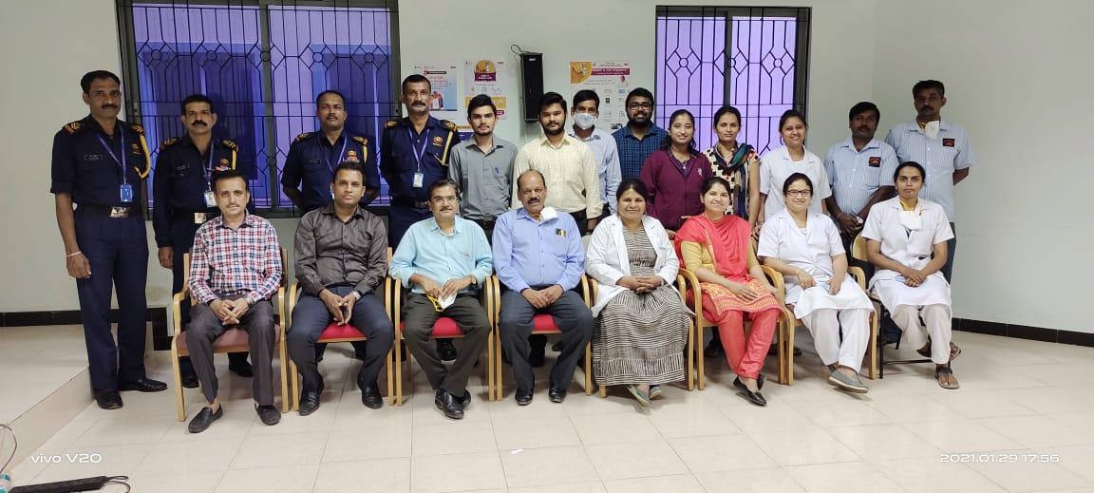

**Covid Vaccination Team**

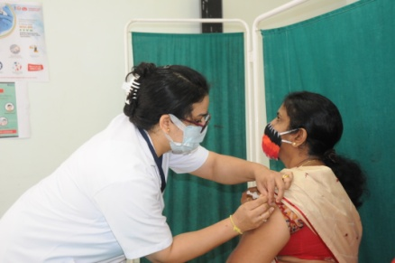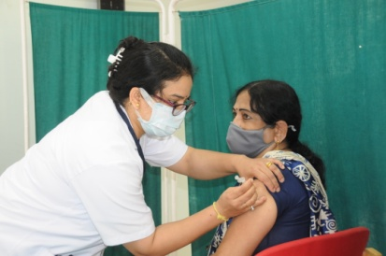

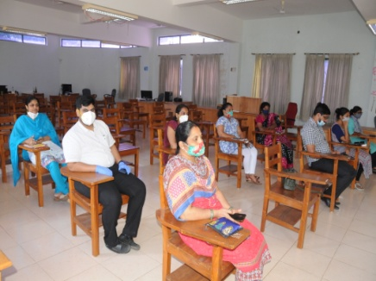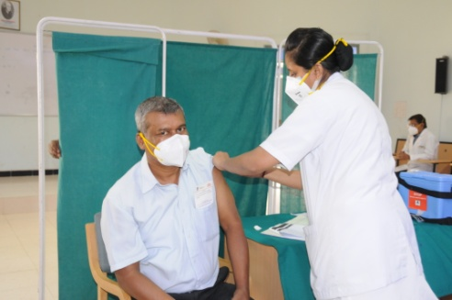

* + - 1. To commemorate World Hearing Day 2021 the Department of ENT offered out patient services to Pediatric, adult and Geriatric population on 14th , 21st & 28th (Sundays) February 2021 respectively**.**

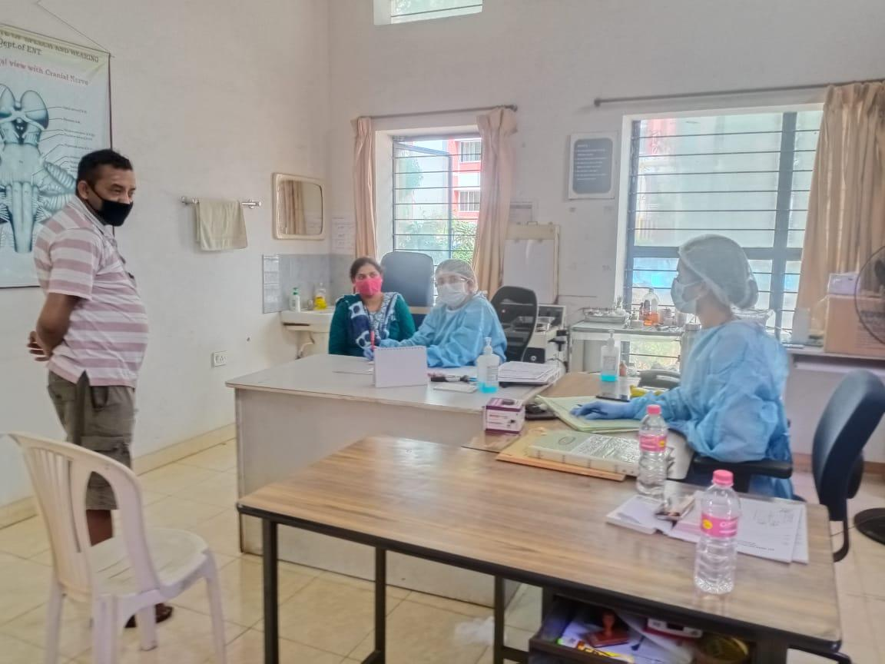

1. **ANY OTHER (*Please specify*):**

Dr. G. Rajeshwari attended virtual meeting regarding RE-BE on 13.08.2020

Dr. G. Rajeshwari attended Virtual meeting regarding “Impediments of Sexual prosecutions” at the place of work” on 27.08.2020.

# Sent information Suo-Moto disclosure under RTI- Act- updated the official website regarding in September 2020.

On 21.05.2020, Teaching & Non-Teaching Staffs, MTS, Housekeeping Staffs of ENT Department, has taken Anti-Terrorism Pledge. [Anti-Terrorism Pledge Photos](https://drive.google.com/drive/folders/169SMDbMTreGYMlOoFhE0SlO32s9fFh1d?usp=sharing)

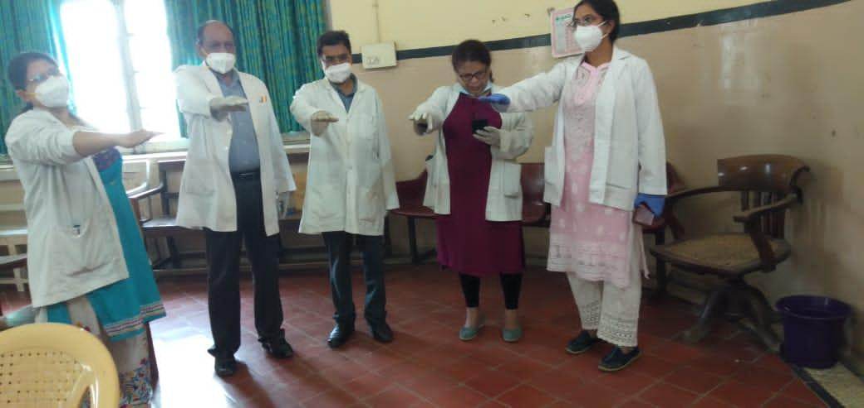

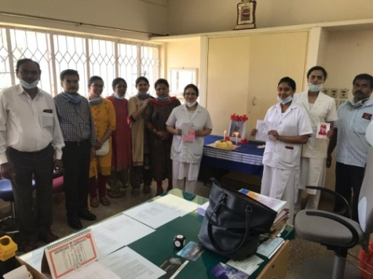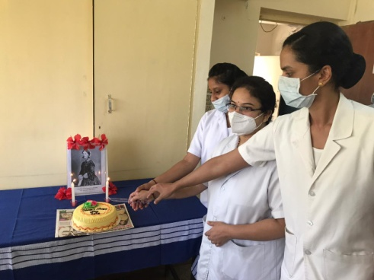

On 12.05.2020, Nurses Day was celebrated at the department of ENT by the staff of the department.

Staff of ENT have taken pledge for Vigilance Awareness week on 26.11.2020.

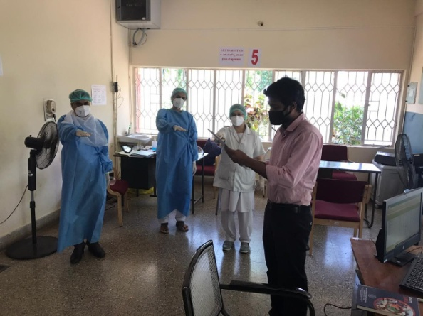

Department staff Celebrated constitution day on 26.11.2020 at 11 a.m. reading the preamble with Hon’ble Prime Minister on virtual mode.

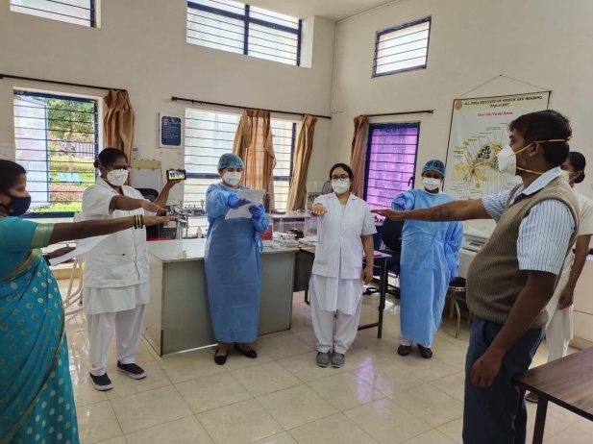

Dr. G. Rajeshwari attended Purchase Committee Meeting on 22.12.2020 on virtual mode.

Dr. G. Rajeshwari attended the condemnation committee meeting held on 18.01.2021.

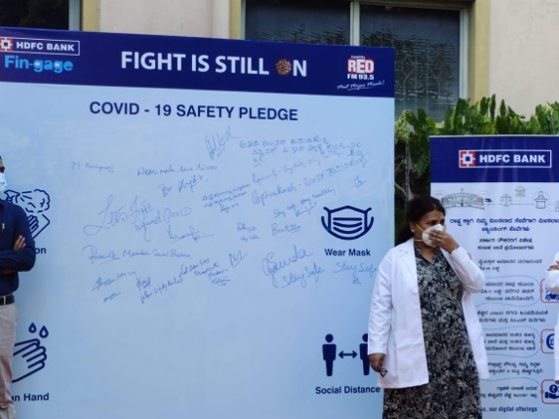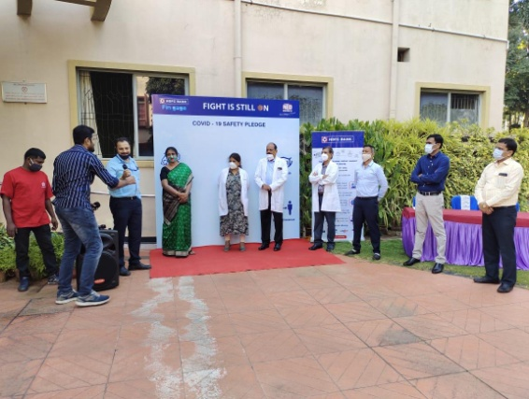

Staff of ENT attended Covid 19 awareness Programme organized by 93.5 FM and took pledge to follow Covid 19 appropriate behavior.

**Official Language Implementation**

* 1. The rubber stamps are made in bilingual form - 5 Nos.
  2. All the name plates are in bilingual form.
  3. The Display boards/ Sign boards are in trilingual form.
  4. Attendance register maintained in bilingual form.
  5. Word of the day displayed in trilingual form.
  6. Sending OLI quarterly report to OLIC section.
  7. Website updating material prepared in bilingual form.
  8. No. of Hindi cases seen / examined: 1112
  9. Letters and emails:

|  |  |  |  |  |  |  |  |  |  |
| --- | --- | --- | --- | --- | --- | --- | --- | --- | --- |
| **क्र.सं**  **Sl. No.** | **हिंदी / द्विभाषी में**  **In Hindi / Bilingual form** | | | | **अंग्रेज़ी में**  **In English** | | | | **भेजे गए कुलपत्र सं./  Total letters sent** |
| **Letters** | **E-mail** | **Fax** | **Total** | **Letters** | **E-mail** | **Fax** | **Total** |
| 1 | 5 | 9 | 0 | 14 | 53 | 112 | 0 | 165 | 179 |

Thank you,

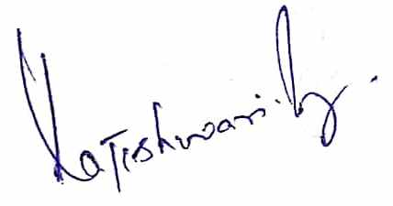

डॉ जी राजेश्वरी / Dr. G.Rajeshwari

प्राध्यापक और विभागाध्यक्ष -ई.ए.नटी.

Prof. & H.O.D.-E.N.T.