DEPARTMENT OF MATERIAL DEVELOPMENT

ANNUAL REPORT 2020-21

(Period of Coverage; 1st April 2020 – 31st March 2021)

The main aim of the Department is to develop material for the general public as well as for professionals regarding prevention, identification and management of various communication disorders. In addition, the Department also develops public education material regarding the various rights and welfare measures available for individuals with communication disorders. To disseminate the information to individuals from different linguistic backgrounds, material is developed in different Indian languages. The material development is usually done by collecting information from the core departments, through workshops or from other sources. The material is developed in such a way that dissemination of information can be done through various modes such as mouth, orientation, street plays, pamphlets, booklets, books, murals, video and radio etc., The department also duplicates the available test and therapy and training material in the form of video for individuals with communication disorders and other stakeholders.

- ACADEMIC ACTIVITIES
C) Seminars/ Conferences/ Workshops/ Training Programs : NIL
- Theme/ Topic
- Coordinator
- Objectives
- Number of Participants

VI C. Material Development:

Material development during 1st April, 2020 to 31st March 2021

Sl.No. | Material | No. of Print/ photos/ pages/ minutes
1 | Photo coverage | No. of Events | No. of photos
1 | Photo coverage | 35 | 1280
2 | Video coverage | No. of Events | No. of Minutes
2 | Video coverage | 10 | 282
3 | Printing & Photocopying (A4 & A3 size) | 28801
4 | Scanning | 148
5 | Material designed/ edited | No. of designs | No. of pages/ editing
 |  | 132 | 529
6 | Content development/ modifications & translation with typing  Kannada –  English –  Hindi – | 423  54  24
STATISTICAL REPRESNTATION OF THE WORK DONE

PRINTING, PHOTOCOPYING & SCANNING
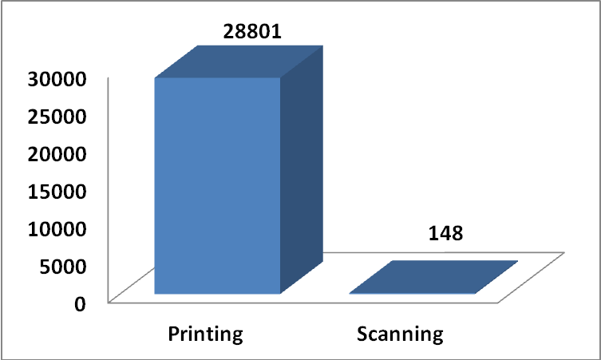

PHOTOGRAPHY & VIDEOGRAPHY
The moments of all major events held at the Institute like national and international level workshops, conferences, seminars and other cultural activities are captured by the Department staff. It also involves video recording of the events and clinical training carried out at the Institute.
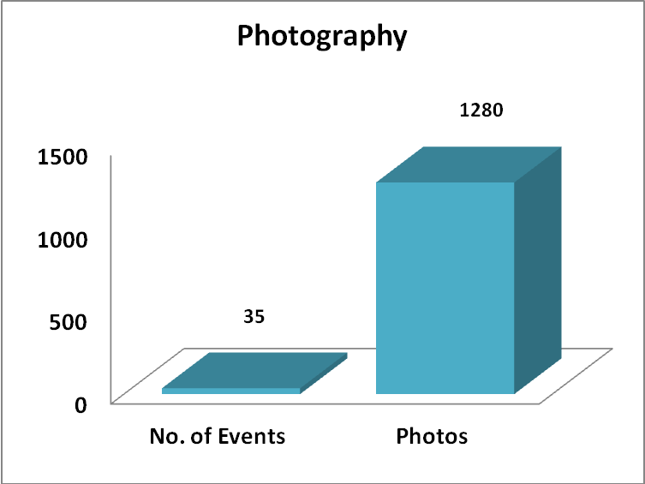

DESIGNING
Designing of public education material to create awareness about communication disorders, publication and training material for conferences, workshops, seminars organized at the Institute is also a major activity of the Department. This includes designing of brochures, pamphlets, posters, books, booklets, invitation cards, certificates, annual reports, CD stickers, handbills, etc.

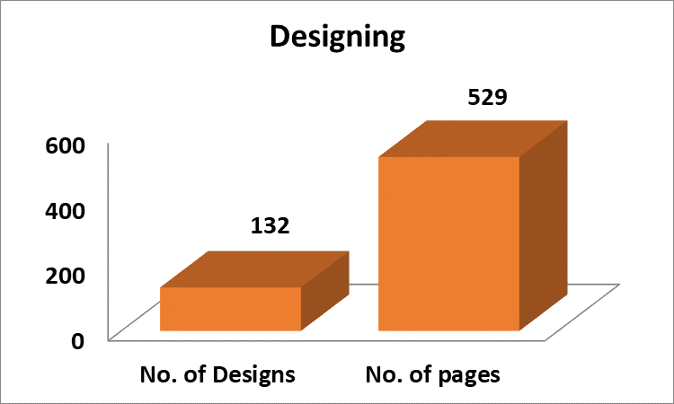

CONTENT DEVELOPMENT/ MODIFICATIONS & TRANSLATION WITH TYPING

Public Education Material, which is one of the most effective modes in creating awareness among general public, is also developed by this Department. Department assists in brainstorming, providing literature for different formats such as street plays, books, posters, training materials, radio programs, dramas and others; bridging the gap between experts and the audience through the effective and creative scripts. In order to disseminate the necessary information on communication disorders to individuals from different linguistic backgrounds, developed training materials, Public Education Pamphlets and other content of different formats are also translated in different Indian languages.

XV. ANY OTHER (Please specify)
Ms. Nithyashree R, Junior Technical Writer
- Served as Nodal officer for official language Hindi for the year 2020-21
- Served as member of the committee formed for the ‘Translation and
Verification of WHO Educational material’.

Mr. Manikantaswamy, Graphic Designer
- Served as coordinated with Desi Adda team for the Institute Video Shoot
between 01.07.2020 and 06.07.2020.

XV. Other Activities
Mass Media based Public Education:

- Coordinated for recording, compiling and editing of Public Education videos of Staff of the Institute to upload on Social Media Platform

- Coordinated for recording and editing of videos on the activities of the Dept. of Clinical Services, ENT and Audiology.

- Slogans were developed related to Covid 19 appropriate behavior for digital display and the same were used for posters to create awareness among the general public.

Equipments added to the department during the reporting year:
- Laptop –Acer was received on 22.09.2020.
- External Hard Disk were received on 6.01.2021.
3. HP Intel Core i7 Computers were received on 24.03.2021.

विभागाध्यक्ष – सामग्री विकास
HOD - Material Development

