OUTREACH SERVICES
The institute carries out various outreach services on communication and its disorders in different parts of the country. The major outreach services carried out during the reporting year are given below.
Communication Disorder Screening Programmes
The Institute conducted screening programmes for communication disorders in different settings and localities. The individuals participating in the programmes were checked for speech, language and hearing abilities and provided with diagnostic and therapeutic services.
New-born /Infant Screening
This programme focuses on screening neonates and infants who are at risk for communication disorders using various tools such as High Risk Register for communication disorders, Behavioral Observation Audiometry, Oto Acoustic Emission Screening and Screening Checklists.
During the reporting year, screening programme was carried out at 15 hospitals and two immunization centres in Mysore, seven Outreach Service Centres of the Institute functioning in different parts of Karnataka and eight Newborn Screening Centres functioning in hospitals attached with the AIISH DHLS centres at Sri Ramachandra Bhanj Medical College and Hospital (SCB MCH), Cuttack, Regional Institute of Medical Sciences (RIMS), Imphal, Janana Hospital & JLNMCH, Ajmer, JIPMER, Puducherry, Netaji Subhash Chandra Bose Medical College (NSCB), Jabalpur, Rajendra Institute of Medical Sciences,Ranchi, King George's Medical University (KGMU), Lucknow and Jawahar Lal Nehru Medical College and Hospital (JLNMCH), Bhagalpur and a total of 57842 newborns were screened. Of these, 5115 babies were at risk for communication disorders. The details are given in table 1.

Table 1: Total number of newborns/infants screened and identified at-risk for communication disorders
Sl.No. | Hospitals/Immunization Centers | Total births | Total No. Screened |  |  | Total No. at risk
Sl.No. | Hospitals/Immunization Centers | Total births | Male | Female | Total | Male | Female | Total
 |  | AIISH- Mysuru
 | Basappa Memorial Hospital | 1 | 0 | 0 | 0 | 0 | 0 | 0
 | Combined Hospital | 326+ | 133 | 140 | 273 | 6 | 5 | 11
 | Kamakshi Hospital | 1406 | 643 | 540 | 1183 | 8 | 13 | 21
 | KR Hospital | 8271 | 3680 | 3608 | 7318 | 112 | 109 | 221
 | Mission Hospital | 457 | 247 | 223 | 470 | 24 | 19 | 43
 | N.P.C Hospital | 116+ | 21 | 21 | 42 | 0 | 0 | 0
 | S.M.T.D.H Hospital | 483 | 213 | 196 | 409 | 3 | 4 | 7
 | Railway Hospital | 25+ | 11 | 10 | 21 | 0 | 0 | 0
 | ESI Hospital | 3+ | 1 | 1 | 2 | 0 | 0 | 0
 | Ashwini Nursing Home | 171 | 86 | 97 | 183 | 1 | 4 | 5
 | Shree Devi Nursing Home | 239 | 85 | 69 | 154 | 1 | 2 | 3
 | Gopala Gowda Shanthaveri Memorial Hospital | 151 | 56 | 58 | 114 | 2 | 1 | 3
 | Mahadeshwara Nursing Home | 304 | 92 | 79 | 171 | 1 | 0 | 1
 | Sigma Hospital | 355 | 260 | 220 | 480 | 8 | 6 | 15
 | Brindavan Hospital | 373 | 97 | 73 | 170 | 14 | 3 | 17
16 | Makkalakoota Immunization Center | NA | 36 | 29 | 65 | 0 | 1 | 1
17 | Immunization Center, Mission Hospital | NA | 15 | 6 | 21 | 2 | 0 | 2
 | Total | 12681 | 5676 | 5370 | 11046 | 182 | 167 | 349
Outreach Service Centres
 | Sub-divisional hospital, K R Nagar Taluk | 1445 | 199 | 238 | 437 | 5 | 3 | 8
 | Sub-divisional hospital, T NarsipuraTaluk | 651 | 122 | 99 | 221 | 1 | 1 | 2
 | Sub-divisional Hospital, Sagara Taluk | 1589 | 709 | 672 | 1453 | 35 | 40 | 75
 | Vivekananda Memorial Hospital, Sarguru | 3292 | 1694 | 1491 | 1329 | 135 | 90 | 225
 | Immunization Centre, Vivekananda Memorial Hospital, Sarguru | NA | 112 | 103 | 215 | 2 | 2 | 4
 | Community Health Centre, Hullahalli | 115 | 72 | 69 | 121 | 3 | 4 | 7
 | Community Health Centre, Santhemarahalli | 150 | 34 | 32 | 66 | 0 | 0 | 0
 | Primary Health Centre, Akkihebbalu | 37 | 24 | 20 | 44 | 3 | 0 | 3
 | Total | 7279 | 2966 | 2724 | 3886 | 184 | 140 | 324
Newborn Screening (NBS) Centres
 | Sri Ramachandra Bhanj Medical College and Hospital, Cuttack | 3929 | 1906 | 1046 | 2773 | 222 | 123 | 345
 | Regional Institute of Medical Sciences, Imphal | 3906 | 1944 | 1908 | 3860 | 77 | 81 | 125
 | Janana Hospital & JLNMCH, Ajmer | 10531 | 3884 | 3617 | 7501 | 432 | 250 | 682
 | JIPMER, Puducherry | 15914 | 6893 | 6327 | 13220 | 492 | 250 | 839
 | Netaji Subhash Chandra Bose Medical College (NSCB), Jabalpur | 1928+ | 2801 | 2356 | 5157 | 817 | 590 | 1407
 | Rajendra Institute of Medical Sciences, Baritayu, Ranchi | 6289 | 2326 | 2127 | 4353 | 288 | 224 | 512
 | KGMU, Lucknow | NA | 1866 | 1543 | 3472 | 212 | 159 | 371
 | JLNMCH, Bhagalpur | 542 | 205 | 193 | 398 | 72 | 40 | 112
 | Total | 43552 | 21960 | 19146 | 41011 | 2629 | 1813 | 4442
 | Overall Total | 63512 | 30602 | 27240 | 57842 | 2995 | 2120 | 5115

The new-borns/infants referred during the new-born screening were followed up through telephone calls to parents/caregivers and advised for detailed evaluation at the Department of Clinical Services at AIISH, Mysore or at the NBS centers /OSCs. A complete test battery was administered for those clients who came for follow-up.The details are given in table 2.
Table 2 : Follow-up Evaluation for Newborns and Infants
Category | Mysore | Ajmer | OSC Sagara | Cuttack | Imphal | Puducherry | Ranchi | Jabalpur | Lucknow | Total
Clinically Normal | 65 | 13 | 158 | 54 | 110 | 349 | 7 | 15 | 153 | 924
ENT disorders | 0 | 0 | 0 | 1 | 23 | 0 | 42 | 1 | 11 | 78
Auditory maturation delay | 0 | 0 | 3 | 2 | 2 | 0 | 0 | 0 | 0 | 07
Hearing disorder | 6 | 17 | 6 | 75 | 25 | 60 | 30 | 17 | 69 | 305
Speech and language disorders | 0 | 3 | 2 | 0 | 45 | 21 | 57 | 6 | 5 | 139
Multiple disorders | 0 | 0 | 1 | 5 | 2 | 1 | 7 | 7 | 17 | 40
Incomplete Testing | 9 | 106 | 15 | 0 | 0 | 45 | 5 | 2 | 0 | 182
Total | 80 | 139 | 185 | 137 | 207 | 476 | 148 | 48 | 255 | 1675

Employee Screening
The Institute also conducts communication disorder screening for the Industrial workers and employees of other occupation who are repeatedly exposed to loud noises at their work settings.
During the reporting year, 21 employees working with the Bannari Industry, Nanjangud were screened for hearing loss and 18 (ears) were found with hearing loss and 24 normal. Those with hearing impairment were advised for detailed evaluation at AIISH. The employees and employerwere also oriented on harmful effects of noise on hearing, importance of hearing conservation program and also use of hearing protective devices in noisy areas.

In addition, the industrial workers and employees of other occupation who are exposed to loud noises were encouraged to undergo hearing evaluation at the Institute outpatient unit. Totally, 304 employees working with Triton Valves Ltd, Mysore, traffic police, Karnataka state transport corporation, railway, Suruchi Khadi and Gramodyoga Sangha, Nanjangudand Indus Granitesavailed clinical service at the Institute during the reporting year and 40 ears tested had hearing impairment. The details of employee screening are given in table 3.

Table 3: Employee Screening

Month | Organization | No. of  Clients | Ears identified with Hearing Impairment | Individuals with normal ears | Individuals ears identified with ENT disorders
19.09.2018 | Traffic Police,  K.S.R.T.C, Railway | 105 | 32 | 172 | 6
21.01.2019 | Suruchi Khadi & Gramodyoga Sangha,  Nanjangud | 34 | 08 | 45 | 15
21.01.2019 | Indus Granites | 11 | 0 | 20 | 02
24.01.2019 | Triton Valves Ltd,  Mysore | 154 | 84 | 222 | 2
Total |  | 304 | 40 | 459 | 25

Student Screening
Nursery and primary school students from 60 schools in Mysuru and Mandya were screened for communication disorders as a part of the school screening programme during the reporting year. Totally, 4076 students were screened and among them 91 (2.23%) were identified with ear-related disorders, 76 (1.86%) with hearing loss and 184 (4.51%) with speech-language disorders. They were recommended for follow-up at the Institute.
Elderly Screening
Speech, language and hearing evaluations were carried out for elderly citizens residing in different old age homes in Mysuru. Totally, 145 elderly citizens were screened and among them 60 were identified with ear-related disorders, 106 had hearing loss, and 14 were identified with speech-language disorders. Also, hearing aids were distributed among 4 elderly persons with hearing impairment.
Camp-based Screening
The Institute organized three camps in various localities across Karnataka during the reporting year. The expert speech, hearing and allied health professionals of the institute screened 528 persons for communication disorders in the camps. The details are given in table 4.
Table 4: Camp-based Screening
Date | Name of the Place | Total Registered | Total identified with communication disorders |  |  | No of Hearing aid issued | Psychology
Date | Name of the Place | Total Registered | Ear related disorder (ears) | Hearing loss (ears) | Speech language disorders | No of Hearing aid issued | Psychology
28.06.2018 | Hospet, Bellary District and organized by Rotary Club, Hospet. | 271 | 49 | 140 | 56 | 99 | 26
02.02.2019 | Chamrajnagara Camp-Seva Bharathi Trust Public School | 130 | 60 | 26 | 14 | - | -
03.02.2019 | Chamrajnagara Camp-Seva Bharathi Trust Public School | 33 | 38 | 48 | 4 | - | -
22.02.2019 | Kumbh Mega Health Mela-Buxar, Bihar | 39 | 15 | 12 | 1 | 4 | -
23.02.2019 | Kumbh Mega Health Mela-Buxar, Bihar | 55 | 9 | 36 | 2 | 44 | -
31.12.2018 | Sargur (Paediatric camp) | 101 | 05 | 04 | 04 | - | -
14.01.2019 | Pediatric camp- Annur | 58 | 03 | - | 02 | - | -
19.02.2019 | Bheemanahalli,HD kote (Paediatric camp) | 53 | 01 | 00 | 02 | - | -
14.03.2019 | Udburu | 08 | 03 | 04 | 03 | - | -
21.03.2019 | Talakadu-Community Camp | 09 | - | 18 | - | - | -
Total |  | 757 | 183 | 288 | 88 | 147 | 26

Clinical Services at Outreach Service Centers (OSCs):

Diagnostic and therapeutic services on communication disorders were provided at the five Outreach Service Centres (OSCs) of the institute located in Sub-divisional taluk hospital, Sagara, Community Health Center (CHC), Hullahalli, Primary Health Centre (PHC), Akkihebbalu, Primary Health Centre (PHC), Gumballi, and Vivekananda Memorial Hospital (VMH), Sarguru. Totally, 2127 persons availed evaluation services, 167 hearing aids were distributed among the needy cases. 476 persons underwent speech-language therapy and the details of those who registered and availed various services/benefits at the OSCs are in tables 5 and 6 respectively, and the follow-up cases in table 7.

Table 5: Clinical Evaluation at the Outreach Service Centres

OSC | Total registered | ENT Evaluation |  |  | Hearing Evaluation |  | Speech & Language Evaluation
OSC | Total registered | Normal  ears | Disorder ears | others | Normal  ears | Disorder  ears | Normal Individuals | Disorder Individuals
CHC, Hullahalli | 553 | 190 | 475 | 122 | 3 | 156 | 0 | 15
PHC, Akkihebbalu | 292 | 88 | 261 | 70 | 01 | 70 | 0 | 9
PHC, Gumballi | 636 | 244 | 579 | 135 | 6 | 109 | 0 | 17
Sub-divisional Hospital, Sagara | 283 | 0 | 0 | 0 | 84 | 385 | 0+ | 30
VMH, Sarguru | 372 | 1 | 1 | 0 | 149 | 235 | 10 | 123
Total | 2127 | 523 | 1191 | 327 | 243 | 1016 | 10 | 193

Table 6: Rehabilitation services provided at the OSCs
OSC | Hearing Aids Dispensed | Speech-language therapy
OSC | Hearing Aids Dispensed | No. of clients | No. of sessions
CHC, Hullahalli | 39 | 12 | 37
PHC, Akkihebbalu | 41 | 19 | 40
PHC, Gumballi | 55 | 37 | 100
Sub-divisional Taluk Hospital, Sagara | 19 | 196 | 949
VMH, Sarguru | 12 | 183 | 549
Total | 167 | 476 | 1755

Table 7: Clients followed-up at the OSCs.
OSC | Total Follow up | ENT Evaluation |  |  | Hearing Evaluation |  | Speech & Language Evaluation
OSC | Total Follow up | Normal (No. of ears) | Disorder  (No. of ears) | others | Normal (No. of ears) | Disorder (No. of ears) | Normal  (No. of individuals) | Disorder  (No. of Individuals)
Primary Health Centre (PHC), Hullahalli | 185 | 63 | 137 | 50 | 0 | 58 | 0 | 0
Primary Health Centre (PHC), Akkihebbalu | 158 | 54 | 119 | 26 | 2 | 86 | 0 | 2
Primary Health Centre (PHC), Gumballi | 316 | 132 | 225 | 36 | 0 | 172 | 0 | 3
Sub-divisional Hospital (PHC), Sagara | 13 | 0 | 0 | 0 | 5 | 17 | 0 | 4
VMH, Sarguru | 153 | 15 | 32 | 7 | 47 | 138 | 2 | 52
Total | 825 | 264 | 496 | 119 | 54 | 471 | 2 | 61

Tele-Assessment and Tele-Intervention Services

The Telecentre for Persons with Communication Disorders (TCPD) of the Institute offers tele-assessment and tele-intervention services to the doorsteps of persons with communication disorders across the country and abroad. Totally 2171 tele-sessions were delivered to 72 casesduring the reporting year.The overseas clients were from Abu Dhabi, Dubai, Japan, Saudi Arabia, South Korea, UK and USA. The details are given in figure 1& 2.

Figure1: Tele-Intervention and Assessment Services: Sessions & Cases
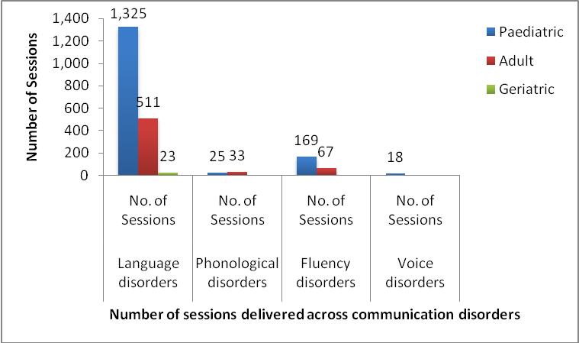
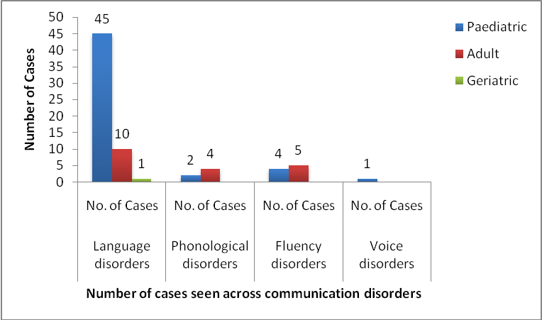

Itinerant Service
The Institute offered itinerant service on prevention and control of communication disorders for the regularschool children through the itinerant speech therapist and medical social worker. The service was providedat 24 schools (61 visits) and follow up activity was carried out for 141 (new-89, follow up-52) children identified with various types ofcommunication disorders availing therapy at AIISH during the reporting year. Also, during the visit, 146 teachers were given guidelines to include children with communication disorders in regular classrooms.
Survey of Persons with Communication Disorders

A survey of persons with communication disorders was going on in the districts of Mysuru, Mandya and Chamarajanagaras a plan project with Dr. S. R. Savithri, former Director, AIISH as the Principal Investigator and Dr. R.Rajasudhakar, Reader in Speech Science, AIISH, Dr. Priya M.B., Lecturer in Speech Science and Dr.H.Sudharshan, Hon. Secretary, Karuna Trust as Co-Investigators. The activities carried out in the reportingyear were from Level IV of Phase 3 of the plan project. Two hundred ASHA /Anganwadi workers performed the survey during the reporting year. Training was provided to the ASHA / anganwadiworkersfor carrying out the survey before mobilizing them into the villages/towns in three sessions. Totally 2,06,194 persons were surveyed in specific hoblis of the three districts to identify persons with communication disorders. The details are given in table 10.

Table 10: Survey of Communication Disorders
Districts | Locality |  | No. of PHCs | No. ofvillages | TotalPopulation
Districts | Taluk | Hobli/Town |  | No. ofvillages | TotalPopulation
Mysuru | Hunsur | Hanagudu Kasaba 2 | 9  1 | 119  25 | 71,199  17,810
Chamarajanagar | Chamarajanagar | Chandakkavadi  Haradanahalli | 5  5 | 49  41 | 60,217  56,968
Total | 2taluks | 4hoblis | 20PHCs | 234  villages | 2,06,194

Sensitization programs
A Sensitization program on Occupational Noise induced hearing loss and its prevention was conducted on 19thOctober 2018. The program was carried out on 19th October 2018 in Knowledge Park Seminar hall, from 10.00 am to 5.00 pm. Total of 125 participants were orientated on Occupational Noise induced hearing loss and its preventive measures. The main aim of this sensitization program was to educate the importance of hearing in day to day life and different ways to preserve them. This program also provided knowledge on Ear Protective Devices in terms of its usefulness in the working environment. Through this program, a step was taken ahead to spread awareness regarding NIHL and its prevention to
different sections of employees at risk of developing NIHL.

