CLINICAL CARE

Patient Registration

Totally 13,432 new clients were registered for availing clinical services at the institute during the reporting year. In addition 29,965 case files were retrieved for repeat/follow up visits for various evaluations. The geographical and gender-wise details of new clients are given in table 1. Majority of them (12970) were from Karnataka, the state in which the institute is located, followed by the neighboring states of Kerala (174), Tamil Nadu (88), and Andhra Pradesh (67). Also there were clients from U.K, USA, Maldives and Nepal. Males (8132) outnumbered females (5294 ) in availing clinical services.
Table 1: Geographical & Gender wise distribution of new clients

Sl. No | Locality | Male | Female | Total
 | Andra Pradesh | 46 | 21 | 67
 | Arunachal Pradesh | - | 1 | 1
 | Assam | 2 | 1 | 3
 | Bihar | 12 | 2 | 14
 | Chattisgarh | 2 | 1 | 3
 | Delhi | 4 | 3 | 7
 | Goa | 1 | - | 1
 | Gujarat | 7 | - | 7
 | Hariyana | 1 | 2 | 3
 | Himachal Pradesh | - | - | -
 | Jarkhand | 6 | 2 | 8
 | Karnataka | 7817 | 5153 | 12970
 | Kashmir | 2 | 1 | 3
 | Kerala | 117 | 57 | 174
 | Madhya Pradesh | 3 | 2 | 5
 | Maharastra | 8 | 6 | 14
 | Manipur | - | - | -
 | Meghalaya | - | - | -
 | Mizoram | - | - | -
 | Nagaland | - | - | -
 | Orissa | 6 | 2 | 8
 | Punjab | 1 | - | 1
 | Rajasthan | 9 | 4 | 13
 | Sikkim | 1 | - | 1
 | Tamil Nadu | 59 | 29 | 88
 | Telangana | 8 | - | 8
 | Tripur | 1 | - | 1
 | Union Territories | - | - | -
 | Uttar Pradesh | 11 | 5 | 16
 | Uttaranchal | 2 | 1 | 3
 | West Bengal | 6 | 1 | 7
 | Total | 8132 | 5294 | 13426
Over Seas Total |  | 04 | 02 | 06
Grand Total |  | 8136 | 5296 | 13432

Speech and Language Assessment and Rehabilitation

The speech and language outpatient unit evaluated 3,922 clients which include 2,824 new and 1098 review cases. Of the new cases, 2,048 were identified with various kinds of speech and language disorders and 92 were found to have normal speech. The details of various speech and language disorders diagnosed are given in table 2 and figure 1.
Table 2: Assessment of Speech-Language Disorders

Disorders | Language Disorders |  |  | Fluency Disorders |  |  | Voice Disorders |  |  | Articulation Disorders |  |  | Multiple Disorders |  |  | Normal |  |  | Total
Months | C | A | G | C | A | G | C | A | G | C | A | G | C | A | G | C | A | G | Total
April | 368 | 32 | 4 | 46 | 21 | 0 | 9 | 27 | 10 | 40 | 3 | 0 | 0 | 0 | 0 | 0 | 0 | 0 | 560
May | 341 | 16 | 1 | 54 | 14 | 0 | 13 | 32 | 12 | 42 | 2 | 0 | 0 | 0 | 0 | 0 | 0 | 0 | 527
June | 388 | 44 | 3 | 39 | 13 | 0 | 5 | 31 | 6 | 25 | 3 | 0 | 0 | 0 | 0 | 0 | 0 | 0 | 557
July | 369 | 51 | 8 | 21 | 20 | 0 | 7 | 28 | 5 | 14 | 1 | 0 | 0 | 0 | 0 | 0 | 0 | 0 | 524
Aug | 255 | 44 | 6 | 15 | 16 | 0 | 7 | 22 | 2 | 16 | 2 | 0 | 0 | 0 | 0 | 0 | 0 | 0 | 385
Sept | 270 | 30 | 15 | 15 | 14 | 0 | 4 | 25 | 10 | 14 | 2 | 0 | 0 | 0 | 0 | 0 | 0 | 0 | 399
Oct | 235 | 30 | 1 | 31 | 7 | 0 | 5 | 28 | 6 | 27 | 3 | 0 | 0 | 0 | 0 | 0 | 0 | 0 | 373
Nov | 203 | 14 | 2 | 18 | 12 | 0 | 5 | 25 | 10 | 14 | 2 | 0 | 0 | 0 | 0 | 0 | 0 | 0 | 305
Dec | 278 | 34 | 7 | 25 | 24 | 0 | 12 | 22 | 14 | 13 | 5 | 0 | 0 | 0 | 0 | 0 | 0 | 0 | 434
Jan | 251 | 28 | 4 | 20 | 13 | 0 | 8 | 20 | 9 | 18 | 2 | 0 | 0 | 0 | 0 | 0 | 0 | 0 | 373
Feb | 233 | 25 | 6 | 8 | 15 | 0 | 3 | 24 | 6 | 13 | 2 | 0 | 0 | 0 | 0 | 9 | 4 | 0 | 348
March | 231 | 22 | 3 | 14 | 13 | 0 | 0 | 27 | 9 | 16 | 1 | 1 | 0 | 1 | 0 | 0 | 0 | 0 | 338
Total | 3422 | 370 | 60 | 306 | 182 | 0 | 78 | 314 | 99 | 252 | 28 | 1 | 0 | 1 | 0 | 9 | 4 | 0 | 5126+1791
Disorder Wise | 3852+1586 |  |  | 488+73 |  |  | 491+49 |  |  | 281+83 |  |  | 01+0 |  |  | 13+0 |  |  | 5126+1791
Over All | 6917
C- Child, A-Adult, G-Geriatric

Figure: 1 Assessment of Speech-Language Disorders (New cases Disorder-wise)

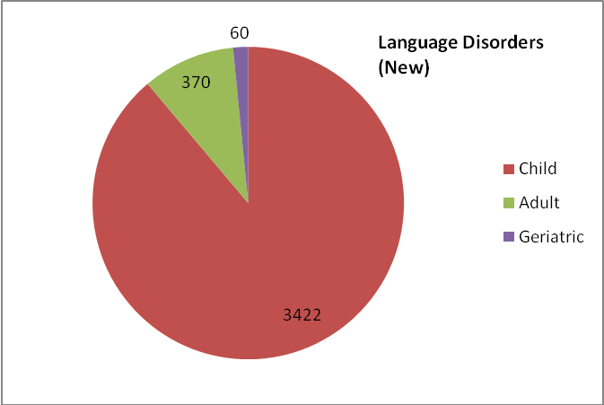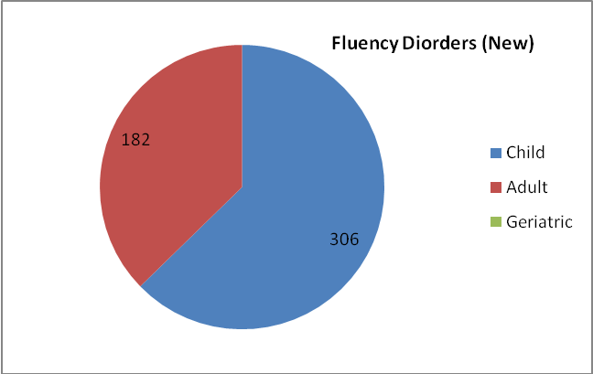

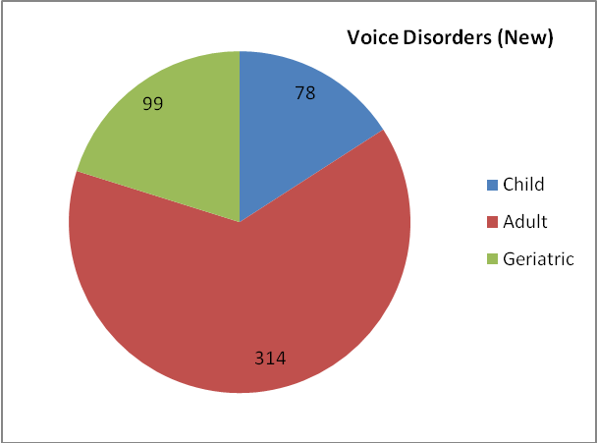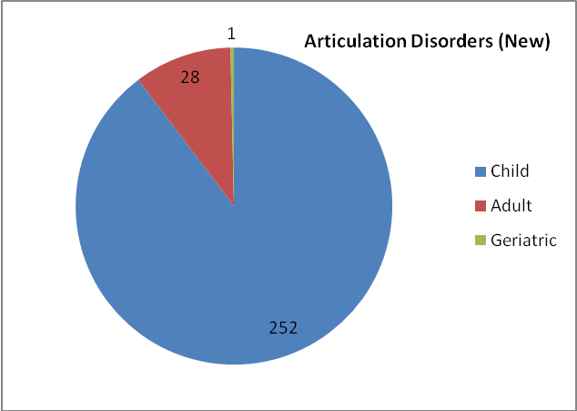

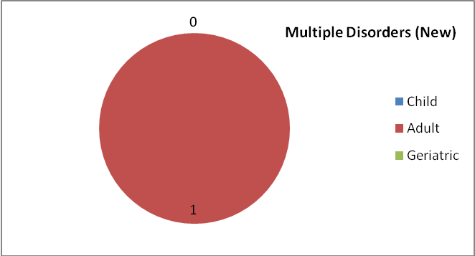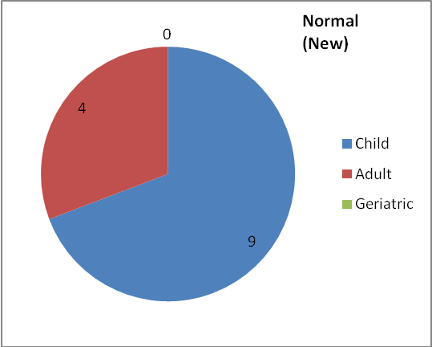

Overall Assessment of Speech-Language Disorders

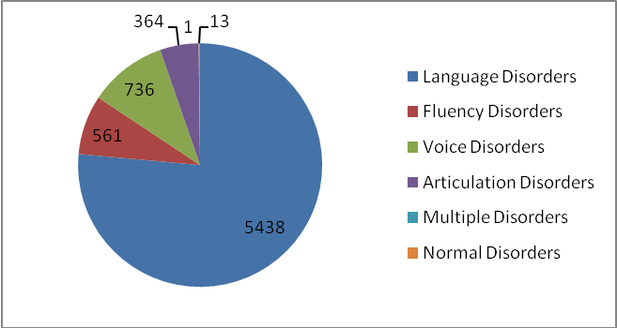
Clients requiring further management were given various speech/language therapies depending upon the type and severity of disorder, for daily sessions of 45 minutes duration. A total of 25,731 therapy sessions were conducted for 5,062 persons with speech/ language disorders during the reporting year. The details of disorder- wise therapy carried out are given in table 3 and figure 2.

Table 3: Speech-Language Therapy
Disorders | Language Disorders |  |  | Voice Disorders |  |  | Articulation Disorders |  |  | Multiple Disorders |  |  | Total
Months | C | A | G | C | A | G | C | A | G | C | A | G | Total
April | 240 | 0 | 2 | 4 | 8 | 2 | 18 | 0 | 1 | 7 | 0 | 0 | 282
May | 152 | 0 | 2 | 1 | 5 | 0 | 14 | 0 | 0 | 1 | 0 | 0 | 175
June | 261 | 0 | 0 | 2 | 9 | 0 | 7 | 0 | 1 | 0 | 0 | 0 | 280
July | 350 | 8 | 4 | 2 | 11 | 3 | 5 | 2 | 0 | 0 | 0 | 0 | 385
Aug | 477 | 12 | 7 | 5 | 28 | 3 | 12 | 3 | 0 | 2 | 0 | 0 | 549
Sept | 401 | 6 | 4 | 2 | 10 | 3 | 13 | 3 | 0 | 2 | 0 | 0 | 444
Oct | 426 | 17 | 4 | 5 | 15 | 2 | 7 | 2 | 0 | 2 | 0 | 0 | 480
Nov | 193 | 11 | 7 | 3 | 20 | 2 | 3 | 4 | 1 | 0 | 0 | 0 | 244
Dec | 326 | 5 | 4 | 6 | 17 | 1 | 1 | 3 | 1 | 0 | 0 | 0 | 364
Jan | 554 | 11 | 4 | 7 | 21 | 3 | 21 | 6 | 4 | 3 | 0 | 0 | 634
Feb | 531 | 18 | 8 | 6 | 23 | 5 | 15 | 6 | 4 | 2 | 0 | 0 | 618
March | 522 | 16 | 7 | 7 | 22 | 9 | 16 | 4 | 2 | 2 | 0 | 0 | 607
Total | 4433 | 104 | 53 | 50 | 189 | 33 | 132 | 33 | 14 | 21 | 0 | 0 | 5062
Disorder-wise Total | 4590 |  |  | 272 |  |  | 179 |  |  | 21 |  |  | 5062
Over All | 5062
C- Child, A- Adult, G- Geriatric
Figure 2: Speech-Language Therapy (Individual)

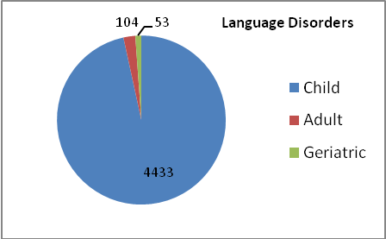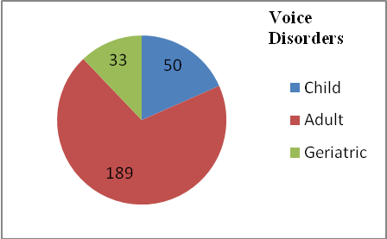

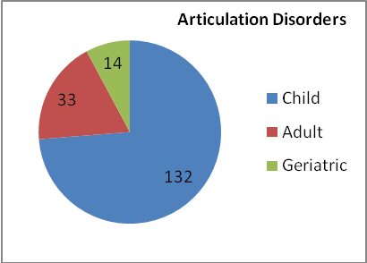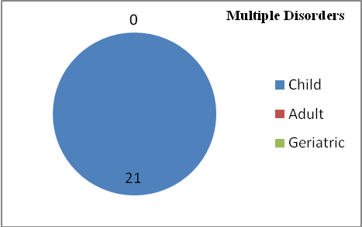

Overall Disorder wise Speech-Language Therapy
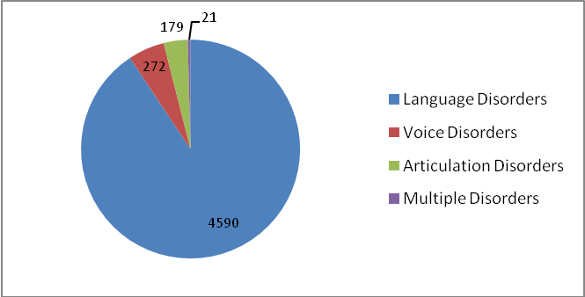

Speech and language assessment and therapeutic services were also provided at the seven DHLS centres of the Institute located in different parts of the country, the details of which are given in table 4.

Table 4 : Speech-Language clinical services at the DHLS Centres

Assessment |  |  |  |  |  | Therapy
Centers | Language | Voice | Phonology | Fluency | MSD/  Dysphasia | Language | Voice | Phonology | Fluency | MSD/  Dysphasia
Mysore | 30 | 3 | 5 | 8 | 6 | 0
Lucknow | 135 | 99 | 56 | 100 | 0 | 269 | 140 | 64 | 147 | 0
Mumbai | 560 | 9 | 34 | 10 | 53 | 1236 | 20 | 67 | 40 | 85
Cuttack | - | - | - | - | - | - | - | - | - | -
Ajmer | 196 | 90 | 122 | 136 | 13 | 133 | 305 | 106 | 153 | 69
Delhi | 44 | 15 | 3 | 35 | 2 | 35 | 11 | 1 | 27 | 0
Ranchi | 194 | 25 | 25 | 35 | 10 | 129 | 15 | 18 | 23 | 4
Shimla | 143 | 292 | 82 | 61 | 45 | 143 | 292 | 82 | 61 | 45
Bhagalpur | 23 | 5 | 72 | 22 | 5 | 21 | 3 | 23 | 13 | 2

Audiological Assessment and Rehabilitation

Hearing Evaluations were carried out on individuals who complained of hearing problems. In outpatient
department a total of 15738 clients were assessed. Hearing evaluations were carried out on 13,525 individuals at Jayachamaraja Block in Clinical services. Different types of audiological evaluations carried out were Auditory Brainstem Responses (3520), Behavioural Observation Audiometry (462), Immittance evaluation (13062), Otoacoustic emissions (4515), Pure Tone Audiometry (12915), Speech Audiometry (12924), Tinnitus evaluation (255), Vestibular evoked Myogenic potentials (131), Visual Reinforcement Audiometry (141), Video Head Impulse Test (43) and Late Latency Response (8). Below mentioned table 5 gives the details of clients seen for hearing evaluation.

Based on these audiological tests different degrees of hearing loss were diagnosed. Ears with normal hearing were 2616 and ears with different degrees of hearing loss were 8205. The numbers of ears with different degrees of hearing loss were: 1068 in minimal, 1115 in mild, 1112 in moderate, 889 in moderately severe, 903 in severe, 1431 in profound, 24 in minimal to mild, 84 in mild to moderate, 68 in moderate to moderately severe, 106 in moderately severe to severe, 198 in severe to profound and 102 in moderate to severe categories. The ears with sloping configuration of hearing loss were 1105.

Of the ears tested, there were 2789 ears with conductive hearing loss, 4077 ears with mixed hearing loss and 6701 ears with sensorineural hearing loss. There were 1467 clients with unilateral hearing loss and 10344 with bilateral hearing loss. The other conditions identified include Auditory Processing Disorders (15), auditory dys-synchrony (102) and functional hearing loss (125). The complete details of hearing evaluation given in table 5.
Table 5: Hearing Evaluation
Sl.  No. | Hearing Evaluation | Total
1 | Conductive hearing loss | 2789
2 | Mixed hearing loss | 4077
3 | Sensorineural hearing loss | 6701
4 | Unilateral hearing loss | 1467
5 | Bilateral hearing loss | 10344
6 | Auditory Processing Disorders | 15
7 | Auditory dys-synchrony | 102
8 | Functional hearing loss | 125

Hearing aid trial and prescription were carried out for clients in need for amplification and/or assistive listening devices. Clients evaluated of hearing aids were 6668 and 5291 hearing aids were prescribed at AIISH. Of the 6668 clients evaluated, 2407 were female and 4261 male. The details are given in table 6 and figure 3.
Table:6
Age group  in years | HAT
Age group  in years | Male | Female
0-1 | 28 | 12
2-5 | 849 | 598
6-10 | 345 | 270
11-15 | 191 | 104
16-20 | 77 | 52
21-25 | 69 | 37
26-30 | 45 | 29
31-35 | 54 | 24
36-40 | 41 | 52
41-45 | 92 | 50
46-50 | 93 | 65
51-55 | 211 | 132
56-60 | 267 | 171
61-65 | 395 | 190
66-70 | 440 | 217
71-75 | 437 | 202
76-80 | 371 | 124
81-85 | 164 | 64
86-90 | 70 | 12
91+ | 22 | 2
Total | 4261 | 2407
Grand Total | 6668

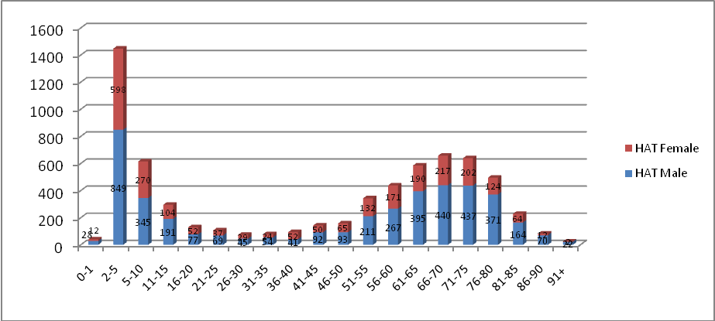
Figure 3: Age wise Clients Evaluation

At Ear mould lab, ear impressions were taken for 5475 clients. Ear impressions were taken for 2043 new and 3516 old clients at AIISH and 140 in community based camps. The total number of ears for which ear impression were taken was 5256. Ear moulds given for free of cost were 2849, for payment were 5713, for clients from camp were 216 and for impressions received under Central Prosthetic Lab activities were 340. Different types of ear moulds made were hard regular moulds (642), hard shell moulds (436), soft moulds (4212) and soft canal moulds (58). Ear impressions taken for ear blocking were 178. Swimmers ear plugs made of soft silicon material were 71. Ear moulds for which sound tube were replaced were 1698 and ear moulds lacquered were 1780.

Referred Evaluation-1: Psychological Assessment and Rehabilitation
Psychological assessment was carried out for the referred cases registered at the Department of Clinical Psychology. This includes Routine Psycho-Diagnostic Assessment for Screening and Identification Detailed Psychological Assessment (including specialized assessment such
as assessment for Learning Disability, neuro-psychological assessment, assessment for disability certification, behavioral assessment and assessment for skill training. Psychological Intervention (including behavior modification programs, home based skill training programs, cognitive-behaviour and group intervention programs for caregivers).

Routine psycho-diagnostic assessment was carried out for 5370 new and 1398 repeat cases at the Department during the reporting year. The detailed is given in table 7.

Table 7: Routine Psycho-Diagnostic Assessment
Classification of disorders according to the criteria included in Chapter V (F) of ICD-10
F 70# | Mental retardation | 1656
F 80.0 | Specific speech articulation disorder | 290
F 80.1 | Expressive language disorder | 503
F 80.2 | Receptive language disorder | 281
F 88# | Other disorders of psychological development | 396
F81# | Specific developmental disorders of scholastic skills | 980
F 84# | Pervasive developmental disorders | 48
F 98.5 | Stuttering (stammering) | 448
F 44.4 | Dissociative motor disorders | 12
F00-F99 | Other disorders included in Chapter V (F) of ICD-10 | 442
The code # refers to "condensed" codes (Ref ICD-IO PC )
Classification according to the criteria included in Chapter XVIII (R) of ICD 10
R 47.0 | Dysphasia and aphasia | 39
R 41.83 | Borderline Intellectual Functioning | 958
Avg. Intelligence with disorders classified elsewhere |  | 715
TOTAL |  | 6768

Psychological assessment includes intelligence / developmental psycho-educational (839 cases in 1882 sessions), neuropsychological (10 cases in 76 sessions), personality (2 cases in 2 sessions), behavioural (38 cases in 109 sessions) and forensic assessments (2 cases in 25 sessions).

The psychological intervention provided includes behavior modification (135 cases in 215 sessions), cognitive behavior therapy (13 cases in 35 sessions) neuropsychological rehabilitation (4 cases in 14 sessions) and motor disorder rehabilitation (12 cases in 34 sessions).

Referred Evaluation-2: Otolaryngological Assessment and Rehabilitation

The Otorhino-laryngological assessment and rehabilitation for persons with communication disorders were being carried out at the Department of Otolaryngology. In addition to the clinical services provided at the Institute, the Department staffs rendered diagnostic, therapeutic and surgical services at K.R. Hospital, Mysore Medical College, Mysore. Totally, 18047 new and 21618 review cases were examined during the reporting year at the institute, and 6116 microscopic, 130 stroboscopic / endoscopic examination, 100 vertigo, 42 otoendoscopic and 07 diagnostic naso endoscopic examinations were carried out. Also, 11299 new and 10867 repeat cases were examined and 109 major and 600 minor surgeries were successfully carried out at K.R.Hospital.

Specialized Clinical Services
The institute provided a variety of specialized clinical services for individuals with communication disorders during the reporting year at the following clinical units.

- Augmentative and Alternative Communication (AAC) Unit
The AAC unit supported, enhanced and provided alternative methods of communication for individuals who are non-verbal. The unit evaluated 58 new and 103 therapy cases in 414 sessions during the reporting year. It also trained 21 PG students.

- Autism Spectrum Disorders (ASD) Unit
Assessment and treatment were provided for 203 clients with autism spectrum disorders at the ASD unit during the reporting year. Of them, 24 were from Hindi region. The unit also attended 337 therapy and 47 demonstration therapy cases. Thirteen therapy cases discharged during the period. The total number of therapy sessions conducted was 1948.

- Clinic for Adult and Elderly Persons with Language Disorders (CAEPLD)
CAEPLD provides clinical services to adult and elderly persons. Totally, 67 clients were evaluated in the clinic during the reporting year. The number of therapy cases were 46 and therapy sessions 196. Also there were 35 DT cases. Twenty six cases were discharged.

- Dysphasia Unit
This unit facilitates assessment and management of persons with swallowing disorders. The unit evaluated 31 cases in 36 sessions. Also, there were 10 therapy cases. The number of cases discharged was 5.

- Fluency Unit
This unit catered to the needs of persons with stuttering and other fluency disorders and provided clinical services to 425 persons with fluency disorders in 2251 sessions during the reporting year.

- Implantable Hearing Devices Unit
The activities of this unit include selection of candidates, mapping/ programming, trouble shooting of implantable hearing devices such as cochlear implant, bone anchored hearing aids and middle ear implants. During the reporting year, 302 clients were seen in the unit. The mapping for Cochlear Implant cases was 271. Trouble shooting was done for 90 client devices. Also, counselling was given for 317 clients.

- Learning Disability Clinic
One case was evaluated in the Unit during the reporting year. Also there was one therapy case who underwent therapy in 15 sessions. There were 40 DT cases.

- Listening Training (LT) Unit
Listening Training Unit: Listening training unit (LTU) is committed to provide aural rehabilitation to the needy. The listening training was provided to not only the clients who use hearing devices such as hearing aids and cochlear implants but also to those with (Central) auditory processing disorders. In addition, training was also imparted to individuals suffering from tinnitus or hyperacusis. Totally, 2998 persons underwent listening training in 12678 sessions during the reporting year. Of the 2998 clients, 348 were new and the remaining 2650 were repeat cases.

- Medical Specialty & Allied Health Services
The institute facilitated the services of various medical specialists such as pediatrician, neurologist, plastic surgeon, prosthodontist, orthodontist, phono-surgeon and services of allied health professionals such as physiotherapist and occupational therapist, to the needy clients. Totally, 1,958 patients underwent Physio and Occupational therapy in 13,520 sessions, during the reporting year. In addition, 244, 226, 193, 53, 51 clients consulted pediatrician, plastic surgeon, phonosurgeon, orthodontist, Dietician respectively. The details are given in figure 4.

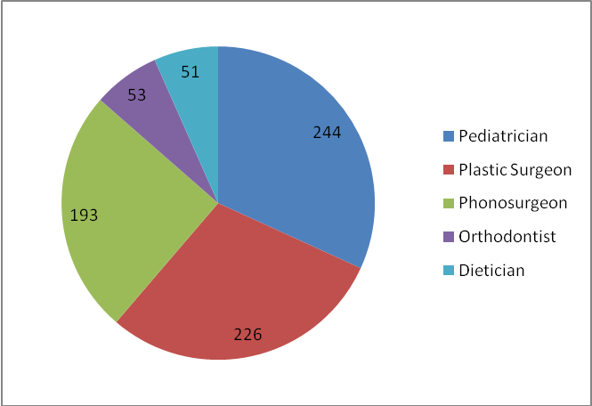
Figure 4: Medical specialty and allied health

- Motor Speech Disorders Unit
This specialized unit caters to the needs of persons with motor speech disorders. It enables them to realize their potential and become contributing members of the society. Totally, 47 cases were evaluated in 47 sessions. Also there were 6 therapy cases and 29 Demonstration therapy.

- Neuropsychology Unit
The services offered in the unit includes the assessment of specific function of the brain through standard individualized test, detailed assessment of lobular functions through standardized batteries and rehabilitation through paper pencil techniques or through computer assisted packages. Totally, 10 (76 sessions) neuropsychological assessments and 4 (14 sessions) neuropsychological rehabilitation were made during the reporting year in the unit.

- Professional Voice Care (PVC) Unit
The unit provided specialized assessment and management services to professional voice users during the reporting year. It organized various programs to orient and sensitize professional voice
users on care, maintenance and conservation of voice. The unit evaluated 12 clients and provided rehabilitation to 20 clients. In addition, the unit trained a total of 64 UG and PG students in 273 hours.

- Structural Orofacial Anomalies (U- SOFA) Unit
Clients with deformalities in the growth of head and facial bones were given multi-disciplinary diagnostic and rehabilitation services in the clinic. The experts of the clinic evaluated 114 clients during the reporting year. Also 114 cases were evaluated 562 sessions.

- Vertigo Clinic
The clinic offered comprehensive care in evaluation and management of patients with vertigo. A multidisciplinary team comprising of otolaryngologist, audiologist and neurologist evaluated 230 new and 290 follow up patients in the clinic for both peripheral and central vertigo during the reporting year and diagnostic tests like microscopic examination of ear, electro nystagmography, vestibulo spinal tests, neurological evaluation, video nystagmography, audiological tests and vestibular evoked myogenic potential test were carried out for the needy ones.

- Voice Clinic
This clinic offered evaluation and management services to persons of all ages with voice disorders. Totally, 620 clients with voice disorders were evaluated in the clinic using video stroboscopy and software for voice assessment and rehabilitation services was provided to 193 cases.
Special Educational Services

The following educational services were provided to the children with special needs at the pre-school, attached to the Department of Special Education during the reporting year.

- Special Educational Assessment: Educational Assessment services are offered for 831 children with communication disorders to determine readiness for schooling and to suggest an appropriate grade, placement as well as necessary services from April 2018 to March 2019.

- Parent Infant Program (PIP): PIP was provided to very young children ranging from birth to 2.5 years with the objective of improving physical, cognitive, communication, social and emotional skills as detailed in figure 5.

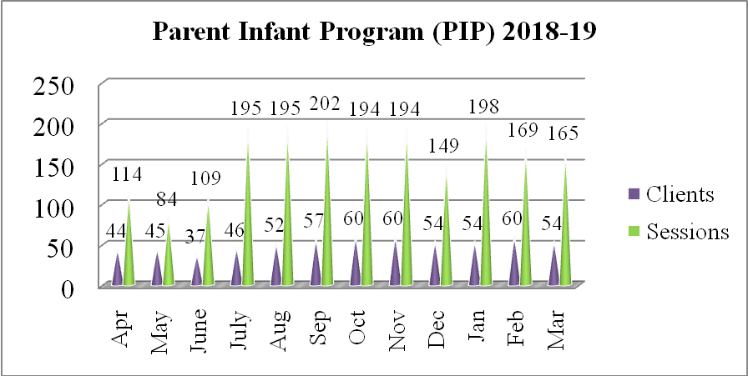
Figure 5: Parent Infant Programme
- Preschool Parent Empowerment Program (PPEP): PPEP was provided to 1886 caregivers of children ranging from 2.5-3 years before formal admission to preschool in 5149 sessions with the aim of empowering caregivers to train their children and get adjusted to preschool atmosphere.

- Preschool Training & Supplementary Services (PSS): Preschool service, a preparatory training for children with communication disorders in self-help, cognitive, communication and academic skills necessary for successful schooling was provided to children in the age range of 3-6 years having hearing impairment, cerebral palsy, and multiple disability and to those in the age range of 3-10 years having intellectual disability and autism. Totally, 2312 children availed the service in 34612 sessions.

- Curricular Support Services, Individualized Education Program and Demonstration Education Therapy / Non formal Education Program were offered respectively to 33, 16 and 80 children with communication disorders who were mainstreamed but have certain difficulties in coping with academics.

- Sensory Adaptation for Education to cater to the sensory issues of young children with special needs.

- Special use of music for educational readiness and up-building
- Speech-Language group therapy
- Support services for Empowering Caregivers
- One-month summer camp for 100 children in 80 sessions

Clinical Support Services
The institute extended a diverse range of support services to patients and their family. These include the following.

- Distribution and Repairing of Aids:
Electro-acoustic evaluation, management and repair of hearing aids were carried out under the aegis of Department of Electronics. Totally 584 hearing aids were distributed (AIISH-292, OSCs-197, Camps-60 & Plan Project - 35), after electro-acoustic evaluation and testing under ADIP scheme. Under AIISH Hearing Aid Dispensing Scheme, 2324 hearing aids were issued at concessional rate. Also, 78110 hearing aid spares such as HA cells, cords, battery doors, ear hooks, body case, wind weather protector and BET Huggies were issued. In addition, 383 body level and 822 BTE hearing aids were repaired, electronic-acoustic evaluation was carried out for 124 hearing aids and 14 audiometers were calibrated.

- Counselling and Guidance: The professional experts of the Institute provided counselling and guidance on various aspects of the disorders such as treatment procedures, usage and care of tools like hearing aids during the reporting year.

- Distribution of toy kits: 31 toy kits were distributed to eligible disabled children worth Rs.23,250/-.

Issue of Certificates:
Various certificates like financial aid, income tax exemption, educational scholarship, and school admission were issued to the eligible candidates during the reporting year, the details of which are given in table 8.

Table 8: Details of certificates issued
Particulars | Total
Transfer certificate | 39
Evaluation reports | 464
Attendance certificate | 31
School admission certificate | 71
Admission to deaf school | 05
MR Certificate | 592
Railway concession certificate (Cli.Psy)  (ENT) | 158  240
Psychological Report | 1088
Income Tax Exemption Certificate | 31
Bonafide certificate | 22
Handicapped Certificate (Pension) | 1512
Medical Certificate | 62

- Financial Aid: The institute distributed total amount of Rs. 14,46,354/- among 151 clients below poverty line towards the purchase of hearing aids during the reporting year under the aegis of the Department of Clinical Services.

- Clinical Observation Posting
The institute facilitated clinical observation posting for students in the area of communication disorders and allied fields from other institutes in the country and abroad. Around five hundred students and staff from 28 institutes across the country and abroad were posted for clinical observation in different clinical units and departments of the institute during the reporting year. The details of the institutions are given below.

- St. Agnes Centre for Post Graduate Studies and Research, Mangalore
- Christ Deemed to be University, Bangalore
- University of Mysore, Mysore
- Department of Water & Health, JSS University, UOM, Mysore
- Central University of Karnataka
- National Institute for the Empowerment of Person with Intellectual Disabilities (NIEPID)
- Maharani’s Arts College, Mysore
- Teresian College, Mysore
- Apollo Hospital, Bengaluru
- Al-Ameen, Biijapur
- Mysore Medical College & Research Centre, Mysore
- Navodaya Medical College, Raichur
- S.S.Institute of Medical Sciences, Davangere
- Mandya Institute of Medical Sciences, Mandya
- KLE Ayurvedic College Belagavi
- College of Community Sciences, UAS, Dharwad
- The Jawaharlal Institute of Postgraduate Medical Education & Research, Pondicherry
- Gurugobind Singh Medical College, Punjab
- Netaji Subhash Chandra Bose Medical College, Jabalpur
- Ashtavakra Institute of Rehabilitation Sciences & Research, New Delhi
- J.N. Medical College, Belagavi
- A.M.C. Medical College, Bijapur
- Mandya Institute of Medical Sciences, Mandya
- KLE Ayurvedic College Belagavi
- Ashtavakra Institute of Rehabilitation Sciences and research, Delhi
- Rajiv Gandhi Institute of Technology, Bangalore
- Vidyavardhaka College of Engineering, Mysore
- S S Institute of Medical Science & Research Centre, Davangere
- Mount Carmel College, Bengaluru
- University of Agricultural Sciences, Dharwad
- Shri BM Kankanawadi Ayurved Mahavidyalaya, Belagavi.

