CLINICAL CARE

Patient Registration

Totally 13,432 new clients were registered for availing clinical services at the institute during the reporting year. In addition 29,965 case files were retrieved for repeat/follow up visits for various evaluations. The geographical and gender-wise details of new clients are given in table 1. Majority of them (12970) were from Karnataka, the state in which the institute is located, followed by the neighboring states of Kerala (174), Tamil Nadu (88), and Andhra Pradesh (67). Also there were clients from U.K, USA, Maldives and Nepal. Males (8132) outnumbered females (5294 ) in availing clinical services.
Table 1: Geographical & Gender wise distribution of new clients

Sl. No | Locality | Male | Female | Total
 | Andra Pradesh | 46 | 21 | 67
 | Arunachal Pradesh | - | 1 | 1
 | Assam | 2 | 1 | 3
 | Bihar | 12 | 2 | 14
 | Chattisgarh | 2 | 1 | 3
 | Delhi | 4 | 3 | 7
 | Goa | 1 | - | 1
 | Gujarat | 7 | - | 7
 | Hariyana | 1 | 2 | 3
 | Himachal Pradesh | - | - | -
 | Jarkhand | 6 | 2 | 8
 | Karnataka | 7817 | 5153 | 12970
 | Kashmir | 2 | 1 | 3
 | Kerala | 117 | 57 | 174
 | Madhya Pradesh | 3 | 2 | 5
 | Maharastra | 8 | 6 | 14
 | Manipur | - | - | -
 | Meghalaya | - | - | -
 | Mizoram | - | - | -
 | Nagaland | - | - | -
 | Orissa | 6 | 2 | 8
 | Punjab | 1 | - | 1
 | Rajasthan | 9 | 4 | 13
 | Sikkim | 1 | - | 1
 | Tamil Nadu | 59 | 29 | 88
 | Telangana | 8 | - | 8
 | Tripur | 1 | - | 1
 | Union Territories | - | - | -
 | Uttar Pradesh | 11 | 5 | 16
 | Uttaranchal | 2 | 1 | 3
 | West Bengal | 6 | 1 | 7
 | Total | 8132 | 5294 | 13426
Over Seas Clients |  | 04 | 02 | 06
Grand Total |  | 8136 | 5296 | 13432

Speech and Language Assessment and Rehabilitation

The speech and language outpatient unit evaluated 3,953 clients which include 2,824 new and 1129 review cases. Of the new cases, 2,048 were identified with various kinds of speech and language disorders and 92 were found to have normal speech. The details of various speech and language disorders diagnosed are given in table 2 and figure 1.
Table 2: Assessment of Speech-Language Disorders

Disorders | Language Disorders |  |  | Fluency Disorders |  |  | Voice Disorders |  |  | Articulation Disorders |  |  | Multiple Disorders |  |  | Normal |  |  | Total
Months | C | A | G | C | A | G | C | A | G | C | A | G | C | A | G | C | A | G | Total
April | 0 | 0 | 0 | 0 | 0 | 0 | 0 | 0 | 0 | 0 | 0 | 0 | 0 | 0 | 0 | 0 | 0 | 0 | 0
May | 35 | 0 | 0 | 8 | 4 | 0 | 2 | 1 | 2 | 2 | 2 | 0 | 0 | 0 | 0 | 2 | 0 | 0 | 58
June | 107 | 31 | 1 | 23 | 5 | 0 | 1 | 21 | 5 | 4 | 0 | 0 | 1 | 0 | 0 | 4 | 3 | 0 | 206
July | 32 | 6 | 1 | 10 | 6 | 0 | 0 | 4 | 0 | 1 | 2 | 0 | 0 | 0 | 0 | 0 | 1 | 0 | 63
Aug | 84 | 14 | 3 | 7 | 4 | 0 | 2 | 1 | 2 | 4 | 2 | 0 | 5 | 3 | 0 | 2 | 1 | 0 | 134
Sept | 123 | 25 | 4 | 16 | 2 | 0 | 2 | 3 | 1 | 12 | 7 | 1 | 6 | 6 | 0 | 4 | 7 | 0 | 219
Oct | 103 | 31 | 1 | 12 | 10 | 0 | 0 | 5 | 1 | 6 | 8 | 0 | 4 | 1 | 0 | 4 | 9 | 0 | 195
Nov | 138 | 27 | 1 | 19 | 3 | 0 | 2 | 10 | 3 | 5 | 4 | 0 | 4 | 6 | 0 | 8 | 1 | 0 | 231
Dec | 242 | 31 | 0 | 29 | 15 | 0 | 4 | 16 | 4 | 19 | 8 | 1 | 4 | 1 | 0 | 7 | 6 | 1 | 388
Jan | 259 | 31 | 2 | 18 | 10 | 0 | 3 | 13 | 3 | 21 | 10 | 0 | 9 | 1 | 1 | 13 | 0 | 0 | 394
Feb | 316 | 47 | 1 | 26 | 11 | 0 | 1 | 18 | 7 | 16 | 10 | 5 | 10 | 4 | 0 | 4 | 4 | 0 | 480
March | 276 | 67 | 9 | 28 | 12 | 0 | 1 | 19 | 2 | 17 | 2 | 1 | 9 | 2 | 0 | 6 | 5 | 0 | 456
Total | 1715 | 310 | 23 | 196 | 82 | 0 | 18 | 111 | 30 | 107 | 55 | 8 | 52 | 24 | 1 | 54 | 37 | 1 | 2824(N) + 1129(R)
Disorder Wise | 2048(N)+869 (R) |  |  | 278(N) + 80(R) |  |  | 159(N) +22(R) |  |  | 170(N) +67(R) |  |  | 77(N) +60(R) |  |  | 92(N) +31(R) |  |  | 2824(N) + 1129(R)
Over All | 3953

C- Child, A-Adult, G-Geriatric

Figure: 1 Assessment of Speech-Language Disorders (New cases Disorder-wise)

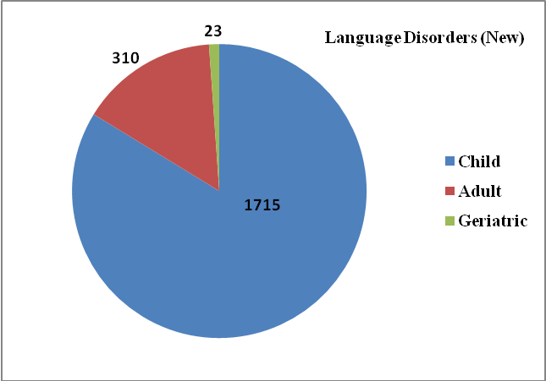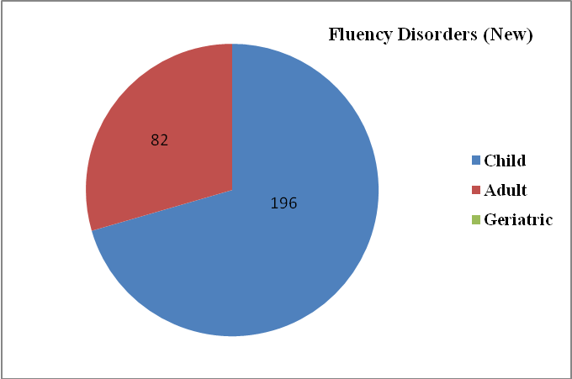
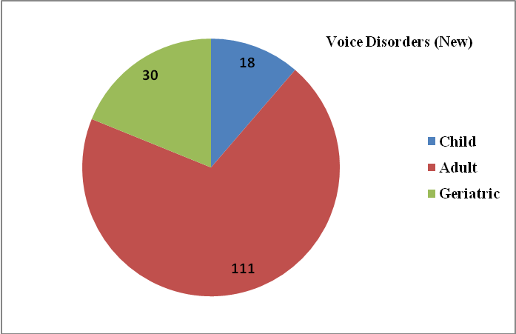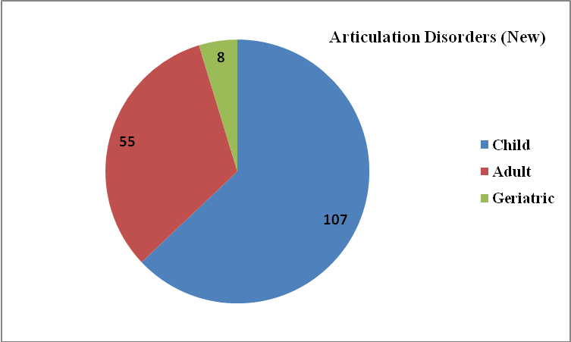

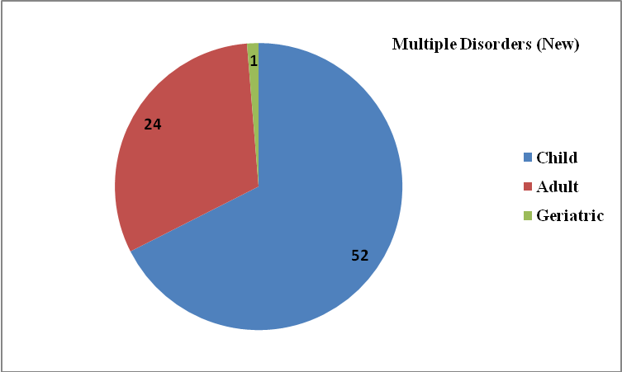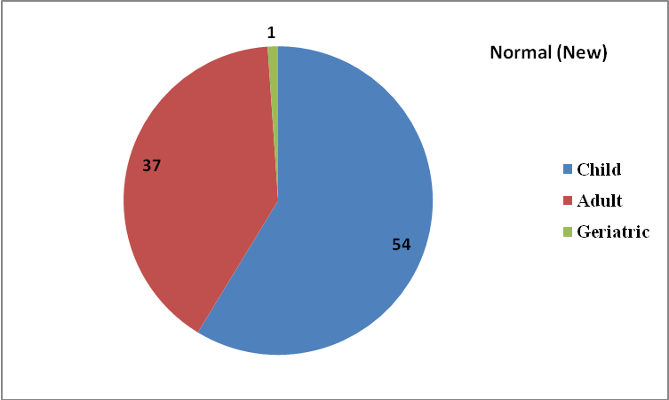

Overall Assessment of Speech-Language Disorders

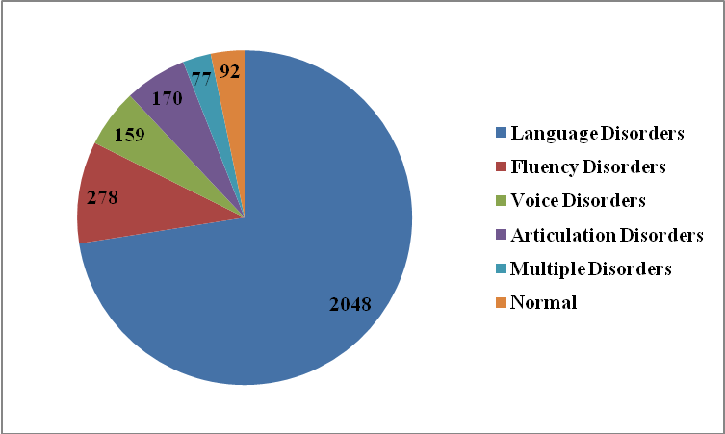
Clients requiring further management were given various speech/language therapies depending upon the type and severity of disorder, for daily sessions of 45 minutes duration. A total of 7,305 therapy sessions were conducted for 1,093 persons with speech/ language disorders (walk in) and a total of 9,154 therapy sessions were conducted for 1,995 persons with speech/ language disorders (tele mode) during the reporting year. The details of disorder-wise therapy carried out are given in table 3 & 4 and figure 2 & 3.

Table 3: Speech-Language Therapy (walk in)

Months | Disorders
Months | Child Language |  | Adult Language | Voice | Articulation | Fluency | Multiple | Normal | Total
April | Lockdown due to pandemic
May | 7 | 0 |  | 1 | 1 | 2 | 0 | 0 | 11
June | 107 | 13 |  | 1 | 6 | 6 | 0 | 1 | 134
July | 56 | 3 |  | 2 | 6 | 3 | 2 | 1 | 73
Aug | 46 | 5 |  | 0 | 3 | 5 | 8 | 1 | 68
Sept | 43 | 14 |  | 1 | 5 | 6 | 5 | 0 | 74
Oct | 69 | 8 |  | 2 | 12 | 20 | 12 | 12 | 135
Nov | 63 | 6 |  | 2 | 9 | 6 | 6 | 4 | 96
Dec | 99 | 13 |  | 2 | 9 | 12 | 6 | 9 | 150
Jan | 104 | 12 |  | 5 | 6 | 4 | 4 | 2 | 137
Feb | 91 | 8 |  | 1 | 5 | 6 | 7 | 0 | 118
Mar | 69 | 6 |  | 2 | 4 | 5 | 10 | 1 | 97
Total | 754 | 88 |  | 19 | 66 | 75 | 60 | 31 | 1093

Figure 2: Overall Disorder wise Speech-Language Therapy

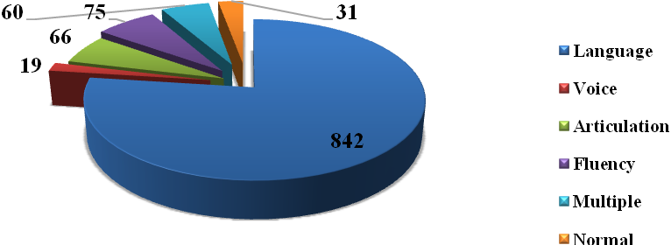

Table 4: Speech-Language Therapy (Tele mode)

Disorders | Language Disorders |  |  | Voice Disorders |  |  | Articulation Disorders |  |  | Multiple Disorders |  |  | MSD |  |  | LD |  |  | Total
Months | C | A | G | C | A | G | C | A | G | C | A | G | C | A | G | C | A | G | Total
April | Lockdown due to pandemic
May | 84 | 14 | 1 | 10 | 0 | 0 | 38 | 0 | 0 | 12 | 3 | 0 | 0 | 6 | 1 | 0 | 0 | 0 | 169
June | 120 | 14 | 0 | 1 | 6 | 2 | 10 | 2 | 0 | 0 | 0 | 0 | 44 | 0 | 0 | 15 | 0 | 0 | 214
July | 91 | 11 | 2 | 0 | 6 | 3 | 10 | 6 | 0 | 0 | 0 | 0 | 26 | 0 | 0 | 9 | 0 | 0 | 164
August | 80 | 5 | 4 | 2 | 6 | 2 | 6 | 3 | 0 | 0 | 0 | 0 | 34 | 0 | 0 | 4 | 0 | 0 | 146
September | 76 | 6 | 2 | 1 | 4 | 1 | 4 | 4 | 0 | 0 | 0 | 0 | 23 | 0 | 0 | 3 | 0 | 0 | 124
October | 127 | 6 | 2 | 1 | 7 | 0 | 8 | 8 | 0 | 0 | 0 | 0 | 34 | 0 | 0 | 3 | 0 | 0 | 196
November | 134 | 6 | 2 | 1 | 7 | 0 | 10 | 7 | 0 | 0 | 0 | 0 | 35 | 0 | 0 | 3 | 0 | 0 | 205
December | 97 | 2 | 2 | 0 | 5 | 0 | 7 | 6 | 0 | 0 | 0 | 0 | 22 | 0 | 0 | 2 | 0 | 0 | 143
January | 111 | 2 | 2 | 0 | 4 | 1 | 6 | 8 | 0 | 0 | 0 | 0 | 28 | 0 | 0 | 2 | 0 | 0 | 164
February | 97 | 1 | 1 | 1 | 5 | 2 | 7 | 7 | 0 | 0 | 0 | 0 | 20 | 0 | 0 | 1 | 0 | 0 | 142
March | 223 | 8 | 0 | 3 | 8 | 0 | 20 | 3 | 0 | 0 | 0 | 0 | 53 | 0 | 0 | 9 | 1 | 0 | 328
Total | 1240 | 75 | 18 | 20 | 58 | 11 | 126 | 54 | 0 | 12 | 3 | 0 | 319 | 6 | 1 | 51 | 1 | 0 | 1995
Disorder Wise | 1333 |  |  | 89 |  |  | 180 |  |  | 15 |  |  | 326 |  |  | 52
Over All | 1995

Figure 3: Overall Disorder wise Speech-Language Therapy

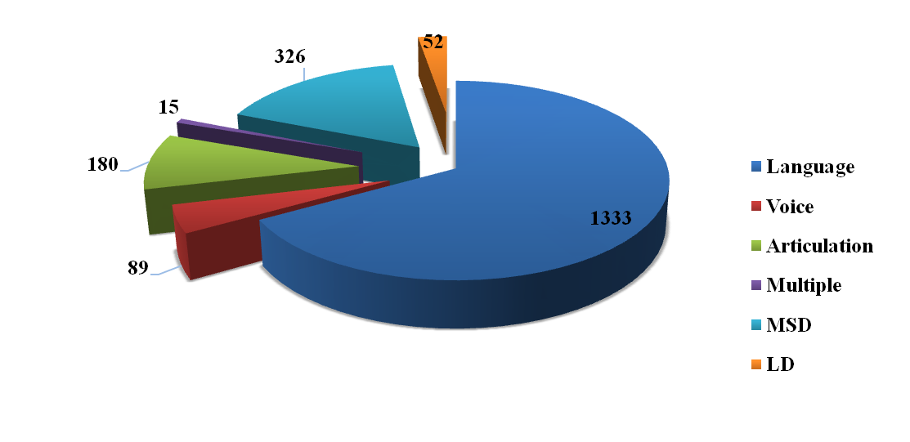
Speech and language assessment and therapeutic services were also provided at the seven DHLS centres of the Institute located in different parts of the country, the details of which are given in table 5.

Table 5 : Speech-Language clinical services at the DHLS Centres

Assessment |  |  |  |  |  | Therapy
Centers | Language | Voice | Phonology | Fluency | MSD/  Dysphasia | Language | Voice | Phonology | Fluency | MSD/  Dysphasia
Mysore | 131 | 30 | 22 | 27 | 0 | -
Ranchi | 55 | - | 17 | 18 | - | 56 | - | 11 | 18 | -
New Delhi | 8 | 17 | 6 | 4 | 1 | 38 | 46 | 14 | 11 | 3
Bhagalpur | 05 | 01 | 01 | 03 | - | 36 | 10 | 15 | 25 | -
Mumbai | 209 | 2 | 4 | 2 | 20 | 302 | 7 | 10 | 13 | 58
Lucknow | 12 | 3 | 4 | 7 | 0 | 26 | 10 | 20 | 12 | 0
MSD:Motor Speech Disorders

Audiological Assessment and Rehabilitation

Hearing Evaluations were carried out on individuals who complained of hearing problems. In the Audiology outpatient department a total of 6,394 clients were assessed and hearing evaluations were carried out for 6,330 individuals. The details of the audiological evaluation are given in table 6.

Table 6: Hearing Evaluation

Sl. | Category | Total
1 | Clients seen in Outpatient department | 6394
2 | Hearing Evaluation | 6330
3 | Normal hearing | 942
4 | Minimal | 722
5 | Mild | 843
6 | Moderate | 785
7 | Moderately severe | 722
8 | Severe | 659
9 | Profound | 713
10 | Minimal to mild | 49
11 | Mild to moderate | 90
12 | Mod. to moderately severe | 219
13 | Modtly severe to severe | 175
14 | Severe to profound | 247
15 | Moderate to severe | 89
16 | Sloping | 424
17 | Ears tested having  - Conductive hearing  - Mixed hearing loss  - SN hearing loss | 1949  2489  3704
18 | Clients with unilateral; Hearing Level | 912
19 | Clients with bilateral Hearing Level | 4825
20 | Ears with Aud. Dys-synchrony | 32
21 | Clients with Auditory Processing Disorder | 2
22 | Clients with Functional Hearing Loss | 82
23 | Clients - tinnitus evaluation | 210
24 | Clients for Pure Tone Audiometry | 6060
25 | Clients for Speech Audiometry | 2219
26 | Clients for Immittance evaluation | 6069
27 | Clients for Otoacoustic Element | 1130
28 | Clients for Auditory Brainstem Response | 1003
29 | Clients for Vestibular Evoked Myogenic Potential | 2
30 | Clients for Video Head Impulse Tests | 1
31 | Clients for Behavioral Observation Audiometry | 195
32 | Clients for Visual Reinforcement Audiometry | 47
33 | Behavioral Vestibular Assessment | 2

Hearing aid trial and prescription were carried out for clients in need for amplification and/or assistive listening devices. Clients evaluated of hearing aids were 3960 and 2510 hearing aids were prescribed at AIISH. Of the 3998 clients evaluated, 1503 were female and 2495 male. The details are given in table 7 and figure 4.
Table 7 : Hearing Aid Trial
Hearing Aid Trial | Total
No. of clients seen for Hearing Aid Trial | 3960
HAs prescribed at AIISH | 2510
- Body level hearing aids | 194
- Analogue BTE | 633
- Digital BTE | 1565
- Trimmer Digital BTE | 2
- Digital ITE | 514
- Digital ITC | 7
- Digital CIC | 19
- Digital RIC | 290
- Testing for CI candidacy | 9
No. of clients recommended
Auditory training | 379
Speech reading | 122
Unaided/aided audiograms | 122
Aided audiogram for Cochlear Implant | 64
Behavioural Observation Audiometry | 5
Aided Visual reinforcement Audiometry | 3
Conditioning | 126
Programming of digital Hearing Aid | 1767
Reprogramming of Hearing Aid | 1534
Retrial with Custom Ear Mould | 362
Recommended for ear plugs | 2
Rec. for Cochlear Implant candidacy | 55

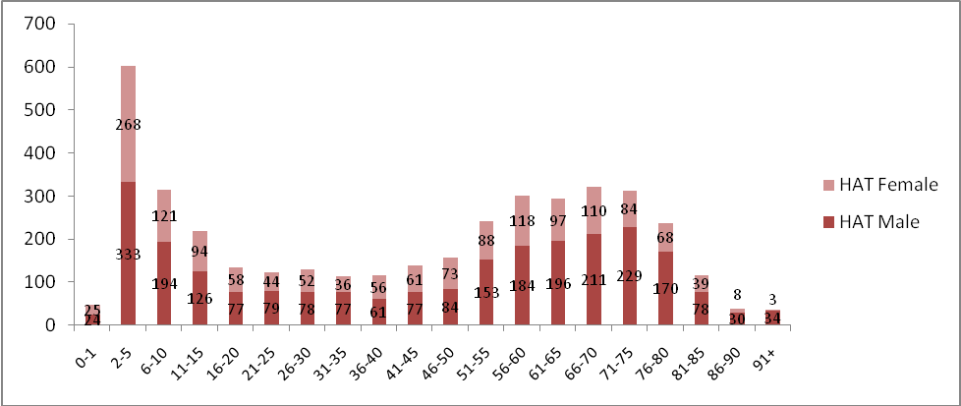
Figure 4: Hearing Aid Trial

At Ear mould lab, ear impressions were taken for 4277 clients. These include 575 new and 3420 old clients at AIISH and 129 in community based camps. The earmould details are given in table 8.

Table 8: Earmould Statistics

Category | Total
Clients attended | 4277
New clients | 575
Old clients | 3420
At Camp | 129
Ear impressions taken | 6921
Free-of-cost | 3187
100% payment | 3601
Ear impression taken-camp | 129
Central Prosthetic Lab impressions | 4
Ear Moulds completed | 4423
No. Mould Lacquered | 1521
No. of sound tube issued | 181
Hard regular moulds | 34
Hard shell mould made | 561
Soft mould made | 2
Hard canal moulds | 443
Soft canal moulds | 17
Instant moulds | 92
In the canal impression made | 24
Swimmer plug (hard) | 5
No. of ear blocked | 1359
Ear Moulds with acoustic modifications | 1178
No. of students posted | 3187

Audiological services were also provided at the DHLS centres of the Institute located in different parts of the country, the details of which are given in table 9.

Centers | OPD  (Case history) | Evaluation | Earmoulds | Hearing aid trial (HAT) | Listening
Mysore | 70 | 156 | 78 | 75 | -
Ranchi | 1110 | 1110 | Nil | Nil | Nil
New Delhi | 430 | 476 | 00 | 16 | 0
Bhagalpur | 219 | 219 | - | - | -
Mumbai | 28 | 28 | - | - | -
Lucknow | 945 | 945 | 0 | 0 | 0

Referred Evaluation-1: Psychological Assessment and Rehabilitation

Psychological assessment was carried out for the referred cases registered at the Department of Clinical Psychology. This includes Routine Psycho-Diagnostic Assessment for Screening and Identification Detailed Psychological Assessment [(including specialized assessment such as assessment for Learning Disability, neuro-psychological assessment, assessment for disability certification, behavioral assessment
and assessment for skill training, Psychological Intervention (including behavior modification programs, home based skill training programs, cognitive-behaviour and group intervention programs for caregivers)].

Routine psycho-diagnostic assessment was carried out for 2851 new, 888 repeat cases and 93 hindi cases at the Department during the reporting year. The detailed is given in table 10.

10: Routine Psycho-Diagnostic Assessment

Classification of disorders according to the criteria included in Chapter V (F) of ICD-10
F 70# | Mental retardation | 1052
F 80.0 | Specific speech articulation disorder | 103
F 80.1 | Expressive language disorder | 401
F 80.2 | Receptive language disorder | 287
F 88# | Other disorders of psychological development | 187
F81# | Specific developmental disorders of scholastic skills | 395
F 84# | Pervasive developmental disorders | 100
F 98.5 | Stuttering (stammering) | 179
F 44.4 | Dissociative motor disorders | 5
F00-F99 | Other disorders included in Chapter V (F) of ICD-10 | 232
The code # refers to "condensed" codes (Ref ICD-IO PC )
Classification according to the criteria included in Chapter XVIII (R) of ICD 10
R 47.0 | Dysphasia and aphasia | 39
R 41.83 | Borderline Intellectual Functioning | 531
Avg. Intelligence with disorders classified elsewhere |  | 321
TOTAL |  | 3,832
Psychological assessment includes intelligence / developmental (203 cases in 322 sessions), psycho-educational (226 cases in 509 sessions), neuropsychological (7 cases in 48 sessions), personality (23 cases in 28 sessions), behavioural (2 cases in 5 sessions) and forensic assessments (4 cases in 18 sessions).

The psychological intervention provided includes behavior modification (69 cases in 162 sessions), cognitive behaviour therapy (8 cases in 22 sessions) neuropsychological rehabilitation (3 cases in 9 sessions).

Referred Evaluation-2: Otolaryngological Assessment and Rehabilitation

The Otorhino-laryngological assessment and rehabilitation for persons with communication disorders were being carried out at the Department of Otolaryngology. In addition to the clinical services provided at the Institute, the Department staffs rendered diagnostic, therapeutic and surgical services at K.R. Hospital, Mysore Medical College, Mysuru. Totally, 11472 new and 12390 review cases were examined during the reporting year at the institute, and 3087 microscopic, 117 stroboscopic / endoscopic examination, 46 vertigo, 25 otoendoscopic and 5 diagnostic naso endoscopic examinations were carried out. Also, 12509 new and 11334 repeat cases were examined and 87 major and 280 minor surgeries were successfully carried out at K.R.Hospital.

Specialized Clinical Services
The institute provided a variety of specialized clinical services for individuals with communication disorders during the reporting year at the following clinical units.

- Augmentative and Alternative Communication (AAC) Unit
The AAC unit supported, enhanced and provided alternative methods of communication for individuals who are non-verbal. The unit evaluated 33 clients in 184 sessions during the reporting year.

- Autism Spectrum Disorders (ASD) Unit
Assessment and treatment were provided for 222 clients with autism spectrum disorders at the ASD unit during the reporting year. Of them, 24 were from Hindi region. The unit also attended 337 therapy and 47 demonstration therapy cases. Thirteen therapy cases discharged during the period. The total number of therapy sessions conducted was 2133 (tele mode) and 1548 (walk in).

- Clinic for Adult and Elderly Persons with Language Disorders (CAEPLD)
CAEPLD provides clinical services to adult and elderly persons. Totally, 67 clients were evaluated in the clinic during the reporting year. The number of therapy cases were 46 and therapy sessions 196. Also there were 35 DT cases. Twenty six cases were discharged.

- Dysphasia Unit
This unit facilitates assessment and management of persons with swallowing disorders. The unit evaluated 31 cases in 36 sessions. Also, there were 10 therapy cases. The number of cases discharged was 5.

- Fluency Unit
This unit catered to the needs of persons with stuttering and other fluency disorders and provided clinical services to 303 persons with fluency disorders in 1565 sessions (Tele mode) and 163 persons with fluency disorders in 1086 sessions (Walk in) during the reporting year.

- Implantable Hearing Devices Unit
The activities of this unit include selection of candidates, mapping/ programming, trouble shooting of implantable hearing devices such as cochlear implant, bone anchored hearing aids and middle ear implants. During the reporting year, 114 clients were seen in the unit. The mapping for Cochlear Implant cases was 67. Trouble shooting was done for 71 client devices. Also, counselling was given for 127 clients.

- Learning Disability Clinic
One case was evaluated in the Unit during the reporting year. Also there was one therapy case who underwent therapy in 15 sessions. There were 40 DT cases.

- Listening Training (LT) Unit
Listening Training Unit: Listening training unit (LTU) is committed to provide aural rehabilitation to the needy. The listening training was provided to not only the clients who use hearing devices such as hearing aids and cochlear implants but also to those with (Central) auditory processing disorders. In addition, training was also imparted to individuals suffering from tinnitus or hyperacusis. Totally, 1282 persons underwent listening training in 7584 sessions during the reporting year. Of the 1282 clients, 130 were new and the remaining 647 were repeat cases.

- Motor Speech Disorders Unit
This specialized unit caters to the needs of persons with motor speech disorders. It enables them to realize their potential and become contributing members of the society. Totally, 127 cases were evaluated in 127 sessions. Also there were 6 therapy cases and 29 Demonstration therapy.

- Neuropsychology Unit
The services offered in the unit includes the assessment of specific function of the brain through standard individualized test, detailed assessment of lobular functions through standardized batteries and rehabilitation through paper pencil techniques or through computer assisted packages. Totally, 7 (48 sessions) neuropsychological assessments and 3 (9 sessions) neuropsychological rehabilitation were made during the reporting year in the unit.

- Professional Voice Care (PVC) Unit
The unit provided specialized assessment and management services to professional voice users during the reporting year. It organized various programs to orient and sensitize professional voice
users on care, maintenance and conservation of voice. The unit evaluated 12 clients and provided rehabilitation to 20 clients. In addition, the unit trained a total of 64 UG and PG students in 273 hours.

- Structural Orofacial Anomalies (U- SOFA) Unit
Clients with deformalities in the growth of head and facial bones were given multi-disciplinary diagnostic and rehabilitation services in the clinic. The experts of the clinic evaluated 8 clients during the reporting year. Also 29 (telemode) and 14 (walk in) cases were evaluated in 178 (telemode) and 85 (walk in) sessions.

- Vertigo Clinic
The clinic offered comprehensive care in evaluation and management of patients with vertigo. A multidisciplinary team comprising of otolaryngologist, audiologist and neurologist evaluated 46 new and 424 follow up patients in the clinic for both peripheral and central vertigo during the reporting year and diagnostic tests like microscopic examination of ear, electro nystagmography, vestibulo spinal tests, neurological evaluation, video nystagmography, audiological tests and vestibular evoked myogenic potential test were carried out for the needy ones.

- Voice Clinic
This clinic offered evaluation and management services to persons of all ages with voice disorders. Totally, 27 clients with voice disorders were evaluated in the clinic using video stroboscopy and software for voice assessment and rehabilitation services was provided to 50 cases.

Special Educational Services

The following educational services were provided to the children with special needs at the pre-school, attached to the Department of Special Education during the reporting year.

- Special Educational Assessment: Educational Assessment services are offered for 337 children with communication disorders to determine readiness for schooling and to suggest an appropriate grade, placement as well as necessary services.

- Parent Infant Program (PIP): PIP was provided to very young children ranging from birth to 2.5 years with the objective of improving physical, cognitive, communication, social and emotional skills as detailed in figure 5.

- Preschool Parent Empowerment Program (PPEP): PPEP was provided to 858 caregivers of children ranging from 2.5-3 years before formal admission to preschool in 3301 sessions with the aim of empowering caregivers to train their children and get adjusted to preschool atmosphere.

- Preschool Training & Supplementary Services (PSS): Preschool service, a preparatory training for children with communication disorders in self-help, cognitive, communication and academic skills necessary for successful schooling was provided to children in the age range of 3-6 years having hearing impairment, cerebral palsy, and multiple disability and to those in the age range of 3-10 years having intellectual disability and autism. The details are given in table 11.

- Curricular Support Services, Individualized Education Program and Demonstration Education Therapy / Non formal Education Program were offered respectively to 256, 42 and 5 children with communication disorders who were mainstreamed but have certain difficulties in coping with academics.

- Sensory Adaptation for Education to cater to the sensory issues of young children with special needs.

- Special use of music for educational readiness and up-building (Unit was discontinued during Covid-19).
- Speech-Language group therapy
- Support services for Empowering Caregivers
- One-month summer camp for children (camp was not conducted due to Covid-19.
- Counselling and guidance for parents and family
- Literacy computer and yoga
- Parent Enrichment Program
- Library of books and toys
- Parents help parents program

Table 11: Pre School Training
Sl.  No. | Apr | May | June | July | Aug | Sep | Oct | Nov | Dec | Jan | Feb | Mar | Total
Clients | 145 | 154 | 154 | 164 | 173 | 169 | 169 | 168 | 164 | 164 | 160 | 153 | 1937
Sessions | 947 | 1391 | 711 | 712 | 561 | 680 | 549 | 590 | 652 | 714 | 696 | 790 | 8993

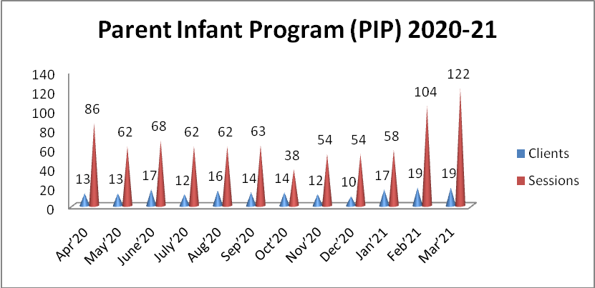
Figure 5: Parent Infant Programme

Medical Speciality & Allied Health Services

The institute facilitated the services of various medical specialists such as pediatrician, neurologist, plastic surgeon, prosthodontist, orthodontist, phono-surgeon and services of allied health professionals such as physiotherapist and occupational therapist, to the needy clients. Totally, 433 (walk in) and 301 (telemode) patients underwent Physio and Occupational therapy in 2337 (walk in) and 1932 (telemode) sessions, during the reporting year. In addition, 39, 31, 39, 10, 30 clients consulted pediatrician, phonosurgeon, plastic surgeon, orthodontist, Dietician respectively. The details are given in figure 6.

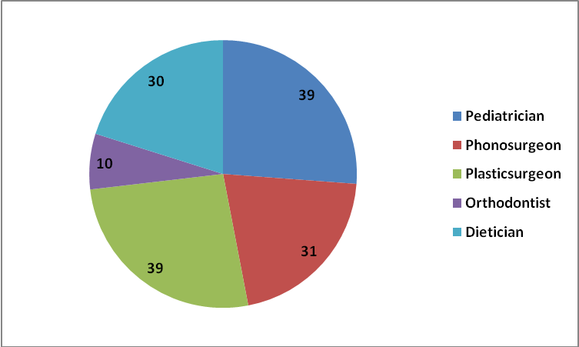

Figure 6: Medical specialty and allied health

Clinical Support Services

The institute extended a diverse range of support services to patients and their family. These include the following.

- Distribution and Repairing of Aids:
Electro-acoustic evaluation, management and repair of hearing aids were carried out under the aegis of Department of Electronics. Totally 1203 hearing aids were distributed (AIISH-948, OSCs-197, Camps-60 & Plan Project - 35), after electro-acoustic evaluation and testing under ADIP scheme. Under AIISH Hearing Aid Dispensing Scheme, 2324 hearing aids were issued at concessional rate. Also, 71291 hearing aid spares such as HA cells, cords, battery doors, ear hooks, body case, wind weather protector, BET Huggies, Domes and Tips were issued. In addition, 249 body level and 954 BTE hearing aids were repaired, electronic-acoustic evaluation was carried out for 7 hearing aids and 5 audiometers were calibrated.

- Counselling and Guidance: The professional experts of the Institute provided counselling and guidance on various aspects of the disorders such as treatment procedures, usage and care of tools like hearing aids during the reporting year.

Issue of Certificates:
Various certificates like financial aid, income tax exemption, educational scholarship, and school admission were issued to the eligible candidates during the reporting year, the details of which are given in table 12.

Table 12: Details of certificates issued

Particulars | Total
Transfer certificate | 6
Evaluation reports | 154
Attendance certificate | 22
School admission certificate | 4
Admission to deaf school | 5
MR Certificate | 592
Railway concession | 17
Bonafide certificate | 9
Handicapped Certificate (Pension) | 690
Medical Certificate | 442

- Financial Aid: The institute distributed total amount of Rs. 3,76,938/- among 7 clients below poverty line towards the purchase of hearing aids during the reporting year under the aegis of the Department of Clinical Services.

- Clinical Observation Posting
The institute facilitated clinical observation posting for students in the area of communication disorders and allied fields from other institutes in the country and abroad. Around hundred students and staff from 5 institutes across the country and abroad were posted for clinical observation in different clinical units and departments of the institute during the reporting year. The details of the institutions are given below.
1. Vidyavardhaka College of Engineering, Mysuru
2. Maharaja Institute of Technology, Mysuru
3. Karnataka Institute of Medical Sciences, Hubli
4. Hassan Institute of Medical Sciences, Hassan
5. Free Lancer

