**CLINICAL CARE**

**Patient Registration**

Totally **13,432** new clients were registered for availing clinical services at the institute during the reporting year. In addition, **29,965** case files were retrieved for repeat/follow up visits for various evaluations. The geographical and gender-wise details of new clients are given in table 1. Majority of them (12970) were from Karnataka, the state in which the institute is located, followed by the neighboring states of Kerala (174), Tamil Nadu (88), and Andhra Pradesh (67). Also there were clients from Maldives, Nepal, Quatar, UAE, U.K and USA. The clients include 8136 males and 5296 females.

Table 1: Geographical & gender-wise distribution of new clients

|  |  |  |  |  |
| --- | --- | --- | --- | --- |
| **Sl. No** | **Locality** | **Male** | **Female** | **Total** |
|  | Andra Pradesh | 46 | 21 | 67 |
|  | Arunachal Pradesh | - | 1 | 1 |
|  | Assam | 2 | 1 | 3 |
|  | Bihar | 12 | 2 | 14 |
|  | Chattisgarh | 2 | 1 | 3 |
|  | Delhi | 4 | 3 | 7 |
|  | Goa | 1 | - | 1 |
|  | Gujarat | 7 | - | 7 |
|  | Hariyana | 1 | 2 | 3 |
|  | Himachal Pradesh | - | - | - |
|  | Jarkhand | 6 | 2 | 8 |
|  | Karnataka | 7817 | 5153 | 12970 |
|  | Kashmir | 2 | 1 | 3 |
|  | Kerala | 117 | 57 | 174 |
|  | Madhya Pradesh | 3 | 2 | 5 |
|  | Maharastra | 8 | 6 | 14 |
|  | Orissa | 6 | 2 | 8 |
|  | Punjab | 1 | - | 1 |
|  | Rajasthan | 9 | 4 | 13 |
|  | Sikkim | 1 | - | 1 |
|  | Tamil Nadu | 59 | 29 | 88 |
|  | Telangana | 8 | - | 8 |
|  | Tripur | 1 | - | 1 |
|  | Uttar Pradesh | 11 | 5 | 16 |
|  | Uttaranchal | 2 | 1 | 3 |
|  | West Bengal | 6 | 1 | 7 |
|  | Overseas | 04 | 02 | **06** |
| **Total** | | **8136** | **5296** | **13432** |

**Speech and Language Assessment and Rehabilitation**

Totally, 3953 clients underwent speech and language evaluation which include 2,824 new and **1129** review cases. Of the **2824** new cases, assessment was carried out for **2350** clients in physical mode and **474** in virtual mode.

Of the new cases, **2,732** persons were identified with various kinds of speech and language disorders and **92** were found to have normal speech. Whereas, of the **1129** review cases, **1098** persons were with various disorders, and the remaining **31** were normal. The details of various speech and language disorders diagnosed are given in table 2 and figure 1.

Table 2: Assessment of Speech-Language Disorders

|  |  |  |  |  |  |  |  |  |  |  |  |  |  |  |  |  |  |  |  |
| --- | --- | --- | --- | --- | --- | --- | --- | --- | --- | --- | --- | --- | --- | --- | --- | --- | --- | --- | --- |
| **Disorders** | **Language Disorders** | | | **Fluency Disorders** | | | **Voice Disorders** | | | **Articulation Disorders** | | | **Multiple Disorders** | | | **Normal** | | | **Total** |
| Months | C | A | G | C | A | G | C | A | G | C | A | G | C | A | G | C | A | G |
| April | Lockdown period | | | | | | | | | | | | | | | | | | |
| May | 35 | 0 | 0 | 8 | 4 | 0 | 2 | 1 | 2 | 2 | 2 | 0 | 0 | 0 | 0 | 2 | 0 | 0 | 58 |
| June | 107 | 31 | 1 | 23 | 5 | 0 | 1 | 21 | 5 | 4 | 0 | 0 | 1 | 0 | 0 | 4 | 3 | 0 | 206 |
| July | 32 | 6 | 1 | 10 | 6 | 0 | 0 | 4 | 0 | 1 | 2 | 0 | 0 | 0 | 0 | 0 | 1 | 0 | 63 |
| Aug | 84 | 14 | 3 | 7 | 4 | 0 | 2 | 1 | 2 | 4 | 2 | 0 | 5 | 3 | 0 | 2 | 1 | 0 | 134 |
| Sept | 123 | 25 | 4 | 16 | 2 | 0 | 2 | 3 | 1 | 12 | 7 | 1 | 6 | 6 | 0 | 4 | 7 | 0 | 219 |
| Oct | 103 | 31 | 1 | 12 | 10 | 0 | 0 | 5 | 1 | 6 | 8 | 0 | 4 | 1 | 0 | 4 | 9 | 0 | 195 |
| Nov | 138 | 27 | 1 | 19 | 3 | 0 | 2 | 10 | 3 | 5 | 4 | 0 | 4 | 6 | 0 | 8 | 1 | 0 | 231 |
| Dec | 242 | 31 | 0 | 29 | 15 | 0 | 4 | 16 | 4 | 19 | 8 | 1 | 4 | 1 | 0 | 7 | 6 | 1 | 388 |
| Jan | 259 | 31 | 2 | 18 | 10 | 0 | 3 | 13 | 3 | 21 | 10 | 0 | 9 | 1 | 1 | 13 | 0 | 0 | 394 |
| Feb | 316 | 47 | 1 | 26 | 11 | 0 | 1 | 18 | 7 | 16 | 10 | 5 | 10 | 4 | 0 | 4 | 4 | 0 | 480 |
| March | 276 | 67 | 9 | 28 | 12 | 0 | 1 | 19 | 2 | 17 | 2 | 1 | 9 | 2 | 0 | 6 | 5 | 0 | 456 |
| **Total** | 1715 | 310 | 23 | 196 | 82 | 0 | 18 | 111 | 30 | 107 | 55 | 8 | 52 | 24 | 1 | 54 | 37 | 1 | **2824(N) + 1129(R)** |
| Disorder Wise | **2048(N)+869 (R)** | | | **278(N) + 80(R)** | | | **159(N) +22(R)** | | | **170(N) +67(R)** | | | **77(N) +60(R)** | | | **92(N) +31(R)** | | |
| **Over All** | **3953** | | | | | | | | | | | | | | | | | | |

*C- Child, A-Adult, G-Geriatric, N-New cases, R-Review cases*

*Figure: 1 Assessment of Speech-Language Disorders (New cases-disorder-wise)*

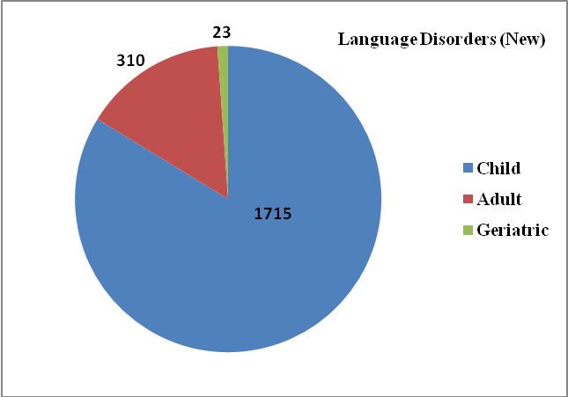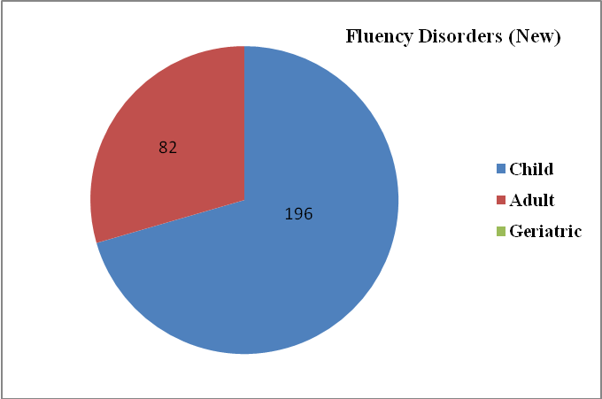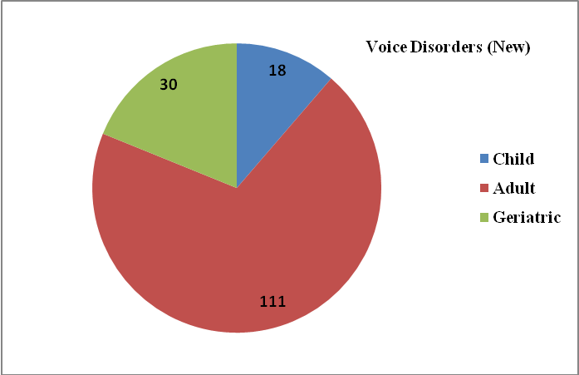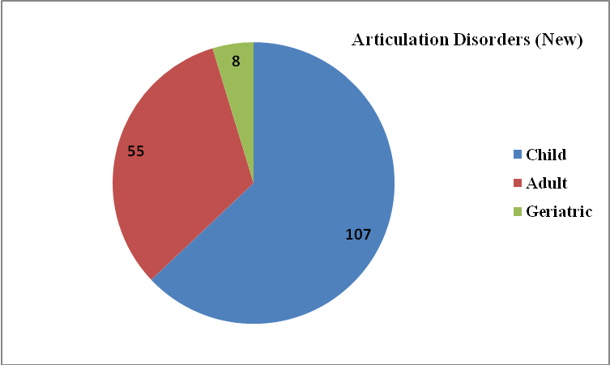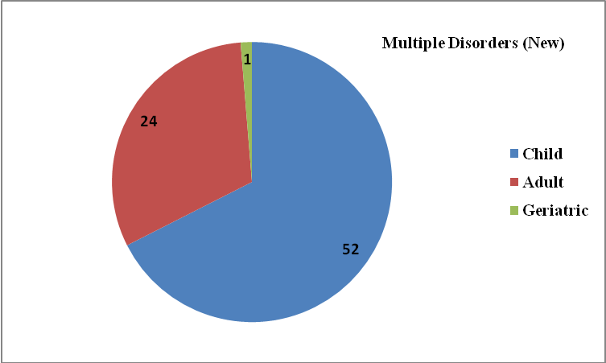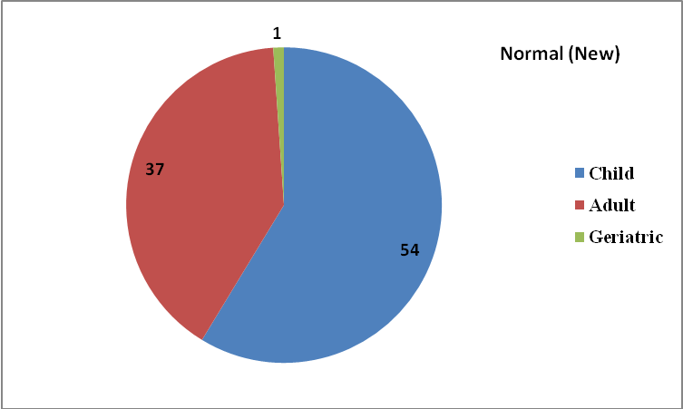

***Overall Assessment of Speech-Language Disorders***

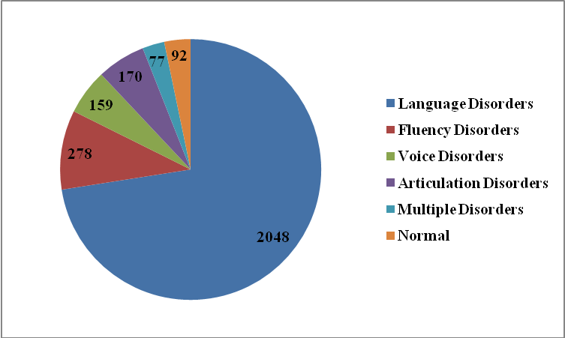

*Figure 2: Overall Disorder wise Speech-Language Therapy*

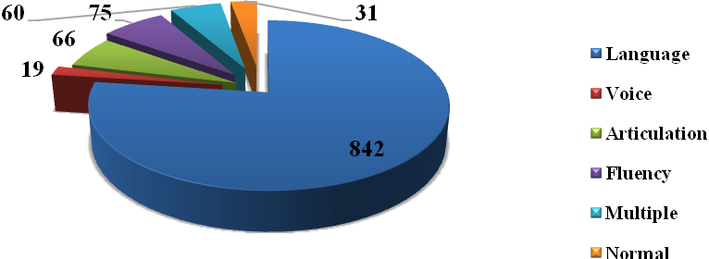

Clients requiring further management were given various speech/language therapies depending upon the type and severity of disorder, for daily sessions of 45 minutes duration. In addition to the normal physical mode, the therapy sessions were conducted in virtual mode. A total of 1995 persons with speech/ language disorders underwenttherapy in physical mode, and 791 persons underwent therapy in virtual mode during the reporting year. The total therapy sessions were 16667. The details of disorder-wise therapy carried out are given in *table 3* & 4, and *figure 2 & 3*.

Table 3: Speech-Language Therapy (*Virtual mode*)

|  |  |  |  |  |  |  |  |  |  |  |  |  |  |  |  |  |  |  |  |
| --- | --- | --- | --- | --- | --- | --- | --- | --- | --- | --- | --- | --- | --- | --- | --- | --- | --- | --- | --- |
| **Disorders** | **Language Disorders** | | | **Voice Disorders** | | | **Articulation Disorders** | | | **Multiple Disorders** | | | **MSD** | | | **LD** | | | **Total** |
| Months | C | A | G | C | A | G | C | A | G | C | A | G | C | A | G | C | A | G |
| April | Lockdown period | | | | | | | | | | | | | | | | | | |
| May | 84 | 14 | 1 | 10 | 0 | 0 | 38 | 0 | 0 | 12 | 3 | 0 | 0 | 6 | 1 | 0 | 0 | 0 | **169** |
| June | 120 | 14 | 0 | 1 | 6 | 2 | 10 | 2 | 0 | 0 | 0 | 0 | 44 | 0 | 0 | 15 | 0 | 0 | **214** |
| July | 91 | 11 | 2 | 0 | 6 | 3 | 10 | 6 | 0 | 0 | 0 | 0 | 26 | 0 | 0 | 9 | 0 | 0 | **164** |
| August | 80 | 5 | 4 | 2 | 6 | 2 | 6 | 3 | 0 | 0 | 0 | 0 | 34 | 0 | 0 | 4 | 0 | 0 | **146** |
| September | 76 | 6 | 2 | 1 | 4 | 1 | 4 | 4 | 0 | 0 | 0 | 0 | 23 | 0 | 0 | 3 | 0 | 0 | **124** |
| October | 127 | 6 | 2 | 1 | 7 | 0 | 8 | 8 | 0 | 0 | 0 | 0 | 34 | 0 | 0 | 3 | 0 | 0 | **196** |
| November | 134 | 6 | 2 | 1 | 7 | 0 | 10 | 7 | 0 | 0 | 0 | 0 | 35 | 0 | 0 | 3 | 0 | 0 | **205** |
| December | 97 | 2 | 2 | 0 | 5 | 0 | 7 | 6 | 0 | 0 | 0 | 0 | 22 | 0 | 0 | 2 | 0 | 0 | **143** |
| January | 111 | 2 | 2 | 0 | 4 | 1 | 6 | 8 | 0 | 0 | 0 | 0 | 28 | 0 | 0 | 2 | 0 | 0 | **164** |
| February | 97 | 1 | 1 | 1 | 5 | 2 | 7 | 7 | 0 | 0 | 0 | 0 | 20 | 0 | 0 | 1 | 0 | 0 | **142** |
| March | 223 | 8 | 0 | 3 | 8 | 0 | 20 | 3 | 0 | 0 | 0 | 0 | 53 | 0 | 0 | 9 | 1 | 0 | **328** |
| **Total** | **1240** | **75** | **18** | **20** | **58** | **11** | **126** | **54** | **0** | **12** | **3** | **0** | **319** | **6** | **1** | **51** | **1** | **0** | **1995** |
| Disorder Wise | **1333** | | | **89** | | | **180** | | | **15** | | | **326** | | | **52** | | | **1995** |
| **Over All** | **1995** | | | | | | | | | | | | | | | | | | |

*Figure 3: Overall Disorder wise Speech-Language Therapy*

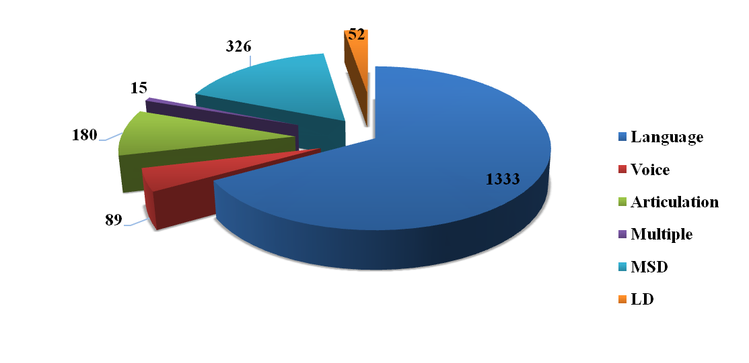

Table 4: Speech-Language Therapy (*Physical mode*)

|  |  |  |  |  |  |  |  |  |  |  |  |  |  |  |  |  |  |  |  |  |
| --- | --- | --- | --- | --- | --- | --- | --- | --- | --- | --- | --- | --- | --- | --- | --- | --- | --- | --- | --- | --- |
| **Disorders** | **Language Disorders** | | | **Voice Disorders** | | | **Articulation Disorders** | | | **Multiple Disorders** | | | **MSD** | | | **LD** | | | | **Total** |
| Months | C | A | G | C | A | G | C | A | G | C | A | G | C | A | G | C | A | G | |
| Apr-20 |  | | | | | | | | | | | | | | | | | |  | |
| May-20 |
| Jun-20 |
| Jul-20 |
| Aug-20 |
| Sep-20 |
| Oct-20 |
| Nov-20 |
| Dec-20 | 110 | 6 | 0 | 0 | 9 | 1 | 18 | 2 | 0 | 0 | 0 | 0 | 26 | 0 | 0 | 1 | 1 | 0 | | **174** |
| Jan-21 | 187 | 9 | 0 | 2 | 12 | 0 | 22 | 1 | 0 | 0 | 0 | 0 | 48 | 0 | 0 | 8 | 0 | 0 | | **289** |
| Feb-21 | 223 | 8 | 0 | 3 | 8 | 0 | 20 | 3 | 0 | 0 | 0 | 0 | 53 | 0 | 0 | 9 | 1 | 0 | | **328** |
| Mar-21 | 0 | 0 | 0 | 0 | 0 | 0 | 0 | 0 | 0 | 0 | 0 | 0 | 0 | 0 | 0 | 0 | 0 | 0 | | **0** |
| **Total** | **520** | **23** | **0** | **5** | **29** | **1** | **60** | **6** | **0** | **0** | **0** | **0** | **127** | **0** | **0** | **18** | **2** | **0** | | **791** |
| Disorder Wise | **543** | | | **35** | | | **66** | | | **0** | | | **127** | | | **20** | | | |
| **Over All** | **791** | | | | | | | | | | | | | | | | | | | |

Speech and language assessment and therapeutic services were also provided at the seven DHLS centres of the Institute located in different parts of the country, the details of which are given in table 5.

Table 5 : Speech-Language clinical services at the DHLS Centres

|  |  |  |  |  |  |  |  |  |  |  |
| --- | --- | --- | --- | --- | --- | --- | --- | --- | --- | --- |
| **Assessment** | | | | | | **Therapy** | | | | |
| **Centers** | **Language** | **Voice** | **Phonology** | **Fluency** | **MSD/**  **Dysphasia** | **Language** | **Voice** | **Phonology** | **Fluency** | **MSD/**  **Dysphasia** |
| Mysore | 131 | 30 | 22 | 27 | 0 | - | | | | |
| Ranchi | 55 | - | 17 | 18 | - | 56 | - | 11 | 18 | - |
| New Delhi | 8 | 17 | 6 | 4 | 1 | 38 | 46 | 14 | 11 | 3 |
| Bhagalpur | 05 | 01 | 01 | 03 | - | 36 | 10 | 15 | 25 | - |
| Mumbai | 209 | 2 | 4 | 2 | 20 | 302 | 7 | 10 | 13 | 58 |
| Lucknow | 12 | 3 | 4 | 7 | 0 | 26 | 10 | 20 | 12 | 0 |

**Audiological Assessment and Rehabilitation**

Hearing Evaluations were carried out on individuals who complained of hearing problems. In the Audiology outpatient department, a total of 6,394 clients were assessed and hearing evaluations were carried out for 6,330 individuals. Of the 6330 clients evaluated, **2495** were female and **3945** male. The details of the audiological evaluation are given in table 6.

Table 6: Hearing Evaluation

|  |  |  |
| --- | --- | --- |
| **Sl.** | **Category** | **Total** |
| 1 | Clients seen in Outpatient department | 6394 |
| 2 | Hearing Evaluation | 6330 |
| 3 | Normal hearing | 942 |
| 4 | Minimal | 722 |
| 5 | Mild | 843 |
| 6 | Moderate | 785 |
| 7 | Moderately severe | 722 |
| 8 | Severe | 659 |
| 9 | Profound | 713 |
| 10 | Minimal to mild | 49 |
| 11 | Mild to moderate | 90 |
| 12 | Mod. to moderately severe | 219 |
| 13 | Modtly severe to severe | 175 |
| 14 | Severe to profound | 247 |
| 15 | Moderate to severe | 89 |
| 16 | Sloping | 424 |
| 17 | Ears tested having   * Conductive hearing * Mixed hearing loss * SN hearing loss | 1949  2489  3704 |
| 18 | Clients with unilateral; Hearing Level | 912 |
| 19 | Clients with bilateral Hearing Level | 4825 |
| 20 | Ears with Aud. Dys-synchrony | 32 |
| 21 | Clients with Auditory Processing Disorder | 2 |
| 22 | Clients with Functional Hearing Loss | 82 |
| 23 | Clients - tinnitus evaluation | 210 |
| 24 | Clients for Pure Tone Audiometry | 6060 |
| 25 | Clients for Speech Audiometry | 2219 |
| 26 | Clients for Immittance evaluation | 6069 |
| 27 | Clients for Otoacoustic Element | 1130 |
| 28 | Clients for Auditory Brainstem Response | 1003 |
| 29 | Clients for Vestibular Evoked Myogenic Potential | 2 |
| 30 | Clients for Video Head Impulse Tests | 1 |
| 31 | Clients for Behavioral Observation Audiometry | 195 |
| 32 | Clients for Visual Reinforcement Audiometry | 47 |
| 33 | Behavioral Vestibular Assessment | 2 |

Hearing aid trial and prescription were carried out for clients in need for amplification and/or assistive listening devices. Clients evaluated of hearing aids were 3960 and 2510 hearing aids were prescribed at AIISH. Of the **3998** clients evaluated, **1503** were female and **2495** male. The details are given intable 7 and figure 4.

Table 7: Hearing Aid Trial

|  |  |
| --- | --- |
| **Hearing Aid Trial** | **Total** |
| No. of clients seen for Hearing Aid Trial | 3960 |
| HAs prescribed at AIISH | 2510 |
| * Body level hearing aids | 194 |
| * Analogue BTE | 633 |
| * Digital BTE | 1565 |
| * Trimmer Digital BTE | 2 |
| * Digital ITE | 514 |
| * Digital ITC | 7 |
| * Digital CIC | 19 |
| * Digital RIC | 290 |
| * Testing for CI candidacy | 9 |
| No. of clients recommended | |
| Auditory training | 379 |
| Speech reading | 122 |
| Unaided/aided audiograms | 122 |
| Aided audiogram for Cochlear Implant | 64 |
| Behavioural Observation Audiometry | 5 |
| Aided Visual reinforcement Audiometry | 3 |
| Conditioning | 126 |
| Programming of digital Hearing Aid | 1767 |
| Reprogramming of Hearing Aid | 1534 |
| Retrial with Custom Ear Mould | 362 |
| Recommended for ear plugs | 2 |
| Rec. for Cochlear Implant candidacy | 55 |

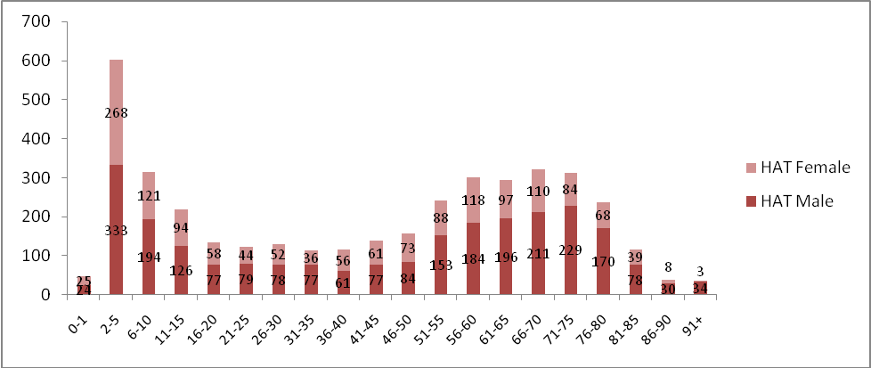

Figure 4: Hearing Aid Trial

At Ear mould lab, ear impressions were taken for **4277** clients. These include **575** new and **3420** old clients at AIISH and **129** in community-based camps. The earmold details are given table 8.

Table 8: Earmould Statistics

|  |  |
| --- | --- |
| **Category** | **Total** |
| Clients attended | 4277 |
| New clients | 575 |
| Old clients | 3420 |
| At Camp | 129 |
| **Ear impressions taken** | |
| Free-of-cost | 3187 |
| 100% payment | 3601 |
| Ear impressions taken-camp | 129 |
| CPL impressions | 4 |
| EMs completed | 4423 |
| No. Mould Lacquered | 1521 |
| No. of sound tube issued | 181 |
| Hard regular moulds | 34 |
| Hard shell mould made | 561 |
| Soft mould made | 2 |
| Hard canal moulds | 443 |
| Soft canal moulds | 17 |
| Instant moulds | 92 |
| ITC impression made | 24 |
| Swimmer plug (hard) | 5 |
| No. of ear blocked | 1359 |
| EMs with aco. modificns. | 1178 |
| No. of students posted | 3187 |

Audiological services were also provided at the DHLS centres of the Institute located in different parts of the country, the details of which are given in table 9.

**Table 9: Audiological services at the DHLS centres**

|  |  |  |  |  |  |
| --- | --- | --- | --- | --- | --- |
| **Centers** | **OPD**  **(Case history)** | **Evaluation** | **Earmoulds** | **Hearing aid trial (HAT)** | **Listening** |
| Mysore | 70 | 156 | 78 | 75 | - |
| Ranchi | 1110 | 1110 | Nil | Nil | Nil |
| New Delhi | 430 | 476 | 00 | 16 | 0 |
| Bhagalpur | 219 | 219 | - | - | - |
| Mumbai | 28 | 28 | - | - | - |
| Lucknow | 945 | 945 | 0 | 0 | 0 |

**Referred Evaluation-1: Psychological Assessment and Rehabilitation**

Psychological assessment was carried out for the referred cases registered at the Department of Clinical Psychology. This includes Routine Psycho-Diagnostic Assessment for Screening and Identification Detailed Psychological Assessment [(including specialized assessment such as assessment for Learning Disability, neuro-psychological assessment, assessment for disability certification, behavioral assessment and assessment for skill training, Psychological Intervention (including behavior modification programs, home based skill training programs, cognitive-behaviour and group intervention programs for caregivers).

Routine psycho-diagnostic assessment was carried out for **3471** new and **946** repeat cases at the Department during the reporting year. The detailed is given in *table 10.*

Table 10: Routine Psycho-Diagnostic Assessment

|  |  |  |
| --- | --- | --- |
| Classification of disorders according to the criteria included in Chapter V (F) of ICD-10 | | |
| F 70# | Mental retardation | 1052 |
| F 80.0 | Specific speech articulation disorder | 103 |
| F 80.1 | **Expressive language disorder** | 401 |
| F 80.2 | **Receptive language disorder** | 287 |
| F 88# | **Other disorders of psychological development** | 187 |
| F81# | **Specific developmental disorders of scholastic skills** | 395 |
| F 84# | **Pervasive developmental disorders** | 100 |
| F 98.5 | **Stuttering (stammering)** | 179 |
| F 44.4 | **Dissociative motor disorders** | 5 |
| F00-F99 | Other disorders included in Chapter V (F) of ICD-10 | 232 |
| *The code # refers to "condensed" codes (Ref ICD-IO PC )*  Classification according to the criteria included in Chapter XVIII (R) of ICD 10 | | |
| R 47.0 | Dysphasia and aphasia | 39 |
| R 41.83 | Borderline Intellectual Functioning | 531 |
| Avg. Intelligence with disorders classified elsewhere | | 321 |
| **TOTAL** | | **3,832** |

Psychological assessment includes intelligence / developmental (203 cases in 322 sessions), psycho-educational (226 cases in 509 sessions), neuropsychological (7 cases in 48 sessions), personality (23 cases in 28 sessions), behavioural (2 cases in 5 sessions) and forensic assessments (4 cases in 18 sessions).

The psychological intervention provided includes behavior modification (69 cases in 162 sessions), cognitive behaviour therapy (8 cases in 22 sessions) neuropsychological rehabilitation (3 cases in 9 sessions) .

**Referred Evaluation-2: Otolaryngological Assessment and Rehabilitation**

The Otorhino-laryngological assessment and rehabilitation for persons with communication disorders were being carried out at the Department of Otolaryngology. In addition to the clinical services provided at the Institute, the Department staffs rendered diagnostic, therapeutic and surgical services at K.R. Hospital, Mysore Medical College, Mysuru. Totally, 11472 new and 12390 review cases were examined during the reporting year at the institute, and 3087 microscopic, 117 stroboscopic / endoscopic examination, 46 vertigo, 25 otoendoscopic and 5 diagnostic naso endoscopic examinations were carried out. Also, 12509 new and 11334 repeat cases were examined and 87 major and 280 minor surgeries were successfully carried out at K.R.Hospital.

**Specialized Clinical Services**

The institute provided a variety of specialized clinical services for individuals with communication disorders in both physical and virtual mode during the reporting year. The details are provided in tables 11, 12 and 13.

**Table 11: Evaluation at the Special Clinics**

|  |  |  |  |  |  |  |  |  |  |  |  |  |  |
| --- | --- | --- | --- | --- | --- | --- | --- | --- | --- | --- | --- | --- | --- |
| **Units** | **Apr** | **May** | **June** | **July** | **Aug** | **Sept** | **Oct** | **Nov** | **Dec** | **Jan** | **Feb** | **Mar** | **Total** |
| **AAC** | **Lockdown due to pandemic – services not provided** | | | | | | | | | 3 | 10 | 8 | **21** |
| **ASD** | 16 | 16 | 14 | **46** |
| **CAEPLD** | - | 1 | - | **1** |
| **Fluency** | - | - | 6 | **6** |
| **VOICE** | - | - | 8 | **8** |
| **LD** | 12 | 12 | 8 | **32** |
| **Phonology** | - | - | 4 | 1 | 1 | - | - | - | - | 2 | 10 | 2 | **20** |
| **U-SOFA** | **Lockdown due to pandemic - services not provided** | | | | | | | | | | | 8 | **8** |
| **MSD** | 2 | **2** |
| **Total** | | | | | | | | | | | | | **144** |

**Table 12: Treatment at special clinic (Virtual mode)**

|  |  |  |  |  |  |  |  |  |  |  |  |  |  |  |  |  |  |
| --- | --- | --- | --- | --- | --- | --- | --- | --- | --- | --- | --- | --- | --- | --- | --- | --- | --- |
| **Disorders** | **Fluency Unit** | | **ASD - Unit** | | **U-SOFA** | | **AAC** | | **ADHD** | | **Total** | **Total Sessions** | | | | | **Overall**  **Total Sessions** |
| Months | C | A | C | A | C | A | C | A | C | A | **FU** | ASD | AAC | U-SOFA | ADHD |  |
| Apr-20 | 0 | 0 | 0 | 0 | 0 | 0 | 0 | 0 | 0 | 0 | **0** | 0 | 0 | 0 | 0 | 0 | **0** |
| May-20 | 9 | 8 | 60 | 0 | 6 | 2 | 6 | 0 | 4 | 0 | **95** | 59 | 367 | 45 | 45 | 20 | **536** |
| Jun-20 | 34 | 10 | 70 | 0 | 3 | 0 | 7 | 0 | 3 | 0 | **127** | 224 | 245 | 42 | 9 | 11 | **531** |
| Jul-20 | 34 | 9 | 41 | 0 | 2 | 0 | 4 | 0 | 1 | 0 | **91** | 155 | 123 | 1 | 0 | 0 | **279** |
| Aug-20 | 17 | 12 | 34 | 0 | 01 | 01 | 01 | 0 | 04 | 00 | **70** | 103 | 144 | 04 | 03 | 12 | **266** |
| Sep-20 | 14 | 9 | 27 | 2 | 0 | 0 | 1 | 0 | 3 | 0 | **56** | 123 | 204 | 7 | 13 | 23 | **370** |
| Oct-20 | 30 | 12 | 42 | 0 | 0 | 2 | 1 | 3 | 0 | 4 | **94** | 252 | 271 | 27 | 15 | 33 | **598** |
| Nov-20 | 29 | 12 | 46 | 0 | 3 | 1 | 3 | 0 | 5 | 0 | **99** | 248 | 337 | 17 | 24 | 33 | **659** |
| Dec(Tele) | 20 | 9 | 27 | 0 | 3 | 1 | 4 | 0 | 5 | 0 | **69** | 178 | 221 | 19 | 29 | 36 | **483** |
| Jan-21 | 24 | 11 | 30 | 0 | 3 | 1 | 3 | 0 | 4 | 0 | **76** | 223 | 221 | 22 | 40 | 20 | **526** |
| Feb-21 | 37 | 8 | 60 | 0 | 3 | 0 | 4 | 0 | 4 | 0 | **116** | 288 | 422 | 18 | 20 | 33 | **781** |
| Mar-21 | 11 | 5 | 4 | 0 | 1 | 0 | 0 | 0 | 0 | 0 | **21** | 97 | 31 | 0 | 6 | 0 | **134** |
| **Total** | **211** | **92** | **377** | **2** | **21** | **8** | **30** | **3** | **29** | **4** | **777** | **1565** | **2133** | **184** | **178** | **188** | **4248** |
| Disorder Wise | 303 | | 379 | | 29 | | 33 | | 33 | |
| Overall total | **7** | | | | | | | | | | | **4248** | | | | | |

*C- Child, A- Adult, Ot*  *hers=Language/Multiple.*

**Table 13: Treatment at special clinic (Physical mode)**

|  |  |  |  |  |  |  |  |  |  |  |  |  |  |  |  |  |  |  |  |  |
| --- | --- | --- | --- | --- | --- | --- | --- | --- | --- | --- | --- | --- | --- | --- | --- | --- | --- | --- | --- | --- |
| **Disorders** | **Fluency Unit** | | **ASD - Unit** | | **U-SOFA** | | **AAC** | | **ISL** | | **ADHD** | | **Total** | **Sessions** | | | | |  | **Total Sessions** |
| Months | C | A | C | A | C | A | C | A | C | A | C | A | **FU** | ASD | ISL | AAC | U-SOFA | ADHD |
| Apr-20 | **Lockdown due to pandemic – services were provided through online mode** | | | | | | | | | | | | | | | | | | | |
| May-20 |
| Jun-20 |
| Jul-20 |
| Aug-20 |
| Sep-20 |
| Oct-20 |
| Nov-20 |
| Dec(walk in) | 25 | 9 | 38 | 0 | 3 | 0 | 1 | 0 | 0 | 0 | 0 | 0 | **76** | 244 | 259 | 0 | 7 | 24 | 0 | **534** |
| Jan-21 | 33 | 12 | 60 | 0 | 6 | 0 | 3 | 0 | 0 | 0 | 3 | 0 | **117** | 298 | 421 | 0 | 18 | 33 | 13 | **783** |
| Feb-21 | 37 | 8 | 60 | 0 | 3 | 0 | 4 | 0 | 0 | 0 | 4 | 0 | **116** | 288 | 422 | 0 | 18 | 20 | 33 | **781** |
| Mar-21 | 31 | 8 | 64 | 0 | 2 | 0 | 2 | 0 | 0 | 0 | 10 | 0 | **117** | 256 | 446 | 0 | 3 | 8 | 74 | **787** |
| **Total** | **126** | **37** | **222** | **0** | **14** | **0** | **10** | **0** | **0** | **0** | **17** | **0** | **426** | **1086** | **1548** | **0** | **46** | **85** | **120** | **2885** |
| Disorder Wise | 163 | | 222 | | 14 | | 10 | | 0 | | 17 | |
| **Over All** | **426** | | | | | | | | | | | | | **2885** | | | | | | |

**Special Educational Services**

The following educational services were provided to the children with special needs at the pre-school, attached to the Department of Special Education during the reporting year.

1. **Special Educational Assessment:** Educational Assessment services are offered for 337 children with communication disorders to determine readiness for schooling and to suggest an appropriate grade, placement as well as necessary services.
2. **Parent Infant Program (PIP):** PIP wasprovided to very young children ranging from birth to 2.5 years with the objective of improving physical, cognitive, communication, social and emotional skills as detailed in *figure 5*.
3. **Preschool Parent Empowerment Program (PPEP):** PPEP was provided to caregivers of children ranging from 2.5-3 years before formal admission to preschool with the aim of empowering caregivers to train their children and get adjusted to preschool atmosphere. The details are provided in table 14.

**Table 14: Preschool Parent Empowerment Program**

|  |  |  |  |  |  |  |  |  |  |  |  |  |
| --- | --- | --- | --- | --- | --- | --- | --- | --- | --- | --- | --- | --- |
|  | Apr’20 | May’20 | June’20 | July’20 | Aug’20 | Sep’20 | Oct’20 | Nov’20 | Dec’20 | Jan’21 | Feb’21 | Mar’21 |
| Clients | 72 | 72 | 76 | 28 | 35 | 40 | 43 | 52 | 56 | 102 | 131 | 151 |
| Sessions | 361 | 285 | 285 | 220 | 220 | 220 | 160 | 216 | 286 | 288 | 304 | 456 |

1. **Preschool Training & Supplementary Services (PSS):** Preschool service, a preparatory training for children with communication disorders in self-help, cognitive, communication and academic skills necessary for successful schooling was provided to children in the age range of 3-6 years having hearing impairment, cerebral palsy, and multiple disability and to those in the age range of 3-10 years having intellectual disability and autism. The details are given in table 15.

Table 15: Pre School Training

|  |  |  |  |  |  |  |  |  |  |  |  |  |  |
| --- | --- | --- | --- | --- | --- | --- | --- | --- | --- | --- | --- | --- | --- |
| Sl.  No. | Apr | May | June | July | Aug | Sep | Oct | Nov | Dec | Jan | Feb | Mar | **Total** |
| Clients | 145 | 154 | 154 | 164 | 173 | 169 | 169 | 168 | 164 | 164 | 160 | 153 | 1937 |
| Sessions | 947 | 1391 | 711 | 712 | 561 | 680 | 549 | 590 | 652 | 714 | 696 | 790 | 8993 |

1. Curricular Support Services, Individualized Education Program and Demonstration Education Therapy / Non formal Education Program were offered respectively to 256, 42 and 5children with communication disorders who were mainstreamed but have certain difficulties in coping with academics.
2. Sensory Adaptation for Education tocater to the sensory issues of young children with special needs.
3. Speech-Language group therapy
4. Support services for Empowering Caregivers
5. Counselling and guidance for parents and family
6. Literacy computer and yoga
7. Parent Enrichment Program
8. Library of books and toys
9. Parents help parents program

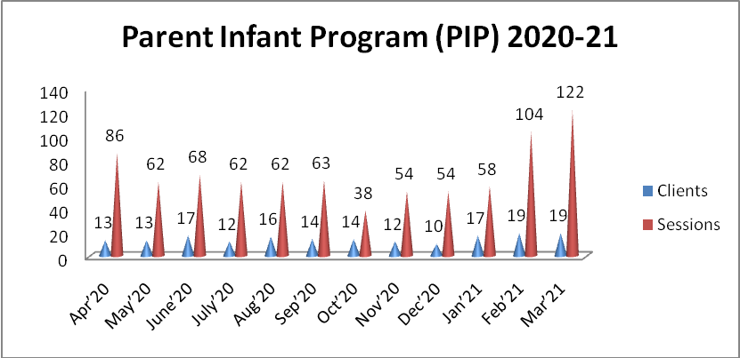

Figure 5: Parent Infant Programme

**Medical Speciality & Allied Health Services**

The institute facilitated the services of various medical specialists such as pediatrician, neurologist, plastic surgeon, prosthodontist, orthodontist, phono-surgeon and services of allied health professionals such as physiotherapist and occupational therapist, to the needy clients. Totally, 433 clients underwent physiotherapy and occupational therapy in physical mode and 301 clients in virtual mode during the reporting year. The physical sessions conducted were 2337 and tele sessions, 1932. In addition, 39, 31, 39, 10, 30 clients consulted pediatrician, phonosurgeon, plastic surgeon, orthodontist, Dietician respectively. The details are given in figure 6.

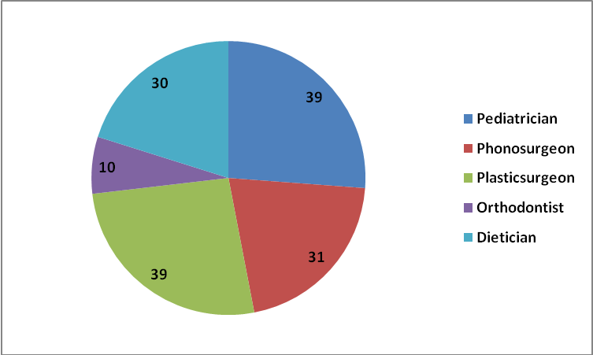

Figure 5: Medical specialty and allied health

**Clinical Support Services**

The institute extended a diverse range of support services to patients and their family. These include the following.

* **Distribution and Repairing of Aids:**

Electro-acoustic evaluation, management and repair of hearing aids were carried out under the aegis of Department of Electronics. Totally 948hearing aids were distributed after electro-acoustic evaluation and testing under AIISH Hearing Aid Dispensing Scheme. Also, 860 free hearing aids were distributed under the Client Welfare Fund. Also, 71291 hearing aid spares such as hearing aid cells, cords, battery doors, ear hooks, body case, wind weather protector, BET huggies, domes and tips were issued. In addition, 249 body level and 954 BTE hearing aids were repaired, electronic-acoustic evaluation was carried out for 7 hearing aids and 5 audiometers were calibrated.

* **Counselling and Guidance:** The professional experts of the Institute provided counselling and guidance on various aspects of the disorders such as treatment procedures, usage and care of tools like hearing aids during the reporting year.

**Issue of Certificates:**

Various certificates like financial aid, income tax exemption, educational scholarship, and school admission were issued to the eligible candidates during the reporting year, the details of which are given in table 12.

Table 12: Details of certificates issued

|  |  |
| --- | --- |
| **Particulars** | **Total** |
| Transfer certificate | 6 |
| Evaluation reports | 154 |
| Attendance certificate | 22 |
| School admission certificate | 4 |
| Admission to deaf school | 5 |
| MR Certificate | 592 |
| Railway concession - ENT | 17 |
| Bonafide certificate | 9 |
| Handicapped Certificate (Pension) | 690 |
| Medical Certificate | 442 |

* **Financial Aid:** The institute distributed total amount of Rs. 3,76,938/- among 36 clients below poverty line towards the purchase of hearing aids during the reporting year under the aegis of the Department of Clinical Services.
* **Clinical Observation Posting**

The institute facilitated clinical observation posting for students in the area of communication disorders and allied fields from other institutes in the country and abroad. Around hundred students and staff from four institutes across the country and abroad were posted for clinical observation in different clinical units and departments of the institute during the reporting year. The details of the institutions are given below.

|  |
| --- |
| 1. Vidyavardhaka College of Engineering, Mysuru |
| 1. Maharaja Institute of Technology, Mysuru 2. Karnataka Institute of Medical Sciences, Hubli 3. Hassan Institute of Medical Sciences, Hassan |