AIISH AISIRI Programs
Initiated second series of AIISH AISIRI Radio Programs in August 2020. Total of 15 programmes were broadcasted in AIR (Mysuru – 100.6MHz).
S.NO | Date | Staff | Topic details
 | 02.08.2020 | Dr. Hema N | Adult Language disorders
 | 09.08..2020 | Dr. S Venkatesan | Psychological problems in children & Parents
 | 16.08.2020 | Dr. Rajeshwari G | Ear discharge causes, Do’s &Don’ts
 | 23.08.2020 | Dr. T K Prakash | Diseases causing voice changes
 | 30.08.2020 | Dr. Santosh M | Myths and facts about stuttering.
 | 06.09.2020 | Dr. Abhishek BP | Dementia
 | 13.09.2020 | Dr. Devi N | Need for early rehabilitation and listening training in children with hearing impairment
 | 20.09..2020 | Dr. Geetha C | Importance of early rehabilitation for individuals with hearing loss
 | 27.09.2020 | Dr. Prashanth Prabhu | Tinnitus and loudness discomfort
 | 03.10.2020 | Dr Yashaswini R | Autism Spectrum Disorders
 | 10.10.2020 | Ms. Sahana V | Voice disorders
 | 18.10.2020 | Ms. Geetha M P | Early identification of communication disorders
 | 25.10.2020 | Ms. Shobha B N | Curriculum adaptation for special children
 | 08.11.2020 | Ms. Kumuda | Role of parents in the educational development of special children
 | 15.11.2020 | Ms. Sumana | Valuation of children with special needs

The first series of 13 episodes of AIISH AISIRI programmes were re-broadcasted from AIR Dharwad during the period August to November 2020.
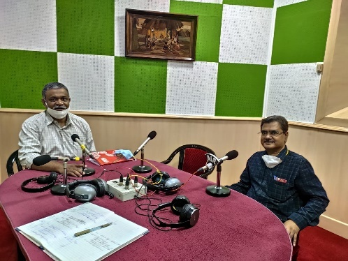 | 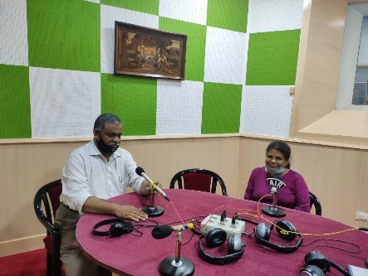
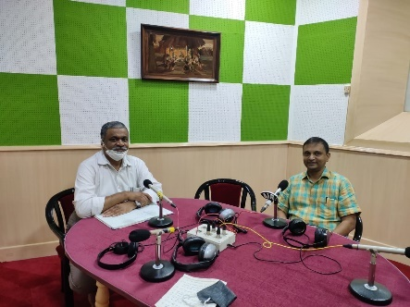 | 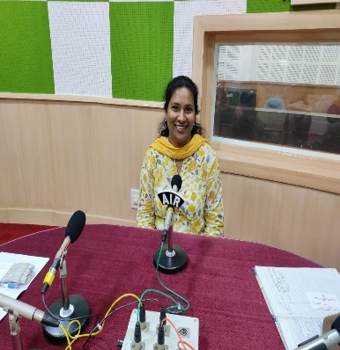
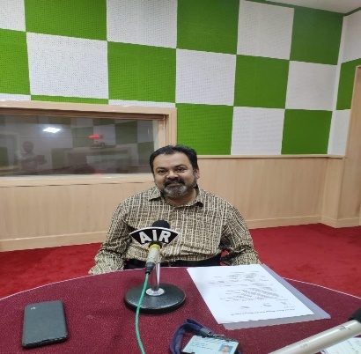 | 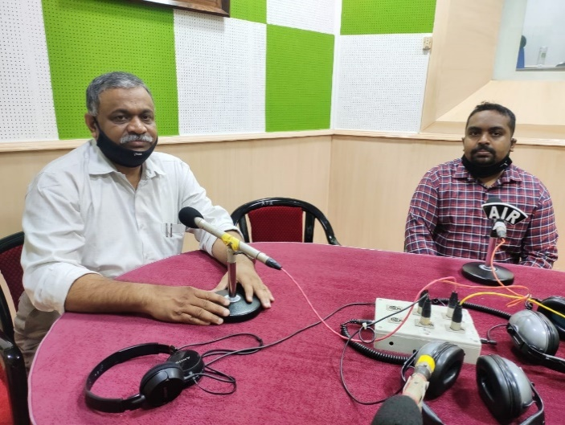
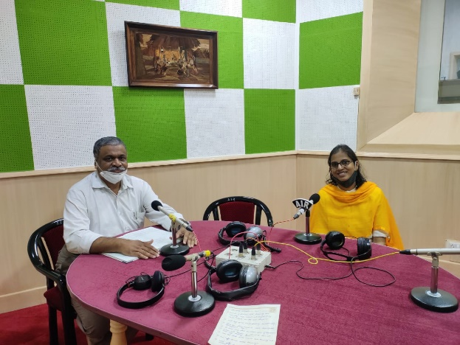 | 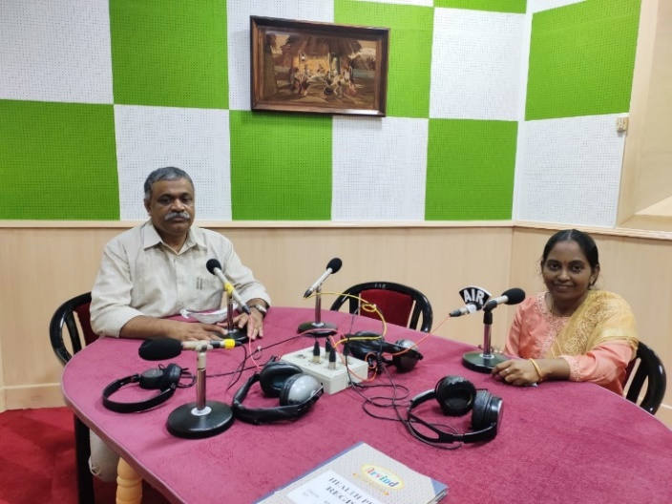
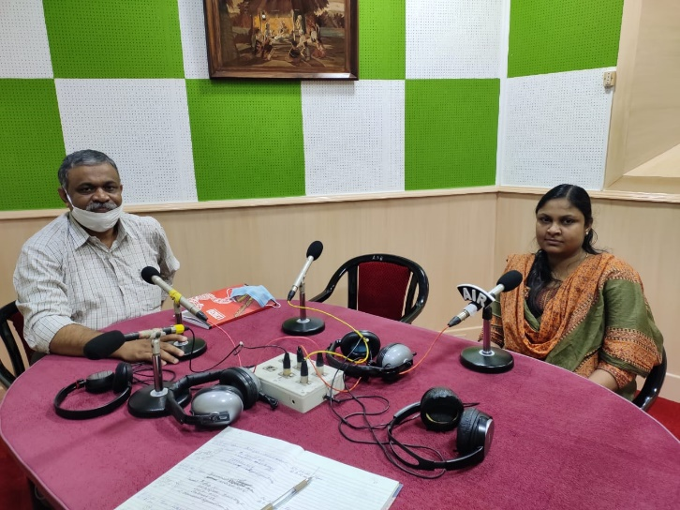 | 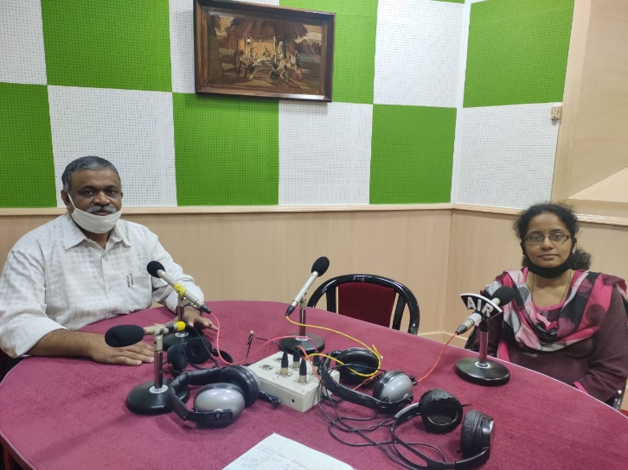
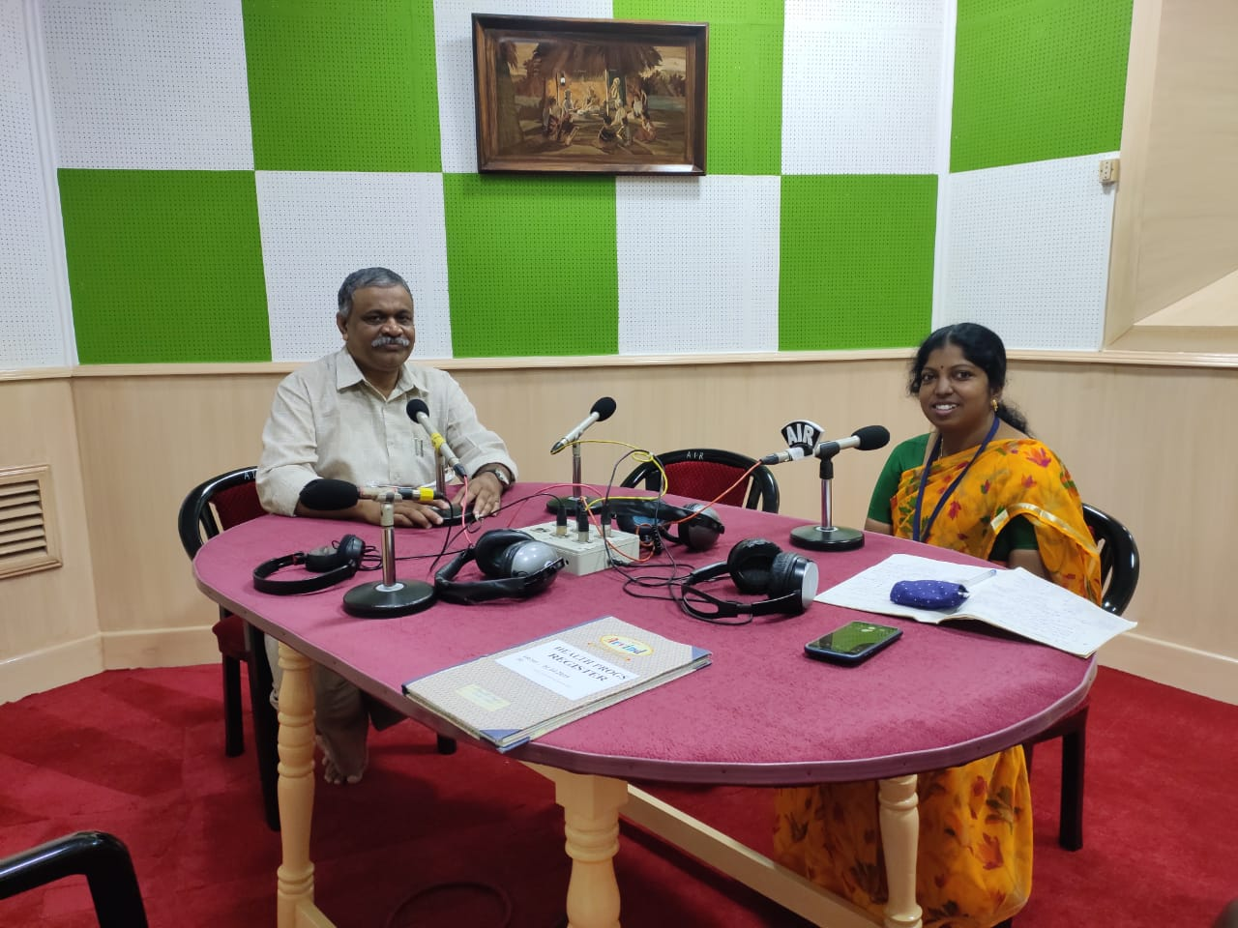 | 