Last update: 31.03.2022

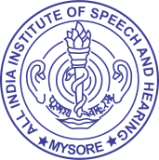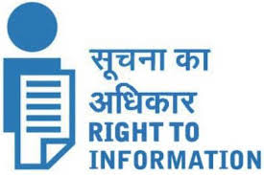

**ALL INDIA INSTITUTE OF SPEECH & HEARING,**

**MANASAGANGOTHRI, MYSORE - 570 006**

**6.2 Guidelines for Indian Government Websites (GIGW) is followed (released in February, 2009 and included in the Central Secretariat Manual of Office Procedures (CSMOP) by Department of Administrative Reforms and Public Grievances, Ministry of Personnel**

* + 1. **Whether STQC certification obtained and its validity.**

As per the records, for the mentioned period, the certification was kept in abeyance as the website was in the process of getting updated in the trilingual format as required. Presently, efforts are being made for getting the STQC certification and installation of Secure Socket Layer (SSL) certification for the website.

* + 1. **Does the website show the certificate on the Website?**

No