Last update: 31.03.2022

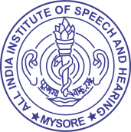

**ALL INDIA INSTITUTE OF SPEECH & HEARING,**

**MANASAGANGOTHRI, MYSORE - 570 006**

**6 Information Disclosed on own initiative**

* 1. Item/information disclosed so that public have minimum resort to use of RTI Act to obtain information

## [Quotation,/tender, recruitment](https://aiishmysore.in/en/news), [annual reports](https://aiishmysore.in/en/aiish-annual-report), [student admission](https://aiishmysore.in/en/admin/file_att/Pros%202020-21%20(1).pdf) etc. are being published on the official website of the Institute at <http://www.aiishmysore.in/en>