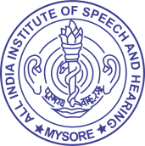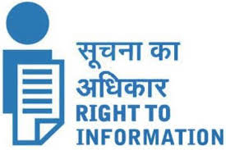

**ALL INDIA INSTITUTE OF SPEECH & HEARING,**

**MANASAGANGOTHRI, MYSORE - 570 006**

**4 E-Governance**

* 1. **When was the information Manual/Handbook last updated? [F No. 1/6/2011-IR dt 15.4.2013]**

Last date of Annual updation : **31.03.2022**