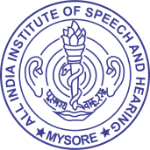**Last update: 31.03.2022**

**ALL INDIA INSTITUTE OF SPEECH & HEARING,**

**MANASAGANGOTHRI, MYSORE - 570 006**

**4E-Governance**

* 1. **Language in which Information Manual/Handbook Available[F.No. 1/6/2011-IR dt. 15.4.2013]**
     1. [English](AIISH%20-Information%20Handbook-%20English%20Version.docx) (Download)
     2. [Hindi](AIISH%20-Information%20Handbook-%20Hindi%20Version.docx) (Download)
     3. [Kannada](AIISH%20-Information%20Handbook-%20Kannada%20Version.docx) (Download)