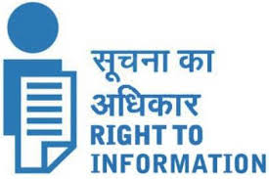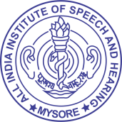**Last update: 31.03.2022**

**ALL INDIA INSTITUTE OF SPEECH & HEARING,**

**MANASAGANGOTHRI, MYSORE - 570 006**

**2 Budget and Programme**

* 1. **Discretionary and non-discretionary grants [F.No. 1/6/2011-IR dt. 15.04.2013]**

1. Discretionary and non-discretionary grants/allocations to State Govt./NGOs/other

Institutions

**Not Applicable**

1. Annual accounts of all legal entities who are provided grants by public authorities

**Not Applicable**