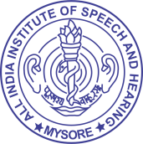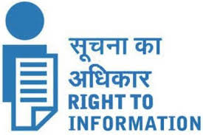Last update :31.03.2022

**ALL INDIA INSTITUTE OF SPEECH & HEARING,**

**MANASAGANGOTRI, MYSORE - 570 006**

1 Organisation and Function

* 1. **Programmes to advance understanding of RTI[Section 26]**

1. Educational Programmes

|  |  |  |
| --- | --- | --- |
| Induction training/ Orientation training for Group A, B and C staff joined after 01.12.2020 | 10.05.2021 | AIISH, Mysuru |

1. **Efforts to encourage public authority to participate in these programmes**

RTI awareness training programmesare being attended time to time

1. **Training of CPIO/APIO**

* Mr. Freddy Antony, former CPIO and Dr. Shijith Kumar C, Transparency Officer attended the training on RTI-MIS organized by the Ministry of Health and family Welfare, Govt. of India, at Nirman Bhavan, New Delhi on 14th July 2016.
* Dr. Gopi Kishore, former CPIO attended the training on RTI organized by Institute of Public Administration at Chennai on 18-19, Septermber 2018.
* Dr.Sreeraj Konadath, current CPIO and Dr. Shijith Kumar C, Transparency Officer attended the training on Suo Moto Disclosure and Transparency Audit organized by National Institute of Health and Family Welfare, New Delhi on 04.02.2020.

1. **Update & publish guidelines on RTI by Public Authorities concerned**

[The updated guidelines on RTI](https://aiishmysore.in/en/how-to-ask-for-information) are being made available on the Institute website.