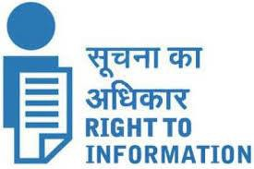Last update:31.03.2022

ALL INDIA INSTITUTE OF SPEECH & HEARING,

MANASAGANGOTHRI, MYSORE-570006

**2 Budget and Programme**

2.6 CAG & PAC paras[FNo.1/6/2011-IRdt.15.4.2013]

(i)CAG and PAC paras and the action taken reports (ATRs) after these have been laid on the table of both houses of the parliament.

Till date No CAG & PAC paras.