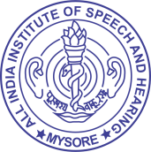Last update : 31.03.2022

**ALL INDIA INSTITUTE OF SPEECH & HEARING,**

**MANASAGANGOTHRI, MYSORE - 570 006**

1. Organisation and Function
   1. **Transfer policy and transfer orders[F.No.1/6/2011-IR dt. 15.4.2013]**

Not Applicable